Set Up Code quality Analysis

Overview
This document explains how to set up SonarQube for performing automated code quality analysis on your Node.js project. We'll use Docker to deploy SonarQube locally and SonarScanner CLI for running code scans.

Prerequisites
- Docker installed on your local machine
- Node.js and npm installed
- Basic understanding of the command line
- Internet access to download Docker images and SonarScanner

Step 1: Setting Up SonarQube
As we have installed docker in our DevOps environment setup documentation, let’s pull the SonarQube Docker image and run it.
- Open your terminal.

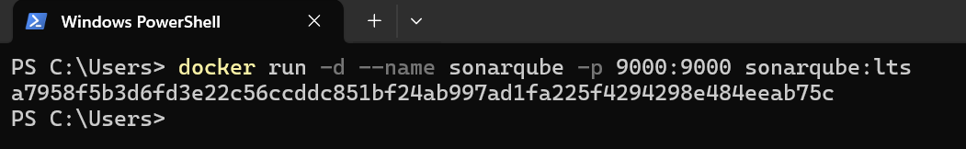
- Pull and run the SonarQube Community Edition Docker image:

- Access the SonarQube web interface:
  - http://localhost:9000

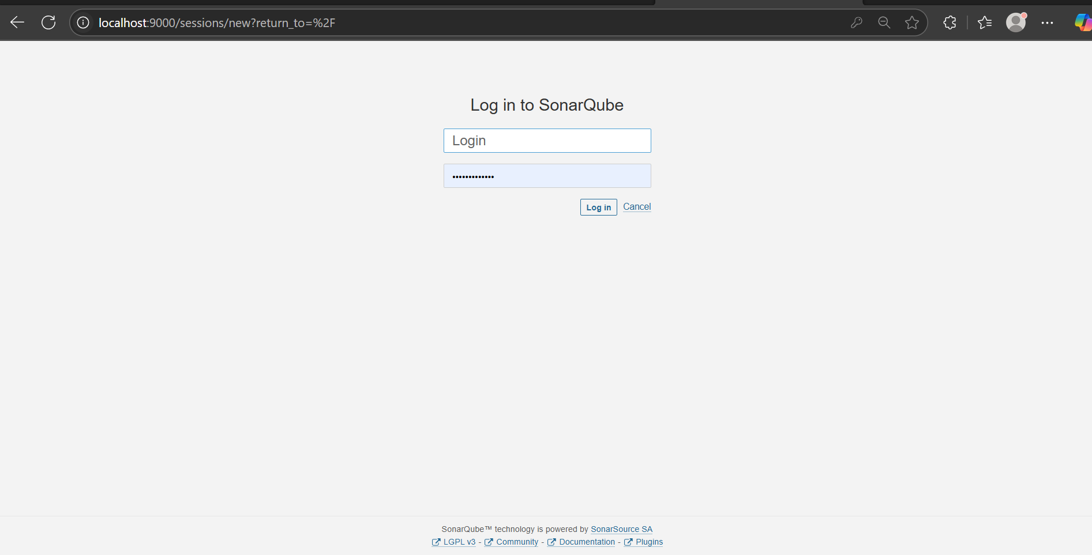
- Default login credentials are admin/admin.
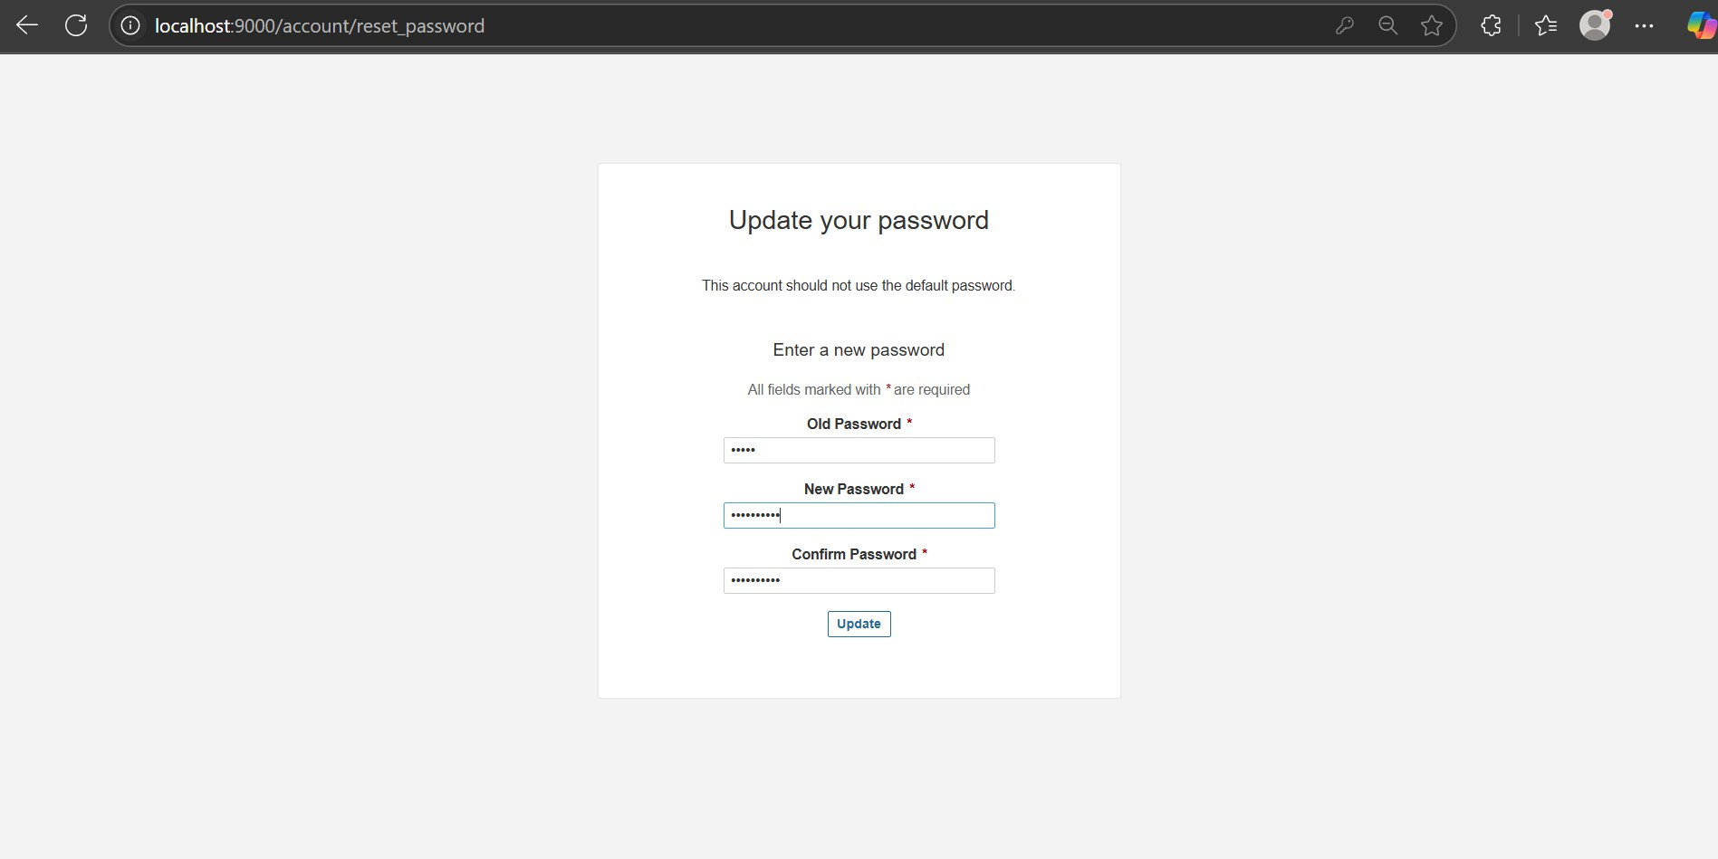
- Reset the password

Step 3: Create a New Project:

Once logged in, you need to create a new project in SonarQube. Follow these steps:

- Click on the “Projects” tab on the top menu.

- Click on the “Create Project” button.

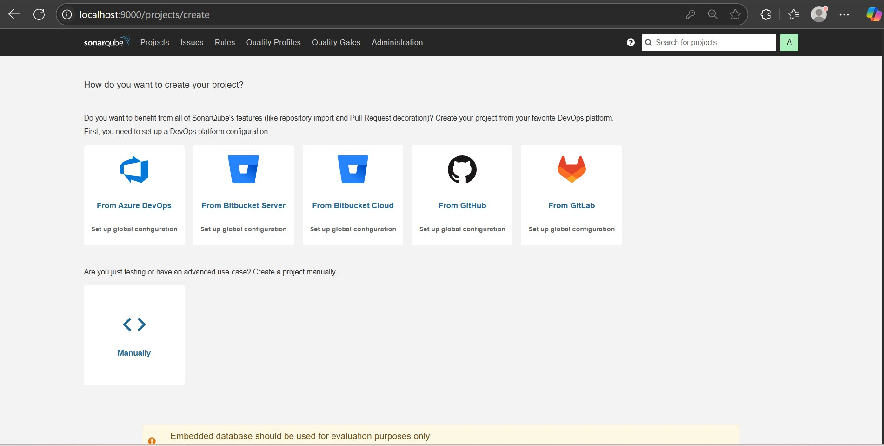
- Select manually.

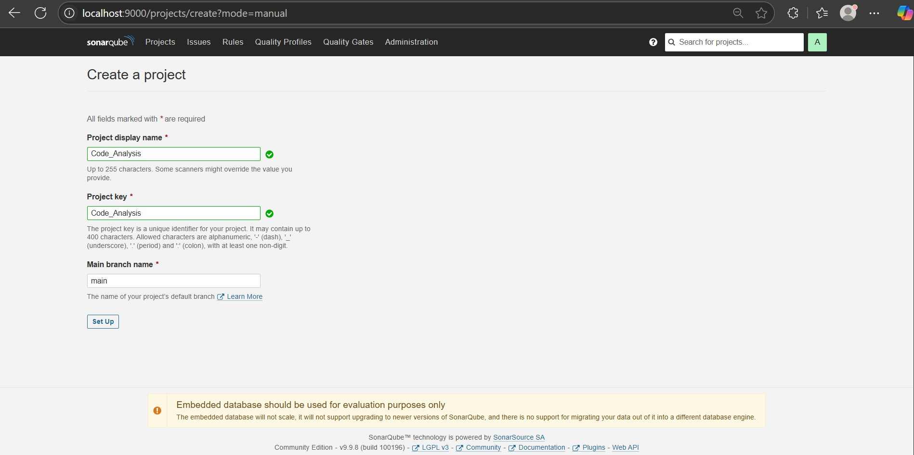
- Enter a Project Key and Project Name, then click “Set Up”.

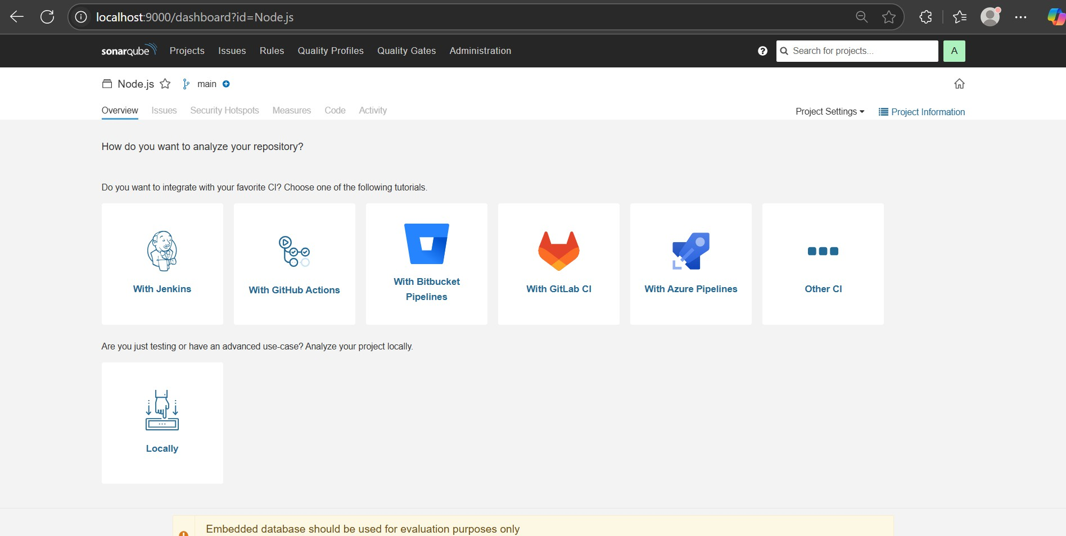
Step 4: To analyze the code , select locally.

Generate an authentication token for your project.

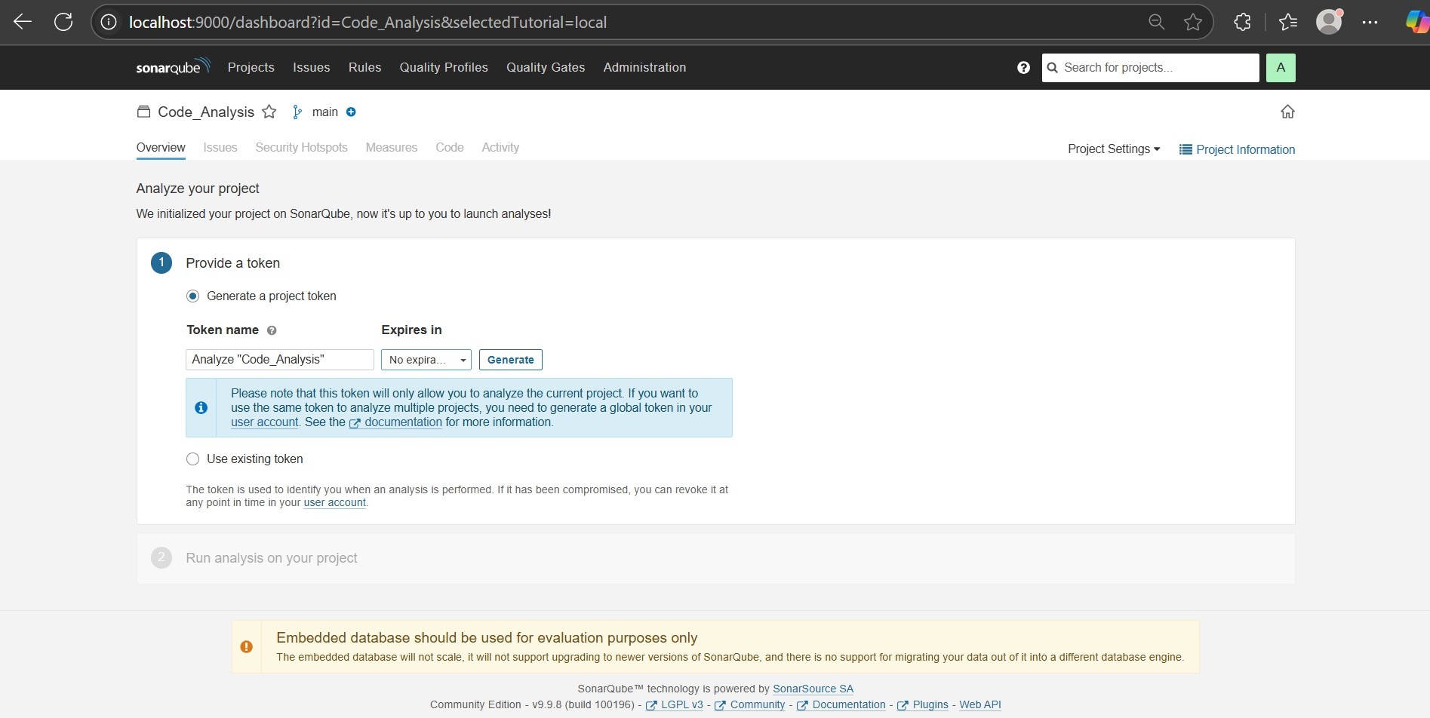
- Copy this token (you’ll use it in the next steps).

- Select the other option

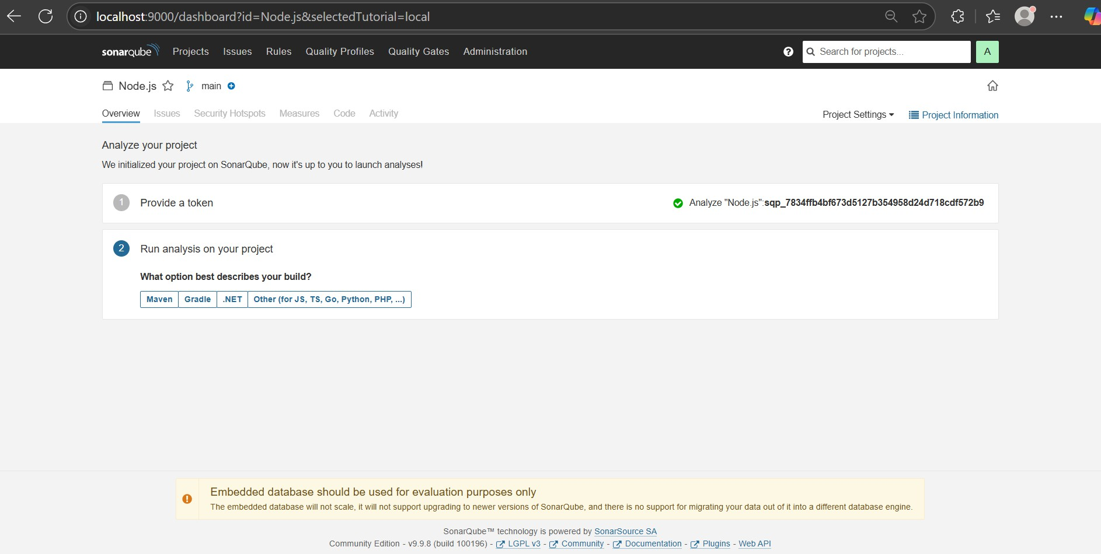
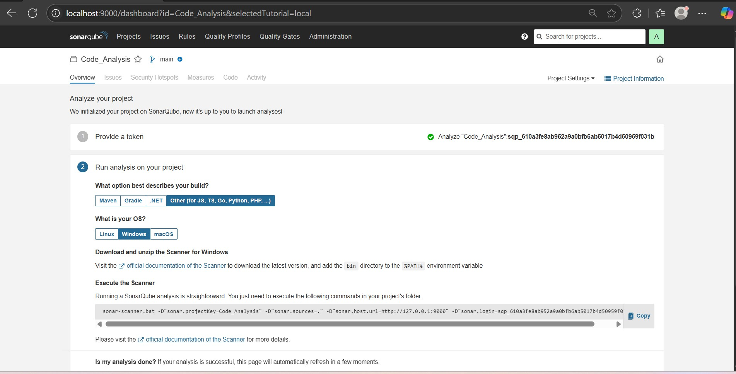
- Under “Other”, select “Windows” as your environment.

Step 5: Install Sonar-scanner in your local machine.
Visit the official documentation of the Scanner to download the latest version, and add the bin directory to the %PATH% environment variable

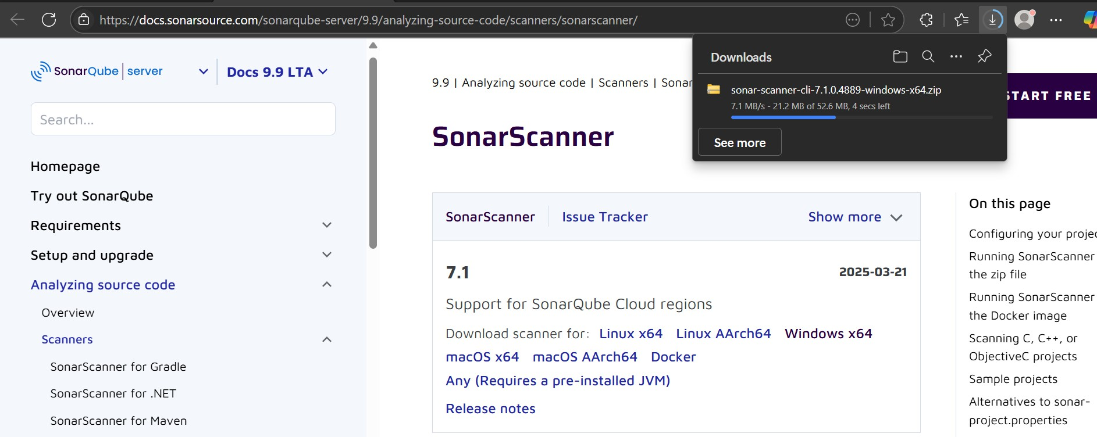
- Extract the folder to a location like:
  - C:\SonarScanner
- Add SonarScanner’s /bin directory to your System Environment PATH:
  - Press Win + R, type sysdm.cpl, and press Enter.
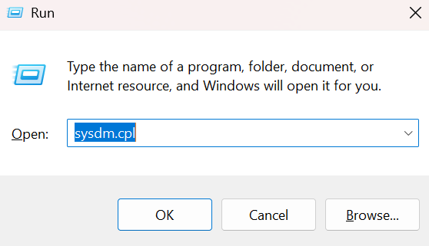

- Click ok

- Go to the Advanced tab → click on Environment Variables.
- Under System Variables, select Path → click Edit.

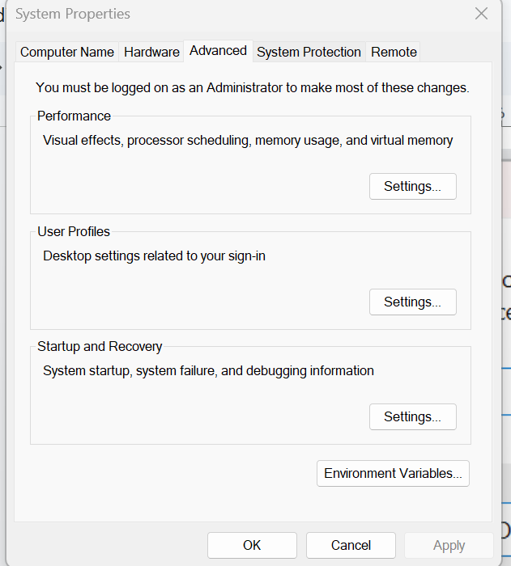

- Click New, then paste your SonarScanner bin directory path
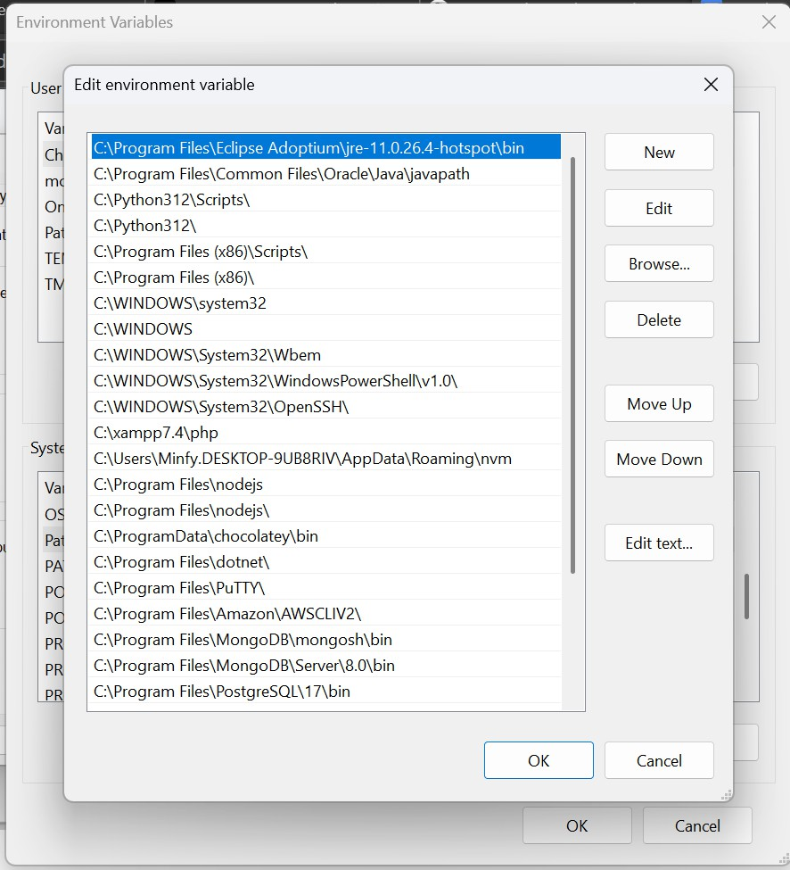
- Click OK to close all dialogs.

- Verify with sonar-scanner --version in your terminal.
- Now the sonar-scanner is successfully installed.

Step 6: Configure Nodejs Project
- npm install -y
- Add your script
- Create sonar-project.projecties file in your project
  - Configure the given values
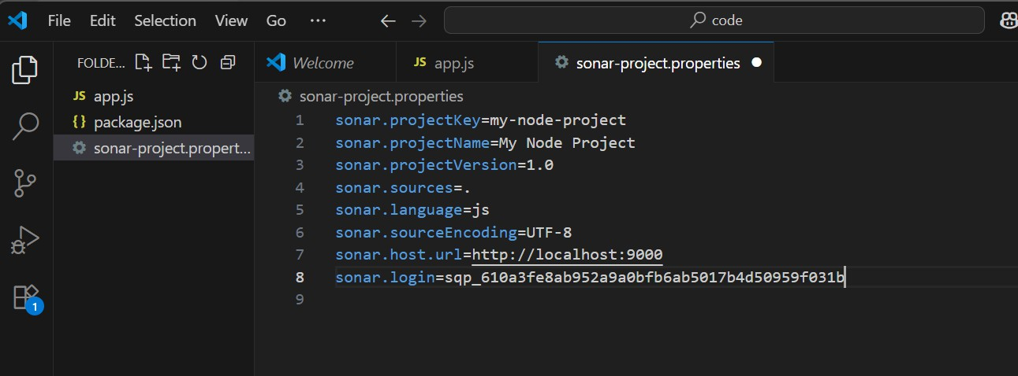
  - Add the generated token in sonar.login

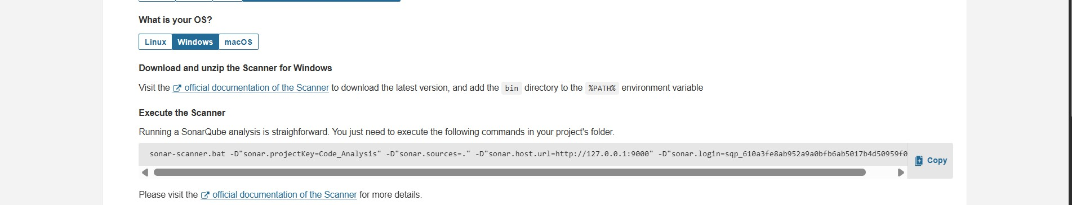
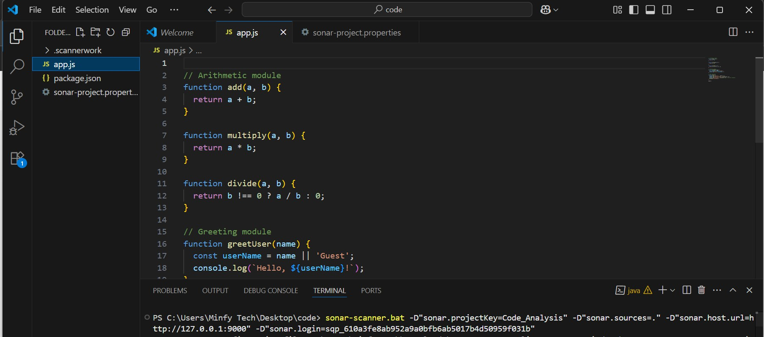
- Execute the Scanner(check your in sonarQube) in terminal:

- The Execution is successful

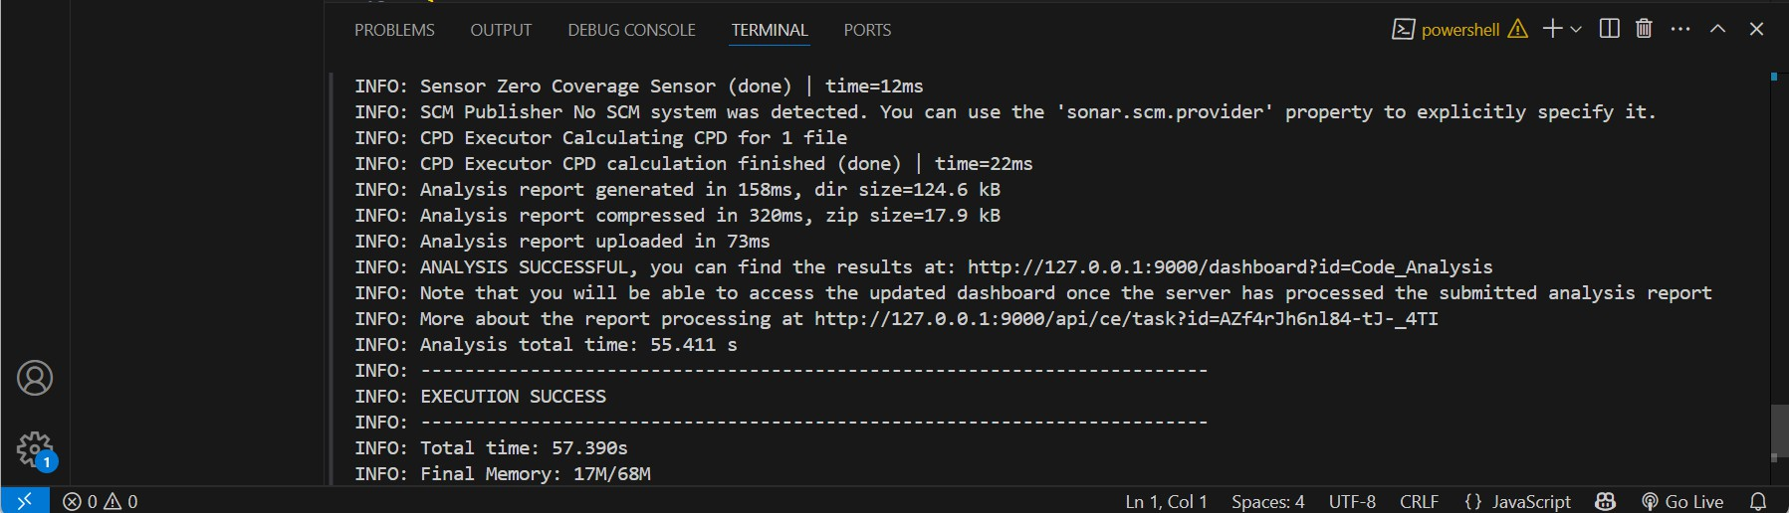
Once the SonarQube stage executes, check the SonarQube dashboard (http://localhost:9000) for the analysis report.
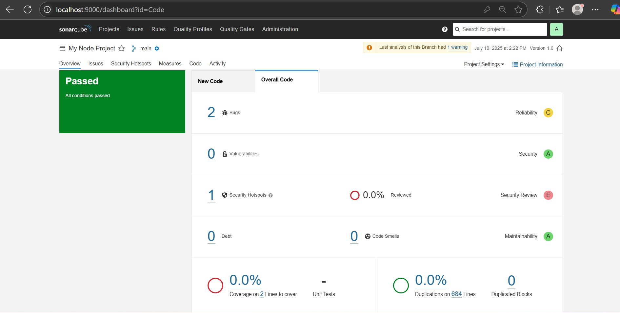
- Verify that the code quality metrics are populated correctly.

Conclusion
By following this guide, you have successfully set up SonarQube for automated code quality analysis of your Node.js project. Using Docker to deploy SonarQube and SonarScanner for analysis ensures a scalable, consistent, and platform-independent setup. With this integration:
- You gain real-time insights into code quality, bugs, vulnerabilities, and code smells.
- SonarScanner enables continuous analysis with each code change.
- The SonarQube dashboard provides detailed reports to help enforce coding standards and improve maintainability.

