Build Multi-container Applications

Overview

Creating custom Docker images means packaging your application, its dependencies, configurations, and environment into a lightweight, portable container image using a Dockerfile. Instead of using pre-built images from Docker Hub, you define your own image that perfectly suits your project’s needs.

This allows you to control exactly how your app runs from the base operating system to the runtime, libraries, and even environment variables.
By writing simple step-by-step instructions in a Dockerfile, you can automate the setup of your app’s environment. Once built, the image can be reused anywhere locally, on servers, or in the cloud ensuring consistent behavior across all systems. This is especially useful for deployment, testing, CI/CD, or sharing apps with others.

Prerequisites
- VS Code
- Docker
- Docker CLI
- Node.js
- MongoDB

Step 1: Create Project

- Open Docker Desktop in your PC.
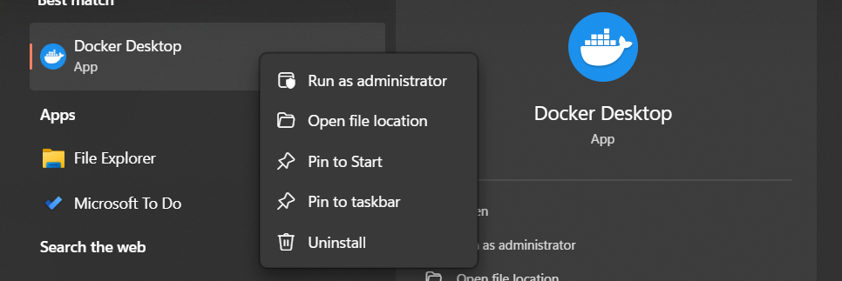

- Open VS Code.

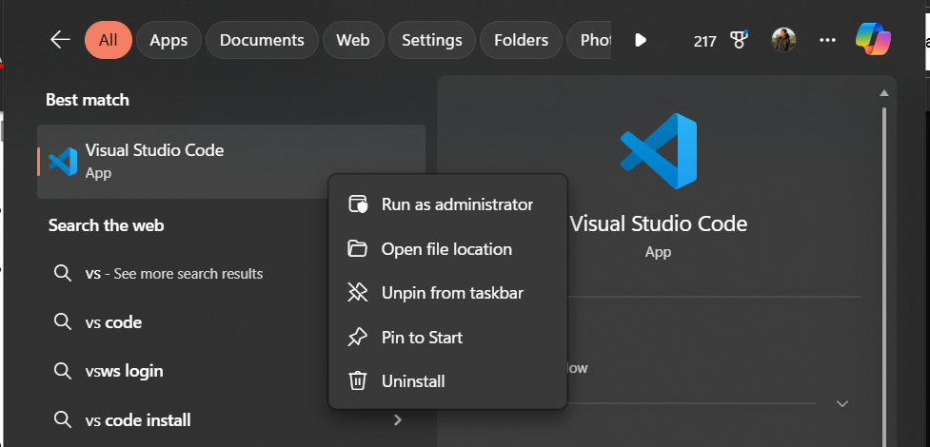

- Create Project Folder, in terminal run the following commands:
  - mkdir multi-container
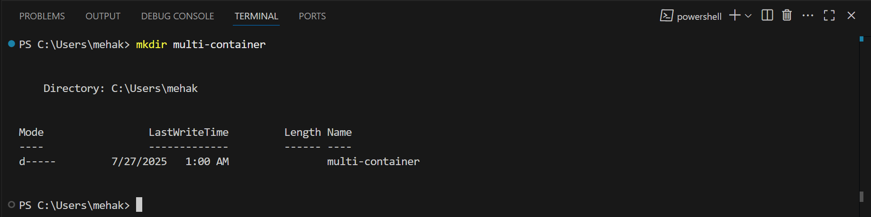

  - cd multi-container
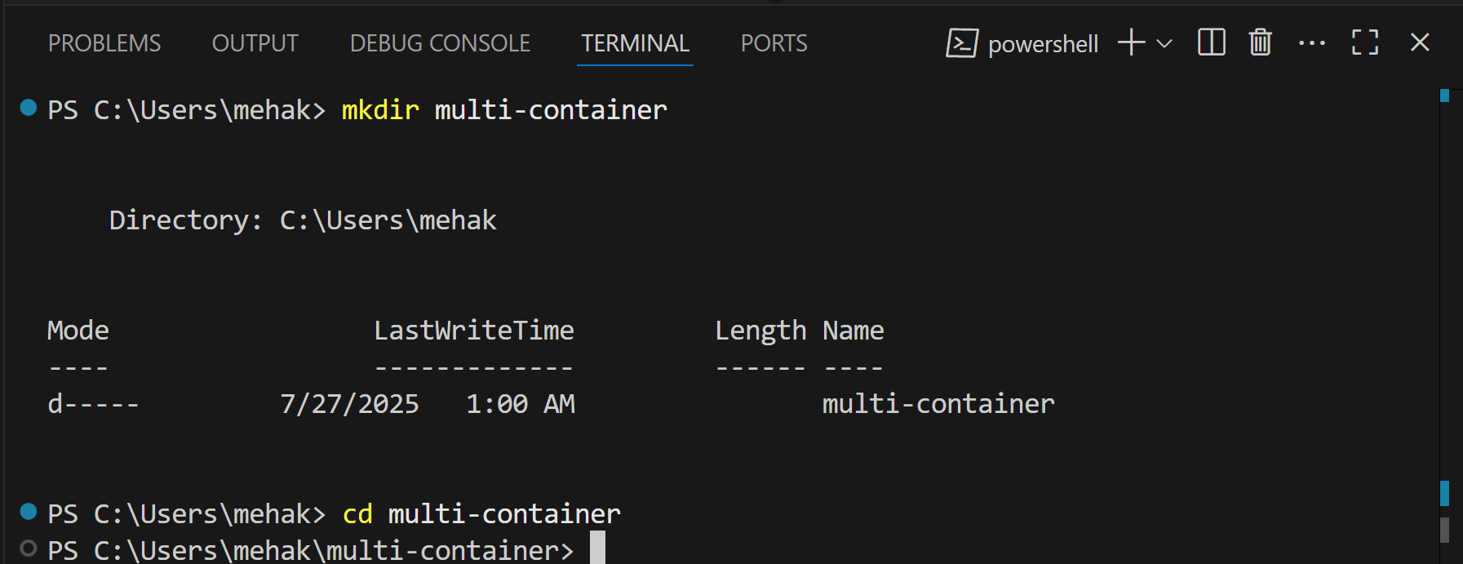

  - mkdir backend

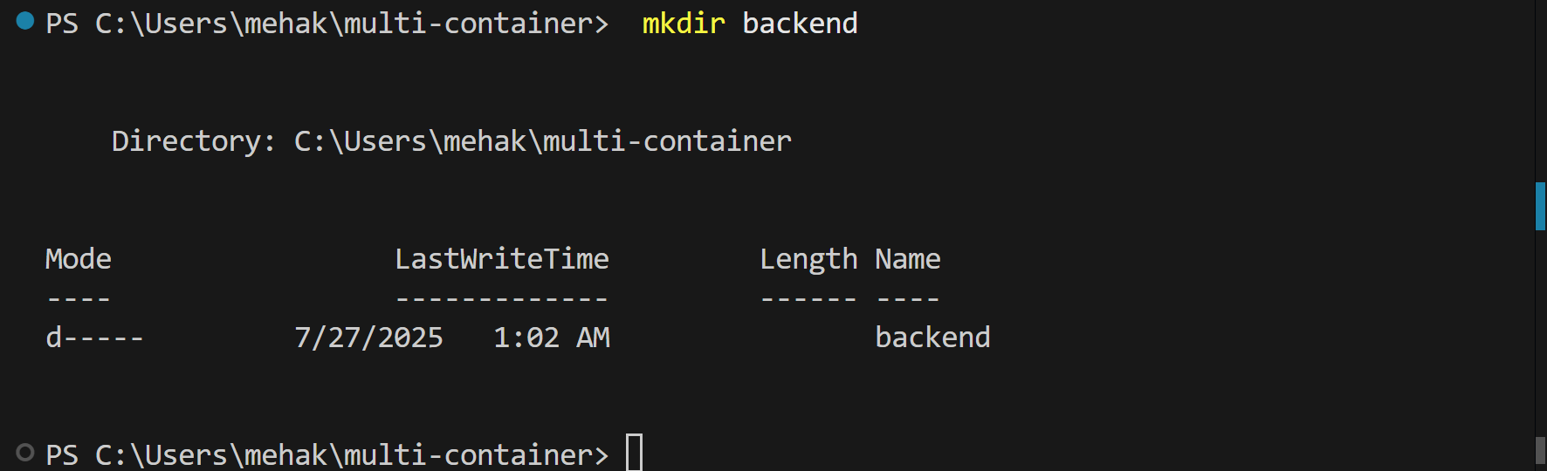

  - cd backend

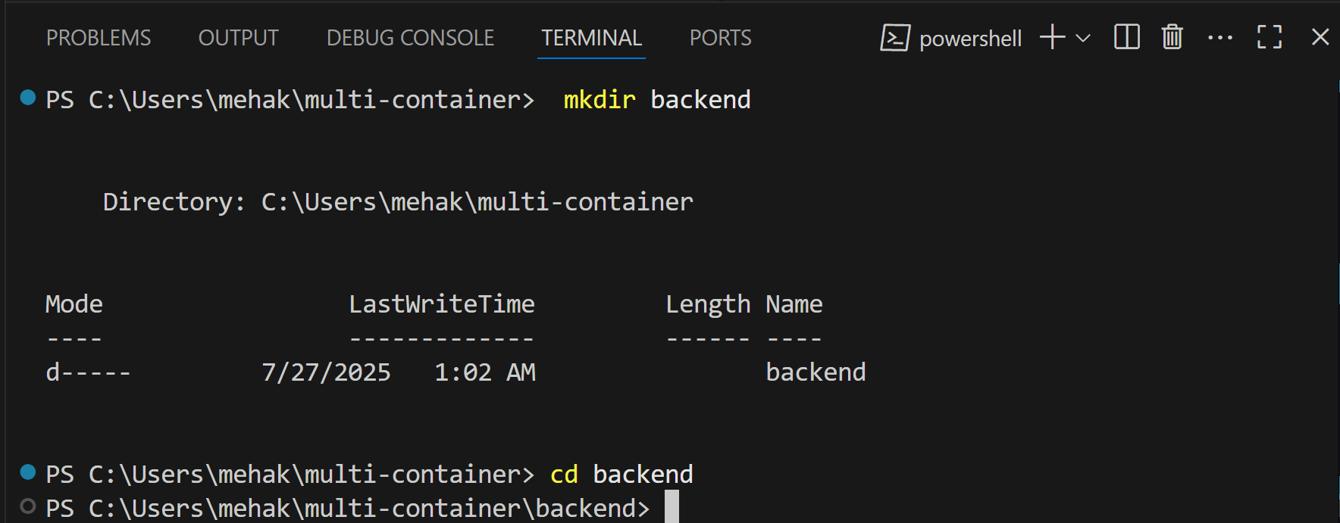

- Initialize Node.js App:
  - npm init -y

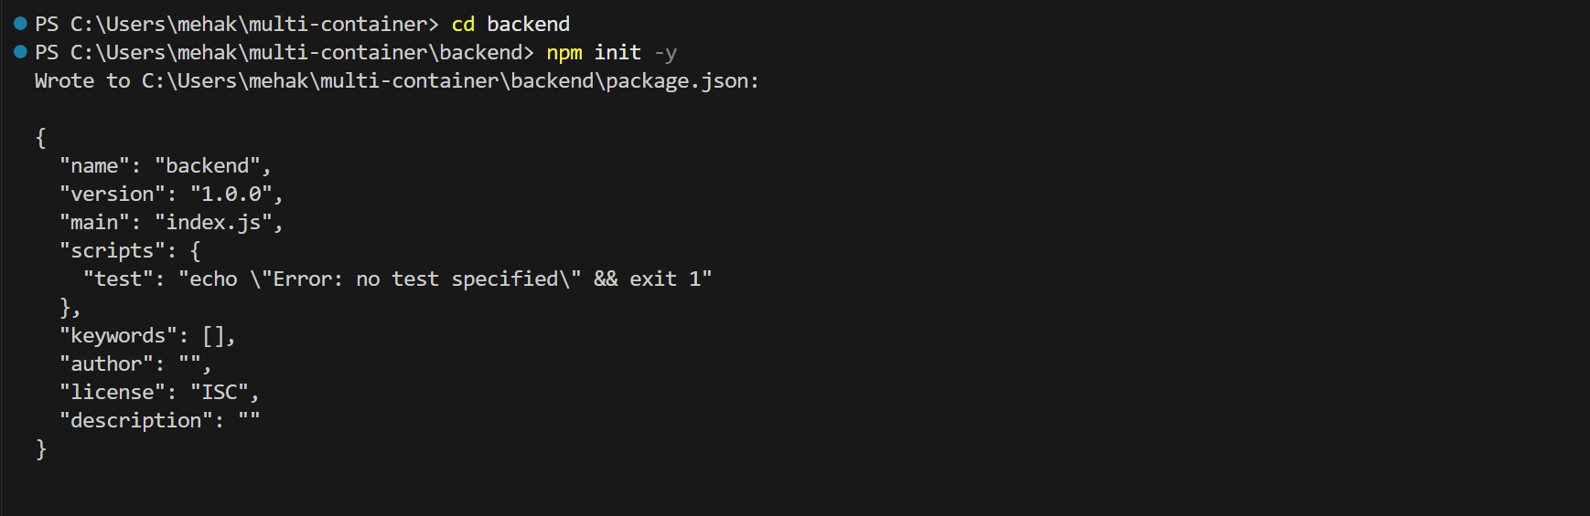

  - npm install express mongoose

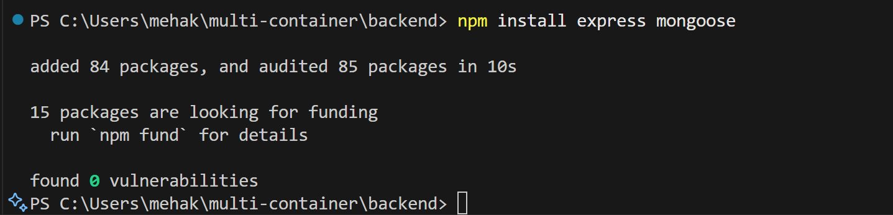

- Create server.js:

const express = require('express');
const mongoose = require('mongoose');

const app = express();
const PORT = 3000;
const MONGO_URI = 'mongodb://mongo:27017/mydatabase';

app.use(express.json());

mongoose.connect(MONGO_URI)
.then(() => console.log('Connected to MongoDB'))
.catch(err => console.error(err));

app.get('/', (req, res) => {
res.send('Hello from Node.js and MongoDB!');
});

app.listen(PORT, () => {
console.log(`Server running on port ${PORT}`);

});

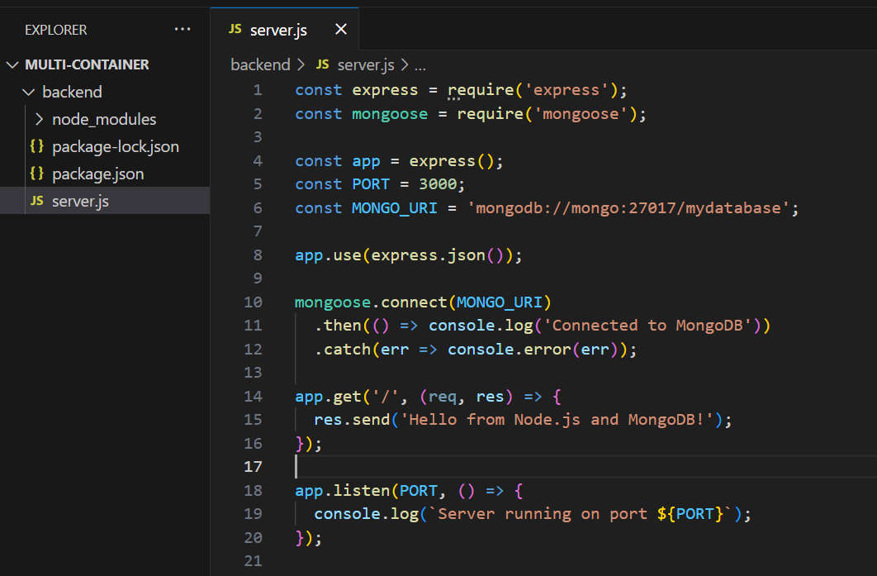

Step 2: Create Dockerfile for Backend

- Inside backend folder make a file Dockerfile:

# Use Node base image
FROM node:18

# Set working directory
WORKDIR /app

# Install dependencies
COPY package*.json ./
RUN npm install

# Copy app files
COPY . .

# Expose port
EXPOSE 3000

# Run the app
CMD ["node", "server.js"]

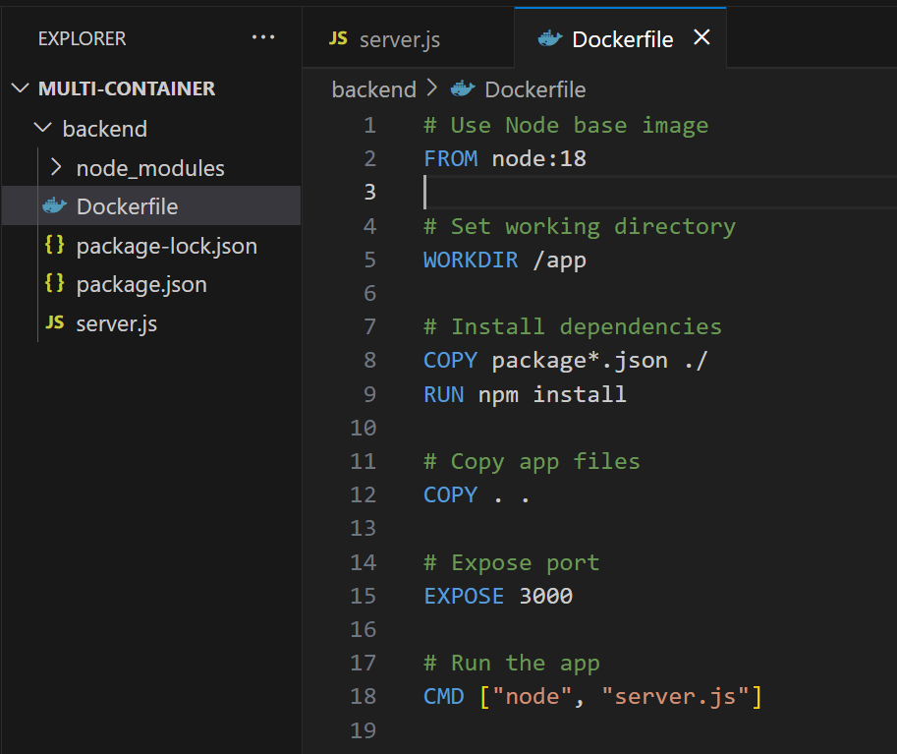

Step 3: Add .dockerignore

- Inside backend, add .dockerignore:
- Add the following folders inside .dockerignore:

node_modules
npm-debug.log
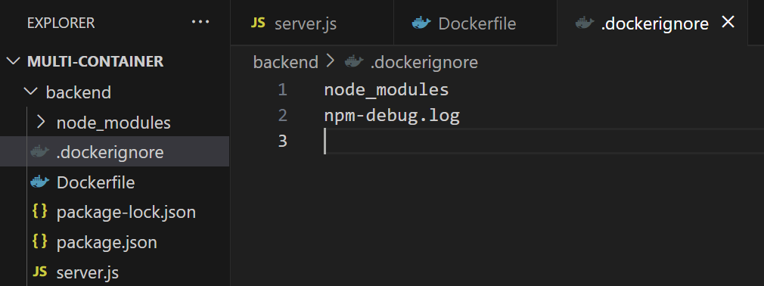

Step 4: Create docker-compose.yml

- Go back to root folder multi-container folder and create:

version: '3.8'

services:
backend:
build: ./backend
ports:
- "3000:3000"
depends_on:
- mongo
restart: always

mongo:
image: mongo
container_name: mongodb
ports:
- "27017:27017"
volumes:
- mongo-data:/data/db
restart: always

volumes:
mongo-data:
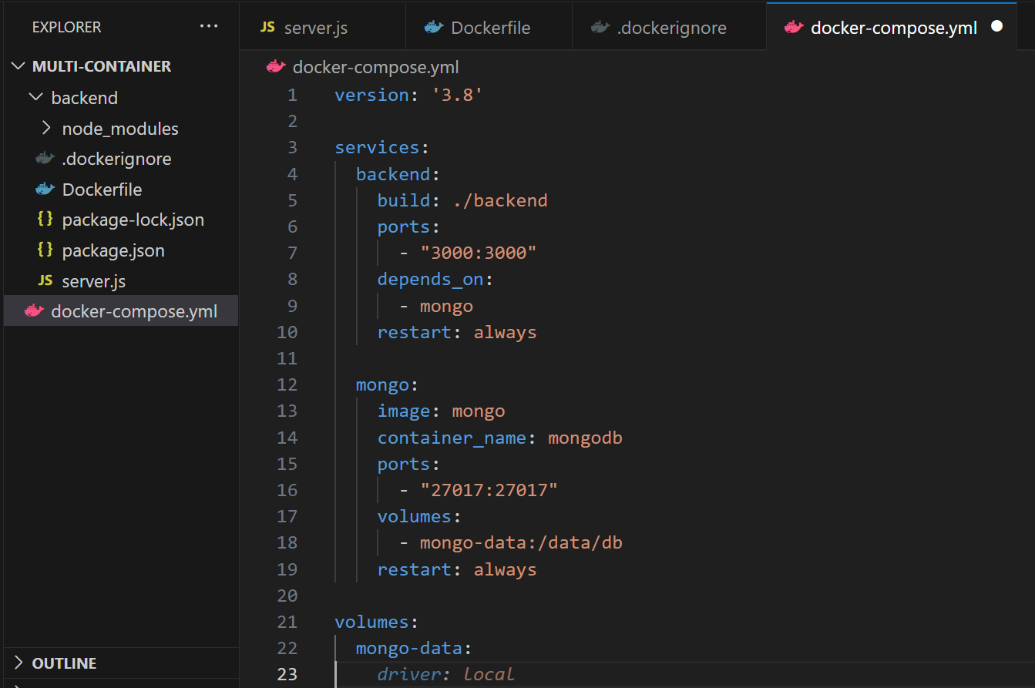

Project Structure:

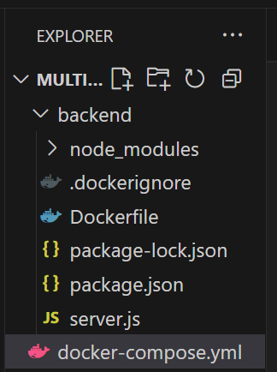

Step 5: Run the App

- Open your project folder in PowerShell or command prompt or terminal.

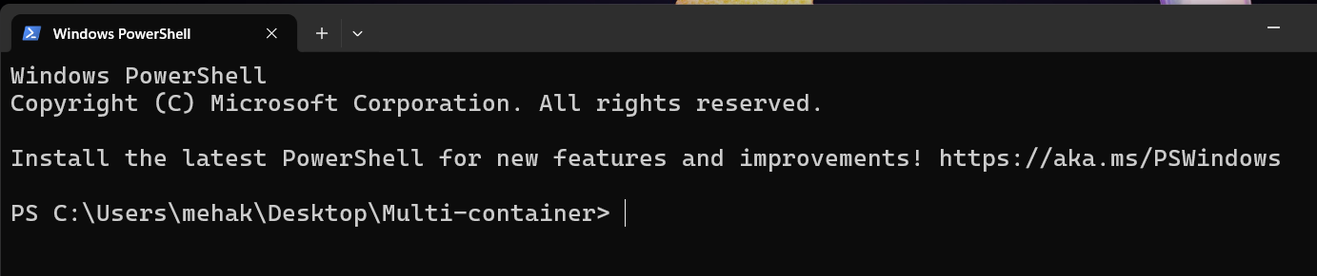
- Make sure Docker Desktop is running.
- From the root folder (multi-container), run:
    - docker-compose up –build
This will:
- Build the backend image
- Pull the MongoDB image
- Run both services in separate containers
- Automatically connect them in a shared network

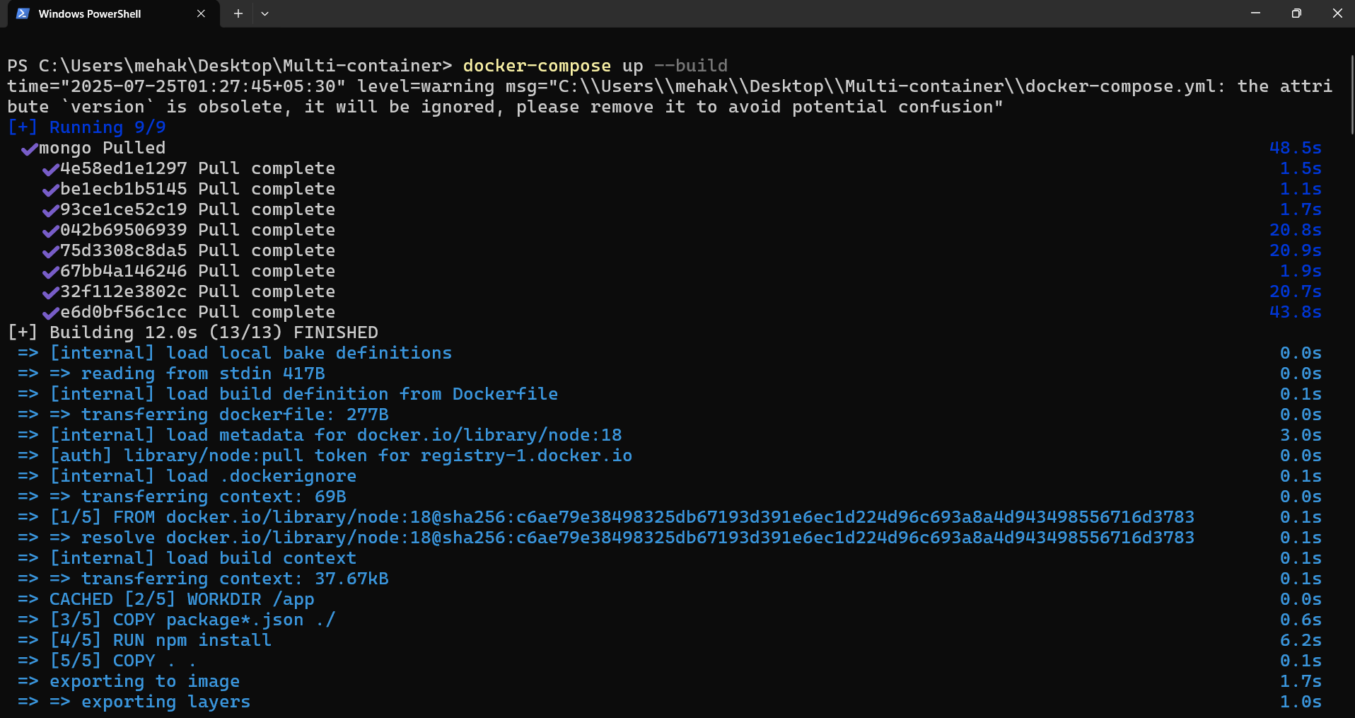

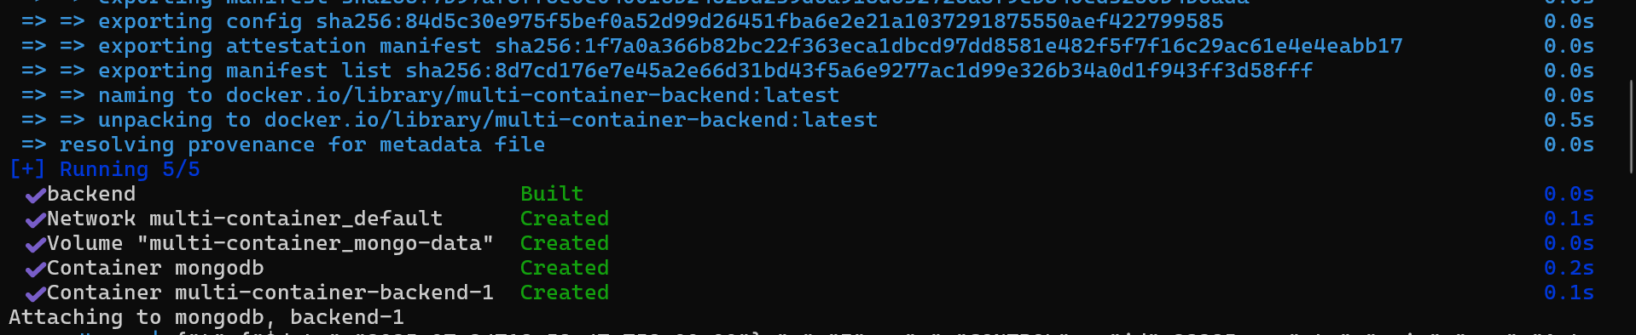

- Visit in browser:
http://localhost:3000

- You should see:
Hello from Node.js and MongoDB!

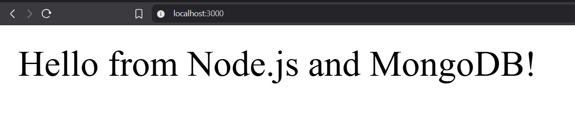

Step 6: Check Status and Logs

- Run the command:
    - Docker-compose ps

This command is used to list all the containers that are part of your Docker Compose application.

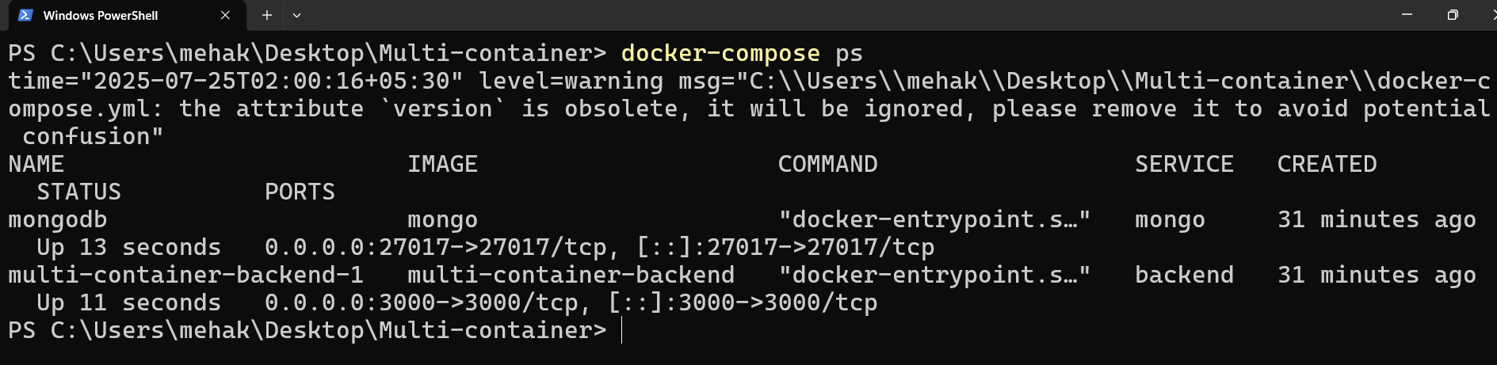

- Run the command:
    - Docker-compose logs backend

Explanation:
It is used to view the logs generated by the backend service in a Docker Compose setup. It shows the output from the backend container, including any print statements, errors, or logs that the service has produced.

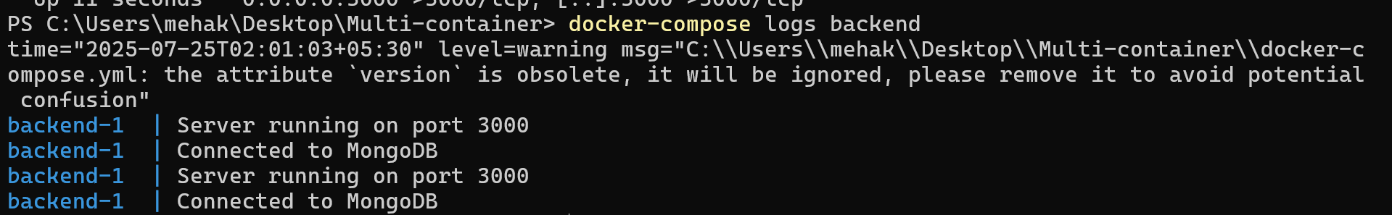

- Run the command:
    - docker-compose logs mongo

Explanation:
It helps you view output from the MongoDB container, such as startup messages, connection attempts, and any errors.

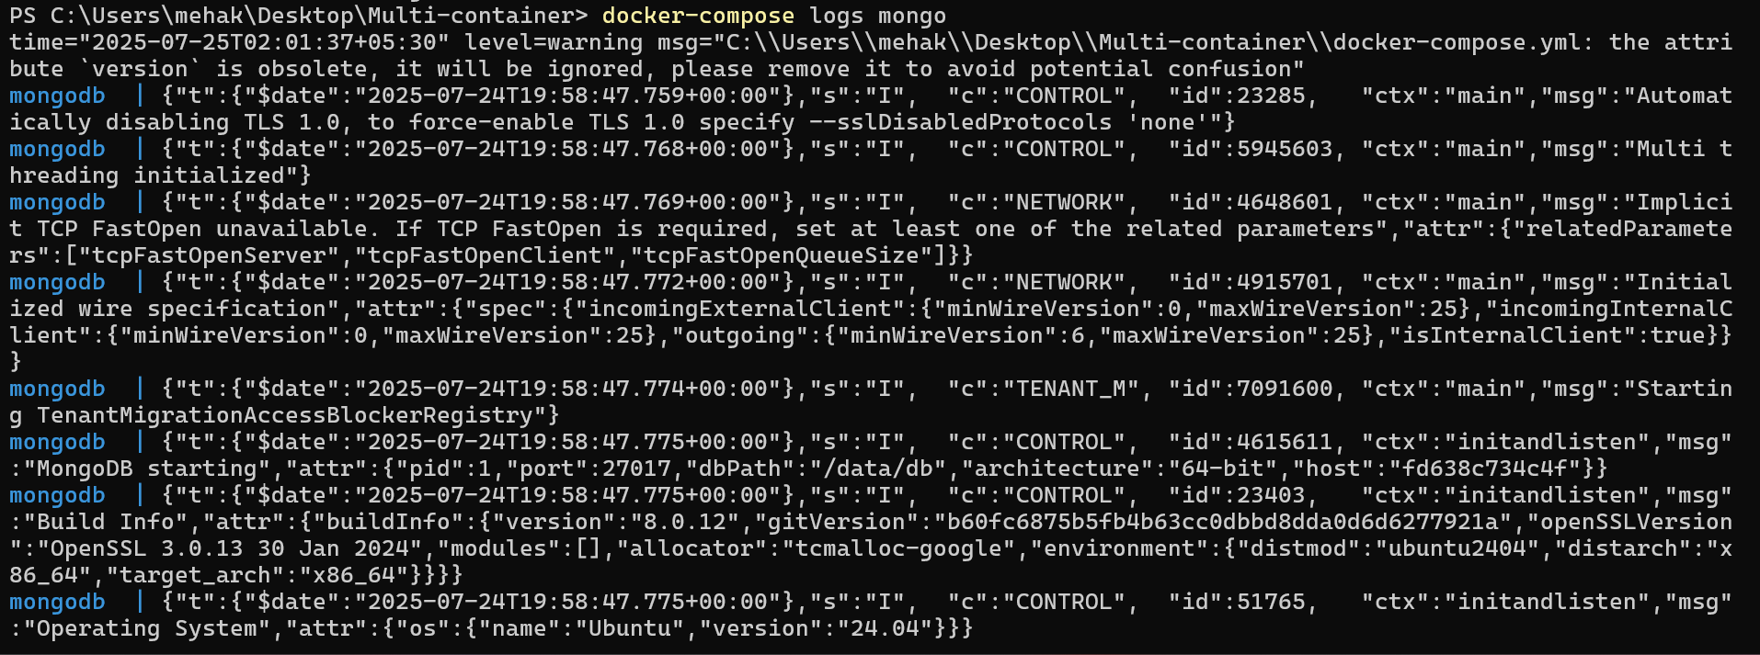

Check your docker desktop:

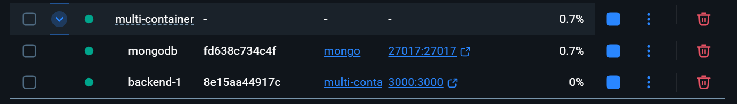

- Both the containers are present inside the multi-container.
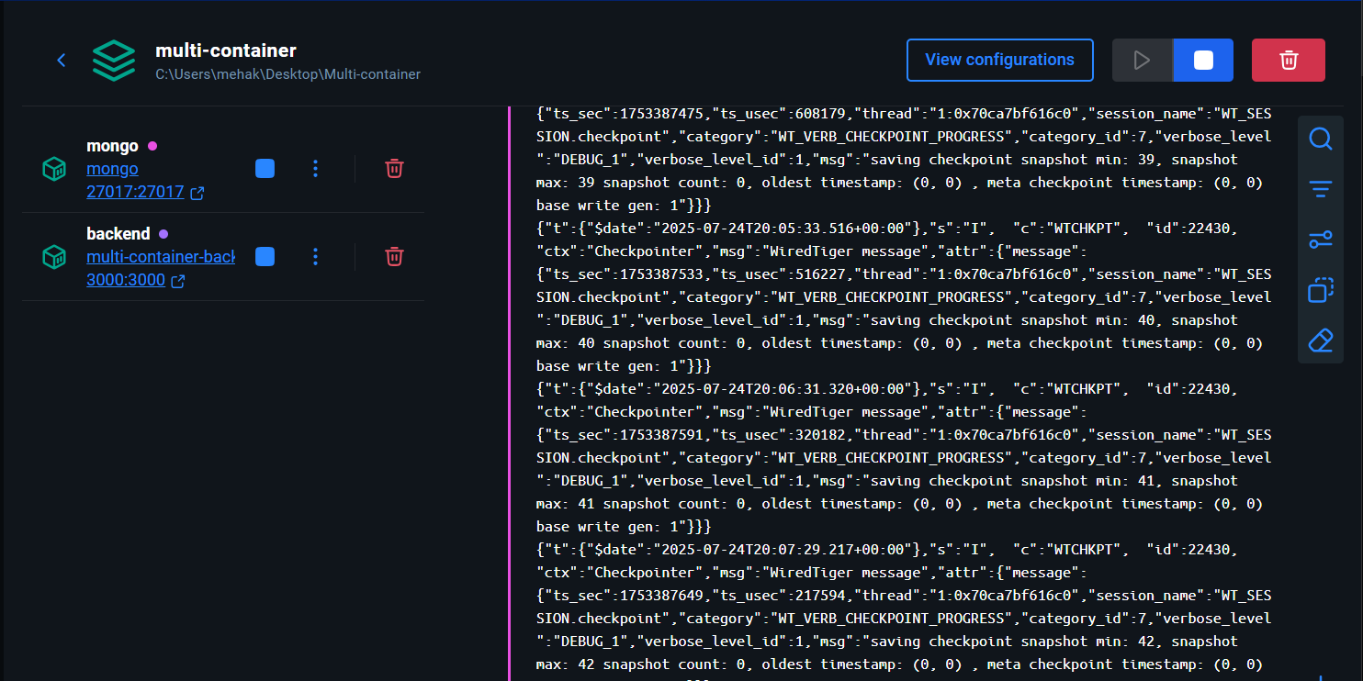

Conclusion

In this guide, we successfully built a multi-container Node.js application using Docker and Docker Compose. By containerizing the backend with a custom Dockerfile and connecting it to a MongoDB container, we ensured that our app runs consistently across different environments.

This approach is essential for modern development workflows—making the app scalable, portable, and ready for CI/CD pipelines, cloud deployment, and team collaboration. Now, you're equipped with the fundamentals to build, manage, and scale multi-service applications using Docker.

