Create Custom Docker Images

Overview

Creating custom Docker images means packaging your application, its dependencies, configurations, and environment into a lightweight, portable container image using a Dockerfile. Instead of using pre-built images from Docker Hub, you define your own image that perfectly suits your project’s needs.

This allows you to control exactly how your app runs from the base operating system to the runtime, libraries, and even environment variables.
By writing simple step-by-step instructions in a Dockerfile, you can automate the setup of your app’s environment. Once built, the image can be reused anywhere locally, on servers, or in the cloud ensuring consistent behavior across all systems. This is especially useful for deployment, testing, CI/CD, or sharing apps with others.

Prerequisites
- VS Code
- Docker
- Docker CLI
- Node.js

Step 1: Run your docker desktop.

- Open Docker Desktop in your PC.

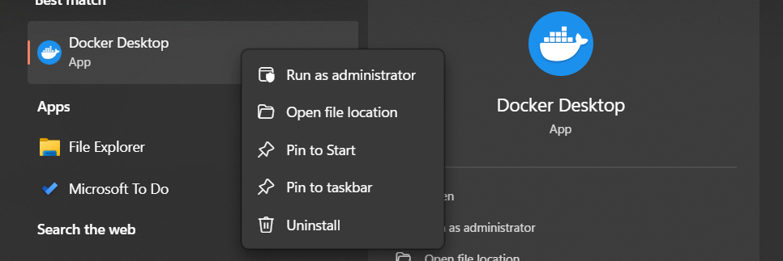

- Ensure Docker is running.
- Log in using your Docker Hub credentials.

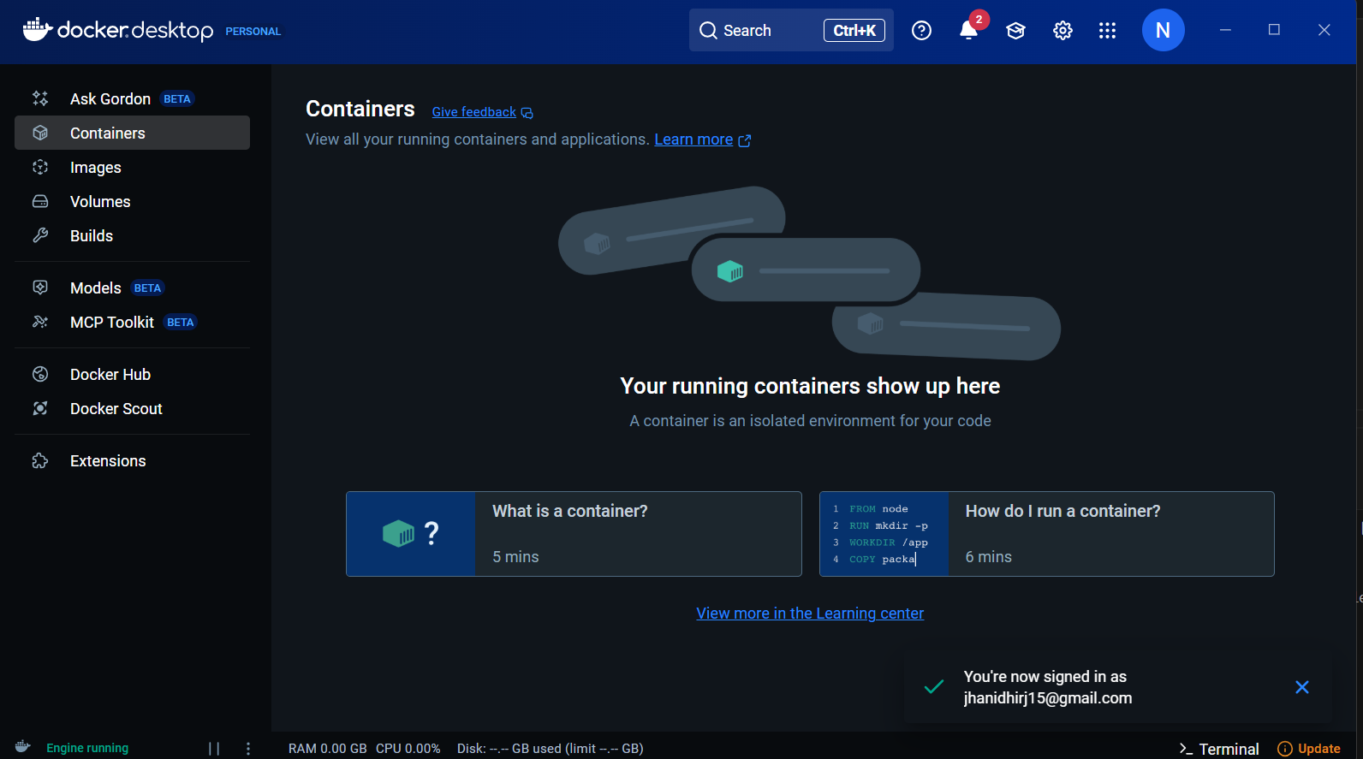

Step 2: Create a Simple Node.js Application

- Open VS code.
- Create a new folder in VS code.
- Inside the folder, run:
  - npm init -y

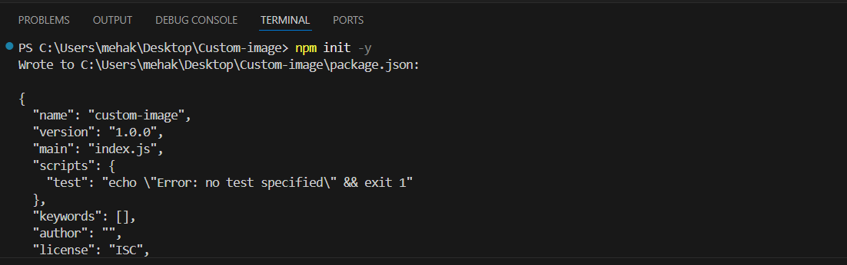

Explanation:

The command npm init -y is used in Node.js to quickly generate a package.json file with default values, allowing developers to set up a new project without manually filling in details like name, version, description, and entry point.

- Install Express:
  - npm install express

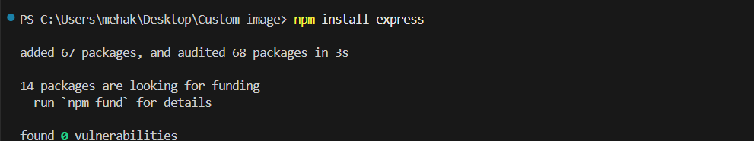

- Create a file: server.js

const express = require('express');
const app = express();
const PORT = 3000;

app.use(express.json());

app.get('/', (req, res) => {
res.send('Hello from Dockerized Node.js App!');
});

app.listen(PORT, () => {
console.log(`Server running on http://localhost:${PORT}`);
});

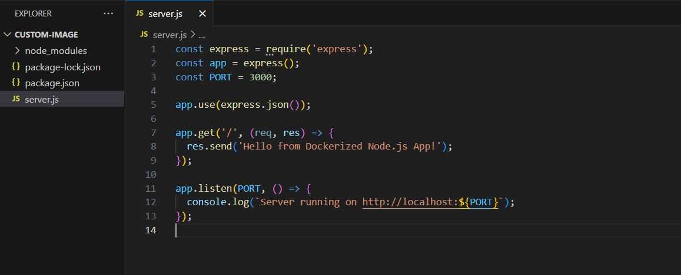

- This code sets up a basic Express server that listens on port 3000.

- Create a .dockerignore file and add:
  - node_modules (It contains all your project’s installed dependencies, which can be huge in size.)
  - npm-debug.log (This is a log file created when npm throws errors.)

Explanation:

We create a .dockerignore file in a Docker project to exclude specific files and folders from being sent to the Docker build context. This helps in improving the build performance, reducing the image size, and preventing unnecessary or sensitive files from being copied into the final Docker image.

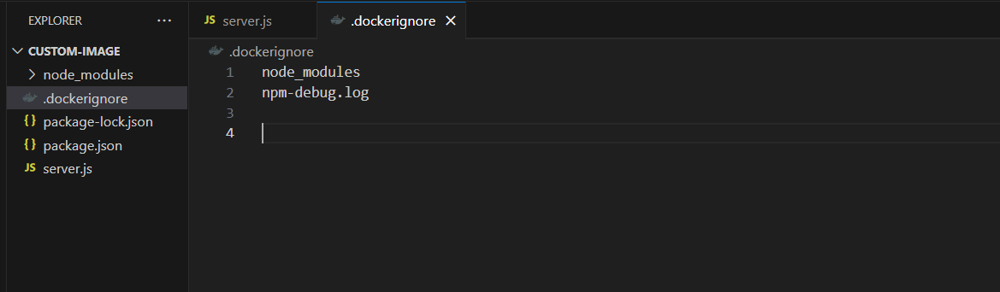

Step 3: Create the Dockerfile

A Dockerfile is a text file that contains a set of instructions used to build a Docker image. It tells Docker how to assemble your application—what base image to use, which files to copy, what dependencies to install, which ports to expose, and how to start the application.
- Create Dockerfile in the project.

# Step 1: Use official Node.js base image
FROM node:18

# Step 2: Set working directory inside container
WORKDIR /app

# Step 3: Copy package.json and install dependencies
COPY package*.json ./
RUN npm install

# Step 4: Copy application files
COPY . .

# Step 5: Expose port the app runs on
EXPOSE 3000

# Step 6: Define the command to run the app
CMD ["node", "server.js"]

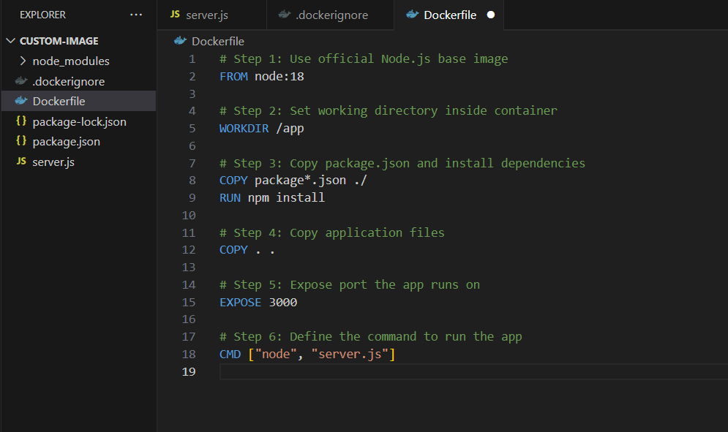

Step 4: Build the Docker Image

- Make sure you login on docker hub.
- Visit: https://hub.docker.com
- Sign in with your credentials.

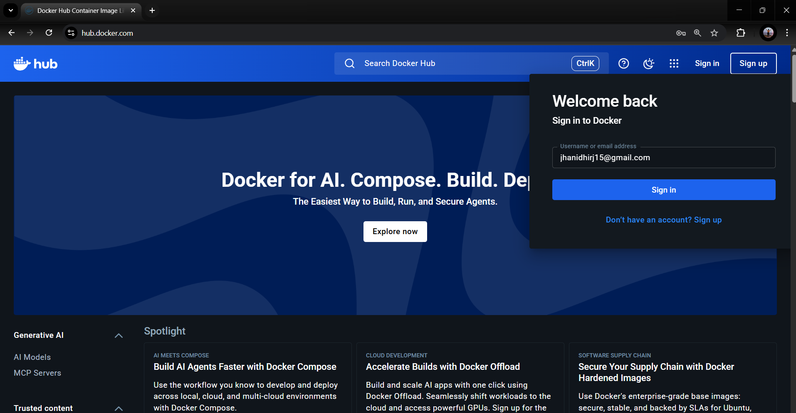

- Make sure Docker is running and you're in the project directory.
- Open your project in Windows PowerShell.

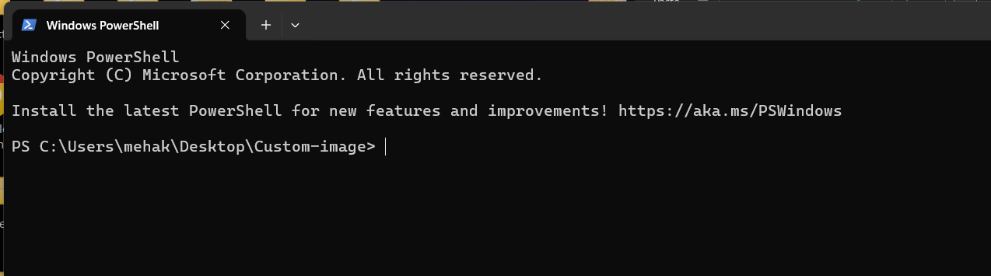

- Before pushing your custom Docker image to Docker Hub, you need to authenticate yourself using:
  - docker login

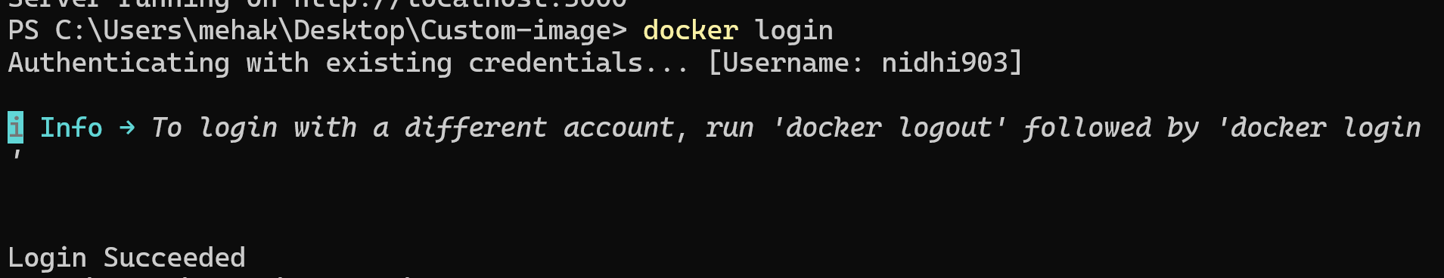

Build the Docker Image

- Run the command:

- docker build -t nodejs-custom-image .

What’s Happening?

- docker build: Starts the build process
- -t nodejs-custom-image: Tags the image with a name
- . : Current directory is the Docker context
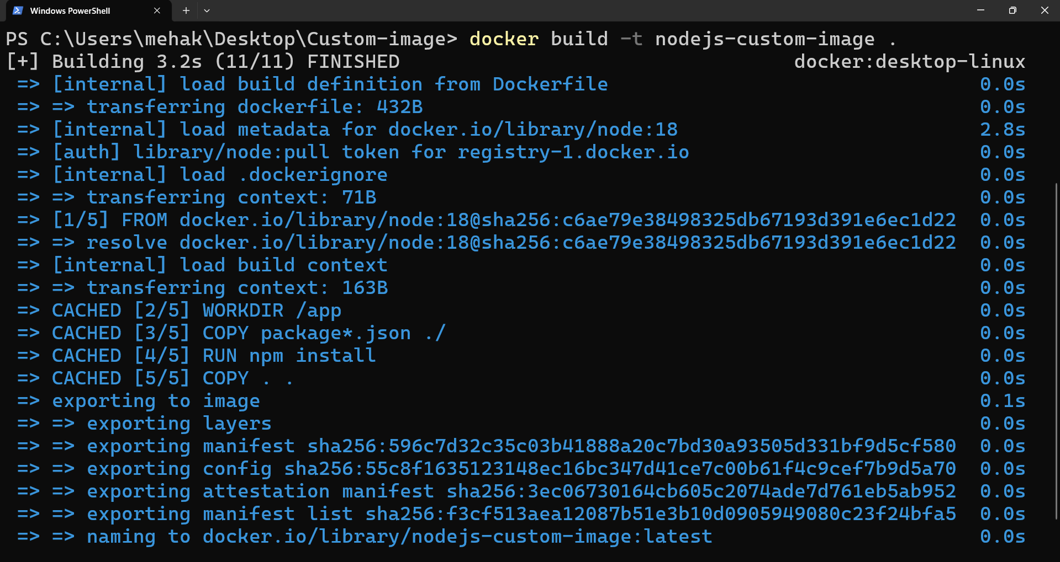

- Your image is successfully built.

Step 5: Run the Docker Container

- Run the image in container:
  - docker run -d -p 3000:3000 nodejs-custom-image

Explanation:

You're basically telling Docker, "Hey, take the image I created (called nodejs-custom-image), start it up in the background (-d), and make sure I can access it on my browser through port 3000 (-p 3000:3000)." Even though the app is running inside a container, this command makes it feel like it’s running right on your computer. So, once it's up, you can just open your browser and go to http://localhost:3000 to see it in action.

- Now visit http://localhost:3000
You’ll see: Hello from Dockerized Node.js App!

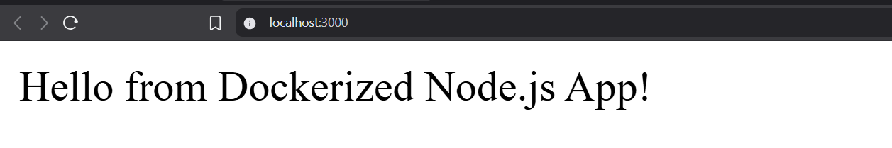

Step 6: Check Container Status

- Run the command:
  - docker ps

Copy this container id

- Shows a list of currently running containers with IDs, port mappings, and status.

- Run the command:
  - Docker logs <container id>

- The command docker logs aa6cf1eda09b displays the output (like console logs or errors) from the running container with ID aa6cf1eda09b, helping you debug or see what your app is doing inside the container.

- Check your docker desktop, you will see one image is created successfully.

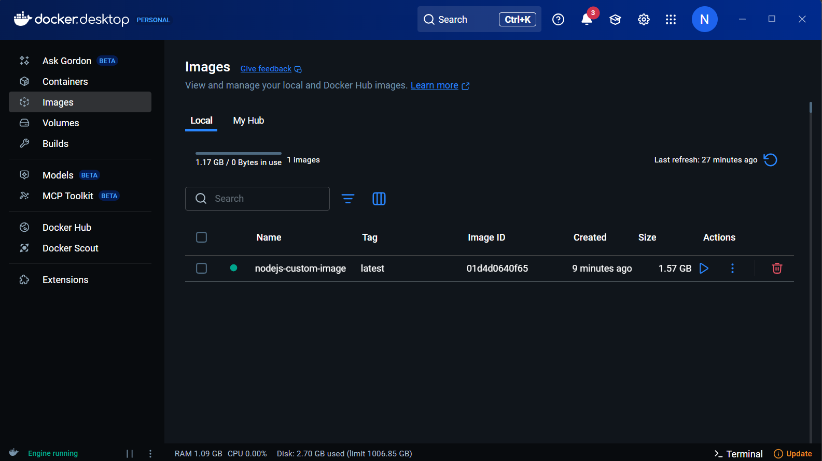

Successfully build a custom image in Docker.

Let’s Add Multi-Stage Build

A multi-stage build in Docker is a technique that allows you to use multiple FROM statements in a single Dockerfile, creating separate stages during the image build process. Each stage can have its own base image and instructions.

Key points about multi-stage builds:

- They help reduce the final image size by excluding unnecessary build tools, dependencies, and intermediate files from the runtime image.
- They increase security by only including essential runtime components in the final image.
- They improve maintainability and build time efficiency by allowing better caching and organized build steps.
- They enable you to keep your Dockerfile concise, avoiding the need for multiple Dockerfiles for different build and runtime environments.

Create a multi-stage build.

Step 7: Upgrade Your Dockerfile for Multi-Stage Build

- Open your project folder.
- Update your Dockerfile.

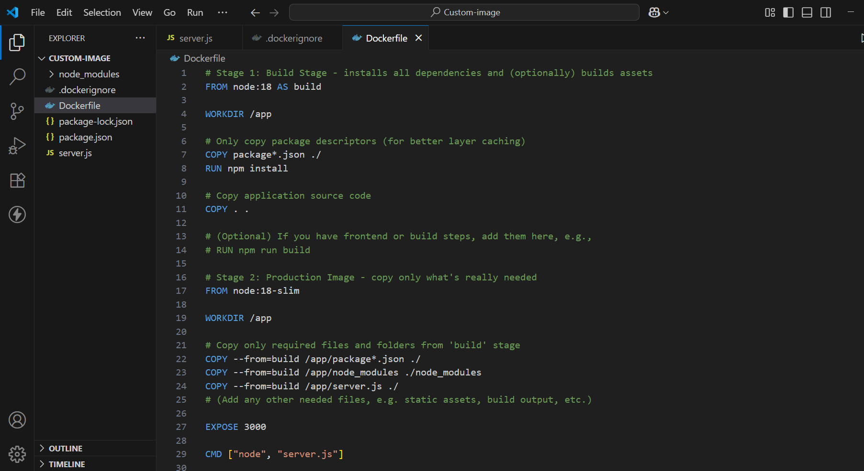

- Open your project in Windows PowerShell.

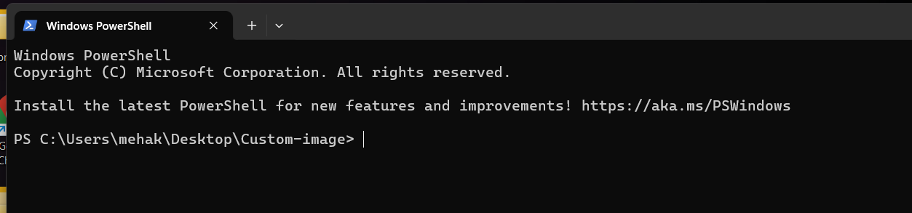

- Use the same build command as before, from your project’s root:

  - docker build -t nodejs-custom-image .

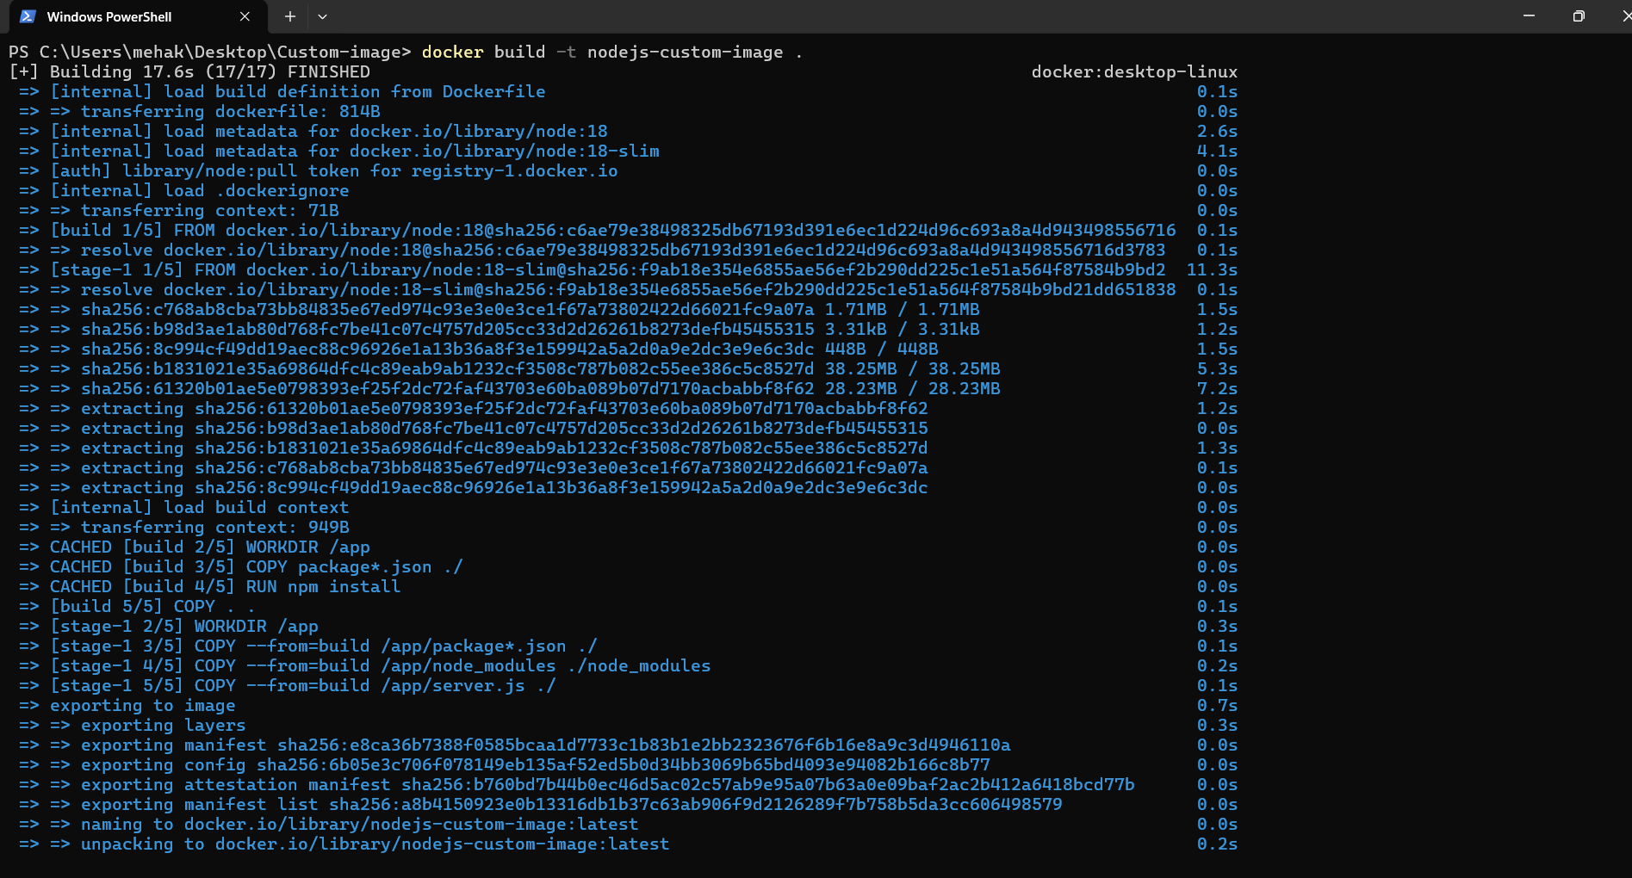

- Run the container just like you did before

docker run -d -p 3000:3000 nodejs-custom-image

Visit http://localhost:3000 in your browser!

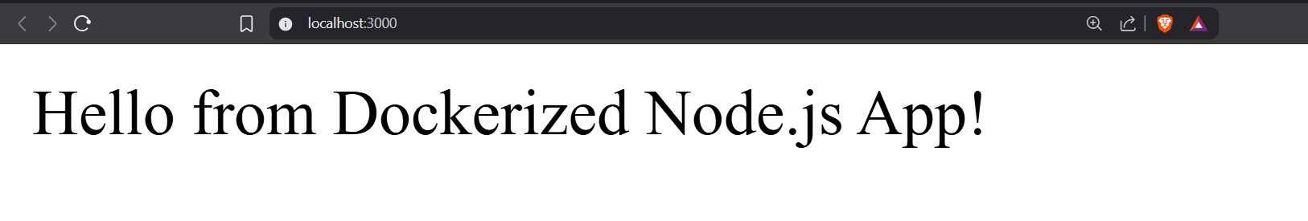

Verify the Multi-Stage Result

- Run:
  - docker images

- Compare the new image size with the old.

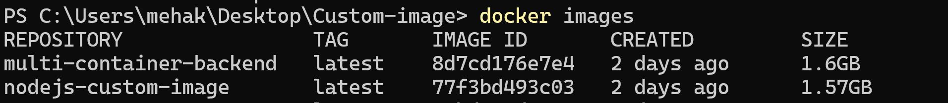

- You can inspect what’s inside the image with:

- docker run -it --rm nodejs-custom-image sh

This command lets you explore the container’s filesystem, inspect installed files, debug the environment, or run commands just like you would on a normal Linux shell—without starting your application as the main process. It is especially useful for verifying contents or troubleshooting after building your Docker image.

Conclusion

In this guide, you learned how to create a custom Docker image for a Node.js application from scratch.
By writing a Dockerfile, building the image, and running it in a container, you've made your app portable, consistent, and ready for deployment.

This process ensures your application runs the same across all environments — local, cloud, or production — making development and deployment smoother and more reliable. With this foundational knowledge, you're now ready to explore more advanced Docker features like Docker Compose, multi-stage builds, and CI/CD integration.

