Implement Docker Volumes for Persistence

Overview

This documentation provides a beginner-friendly, step-by-step guide to setting up and using Docker volumes for data persistence. Docker volumes enable you to store container data outside the container's filesystem, ensuring data survives container restarts, removals, or updates. You will learn how to create volumes, mount them into containers, verify that data persists, share volumes between multiple containers, and safely clean up resources.

By following this guide, you will develop a solid understanding of Docker volumes, allowing you to confidently manage persistent data in containerized environments, which is essential for real-world applications like databases, file uploads, and logs.

Prerequisites
- Docker Desktop
- Terminal (Command Prompt/PowerShell/Terminal)
- Basic commands

Step 1: Run your docker desktop and Command Prompt.

- Make sure docker desktop is installed in your PC.
- Open Docker Desktop in your PC.

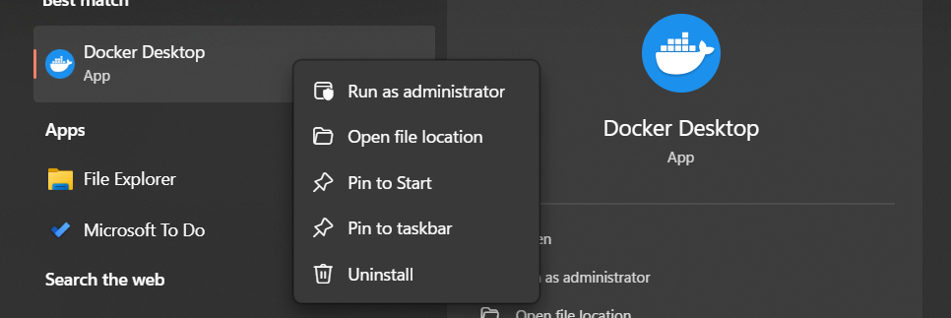

- Ensure Docker is running.
- Log in using your Docker Hub credentials.

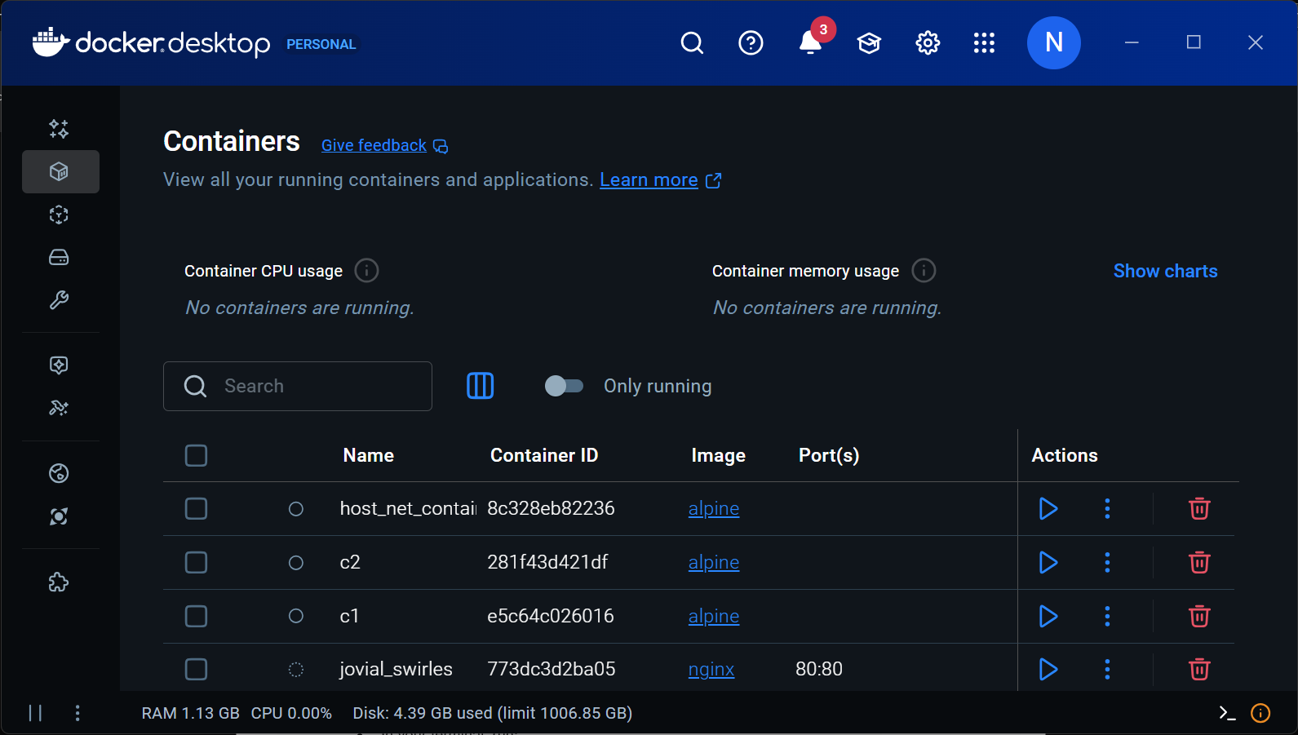

Step 2: Create a Docker Volume

- Open your command prompt (Run as administrator)

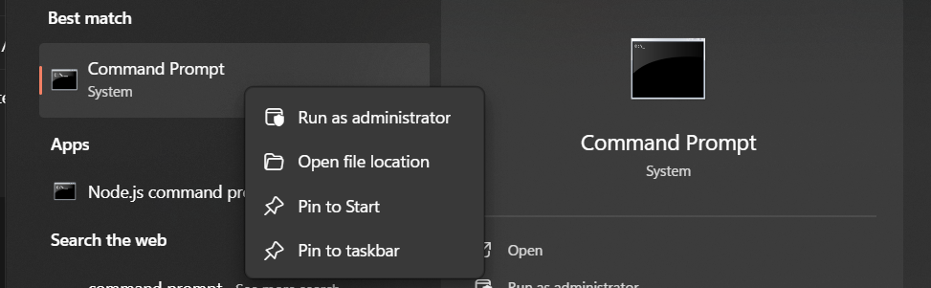

- In your terminal, run:
  - docker volume create mydata

(This creates a named volume mydata that Docker manages.)
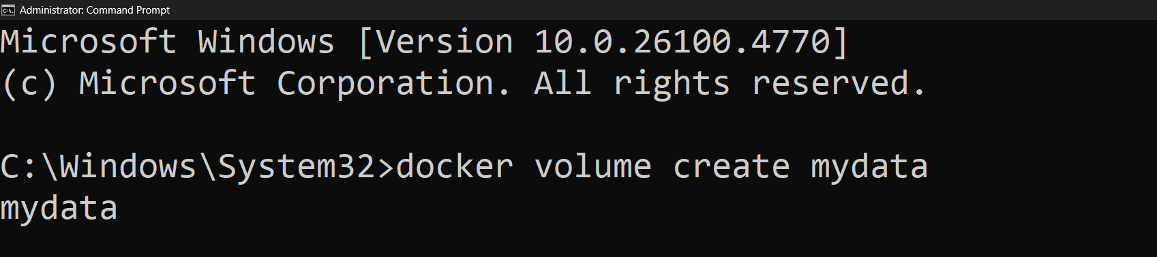

- Verify creation with:
  - docker volume ls

You should see mydata listed.

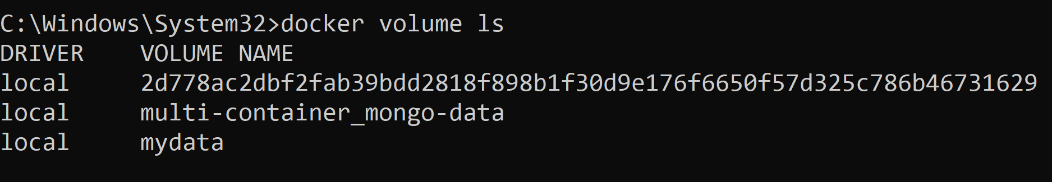

Tip: You can name volumes anything meaningful, like dbdata, uploads, or appfiles to match their purpose.

Step 3: Run a Container Using Your Volume

- Start an interactive container with the volume mounted:
  - docker run -it --name testbox -v mydata:/data alpine sh

Explanation:
- -it: interactive terminal
- --name testbox: names the container testbox
- -v mydata:/data: mounts the volume mydata at /data inside the container
- alpine sh: launches a lightweight Linux container and opens a shell

You are now inside the container (prompt looks like / #).

Step 4: Store Data in the Volume

- Inside the container terminal, run:
  - cd /data
echo "Hello world" > hello.txt
ls
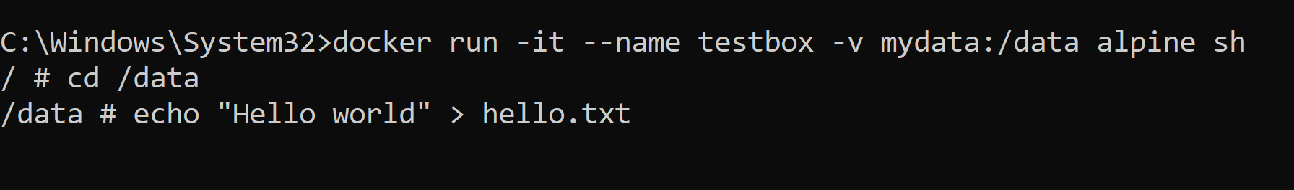

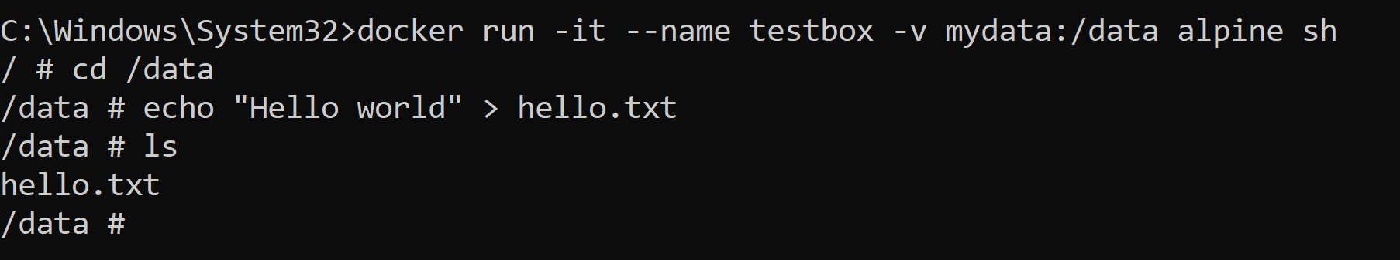

- You should see hello.txt listed.

- Exit the container shell to return to your host terminal:
  - exit

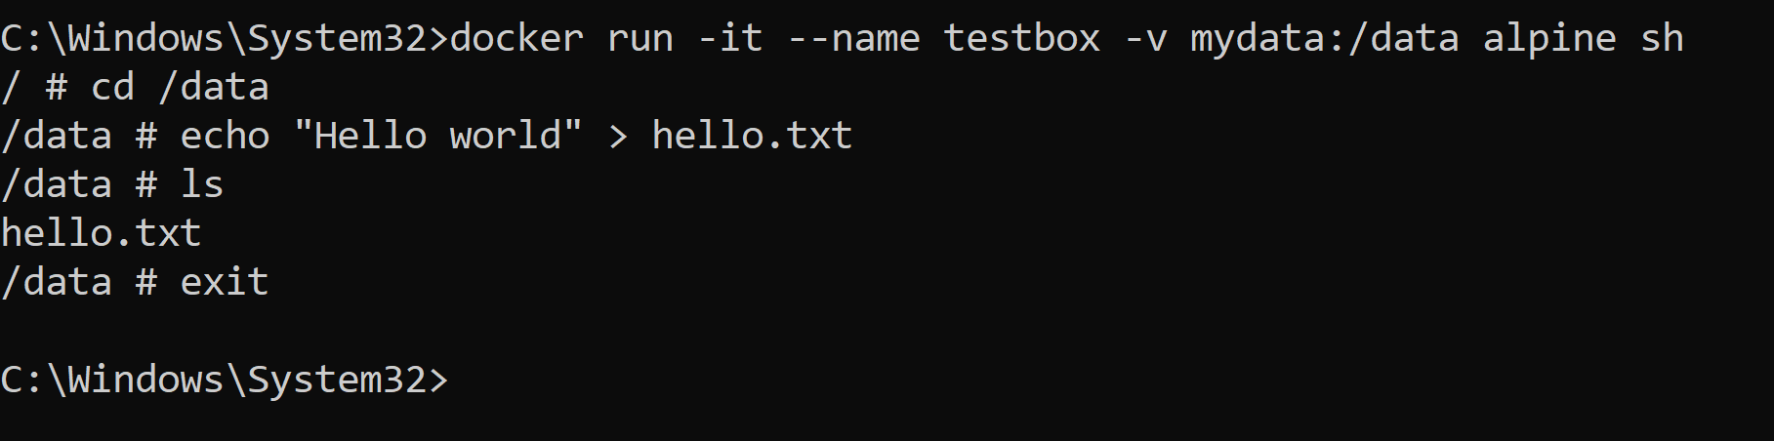

Step 5: Remove the Container and Verify Data Persistence

- Remove your container:
  - docker rm testbox

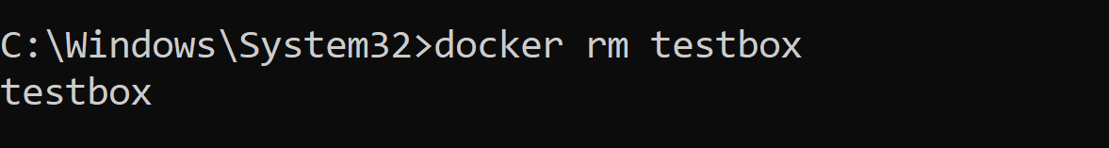

- Run a new container with the same volume:
  - docker run -it --name test2 -v mydata:/data alpine sh
  - cd /data
  - ls
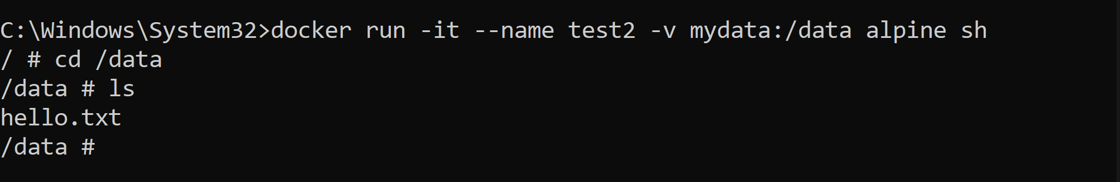

  - cat hello.txt

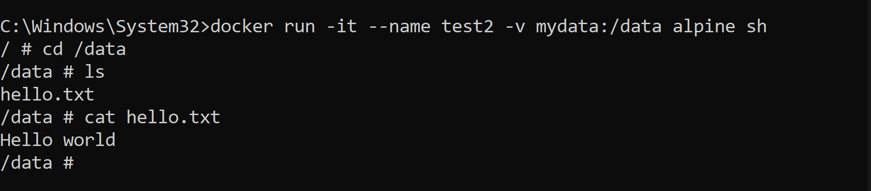

You should see hello.txt still there, and its content "Hello world" displayed.

This confirms your data is persisted in the volume even after the container is removed.

Why Use Docker Volumes?
- Containers are temporary by default: if you delete or recreate a container, data inside it is lost.
- Docker volumes store data persistently on your computer, surviving container restarts and removals.
- Volumes can be shared between multiple containers, enabling data sharing.
- Volumes help keep important files safe—like databases, uploads, configs, or logs.

Step 6: Share Volumes Between Multiple Containers
- You can mount the same volume into multiple containers to share data:
  - docker run -d --name app1 -v mydata:/shared busybox
docker run -d --name app2 -v mydata:/shared busybox

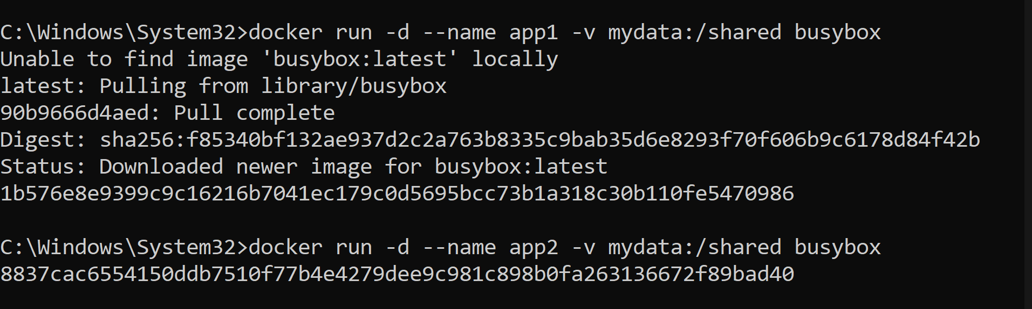

- Go to your docker desktop, you can see two containers.



- Both app1 and app2 containers access the same data at /shared.

Step 7: Mount a Volume as Read-Only

- To protect data from accidental changes, mount it read-only:
  - docker run -it -v mydata:/data:ro alpine sh

The :ro suffix means read-only; the container can read but not write files in /data.

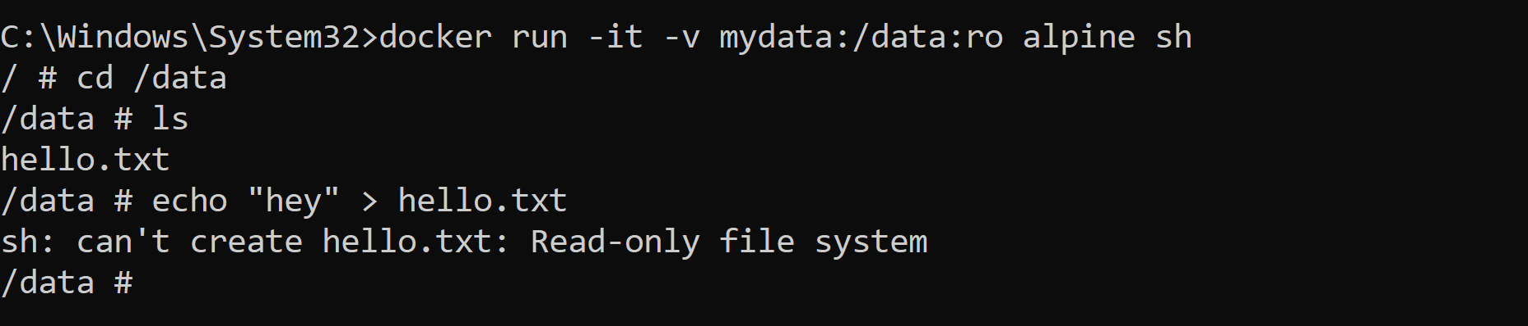

If you try to write anything, you will not able to write because of read-only option.

Purpose:
- It protects the data in the volume from being changed or deleted by anything inside this container.
- Useful when you want the container to access files without risking accidental
Step 8: Inspect Volume Details

- To see where Docker keeps the volume data on your computer, run:
  - docker volume inspect mydata

This displays the volume’s metadata, including the exact host filesystem path.

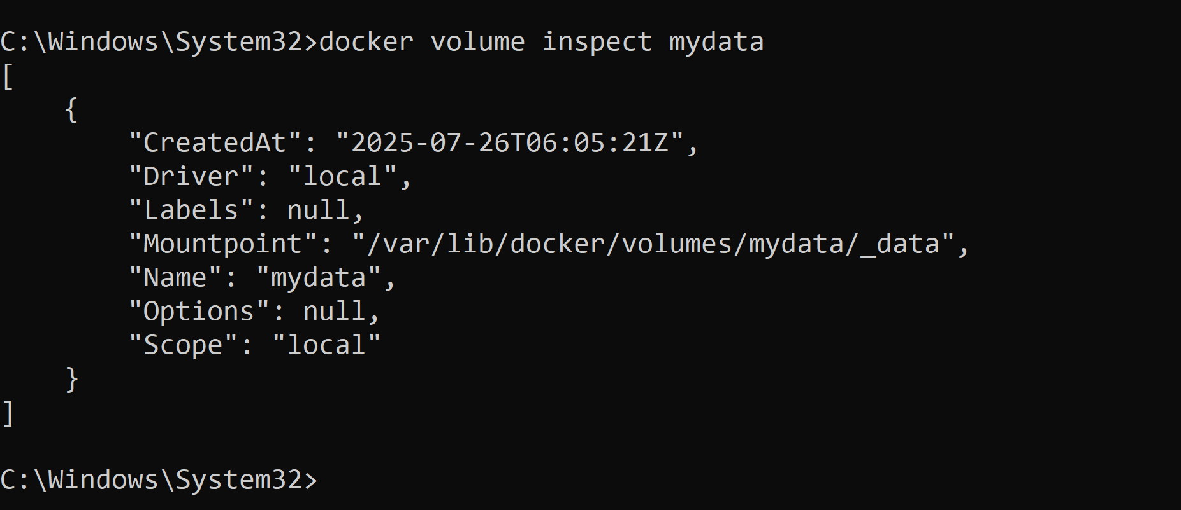

Best Practices

- Always use volumes to persist data you don’t want to lose, such as databases, user uploads, or configuration files.
- Name your volumes clearly to keep track of them easily.
- Volumes can be shared safely between containers, enabling collaborative workflows.
- Use read-only mounts to prevent containers from accidentally modifying shared data.
- Use docker volume inspect to learn where your volume’s data lives on your host system.
- Clean up unused volumes and containers regularly to save disk space

Conclusion

Docker volumes are an essential tool for ensuring your container data persists beyond the lifecycle of individual containers. By using volumes, you avoid losing important data when containers are stopped, removed, or updated. Volumes also facilitate data sharing across multiple containers and provide a safer, more manageable way to handle persistent storage.

In this guide, you learned how to:
- Verify Docker installation and open a terminal to run commands.
- Create Docker volumes and understand their purpose.
- Run containers that mount volumes to store and retrieve data.
- Confirm that data persists even after containers are deleted.
- Share a volume between multiple containers.
- Use read-only mounts for safer data access.
- Inspect volume details on the host machine.

