Implement Container Networking

Overview

This document serves as a step-by-step beginner-friendly guide to understanding and implementing Docker container networking using the Docker CLI. It starts with the basic prerequisites and leads developers through creating custom Docker networks, running containers within them, enabling inter-container communication, and testing HTTP connections using NGINX.

Prerequisites
- Docker Desktop
- Docker CLI
- Terminal Command Prompt/PowerShell/Terminal

Step 1: Check if Docker is installed
- Open Command Prompt as Run as administrator.

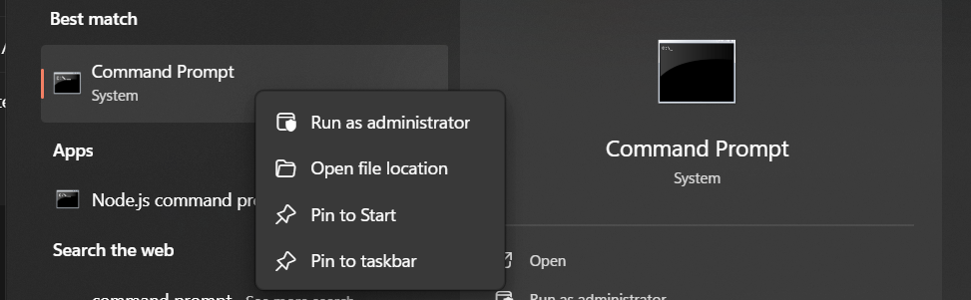

- Run the following command if Docker is installed:
  - docker --version
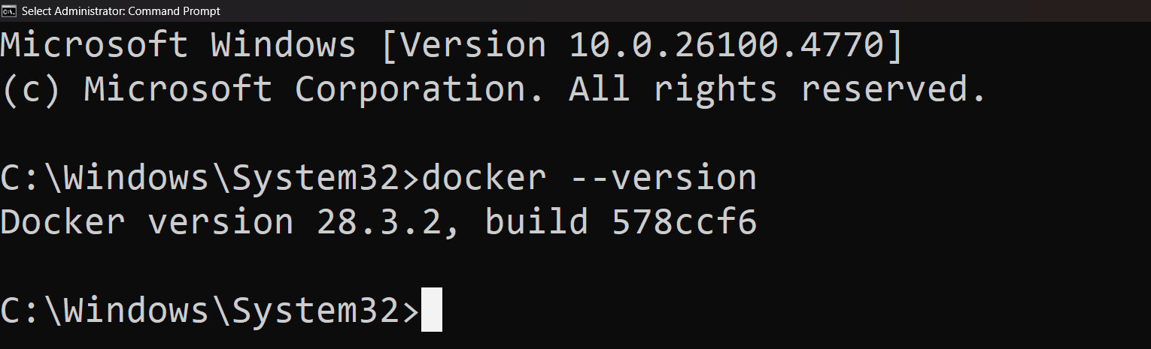

  - Docker version 28.3.2 and build 578ccf6 is a internal build ID

Step 2: Start Docker Desktop
- Open Docker Desktop.

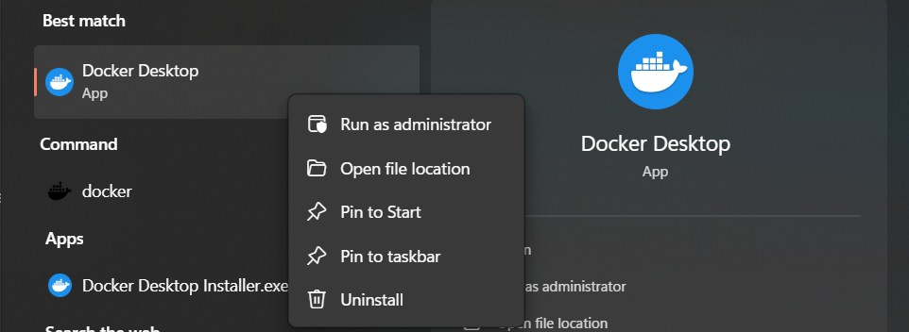

- Start the Docker Engine

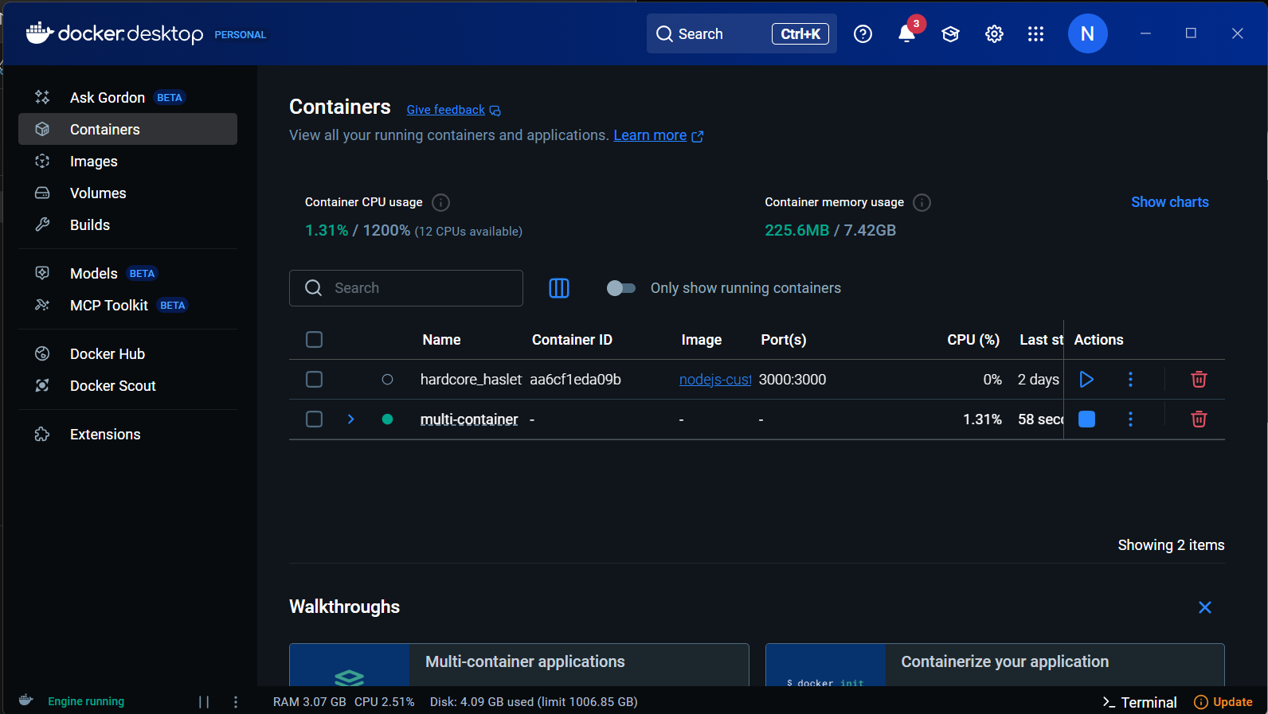

- Go to Settings.
- Make sure “Use the WSL 2 based engine” is enabled.
- If it is enabled, click Close otherwise enable it and click Apply.

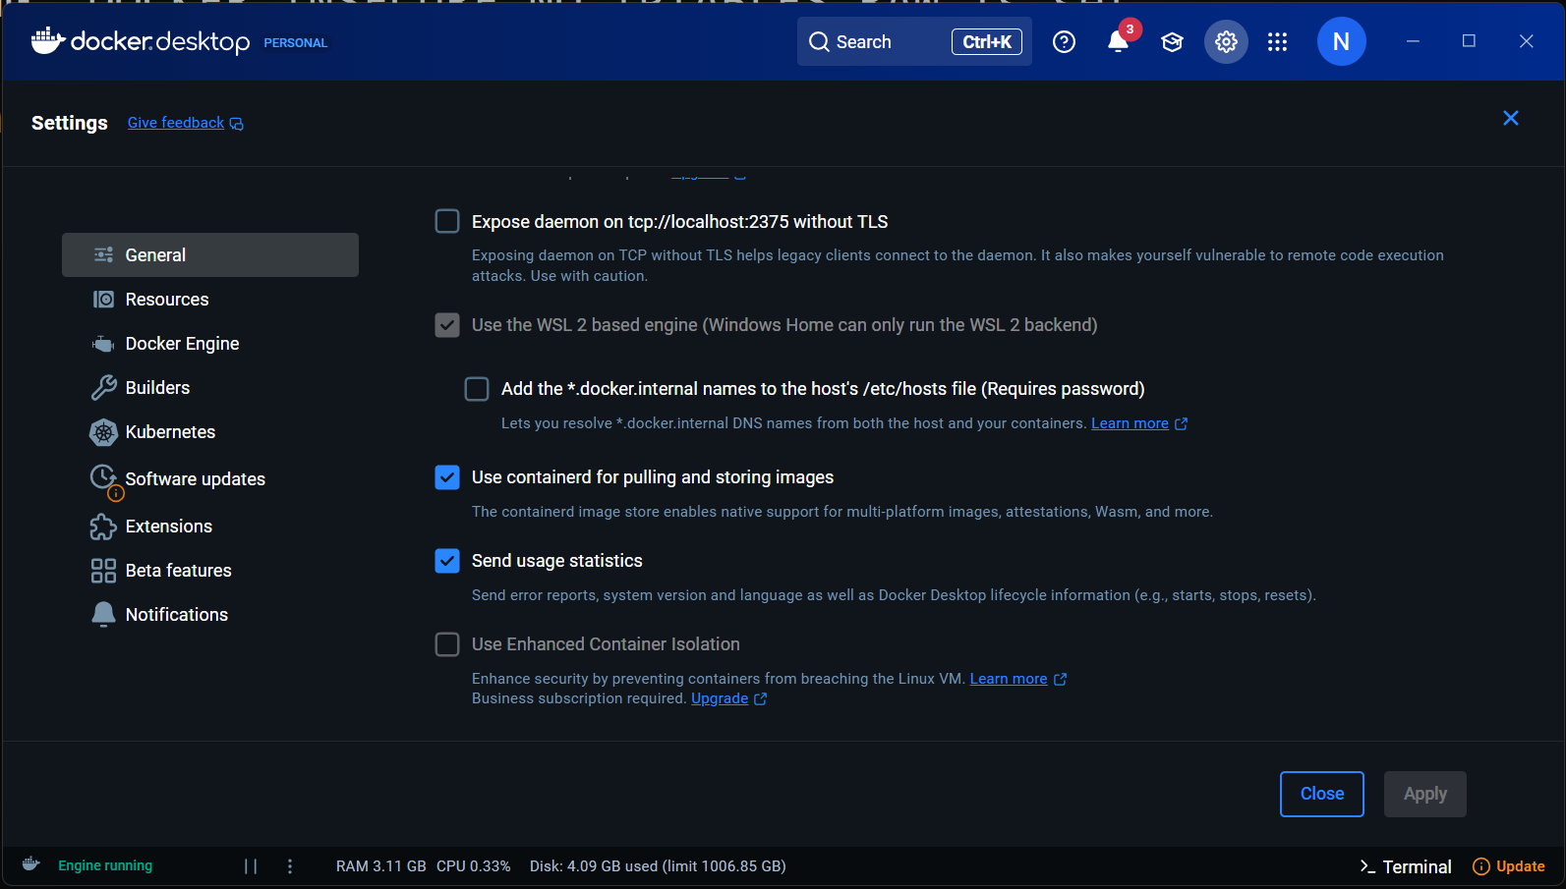
3
2
1

Step 3: List Docker Networks

- Run the following command to see built-in networks:

  - docker network ls

Column | Meaning
NETWORK ID | Unique identifier for the network
NAME | Name of the network (bridge, host, none are default built-in ones)
DRIVER | Networking type used
SCOPE | local means the network is only on your current Docker host
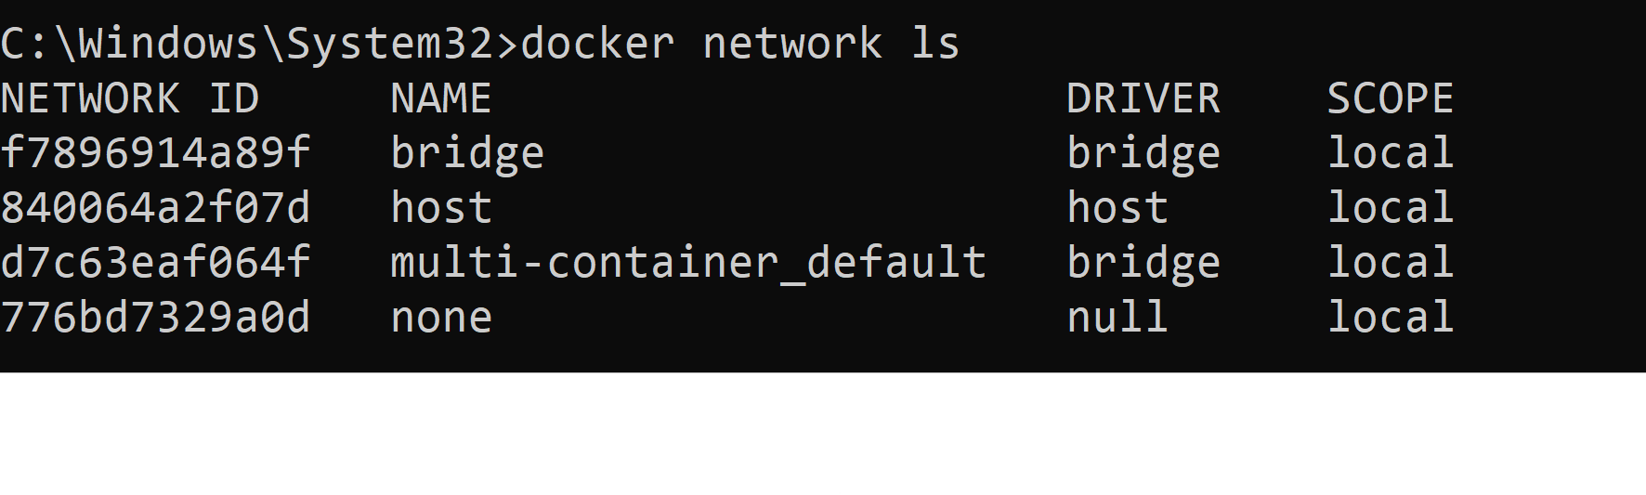

Types of built-in networks:
- Bridge: The default network for standalone containers. It enables communication between Docker containers on the same host via a virtual bridge, and network isolation from the host unless ports are published.
- Host: Removes network isolation between the container and the Docker host, letting the container use the host’s networking directly.
- None: Completely isolates the container from the host network and all other containers

Step 4: Create a Custom Network

- In terminal, run the command:

  - docker network create eduhubspot

You can write any name of your network.

- Verify if network created or not, run:

  - docker network inspect eduhubspot

It is used to retrieve detailed information about a specific Docker network named eduhubspot.
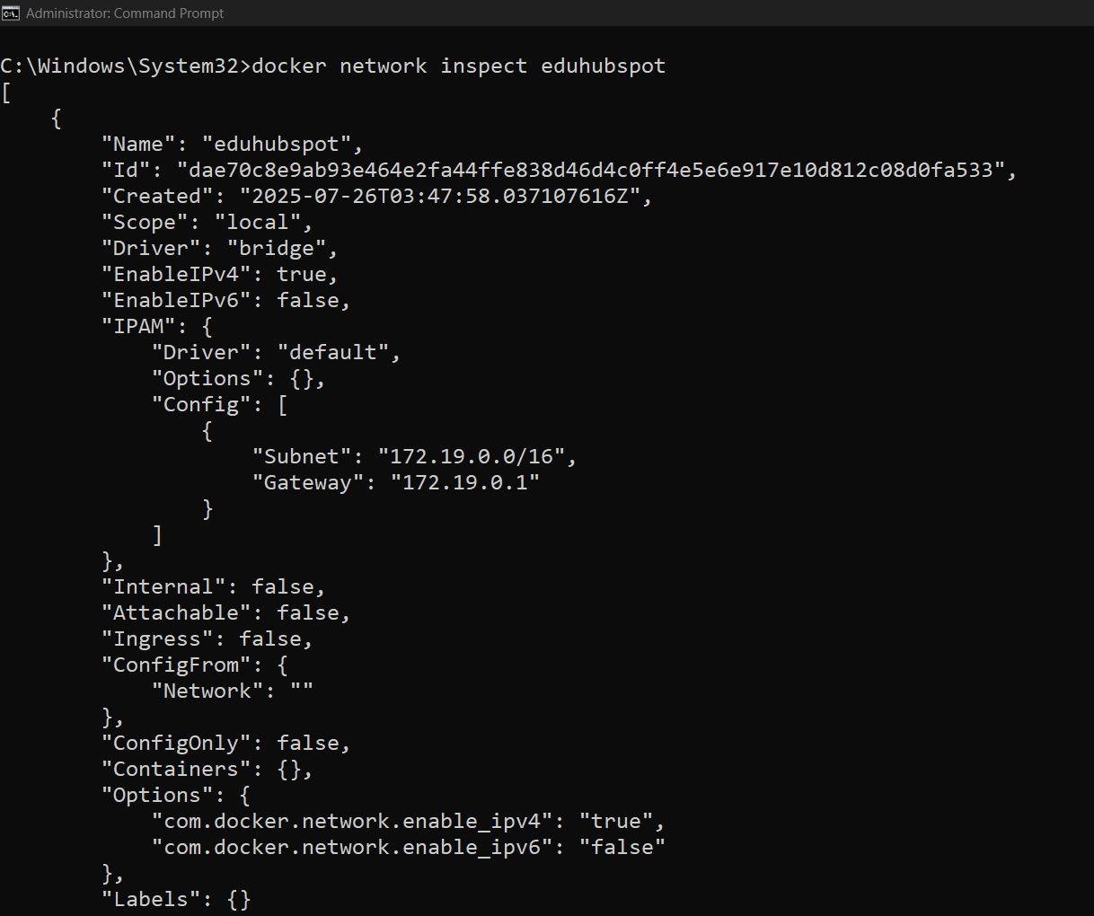

Step 5: Run Two Containers in Same Network

- Run the command:

  - docker run -dit --name container1 --network eduhubspot alpine sh
docker run -dit --name container2 --network eduhubspot alpine sh



Launch Two Alpine Containers on the Same Custom Network.

- Check your docker desktop if two containers are running:


Also, check on terminal if the containers are running:
- docker ps

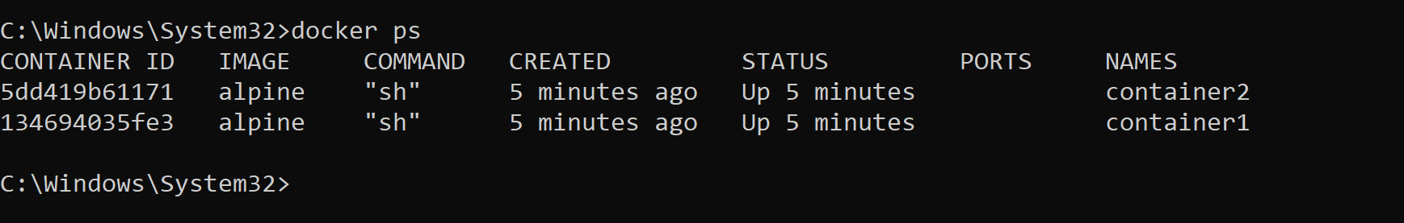

Step 6: Ping Between Containers

- Ping container2 from inside container1:
  - docker exec -it container1 ping container2
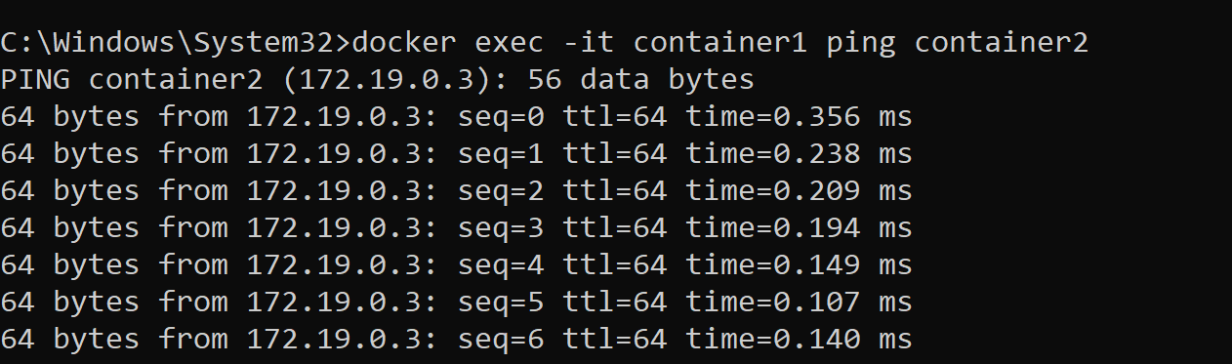

If it works, you’ll see:
64 bytes from container2: icmp_seq=1 ttl=64 time=0.064 ms

Press Ctrl+C to stop pinging.

Step 7: Test HTTP Communication with NGINX

- Run a web server:
  - docker run -dit --name web --network eduhubspot nginx

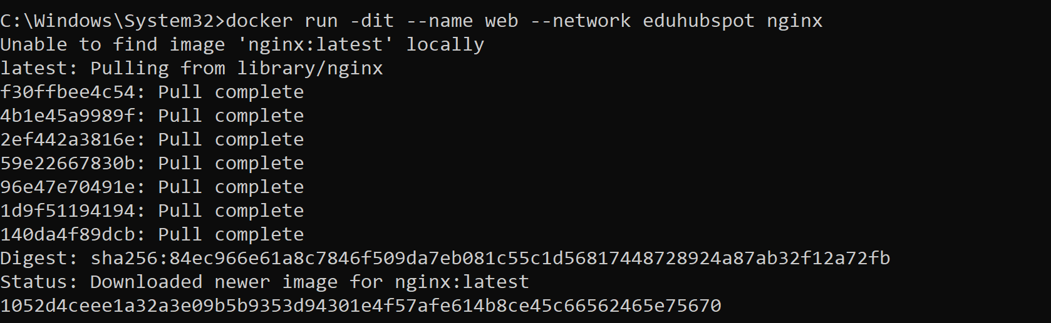

- Run a container to test with curl:
  - docker run -it --rm --network eduhubspot curlimages/curl curl http://web
- You should get HTML response from NGINX.

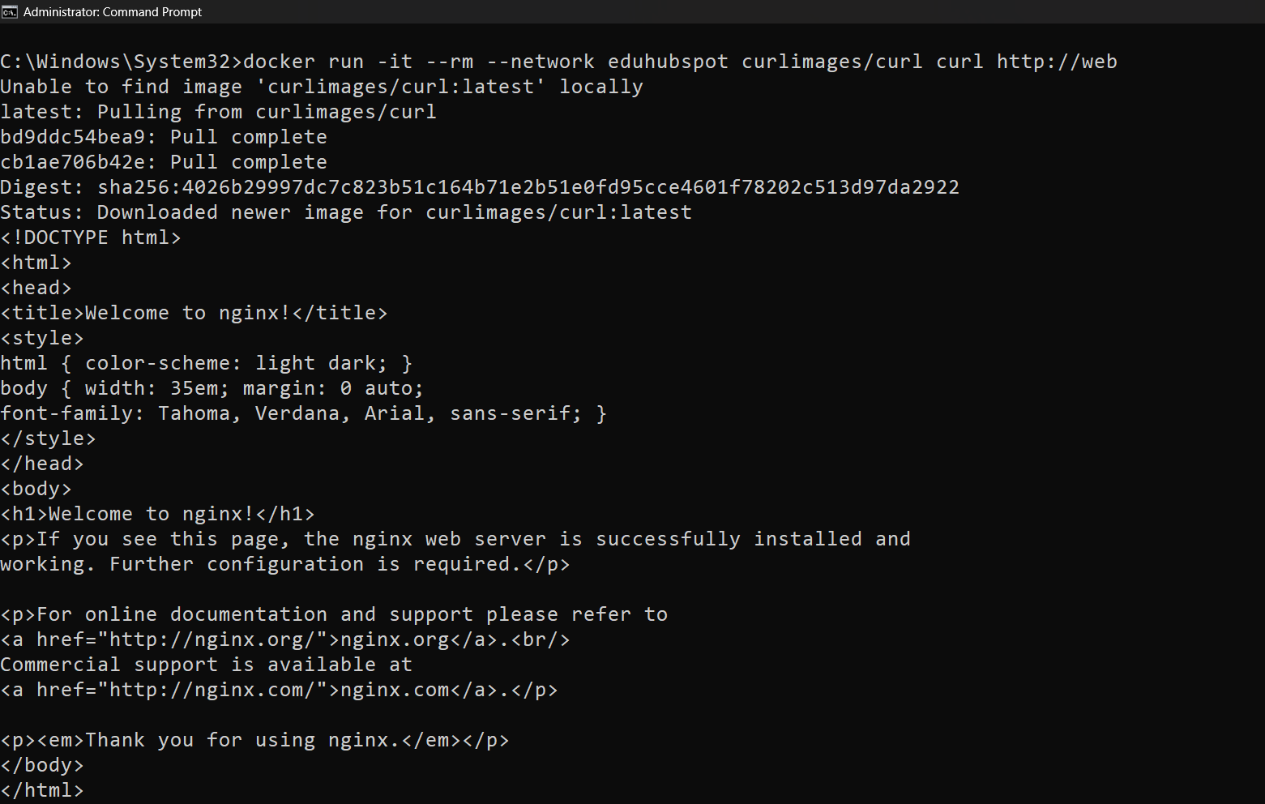

Step 8: Connect One Container to Two Networks
- Create another network:
    - docker network create another_network

- Connect container1 to it:
docker network connect another_network container1

You won’t see any output in the terminal — Docker silently succeeds.

- You can verify by running:
docker network inspect another_network

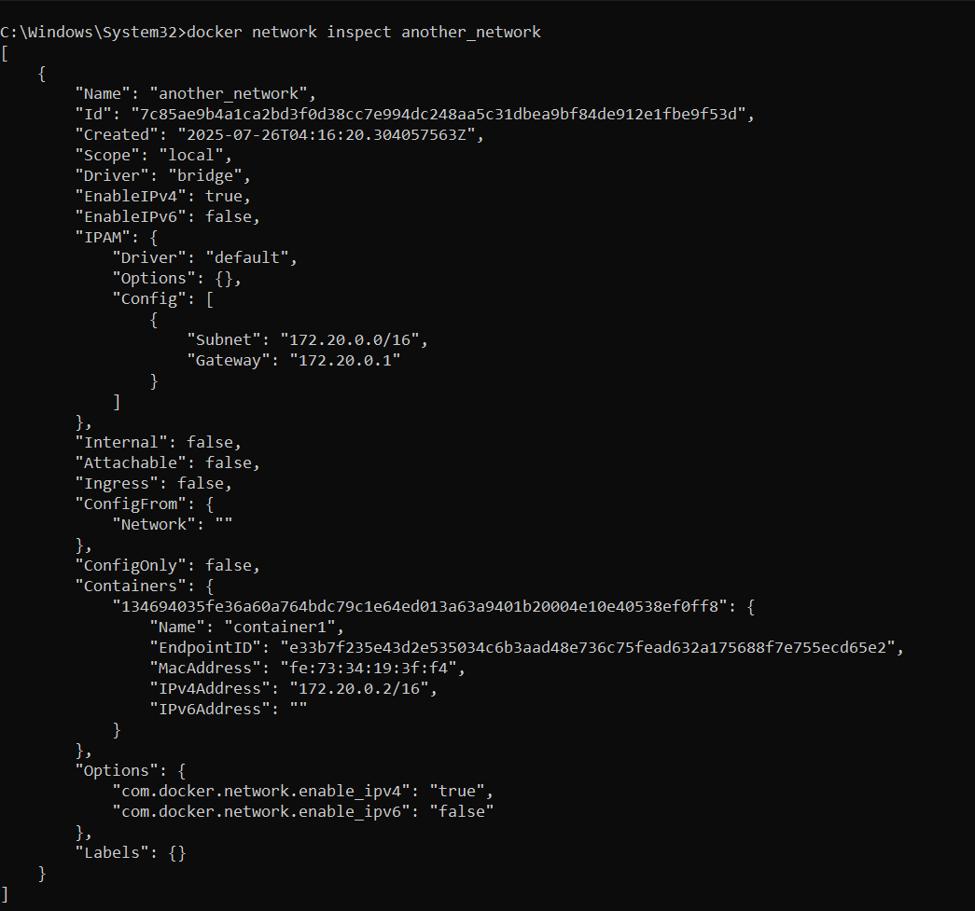

It is used to display detailed information about the Docker network named "another_network".

- To disconnect:
- docker network disconnect another_network container1

Step 9: Cleanup

- Remove all containers:
- docker rm -f container1 container2 web

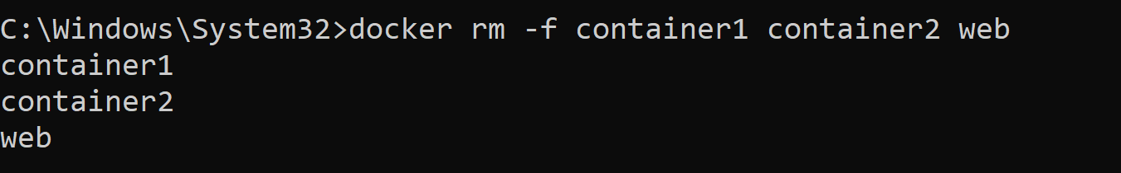

- Remove networks:
- docker network rm eduhubspot another_network

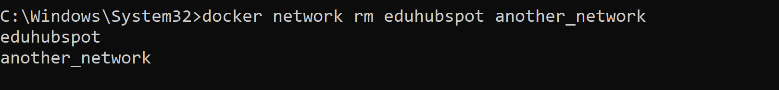

Troubleshooting and Common Issues

- Docker daemon not running:
If Docker commands fail or say "Cannot connect to the Docker daemon," the Docker service may not be running.
Solution: Restart Docker Desktop or the Docker service, then try again.
- Port conflicts:
If a container won’t start or fails with an "address already in use" error, another application (or container) is already using the port you’re trying to bind.
Solution: Use a different port for your container, or stop the other service using that port.
- Network name conflicts:
Attempting to create a new network with a name that already exists will cause an error.
Solution: Use unique network names, or remove the old network if it’s no longer needed.

Conclusion

Implementing container networking is a fundamental skill for developers and DevOps professionals working with Docker. This guide has walked you through the essential steps—from verifying Docker installation and understanding built-in networks to creating custom networks, enabling communication between containers, and handling multi-network connectivity.

By mastering these concepts, you gain better control over how your containers interact, which is crucial for building secure, scalable, and modular applications. Additionally, the troubleshooting tips provided ensure you're equipped to resolve common issues confidently.

