Install and Configure Docker

Overview

Docker is an open-source platform designed to automate the deployment, scaling, and management of applications inside lightweight, portable containers. It enables developers to package applications with all dependencies into a standardized unit for software development.

This guide provides an end-to-end walkthrough for installing, configuring, and verifying Docker on Windows along with post-install configurations for a seamless containerization experience.

System Requirements
- Hardware Requirements
  - Minimum 4 GB RAM (8 GB recommended)
  - 64-bit architecture
  - Virtualization enabled in BIOS
- Software Requirements
  - Windows 10 64-bit

Step 1: Enable WSL2

- Open Windows PowerShell (Run as administer).
- Run the following command in the terminal:
  - wsl --install

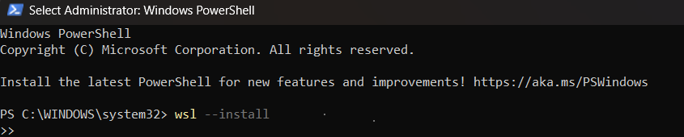

Explanation:

The wsl --install command installs WSL (Windows Subsystem for Linux) on your Windows system, which is essential for running Docker Desktop—especially on Windows 10 Home and Windows 11. WSL is a compatibility layer developed by Microsoft that enables a real Linux environment to run directly on Windows without needing a virtual machine.

- After it finishes, restart your computer if asked.
Step 2: Download Docker Desktop for Windows

- Go to https://www.docker.com/products/docker-desktop/
- Click Download for Windows – AMD64.

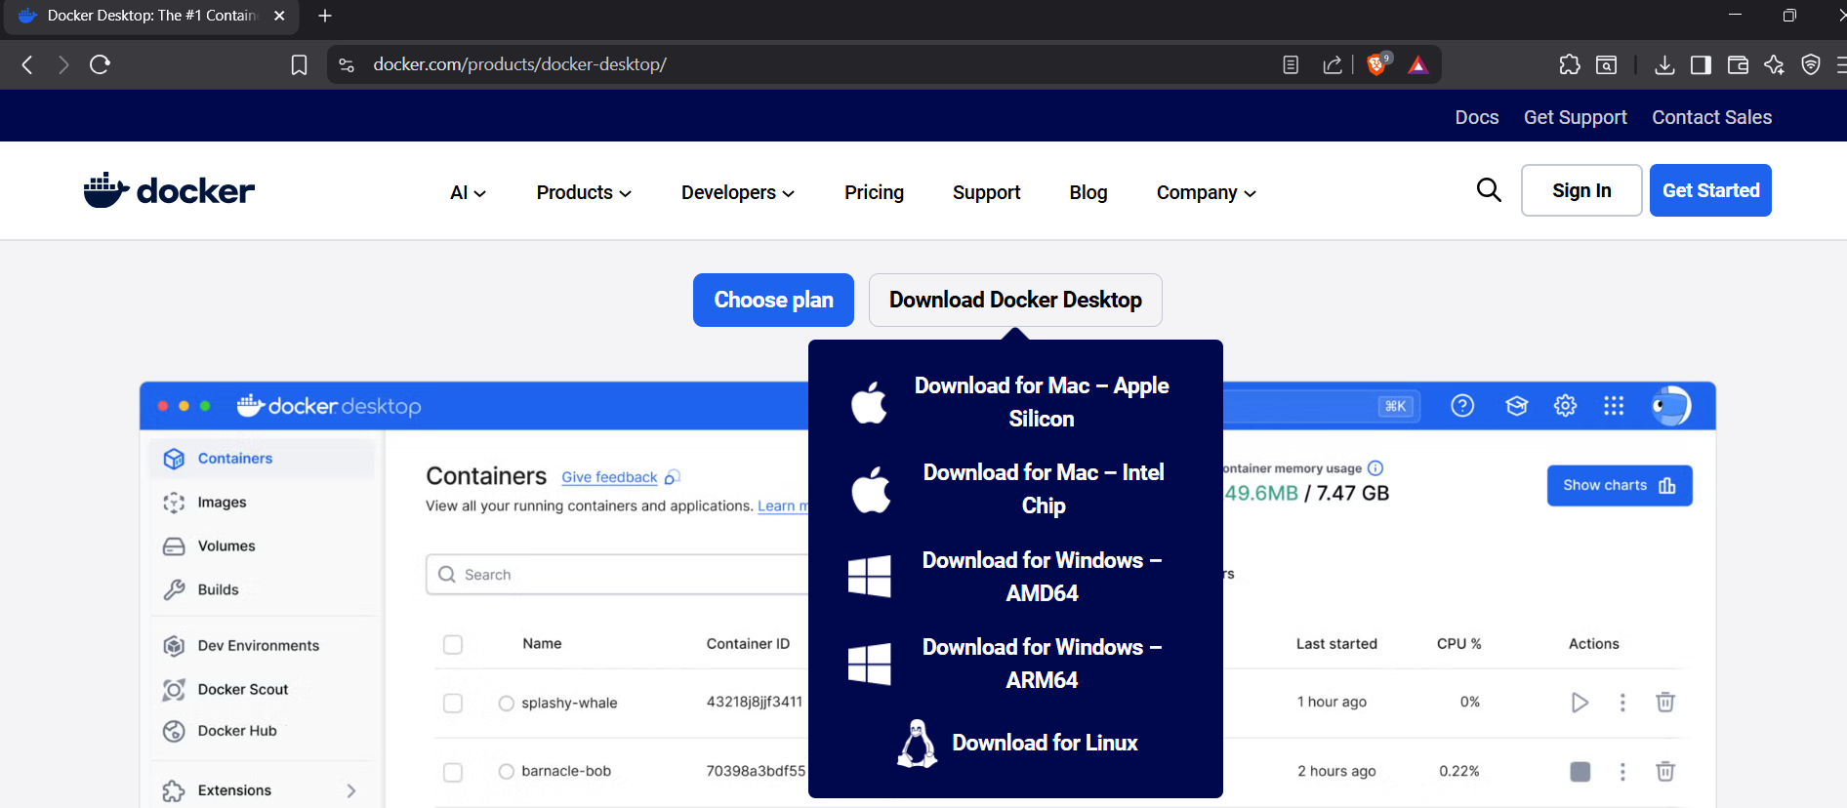

Step 3: Install Docker

- In recently downloaded history, double-click on the docker folder.

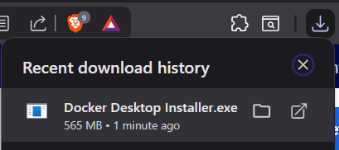

- Configuration page will open.
- Tick mark Add shortcut to desktop.
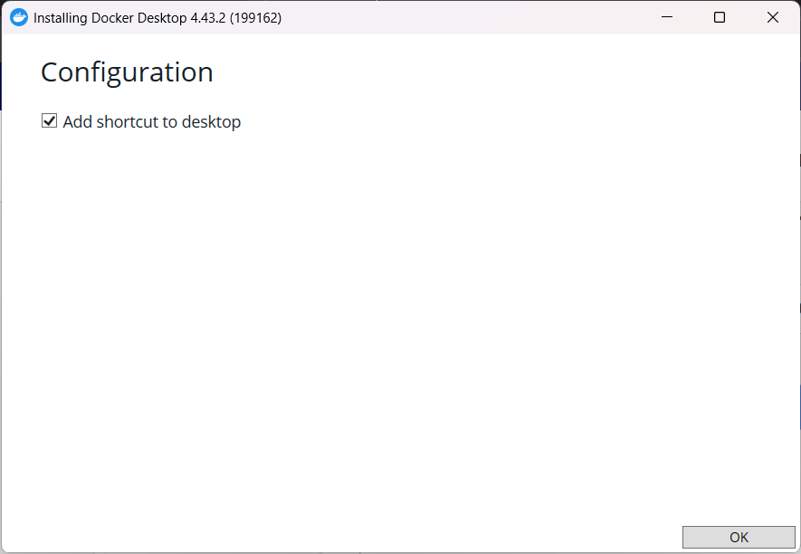

- Click on OK Docker desktop will start installing.
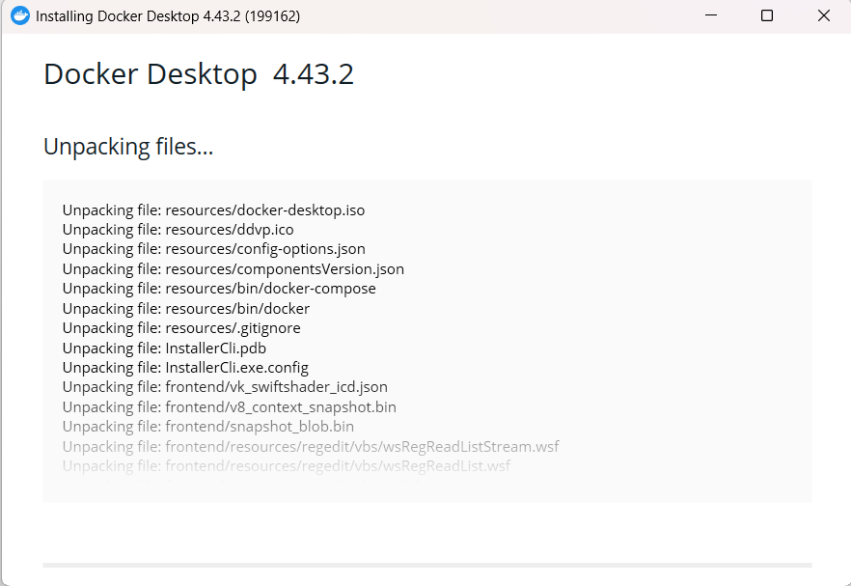
- Docker is installed.
- Now close and restart the PC.

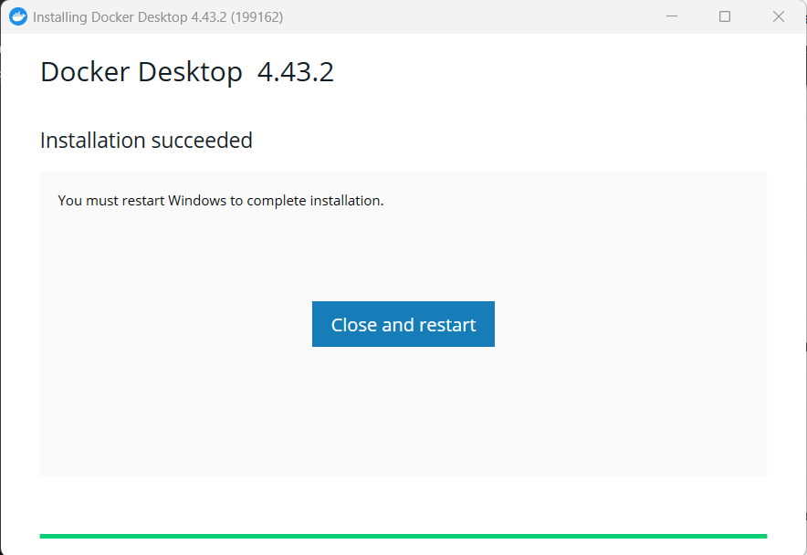

- Docker successfully installed in your PC.

Step 4: Configure Docker

- Search for Docker Desktop in the Start menu.
- Click Run as administrator.

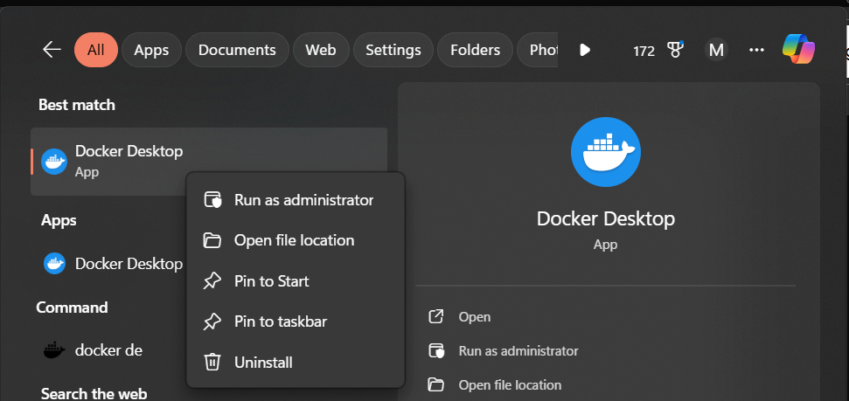

- Service Agreement screen will appear on your laptops.



Explanation:

This screen is Docker informing you about their license terms. Docker Desktop is no longer completely free for all types of users. They’ve introduced a subscription-based model for organizations but still offer it free for individuals, small businesses, and students.

By clicking Accept, you agree to:
- Subscription Service Agreement
- Docker Data Processing Agreement
- Docker Privacy Policy

- For students docker is free, so you can accept the agreement.
- Click on Accept.

- As you accept the agreement, login to the docker with your credentials.

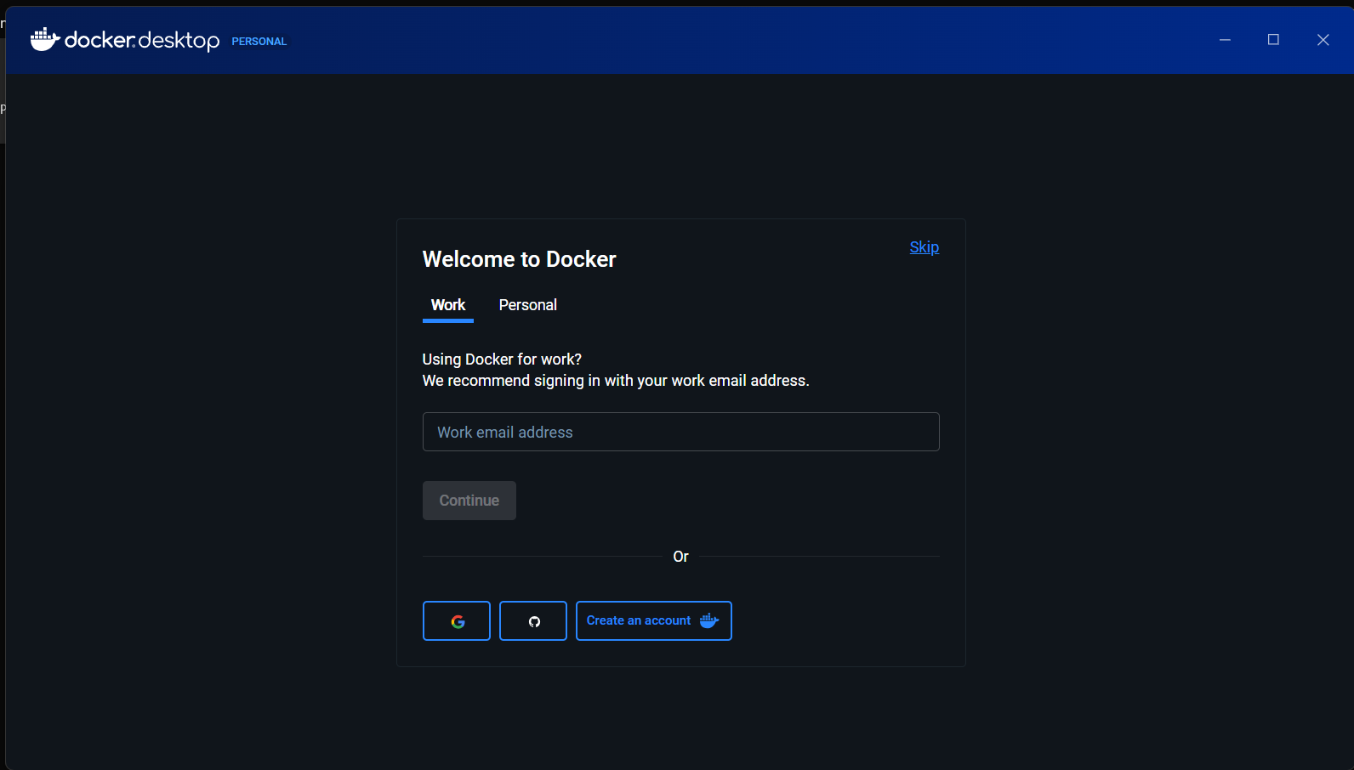

- As you are new to docker desktop, firstly let’s create an account.

You can also skip this, docker will run without any issue by clicking on the Skip option.

Create a docker account

- Click on create an account.
- You will be navigated to signup page.
- Select personal.
- Create your account by providing email, username (as you preferred) and password.
- After filling all the information, click on sign up.
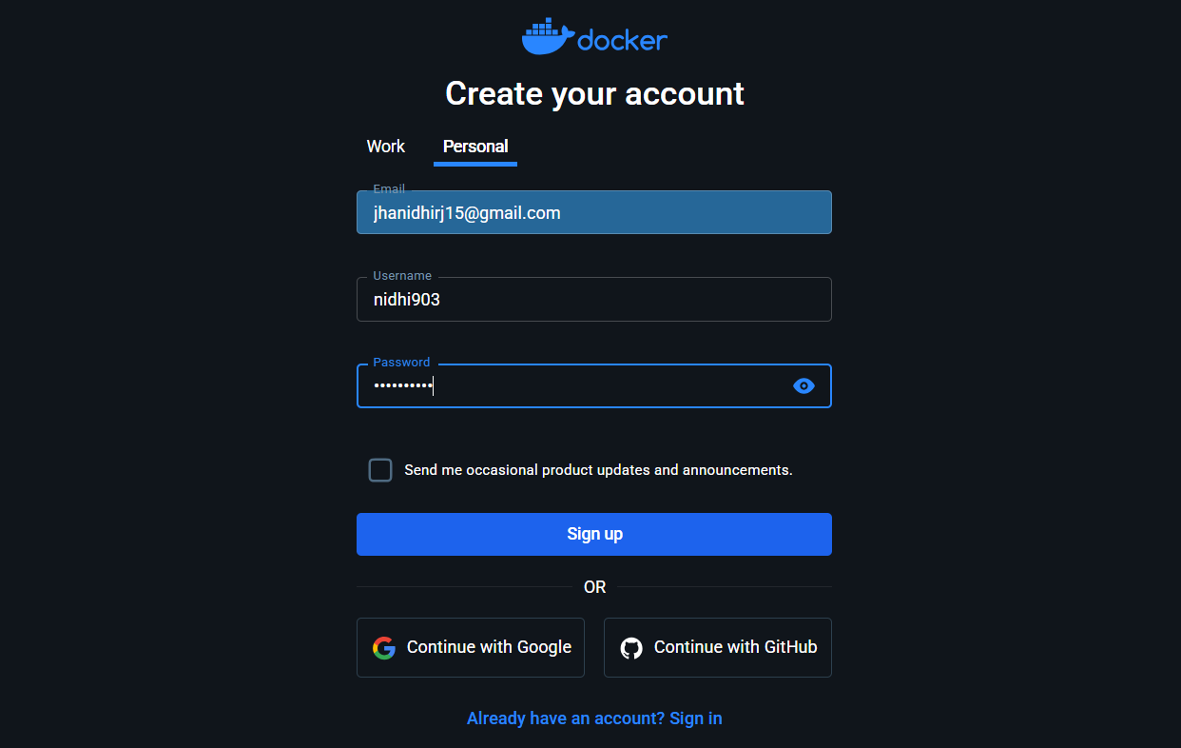

- You will successfully sign up the docker desktop.
- It will redirect you to sign in page.
- Sign in using your username or email address.

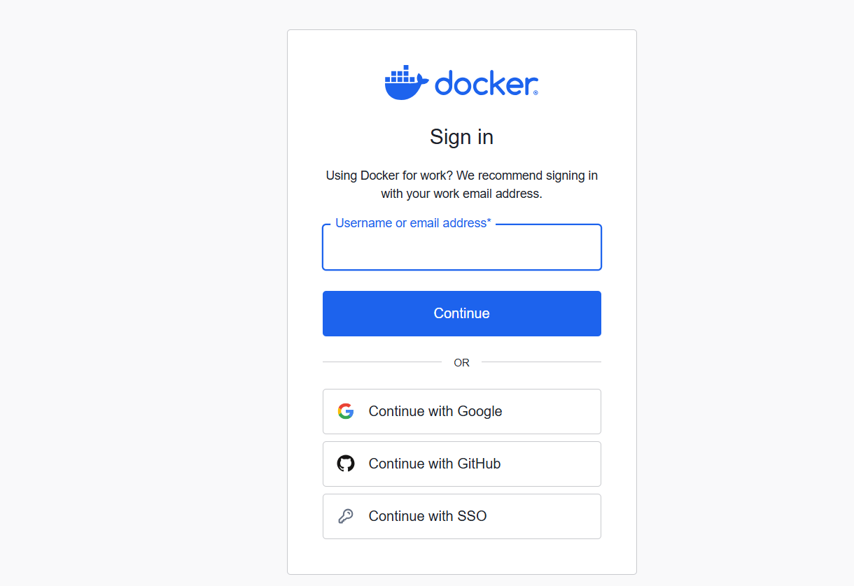

- Click on continue.
- Enter your password.
- Click on continue.
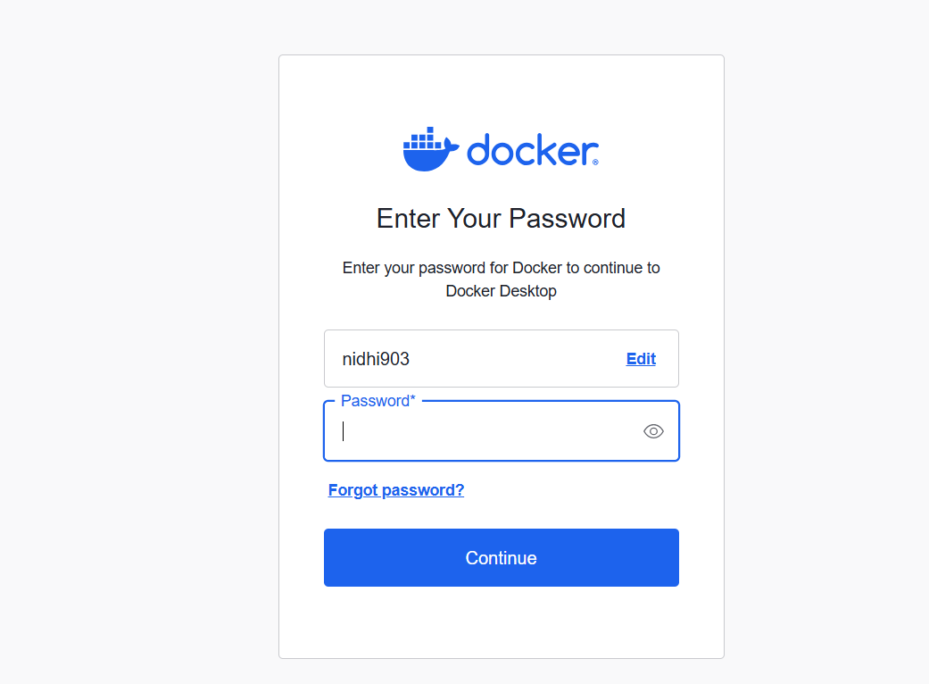

- You sign up successfully.



- Click on Proceed to Docker Desktop.
- You will get the pop-up Click on Open Docker Desktop.

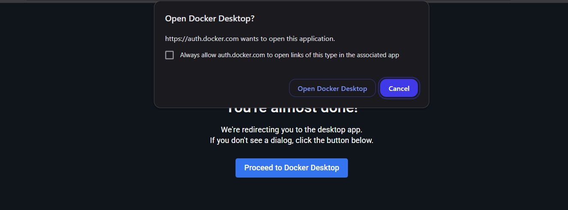

- Docker Desktop will open with your credentials.

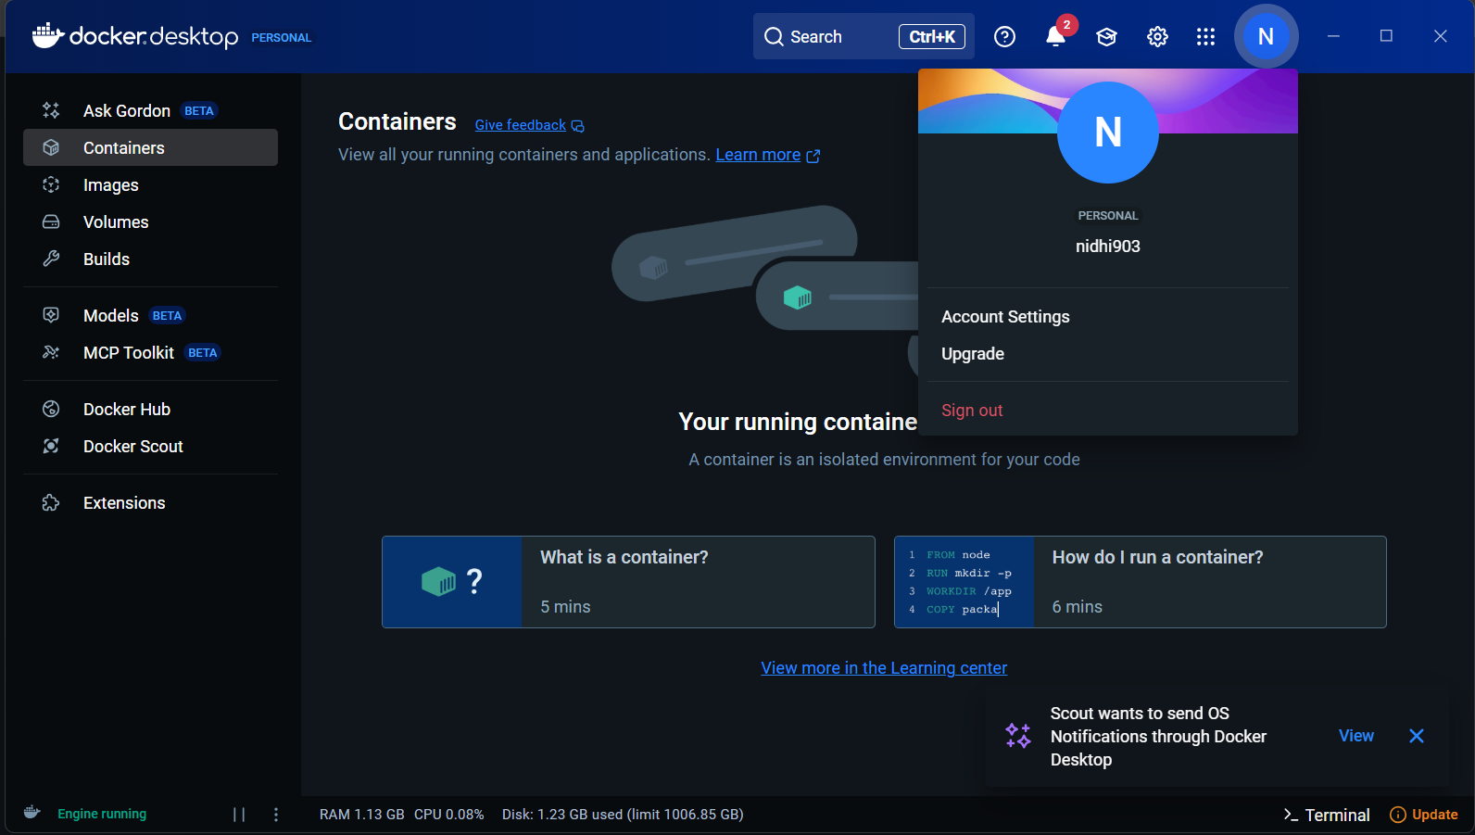

Step 6: Test Docker Installation

- Open Command Prompt or PowerShell.
- Run as administrator.

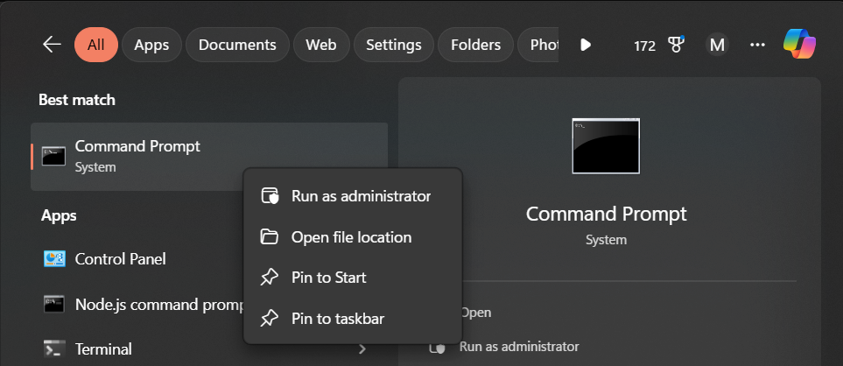

- Run the following command:
  - docker --version

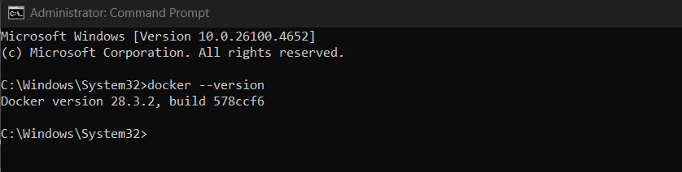

Explanation:

This command is used to verify that Docker is successfully installed and to check the currently installed version of Docker on your system.

- 28.3.2 → the version number of Docker installed.
- cb74dfc → the build ID.
- Docker is successfully installed and configured.

Conclusion

- By following this step-by-step guide, you have successfully installed, configured, and validated Docker Desktop on your Windows system.

- With WSL 2 integration and Docker’s streamlined interface, you’re now equipped to build, run, and manage containerized applications efficiently.

- This foundational setup not only ensures compatibility with modern development workflows but also prepares you for advanced container orchestration, image creation, and real-world deployment scenarios.

