Prerequisites

To successfully complete the upcoming hands-on exercises, please ensure you have the following prerequisites set up. These tools and accounts are essential for working with Git, GitHub, and related development workflows.
Before you start working with Advanced Git and GitHub Workflows, here's what you need to have set up:

1. Install Git

Step 1: Download Git for Windows
Open your web browser and search for "Git for Windows" and click on the very first link that pops up, or you can navigate to https://git-scm.com/downloads/win
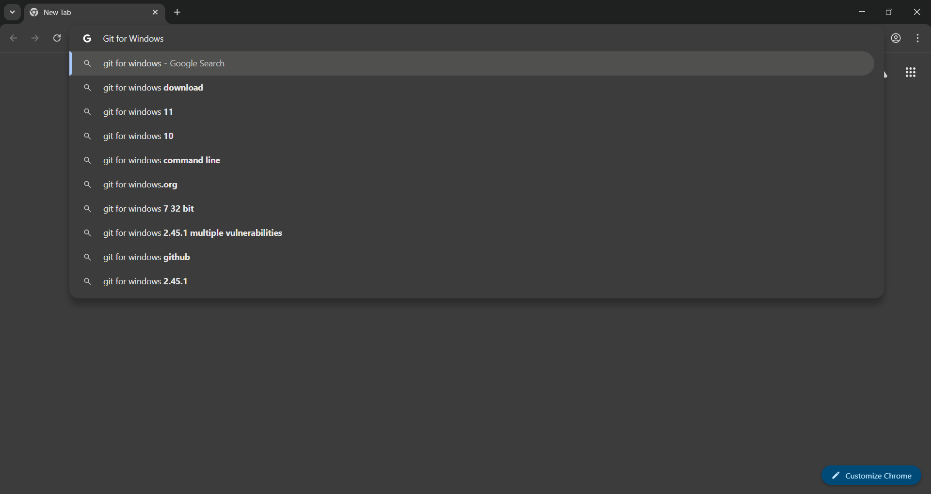
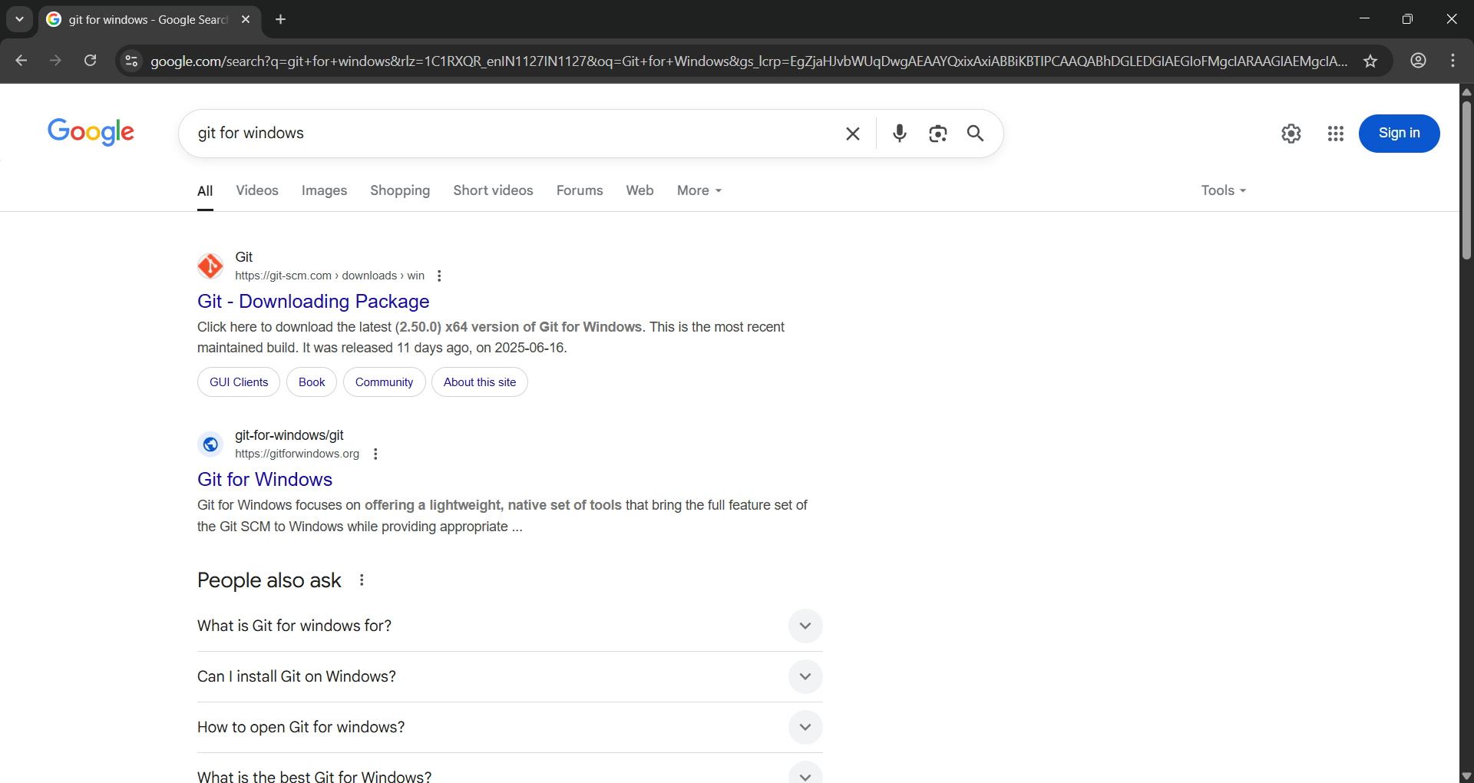
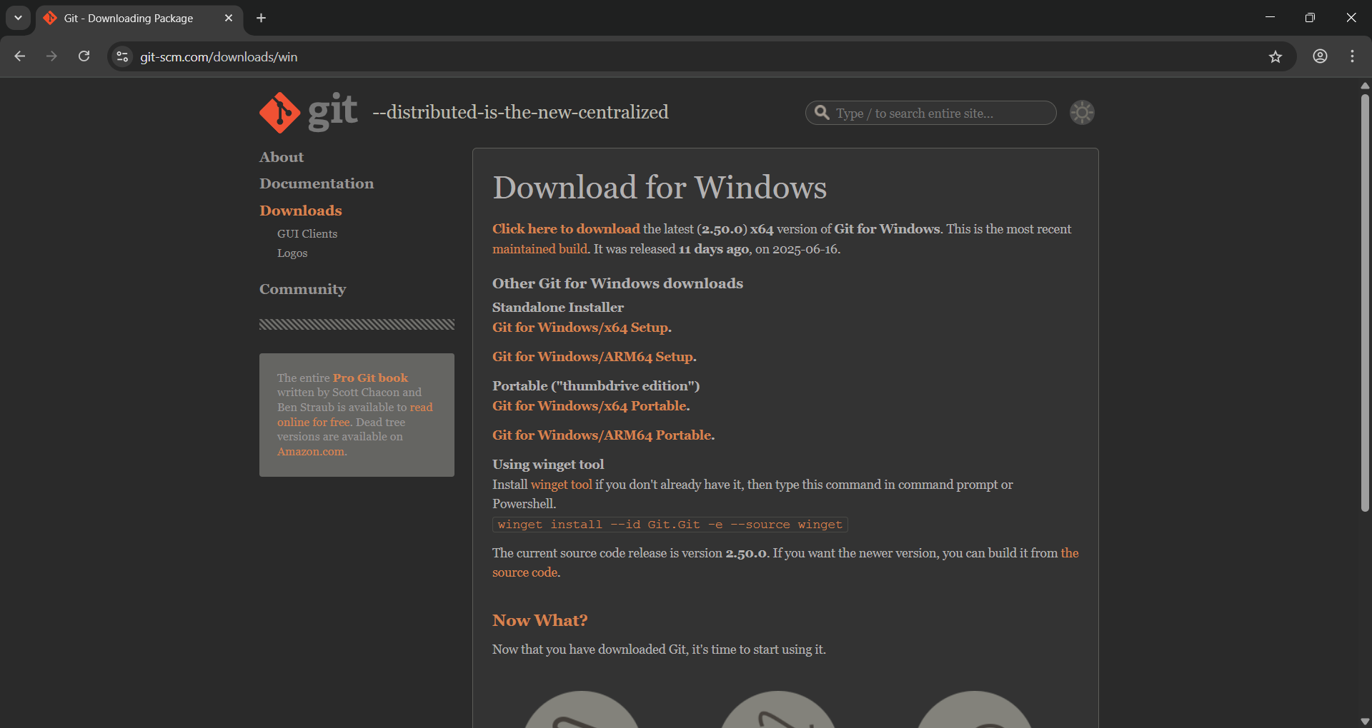
Click the hyperlink that says "Click here to download" to download the latest version of Git.
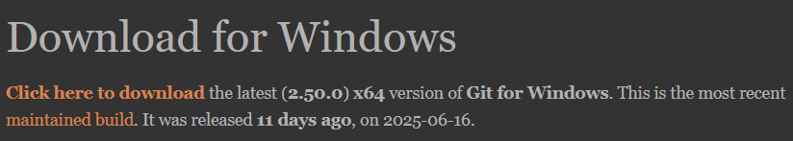
Alternatively, you can use the winget tool to install Git. Just run the following command in Command Prompt or PowerShell:
winget install --id Git.Git -e --source winget
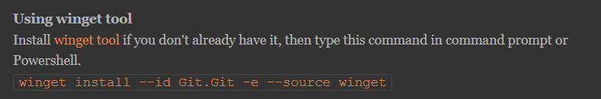
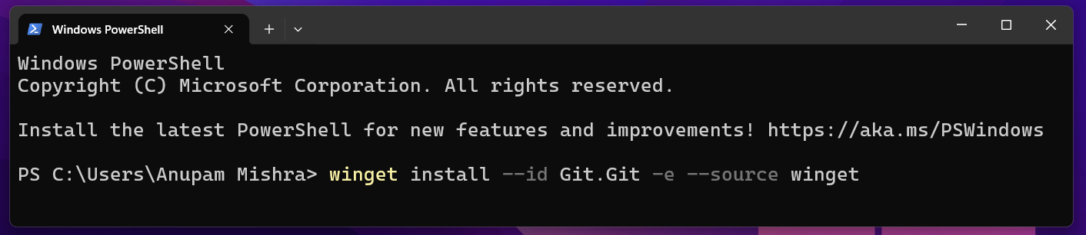

Step 2: Install Git on Windows
After the download finishes, double-click the installer file to start installing Git.
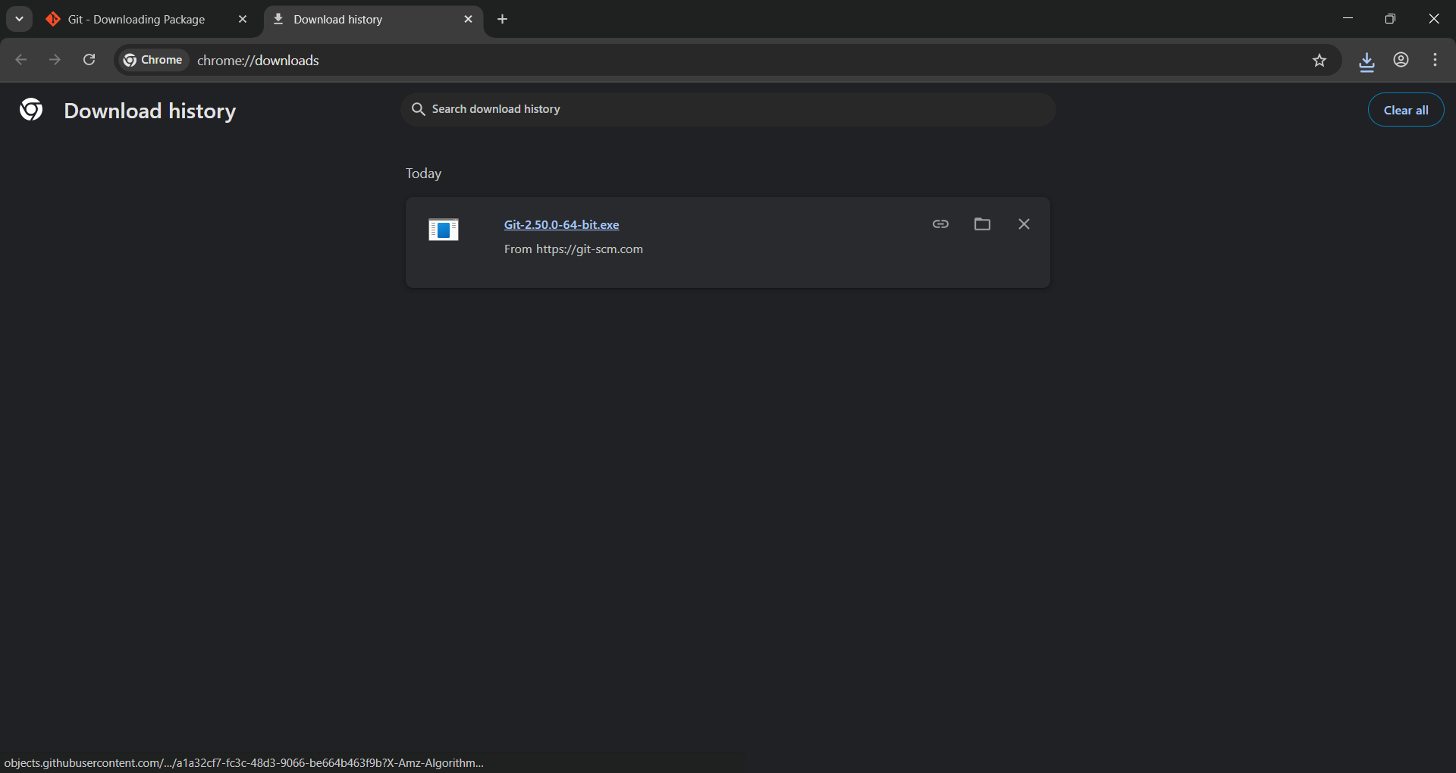

Once the Git Setup window opens, click the Next button to continue the installation.
During installation, you need to select the default options. This includes ensuring that the PATH environment variable is set correctly so you can use Git from the command line.
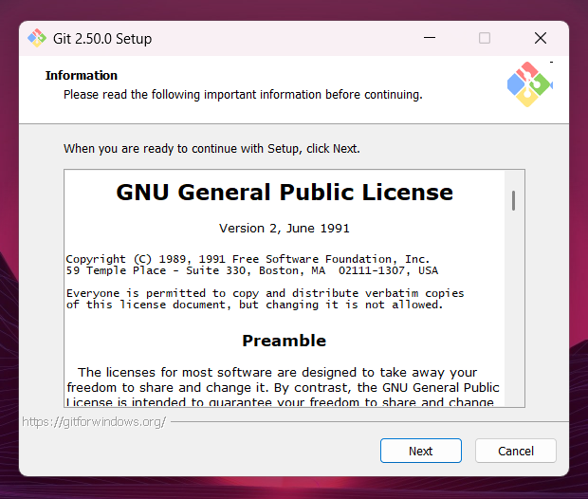

On the Select Components screen, make sure the Windows Explorer integration option is selected. This allows you to right-click in folders and open Git Bash or Git GUI directly from the context menu.
Also, under Additional icons, check In the Quick Launch to add a shortcut to the Quick Launch bar.
You can also check On the Desktop if you want a Git shortcut on your desktop.
Once done, click Next to continue.
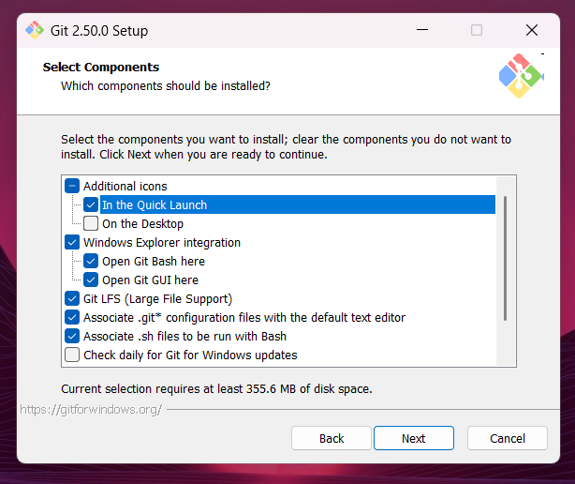

On the Choosing the default editor screen, If you have a preferred text editor like Visual Studio Code or Notepad++, select it here. If you're unsure, the default Vim editor is a safe choice, but you can change it later.
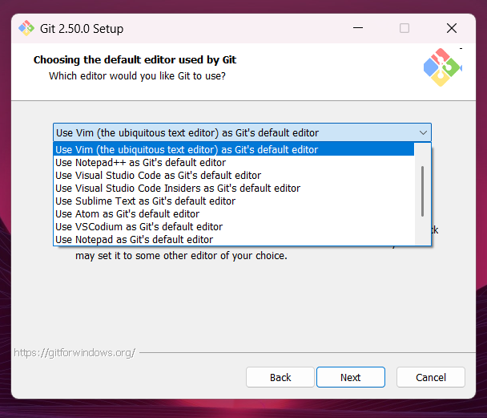

On the Adjusting the name of the initial branch screen, you can leave the default option selected as Let Git decide.
This means Git will use its default branch name when you create a new repository.
Click Next to continue.
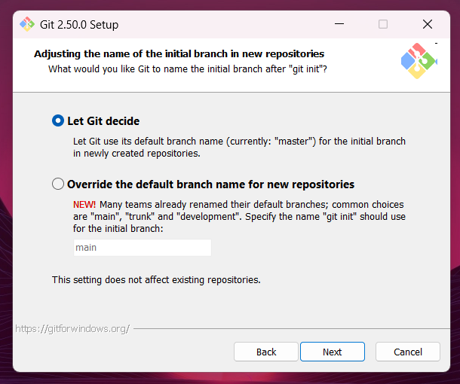

On the Adjusting your PATH environment screen, choose Git from the command line and also from 3rd-party software.
This lets you use Git not only from Git Bash, but also from Command Prompt, PowerShell, and other tools that rely on Git being available in the system PATH.
This option gives the most flexibility without messing up existing Windows tools.
Click Next to continue.
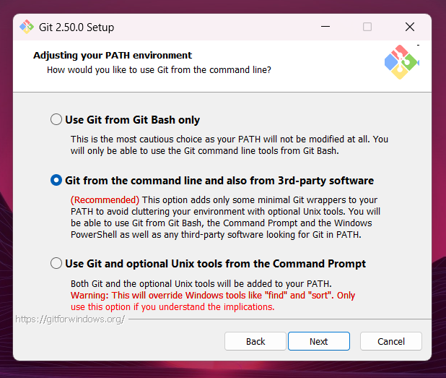

On the Choosing the SSH executable screen, keep the default option as Use bundled OpenSSH.
This uses the SSH client that comes with Git, so you don’t need to worry about setting up anything extra or messing with system paths.
Only choose Use external OpenSSH if you already have your own SSH setup and know how to manage it.
Click Next to continue.
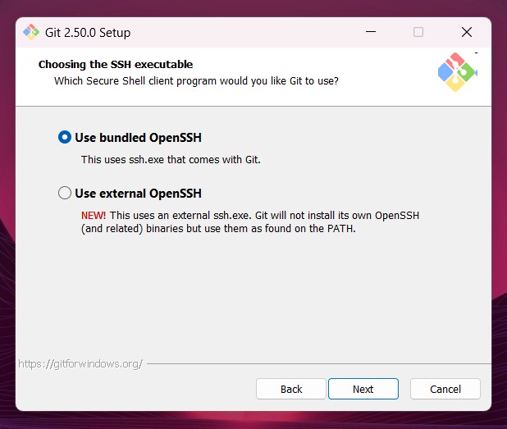

On the Choosing HTTPS transport backend screen, keep the default option as Use the OpenSSL library.
This means Git will validate HTTPS connections using its own certificate bundle, which works well in most situations.
Only choose Use the native Windows Secure Channel library if you work in a corporate environment where internal certificates are managed by Windows.
Click Next to continue.
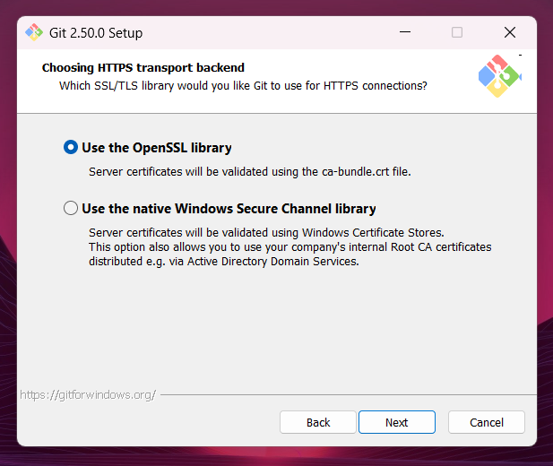

On the Configuring the line ending conversions screen, choose Checkout Windows-style, commit Unix-style line endings.
This setting converts line endings to Windows-style (CRLF) when you check out code, and to Unix-style (LF) when you commit — making your commits more consistent and compatible with Linux/macOS systems.
This is the safest choice if you're collaborating with people on other operating systems.
Click Next to continue.
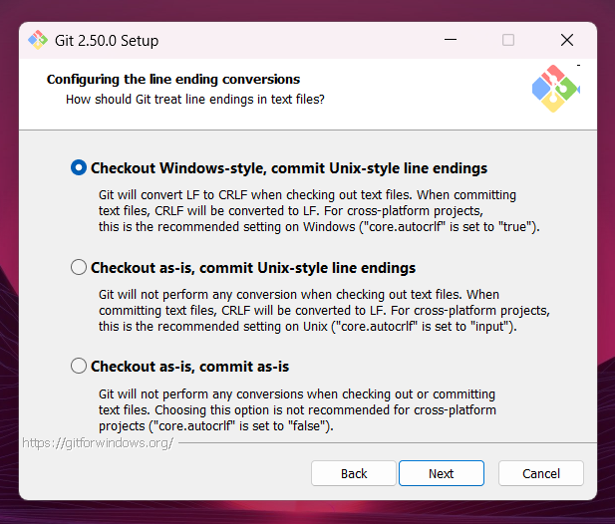

On the Configuring the terminal emulator to use with Git Bash screen, choose Use MinTTY (the default terminal of MSYS2).
MinTTY gives you a better terminal experience: it’s resizable, supports Unicode, allows non-rectangular selections, and looks cleaner than the default Windows command prompt.
This is the default and recommended choice for Git Bash.
Click Next to continue.
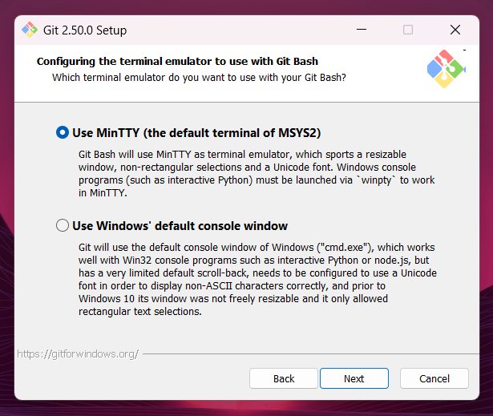

On the Choose the default behavior of git pull screen, select Fast-forward or merge.
This option attempts to fast-forward the current branch to match the fetched branch when possible. If a fast-forward isn’t possible, it will create a merge commit instead.
This is the recommended choice for users who prefer to preserve the full context of their changes, including explicit merge commits when necessary. It provides a balance between a clean history and complete visibility of integration points.
Click Next to continue.
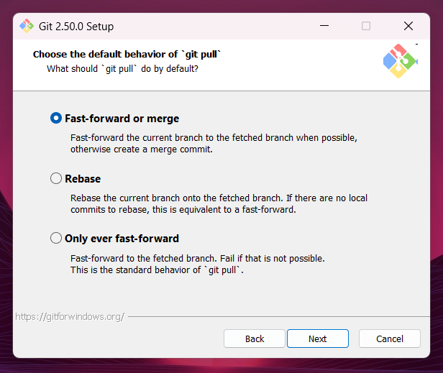

On the Choose a credential helper screen, select Git Credential Manager.
The Git Credential Manager securely stores your Git credentials such as usernames and personal access tokens so you don’t have to enter them every time you interact with a remote repository over HTTPS.
This is the recommended and default option for Windows users, as it simplifies authentication securely and automatically.
Click Next to continue.
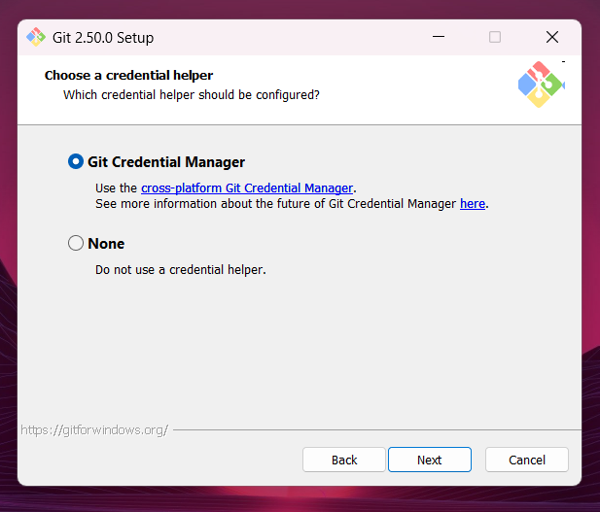

On the Configuring extra options screen, keep the checkbox Enable file system caching selected.
This feature allows Git to cache file system data in memory for certain operations, which improves performance.
This is enabled by default and is recommended for better speed and responsiveness during Git operations.
After confirming your choices, click Install to proceed with the installation.
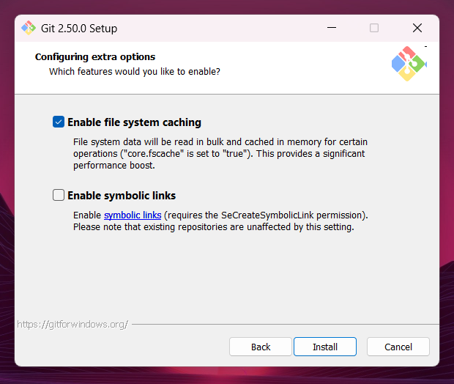

Once you click Install, the setup will begin copying files and configuring Git on your system.
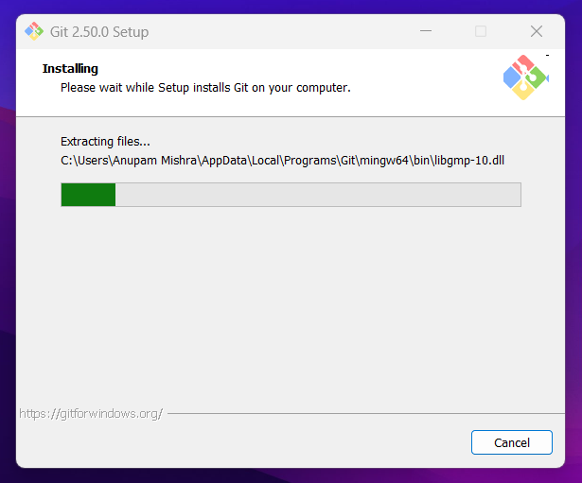

Once the progress bar reaches 100%, you’ll be taken to the final completion screen.
At this point, Git has been successfully installed on your system.
Unless you specifically want to launch Git Bash right away or read the release notes, it’s best to leave both checkboxes unchecked.
Click Finish to exit the setup wizard.
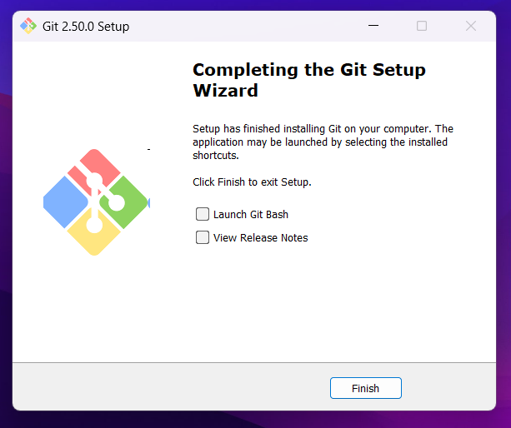

2. Verify Git Installation

After installing Git, you can verify that it’s properly installed. To do this:
Open Git Bash which was installed along with Git and run the following command:
git --version

This command will display the version of Git that you’ve installed, confirming that Git is set up and ready to use.
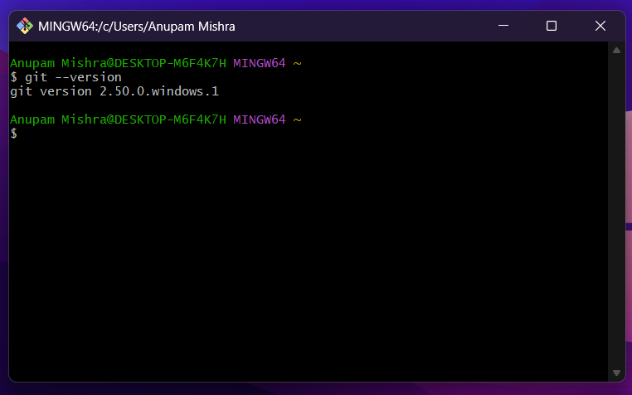

3. Set up Initial Configuration

Before you start using Git for your projects, it's essential to set up your identity. This information will be embedded in every commit you make, helping to identify who made changes.

Step 1: Open Git Bash

Search for "Git Bash" in your Windows Start Menu and open it. This will provide you with a command-line interface suitable for Git commands.

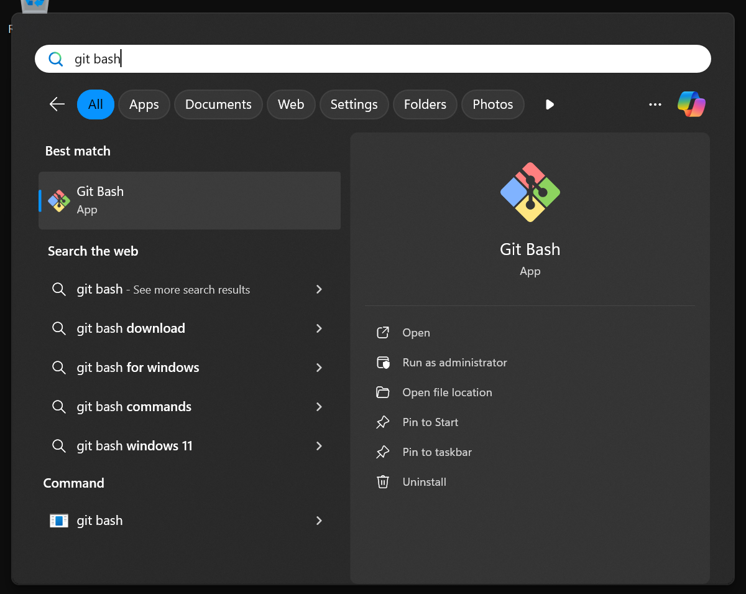

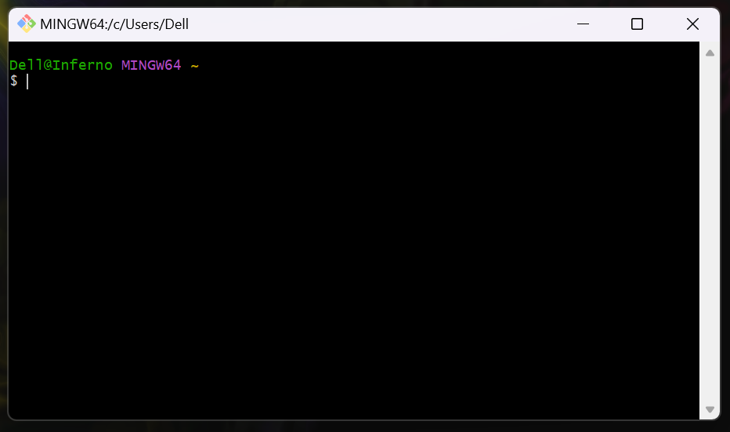

Step 2: Configure Your Username

In the Git Bash window, type the following command, replacing "Your Name" with your full name:

git config --global user.name "Your Name"

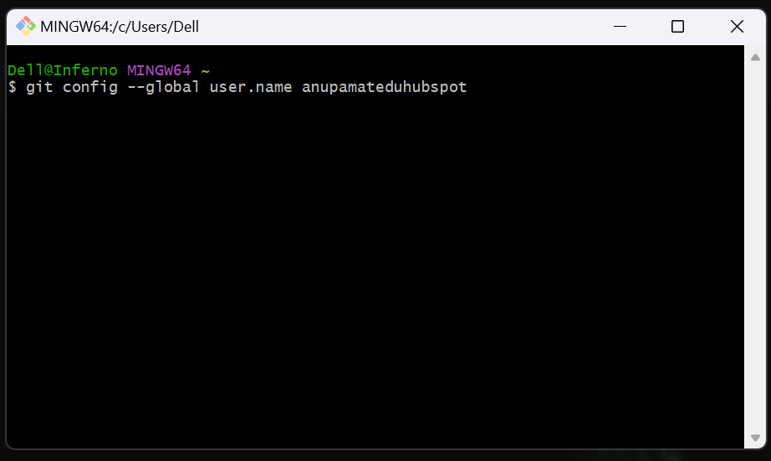

git config: This command is used to set Git configuration options.

--global: This flag ensures that the setting applies to all your Git repositories on your computer, not just a specific one.

user.name: This is the configuration key for your username.

Step 3: Configure Your Email Address

Next, type the following command, replacing "your.email@example.com" with the email address you will use for your Git commits (it's recommended to use the email associated with your GitHub account):

git config --global user.email "your.email@example.com"

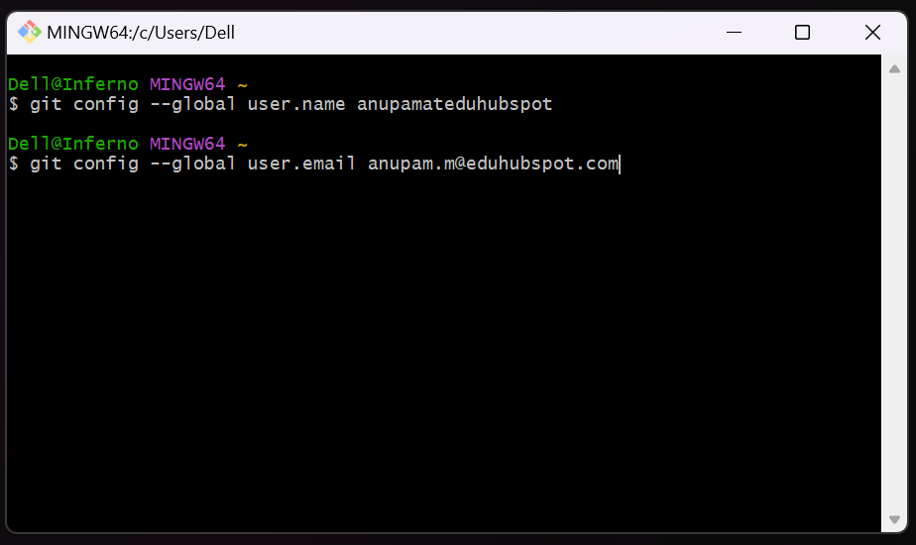

user.email: This is the configuration key for your email address. Git uses this to associate commits with your identity, especially when pushing to platforms like GitHub.

Step 4: Verify Your Configuration (Optional)

To confirm that your username and email have been set correctly, you can list all your global Git configurations using:

git config --global --list

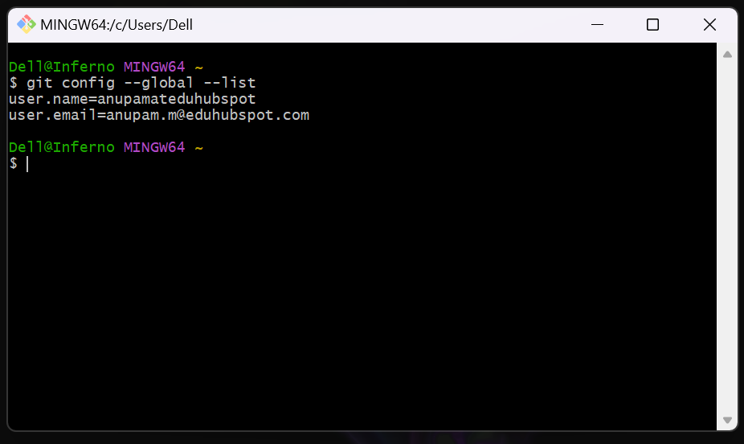

You should see user.name and user.email listed with the values you just set.

4. Create a GitHub Account

GitHub is a web-based platform that uses Git for version control. We will be using it for repository hosting, pull requests, and GitHub Actions.

Step 1: Sign Up for a GitHub Account

If you don't already have one, open your web browser and navigate to:

https://github.com/join

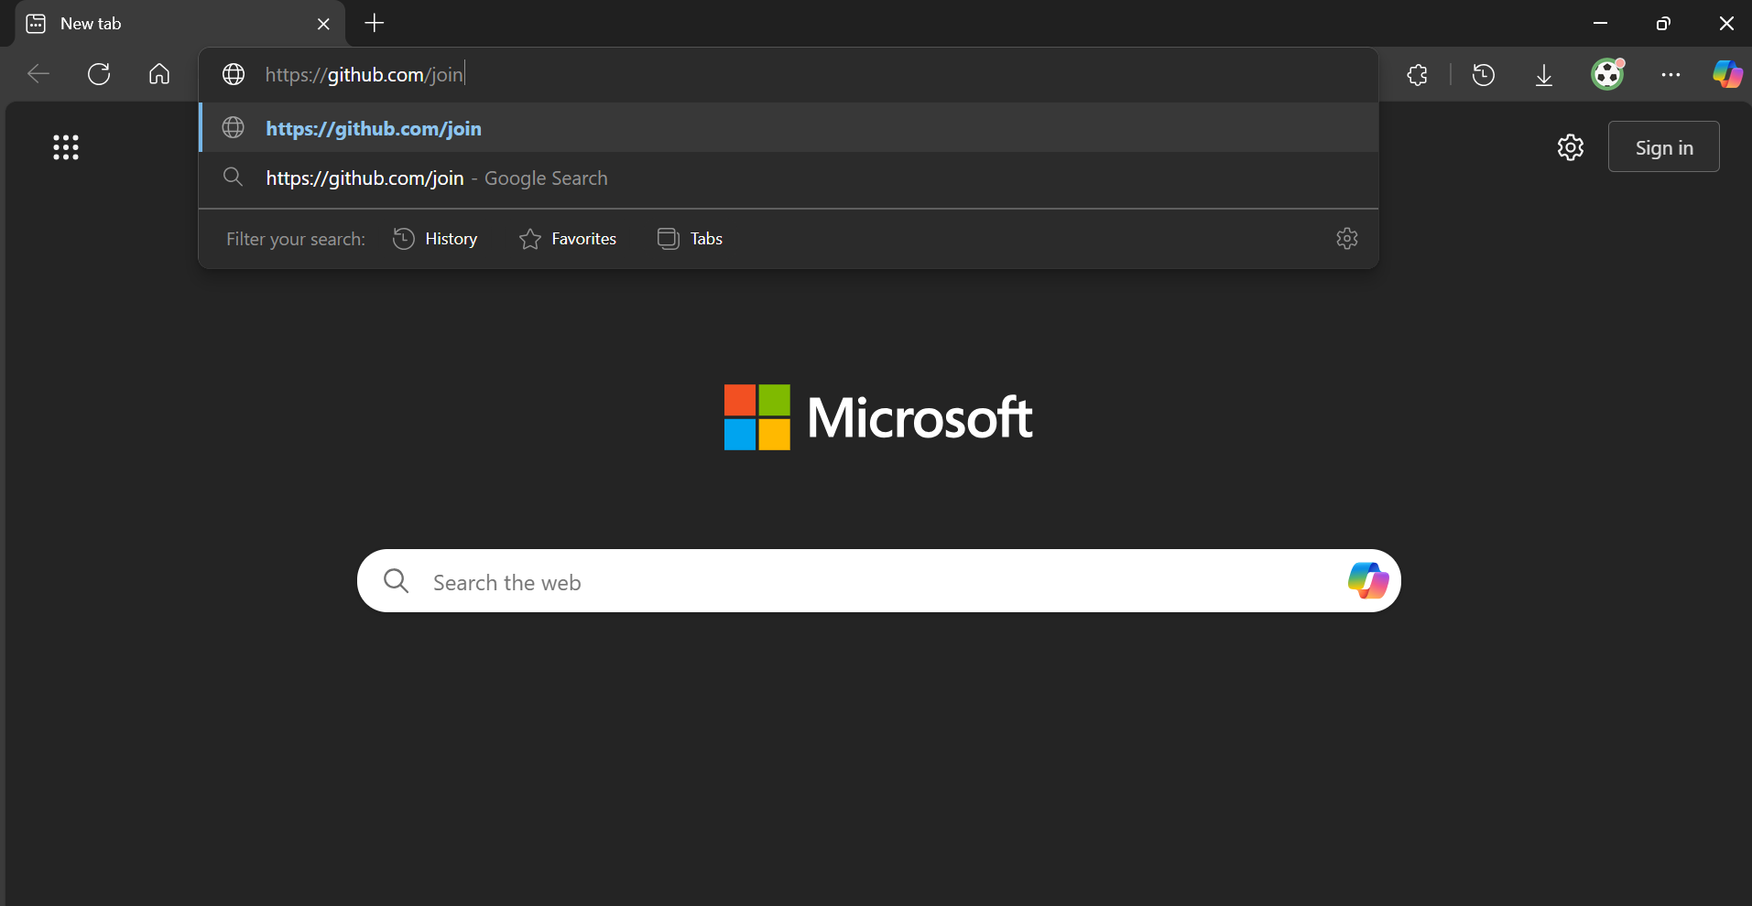

Follow the on-screen instructions to create your free account. You will need to provide an email address, create a password, and choose a username.

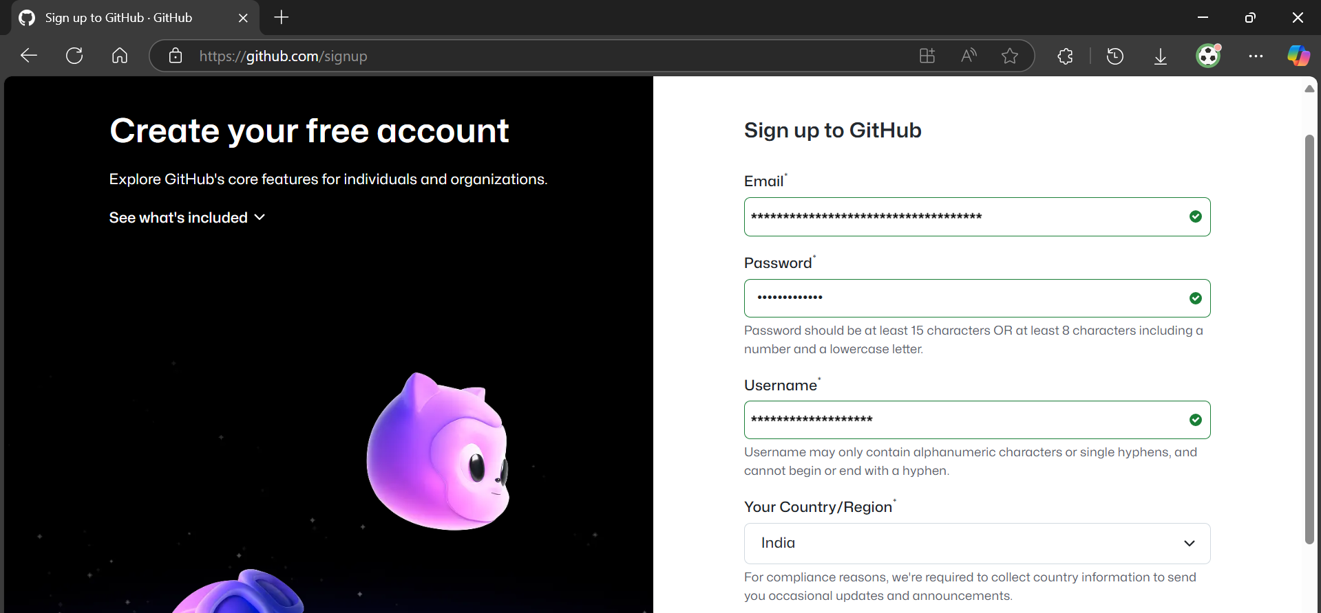

Step 2: Verify Your Account

After signing up, you will likely receive an email to verify your email address. Make sure to complete this verification step.

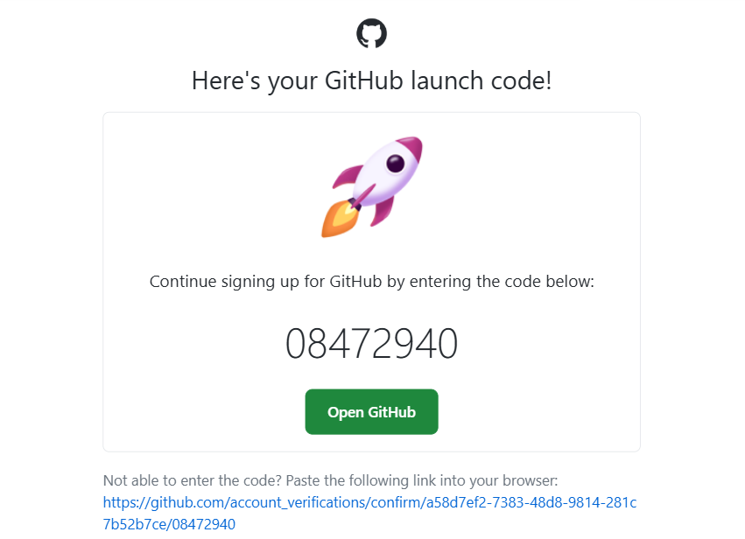

Once verified, log in to your GitHub account in your web browser and ensure you can access your dashboard.

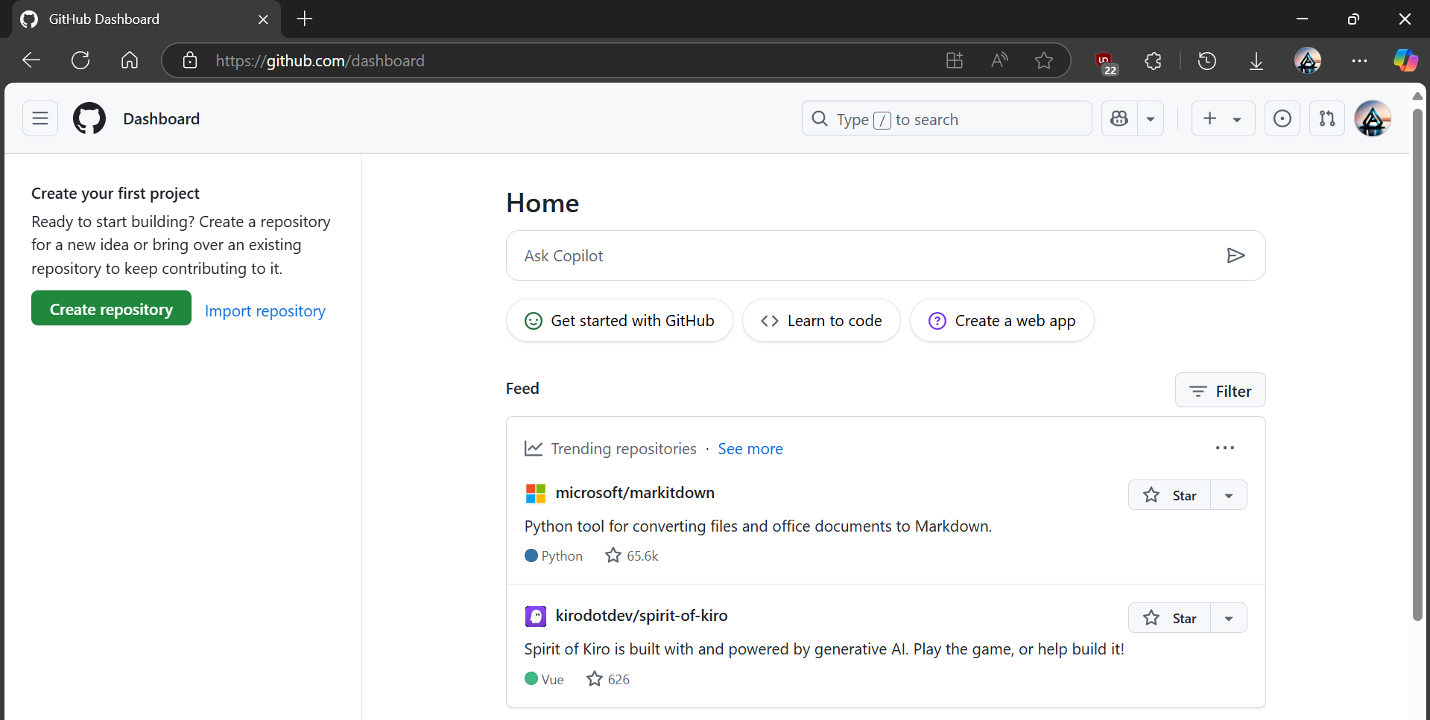

5. Download Text Editor or IDE

You'll need a text editor or Integrated Development Environment (IDE) to create and modify code files throughout these hands-on exercises.

VS Code (Recommended): https://code.visualstudio.com/

Notepad++: https://notepad-plus-plus.org/downloads/

Sublime Text: https://www.sublimetext.com/

6. Command Line Interface (CLI) Access

All Git and many GitHub operations are performed via the command line. You will be primarily using Git Bash for these exercises.

Git Bash:

Search for "Git Bash" in your Windows Start Menu and click to open it.



Alternatives:

1. Command Prompt (CMD): Search for "cmd" in your Start Menu.

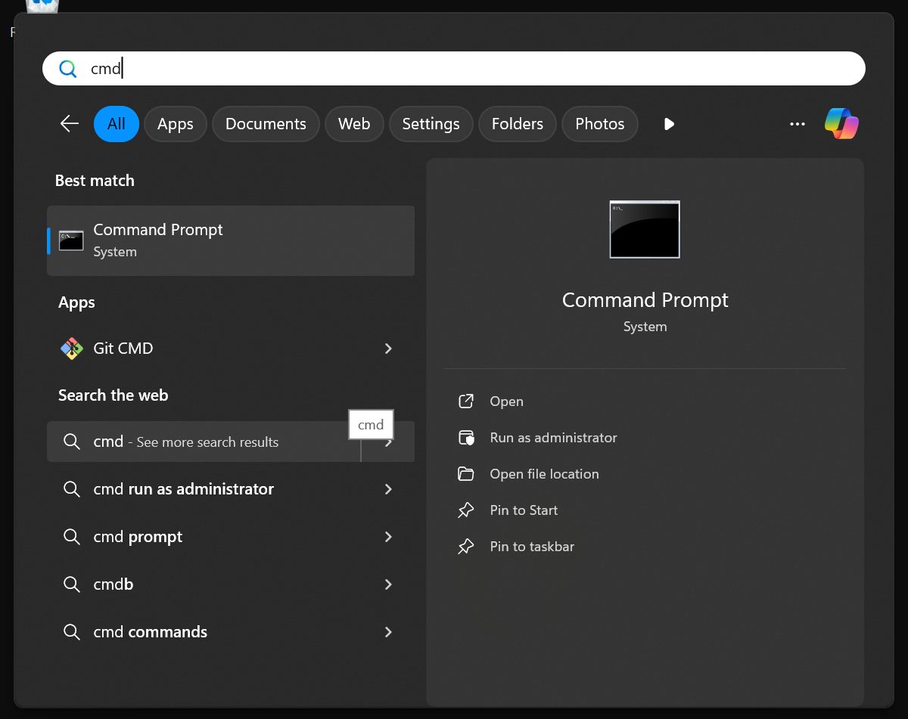

2. PowerShell: Search for "PowerShell" in your Start Menu.

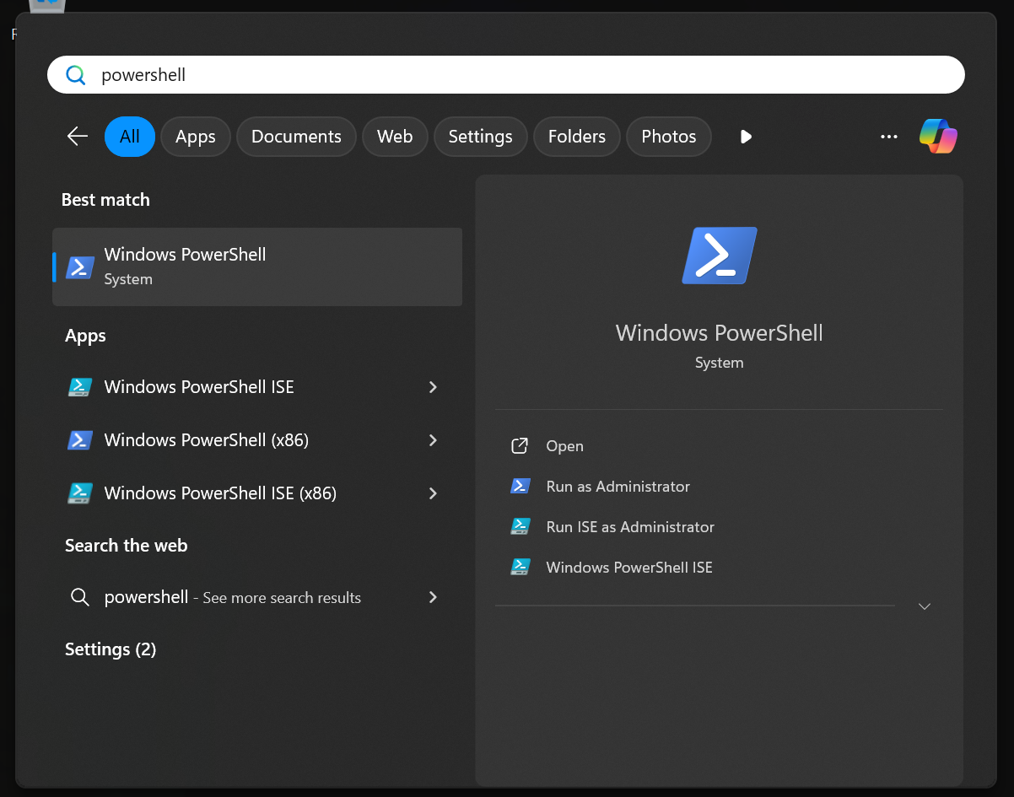

7. GitHub Copilot Subscription & VS Code Extension

Step 1: Acquire GitHub Copilot Subscription

You'll need an active subscription to GitHub Copilot.

To subscribe, you can visit https://github.com/features/copilot for details on pricing and how to subscribe. Ensure your GitHub account has an active Copilot subscription.

Step 2: Install VS Code GitHub Copilot Extension

- Open Visual Studio Code.
- Go to the Extensions view by clicking the Extensions icon in the Activity Bar on the side of the window, or by pressing Ctrl+Shift+X.
- In the Extensions search bar, type GitHub Copilot and press Enter.
- Find the GitHub Copilot extension (published by GitHub) and click the Install button.
- After installation, VS Code will prompt you to sign in with your GitHub account. Follow the prompts to Sign in to GitHub and Authorize GitHub Copilot.

  - This will open a browser window to complete the authentication process.
  - Ensure you grant the necessary permissions.

Once successfully authenticated, GitHub Copilot will be active in your VS Code environment, ready to assist with code and commit message suggestions.

Topics Covered:

- Git installation
- Git installation verification
- Git configuration set up
- GitHub account creation
- Text editor or IDE download
- CLI access
- GitHub Copilot subscription and VS Code extension set up

