Configure Basic CI with GitHub Actions

Problem Statement:

As projects grow, manually testing every change before merging can become time-consuming and error-prone. Continuous Integration (CI) is a software development practice where developers frequently merge their code changes into a central repository, and automated builds and tests are run on these changes. This helps to detect integration issues early and ensures the codebase remains healthy.

GitHub Actions is a powerful automation platform directly integrated into GitHub, allowing you to create custom CI/CD workflows right in your repository.

This hands-on exercise will guide you through setting up a simple GitHub Actions workflow to perform basic Continuous Integration (CI) checks on your project.

Steps:

Before you begin, ensure you have:

- A GitHub Account.
- Your private repository.
- A web browser to access github.com.

We will perform all steps directly on the GitHub website.

Step 1: Navigate to Your Repository on GitHub

First, let's get to your project's home on GitHub.

All GitHub Actions workflows are defined within your repository on GitHub.

1. Navigate to your Private Repository:

Open your web browser and go to your private repository on GitHub.

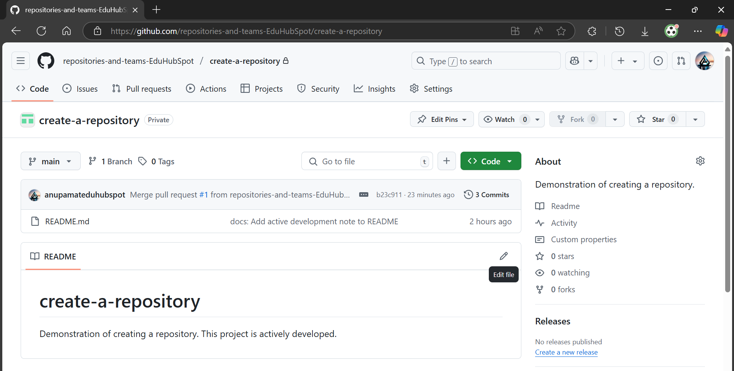

Step 2: Create a Basic GitHub Actions Workflow File

GitHub Actions workflows are defined in YAML files located in a .github/workflows/ directory within your repository.

This is where GitHub looks for automation instructions. A simple workflow will tell GitHub what to do when certain events occur.

1. Click the Actions tab in your repository's navigation bar.

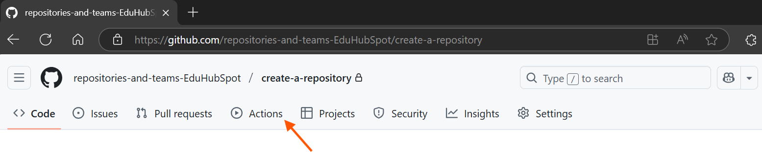

If this is your first time using Actions, you might see some suggested workflows.

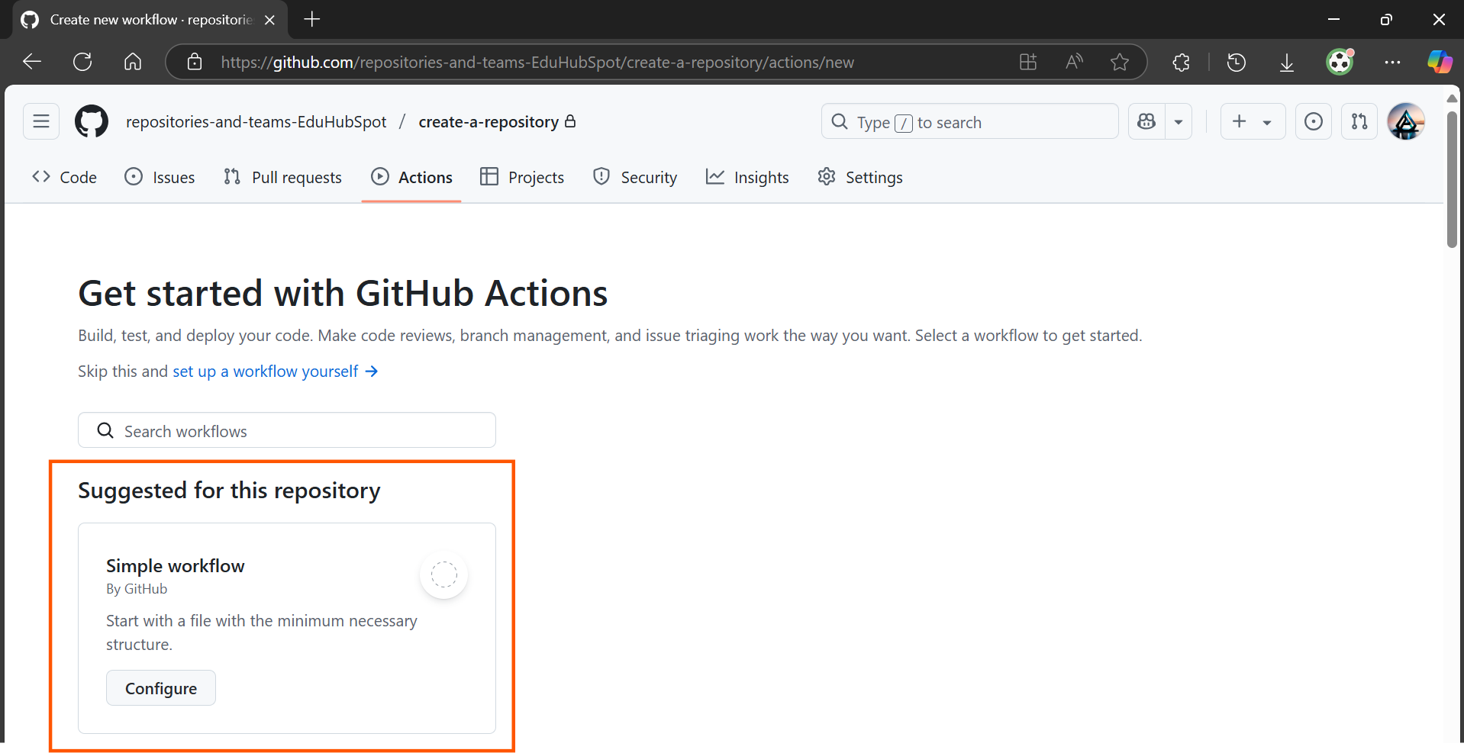

2. Set up a new workflow:

Look for a button like set up a workflow yourself.

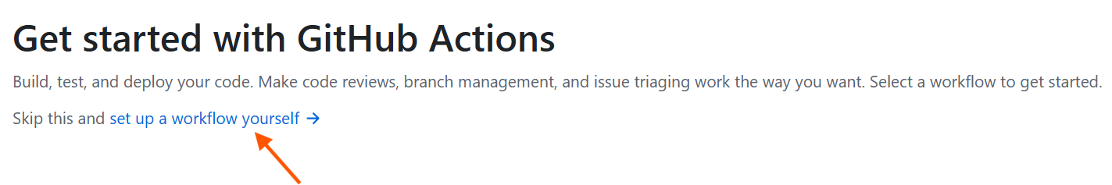

Clicking this will take you to a new file editor on GitHub. The file path will be something like .github/workflows/main.yml.

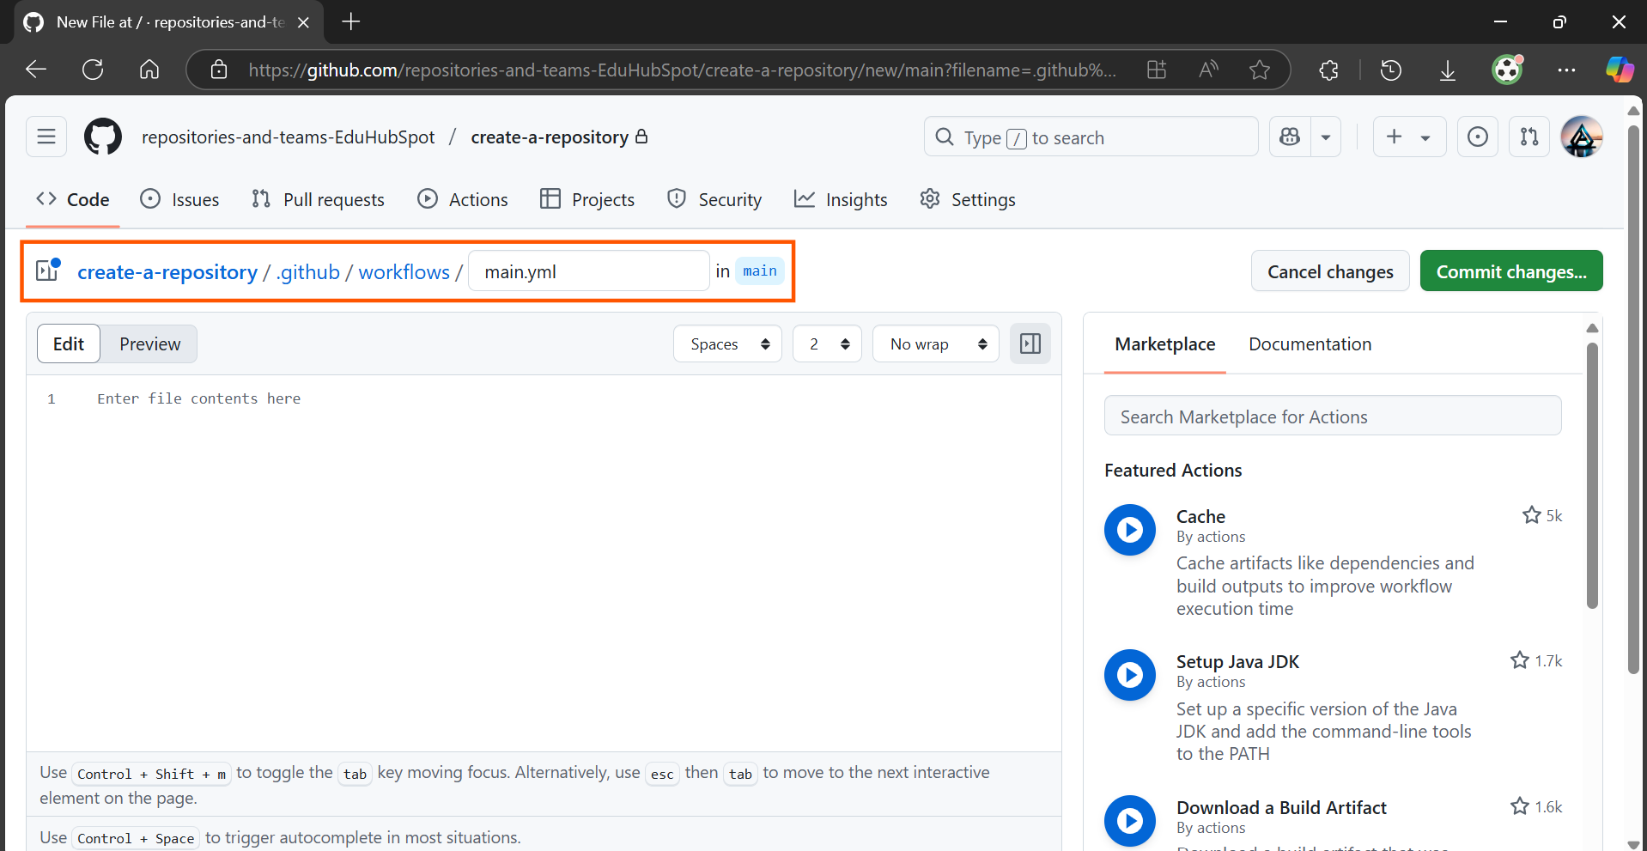

3. Replace the default content with the following YAML code:

- Delete all the pre-filled content in the editor and paste this minimal workflow.
- Make sure to delete any existing lines and replace it entirely to avoid syntax errors.

name: Simple CI Check

on: [push] # This workflow runs on every push to any branch

jobs:
build:
runs-on: ubuntu-latest # The type of runner that the job will run on

steps:
- name: Checkout code
uses: actions/checkout@v4 # This action checks out your repository code

- name: Display a message
run: echo "Hello, CI! Workflow triggered successfully!"

- name: List files to demonstrate CI context
run: ls -la

- name: Simulate a 'test' step
run: echo "Running basic checks... All good!"

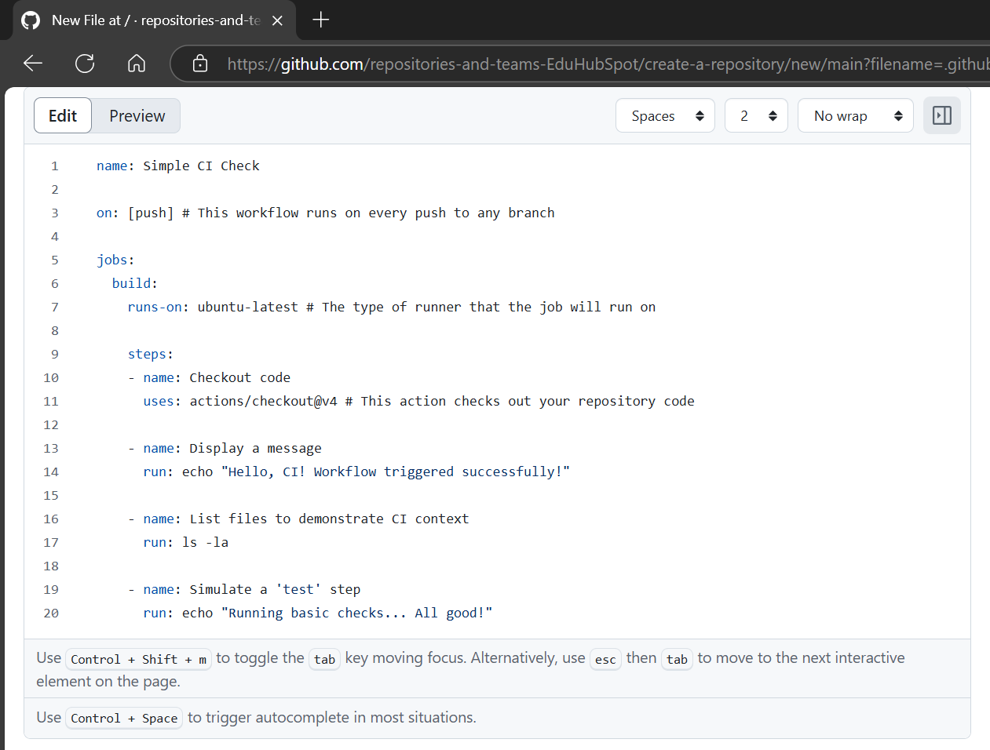

- name: Simple CI Check: Gives your workflow a readable name.
- on: [push]: This is the trigger. It means this workflow will run automatically every time a new commit is pushed to the repository.
- jobs:: Workflows consist of one or more jobs. Here we have one job named build.
- runs-on: ubuntu-latest: Specifies the operating system environment where the job will run (a virtual machine hosted by GitHub).
- steps:: A job contains a sequence of steps.
- uses: actions/checkout@v4: This is a pre-built action from GitHub that downloads your repository's code into the runner environment, so your workflow can access your files.
- run: echo ...: run steps execute shell commands directly on the runner. We're just printing messages and listing files for demonstration.

4. Rename the workflow file:

In the File name field at the top of the editor, change main.yml to something more descriptive like simple-ci.yml. The full path will be .github/workflows/simple-ci.yml.

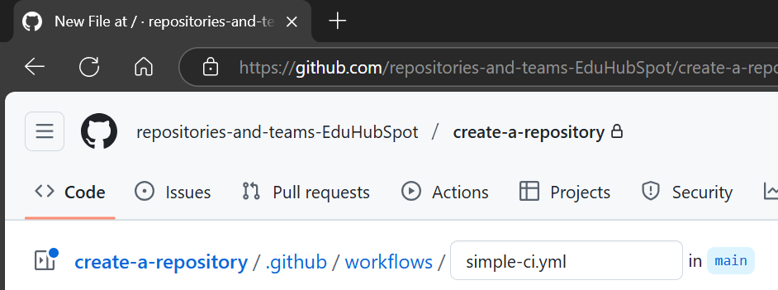

5. Commit the new workflow file:

At the top right of the editor, click the green Commit changes... button.

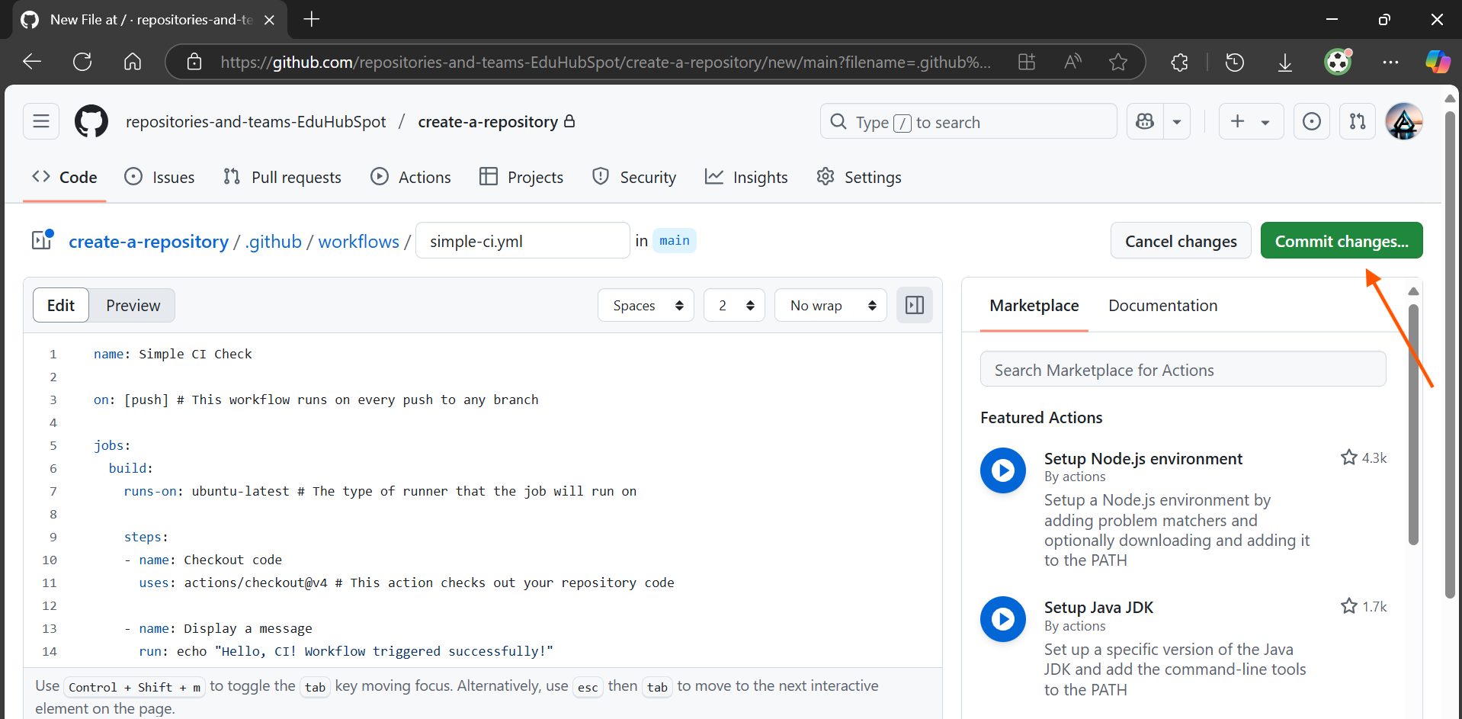

In the Commit message box, type a clear message.

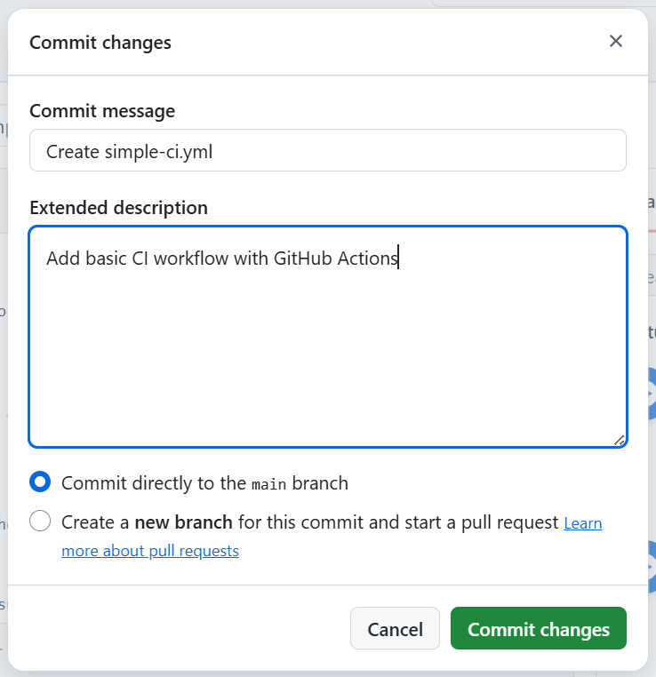

Ensure the option Commit directly to the main branch is selected.

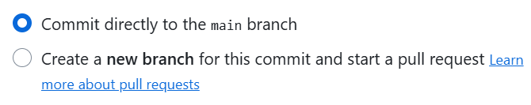

Click the green Commit changes button.

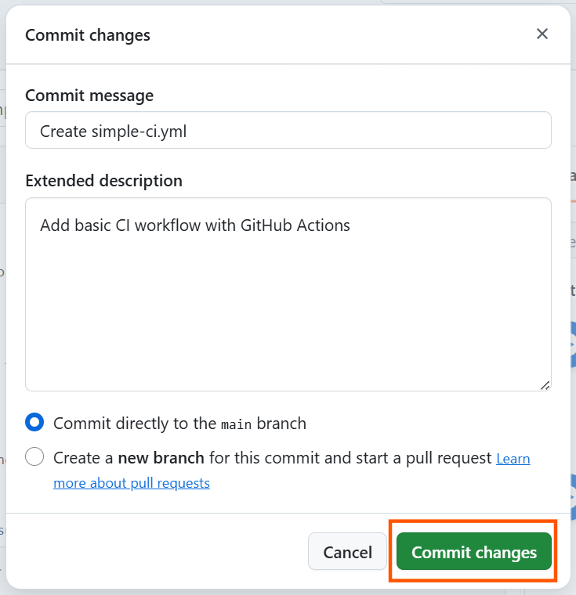

Step 3: Observe Your First CI Workflow Run

Committing the simple-ci.yml file to your main branch automatically triggers your first workflow run.

We're doing this to see the automation in action and verify that your CI setup is working as expected.

1. Navigate to the Actions tab:

After committing, GitHub will often automatically redirect you to the Actions tab, or you can click on it manually.

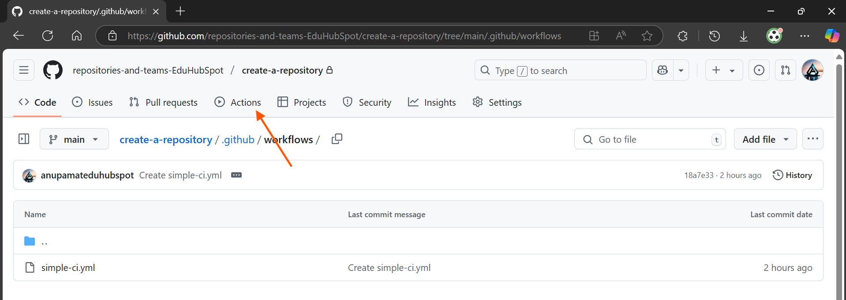

2. Find your workflow run:

On the left sidebar, you should see Simple CI Check listed under All workflows. Click on it.

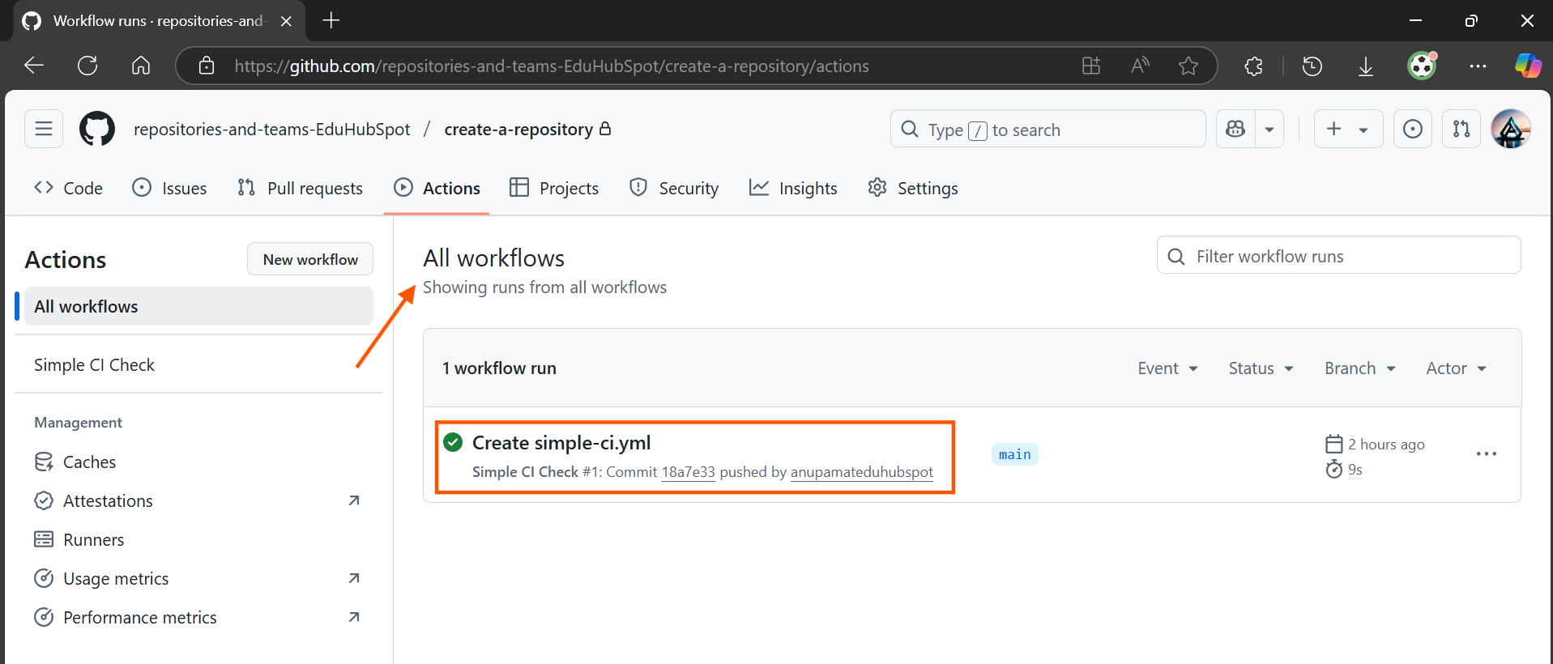

You'll see a list of runs. The top-most run should correspond to your recent commit message.

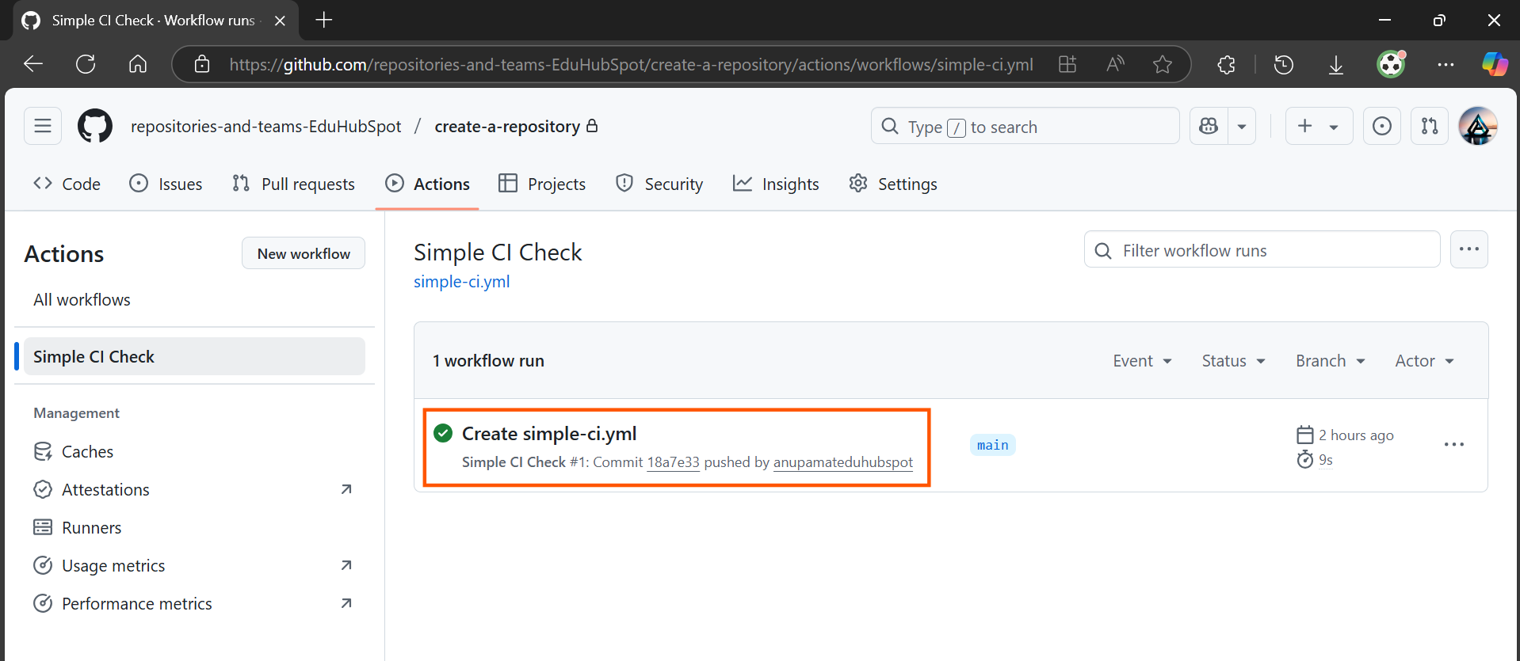

Next to it, you'll see a yellow spinning circle (if running), a green checkmark (if successful), or a red X (if failed). Wait for it to turn green.

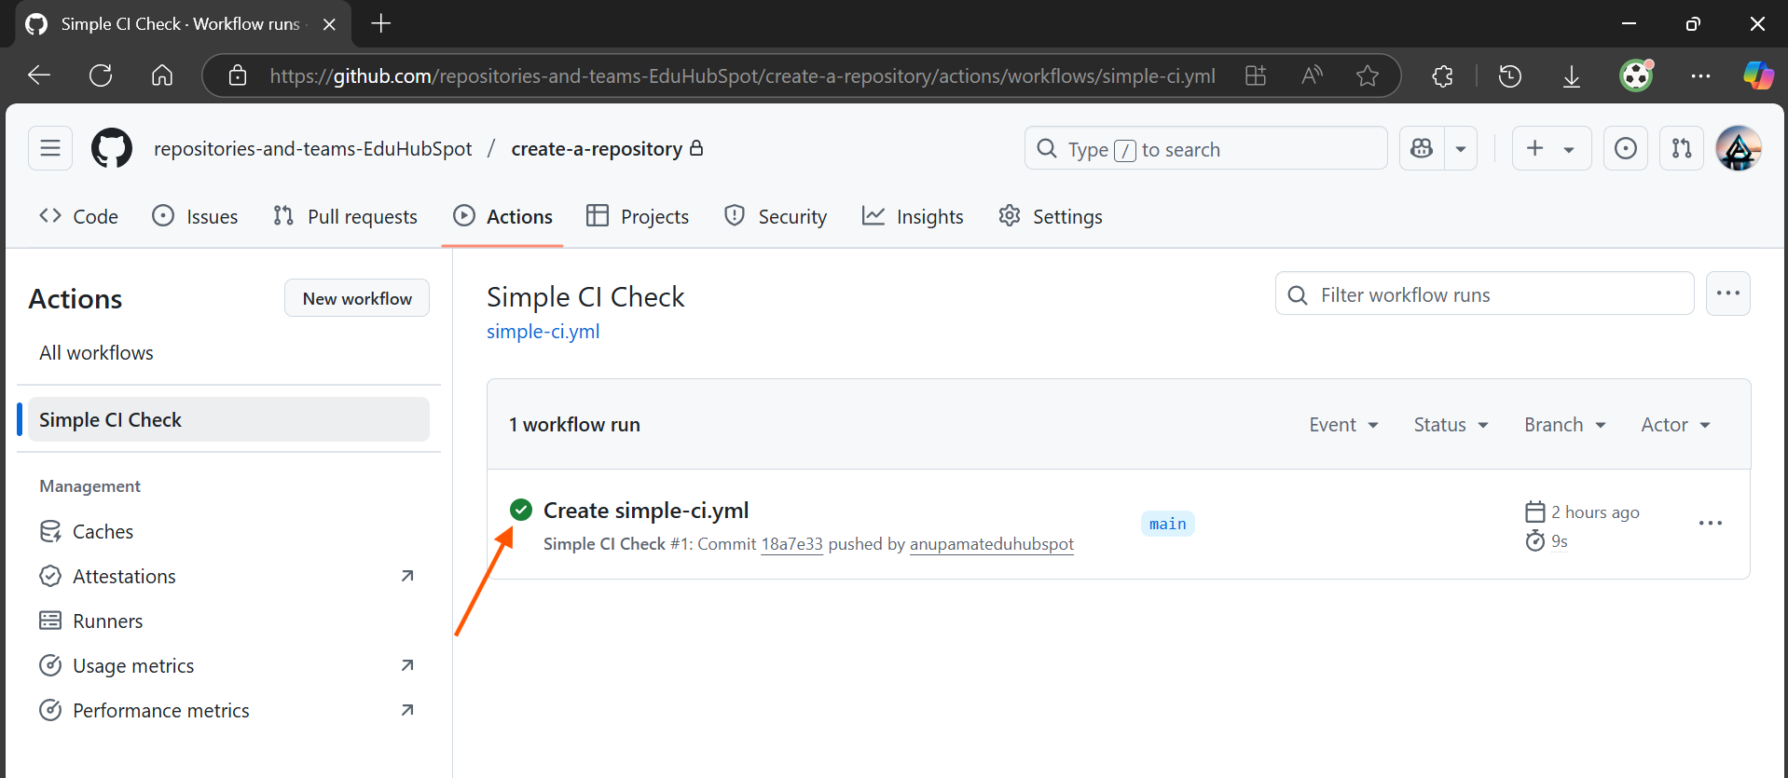

3. Explore the workflow details:

Click on the name of your latest run.

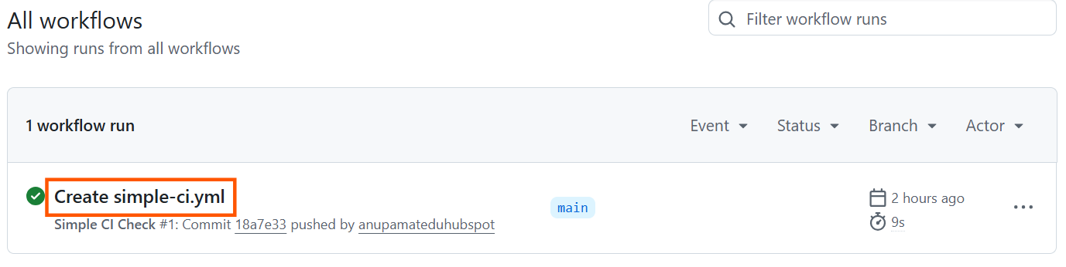

This page shows the jobs within your workflow. Click on the build job.

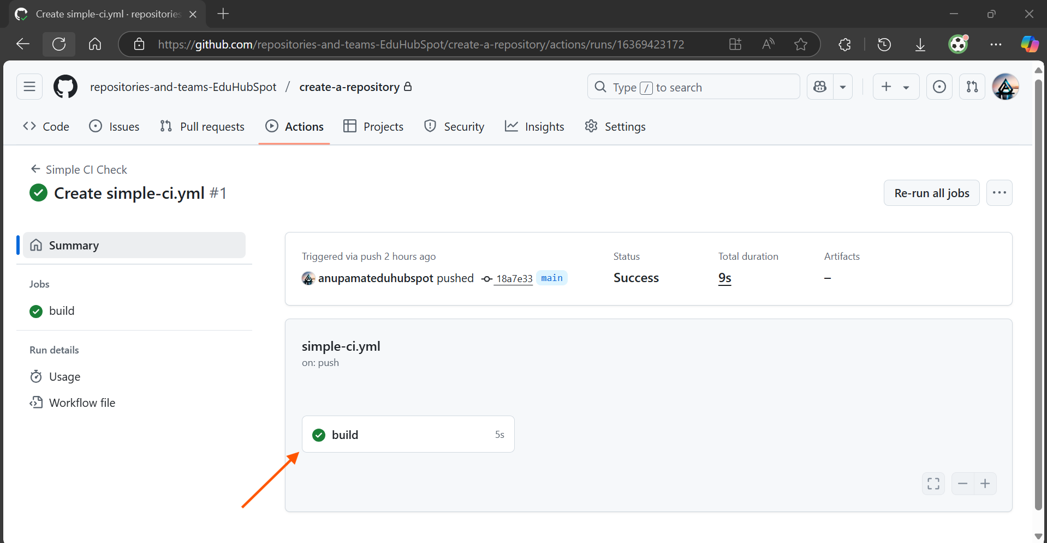

You'll now see a detailed log of each step within the build job.

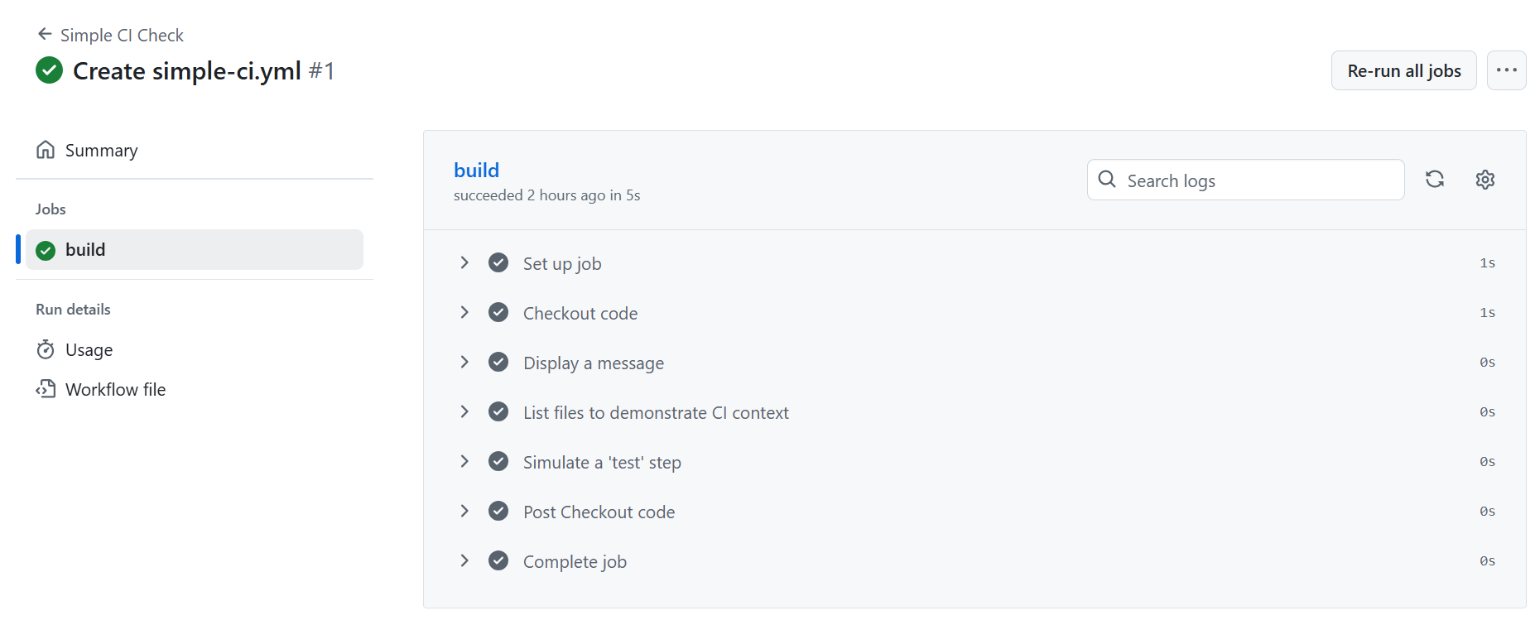

Click on the arrows next to each step name to expand their output and see the commands that were run and their results.

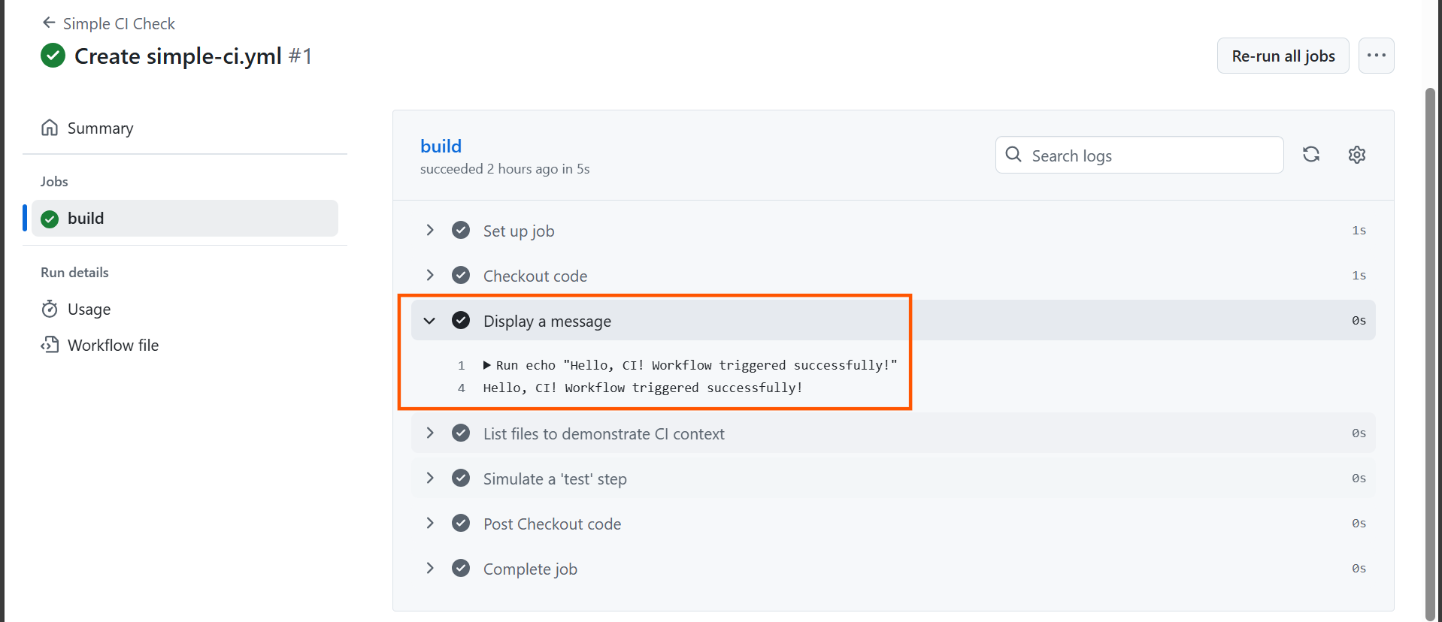

You should see your Hello, CI! Workflow triggered successfully! message and a listing of your repository's files.

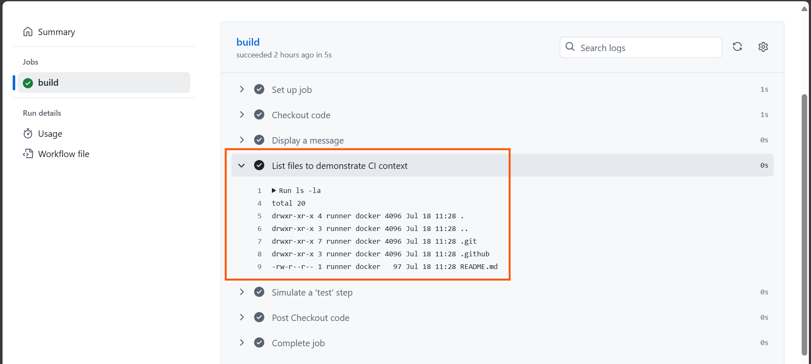

Step 4: Trigger the Workflow Again with a Code Change

Now, let's make a small change to another file to see the CI workflow automatically re-trigger.

1. Navigate back to the Code tab of your repository.

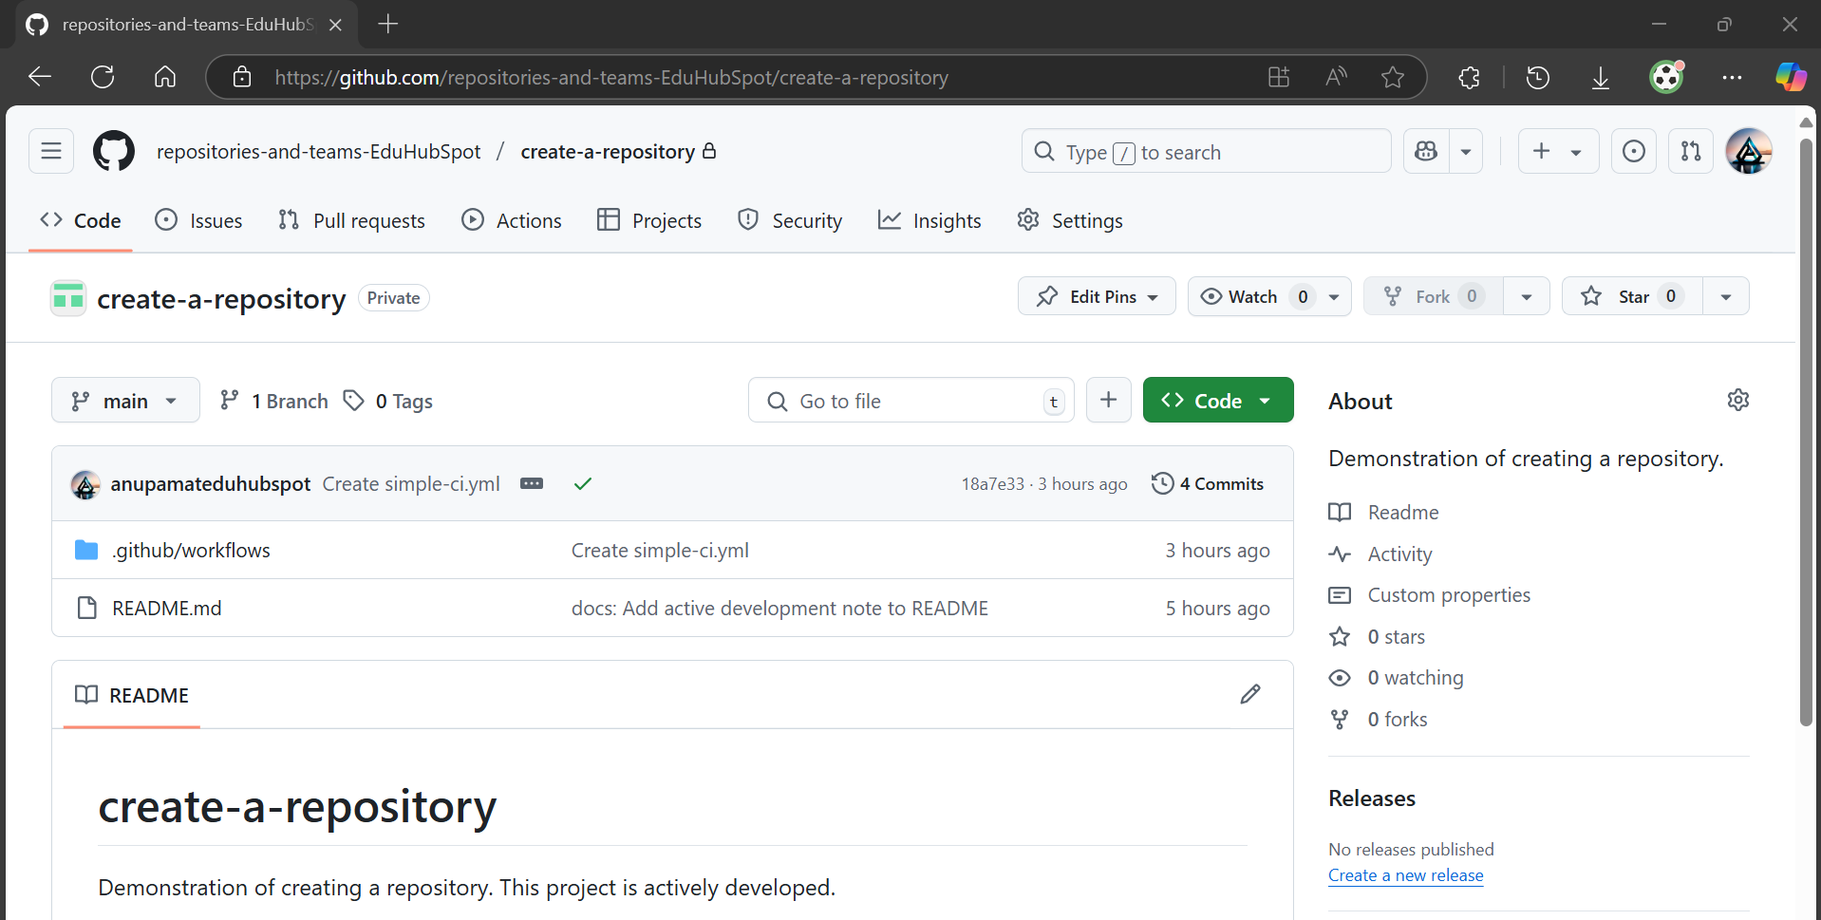

2. Edit the README.md file:

Click on README.md.

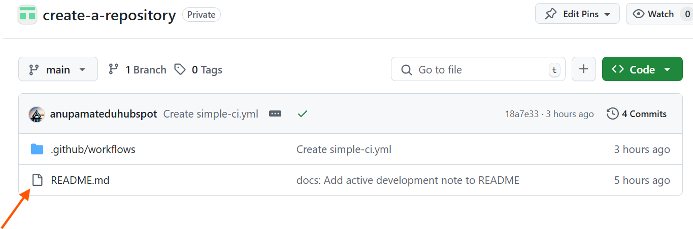

Click the pencil icon near the top right of the file content.

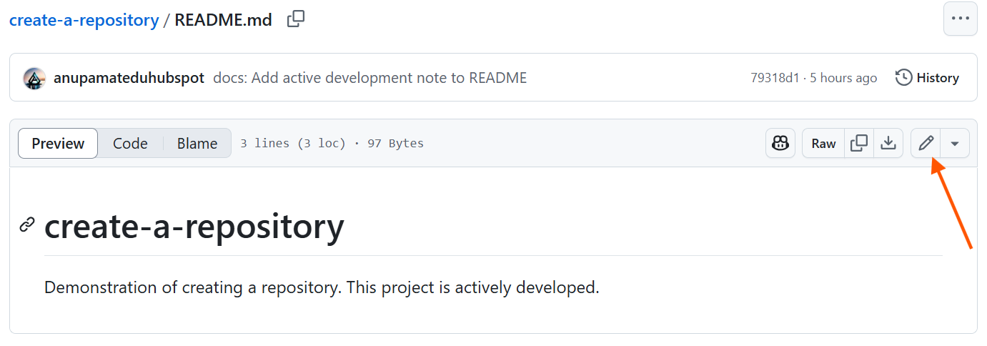

Add another line to the README.md file, for example:

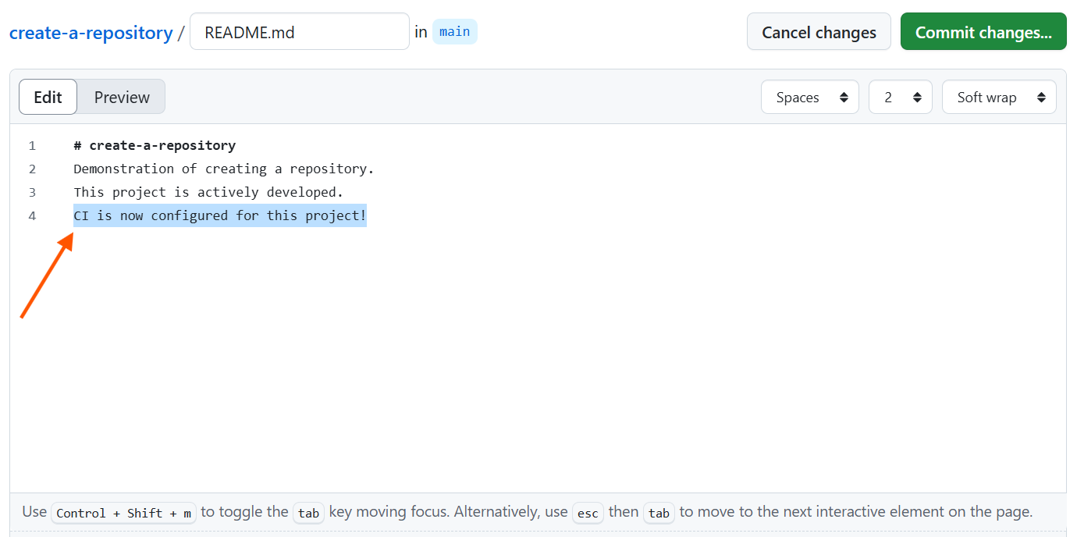

3. Commit the change:

Hover to the Commit changes button.

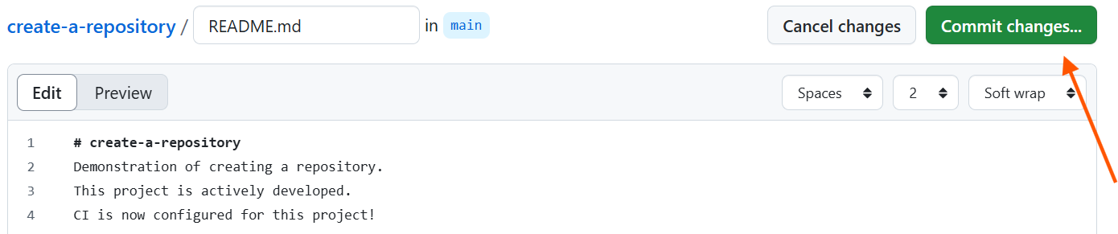

Add a commit message.

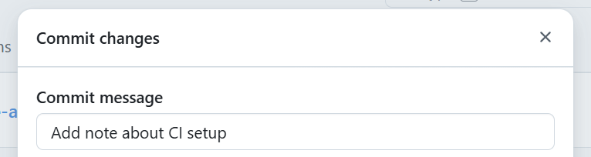

Ensure Commit directly to the main branch is selected.

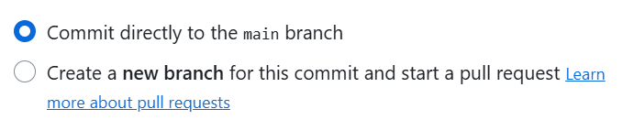

Click the green Commit changes button.

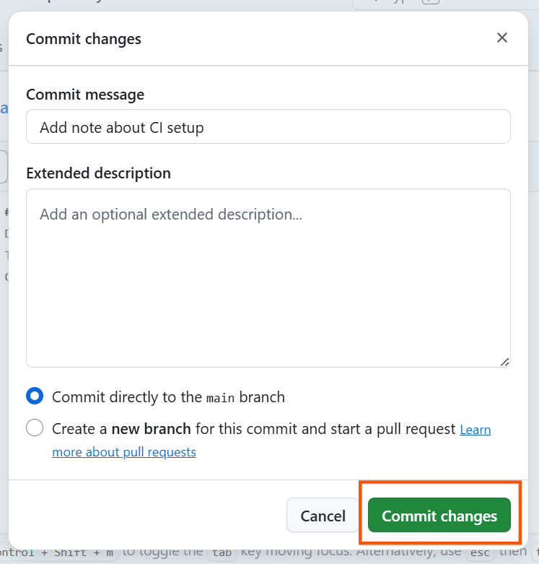

4. Observe the new workflow run:

Immediately go to the Actions tab again.

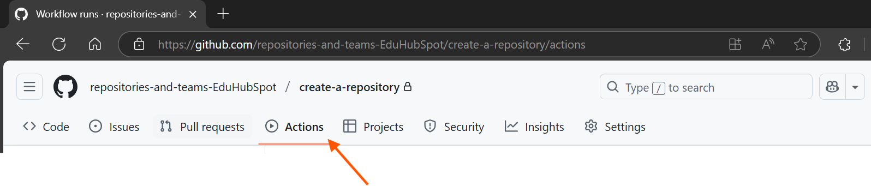

You should see a new workflow run triggered by your latest commit.

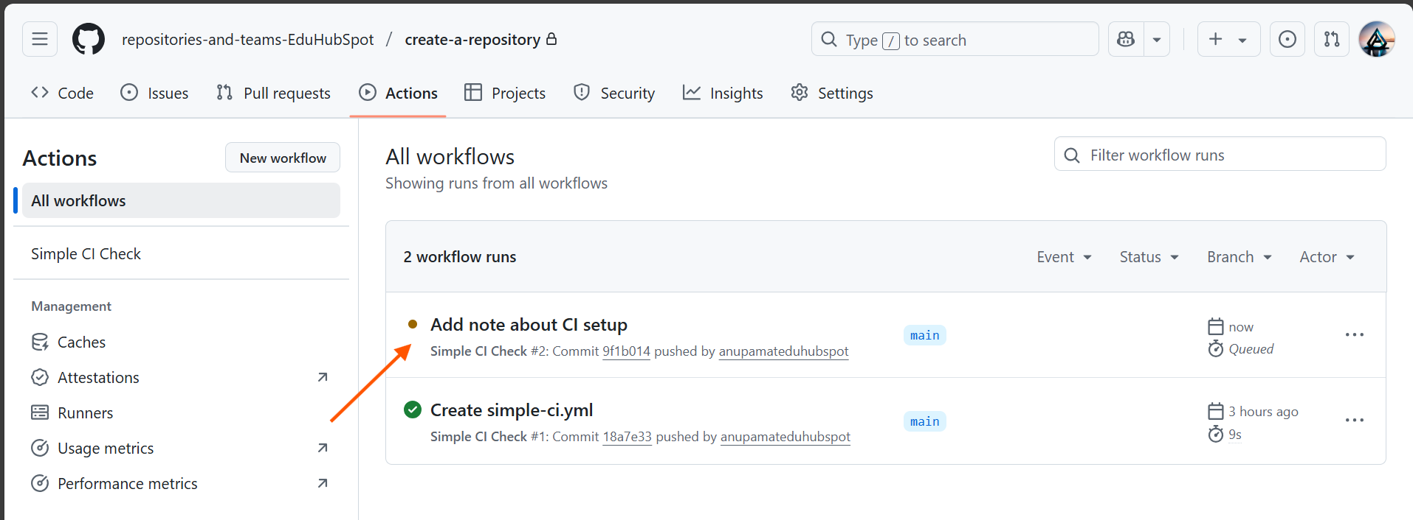

Wait for it to complete, and optionally click into it to inspect its logs again.

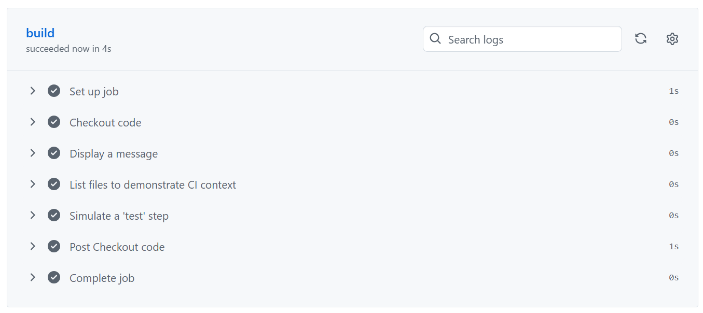

Topics Covered:
- Continuous Integration (CI) Concept: Understanding the importance of automated checks for code quality.
- GitHub Actions Basics: Introduction to the platform for workflow automation.
- Workflow File Structure: How to define a workflow using YAML (.github/workflows/).
- Workflow Triggers: Using on: [push] to automate runs on code changes.
- Jobs and Steps: Organizing tasks within a workflow.
- Pre-built Actions: Using actions/checkout to get repository code.
- Monitoring Workflows: Navigating the "Actions" tab to view run status and logs.
- Automated Feedback: Observing how CI provides immediate feedback on every commit.

