Copilot-powered Commit Messages

Problem Statement:

Writing clear, concise, and descriptive Git commit messages is essential for maintaining a readable project history, facilitating collaboration, and simplifying debugging. However, crafting effective commit messages can often be a time-consuming and challenging task, leading to generic or insufficient descriptions.

Here, we’ll explore how GitHub Copilot can assist developers in quickly generating meaningful commit messages by analyzing staged code changes, thereby improving commit quality and workflow efficiency.

Steps:

Before you begin, ensure you have:

- Git Installed: Git configured on your system.
- GitHub Copilot Access: An active GitHub Copilot subscription.
- VS Code Installed: Visual Studio Code.
- GitHub Copilot Extension: Installed and enabled in VS Code.
- Git CLI Integration (in VS Code): Ensure VS Code's Git integration is functional.

Step 1: Initialize a Git Repository

1. If you have an existing Git project, skip this.

Create a new folder:

mkdir copilot-commits-demo
cd copilot-commits-demo

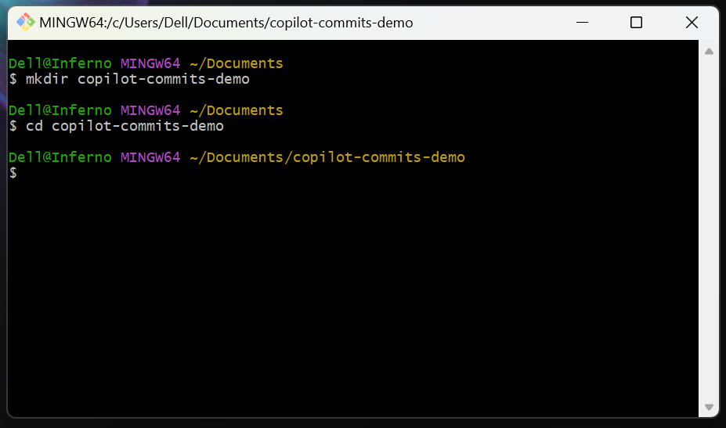

2. Initialize Git:

git init

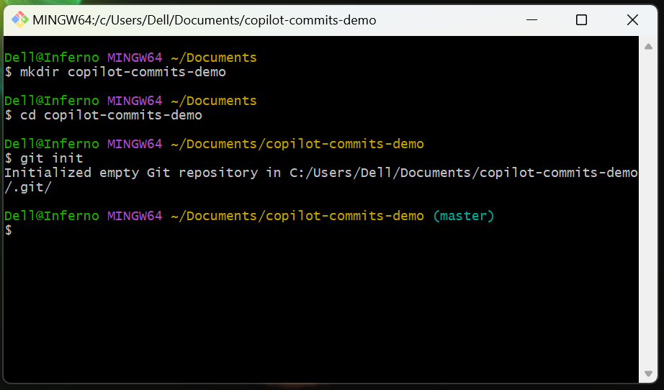

3. Create initial file:

echo "# Copilot Commits Demo" > README.md
git add README.md
git commit -m "Initial commit"

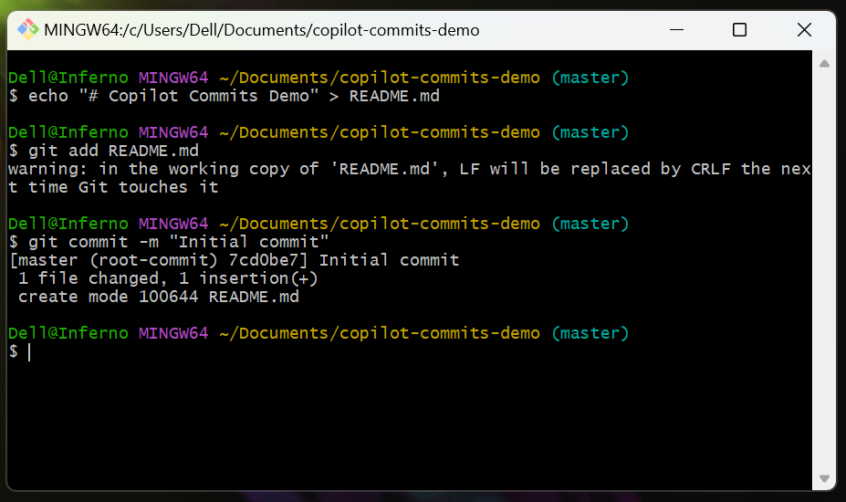

Step 2: Make Code Changes

Copilot generates messages based on your staged modifications.

1. Open the project in VS Code:

code .

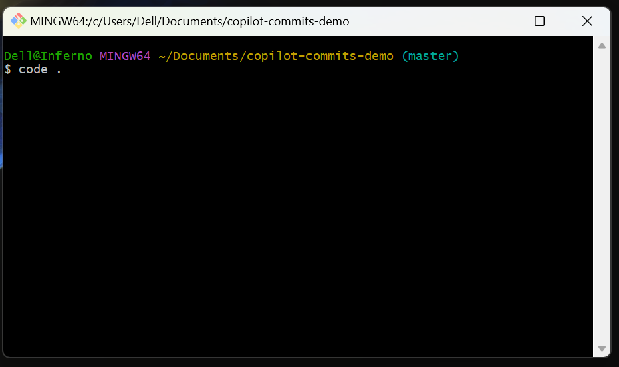

2. Modify a file or create a new one with meaningful content.

Example (README.md):

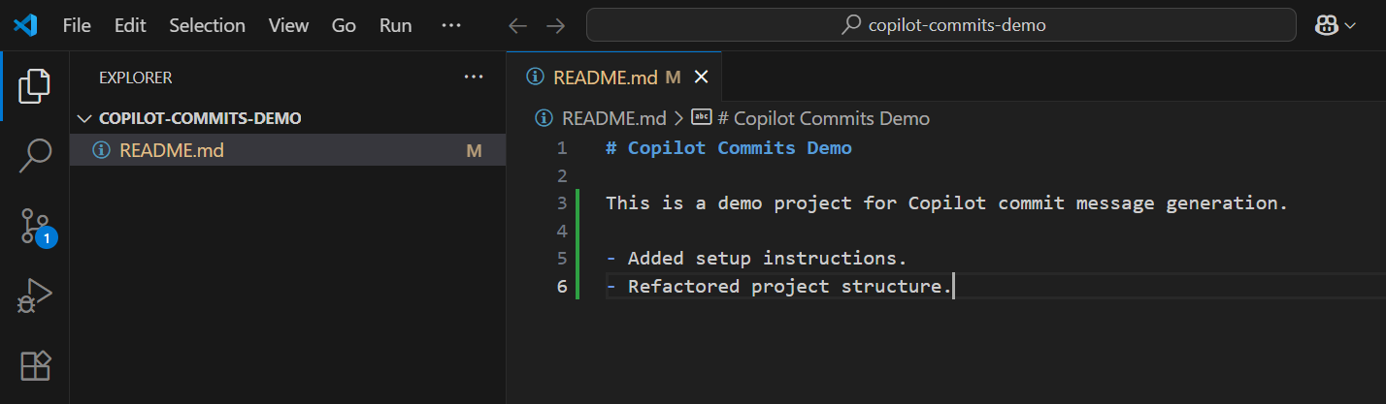

3. Save the file.

Step 3: Stage Your Changes

Copilot only provides suggestions for staged changes.

1. In VS Code, open the Source Control view (Ctrl+Shift+G).

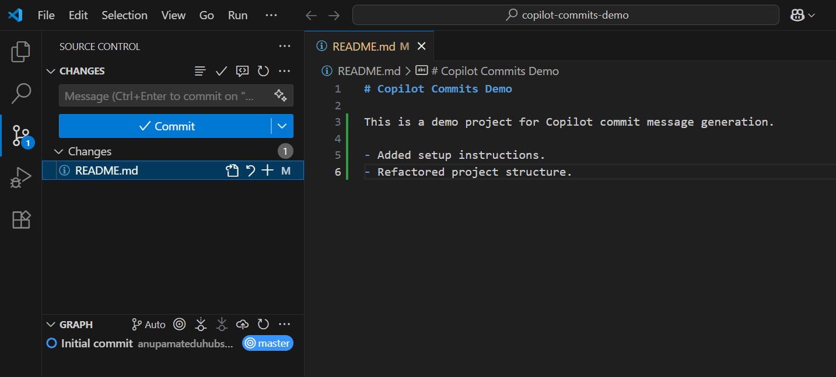

2. Stage your changes by clicking the "+" (Stage Changes) icon next to modified files, or use:

git add .

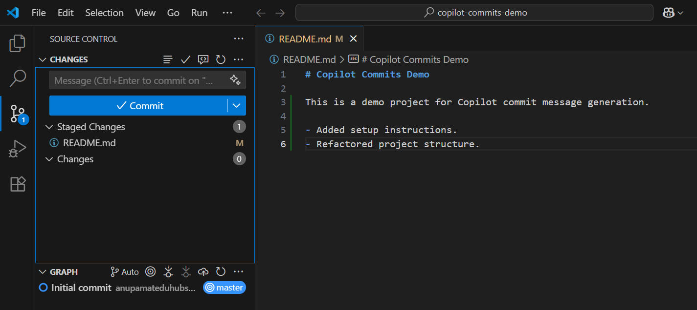

Step 4: Generate Commit Message with Copilot

Initiate Copilot for message generation.

1. In the VS Code Source Control view, locate the Message (Ctrl+Enter to commit) input box.

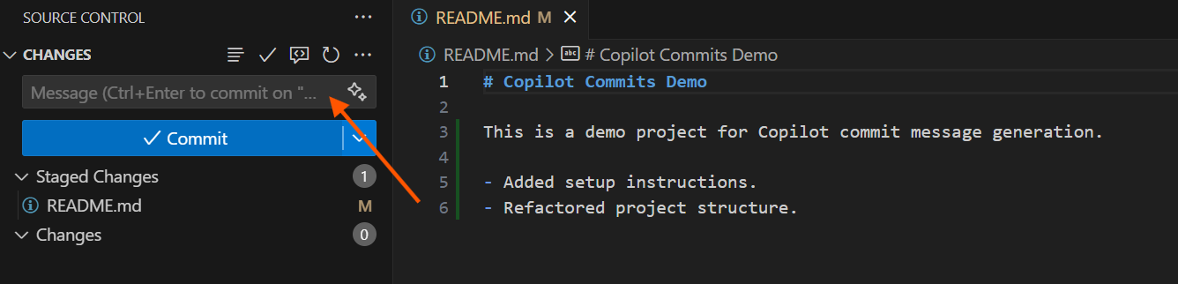

2. Click the Copilot icon or Generate Commit Message button near the message box.

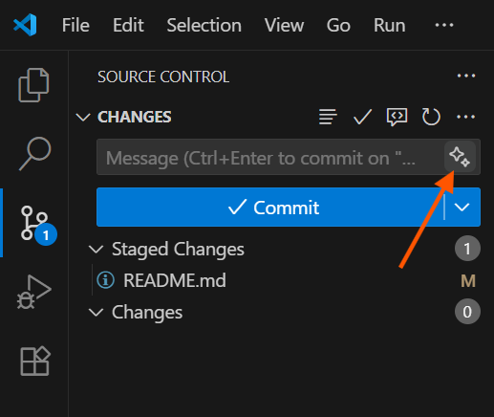

Copilot will analyze staged changes and present message suggestions.

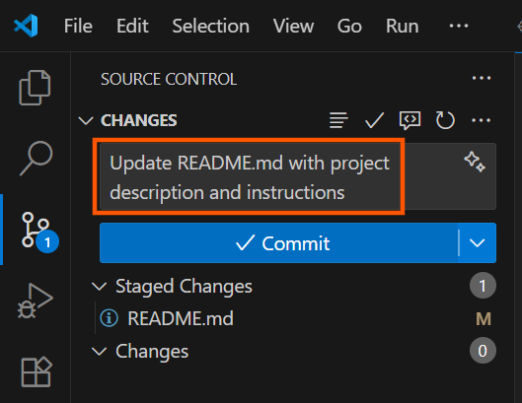

Step 5: Commit Your Changes

Finalize the commit with the Copilot-generated message.

1. The Copilot-generated message will be in the input box.



2. Click the Commit button in the Source Control view, or press Ctrl+Enter.

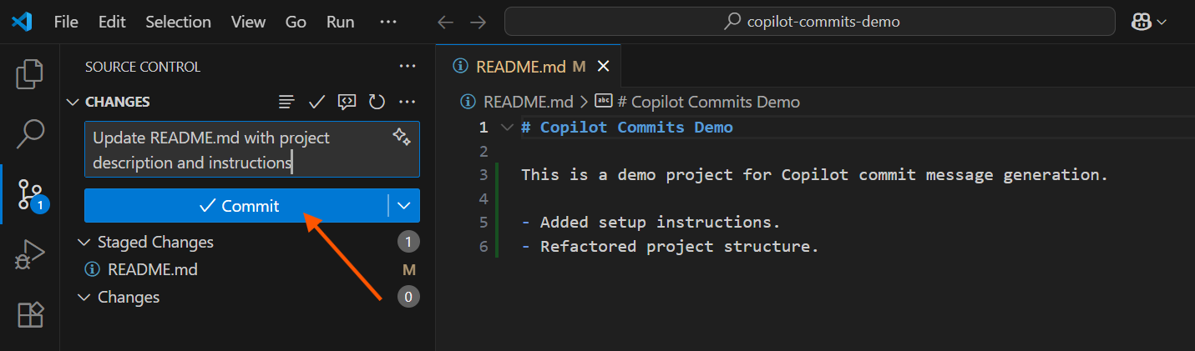

3. Verify the commit:

git log --oneline -1

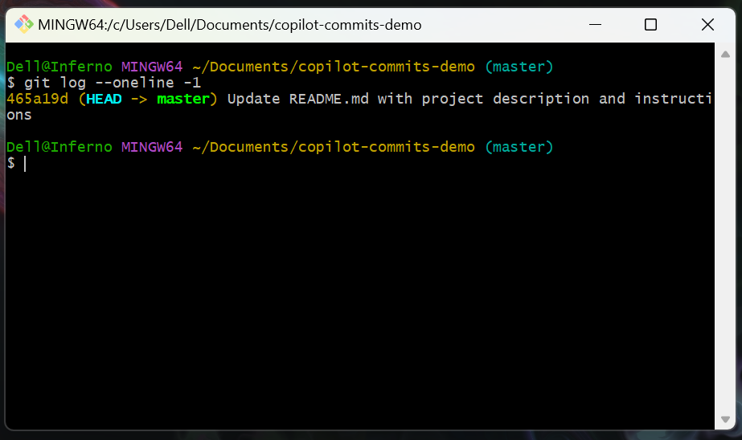

Step 6: Experiment and Best Practices

- Review Suggestions: Always verify generated messages for accuracy and relevance.
- Refine as Needed: Edit suggestions to fit team conventions or improve clarity.
- Meaningful Changes: Better code changes lead to better message suggestions.

Topics Covered:

- Git Commit Message Importance: Understanding the value of good commit hygiene.
- GitHub Copilot Role: How AI can assist in developer workflows.
- Copilot Commit Message Generation: Practical application of Copilot for commits.
- VS Code Source Control Integration: Utilizing VS Code's built-in Git features with extensions.
- Staging Changes: The prerequisite for Copilot's analysis.
- Review and Refinement: Best practices for using AI-generated content.

