Create and Manage Pull Requests

Problem Statement:

In collaborative software development, safely integrating new code into the main project requires a process of review and approval. Pull Requests (PRs) on GitHub provide a structured way for developers to propose changes, discuss them with teammates, and get feedback before the code is merged.

This hands-on exercise will guide you through the essential steps of creating a Pull Request on GitHub, making a small change, pushing it, and then merging the PR.

Steps:

Before you begin, ensure you have completed the following prerequisites:

- A GitHub Account.
- A GitHub Organization and a private repository set up within it.
- Git for Windows installed and configured.
- Git Bash for command-line operations.

We will primarily use Git Bash for minimal local Git operations and the GitHub website for the core Pull Request creation and management.

Step 1: Clone Your Repository Locally

To work on your project, you first need a local copy of your GitHub repository.

Cloning downloads the entire repository, including its history, to your local machine, allowing you to work on files without being connected to the internet and to manage your changes locally before pushing them.

1. Navigate to Your Repository on GitHub:

Open your web browser and go to your private repository on GitHub.

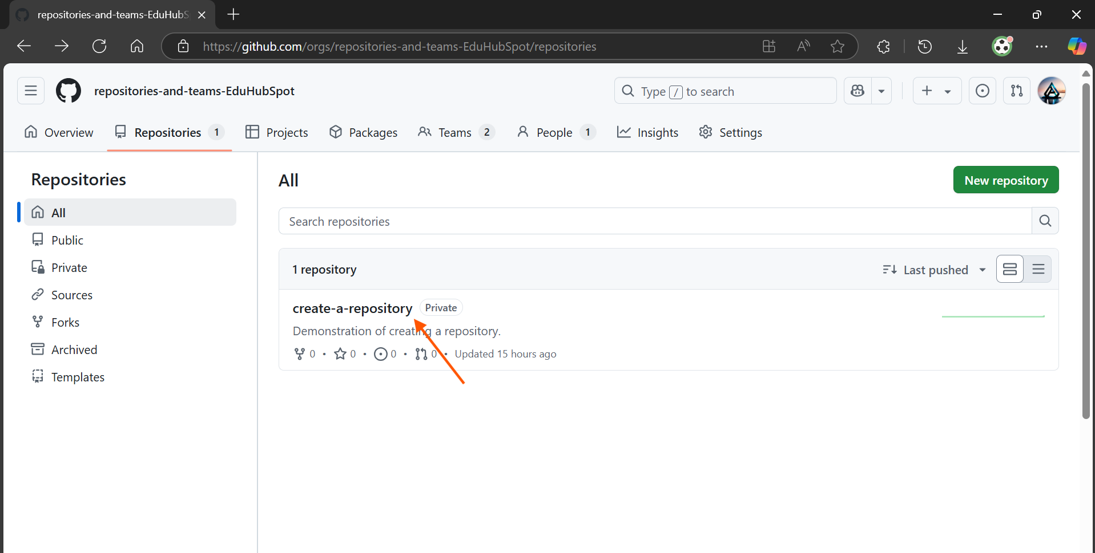

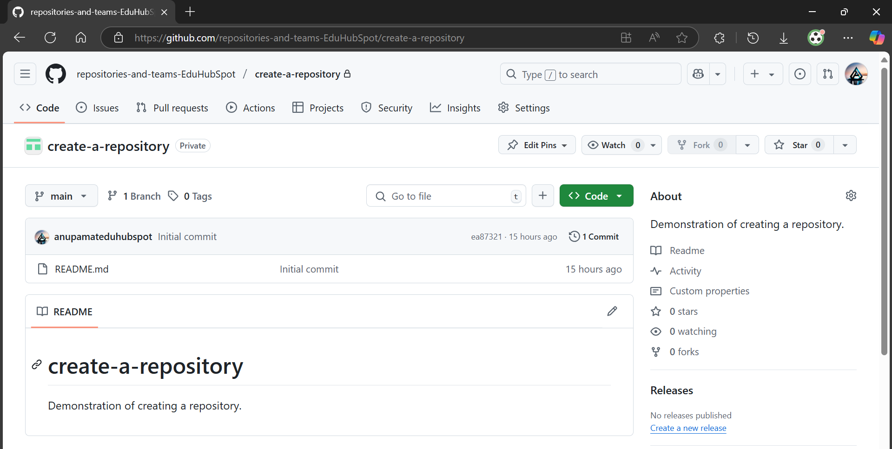

Click the green <> Code button.

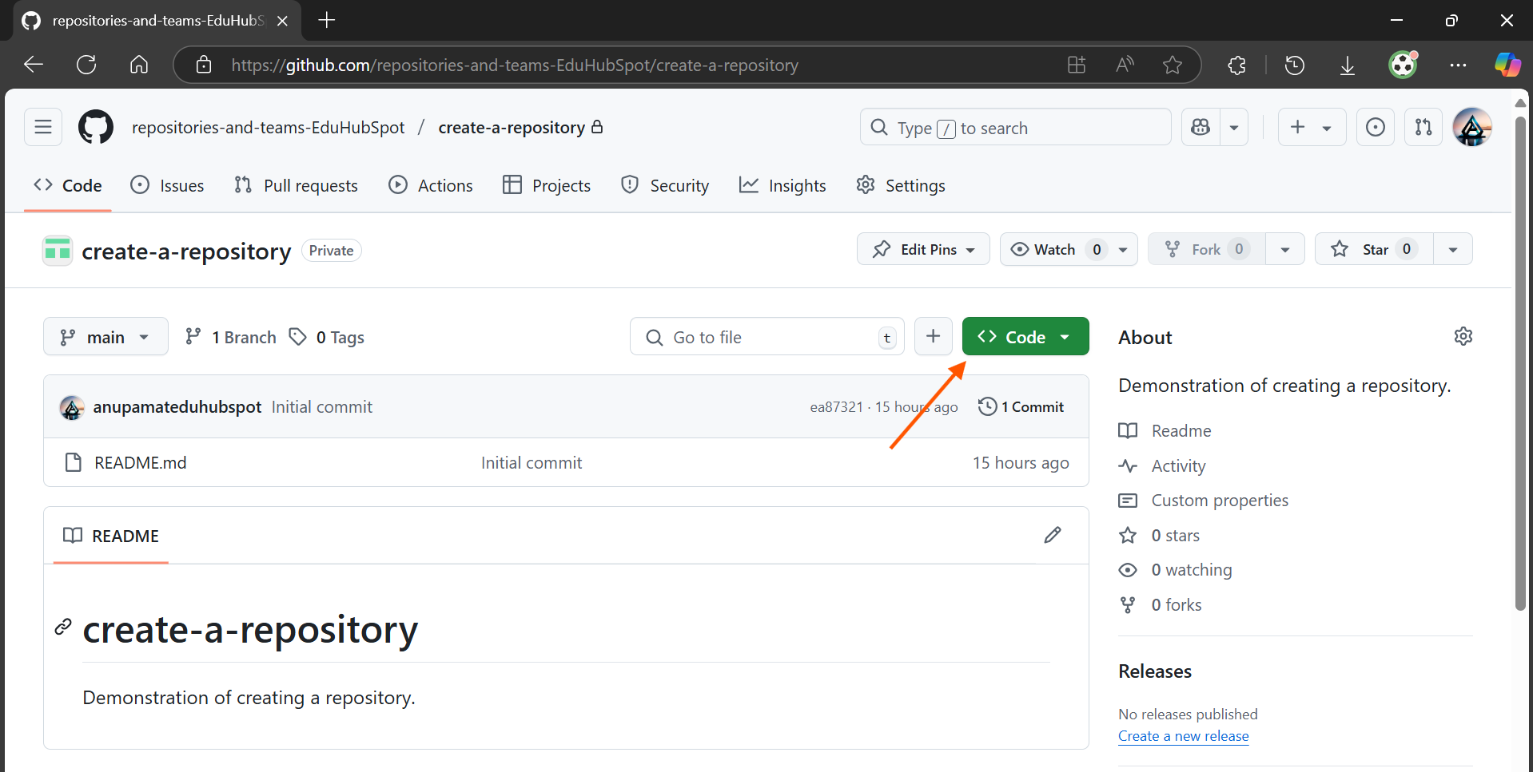

2. Choose Your Cloning Method:

You'll see options for HTTPS and SSH.

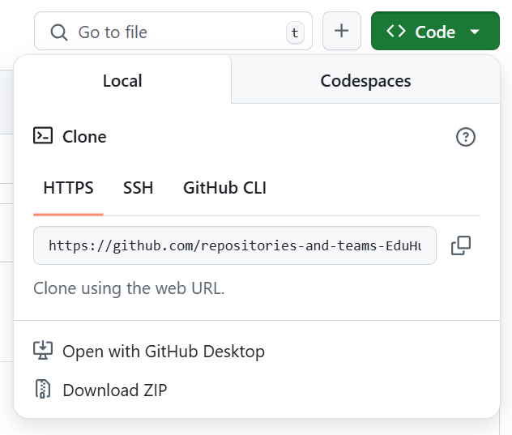

If you set up SSH keys in the prerequisites, click on the SSH tab and copy the URL.

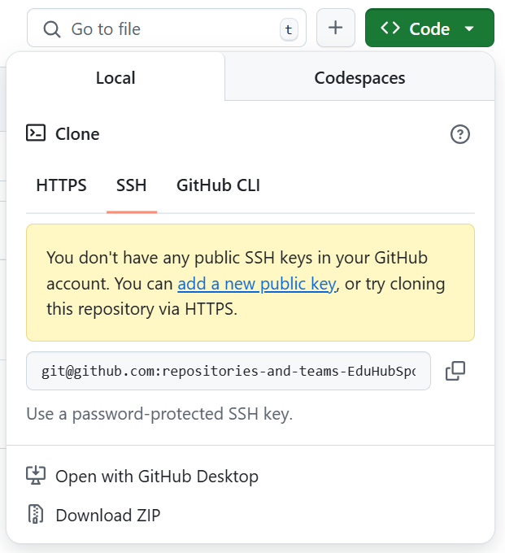

If you did not set up SSH keys, click on the HTTPS tab and copy the URL.

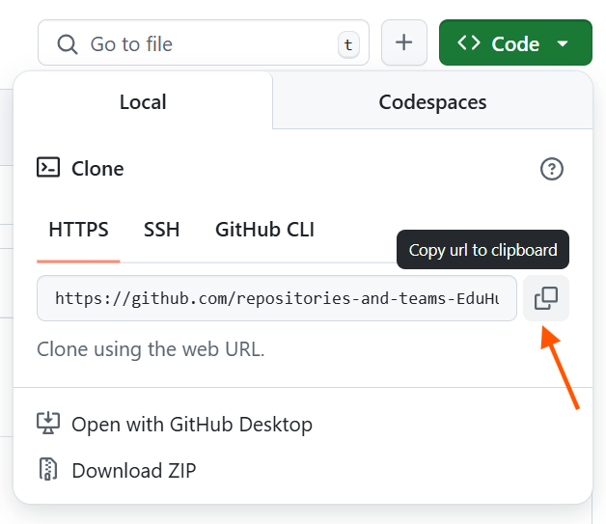

3. Open Git Bash:

Search for Git Bash in your Windows Start Menu and open it.

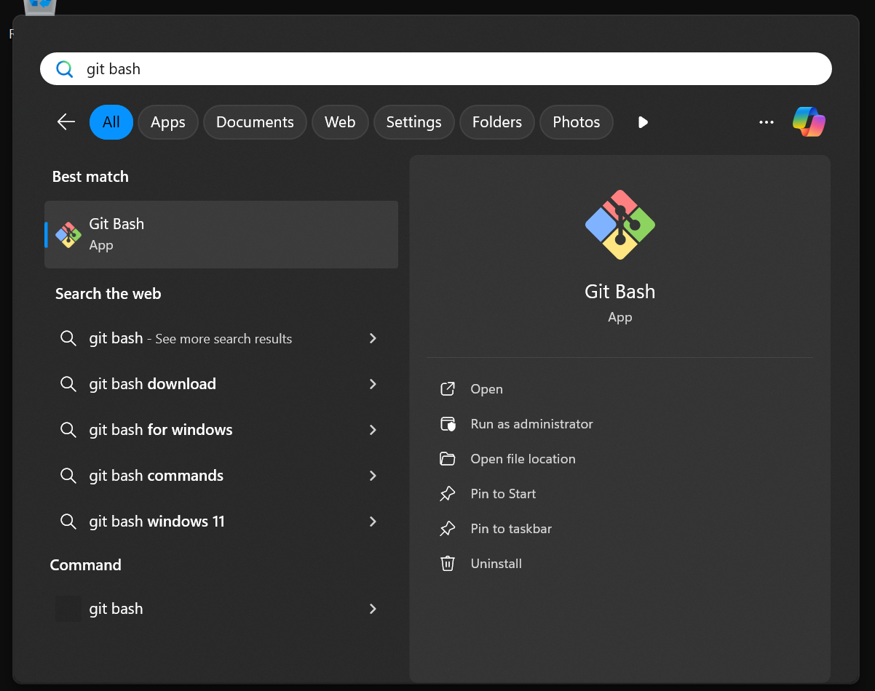

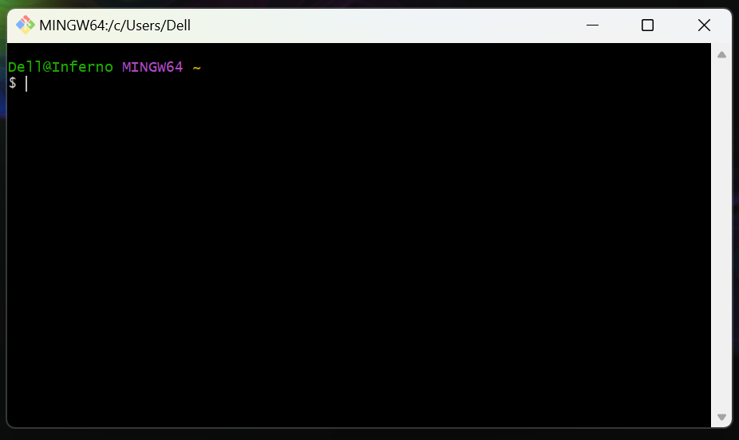

4. Navigate to Your Desired Local Directory:

Use cd command to go to where you want to store your project. For example, to go to your Documents folder:

cd /c/Users/YourWindowsUsername/Documents/

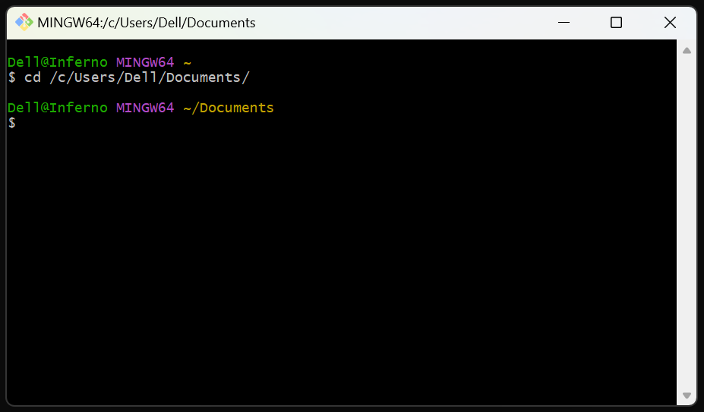

Replace YourWindowsUsername with your actual Windows username.

You can create a new folder for your GitHub projects:

mkdir github-projects
cd github-projects

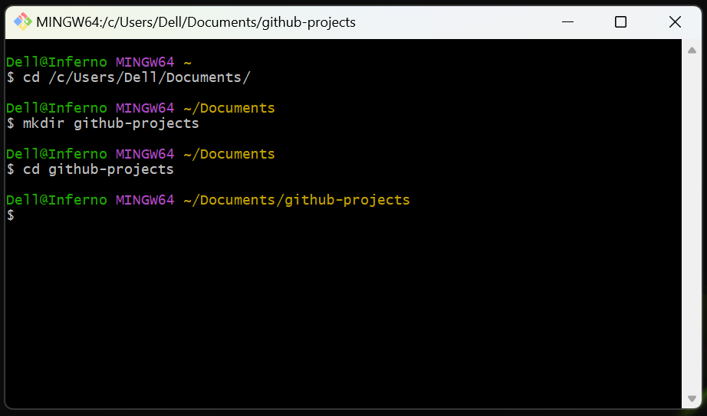

5. Clone the Repository:

Type git clone followed by the URL you copied from GitHub.

Using SSH:

git clone git@github.com:repositories-and-teams-EduHubSpot/create-a-repository.git

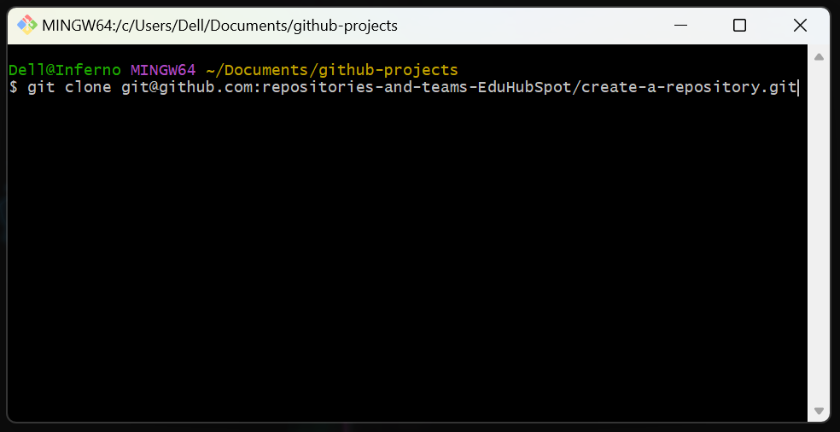

Using HTTPS:

git clone https://github.com/repositories-and-teams-EduHubSpot/create-a-repository.git

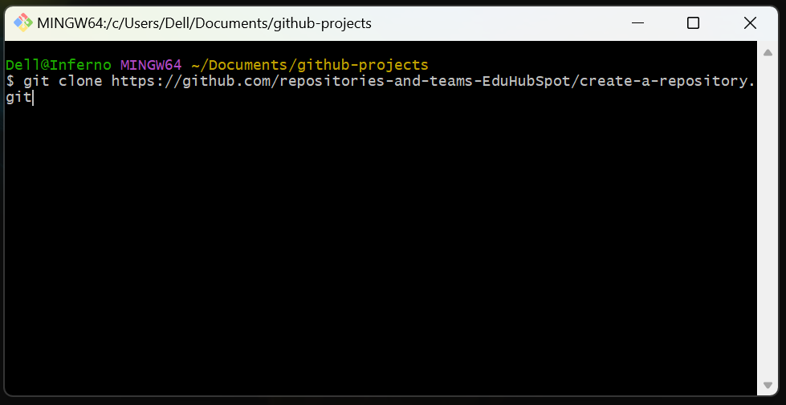

Press Enter.

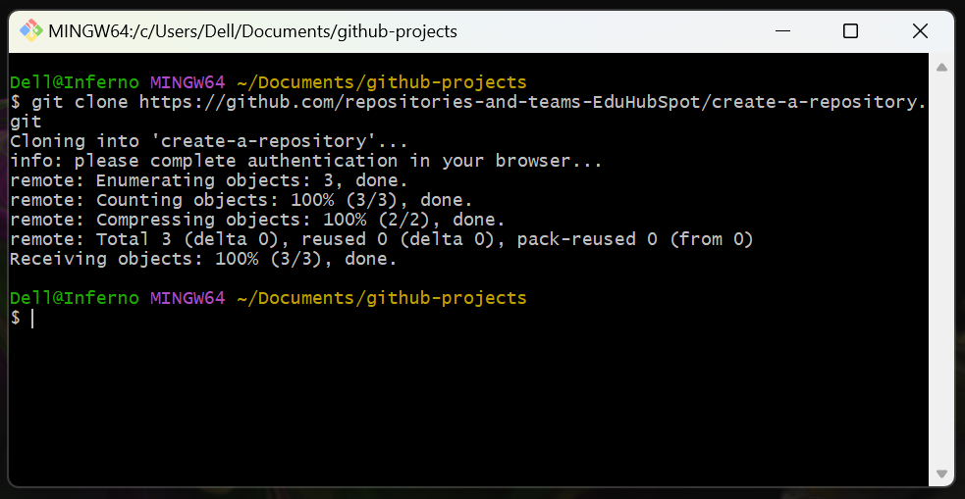

- If using SSH for the first time: You might be asked to confirm the authenticity of the host. Type yes and press Enter.
- If using HTTPS: The Git Credential Manager Core will likely handle authentication automatically the first time you push/pull, prompting you to log in via a web browser if needed.

6. Navigate into the Cloned Repository:

Once cloning is complete, change your directory into the newly cloned repository folder:

cd create-a-repository

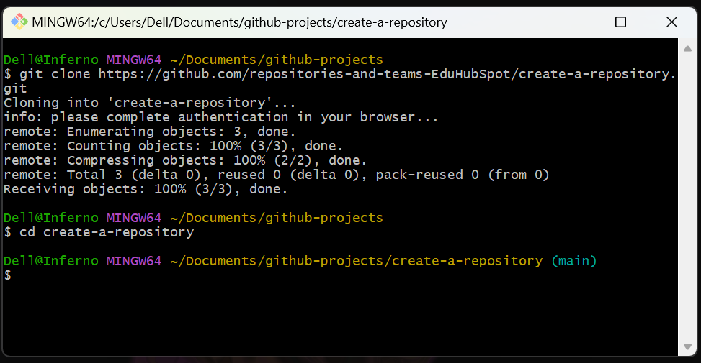

Step 2: Create a Feature Branch, Make a Small Change, and Push

We'll quickly create a new branch, add a minor change, and push it to GitHub. This will be the basis for our Pull Request.

All changes for a Pull Request originate from a dedicated feature branch. This keeps the primary branch clean and allows for isolated development and review.

1. Ensure Your Primary Branch is Up-to-Date:

First, confirm which branch is your primary production branch.

In Git Bash, run git branch -a. Your primary branch is likely master or main.

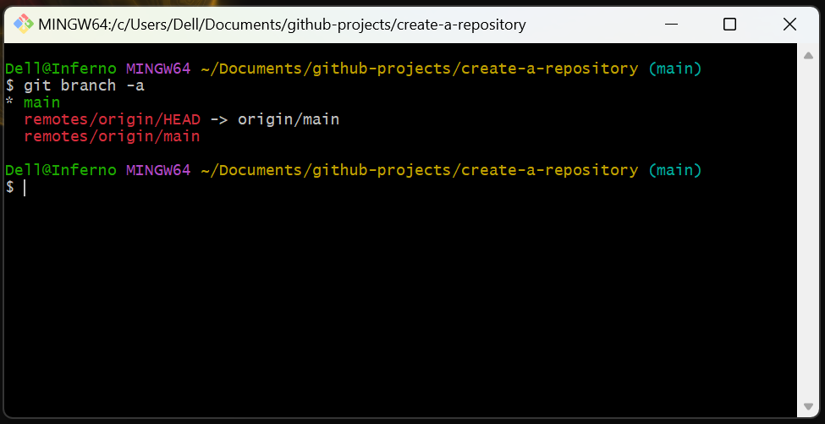

Switch to your primary branch and pull the latest changes:

git checkout main
git pull origin main

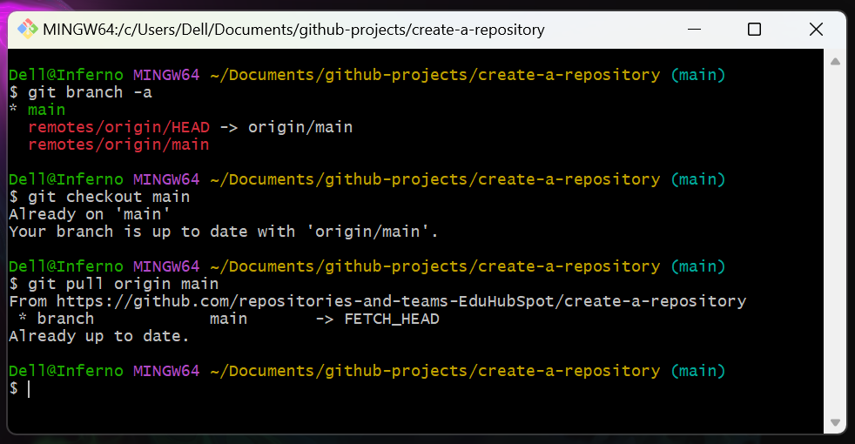

This synchronizes your local primary branch with the remote, so any new feature branch you create will be based on the latest code.

2. Create and Switch to a New Feature Branch:

Give it a simple, descriptive name:

git checkout -b feature/add-readme-update

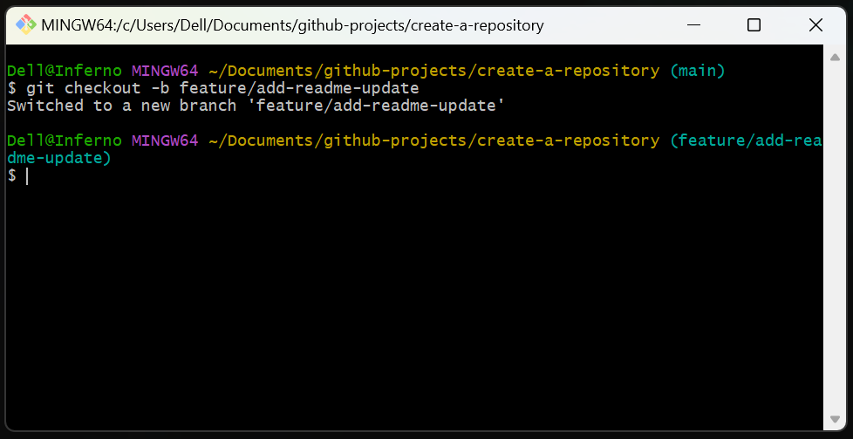

This command creates a new branch named feature/add-readme-update and immediately switches you to it.

3. Make a Small Change:

Open the README.md file in your repository’s folder using a text editor.

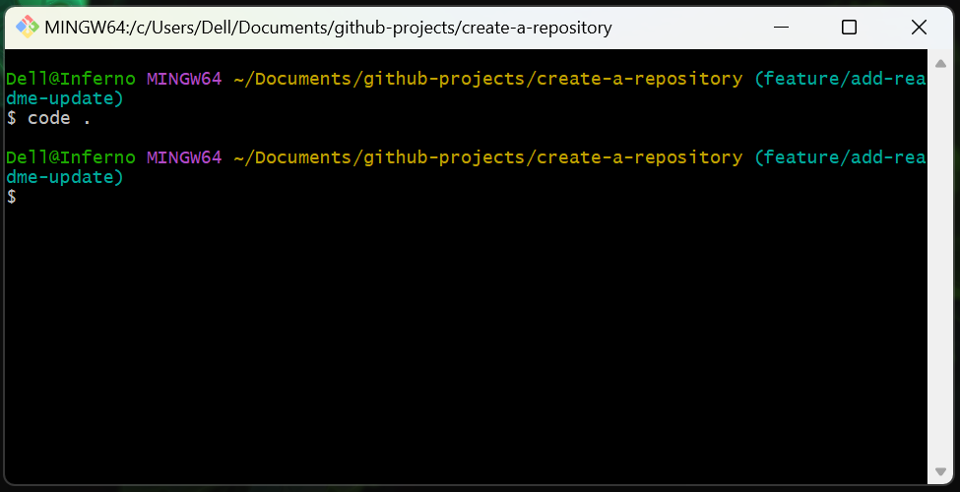

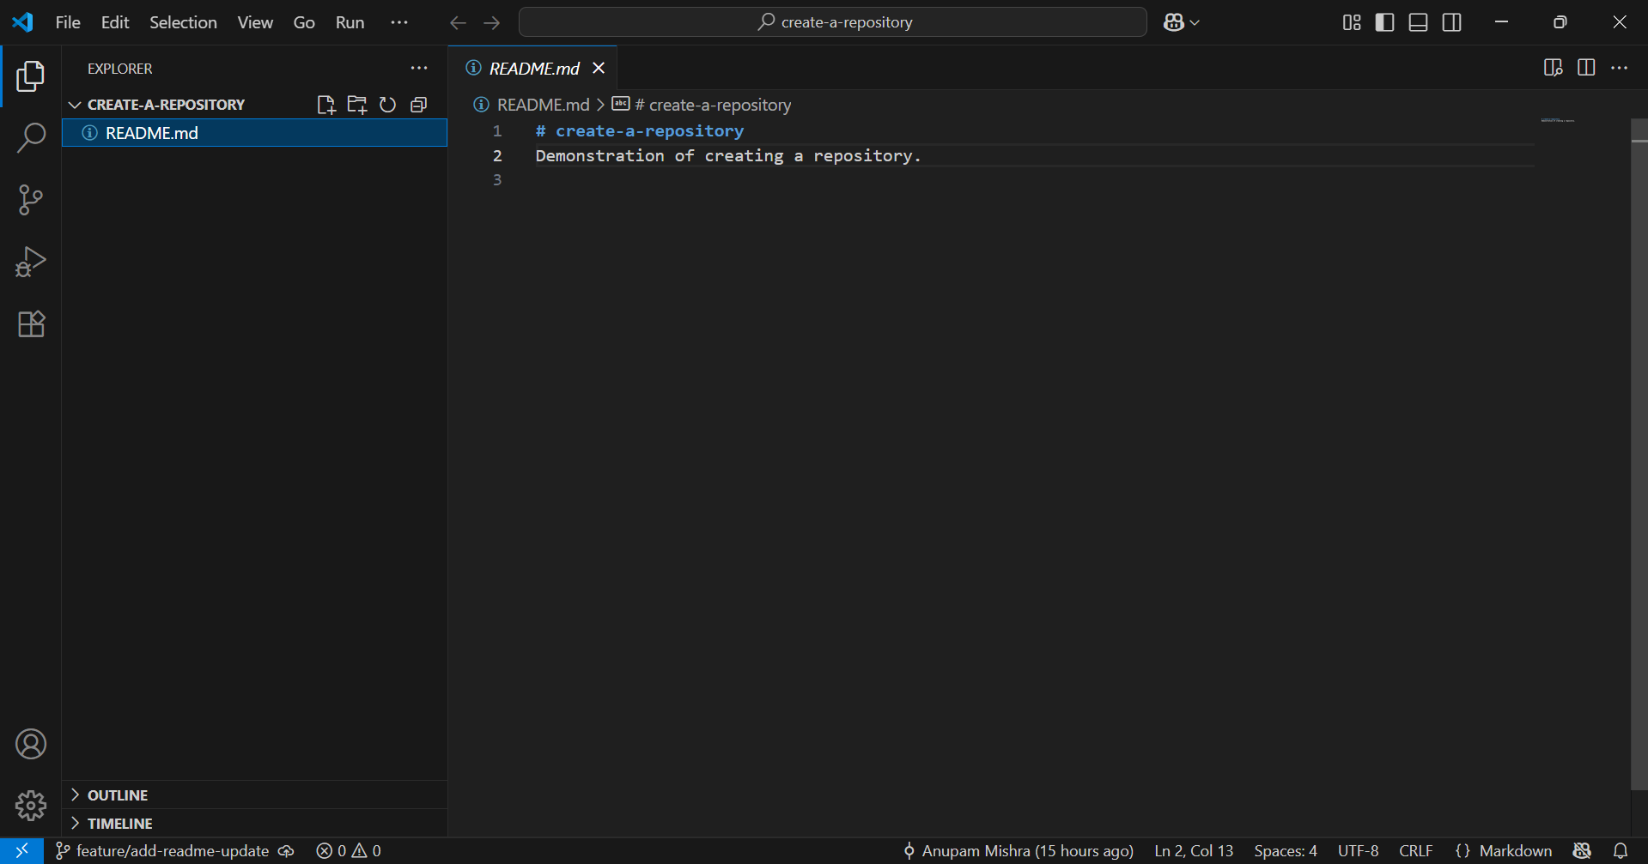

Add a new line at the end of the README.md file, for example:

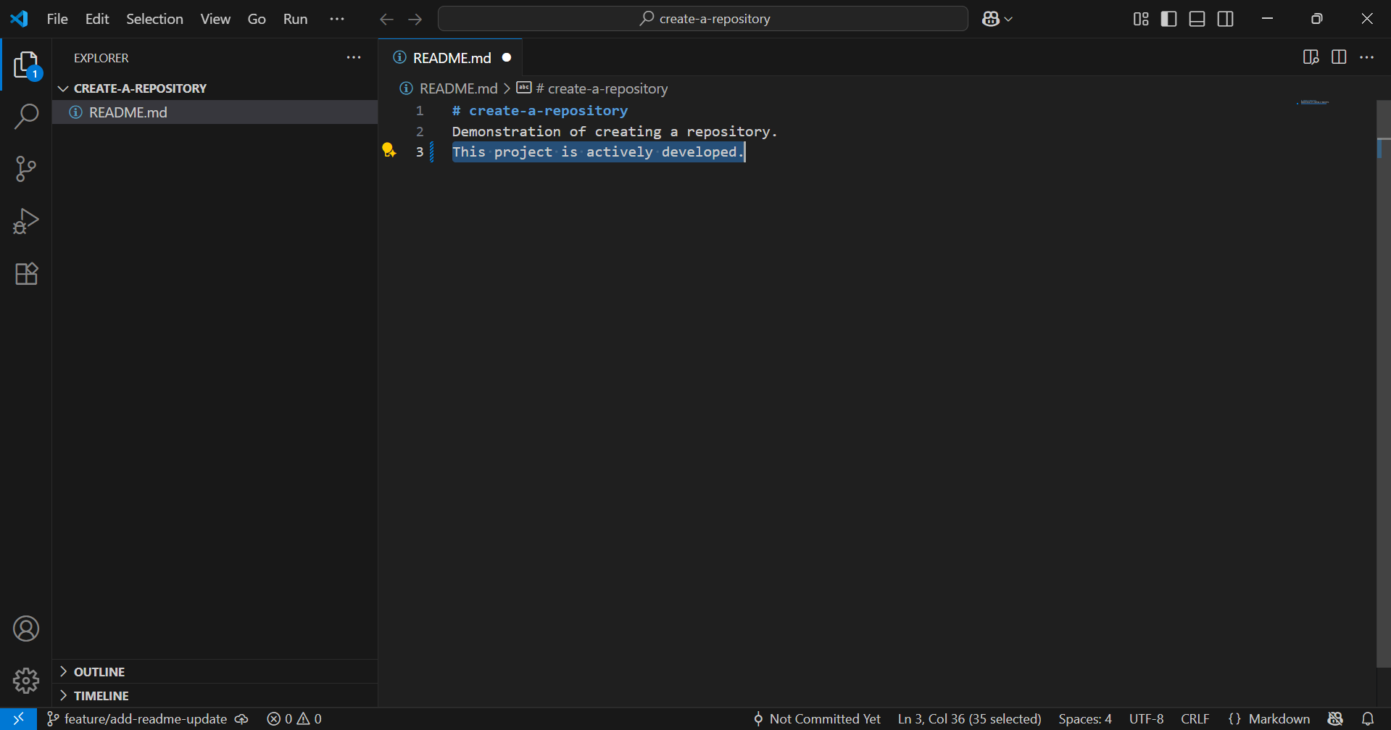

Save the file.

4. Stage and Commit Your Change:

In Git Bash, commit your change:

git add README.md
git commit -m "docs: Add active development note to README"

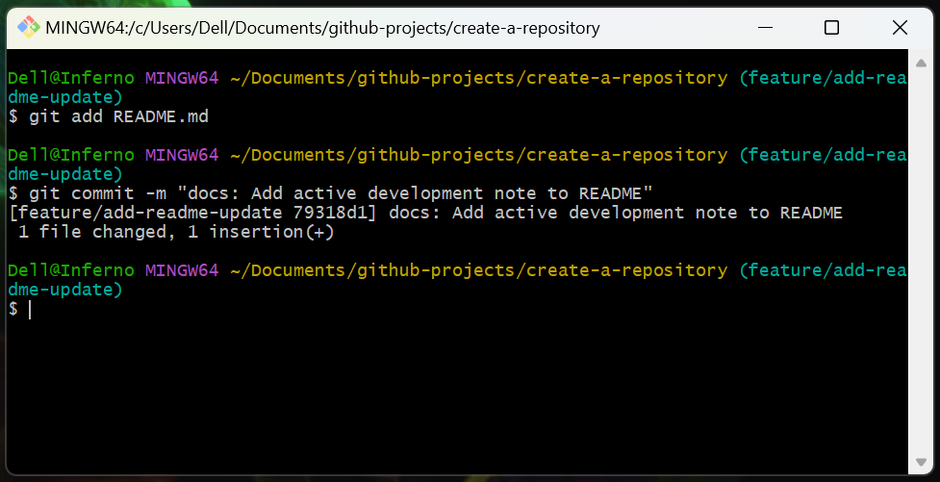

These commands track the change you made and save it as a snapshot in your branch's history.

5. Push Your Feature Branch to GitHub:

Send your local feature branch to the remote GitHub repository:

git push -u origin feature/add-readme-update

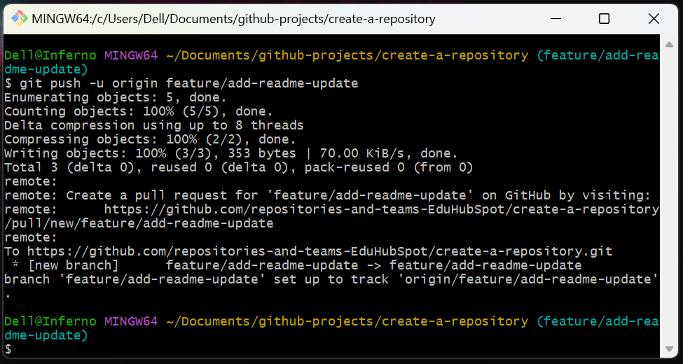

This makes your new branch and its changes visible on GitHub, allowing you to create a Pull Request from it.

Step 3: Create the Pull Request on GitHub

Now that your feature branch is on GitHub, you can formally propose its changes for review.

The Pull Request is the central mechanism for code review. It provides a dedicated interface on GitHub for discussion, code diffs, and integration.

1. Go to Your Repository on GitHub:

Open your web browser and go to your repository on GitHub.

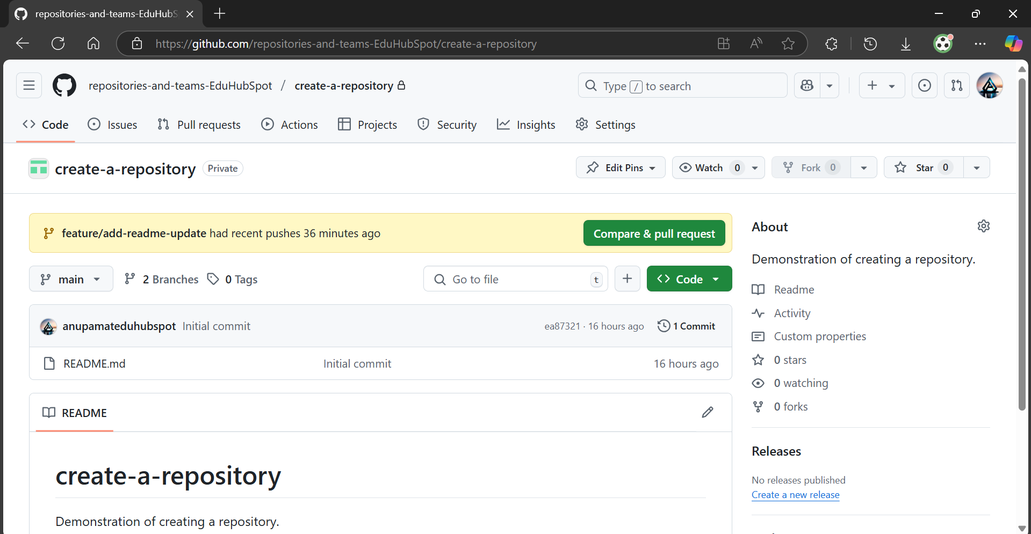

2. Initiate New Pull Request:

GitHub will often detect your recently pushed branch and display a prominent green button: Compare & pull request. Click this button.

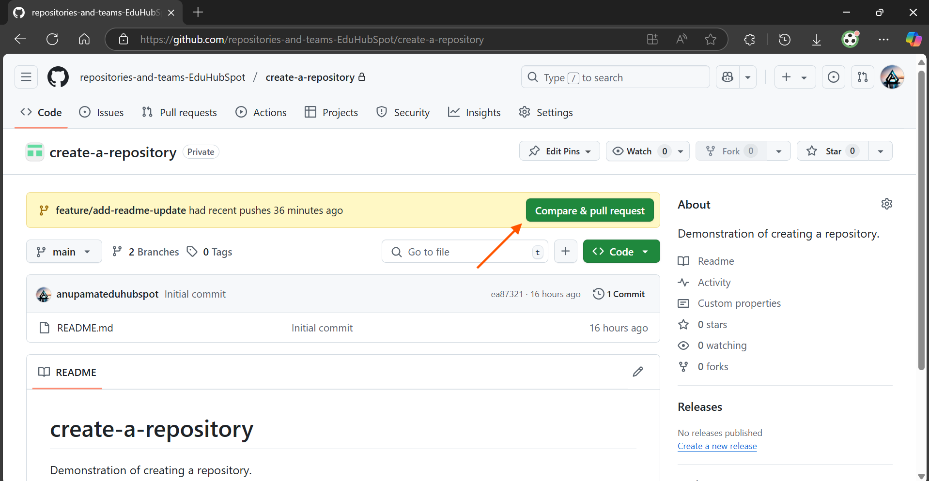

Alternatively, click on the Pull requests tab, then click the New pull request button.

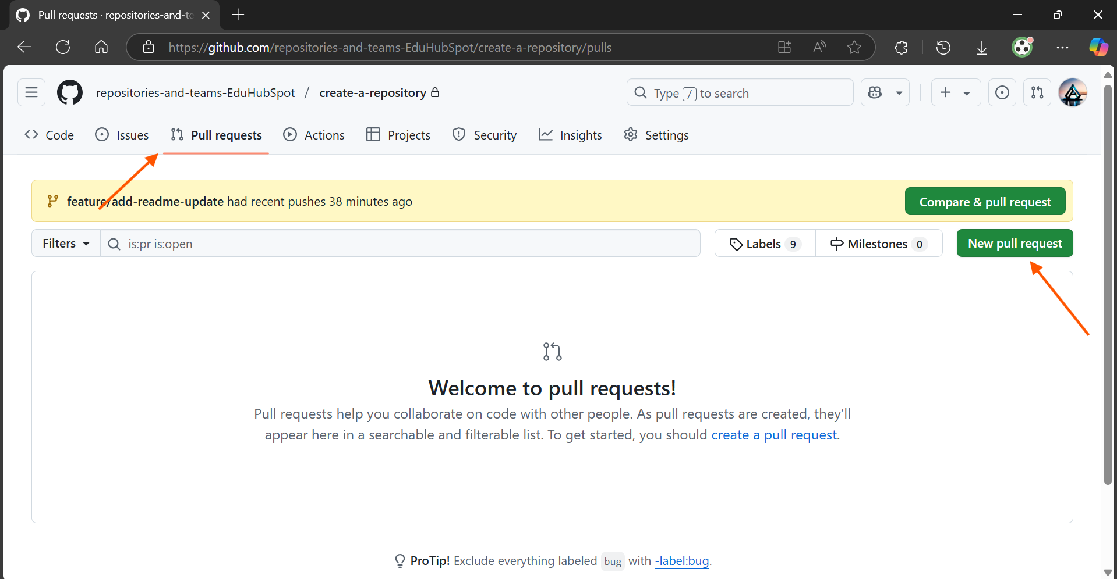

3. Configure the Pull Request:

Base vs. Compare Branches:

- Base: This is the branch you want to merge your changes into. Select your primary production branch here.
- Compare: This is your feature/add-readme-update branch.

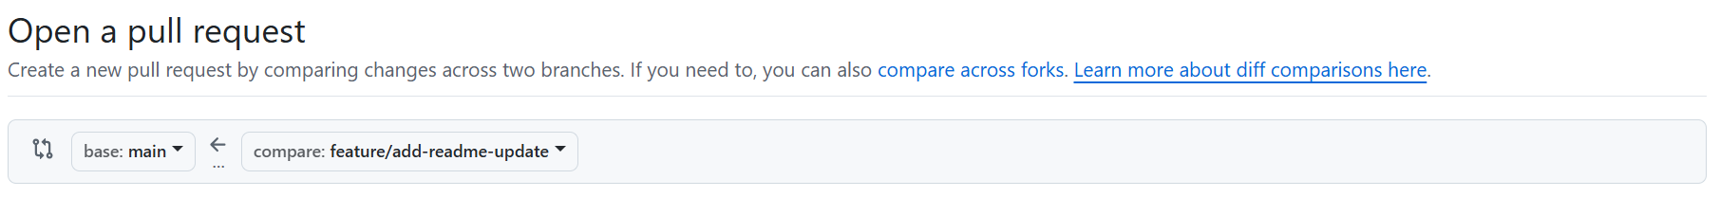

Title: A clear, concise title.

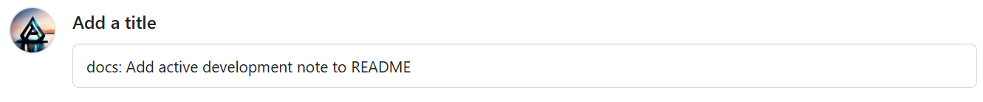

Description: Briefly explain the change.

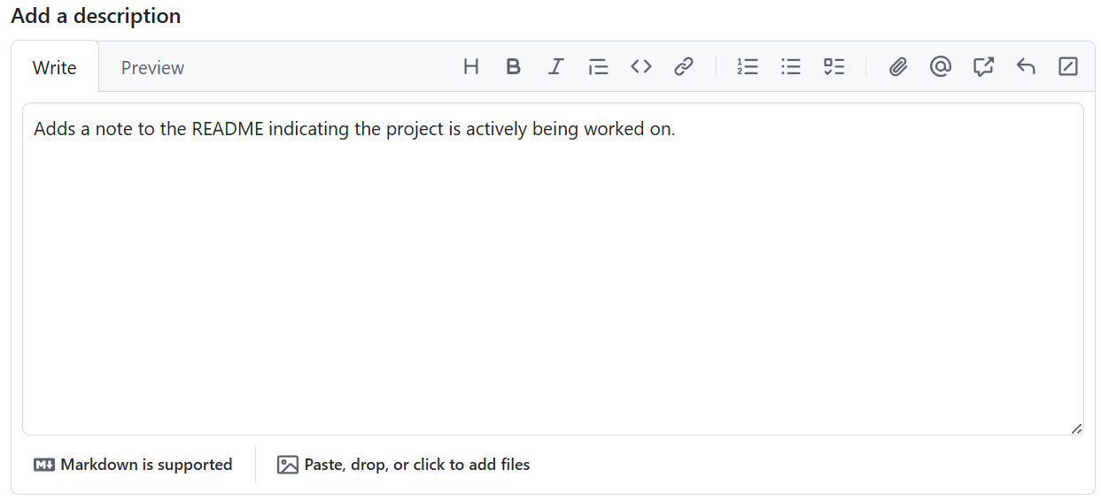

Click the green Create pull request button.

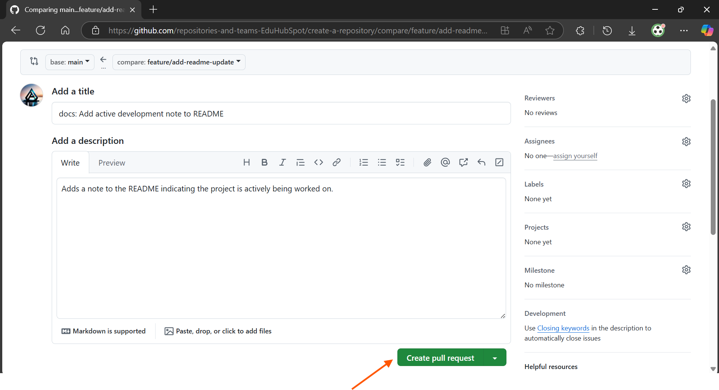

Step 4: Review and Merge the Pull Request

Once the Pull Request is open, you can review its changes and then merge it.

Reviewing ensures code quality and correctness. Merging integrates the approved changes into the main codebase.

1. Review the Changes:

On the Pull Request page, click the Files changed tab. Observe the side-by-side comparison showing your addition to README.md.

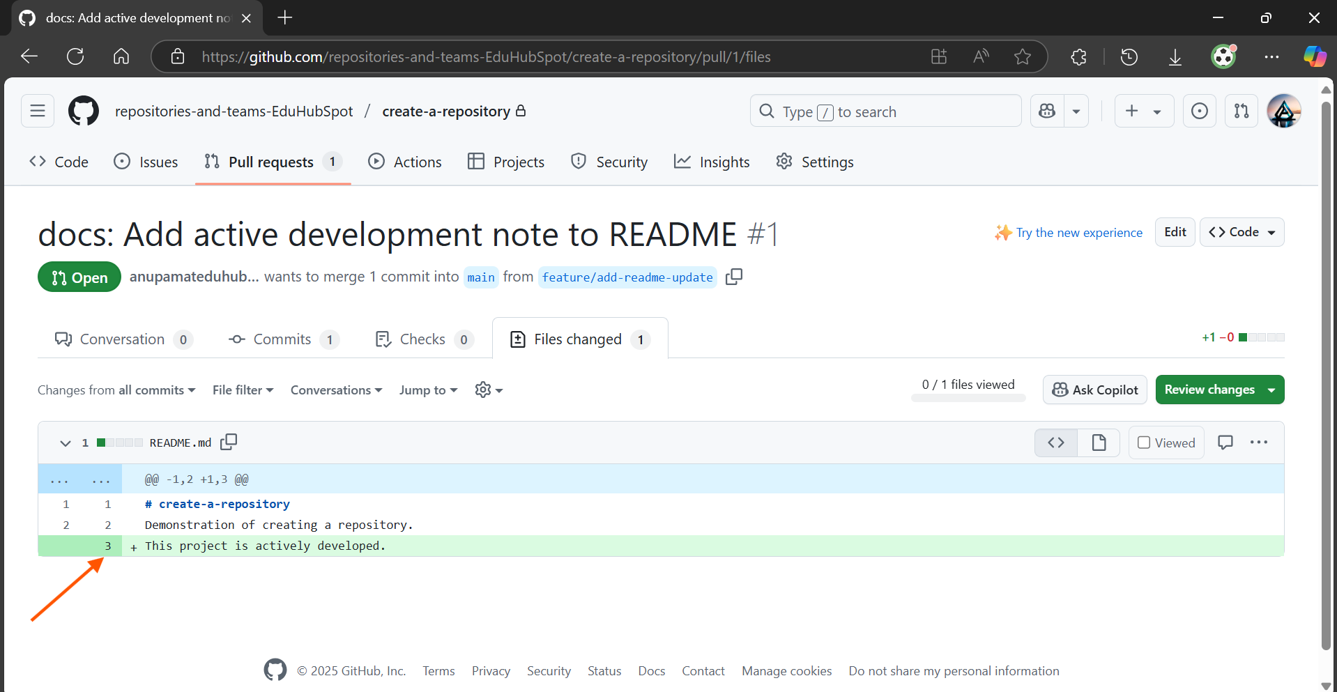

After reviewing the changes, look for the green Review changes button, typically found at the top right of the Files changed tab. Click the Review changes button.

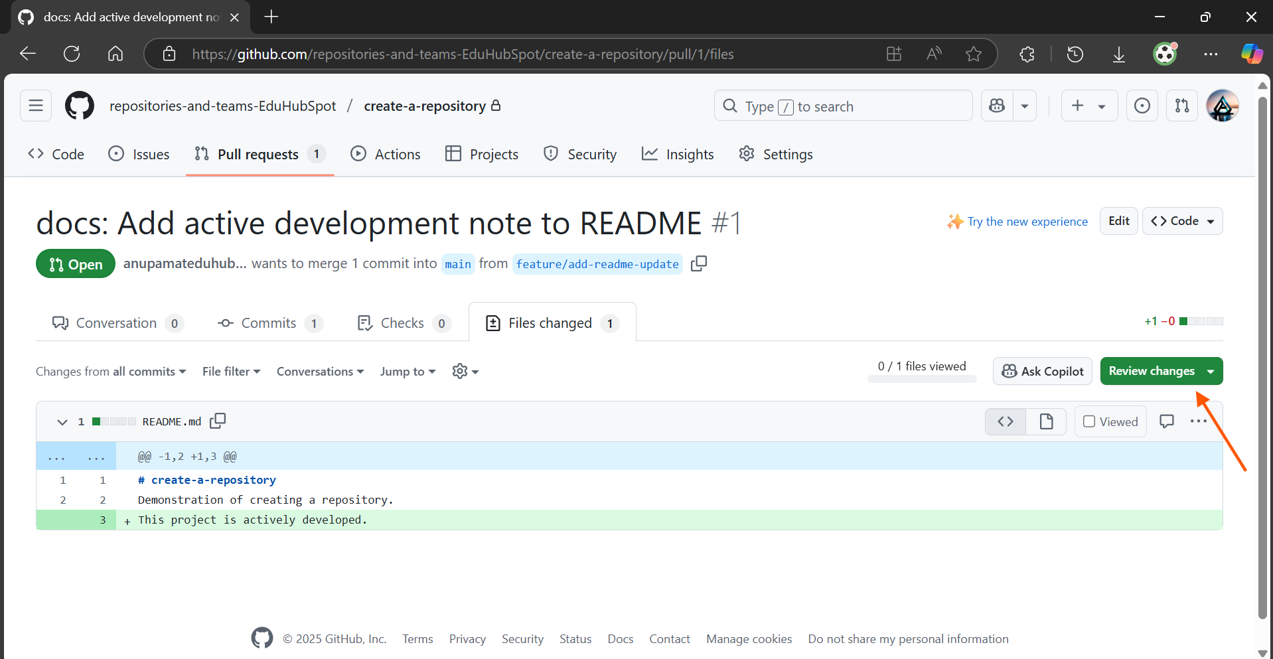

Add a comment like Looks good, ready to merge! and select Comment.

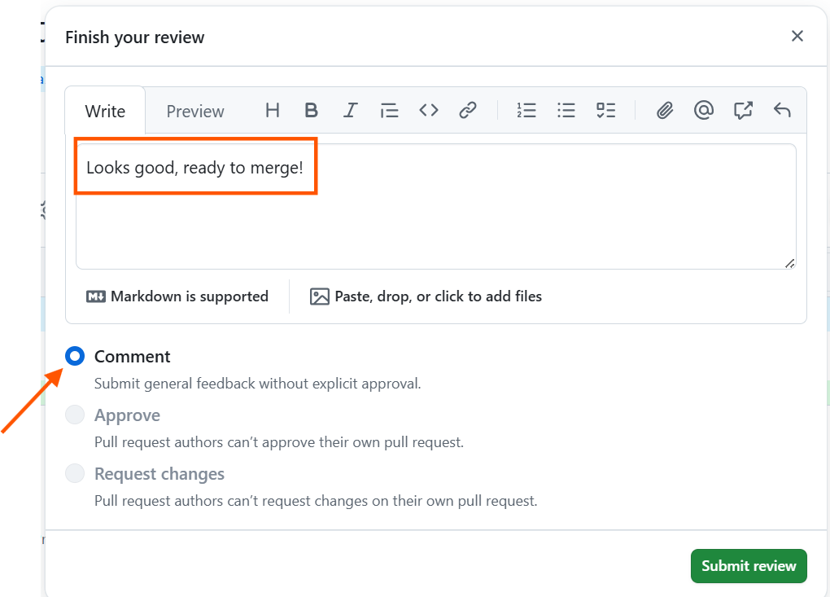

Click Submit review.

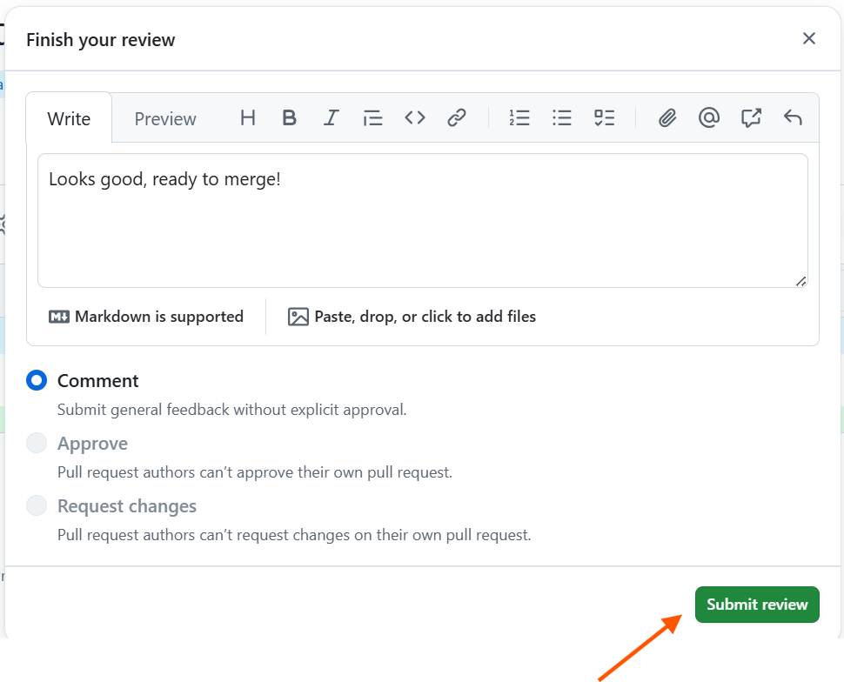

In a real team setting, another developer would now review your code, potentially add line-specific comments, and then formally Approve or Request changes on your PR.

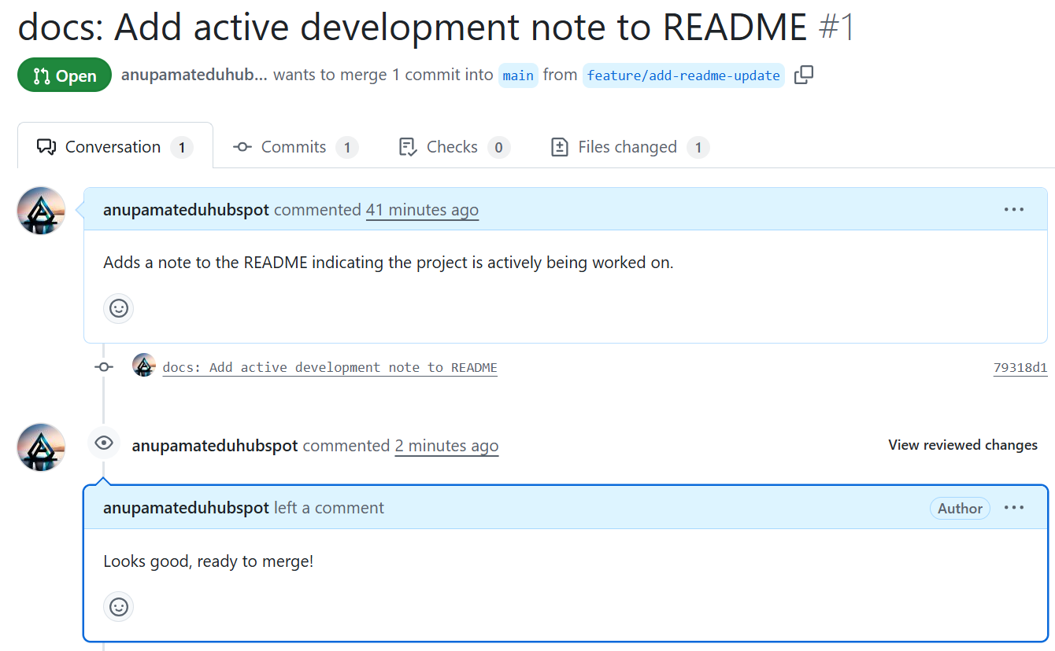

2. Merge the Pull Request:

In a real-world scenario, you would now wait for another team member to review and formally Approve your Pull Request. Only after an approval would you typically merge.

For the purpose of this hands-on, we will proceed directly to merging, simulating that an approval has been given by a team member.

Locate the green Merge pull request button on the Conversation tab.

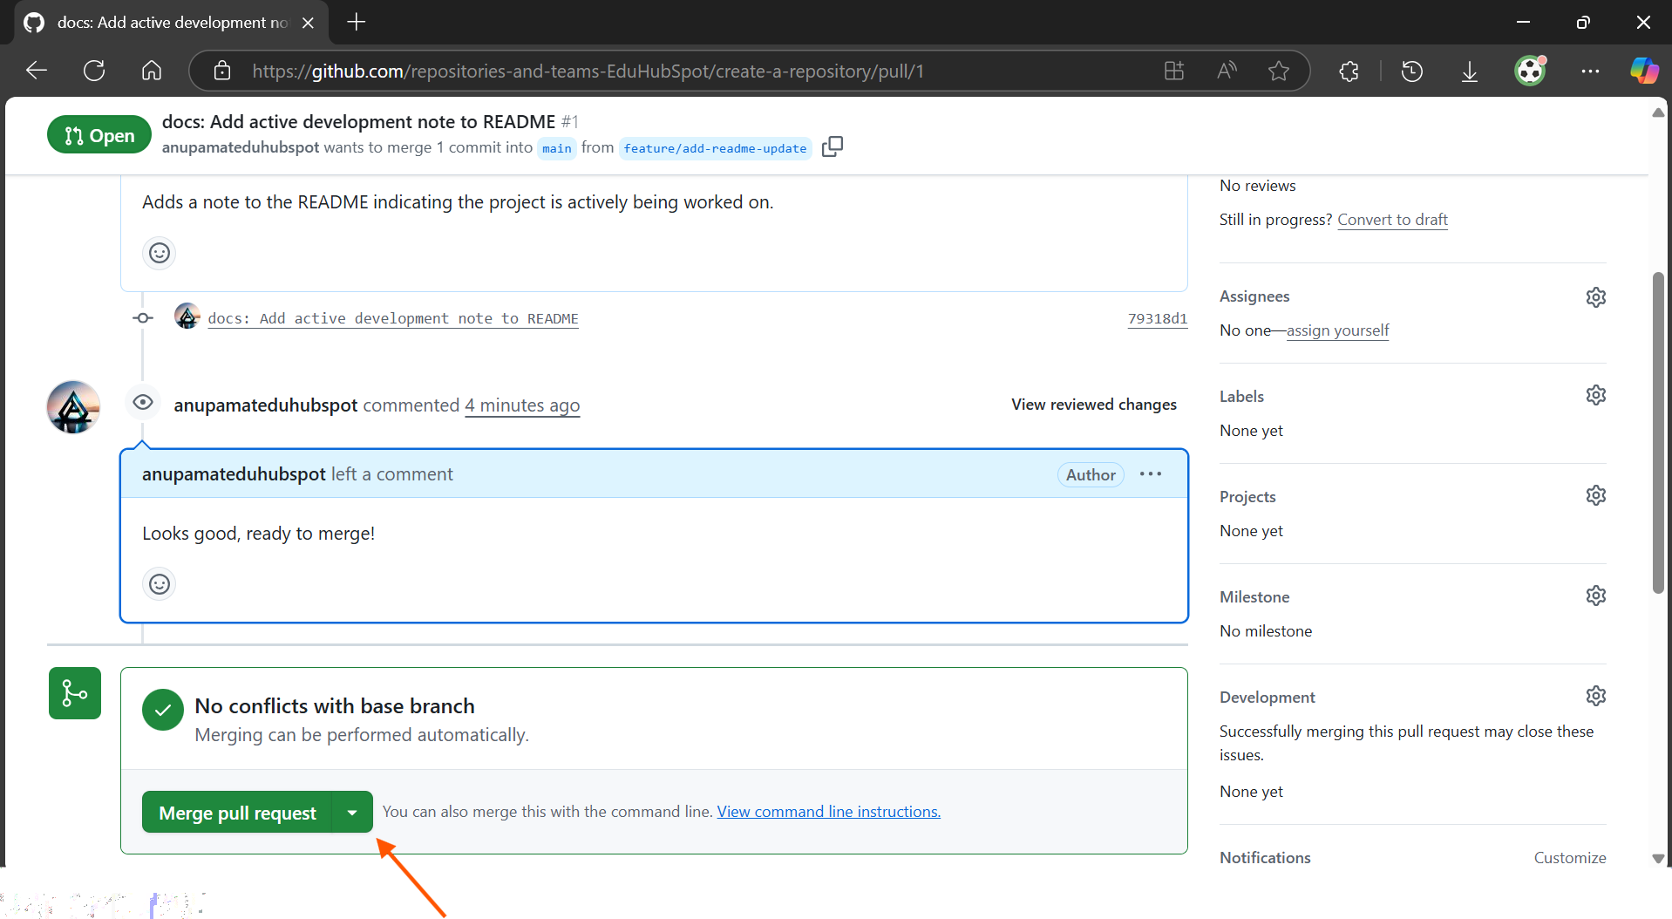

Note: This button will be enabled once a formal approval is given or if the repository settings allow merging without approval, which we are simulating here for the exercise.

Click the green Merge pull request button.

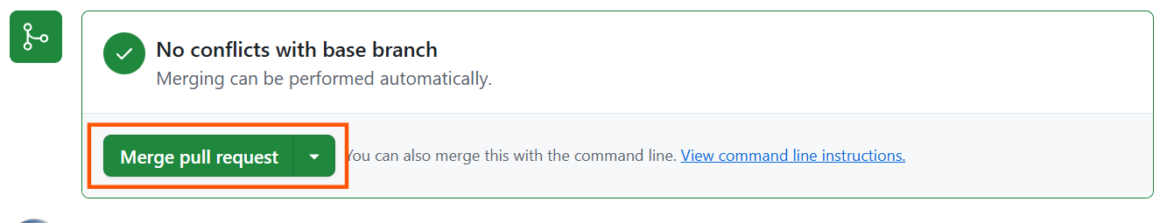

For this hands-on, accept the default merge option: Create a merge commit.

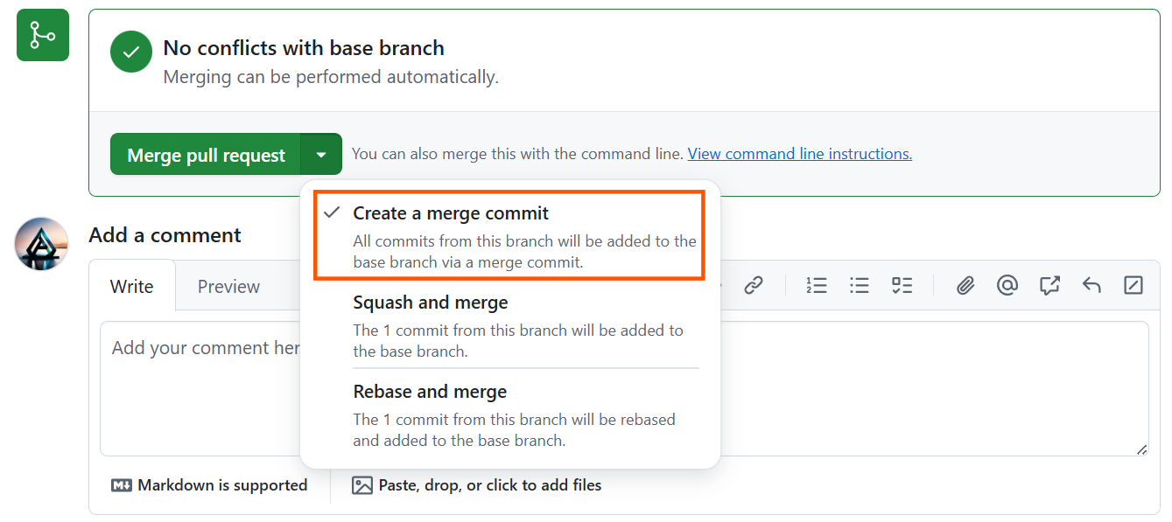

Confirm the default merge message or customize it.
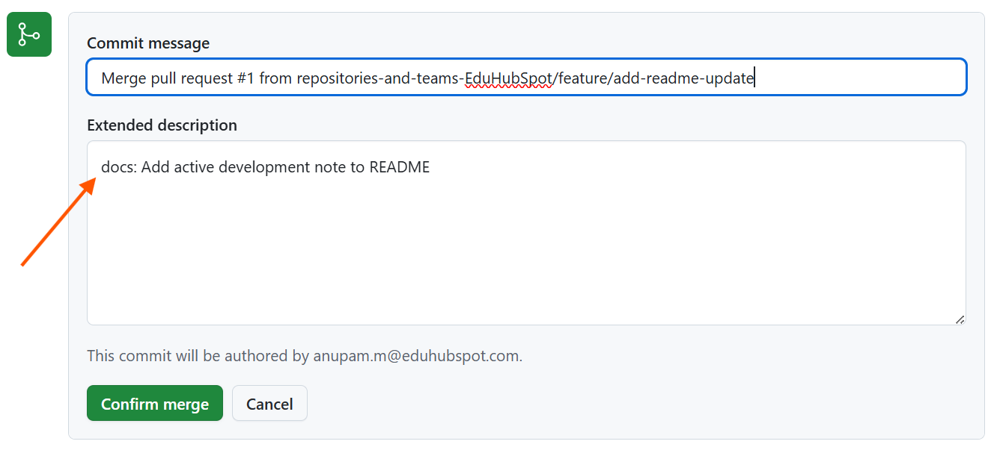
Click the green Confirm merge button.

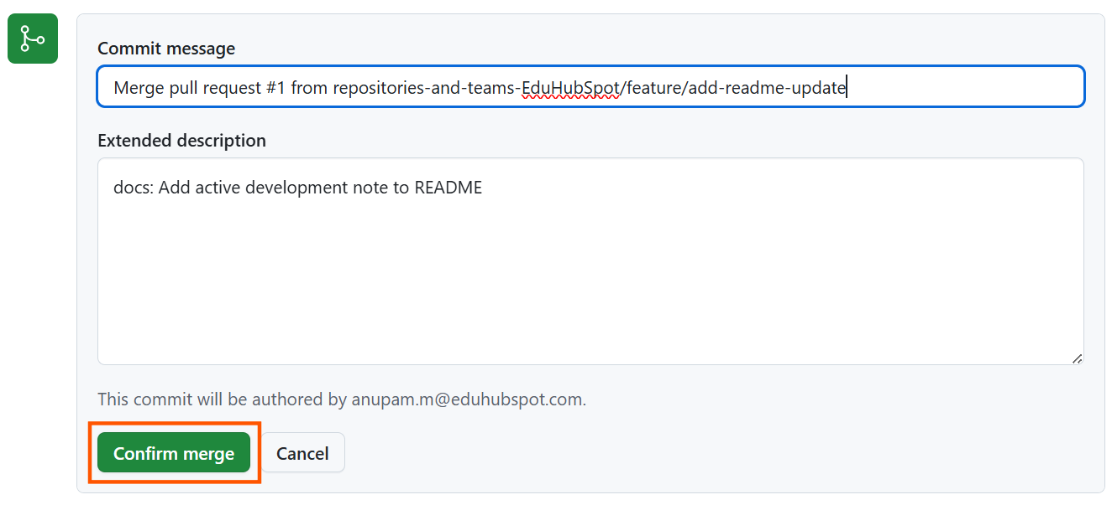

Create a merge commit preserves the history of your feature branch, making it clear when and how your changes were integrated.

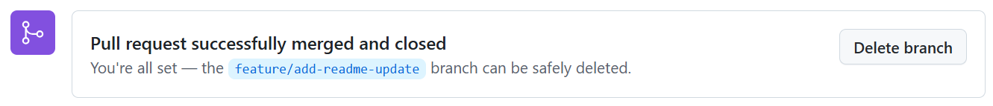

3. Delete the Feature Branch on GitHub:

After a successful merge, GitHub will present a button Delete branch. Click this button.

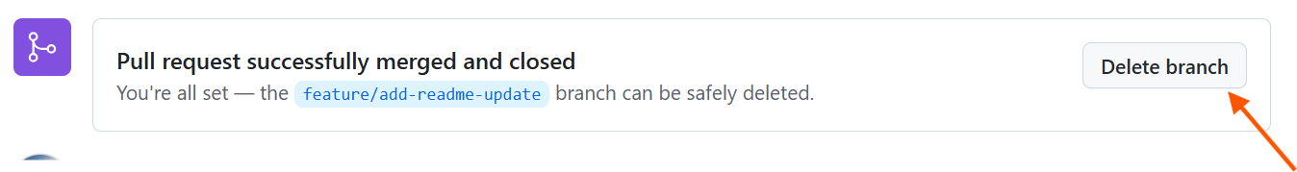

Once a branch is merged, it's typically no longer needed. Deleting it keeps your repository tidy and organized.

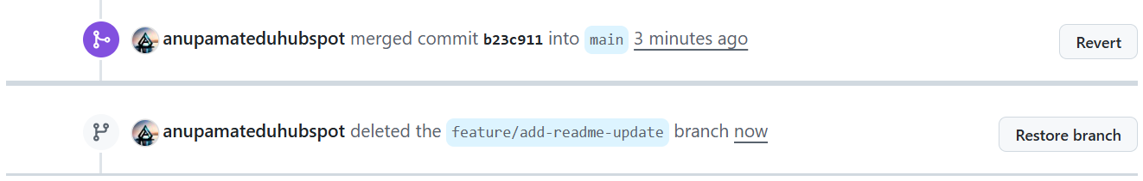

Topics Covered:

- Repository Synchronization: Ensuring local branch is up-to-date (git pull).
- Feature Branching: Creating a new branch for isolated work (git checkout -b).
- Local Commits: Staging and saving changes (git add, git commit).
- Pushing Branches: Sending local changes to GitHub (git push).
- Pull Request Creation: Initiating a PR, setting base/compare branches.
- Code Review: Understanding the purpose of review and submitting an approval.
- Merging Pull Requests: Integrating changes into the primary branch using a merge commit.
- Branch Cleanup: Deleting merged branches on GitHub and locally (git branch -d).
- Keeping Local Up-to-Date: Pulling latest changes from the remote repository (git pull).

