Generate Shell Scripts Using Natural Language Prompt

Overview

Generating shell scripts using natural language prompts allows developers to write commands and automatically translate them into working shell scripts. This process is enhanced using AI tools like GitHub Copilot integrated into editor such as VS Code.

Prerequisites
- VS Code
- GitHub Copilot

Step 1: Create a Shell Script File

- Open VS code.
- Create a new file: script.sh.

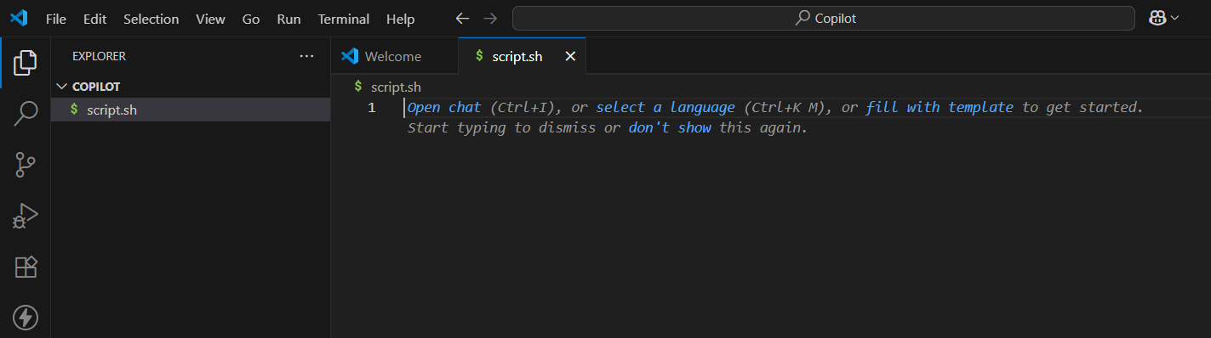

- Add the shebang line: #!/bin/bash
(This tells the system to use the Bash shell to run the script.)

Step 2: Use Natural Language Prompts

- Activate Copilot
  - Make sure GitHub Copilot is installed and enabled.
  - Press Ctrl + I to activate Copilot in the script.
- Type a natural language prompt describing what you want the script to do.

What is a Natural Language Prompt?

A natural language prompt is just a plain-English comment or instruction.
Copilot will read this and generate a corresponding script using Bash.

- For example, we want a shell script to back up a folder to another directory with a timestamp. Write the prompt in copilot.

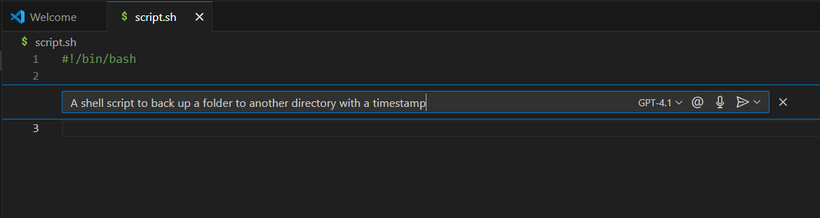

- Press ENTER key.
- Wait a second, and Copilot will auto-suggest a script based on your prompt.
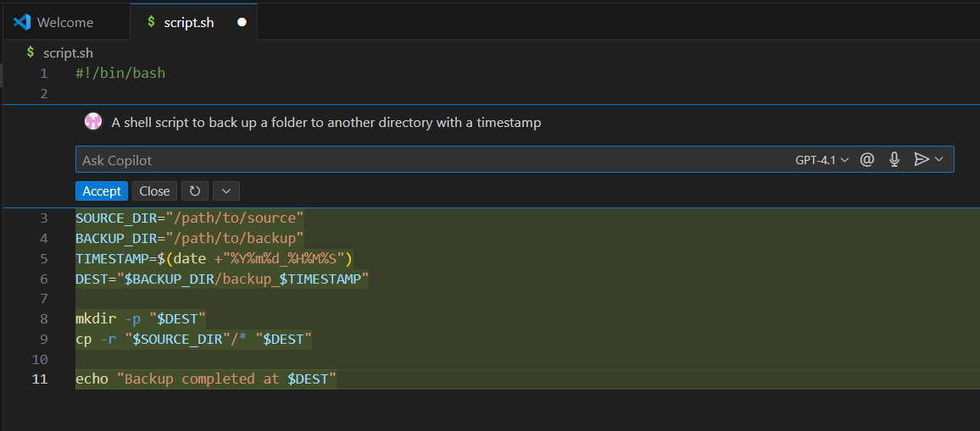

Code generated by copilot.

- Click on Accept.

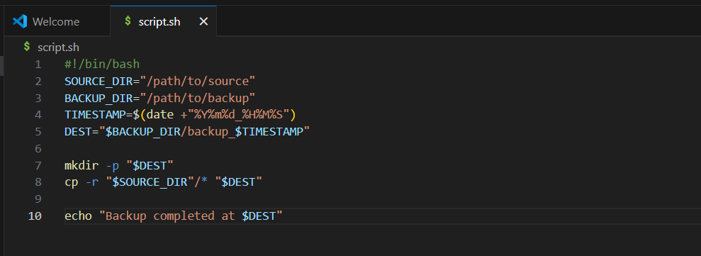

Step 3: Modify or Expand the Script

- You can add more comments like:
  - Check if backup folder exists, if not create it
  - Compress the folder
  - Save it with a timestamp

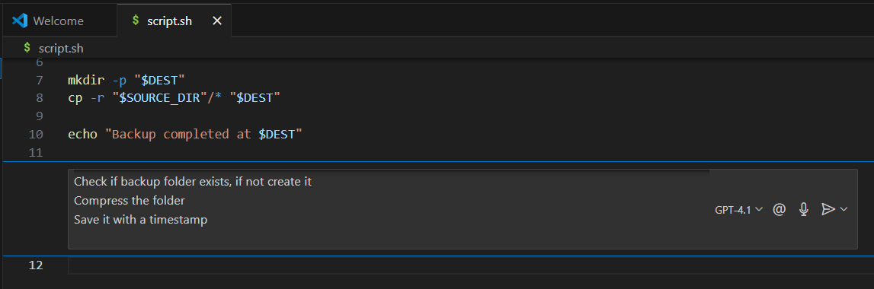

- Press ENTER key.
- Copilot will keep generating more code based on your prompts.
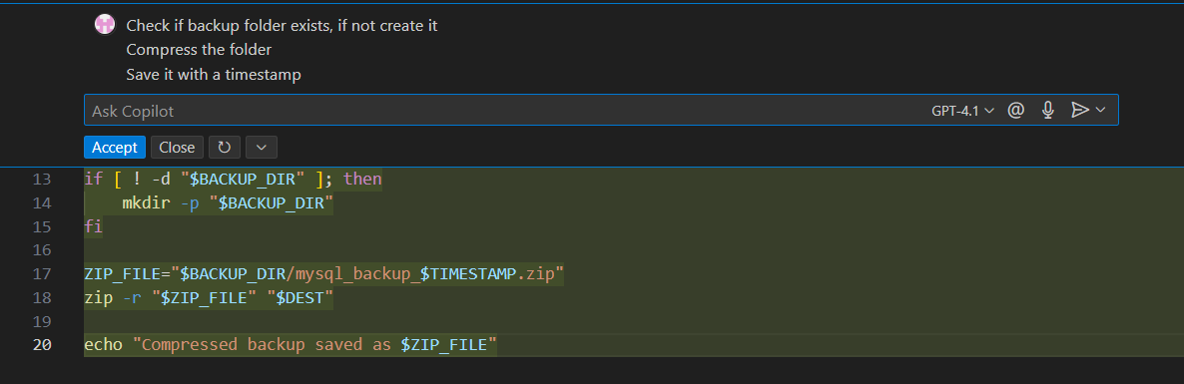
- Accept the code.

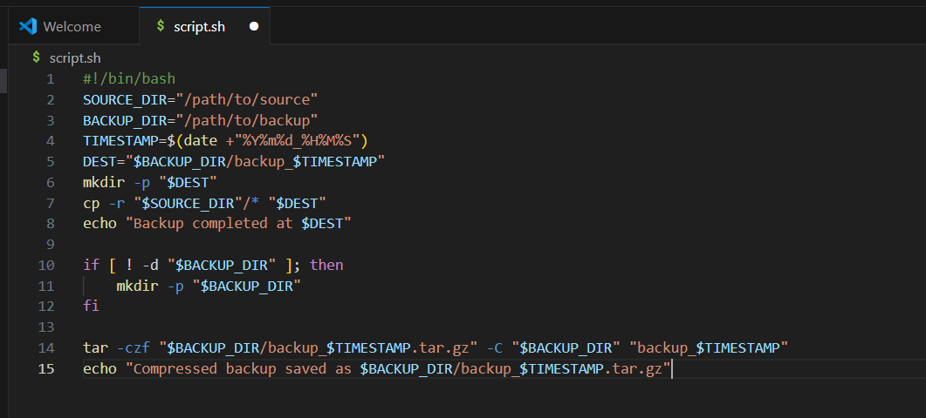

Note: Before running the script, make sure to update the paths:

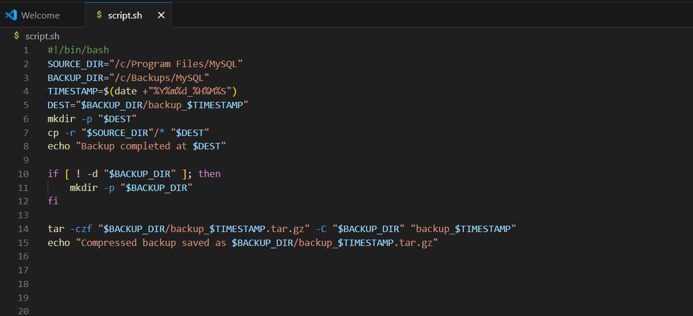

Complete shell script using prompt

Step 4: Save and test the script

- Save the file.
- Open your file in git bash.
- Give execute permission:
  - chmod +x script.sh
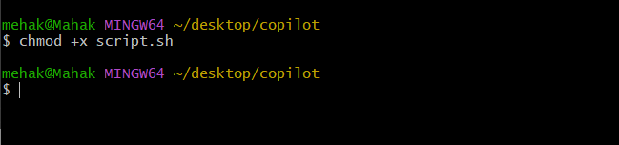

- Run the script:
  - ./script.sh

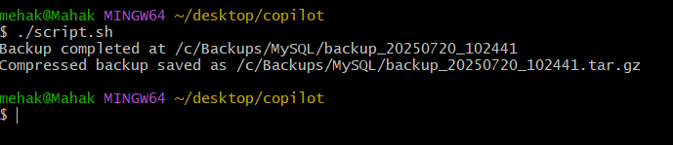

- The script ran successfully and performs the backup operation as expected.

Conclusion

Generating shell scripts using natural language prompts with GitHub Copilot simplifies the scripting process, making it accessible even to beginners. By combining the power of plain English instructions with Copilot's AI-driven suggestions, you can quickly automate tasks without deep knowledge of Bash syntax.

Whether you're backing up files, monitoring system resources, or scheduling jobs, this approach allows you to:
- Save time on boilerplate code
- Learn scripting concepts interactively
- Build confidence in writing and customizing shell scripts

