Implement AI-assisted Pipeline Debugging

Overview

This documentation provides a step-by-step guide for beginners to implement AI-assisted pipeline debugging using GitHub Copilot within Visual Studio Code (VS Code). The goal is to help developers leverage the power of AI to automatically suggest, fix, and improve continuous integration (CI) pipelines, using GitHub Actions as the pipeline platform.

Prerequisites
- VS Code
- GitHub Copilot

Step 1: Install GitHub Actions in VS Code

- Open VS code.
- In VS Code, create a new folder for your project
- Run the following commands in terminal:
  - mkdir copilot-pipeline-debug
  - cd copilot-pipeline-debug
  - code .
- Create a file:
  - File name: .github/workflows/main.yml
  - Add an incomplete pipeline code.

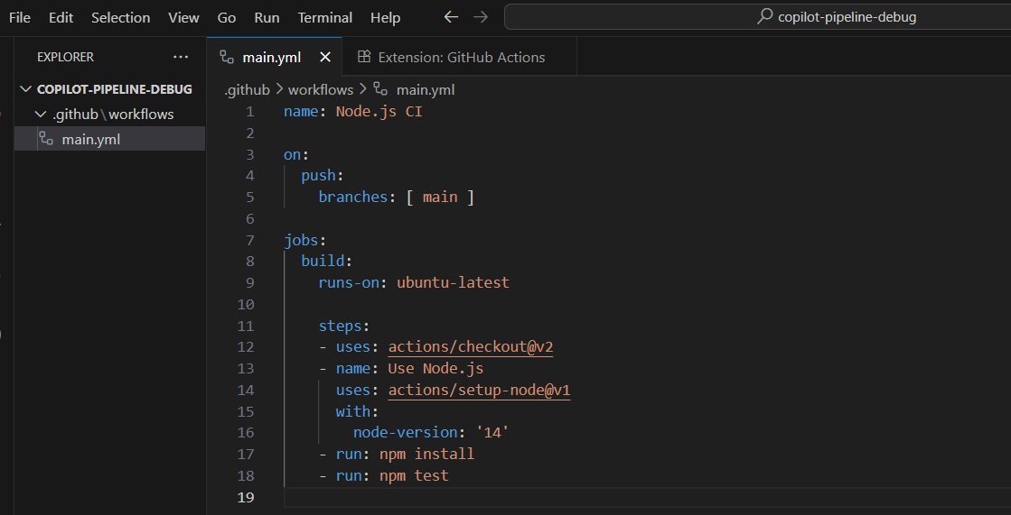
Step 2: Use Copilot to Assist in Debugging

Now, suppose you don’t know if this workflow will work. Let's Copilot guide us:

- Press Ctrl + I, add a prompt above any line where you feel unsure:
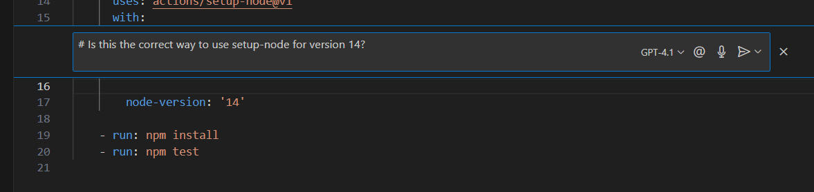

- Copilot will auto-suggest a correct block or explain usage.
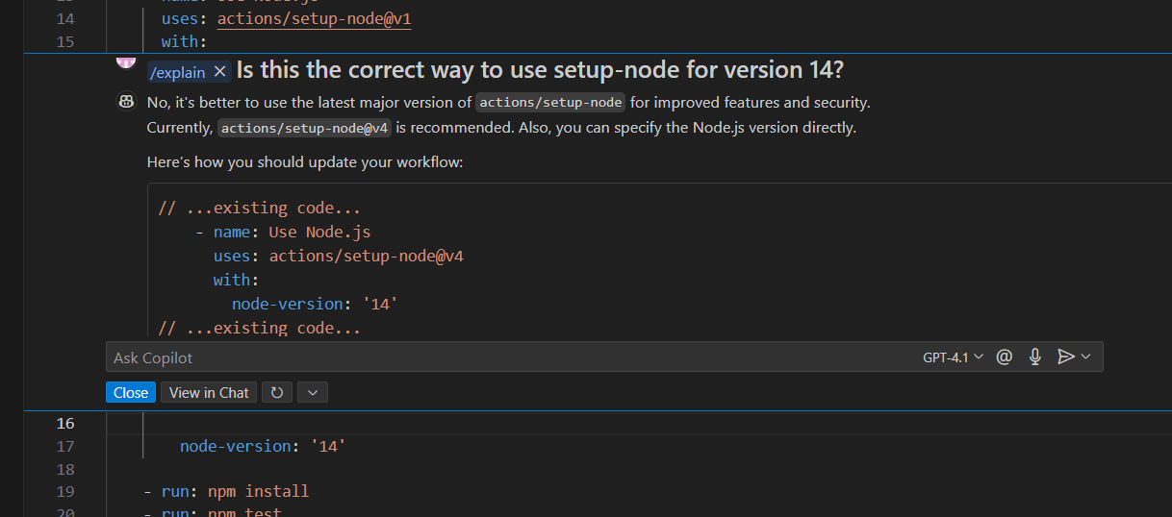

- Accept the correct code.
- Try writing comments like:
  - Fix the version issue in setup-node
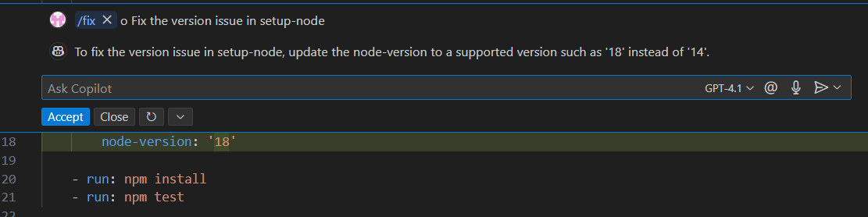

Step 3: Use Copilot for Debug Script for Log Errors

To simulate real-world pipeline debugging, we’ll create a simple Node.js script called debug.js that scans a pipeline log file and extracts error messages. This helps you understand how log-based debugging works and how GitHub Copilot can assist in writing such scripts.

- Create a new file: debug.js.

- Write a debug pipeline script to identify failed steps:

const fs = require('fs');

function varOcg(logFilePath) {
fs.readFile(logFilePath, 'utf8', (err, data) => {
if (err)
{
console.error("Failed to read log file:", err);
return;
}

if (data.includes("ERROR"))
{
console.log("Pipeline failed with error:");
const lines = data.split('\n');
lines.forEach(line => {
if (line.includes("ERROR")) console.log(line);
});
}
else
{
console.log("No errors found in pipeline log.");
}
});
}

// Call with a hello log path

varOcg('./hello.log');

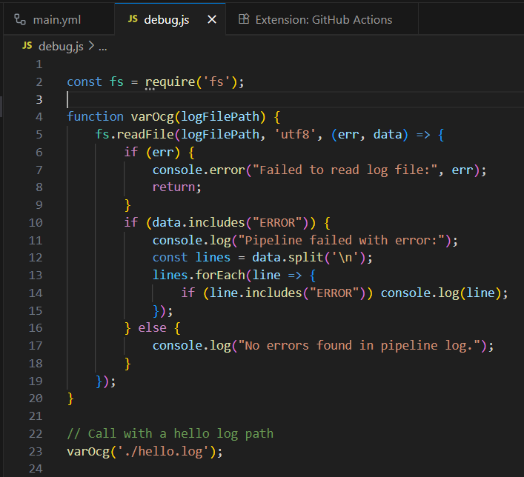

- Use Copilot to auto-complete this code by writing a comment like:

  - Write a function to read a pipeline log file and extract error lines

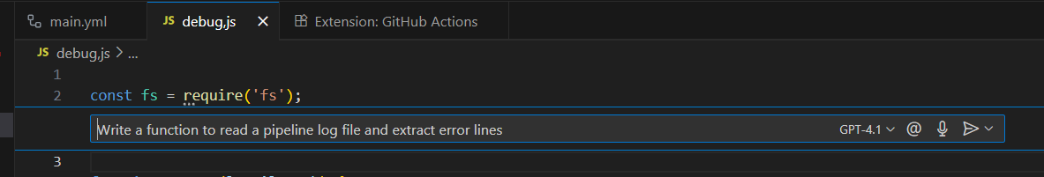

- Accept the correct pipeline code

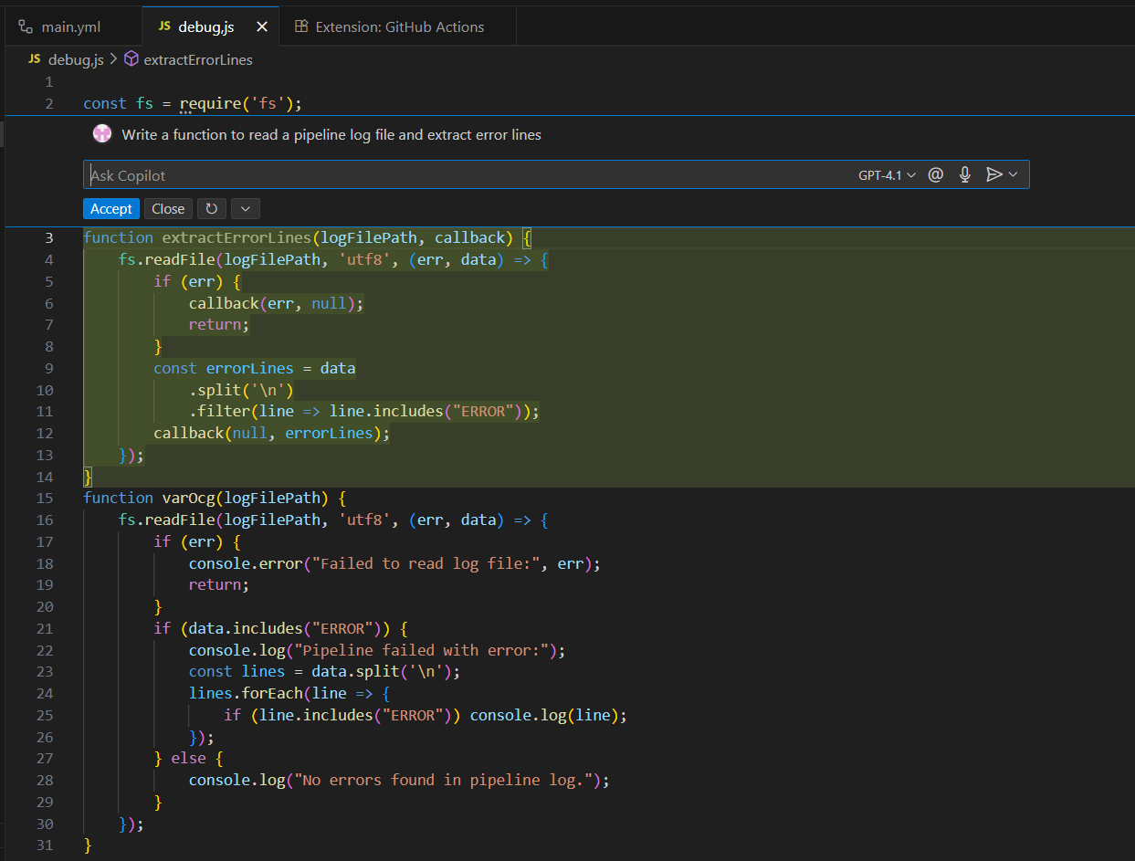

Step 4: Create the Sample log file

- In your project folder, create a new file named:
  - hello.log
- Add the following content inside it:
  - [INFO] Starting pipeline...
  - [INFO] Installing dependencies...
  - [ERROR] npm install failed: missing package.json
  - [INFO] Running tests...
  - [ERROR] Unit tests failed
  - [INFO] Pipeline complete.

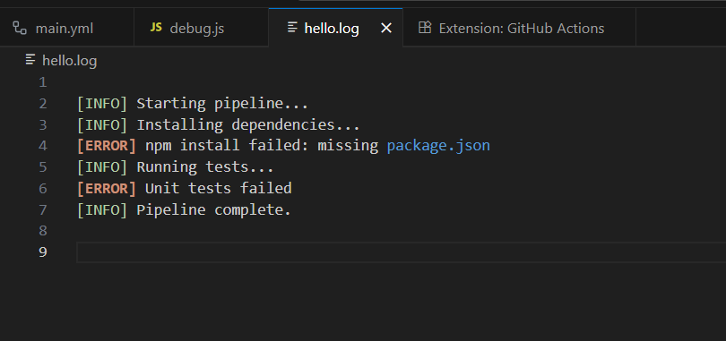

- Run the script.

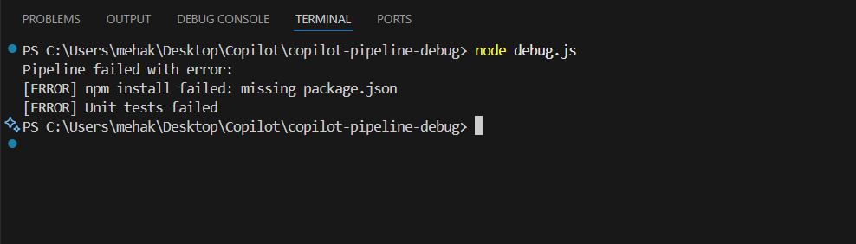

- This is the expected output from the code.

Conclusion

By following this guide, you’ve learned how to implement AI-assisted pipeline debugging
using GitHub Copilot in Visual Studio Code.

You’ve seen how Copilot can:
- Suggest and correct GitHub Actions workflow configurations.
- Help debug CI pipelines with intelligent code completions and comments.
- Assist in writing custom scripts (like debug.js) to parse and analyze pipeline logs.

