Implement Git-flow Workflow for a Project

Problem Statement:

As projects grow in complexity and team size, managing branches for new features, releases, and hotfixes can become challenging. The Git-flow workflow provides a structured and robust branching model to streamline development, ensure stable releases, and manage parallel work efficiently.

This hands-on exercise will guide you through initializing a repository with Git-flow, creating a new feature, preparing for a release, and finishing a hotfix.

Steps:

Before you begin, ensure you have completed the Prerequisites document, specifically having:

- Git for Windows is installed and configured.
- Git Bash for command-line operations.
- (Optional) A GitHub repository to push your changes to, as Git-flow operations are primarily local but eventually get pushed. For this exercise, we will assume you have a local Git repository, or you can quickly create one.

We will perform all steps using Git Bash on your Windows machine.

Step 1: Initialize a Git Repository and Install Git-flow

First, we need a local Git repository to work with. If you already have one, you can skip creating a new one. We'll also ensure the git-flow extensions are available. Git for Windows typically includes git-flow by default, but it's good to be aware.

Git-flow commands are extensions to Git. We need a repository to apply this workflow, and the git flow init command requires an existing Git repository.

1. Open Git Bash:

Search for Git Bash in your Windows Start Menu and open it.

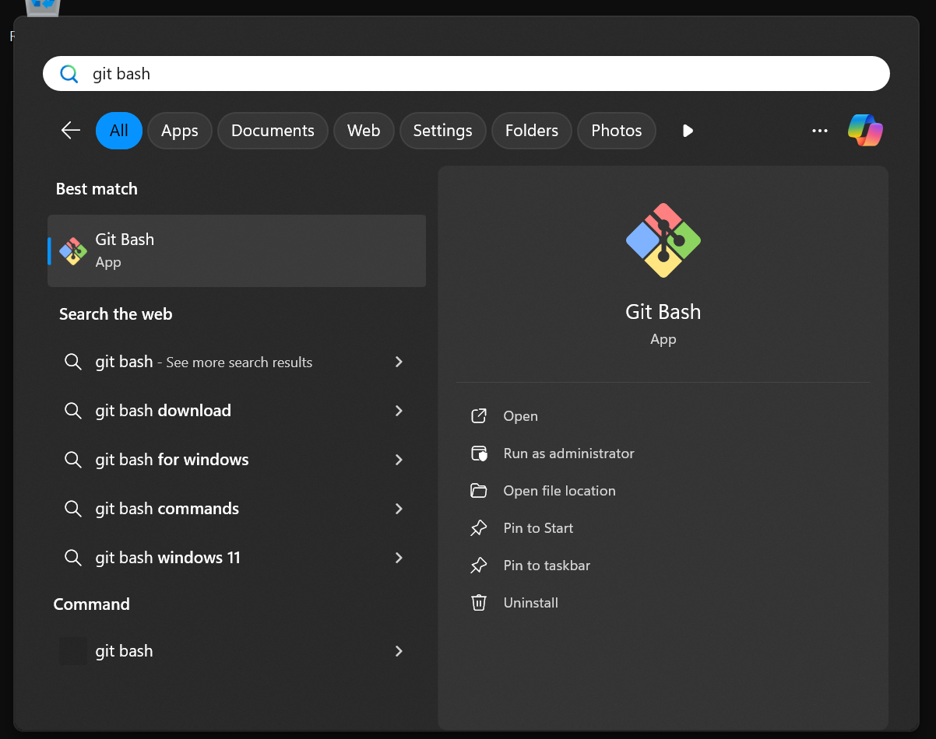

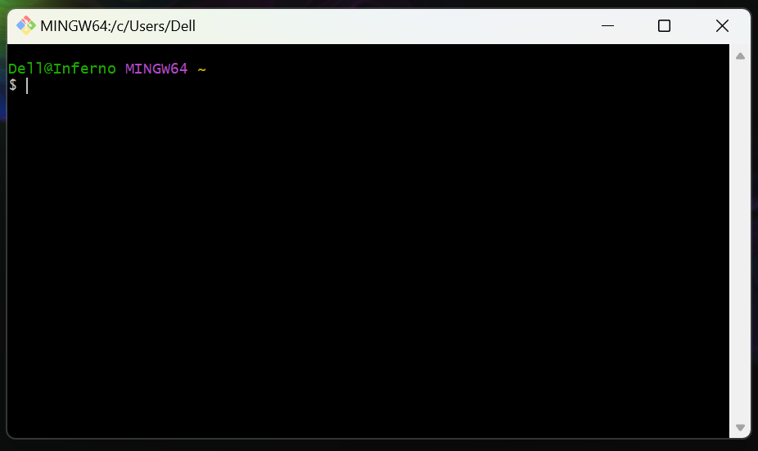

2. Navigate to a Desired Directory:

Choose a location where you want to create your project folder. For example, to go to your Documents folder:

cd /c/Users/YourWindowsUsername/Documents/

Replace YourWindowsUsername with your actual Windows username.

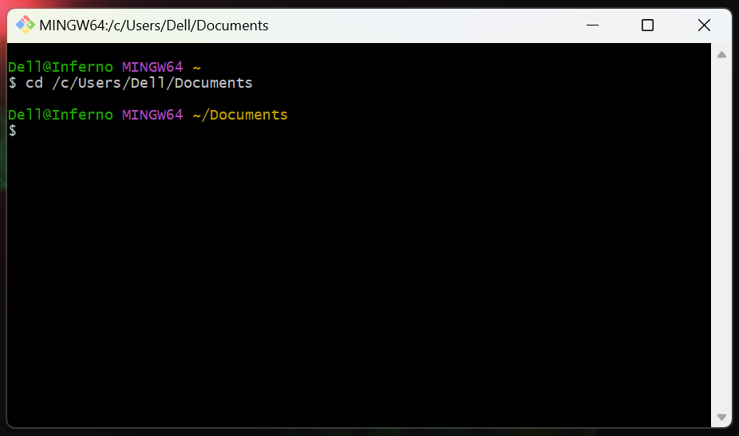

Create a new directory for this project:

mkdir gitflow-project
cd gitflow-project

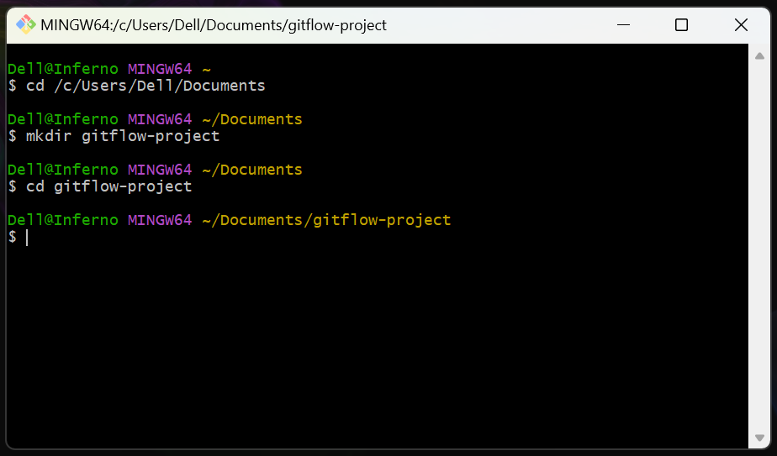

3. Initialize a New Git Repository:

Inside your gitflow-project directory, initialize a standard Git repository:

git init

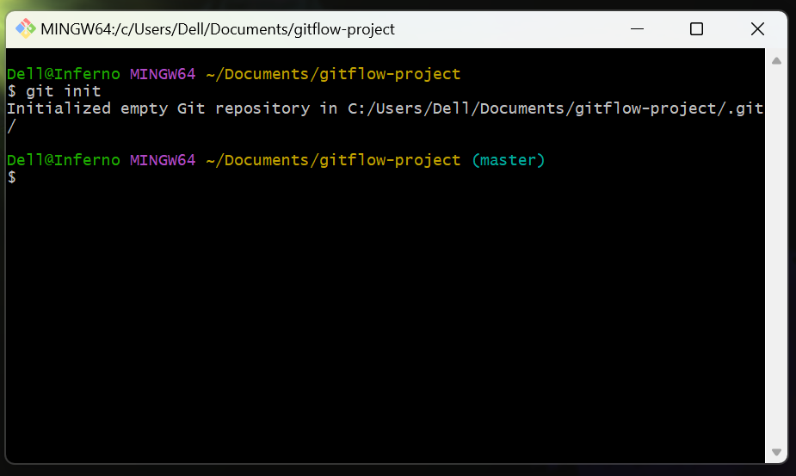

git init creates a new, empty Git repository or reinitializes an existing one. This makes the current directory a Git-managed project.

4. Create an Initial Commit:

Git-flow needs at least one commit on the main branch to initialize.

Create a dummy file:

echo "# Gitflow Project" > README.md

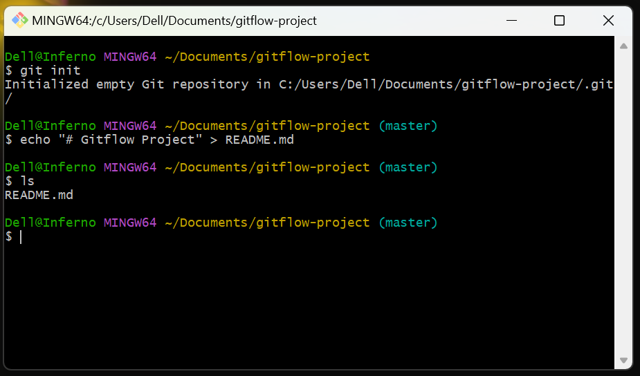

Stage and commit the file:

git add README.md
git commit -m "Initial commit for Gitflow project"

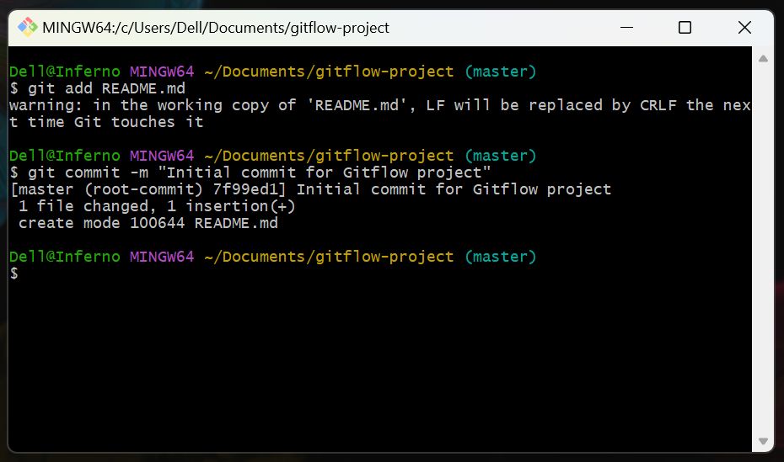

git-flow init sets up the branching structure based on an existing main branch. Without an initial commit, the main branch effectively doesn't exist yet for Git-flow to operate on.

Step 2: Initialize Git-flow in Your Repository

Now that you have a basic Git repository with an initial commit, you can initialize the Git-flow workflow. This command will set up the default branch names like develop, feature/, release/, hotfix/ for your project.

This is the core step that transforms a standard Git repository into a Git-flow repository. It configures the specific naming conventions and prepares the branches needed for the workflow.

1. Initialize Git-flow:

In your gitflow-project directory within Git Bash, run:

git flow init

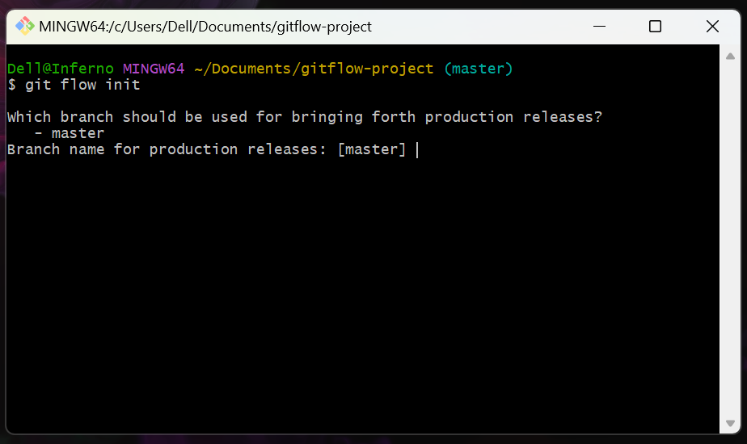

You will be prompted to confirm default branch names. For this hands-on, simply press Enter for each prompt to accept the default values:

- Branch name for production releases: [main] -> Press Enter
- Branch name for "next release" development: [develop] -> Press Enter
- How to name your feature branches? [feature/] -> Press Enter
- How to name your bugfix branches? [bugfix/] -> Press Enter
- How to name your release branches? [release/] -> Press Enter
- How to name your hotfix branches? [hotfix/] -> Press Enter
- How to name your support branches? [support/] -> Press Enter
- How to name your version tag prefix? -> Press Enter
- Hooks and filters directory? [C:/Users/Dell/Documents/gitflow-project/.git/hooks] -> Press Enter

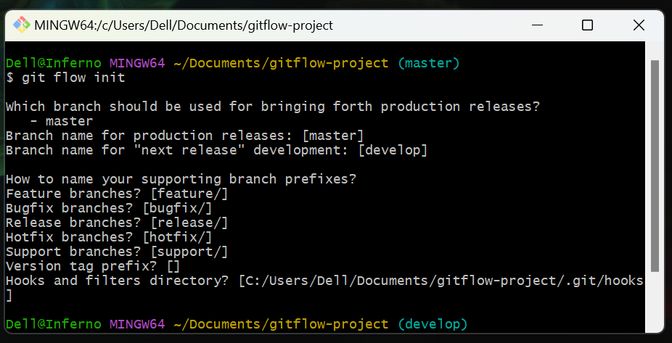

2. Verify Git-flow Initialization:

After initialization, you should automatically be on the develop branch. You can verify this by checking your current branch:

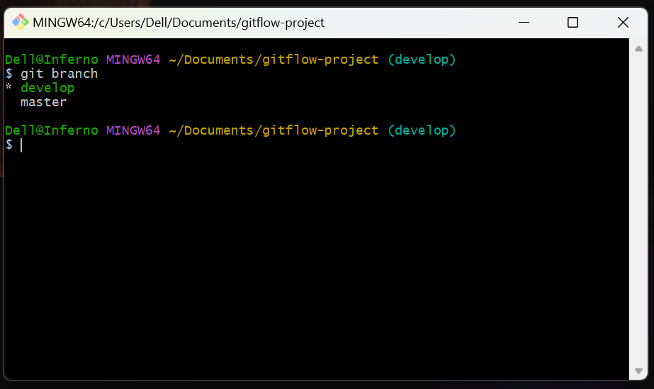

You should see * develop and master listed. The * indicates your current branch.

git flow init automatically creates the develop branch from main and switches you to develop. In Git-flow, develop is where all new features are integrated before a release.

Step 3: Start and Work on a New Feature

In the Git-flow model, all new development for upcoming releases happens on feature branches, which branch off from develop.

Feature branches allow developers to work on specific functionalities in isolation without affecting the stable develop branch or other features. This prevents conflicts and ensures a clean history for each feature.

1. Start a New Feature Branch:

From the develop branch, initiate a new feature:

git flow feature start user-authentication

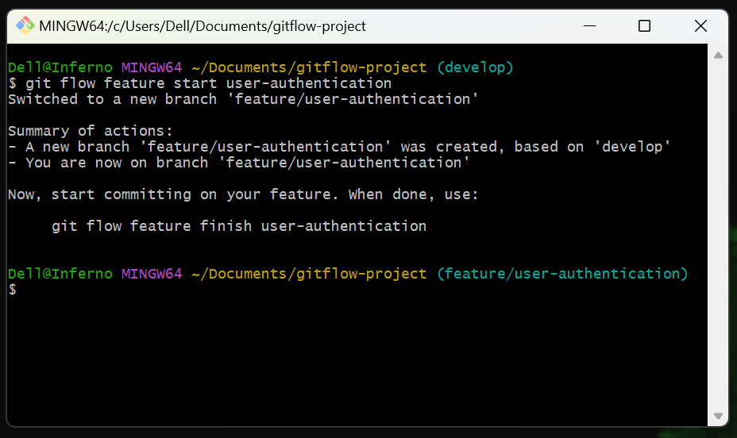

git flow feature start user-authentication creates a new branch named feature/user-authentication from develop and automatically switches you to it.

Verify you are on the new feature branch:

git branch

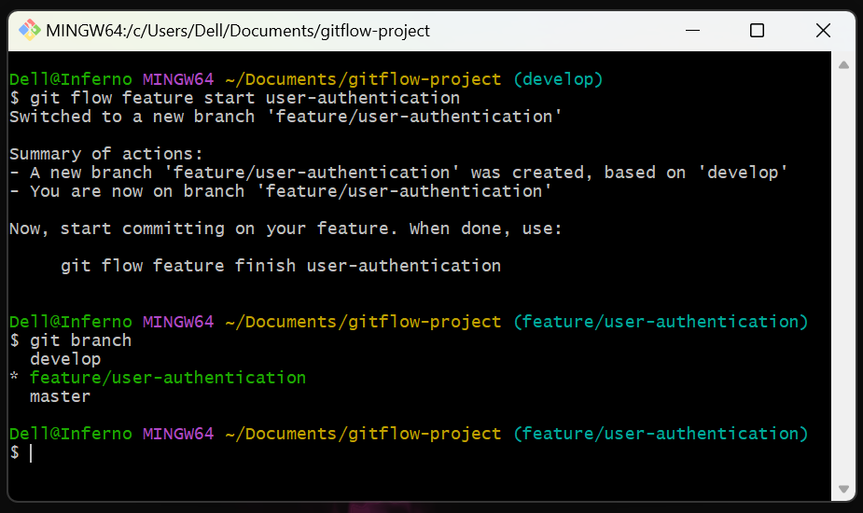

You should see * feature/user-authentication.

2. Make Changes on the Feature Branch:

Create a new file for your feature:

echo "Authentication module code..." > src/auth.js

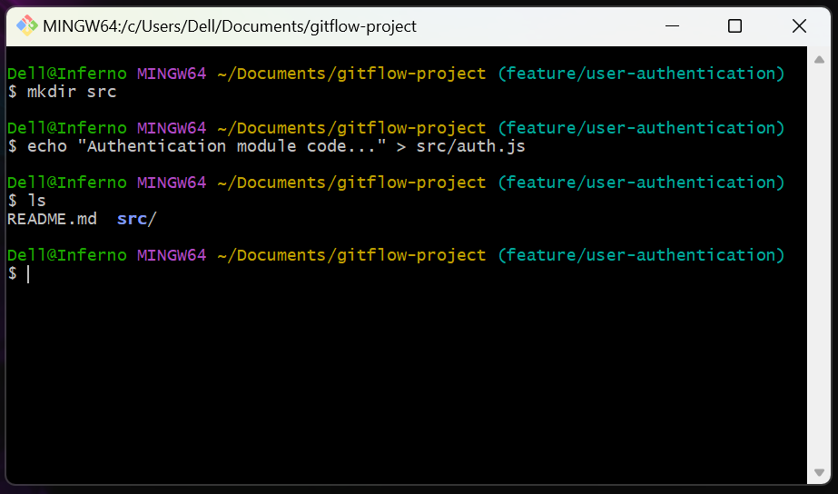

Note: You might need to create the src directory first: mkdir src

Modify the README.md to mention the new feature:

echo "## Features" >> README.md
echo "- User Authentication" >> README.md

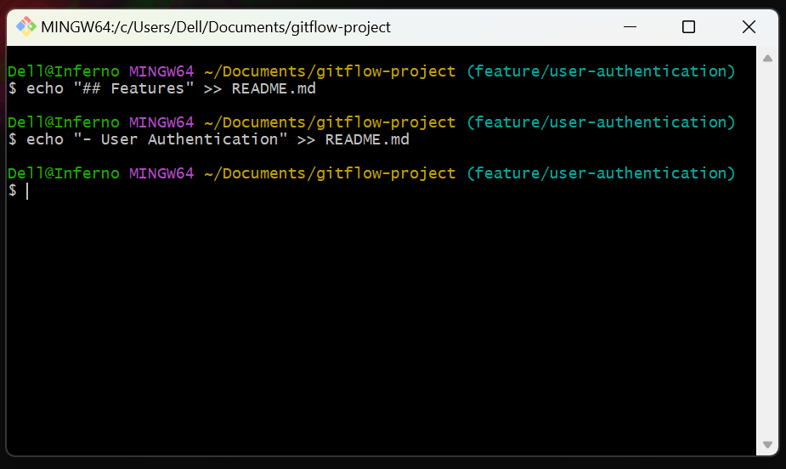

We're doing this to simulate actual development work on the feature branch.

3. Stage and Commit Your Feature Changes:

Add the new file and the modified README to staging:

git add src/auth.js README.md

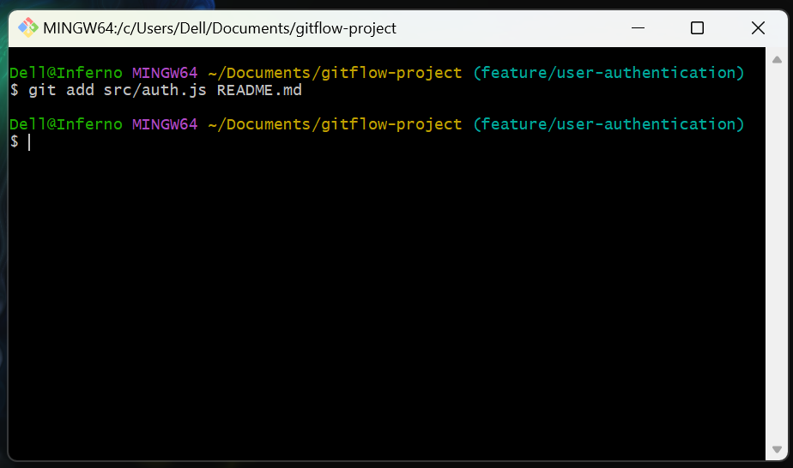

Commit the changes:

git commit -m "Implement basic user authentication module"

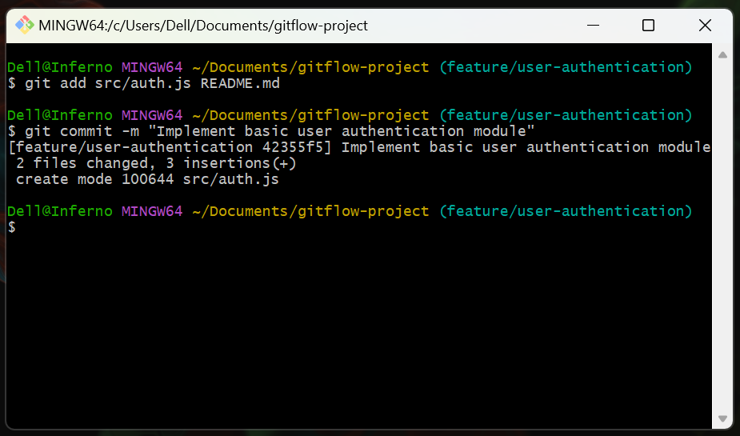

Saving your progress as a commit on the feature branch.

Step 4: Finish the Feature

Once a feature is complete and reviewed, it's merged back into the develop branch.

Finishing a feature integrates the new functionality into the main development line, making it available for the next release. git flow feature finish handles the merging and cleanup automatically.

1. Finish the Feature Branch:

From your feature/user-authentication branch, run:

git flow feature finish user-authentication

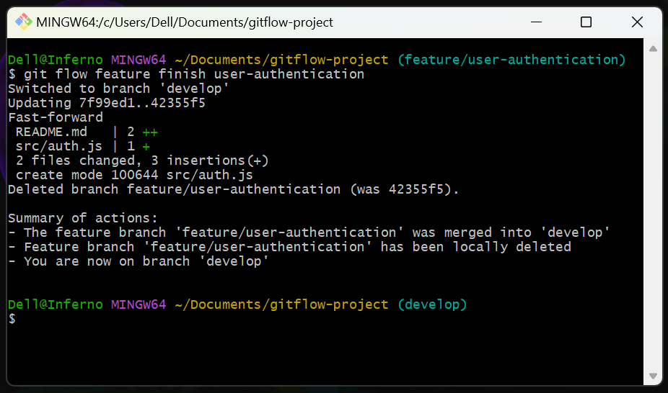

git flow feature finish user-authentication automatically does the following:

- Switches back to the develop branch.
- Merges feature/user-authentication into develop.
- Deletes the feature/user-authentication branch.

Git might open your configured text editor for a merge commit message. If it does, simply save and close the file.

2. Verify Feature Integration:

Check your current branch:

git branch

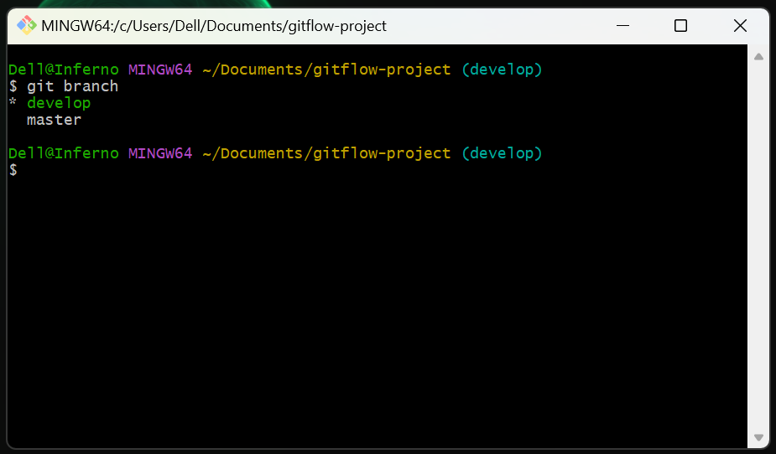

You should now be back on * develop, and the feature/user-authentication branch should no longer exist locally.

Verify the content of README.md and src/auth.js on develop:

cat README.md
cat src/auth.js

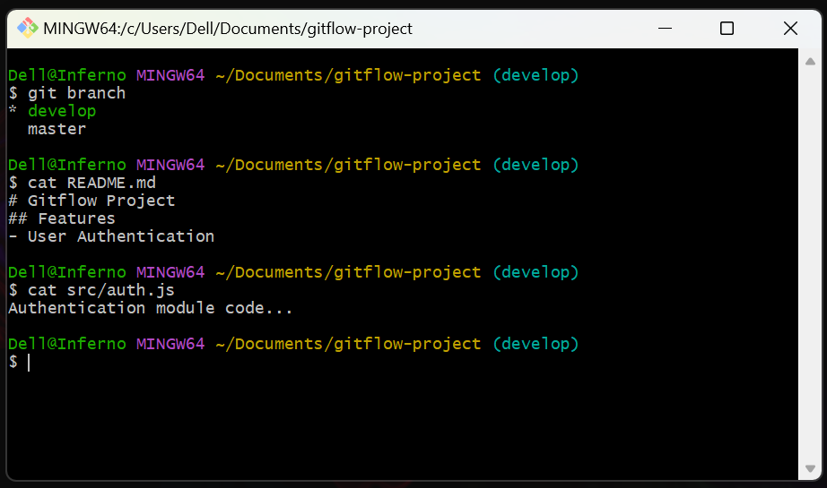

You should see the changes you made in Step 3.

Step 5: Start a Release

When the develop branch has enough features for a new release, a release branch is created from it. This branch is used for final polishing, bug fixes specific to the release, and preparing for deployment.

The release branch provides a stable environment for final testing and fixes without introducing new features. This keeps the develop branch free for ongoing new development.

1. Start a New Release Branch:

From the develop branch, initiate a new release:

git flow release start v1.0.0

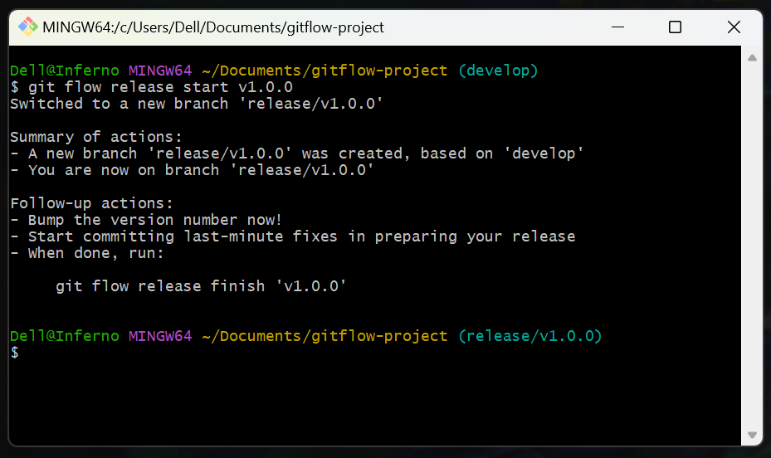

git flow release start v1.0.0 creates a new branch named release/v1.0.0 from develop and switches you to it.

Verify you are on the release branch:

git branch

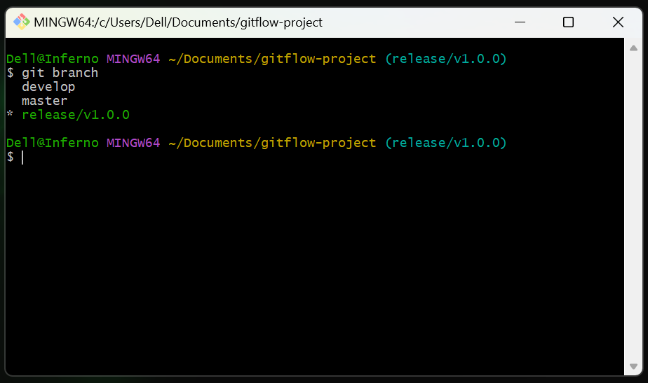

You should see * release/v1.0.0.

2. Make Release-Specific Changes

Simulate updating a version file or release notes:

echo "Version 1.0.0 released on $(date +%F)" > RELEASE_NOTES.md

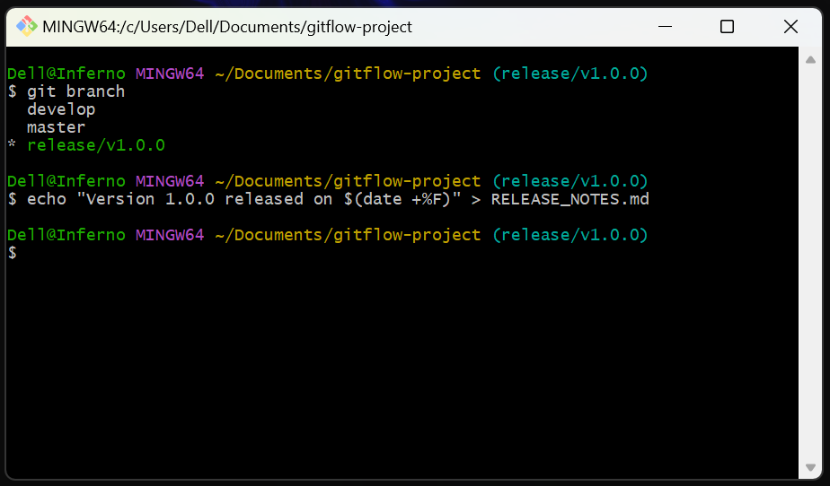

Commit this change:

git add RELEASE_NOTES.md
git commit -m "Update release notes for v1.0.0"

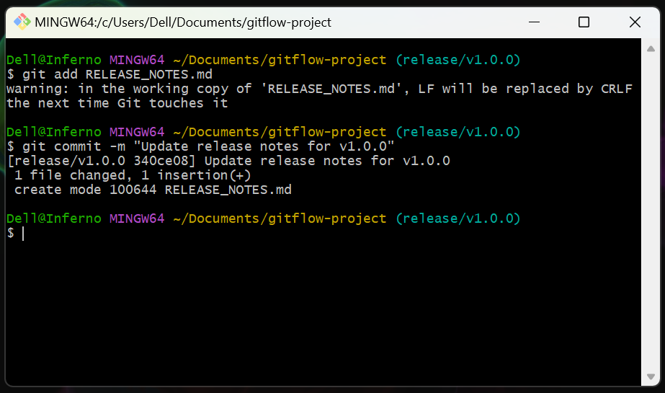

Release branches are where you finalize things like version numbers, copyright dates, or last-minute bug fixes found during pre-release testing.

Step 6: Finish the Release

Once the release branch is stable and ready for deployment, it's finished. This involves merging it into main and back into develop. It also tags the release.

Finishing a release marks the official point of a new production version. It ensures that the main branch always reflects deployable code and that the develop branch contains all fixes from the release.

1. Finish the Release Branch:

From your release/v1.0.0 branch, run:

git flow release finish v1.0.0

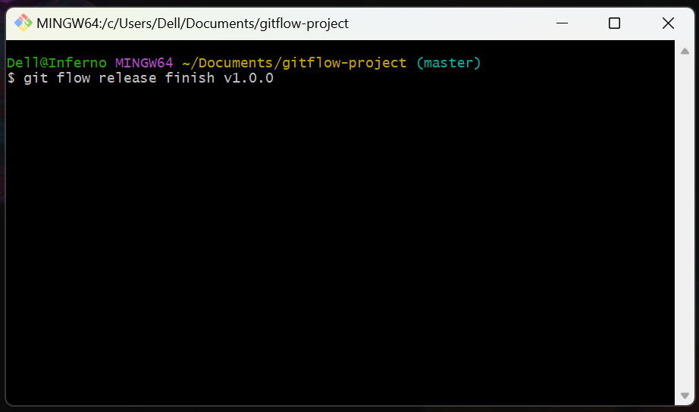

Git will open your configured text editor three times during this process.

First Prompt: Merge Commit Message

For this, simply save and close the editor.

- If using Vim: Press Esc, then type :wq, and press Enter.
- If using a graphical editor: Just close the editor window.

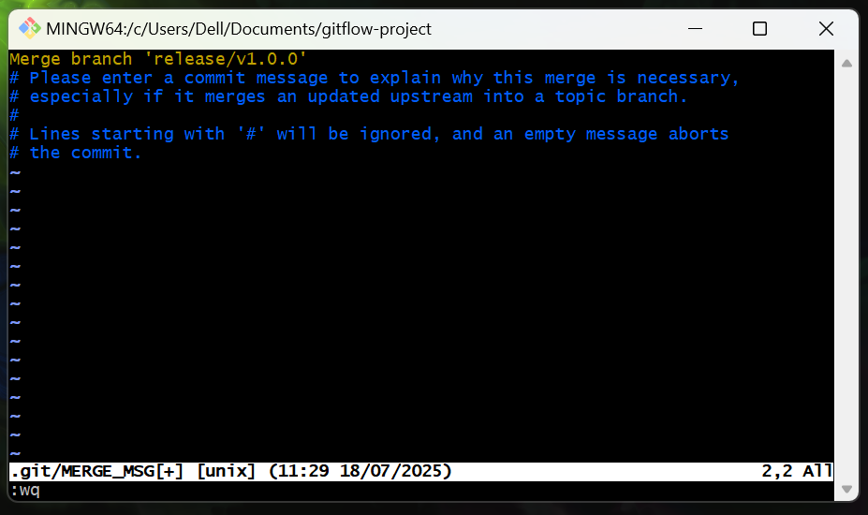

Second Prompt: Tag Message

The editor will open again specifically for the release tag.

Crucially, you MUST type a message on the first non-comment line before saving. An empty tag message is not allowed.

If using Vim:

- Press i to enter insert mode.
- Type a short, descriptive message on the first line, such as: Release v1.0.0 or Final version 1.0.0 production release.
- Press Esc to exit insert mode.
- Type :wq and press Enter.

If using a graphical editor:

- Type your tag message on the first line and then close the editor.

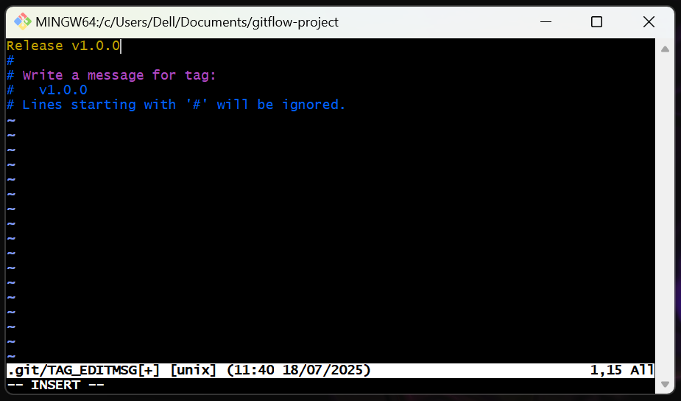

Third Prompt: Merge Commit Message

The editor will open a third time with a message.

Again, the default message is usually sufficient. Simply save and close the editor.

- If using Vim: Press Esc, then type :wq, and press Enter.
- If using a graphical editor: Just close the editor window.

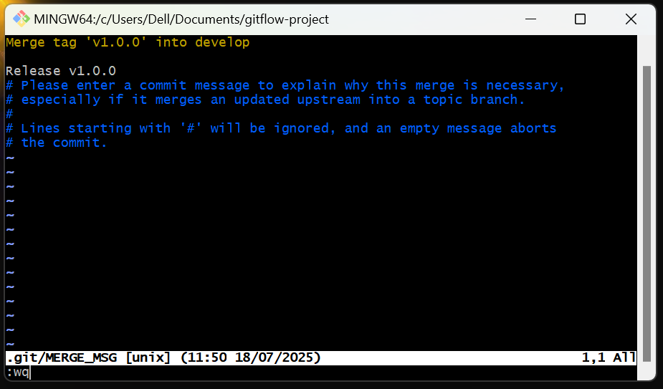

git flow release finish v1.0.0 performs the following critical steps:

- Merges release/v1.0.0 into main.
- Tags the main branch with the release version.
- Merges release/v1.0.0 into develop.
- Deletes the release/v1.0.0 branch.

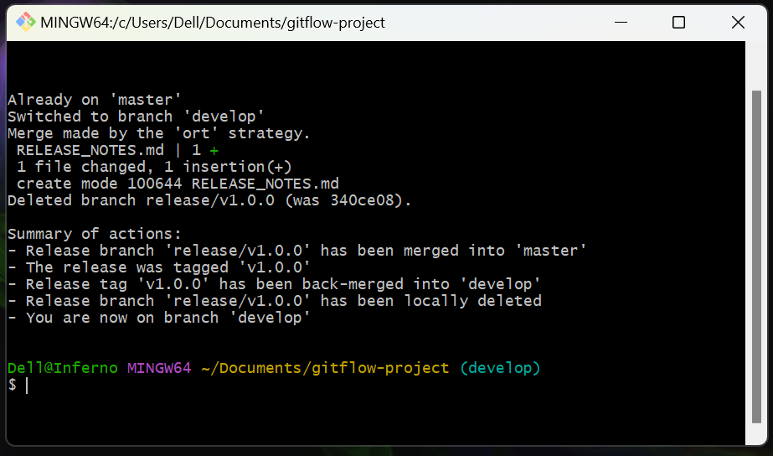

2. Verify Release Completion:

Check your branches:

git branch

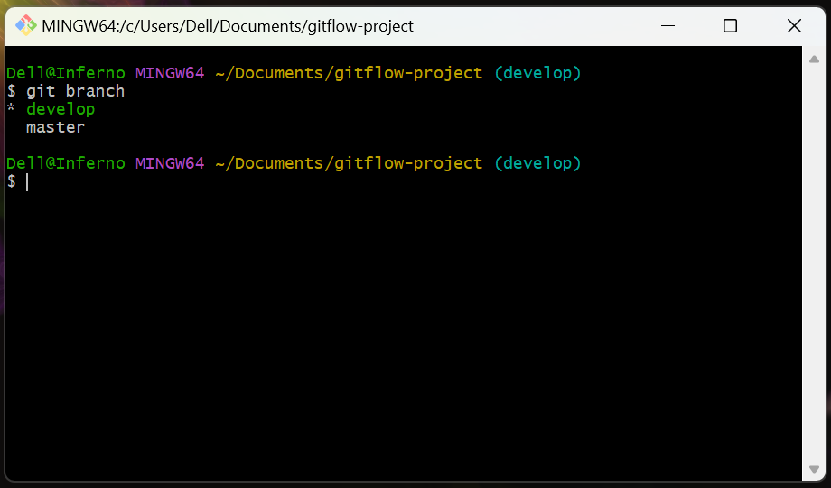

You should be back on * develop, and release/v1.0.0 should be gone.

Check the main branch to see the release commit and tag:

git checkout master
git log --oneline --decorate --graph
git tag

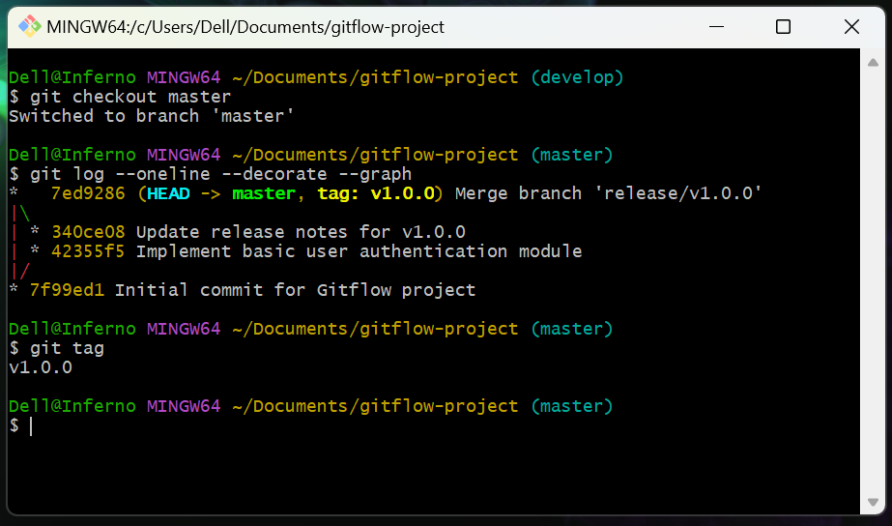

You should see (HEAD -> master, tag: v1.0.0) associated with the release commit in the log, and v1.0.0 listed by git tag.

Switch back to develop:

git checkout develop

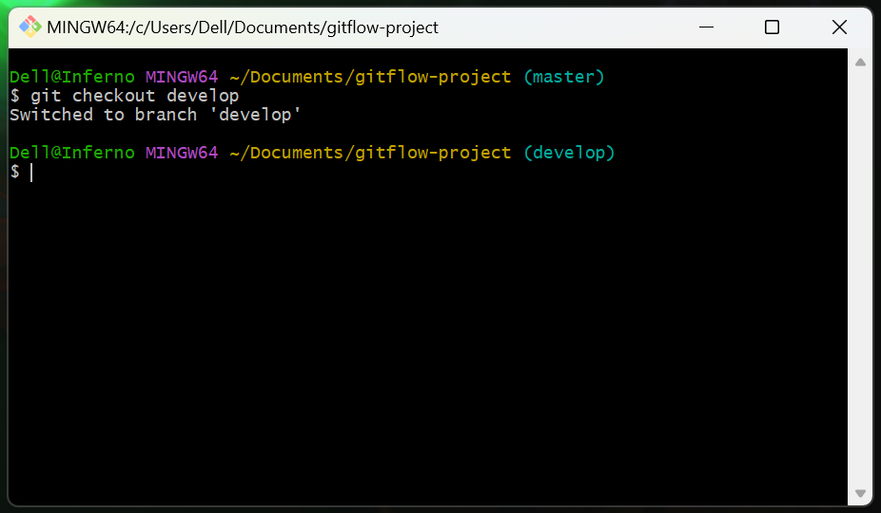

Step 7: Start and Finish a Hotfix

A hotfix is for critical bugs found in production that need to be fixed immediately without waiting for the next regular release cycle.

Hotfixes allow for rapid patches to production issues. They branch directly from your primary production branch and are merged back into both that branch and develop.

1. Start a Hotfix Branch:

From any branch, initiate a hotfix. Git-flow will automatically base it off your primary production branch.

git flow hotfix start fix-critical-bug-v1.0.1

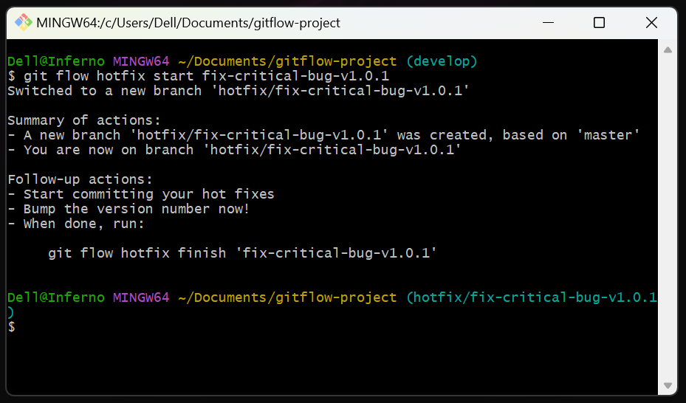

git flow hotfix start fix-critical-bug-v1.0.1 creates a new branch named hotfix/fix-critical-bug-v1.0.1 directly from your primary production branch and switches you to it.

Verify you are on the hotfix branch:

git branch

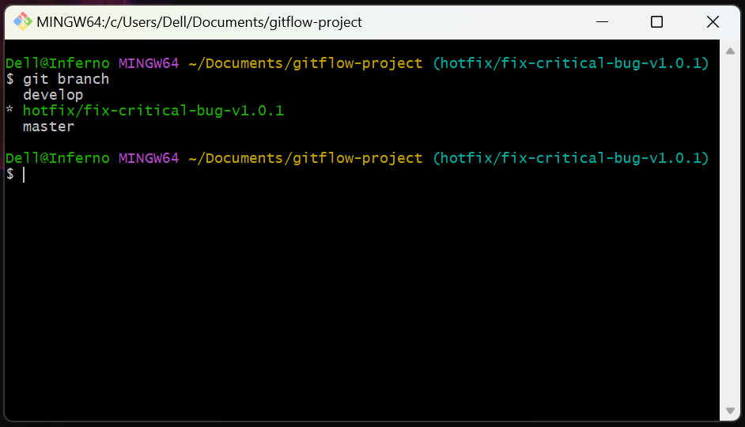

You should see * hotfix/fix-critical-bug-v1.0.1.

2. Make Hotfix Changes:

Simulate fixing a bug by modifying src/auth.js:

echo "Authentication module code... (Bug fix applied for login issue)" > src/auth.js

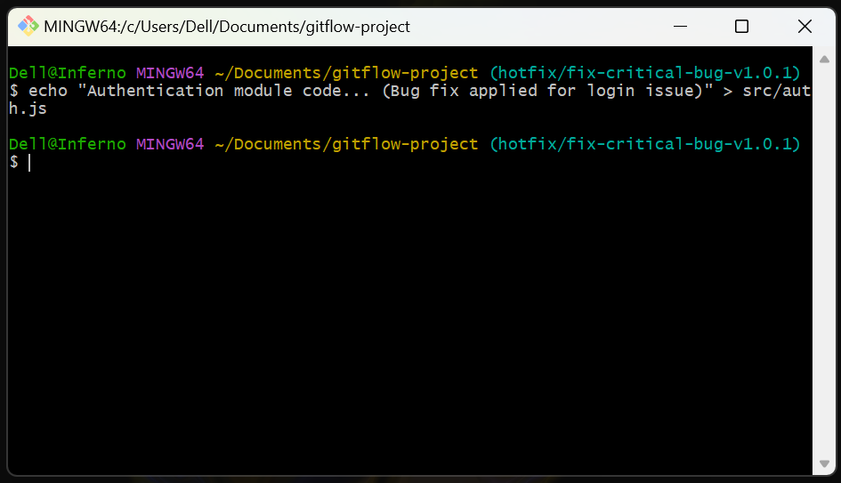

Commit the change:

git add src/auth.js
git commit -m "HOTFIX: Apply critical bug fix for login issue"

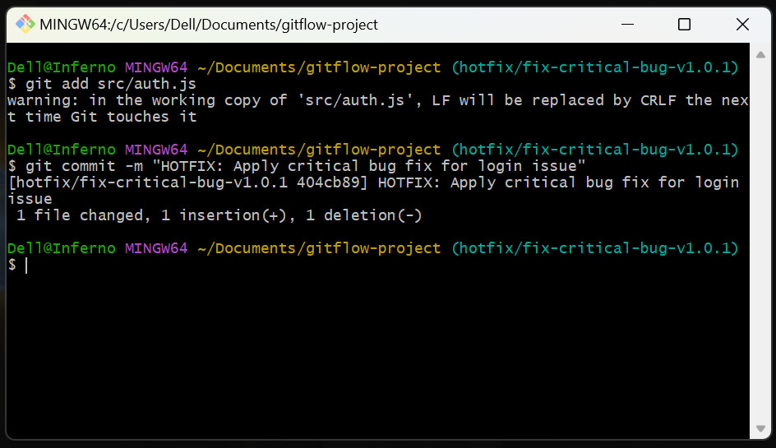

3. Finish the Hotfix Branch:

From your hotfix/fix-critical-bug-v1.0.1 branch, run:

git flow hotfix finish fix-critical-bug-v1.0.1

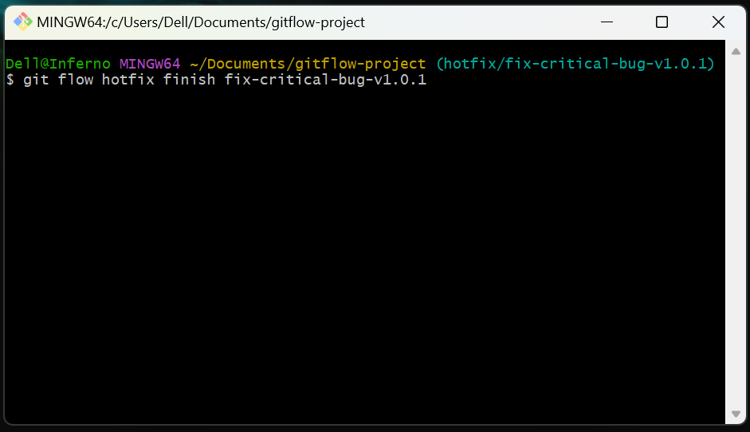

Git will open your configured text editor three times during this process. Handle each prompt as described in Step 6, making sure to provide a message for the tag.

First Prompt: Merge Commit Message

- Default message is fine. Save and close.

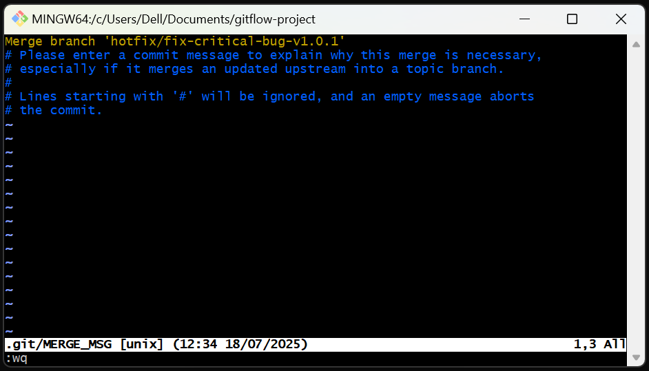

Second Prompt: Tag Message

- You MUST type a message. E.g., Hotfix v1.0.1 for login issue. Save and close.

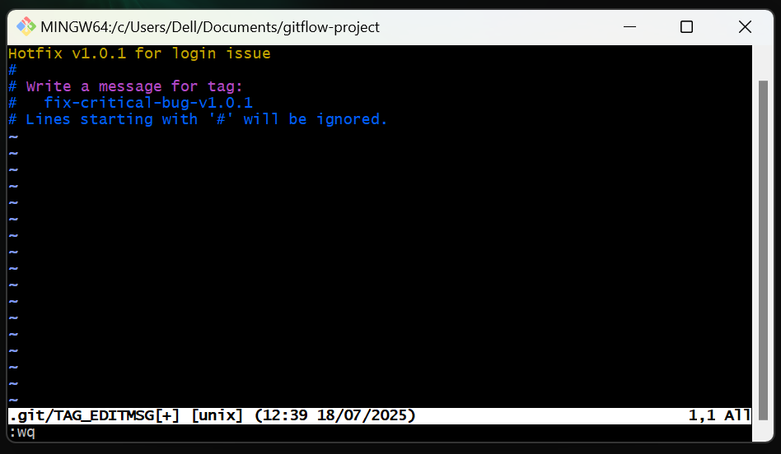

Third Prompt: Merge Commit Message

- Default message is fine. Save and close.

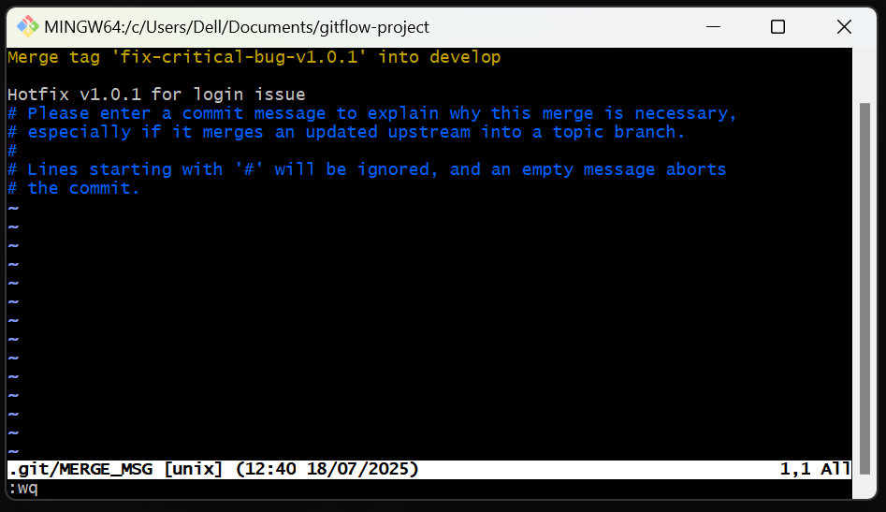

git flow hotfix finish fix-critical-bug-v1.0.1 performs the following critical steps:

- Merges hotfix/fix-critical-bug-v1.0.1 into your primary production branch.
- Tags the primary production branch with the hotfix version.
- Merges hotfix/fix-critical-bug-v1.0.1 into develop.
- Deletes the hotfix/fix-critical-bug-v1.0.1 branch.

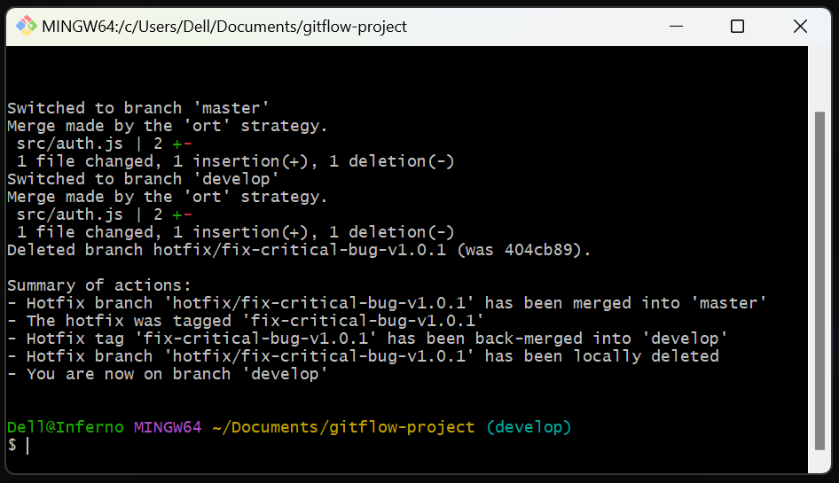

4. Verify Hotfix Completion:

Check your branches:

git branch

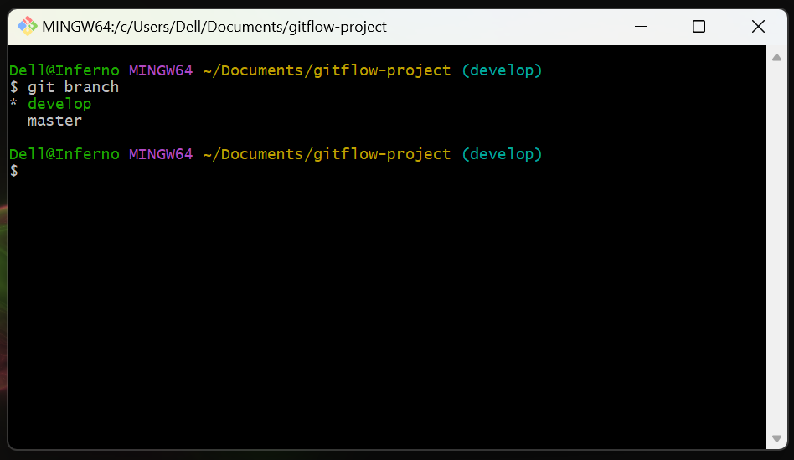

You should be back on * develop, and hotfix/fix-critical-bug-v1.0.1 should be gone.

Switch to your primary production branch to see the hotfix commit and tag:

git checkout master
git log --oneline --decorate --graph
git tag

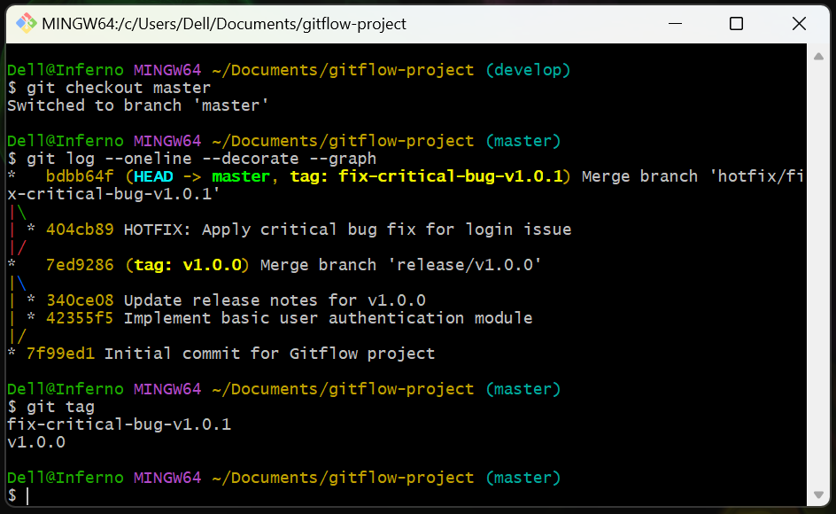

You should now see (HEAD -> master, tag: v1.0.1) in the log, and both v1.0.0 and v1.0.1 listed by git tag.

Switch back to develop to continue normal development:

git checkout develop

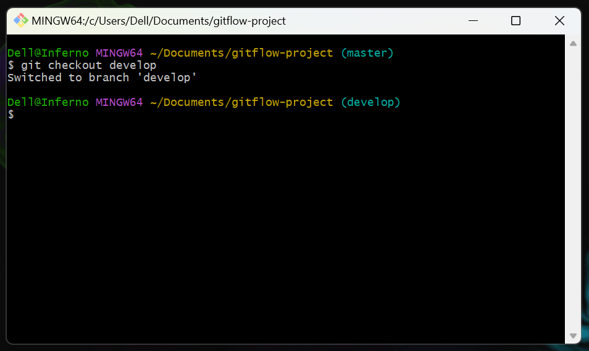

Topics Covered:

- Git-flow Workflow: Understanding the core concepts and branch types (main/master, develop, feature, release, hotfix).
- Initializing Git-flow: Setting up Git-flow for a new or existing repository (git flow init).
- Feature Development: Starting, working on, and finishing feature branches (git flow feature start, git flow feature finish).
- Release Management: Starting and finishing release branches for production readiness (git flow release start, git flow release finish).
- Hotfix Management: Addressing urgent bugs in production with hotfix branches (git flow hotfix start, git flow hotfix finish).
- Git Editor Interaction: Handling commit and tag messages in the default Git editor (Vim).
- Basic Git Commands: git init, git add, git commit, git branch, git checkout, git log, git tag.

