Install and configure Copilot in VS Code

Overview

GitHub Copilot is an AI-powered code assistant developed by GitHub in collaboration with OpenAI. It helps developers by suggesting entire lines or blocks of code, comments, or documentation based on the context in your editor. This guide will walk you through installing and configuring GitHub Copilot in VS Code.

Prerequisites
- VS Code
- GitHub

Step 1: Install GitHub Copilot in VS Code

- Open VS code.
- Open any empty folder.

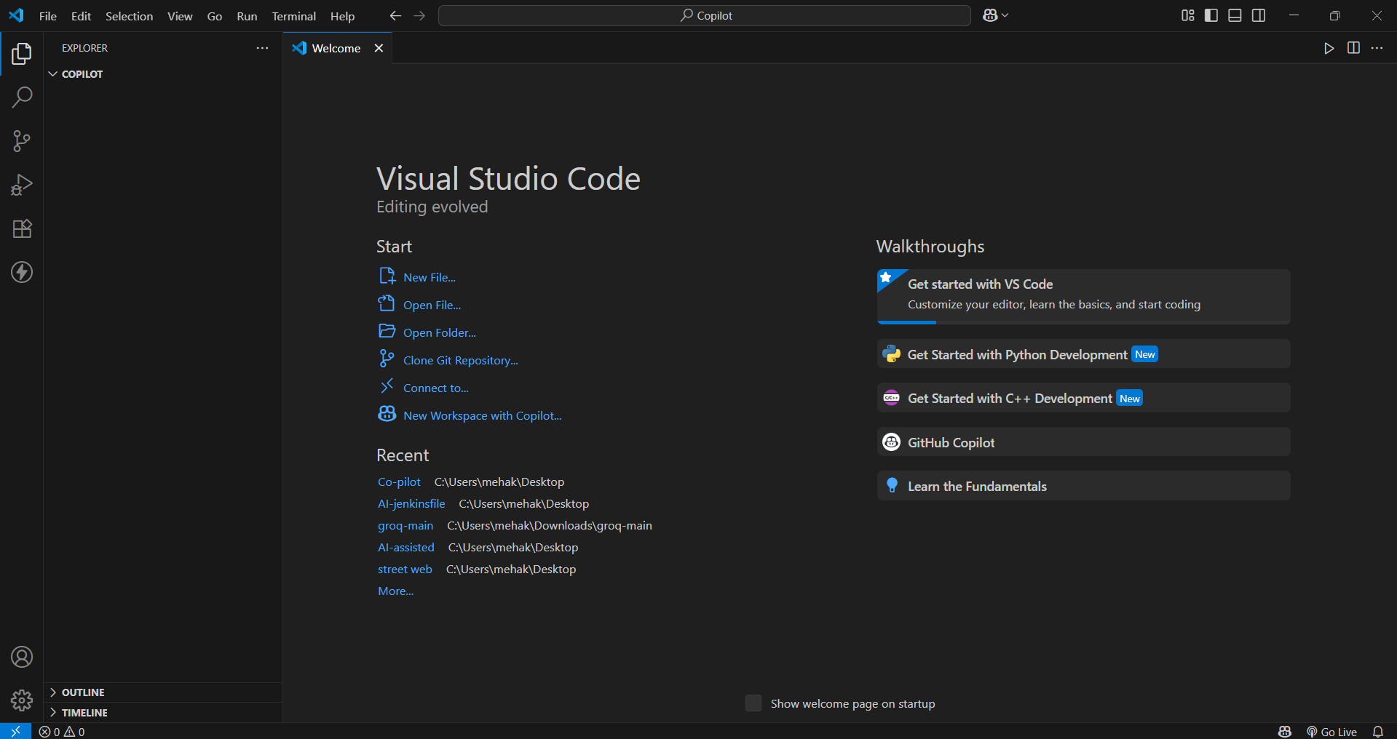

- Go to the Extensions Panel on the sidebar or press Ctrl + Shift + X.

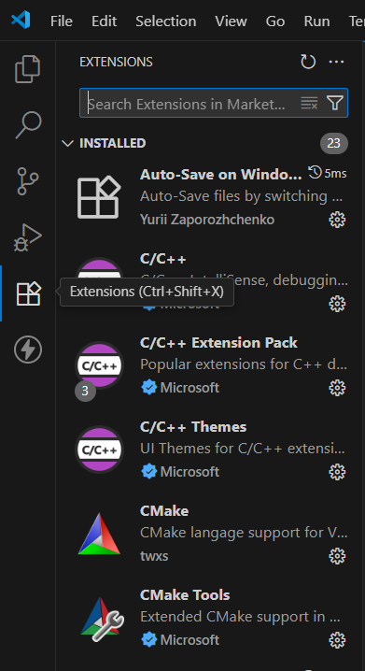

- In the search bar, type "GitHub Copilot".

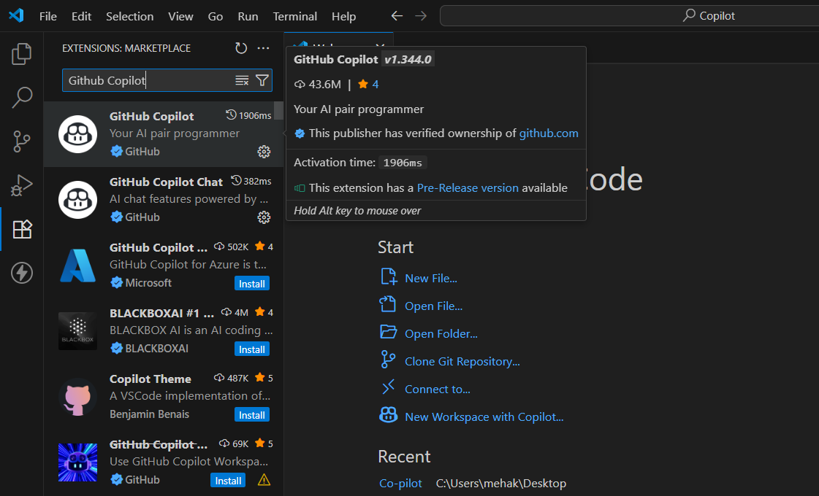

- Click Install.

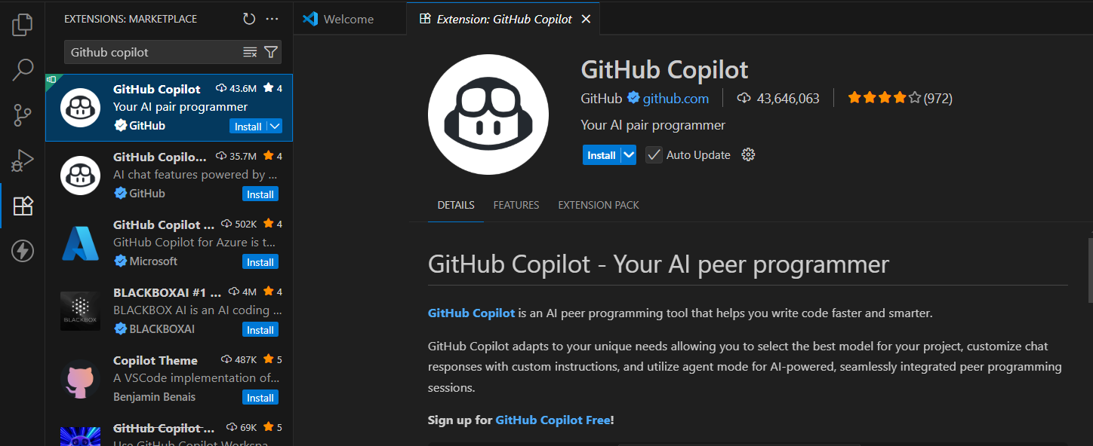

- GitHub copilot is successfully installed in your VS Code. After this, you have to sign in your copilot with your GitHub account.

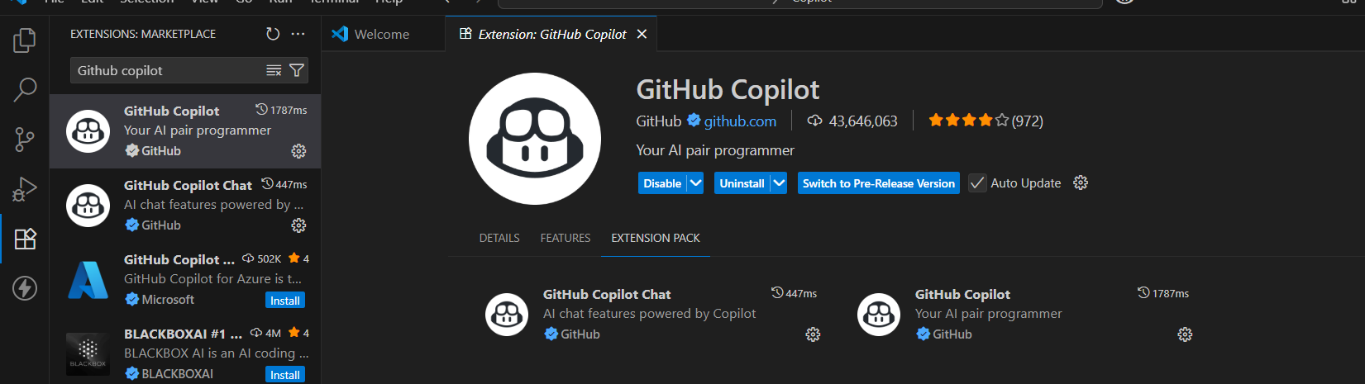

Step 2: Sign In to GitHub

- After installation, click on the toggle chat on the top.



- VS Code will prompt you to Continue with GitHub.

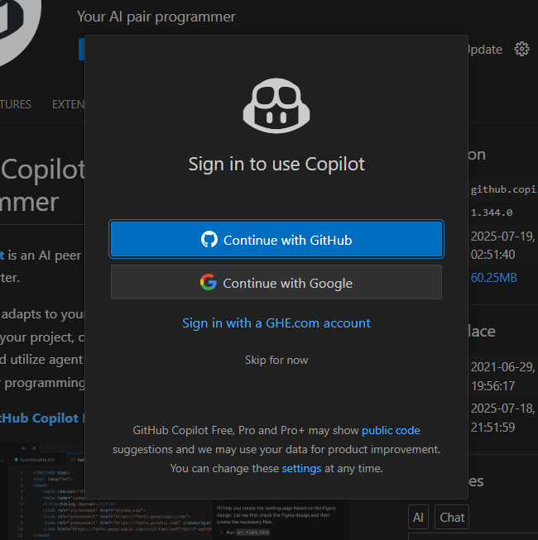

When you will click on continue with GitHub, your browser will open where you have to sign in your GitHub account and authorize VS Code.

- Sign in your GitHub account.
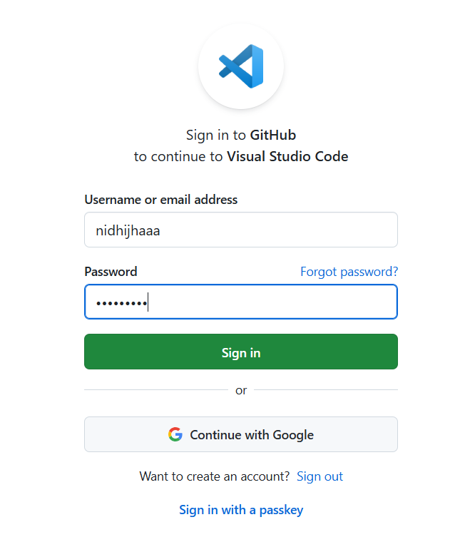

- A browser tab will open → authorize GitHub Copilot by clicking “Authorize Visual Studio Code”.
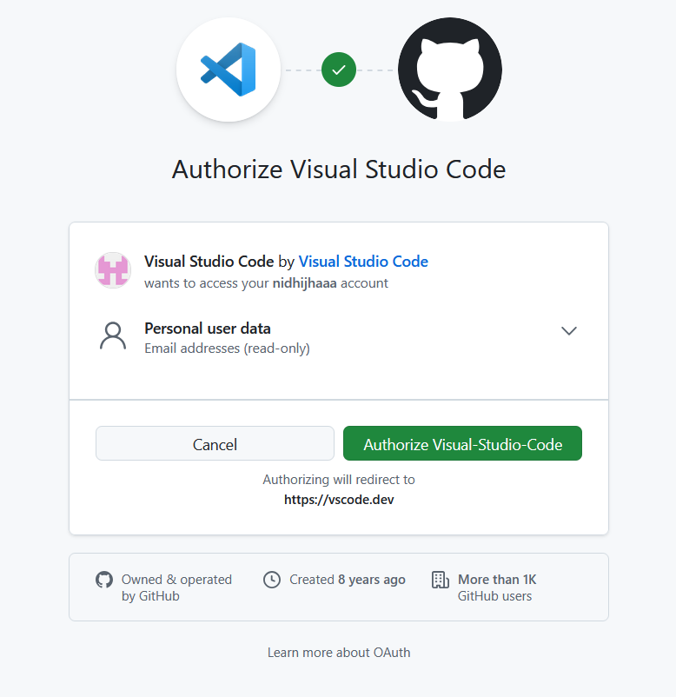

- You will be redirected to the VS Code.

Step 3: Configure Copilot in VS Code

- To configure Copilot, we can directly go to Settings in VS Code or press Ctrl +,
- Search for “Copilot” in the search bar and open settings.json.

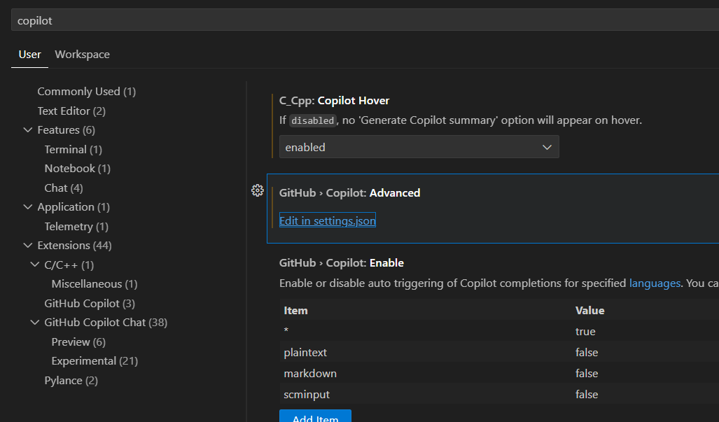

- You can add configurations like:
"github.copilot.enable": true,
"github.copilot.inlineSuggest.enable": true,
"github.copilot.suggestionDelay": 100

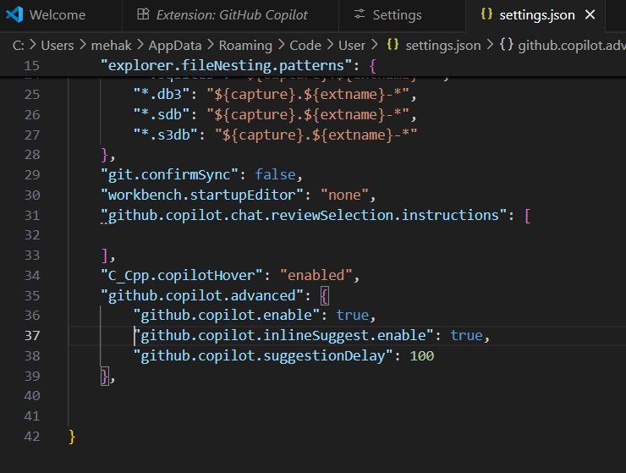

We added these configurations because "github.copilot.enable": true activates GitHub Copilot globally, ensuring it's ready to provide suggestions while you code. "github.copilot.inlineSuggest.enable": true allows inline code suggestions to appear directly in the editor as you type, making it easier to accept or modify them in real-time. "github.copilot.suggestionDelay": 100 sets the delay in milliseconds (100 ms here).

Copilot is successfully installed and configure in VS Code. You can assess copilot in you VS Code.

Step 4: Test Copilot

- Create a new JavaScript file.
- Start typing the code
- Notice that as you type, you automatically get code suggestions in dimmed text.
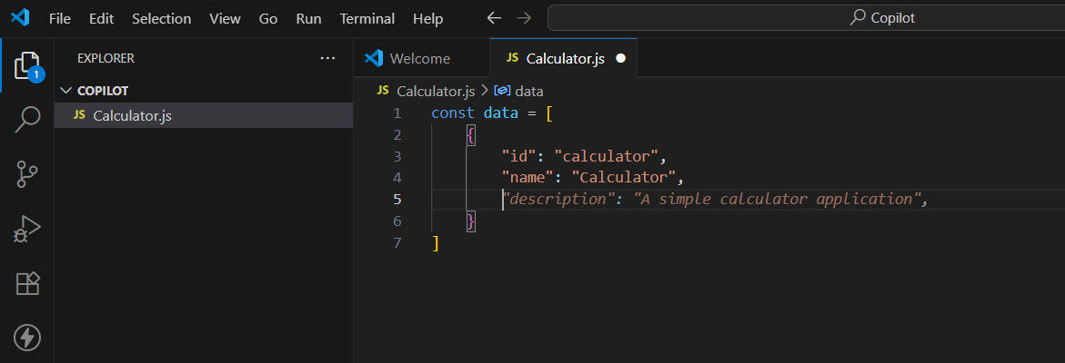

- To accept the suggestion, press Tab key.
- You've just accepted your first AI-powered code suggestion. As you continue typing, Copilot updates the code suggestion accordingly.

Conclusion

GitHub Copilot has transformed the development workflow by serving as an AI-powered pair programmer. It assists developers in writing code faster, reducing boilerplate, and improving productivity.
By following this guide, you have successfully:
- Installed and enabled GitHub Copilot in Visual Studio Code
- Signed in with your GitHub account to authenticate access
- Configured Copilot to enhance its usability and performance

