Version Control Fundamentals with Git

Prerequisites:

Before you start working with Version Control Fundamentals with Git, here's what you need to have set up:

1. Install Git:

To manage version control with Git, you need to have Git installed on my Windows machine. Here’s how you can do that:

Step 1: Download Git for Windows

Open your web browser and search for "Git for Windows" and click on the very first link that pops up, or you can navigate to https://git-scm.com/downloads/win

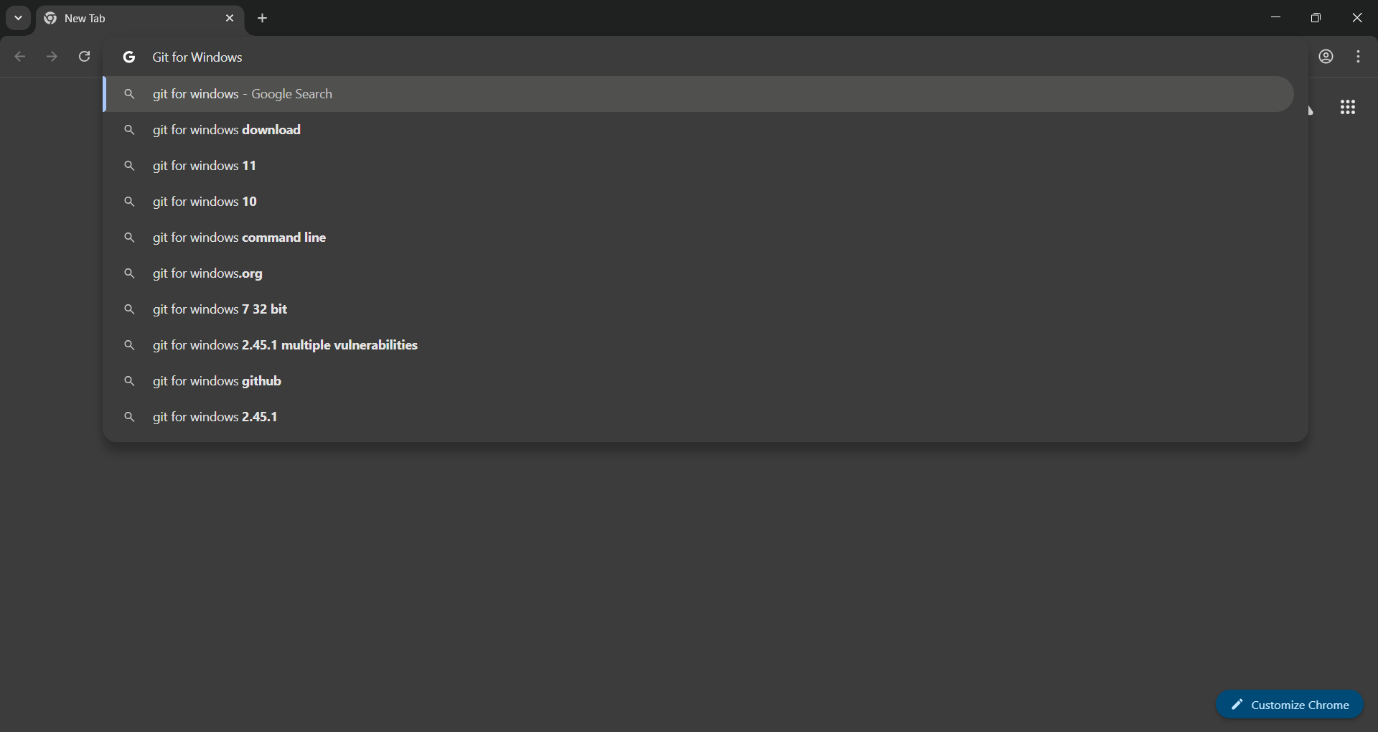

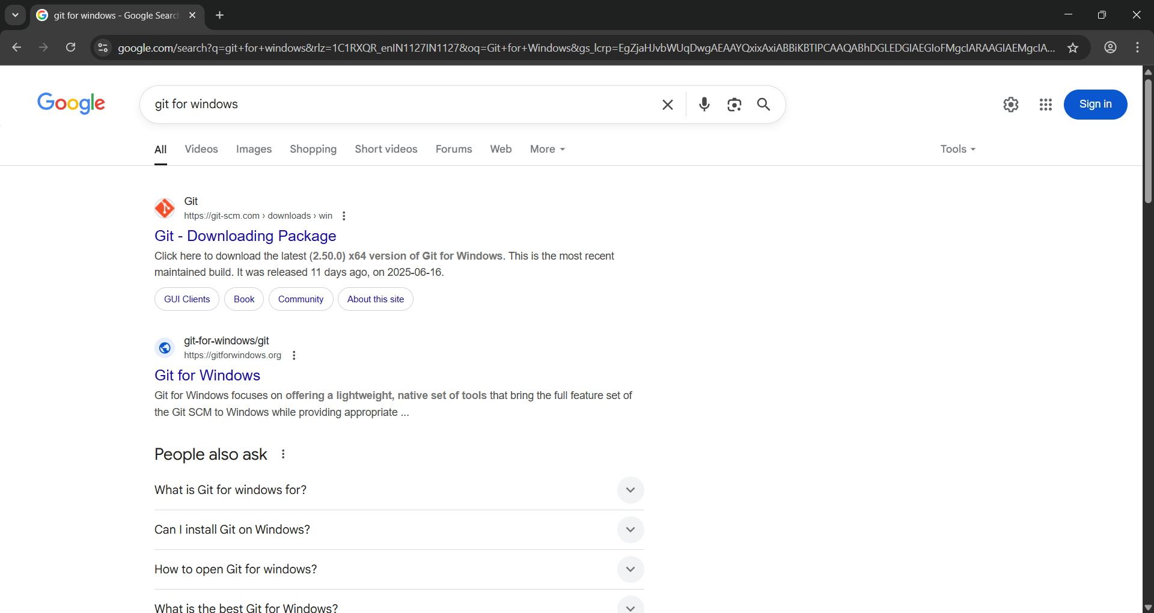

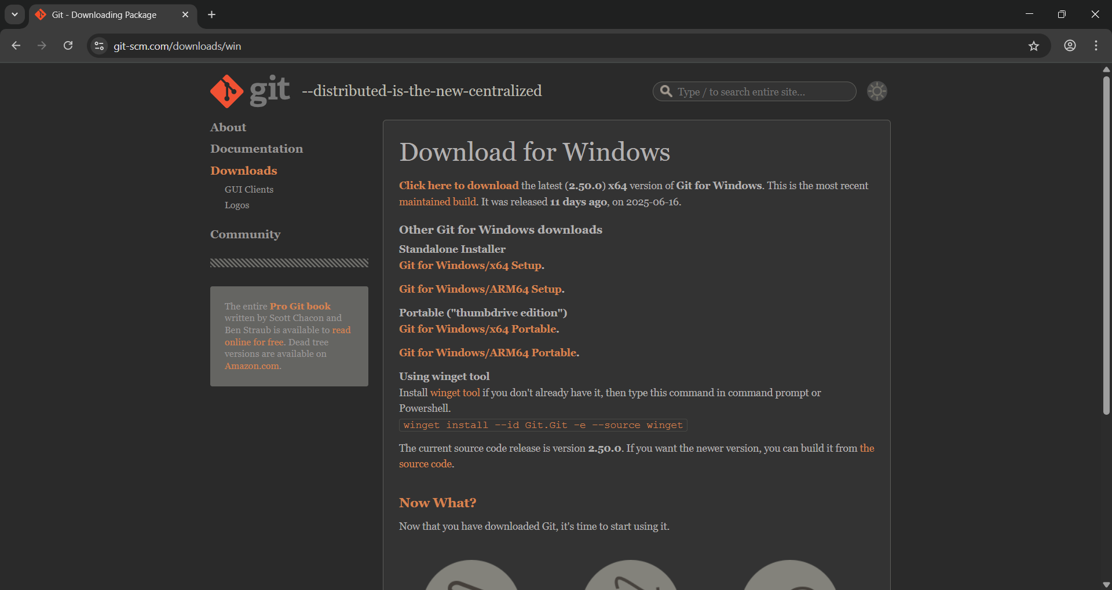

Click the hyperlink that says "Click here to download" to download the latest version of Git.

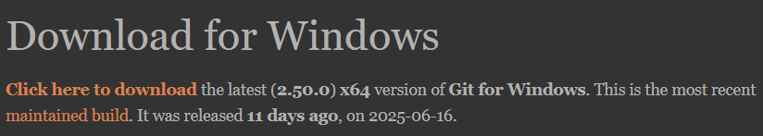

Alternatively, you can use the winget tool to install Git. Just run the following command in Command Prompt or PowerShell:

winget install --id Git.Git -e --source winget

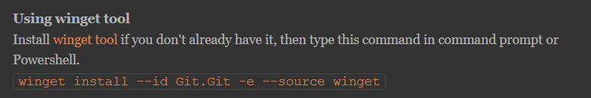

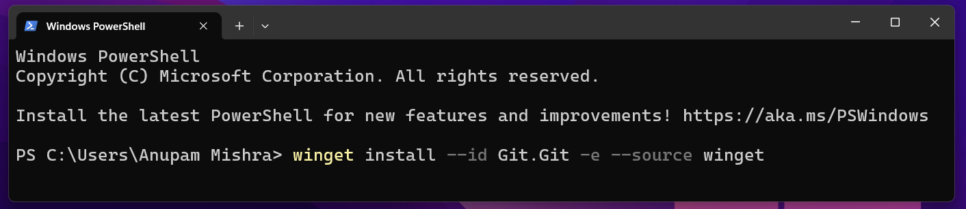

Step 2: Install Git on Windows

After the download finishes, double-click the installer file to start installing Git.

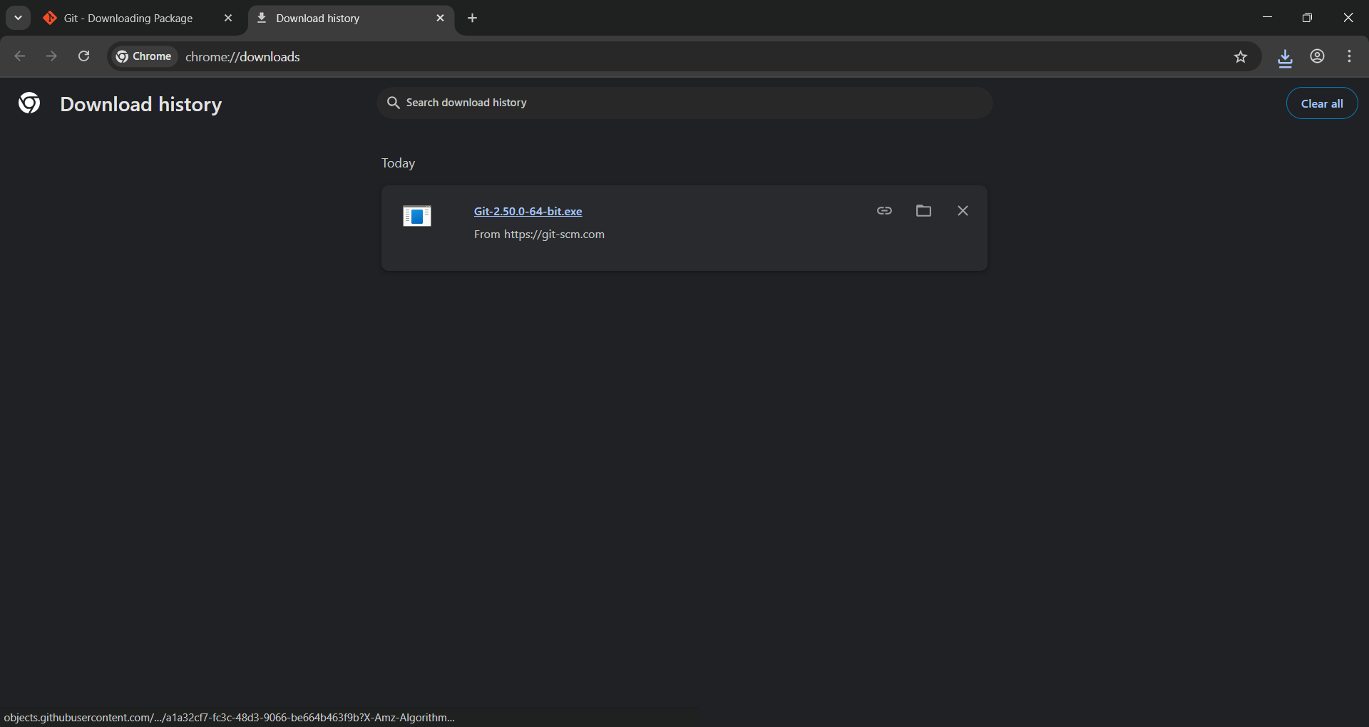

Once the Git Setup window opens, click the Next button to continue the installation.

During installation, you need to select the default options. This includes ensuring that the PATH environment variable is set correctly so you can use Git from the command line.

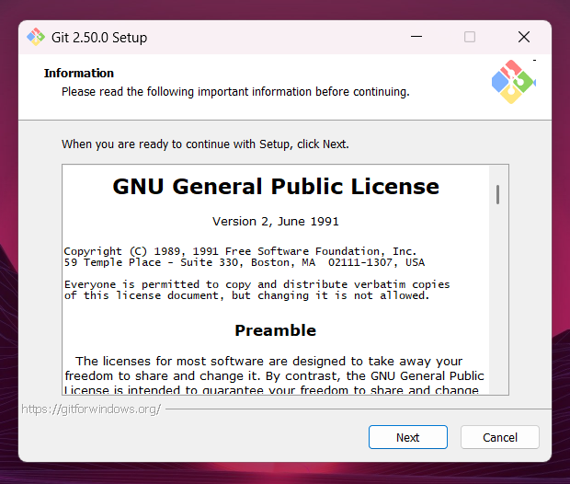

On the Select Components screen, make sure the Windows Explorer integration option is selected. This allows you to right-click in folders and open Git Bash or Git GUI directly from the context menu.

Also, under Additional icons, check In the Quick Launch to add a shortcut to the Quick Launch bar.

You can also check On the Desktop if you want a Git shortcut on your desktop.

Once done, click Next to continue.

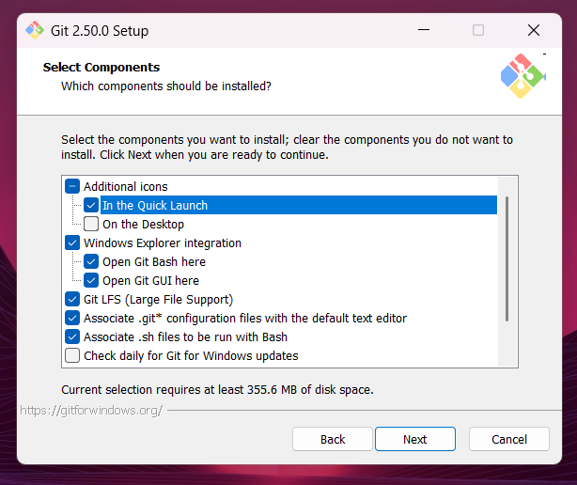

On the Choosing the default editor screen, If you have a preferred text editor like Visual Studio Code or Notepad++, select it here. If you're unsure, the default Vim editor is a safe choice, but you can change it later.

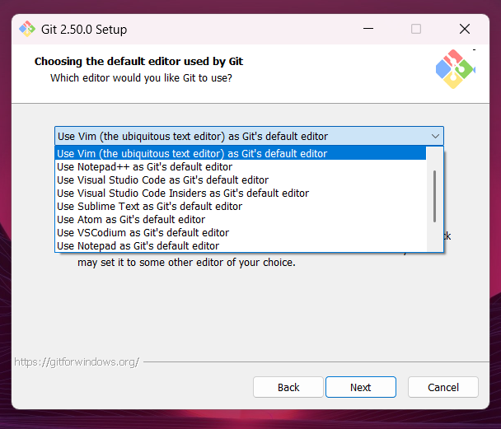

On the Adjusting the name of the initial branch screen, you can leave the default option selected as Let Git decide.

This means Git will use its default branch name when you create a new repository.

Click Next to continue.

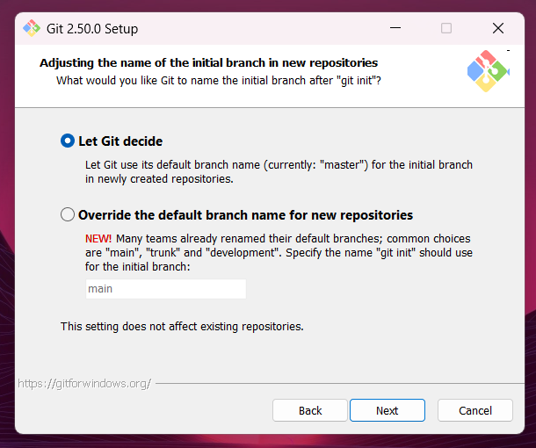

On the Adjusting your PATH environment screen, choose Git from the command line and also from 3rd-party software.

This lets you use Git not only from Git Bash, but also from Command Prompt, PowerShell, and other tools that rely on Git being available in the system PATH.

This option gives the most flexibility without messing up existing Windows tools.

Click Next to continue.

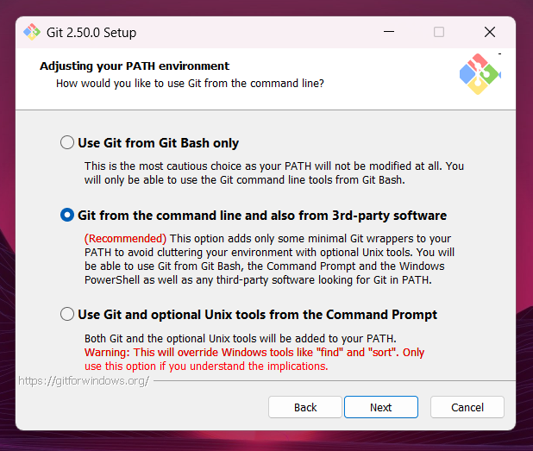

On the Choosing the SSH executable screen, keep the default option as Use bundled OpenSSH.

This uses the SSH client that comes with Git, so you don’t need to worry about setting up anything extra or messing with system paths.

Only choose Use external OpenSSH if you already have your own SSH setup and know how to manage it.

Click Next to continue.

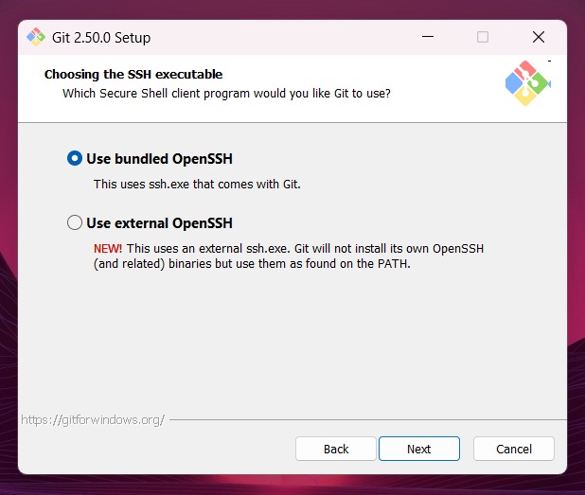

On the Choosing HTTPS transport backend screen, keep the default option as Use the OpenSSL library.

This means Git will validate HTTPS connections using its own certificate bundle, which works well in most situations.

Only choose Use the native Windows Secure Channel library if you work in a corporate environment where internal certificates are managed by Windows.

Click Next to continue.

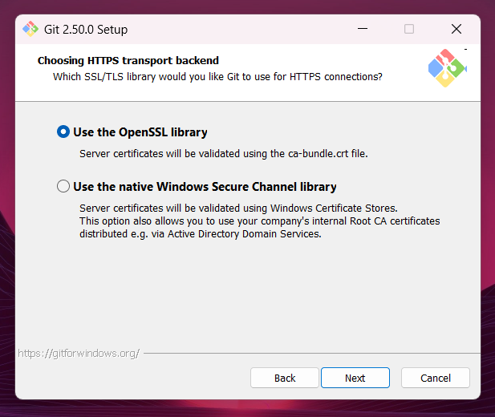

On the Configuring the line ending conversions screen, choose Checkout Windows-style, commit Unix-style line endings.

This setting converts line endings to Windows-style (CRLF) when you check out code, and to Unix-style (LF) when you commit — making your commits more consistent and compatible with Linux/macOS systems.

This is the safest choice if you're collaborating with people on other operating systems.

Click Next to continue.

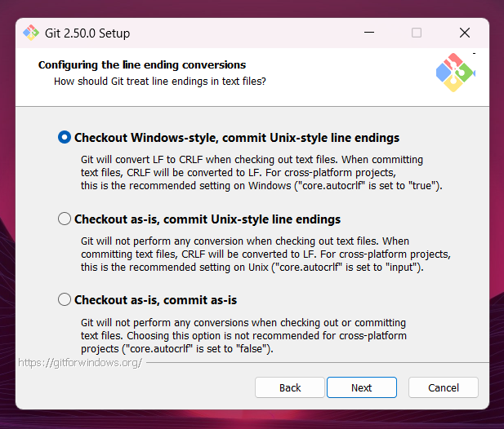

On the Configuring the terminal emulator to use with Git Bash screen, choose Use MinTTY (the default terminal of MSYS2).

MinTTY gives you a better terminal experience: it’s resizable, supports Unicode, allows non-rectangular selections, and looks cleaner than the default Windows command prompt.

This is the default and recommended choice for Git Bash.

Click Next to continue.

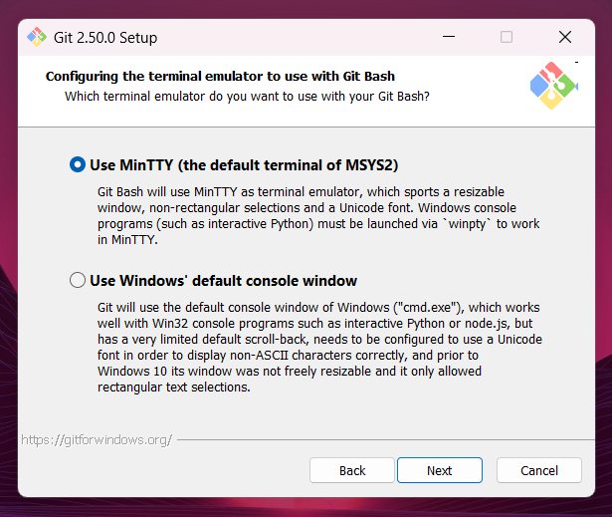

On the Choose the default behavior of git pull screen, select Fast-forward or merge.

This option attempts to fast-forward the current branch to match the fetched branch when possible. If a fast-forward isn’t possible, it will create a merge commit instead.

This is the recommended choice for users who prefer to preserve the full context of their changes, including explicit merge commits when necessary. It provides a balance between a clean history and complete visibility of integration points.

Click Next to continue.

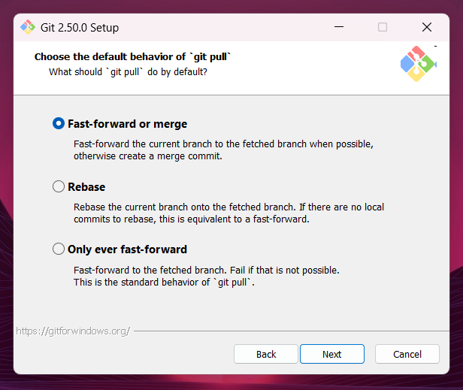

On the Choose a credential helper screen, select Git Credential Manager.

The Git Credential Manager securely stores your Git credentials such as usernames and personal access tokens so you don’t have to enter them every time you interact with a remote repository over HTTPS.

This is the recommended and default option for Windows users, as it simplifies authentication securely and automatically.

Click Next to continue.

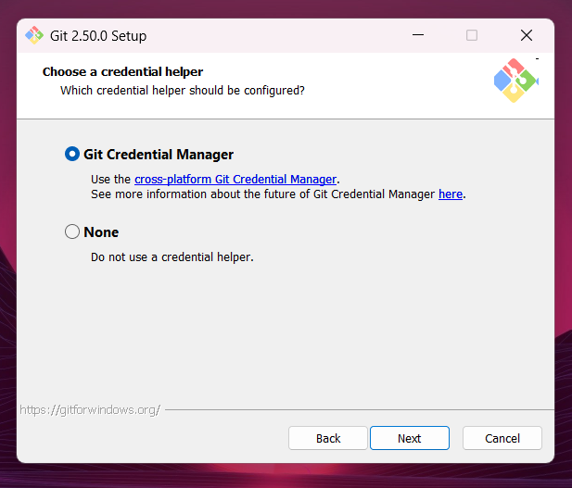

On the Configuring extra options screen, keep the checkbox Enable file system caching selected.

This feature allows Git to cache file system data in memory for certain operations, which improves performance.

This is enabled by default and is recommended for better speed and responsiveness during Git operations.

After confirming your choices, click Install to proceed with the installation.

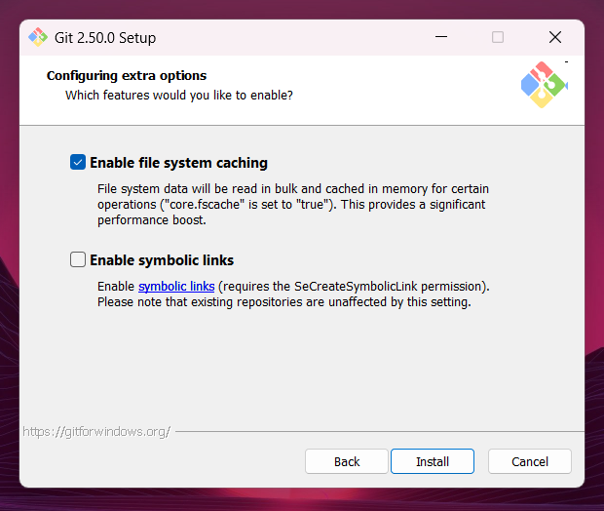

Once you click Install, the setup will begin copying files and configuring Git on your system.

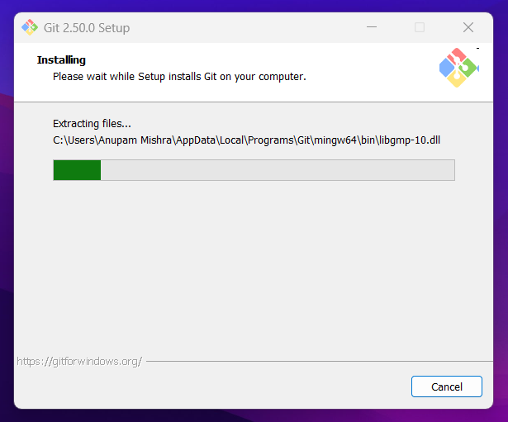

Once the progress bar reaches 100%, you’ll be taken to the final completion screen.

At this point, Git has been successfully installed on your system.

Unless you specifically want to launch Git Bash right away or read the release notes, it’s best to leave both checkboxes unchecked.

Click Finish to exit the setup wizard.

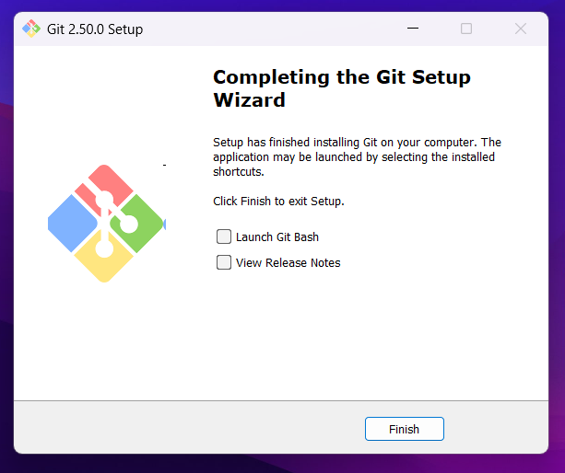

2. Verify Git Installation:

After installing Git, you can verify that it’s properly installed. To do this:

Open Git Bash which was installed along with Git and run the following command:

git --version

This command will display the version of Git that you’ve installed, confirming that Git is set up and ready to use.

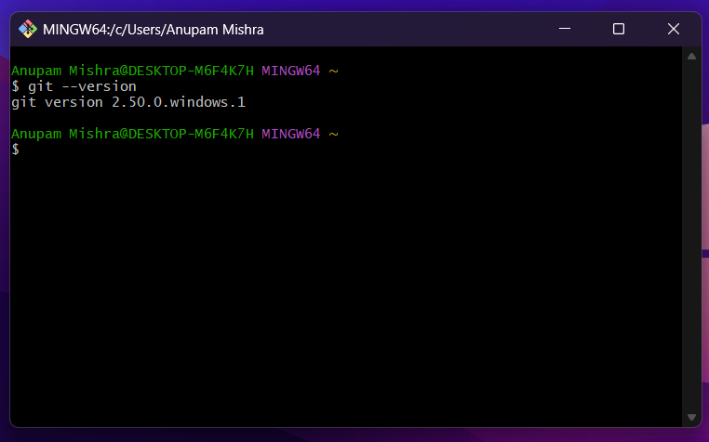

3. Text Editor or IDE:

Although not strictly required, using a text editor or IDE can make working with Git easier and more efficient. Some popular options include:

VS Code: Download Visual Studio Code

Sublime Text: Download Sublime Text

Atom: Download Atom

These editors can help you edit your code while seamlessly integrating with Git for version control.

4. Git Bash:

We’ll be using Git Bash to execute Git commands throughout this guide. Git Bash is included with the Git for Windows installation and offers a terminal experience similar to a Unix shell. It makes running Git commands on Windows much easier and more familiar, especially if you're used to working in a Linux or macOS environment.

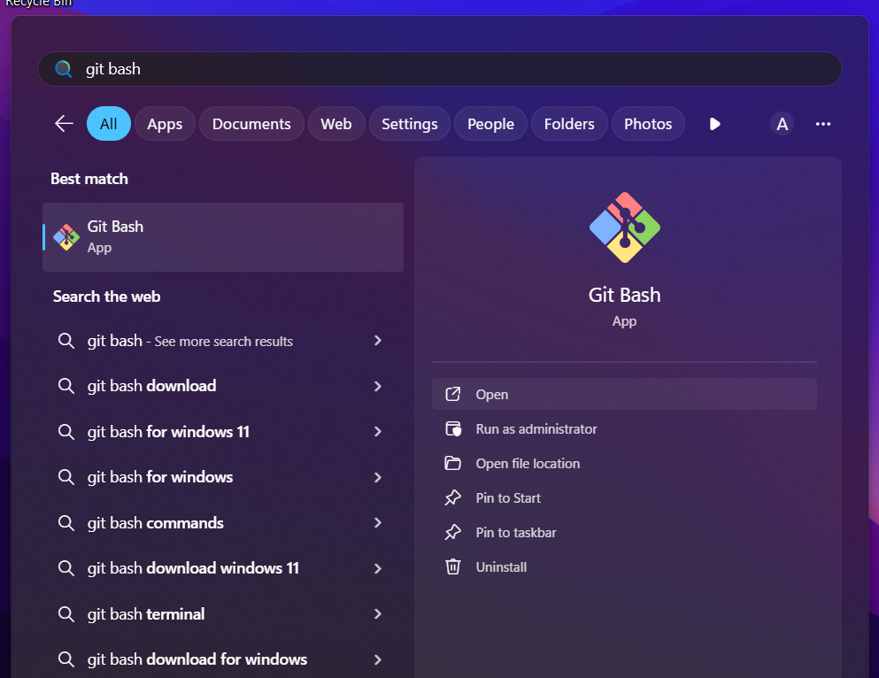

Once Git and Git Bash are installed and a text editor or IDE is set up, we’ll be ready to start using Git for version control on our Windows machine!

Initialize and Configure Git Repositories

Problem Statement:

Set up Git in a new project folder and configure your personal details so Git can associate your commits with you.

Steps:

1. Open Git Bash:

Press Windows + S, search for Git Bash, and hit Enter.

2. Create a directory for your project:

mkdir my_git_project

cd my_git_project

3. Initialize Git in this directory:

git init

4. Configure your Git username and email:

git config --global user.name "Your Name"

git config --global user.email "youremail@example.com"

5. Confirm your settings:

git config --list

Topics Covered:

- Repository initialization
- User identity configuration

