Set up Git Hooks for Pre-commit Validation

Problem Statement:

In collaborative software development, it's crucial to maintain code quality, consistency, and a clean commit history. Developers might accidentally commit work-in-progress code, malformed commit messages, or code that doesn't follow style guides. Git Hooks are scripts that Git executes automatically before or after events like committing, pushing, or receiving commits.

A pre-commit hook is particularly powerful because it runs before a commit is finalized. This allows you to perform automated checks and prevent a commit from being created if it fails these checks. This ensures only high-quality, valid code makes it into your repository's history.

This hands-on exercise will guide you through setting up a simple pre-commit hook to enforce a minimum commit message length and detect trailing whitespace in your files.

Steps:

Before you begin, ensure you have:

- Git installed locally.
- A local Git repository.
- A text editor like VS Code.

We will perform all steps using Git Bash and a text editor.

Step 1: Navigate to Your Local Repository's Hooks Directory

Git hooks are simple executable scripts located in a special directory within your local .git folder.

To access the place where Git looks for hook scripts. Each Git repository has its own set of hooks, making them local to that specific repository.

1. Open Git Bash:

Search for Git Bash in your Windows Start Menu and open it.

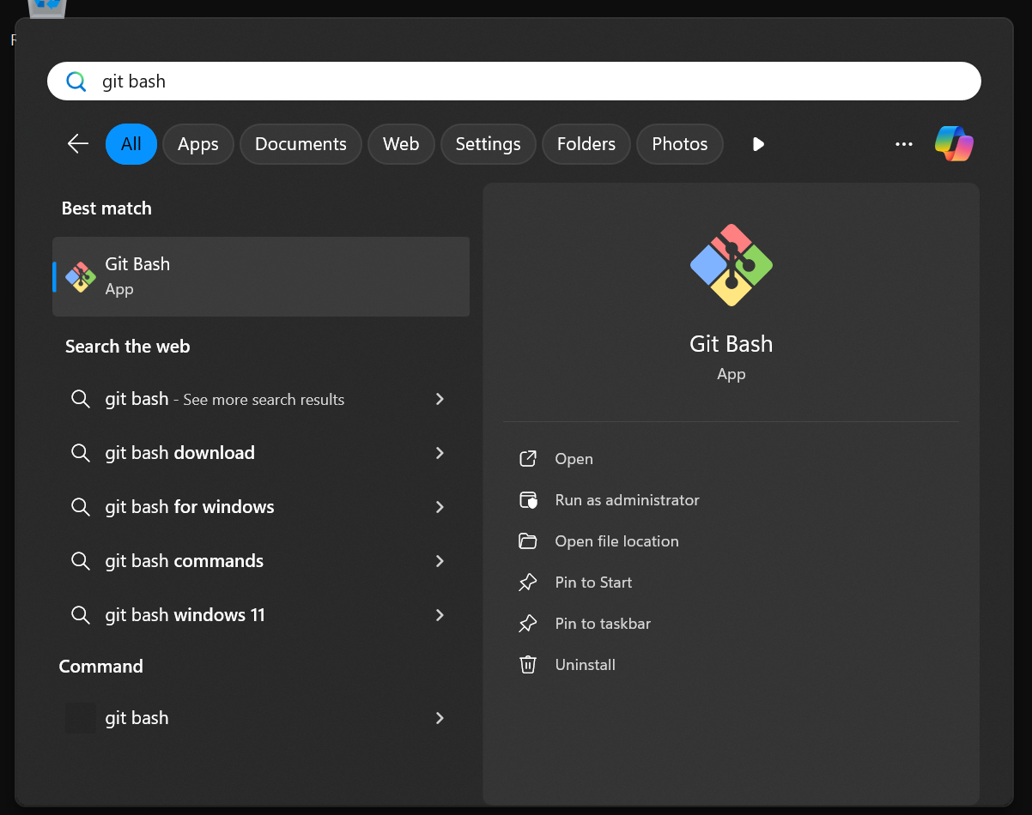

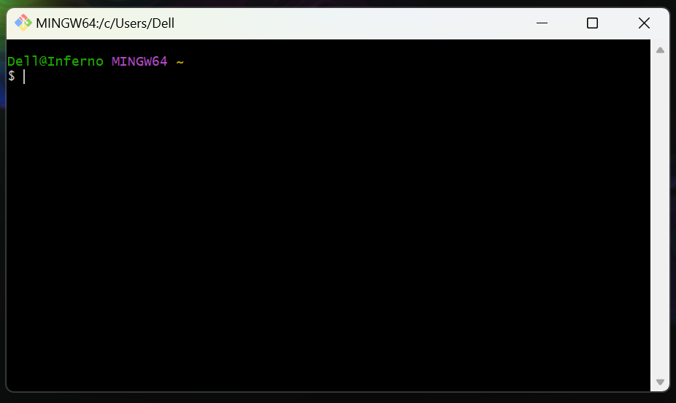

2. Navigate to Your Local Repository:

Go to the root directory of your project.

cd /c/Users/Dell/Documents/github-projects/create-a-repository

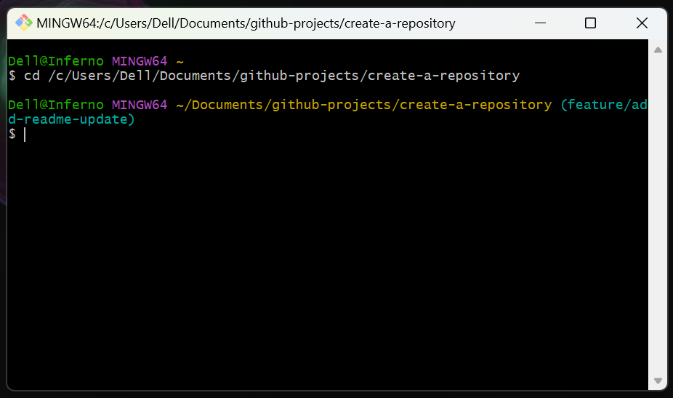

3. Navigate into the .git/hooks directory:

From the root of your repository, enter the hooks directory:

cd .git/hooks

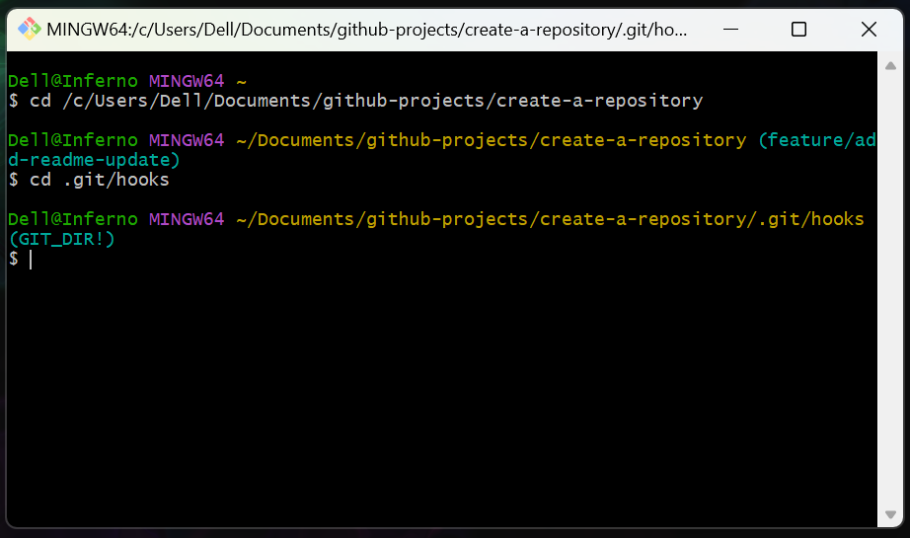

The .git directory is a hidden folder where Git stores all its internal metadata, including hooks.

4. List existing hook samples:

Type ls or ls -la to see the contents of this directory.

ls -la

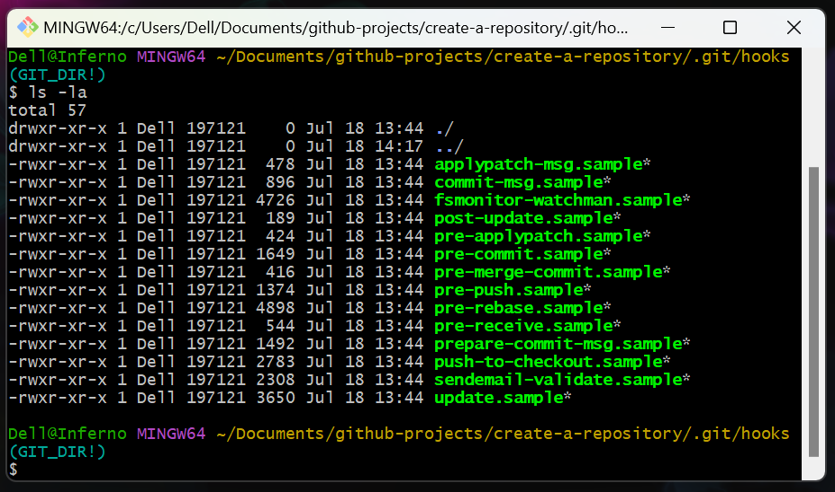

You will see several files ending with .sample. These are example hook scripts provided by Git.

Step 2: Create Your pre-commit Hook Script

To activate a hook, you remove the .sample extension from its name and make it executable. We will use the pre-commit hook.

We're setting up the script that Git will automatically run before you create any new commit.

1. Copy and Rename the sample hook:

Create an executable copy of the pre-commit.sample file by renaming it:

cp pre-commit.sample pre-commit

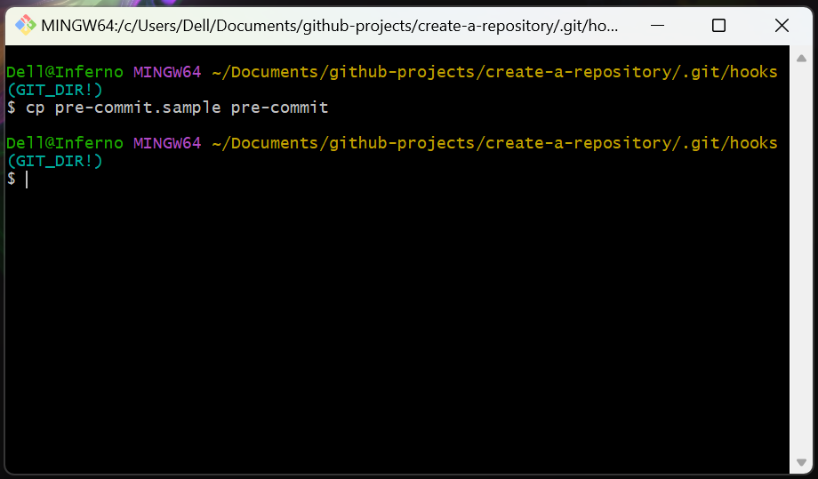

This creates a new file named pre-commit from the sample. On Windows Git Bash, this usually makes it executable enough for Git's purposes when it's just a simple shell script.

2. Open the pre-commit file in your text editor:

While still in the .git/hooks directory in Git Bash, open the new pre-commit file:

For VS Code: code pre-commit

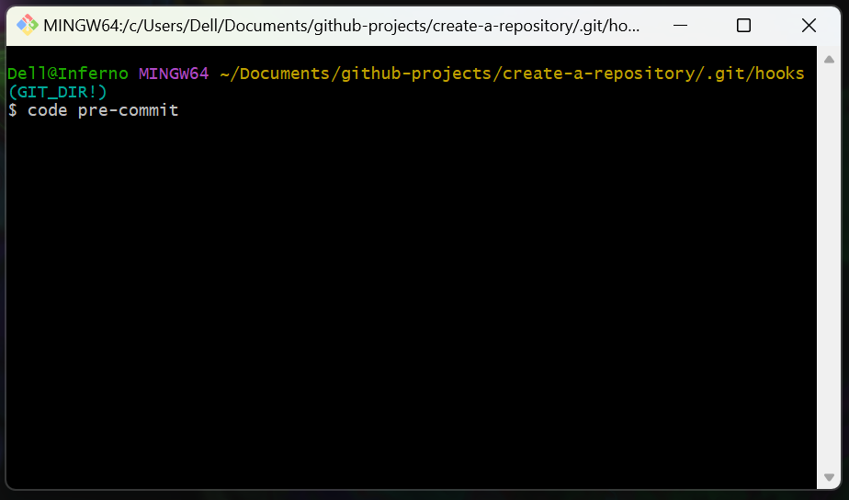

For Notepad: notepad pre-commit

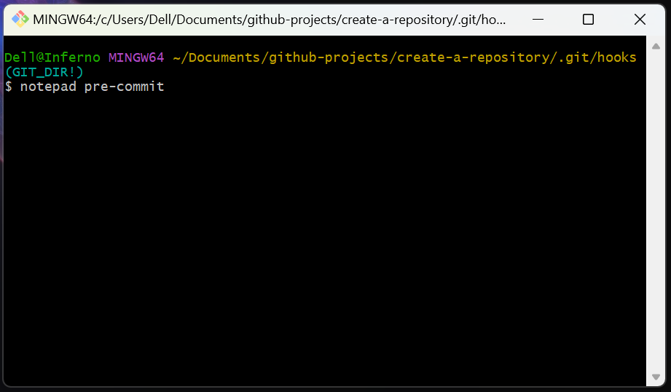

Note: If prompted to create a new file, ensure you are in the correct directory. You should be opening the file you just created.

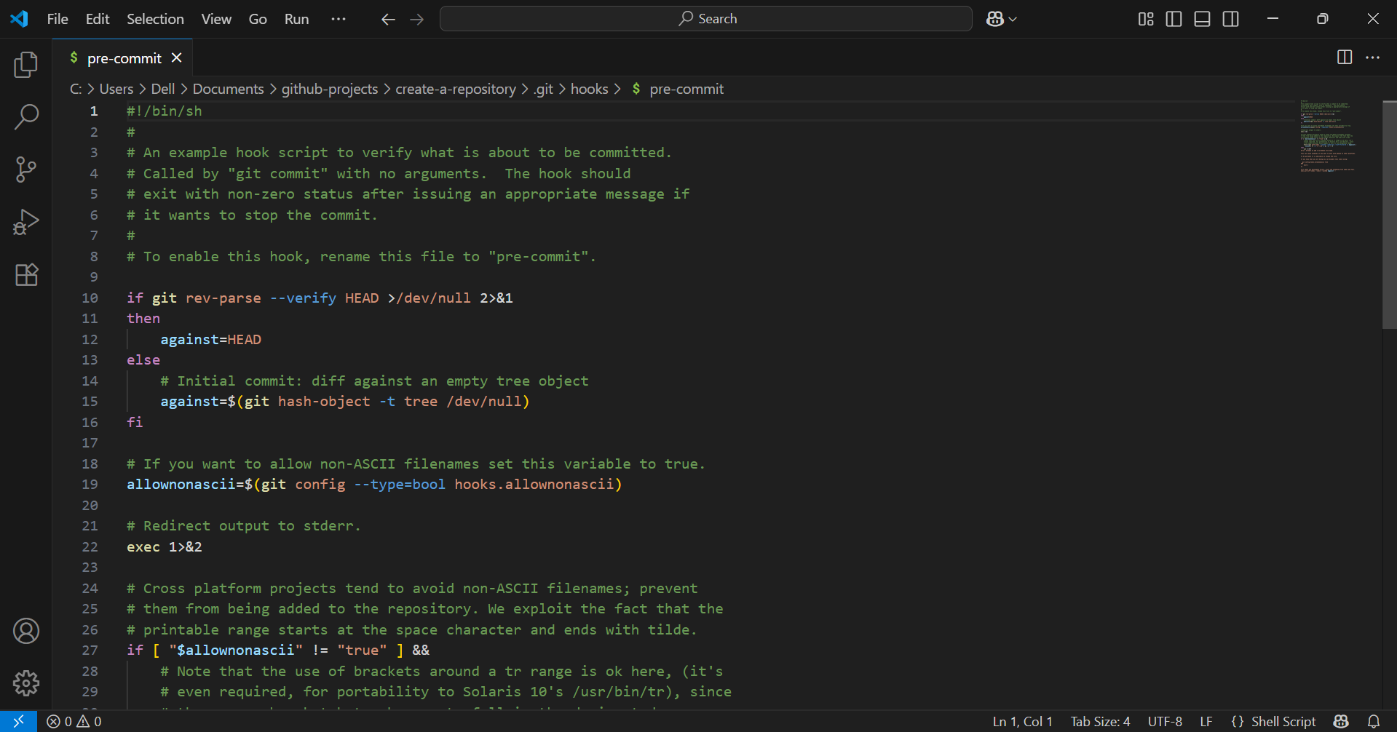

3. Replace the file content with the following simple validation script:

Delete any existing content in the pre-commit file and paste this script.

#!/bin/sh
#
# A simple pre-commit hook to:
# 1. Prevent trailing whitespace in staged files.

# --- 1. Check for Trailing Whitespace ---
# `git diff --cached --check`: Checks for trailing whitespace in staged files.
# The --check option will exit with non-zero status if problems are found.
if ! git diff --cached --check; then
echo "---------------------------------------------------------"
echo "ERROR: Trailing whitespace detected in staged files!"
echo " Please remove trailing whitespace before committing."
echo "---------------------------------------------------------"
exit 1 # Abort the commit
fi

# If all checks pass, allow the commit
exit 0

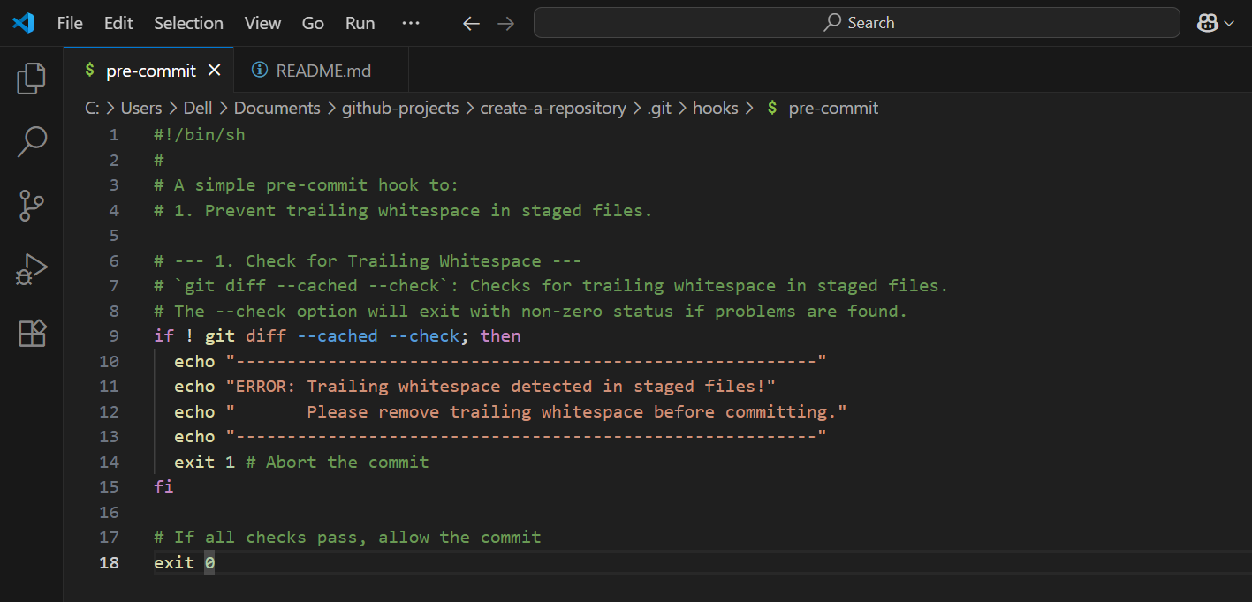

- #!/bin/sh: This is the shebang line, which tells the system to execute this script using the sh (shell) interpreter.
- git diff --cached --check: This is a built-in Git command that specifically checks for common issues like trailing whitespace in staged files (files you've added with git add). If it finds any problems, it exits with a non-zero status, indicating a failure.
- if ! git diff --cached --check; then ... exit 1: This block checks the exit status of the git diff command. If git diff --cached --check finds trailing whitespace (meaning it "fails" and exits with a non-zero status), the ! (negation) makes the if condition true. It then prints an error message to the console and exit 1, which tells Git to abort the commit.
- exit 0: If all checks pass (in this case, only the trailing whitespace check), exit 0 tells Git that the hook succeeded, and the commit can proceed normally.

Make sure to save the file after pasting the content!

Step 3: Test the pre-commit Hook (Failure Scenario)

Now, let's try to commit something that violates our new hook's rules to see it in action.

To confirm the hook is working and effectively preventing undesirable commits.

1. Navigate back to the root of your repository:

cd ../..

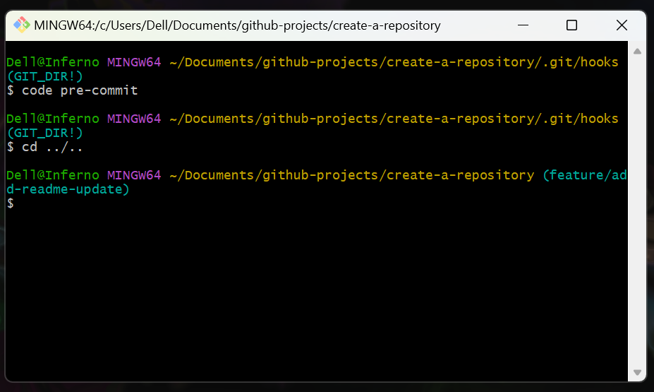

2. Make a change with trailing whitespace:

Open README.md in your text editor.

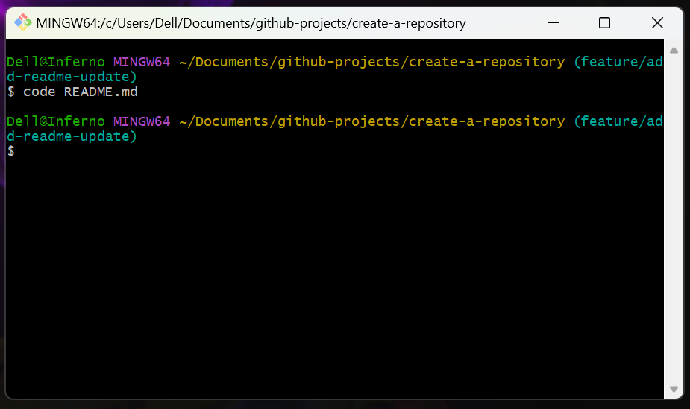

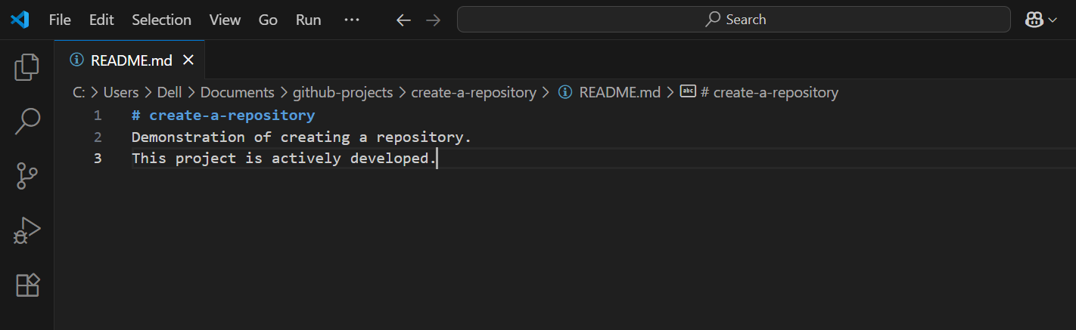

Add a new line at the end, but purposefully add some spaces after your text. For example:

This line has trailing spaces.

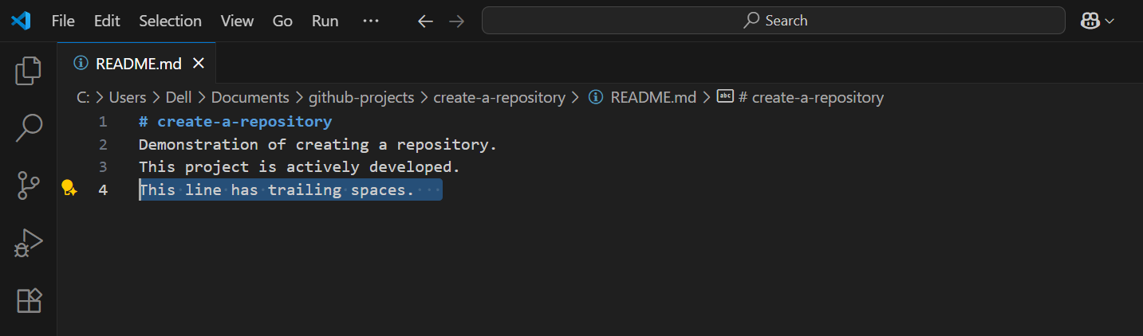

Note: Make sure to actually type spaces after spaces.

Save the file.

3. Attempt to commit with trailing whitespace:

Stage the change:

git add README.md

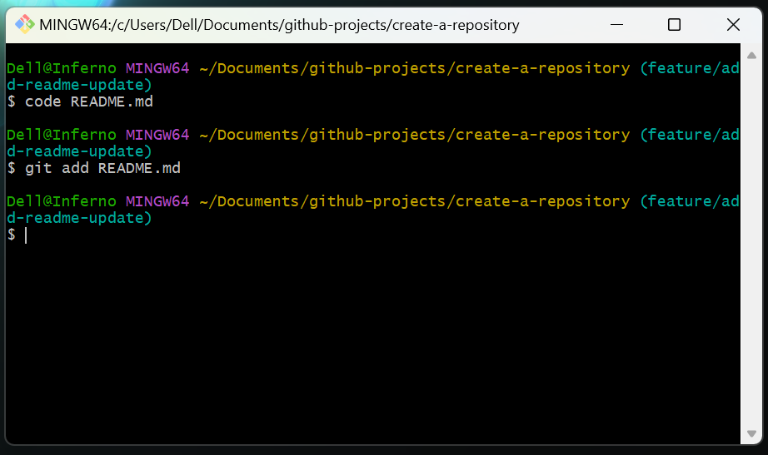

Try to commit with a very short message (Fix):

git commit -m "Fix"

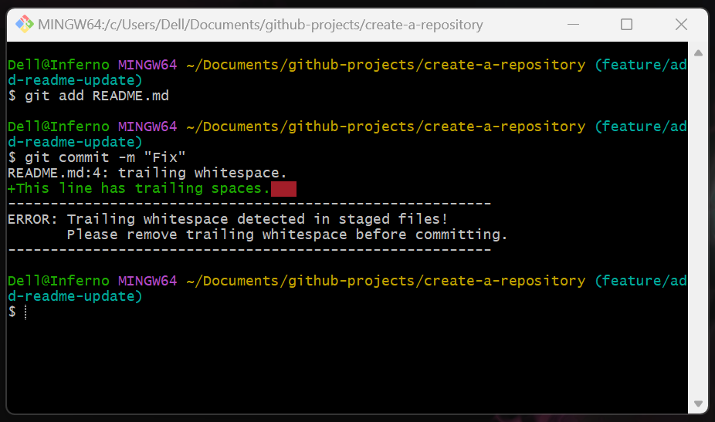

The pre-commit hook will run. You should see the error messages about the trailing whitespace. The commit will be aborted.

Step 4: Test the pre-commit Hook (Success Scenario)

Now, let's fix the issue and commit successfully. Let’s demonstrate that once the rules are followed, the commit proceeds as normal.

1. Fix the trailing whitespace:

Open README.md in your text editor again.

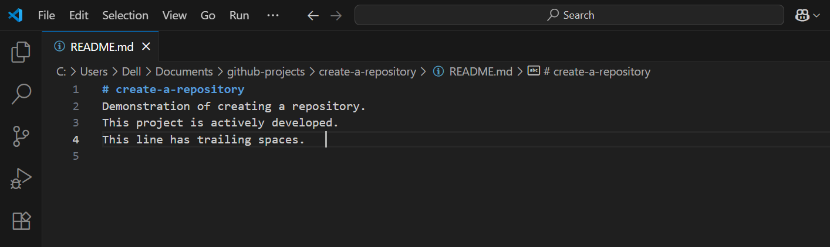

Remove the extra spaces at the end of the line you added. Ensure there are no spaces after the last character of the text on that line.

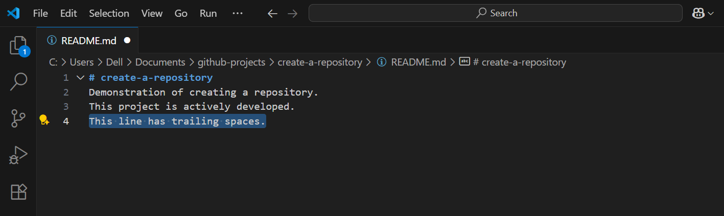

Save the file.

2. Stage the fixed change:

You need to restage the file after fixing it, as git commit only operates on the staged version of the file.

git add README.md

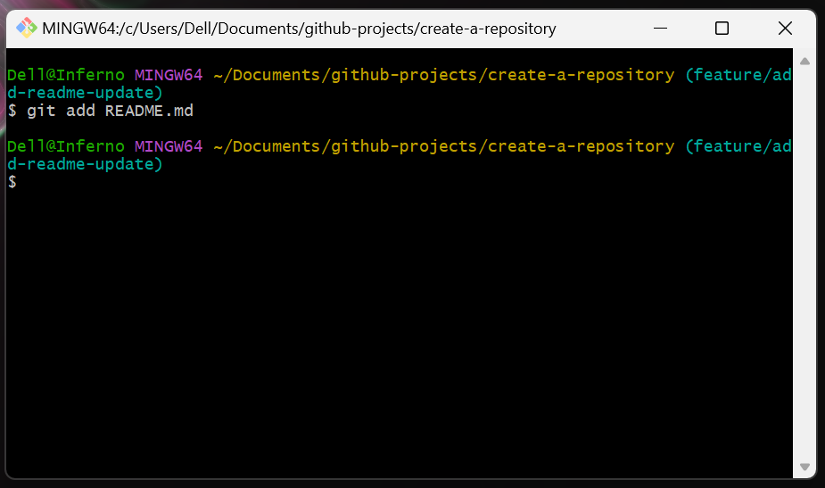

3. Commit with a valid message:

Try to commit with a meaningful message:

git commit -m "docs: Remove trailing whitespace from README"

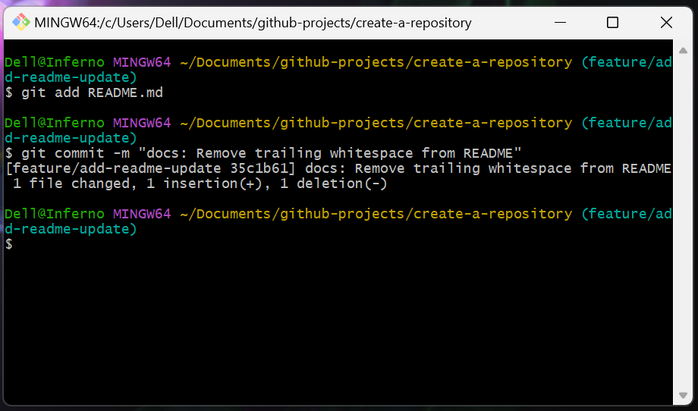

4. Observe the output:

The pre-commit hook will run, but this time it will pass. The commit will be created successfully.

[<your-primary-branch> <commit-hash>] docs: Remove trailing whitespace from README
1 file changed, 1 insertion(+)

The exact output might vary slightly, but it should indicate a successful commit.

Step 5: (Optional) Disable or Remove the Hook

Git hooks are local and not version-controlled. If you want to temporarily disable a hook or remove it, it's straightforward.

1. To temporarily disable a hook for a single commit:

You can bypass all pre-commit hooks for a single commit using the --no-verify flag:

git commit --no-verify -m "This commit will bypass hooks"

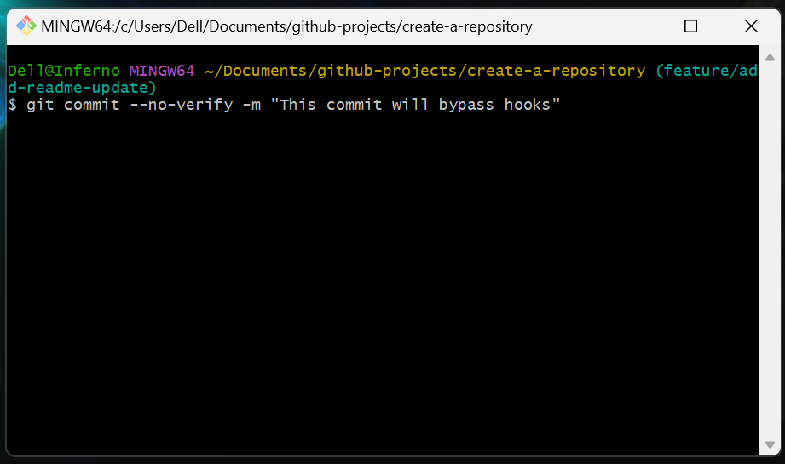

Caution: Use this sparingly, as it bypasses the very checks you set up for quality.

2. To disable the hook permanently (but keep the file):

In Git Bash, navigate back to the .git/hooks directory:

cd /c/Users/Dell/Documents/github-projects/create-a-repository/.git/hooks

Rename the pre-commit file to something Git won't recognize as a hook:

mv pre-commit pre-commit.disabled

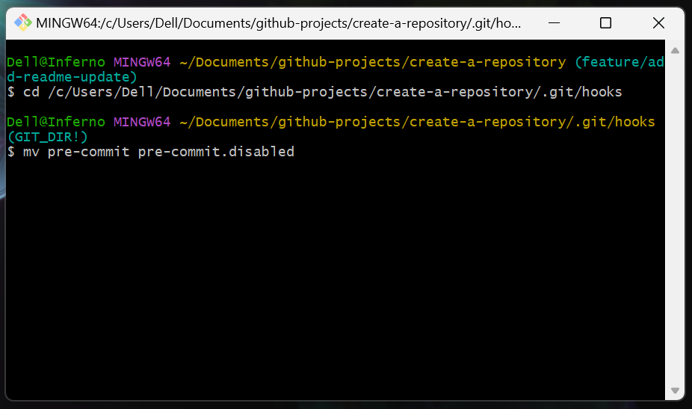

3. To completely remove the hook:

In Git Bash, from the .git/hooks directory:

cd /c/Users/Dell/Documents/github-projects/create-a-repository/.git/hooks

rm pre-commit

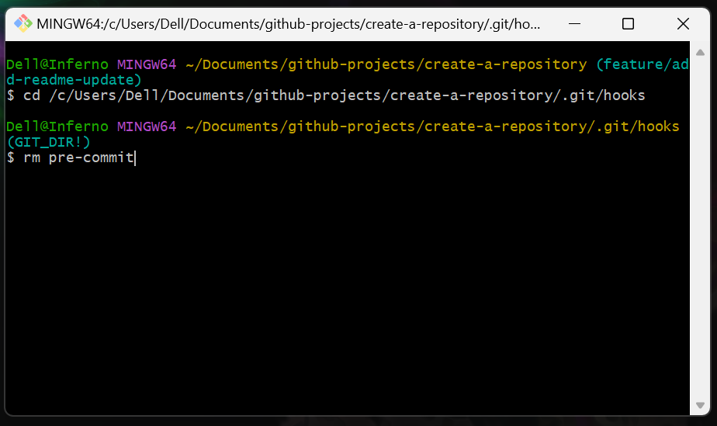

Topics Covered:

- Git Hooks Concept: Understanding what Git hooks are and their purpose.
- pre-commit Hook: Learning its specific function and execution timing.
- Local Nature of Hooks: Recognizing that hooks are specific to individual local repositories and not part of the versioned codebase.
- Creating Hook Scripts: Modifying sample scripts and writing simple shell scripts for validation.
- Common Pre-commit Checks: Implementing rules for preventing trailing whitespace.
- Hook Failure and Success: Observing how hooks prevent or allow commits based on validation results.
- Bypassing Hooks: Using --no-verify (with caution).
- Managing Hooks: Disabling or removing hooks.

