Set up GitHub Repositories and Teams

Problem Statement:

As a developer, you often work on projects with multiple team members. To collaborate effectively and manage access to your codebase, you need to:

- Create a centralized place (a repository) on GitHub to host your project's code.
- Organize your team members into teams within a GitHub organization.
- Grant these teams specific permissions to your repositories, ensuring everyone has the right level of access without individually managing each user.

This hands-on exercise will guide you through setting up a new GitHub Organization, creating a repository within it, forming teams, and then assigning those teams appropriate permissions to your repository.

Steps:

Before you begin, ensure you have completed the Prerequisites document, specifically having a GitHub Account.

We will perform all steps using the GitHub website interface.

Step 1: Create a GitHub Organization

Before creating teams and sharing repositories with them, it's best practice to group your repositories and teams under a GitHub Organization. An organization acts like a shared account for companies or large open-source projects, allowing for centralized management of multiple repositories, teams, and access policies.

You might ask, why not a personal account? Personal accounts are great for individual projects, but organizations provide features crucial for teamwork, such as granular team permissions, shared ownership, and auditing capabilities.

1. Log in to GitHub:

Open your web browser and go to https://github.com/login. Enter your username/email and password to log in.

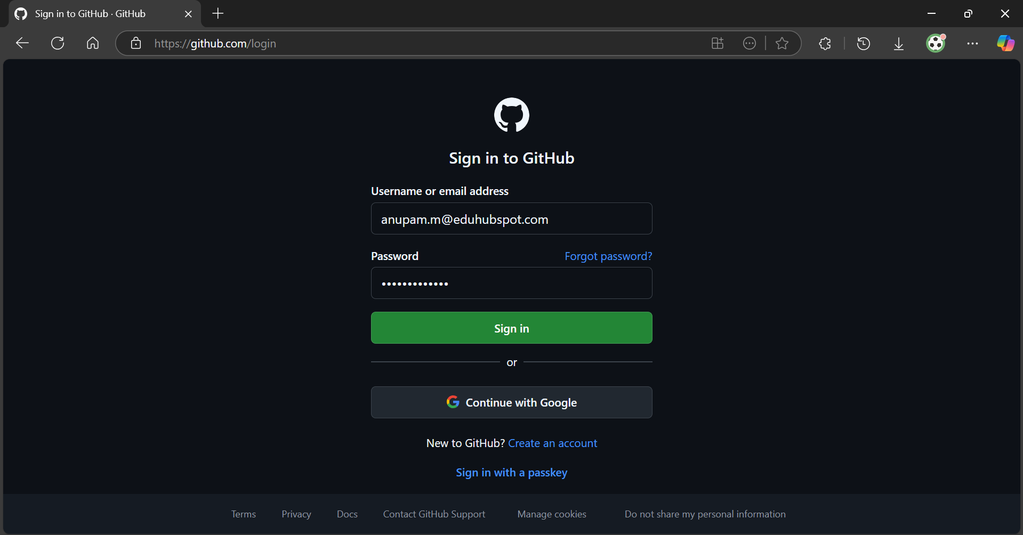

2. Navigate to Organizations:

In the top-right corner of the GitHub page, click on your profile picture.

From the dropdown menu, click on Your organizations.

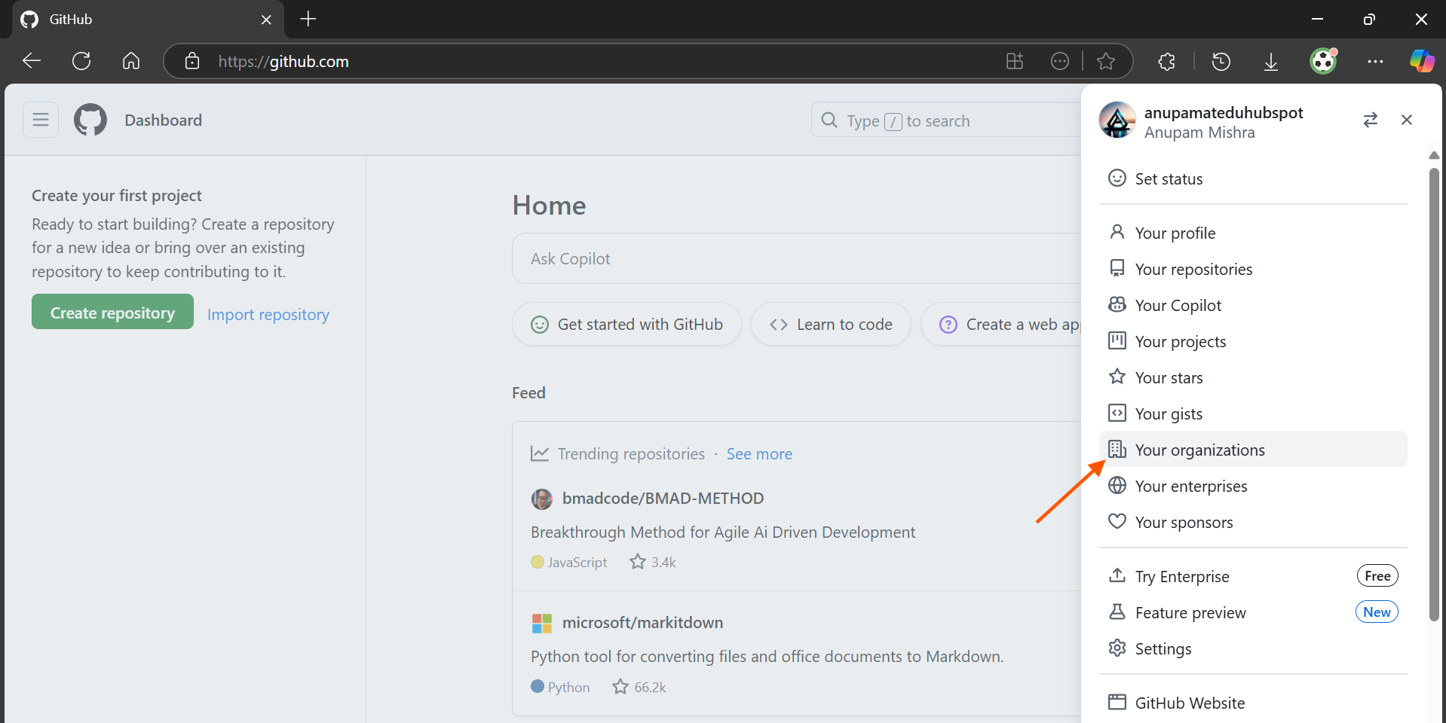

If you already have an organization, you'll see a list of your organizations. You can click on an existing one to use it, or create a new one if you prefer to start fresh.

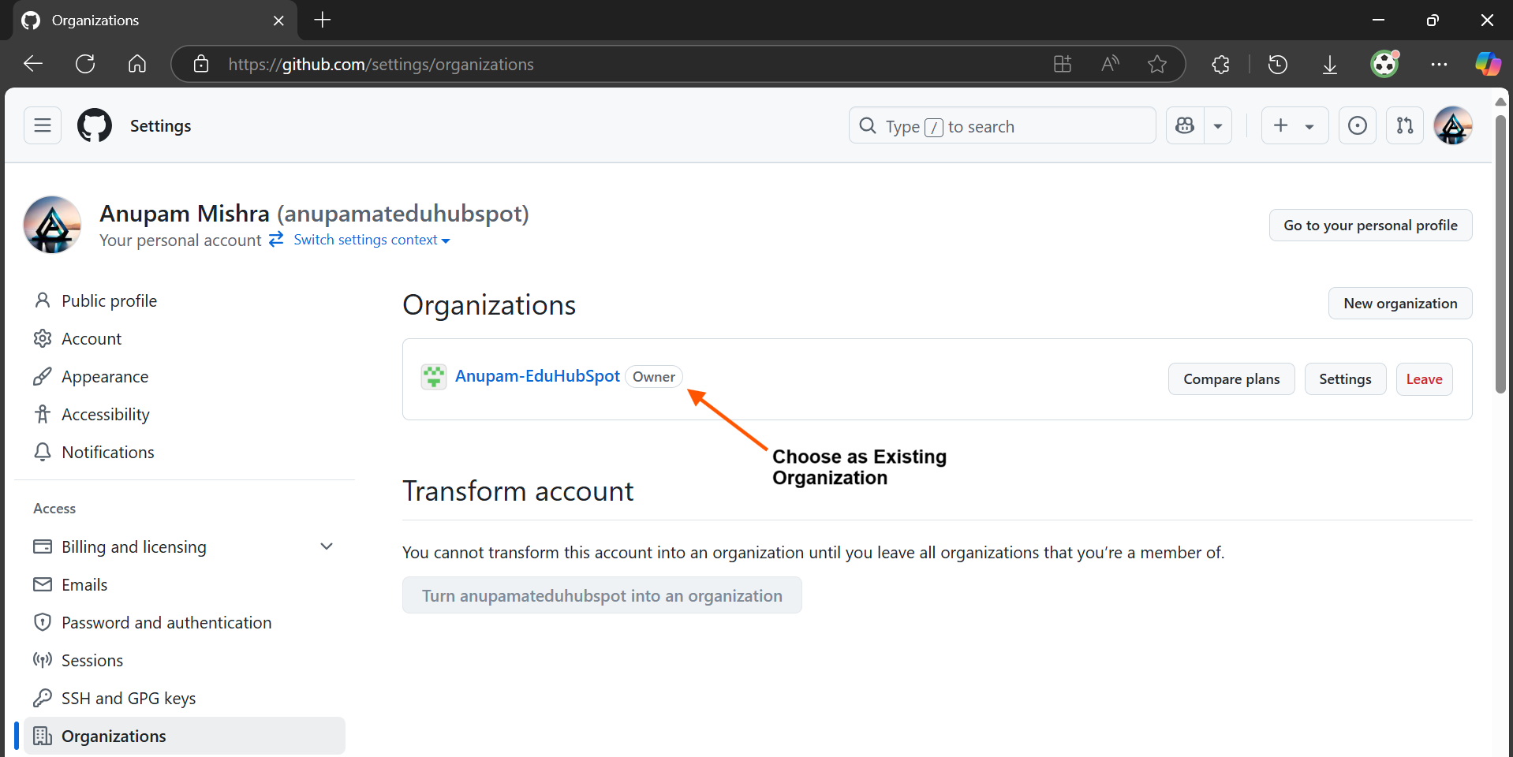

If you don't have any organizations, you'll see an option to create a new one.

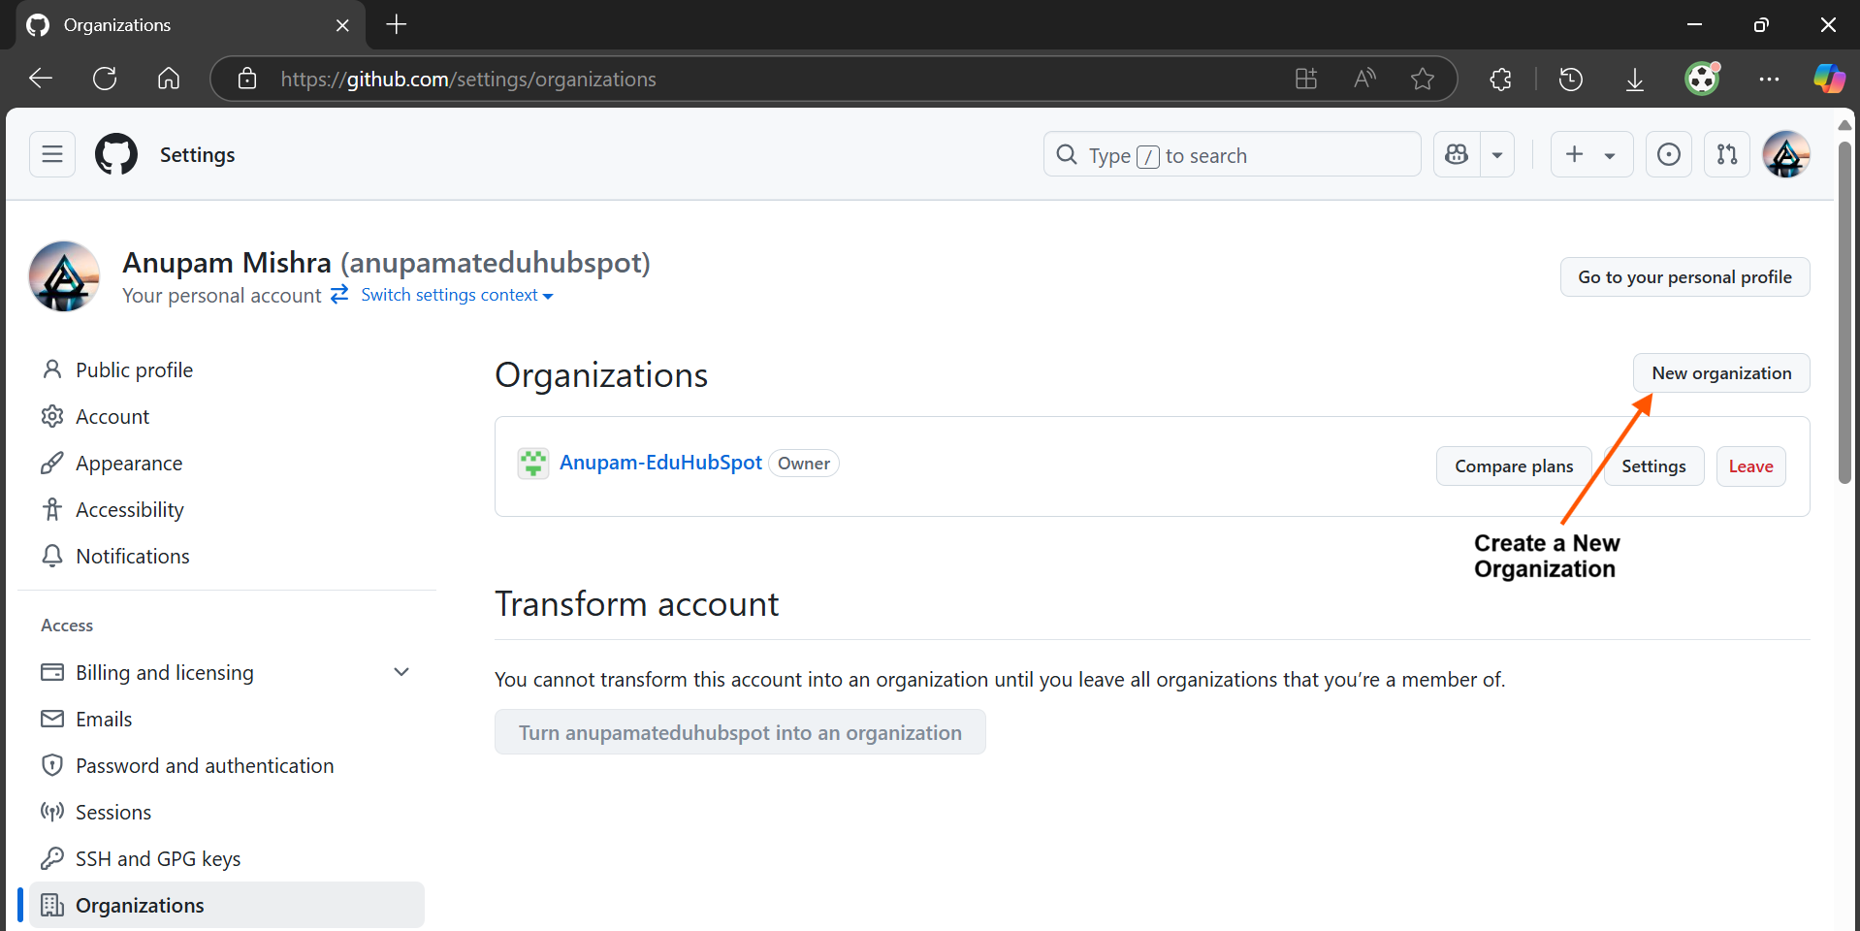

3. Create a New Organization:

Click the New organization button.

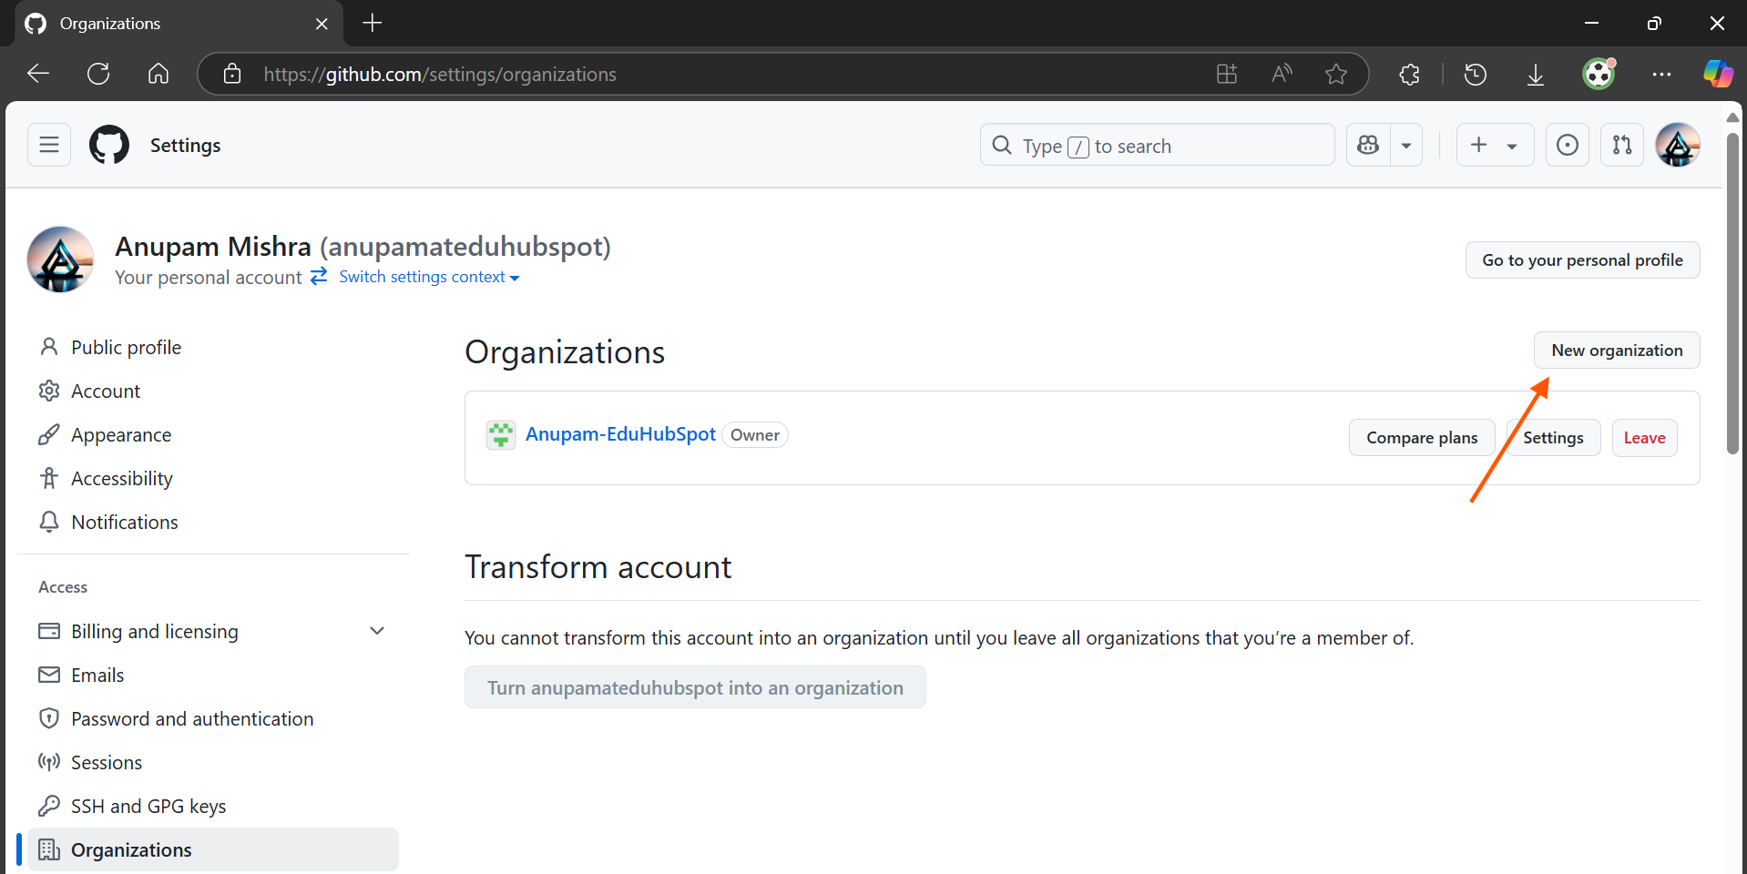

Select the Free plan for this hands-on. GitHub's free organization plan is sufficient for most team collaboration needs, including creating public and private repositories, teams, and basic access control.

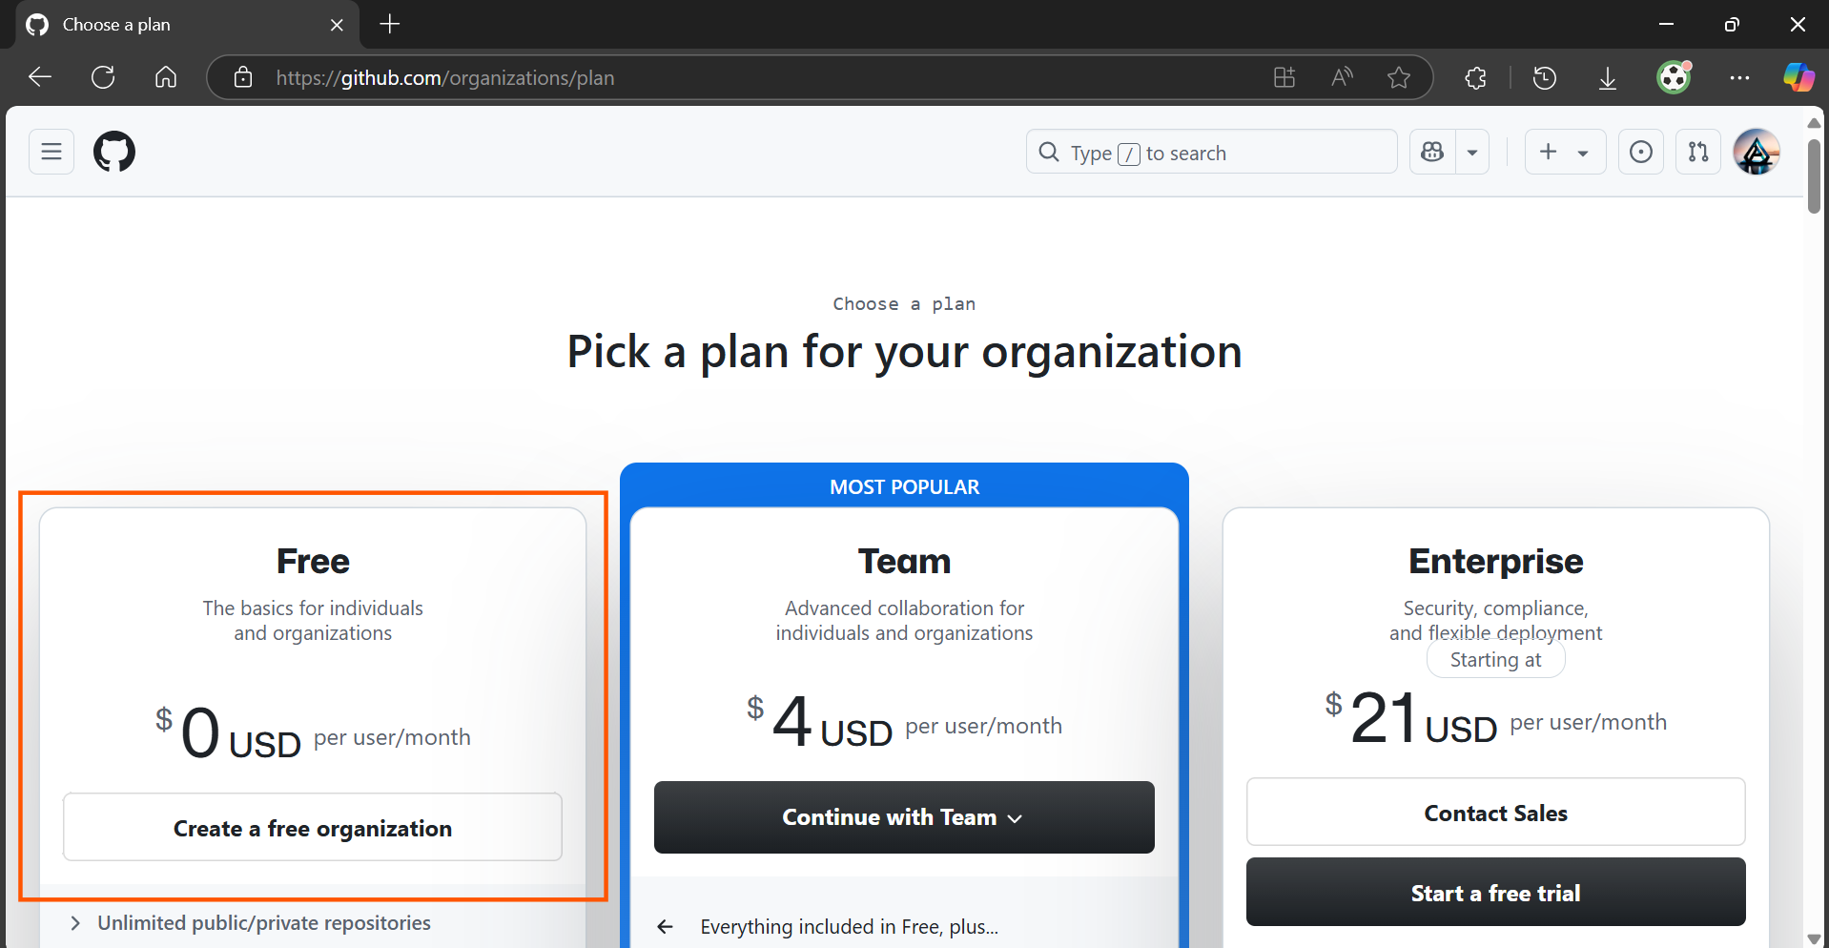

Enter a unique and descriptive name for your organization.

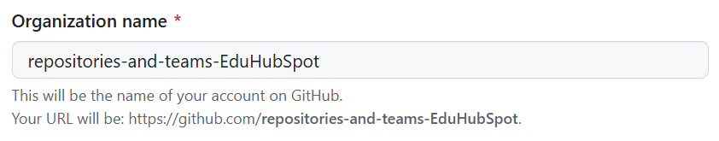

Provide your email address.



This organization can be owned by a personal account or a business. Select My personal account for this exercise.

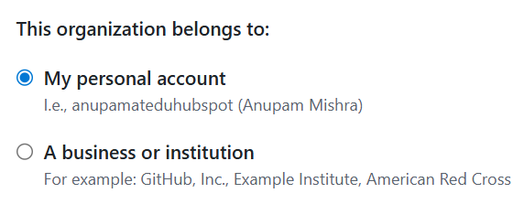

Accept the Terms of Service by clicking on the checkbox.

Click Next.

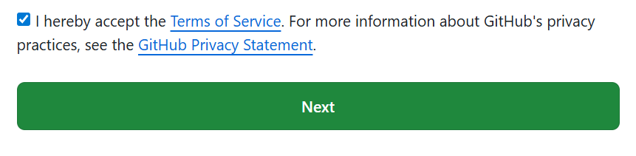

4. Invite Members:

You'll be prompted to invite members. For this hands-on, you can skip this step for now. We will add members when creating teams.

Click Skip this step to complete the organization creation process.

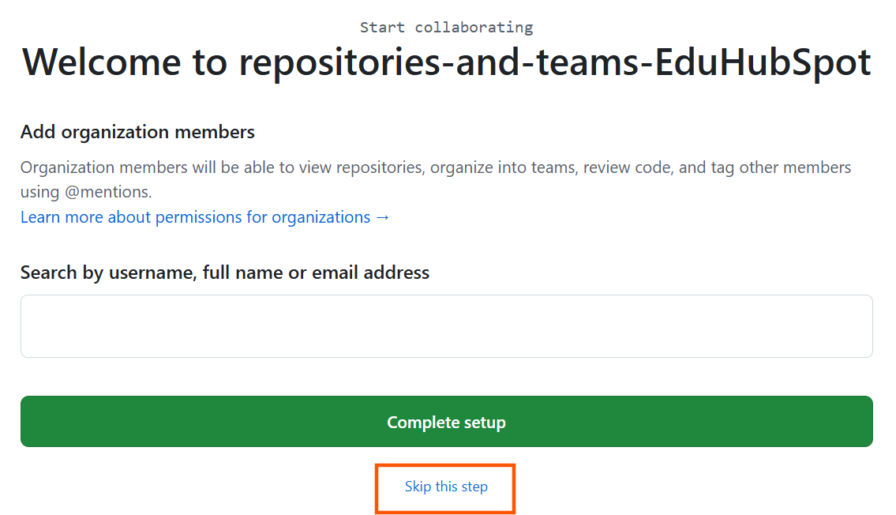

You should now be on your new organization's dashboard.

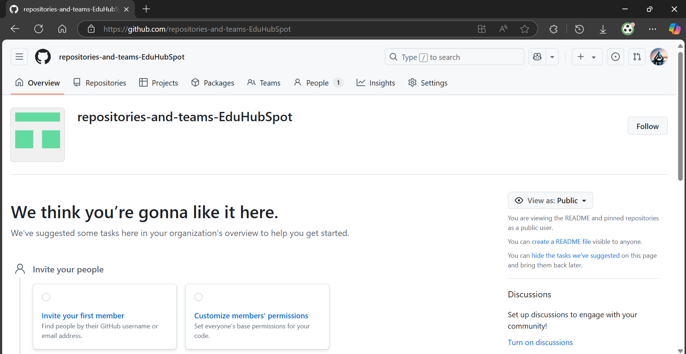

Step 2: Create a New GitHub Repository within Your Organization

Now that you have an organization, let's create a new repository to host your project's code. This repository will be owned by the organization.

1. Navigate to Your Organization's Repositories:

From your GitHub dashboard, ensure you are viewing your newly created organization. You can switch between your personal account and organizations using the dropdown next to your profile picture in the top-right corner, or by going to Your organizations as in Step 1.

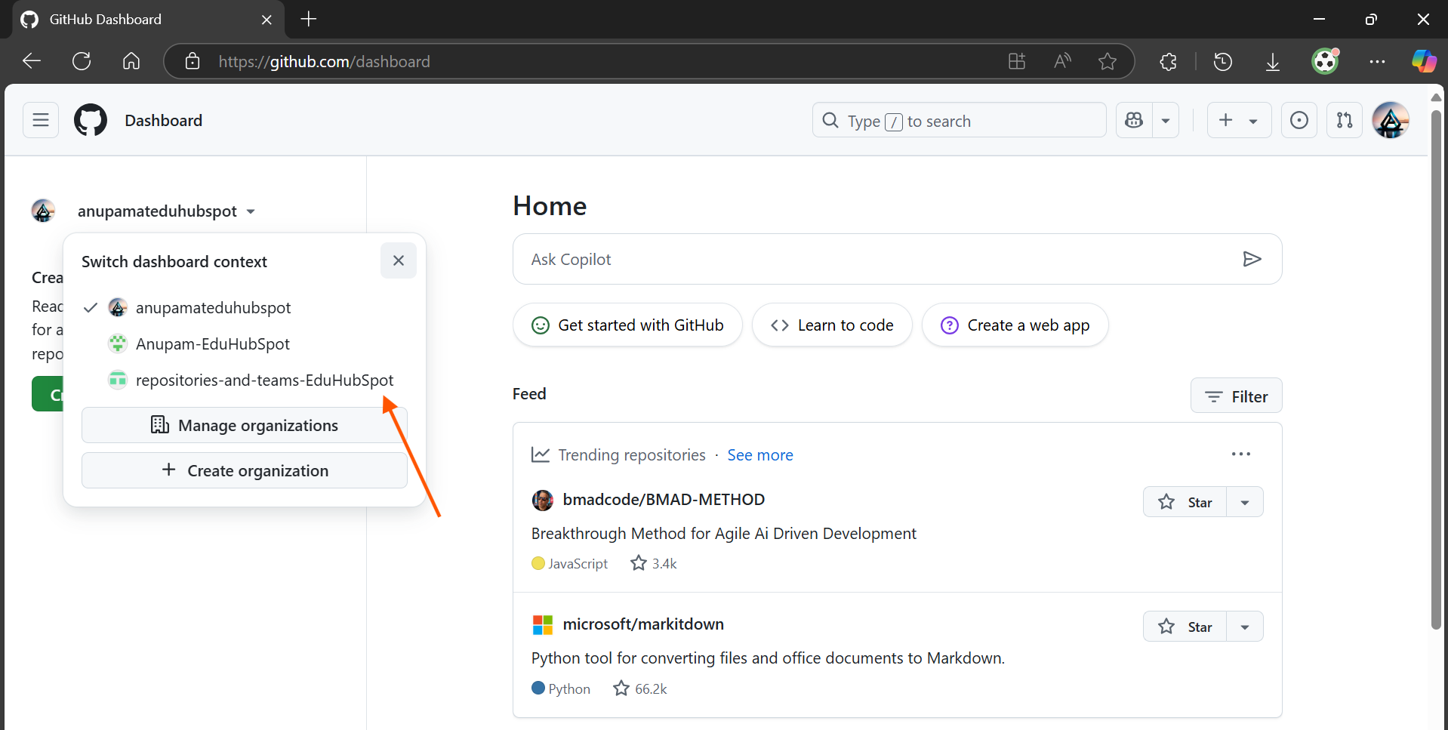

Once in your organization's view, click on the Repositories tab.

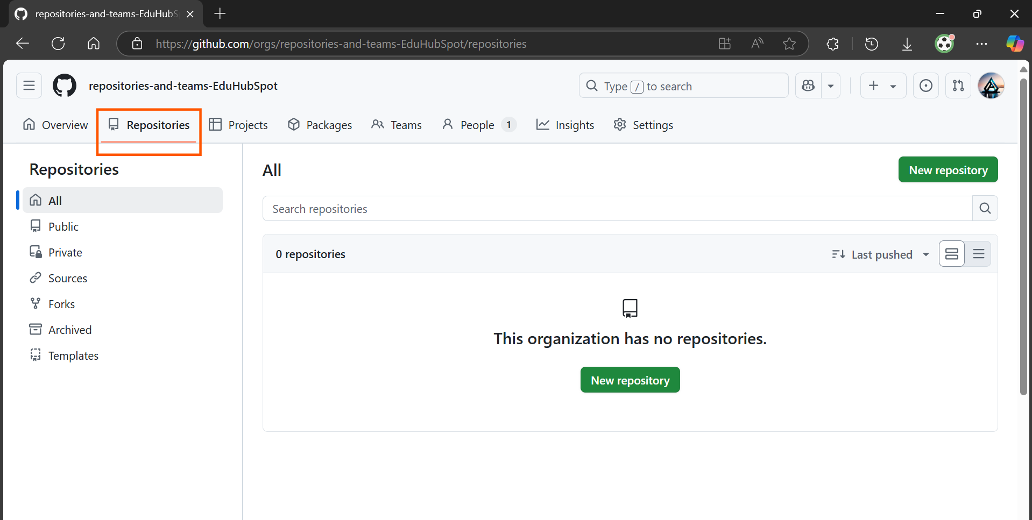

2. Create a New Repository:

Click the New repository button.

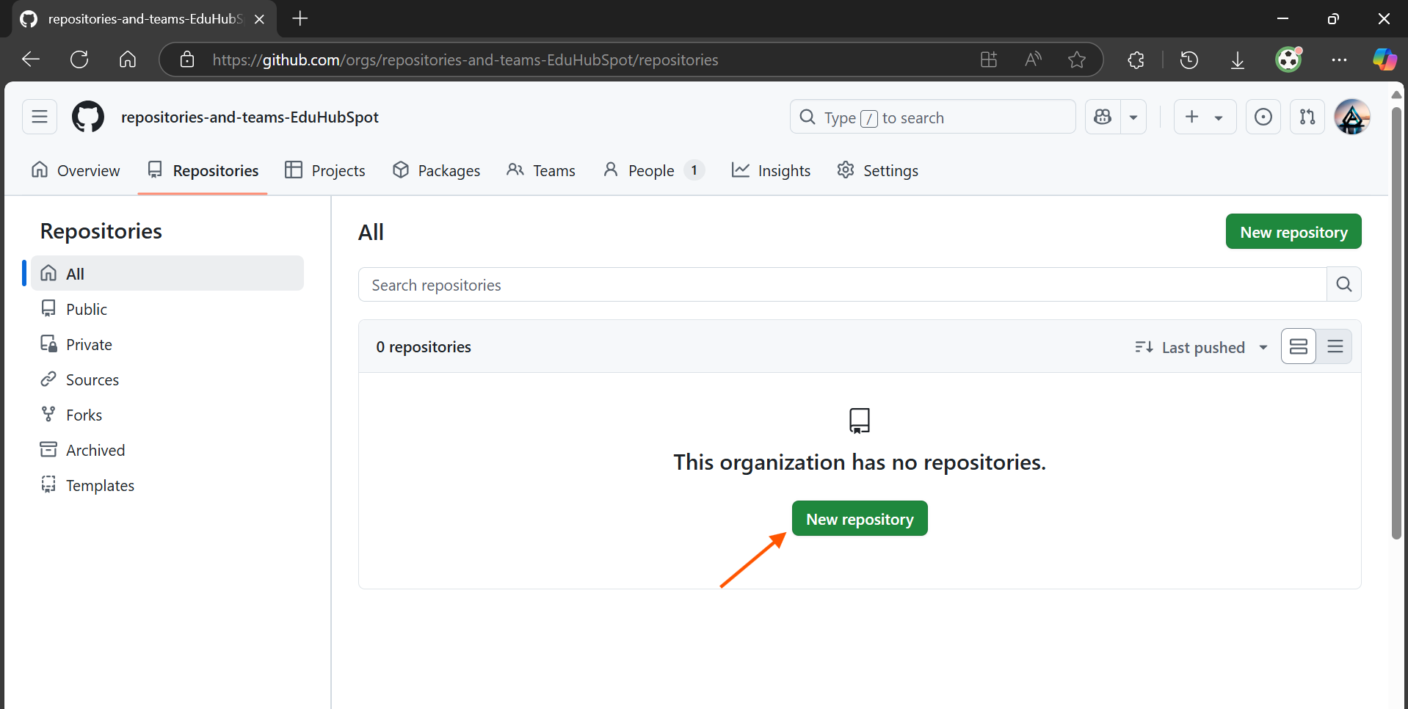

Configure the New Repository:

Owner: This should automatically be set to your organization's name. Ensure that the repository belongs to the organization, not to your personal account.

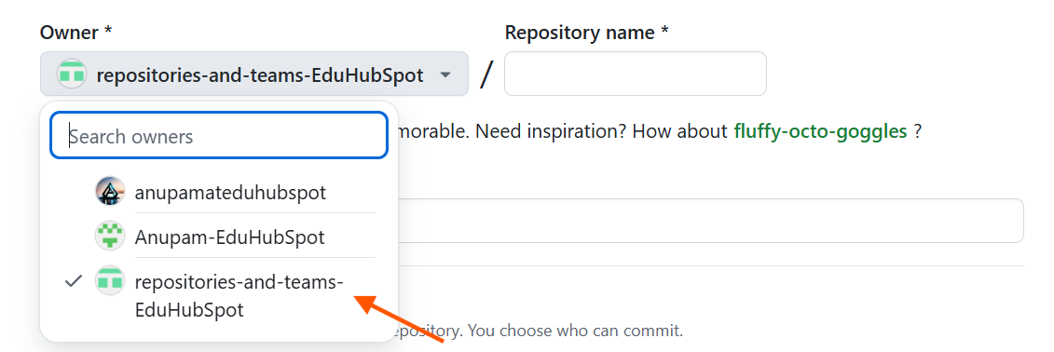

Repository name: Choose a short, descriptive name for your project. Use hyphens for spaces, as it's a common convention for repository names.

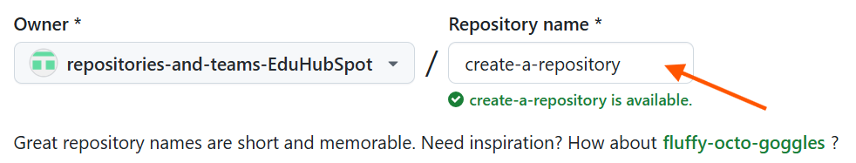

Description: Briefly describe what your project is about.

Public or Private: Select Private. For most team projects, you want to keep your code confidential among team members. Public repositories are visible to everyone on the internet.



Add a README file: A README.md file is the first thing people see when they visit your repository. It explains what the project is, how to set it up, and how to use it. It also helps initialize the repository with an initial commit, making it easier to clone later.

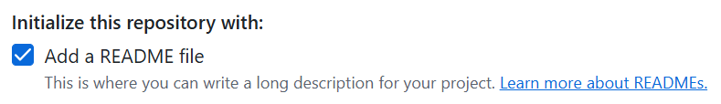

You can also add a .gitignore template and choose a license if your project requires it. For this hands-on, the README is sufficient.

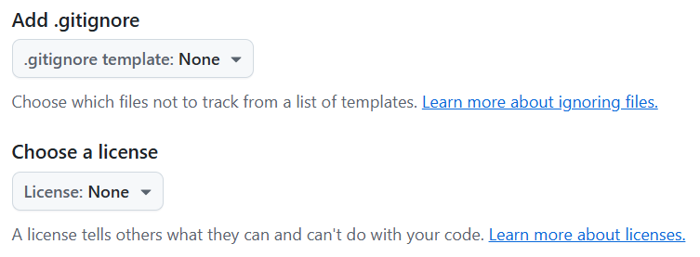

Click the Create repository button.

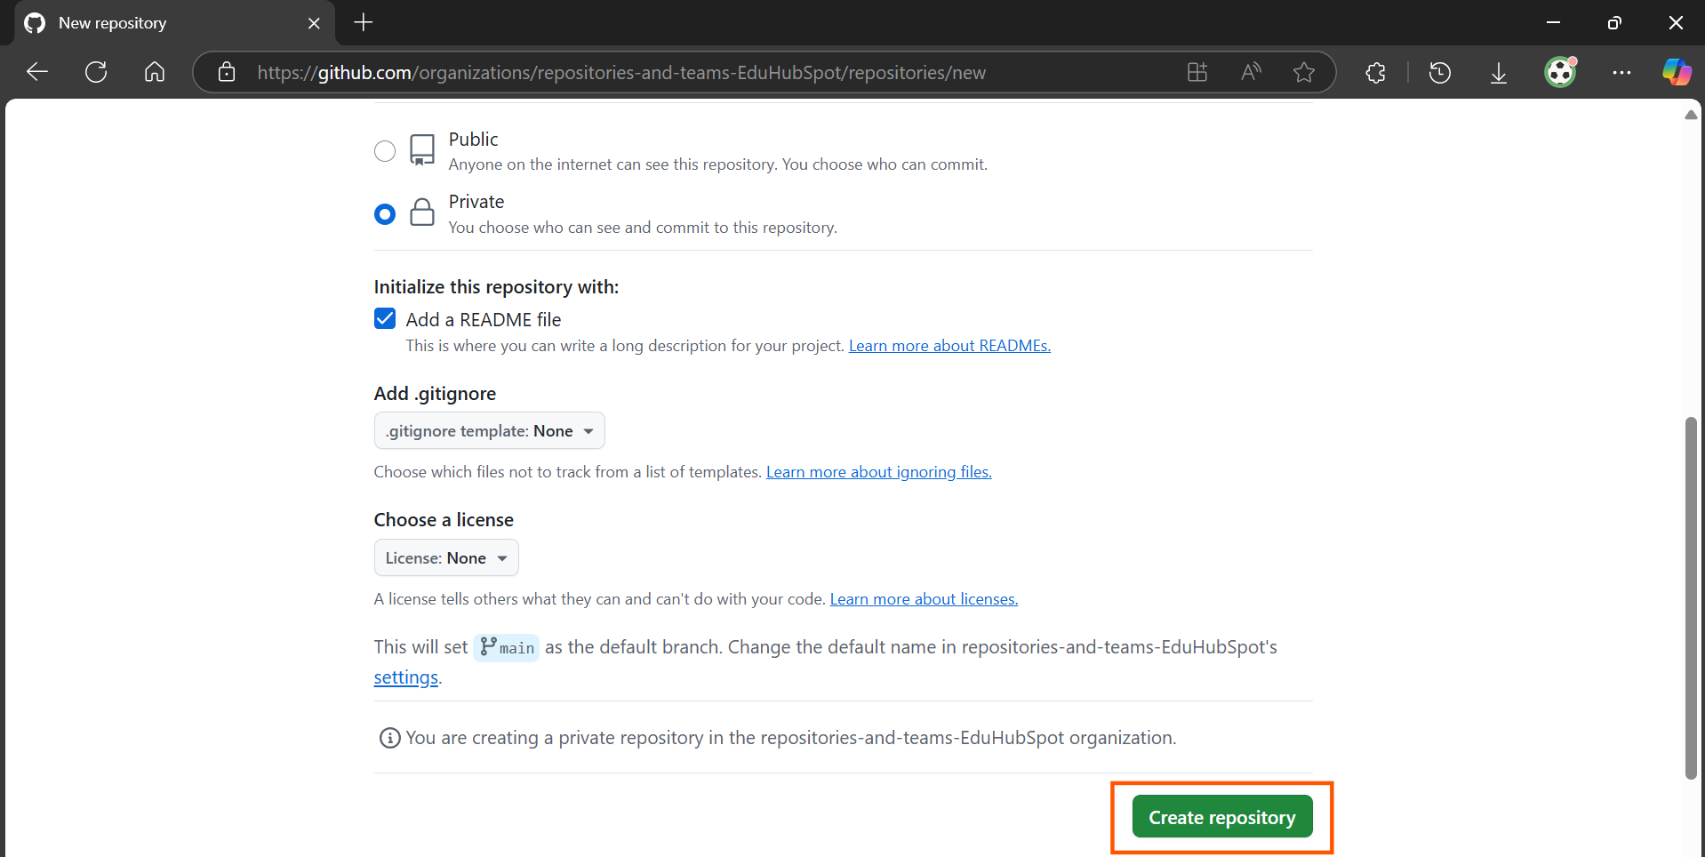

3. Verify Repository Creation:

You will be redirected to the newly created repository's page. You should see the README.md file you just created.

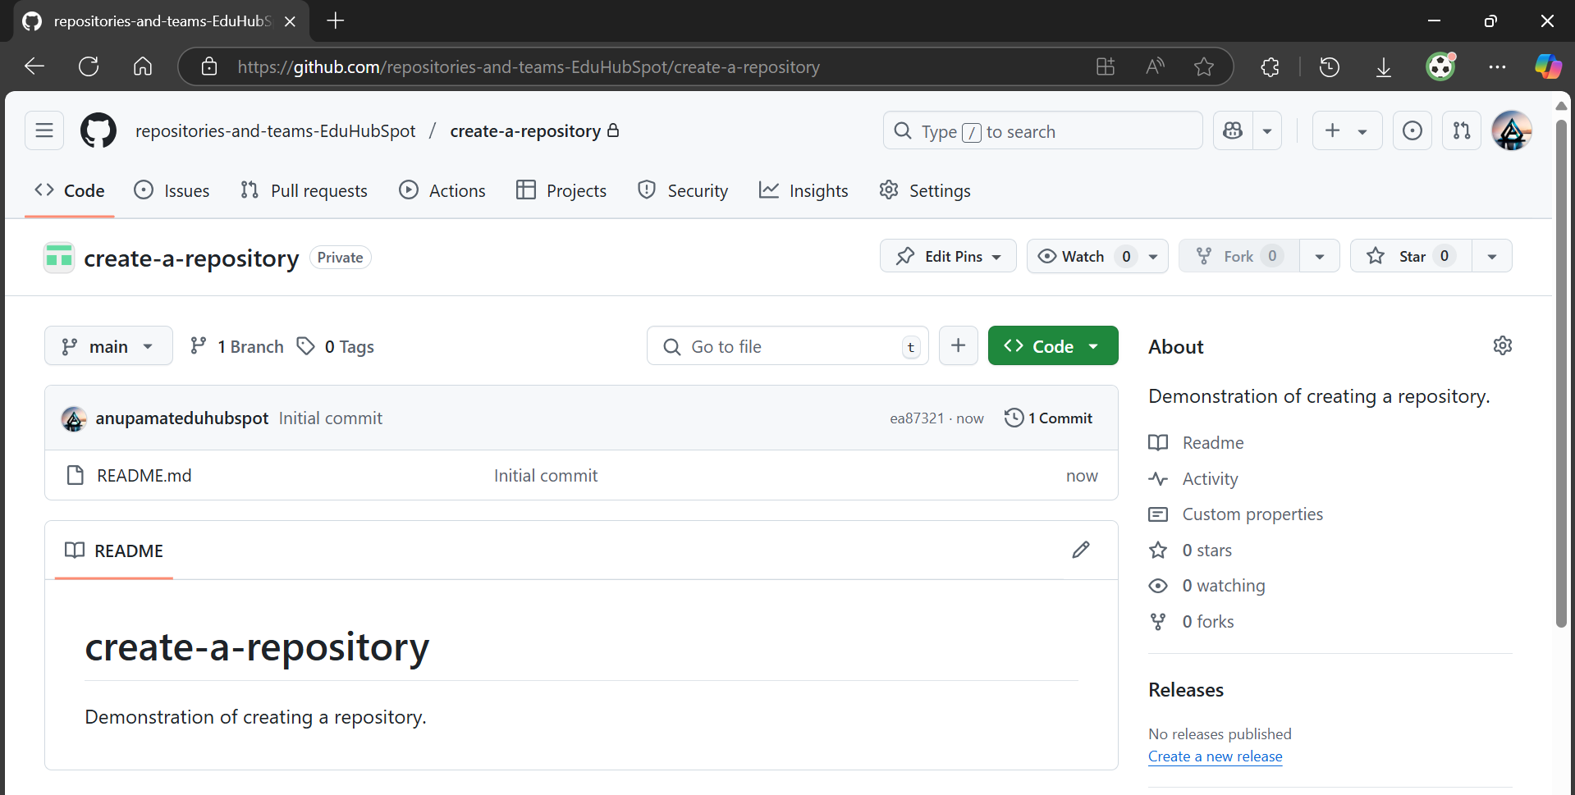

The URL will be: https://github.com/YourOrganizationName/YourRepositoryName.

In my case, it’s repositories-and-teams-EduHubSpot/create-a-repository: Demonstration of creating a repository.

Step 3: Create Teams within Your Organization

Now, let's create a couple of teams to manage access. We'll create an Admins team and a Developers team.

Teams simplify permission management. Instead of adding individual users to each repository with specific roles, you add users to a team, and then grant the team access to repositories. If a team member leaves or joins, you only modify team membership, not repository permissions.

1. Navigate to Organization Teams:

From your organization's dashboard, click on the Teams tab.

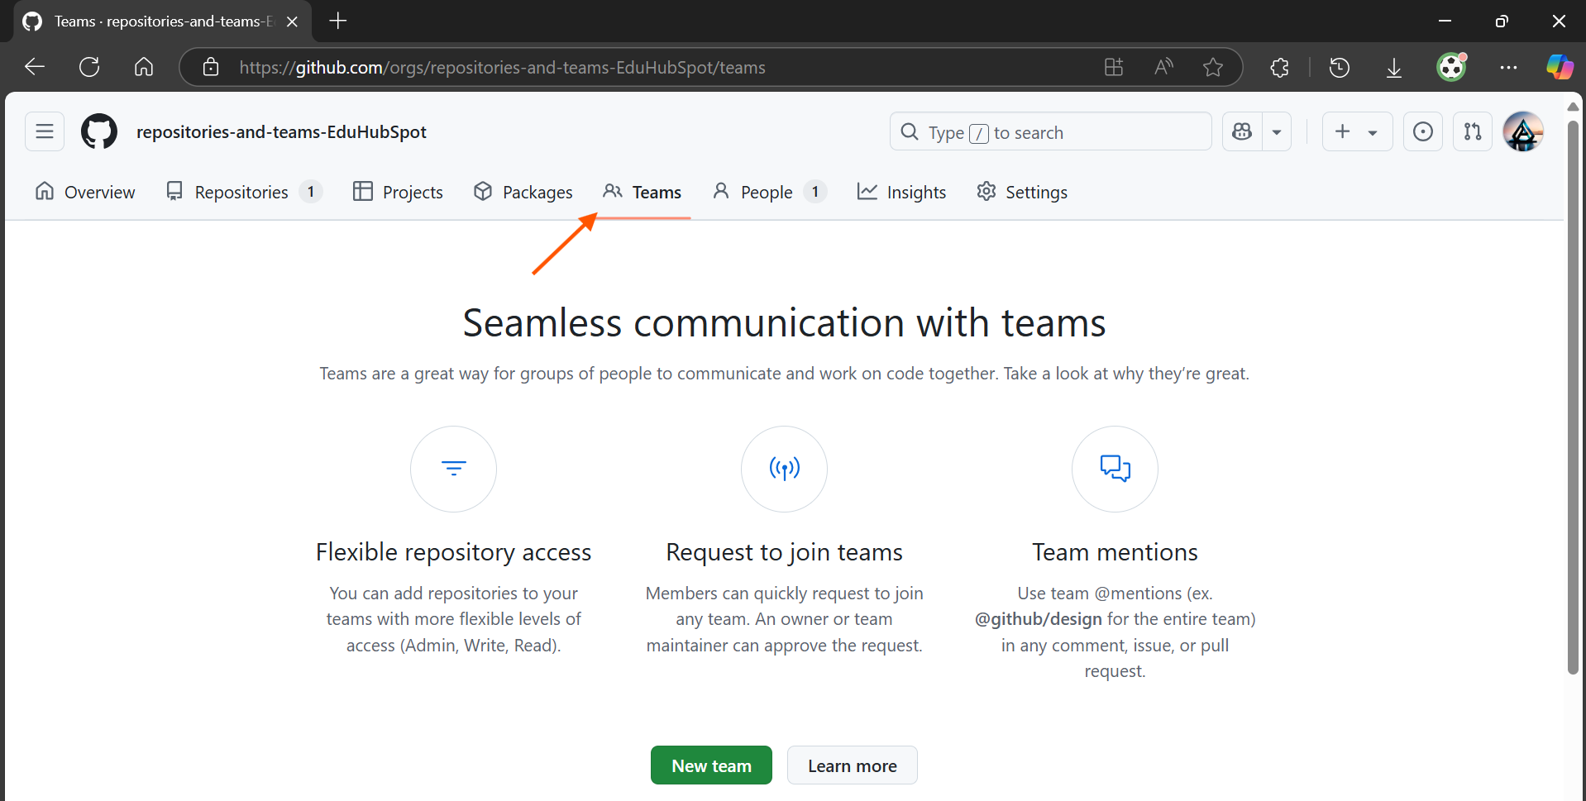

2. Create a New Team:

Click the New team button.

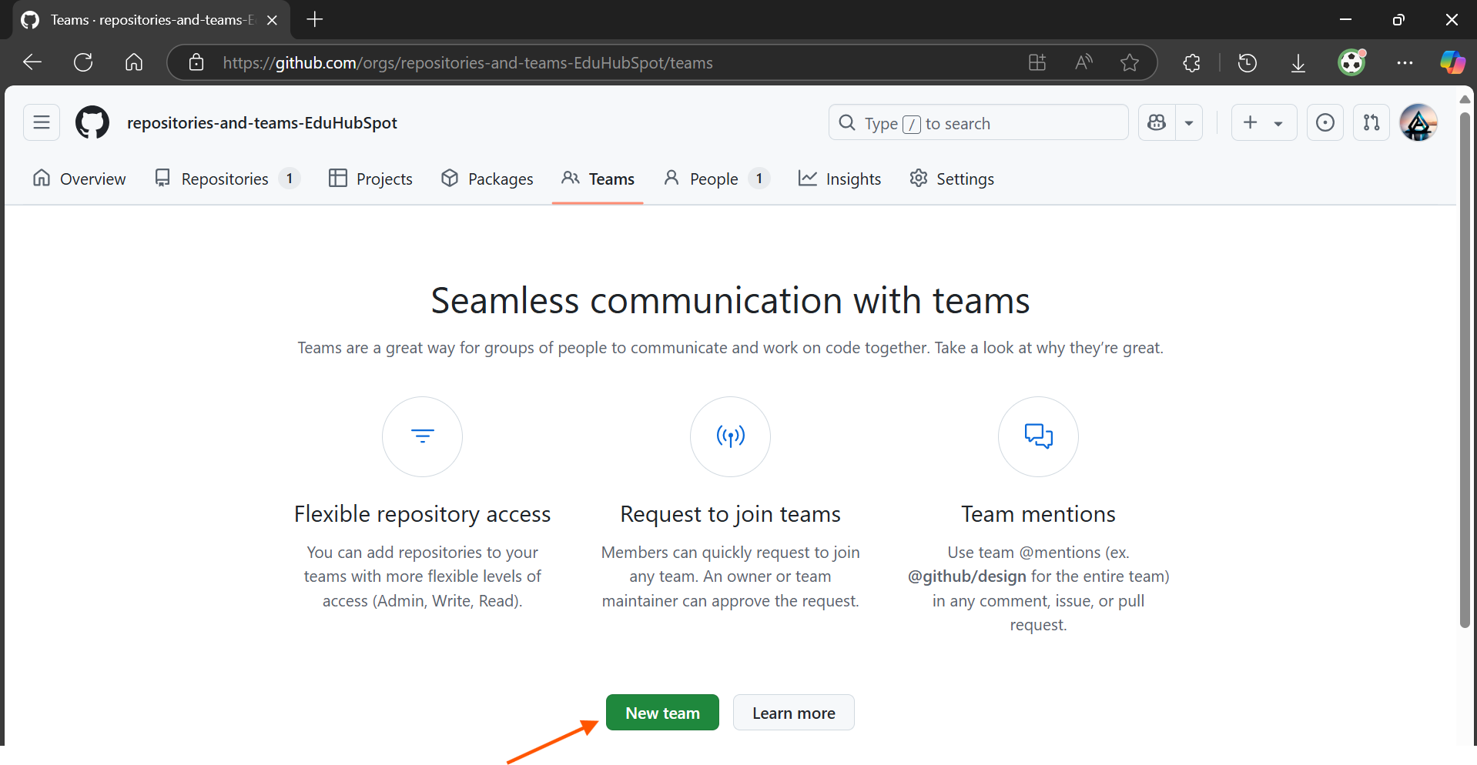

3. Configure the First Team (Admins):

Team name: Enter Admins.

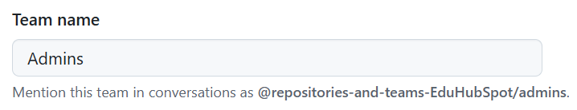

Description: Enter Team with administrative access to the repositories.

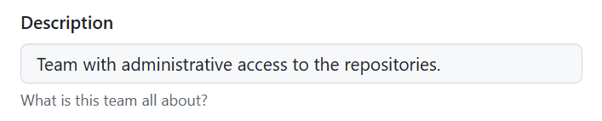

Parent team: Leave this as No parent team. In our case, no parent team can be selected.

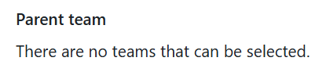

Team visibility: Choose Visible.

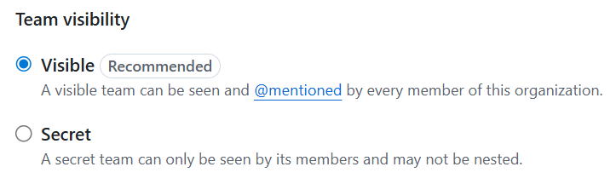

Visible teams are discoverable by other organization members. Secret teams are only visible to team members and organization owners. For most functional teams, Visible is appropriate.

Team notifications: Choose Enabled.

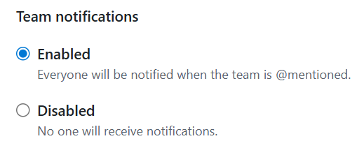

Click Create team.

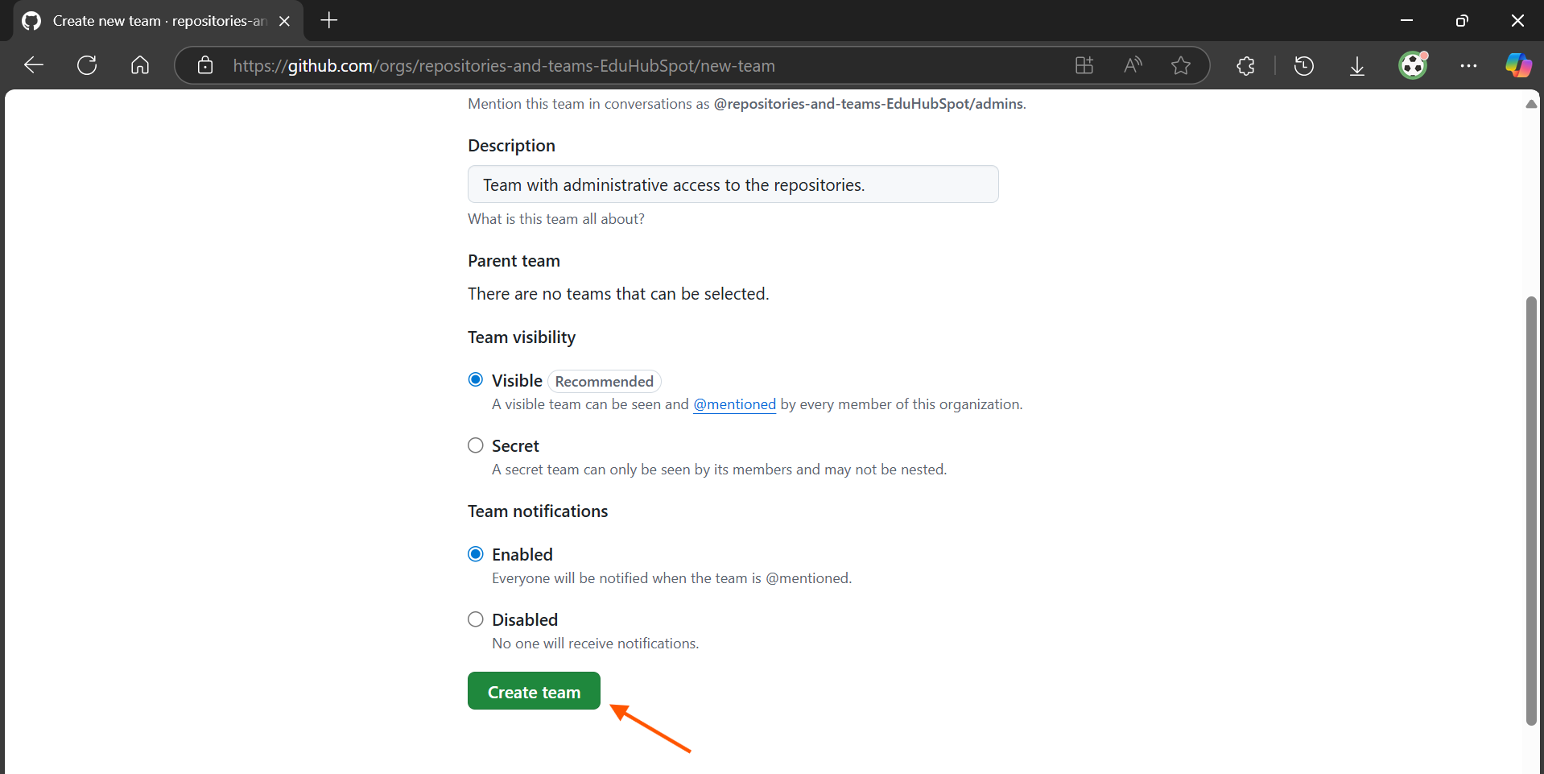

4. Configure the Second Team (Developers):

After creating the Admins team, you'll be on its page.

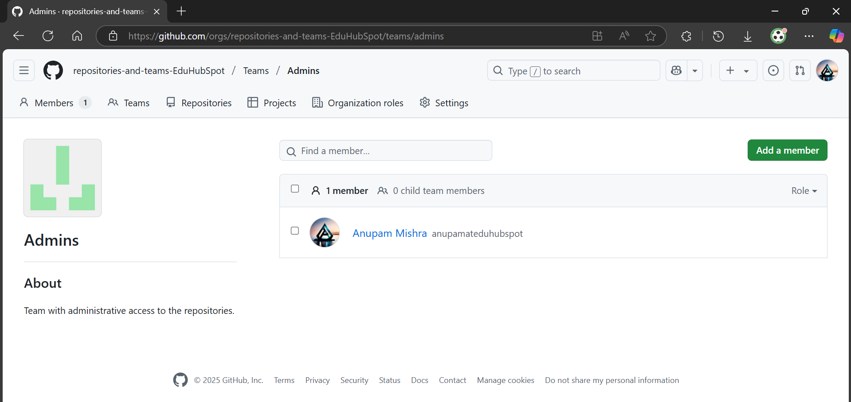

To create another, go back to the Teams tab in your organization.



Click the New Team button again.

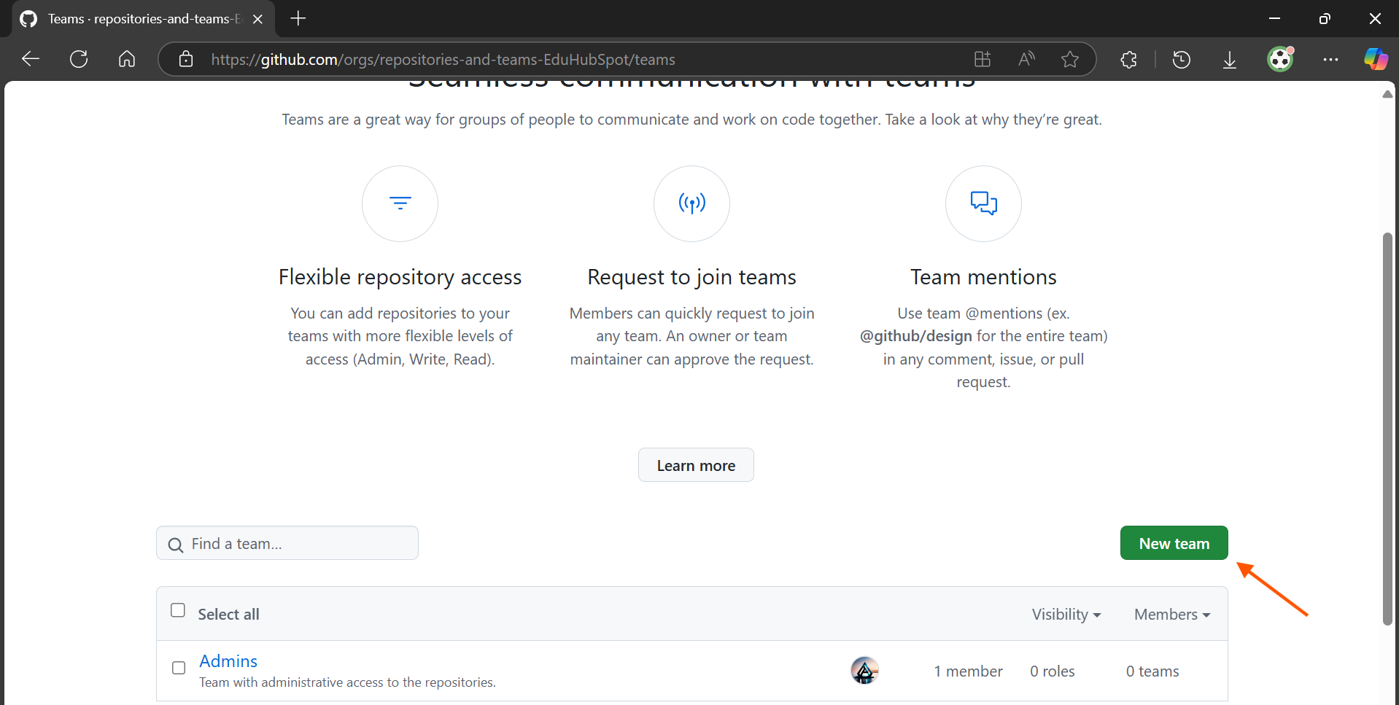

Team name: Enter Developers.

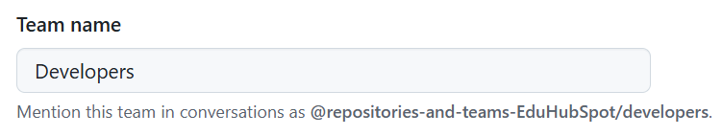

Description: Enter Team responsible for developing the project features.

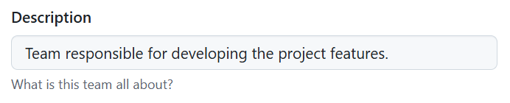

Parent team: Leave this as No parent team.

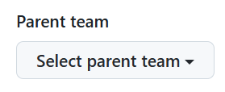

Team visibility: Choose Visible.

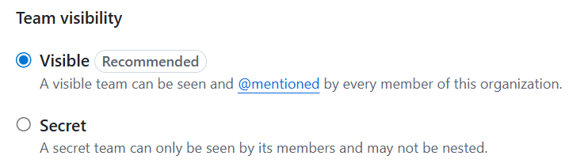

Team notifications: Choose Enabled.

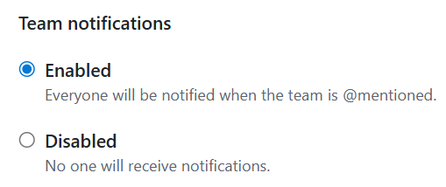

Click Create team.

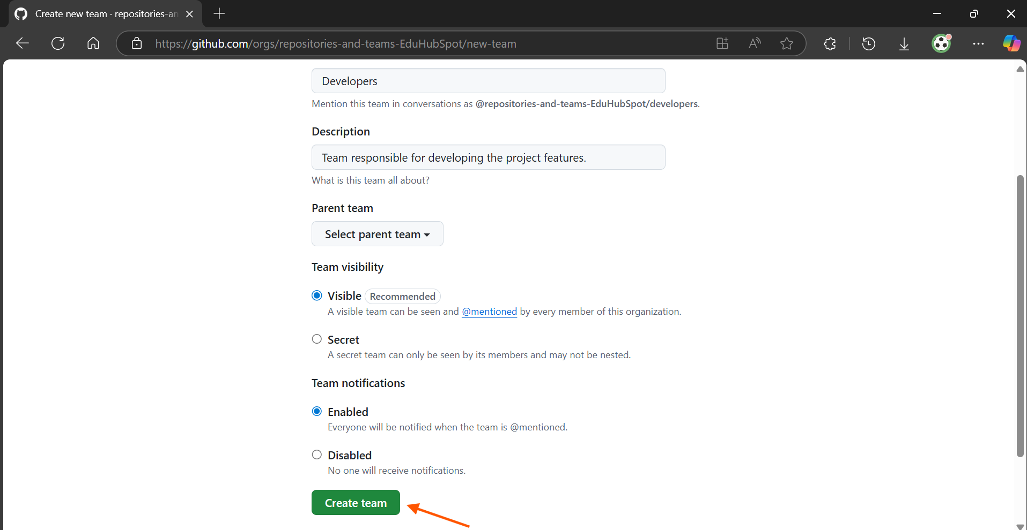

Step 4: Add Members to Your Teams

Now, let's add yourself and possibly a hypothetical collaborator to these teams.

Teams are useless without members! Adding members, associates GitHub users to a team, which then determines their access based on the team's repository permissions.

1. Add Yourself to the Admins Team:

From the Teams tab, click on the Admins team.

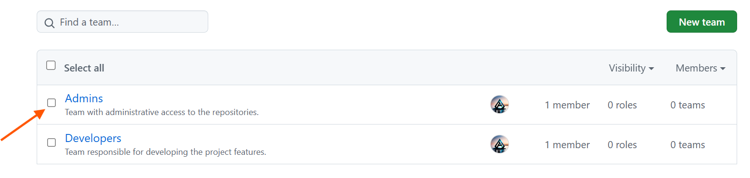

Click on the Members tab.

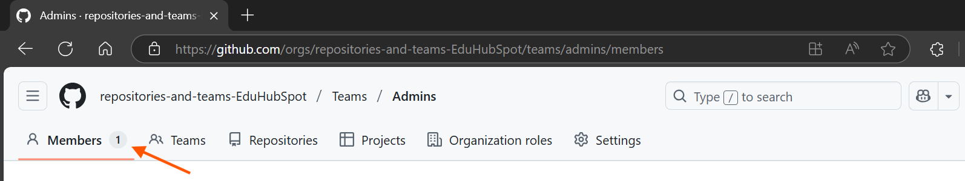

Click the Add a member button.

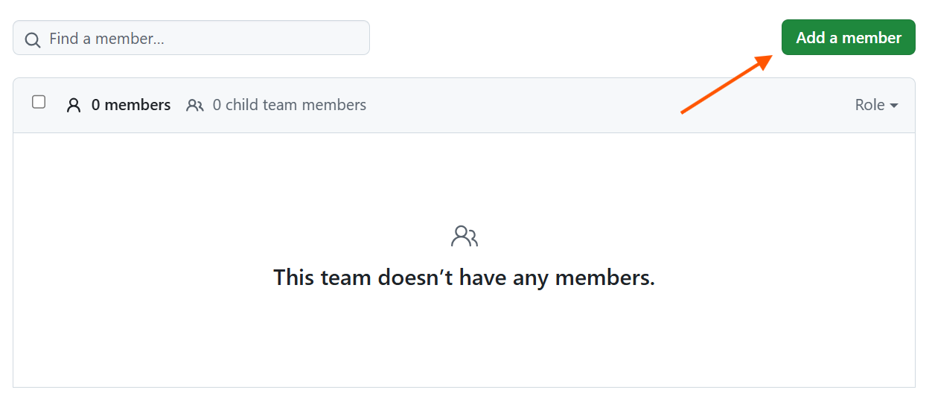

In the search box, type your GitHub username. Select your username from the dropdown.

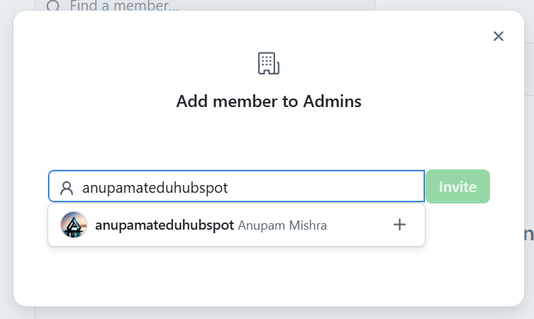

Click Invite.

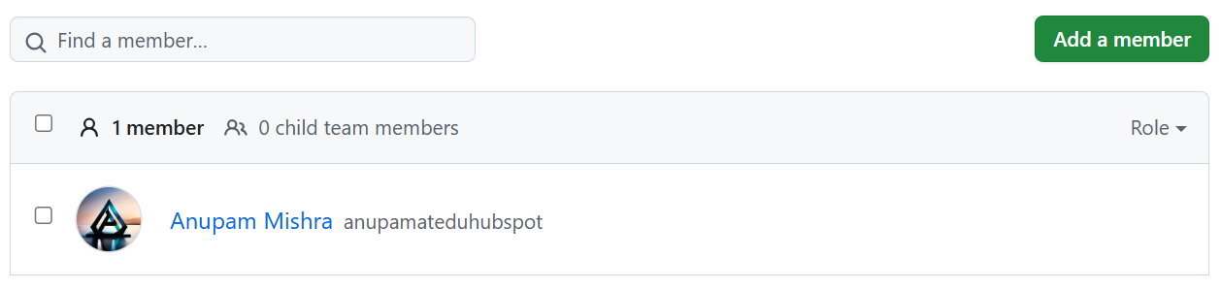

2. Add Yourself and a Hypothetical Second User to the Developers Team:

Go back to the Teams tab and click on the Developers team.

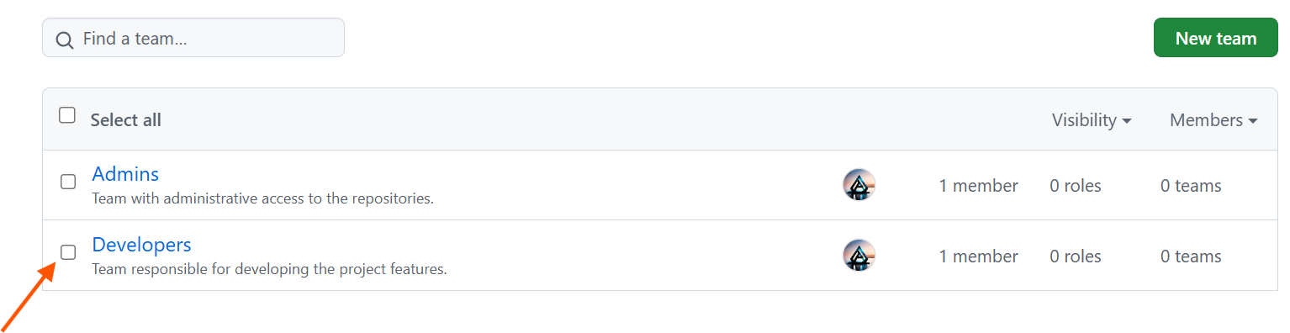

Click on the Members tab.

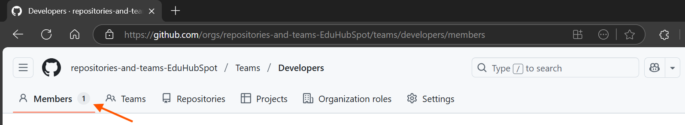

Click the Add a member button.



Type your GitHub username and select it.

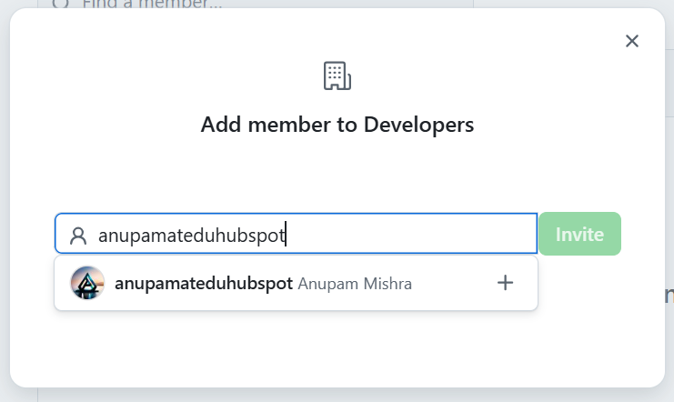

Optional: If you have a second GitHub account or a friend's username you can use for testing, you can invite them here by typing their username/email. For this exercise, adding only yourself is sufficient.

Click Invite.

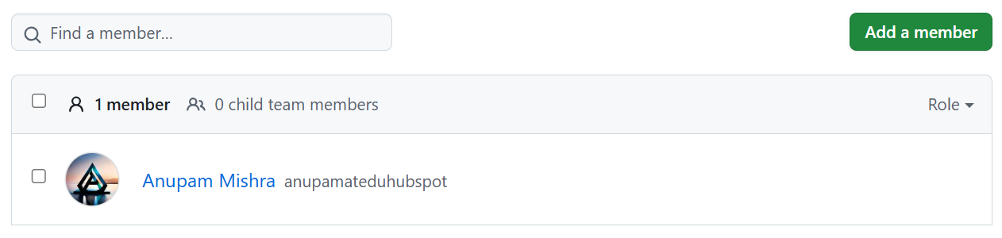

Step 5: Grant Teams Access to Your Repository

This is where you link your teams to your repository and define their permission levels.

This step implements the core of access control. Instead of giving individual users read or write access, you give the entire Developers team write access, and the Admins team admin access to your repository. This is much more scalable and efficient for managing a growing team.

1. Navigate to the Repository's Settings:

From your organization's dashboard, click on the Repositories tab.

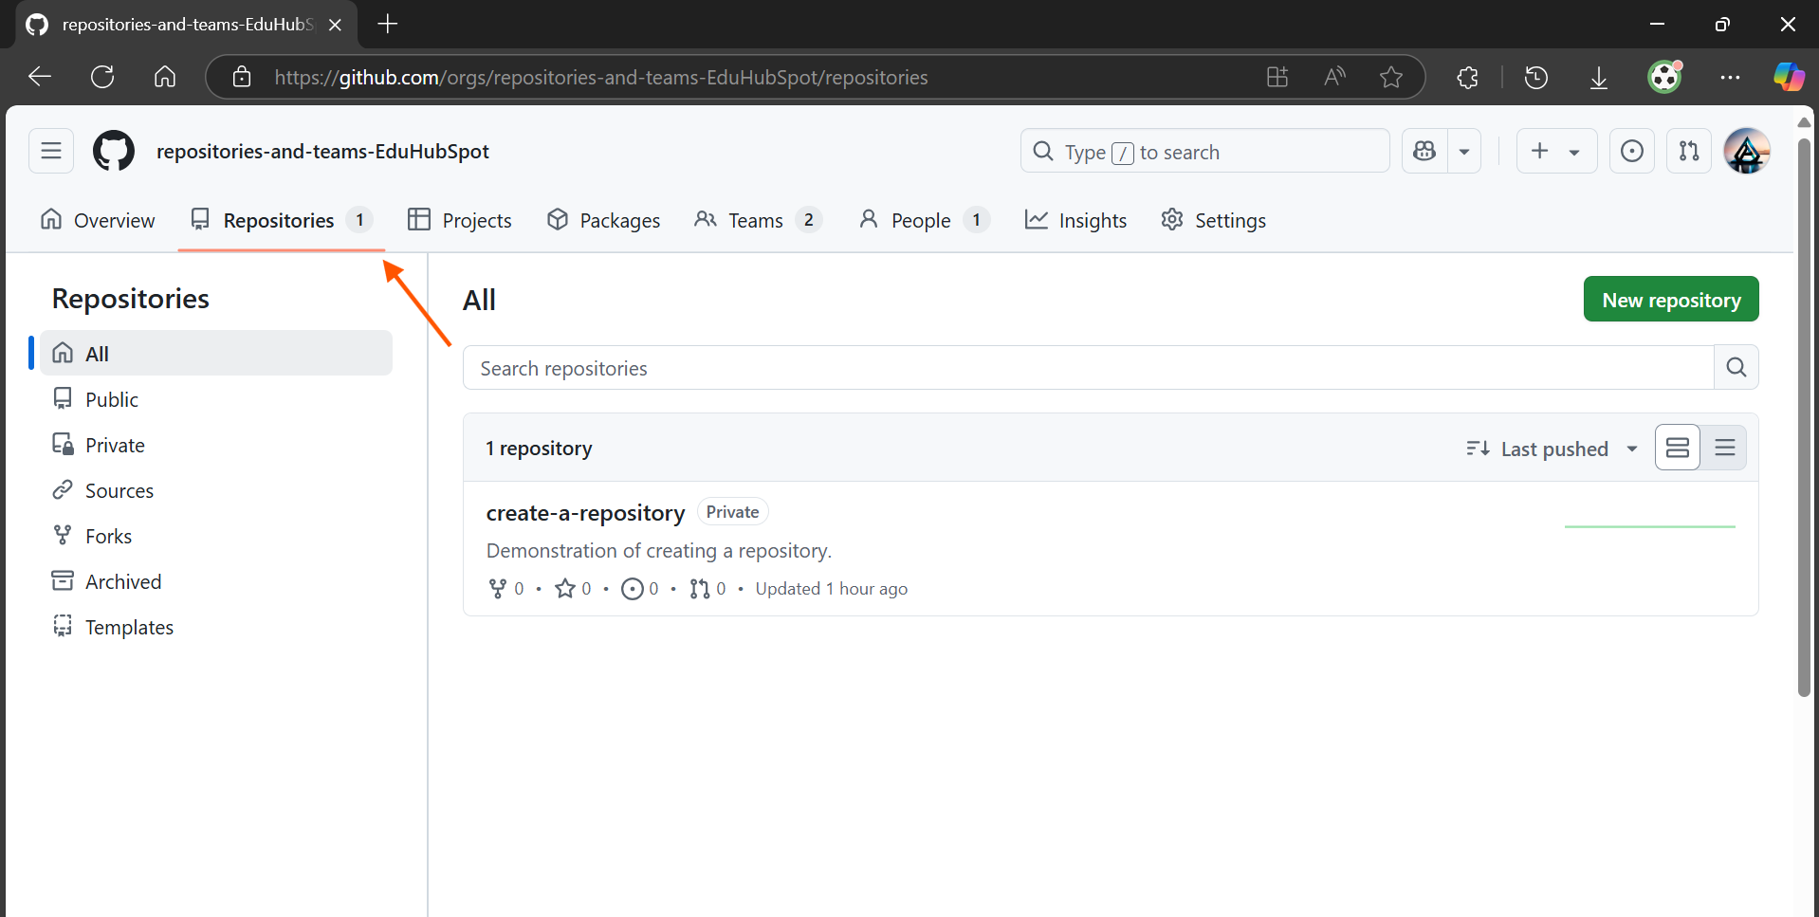

Click on the repository you created.

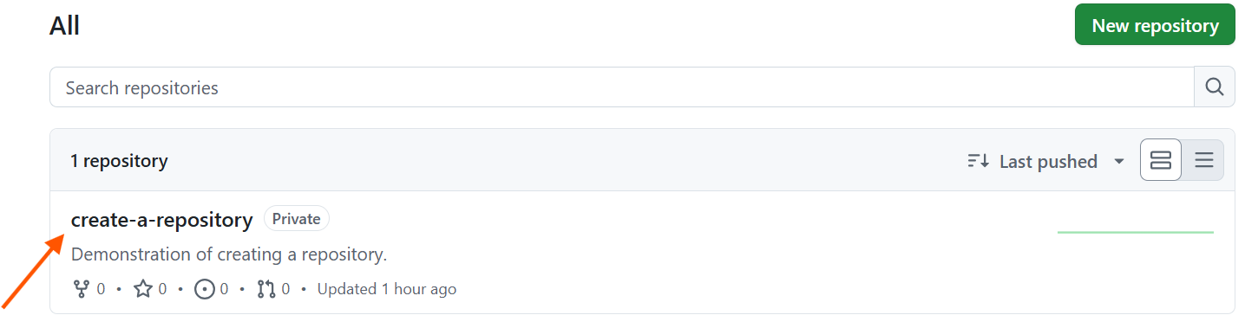

On the repository's page, click on the Settings tab.

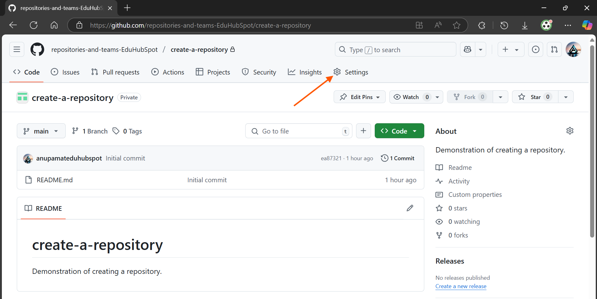

2. Go to Collaborators and Teams:

In the left sidebar of the repository settings, click on Collaborators and teams.

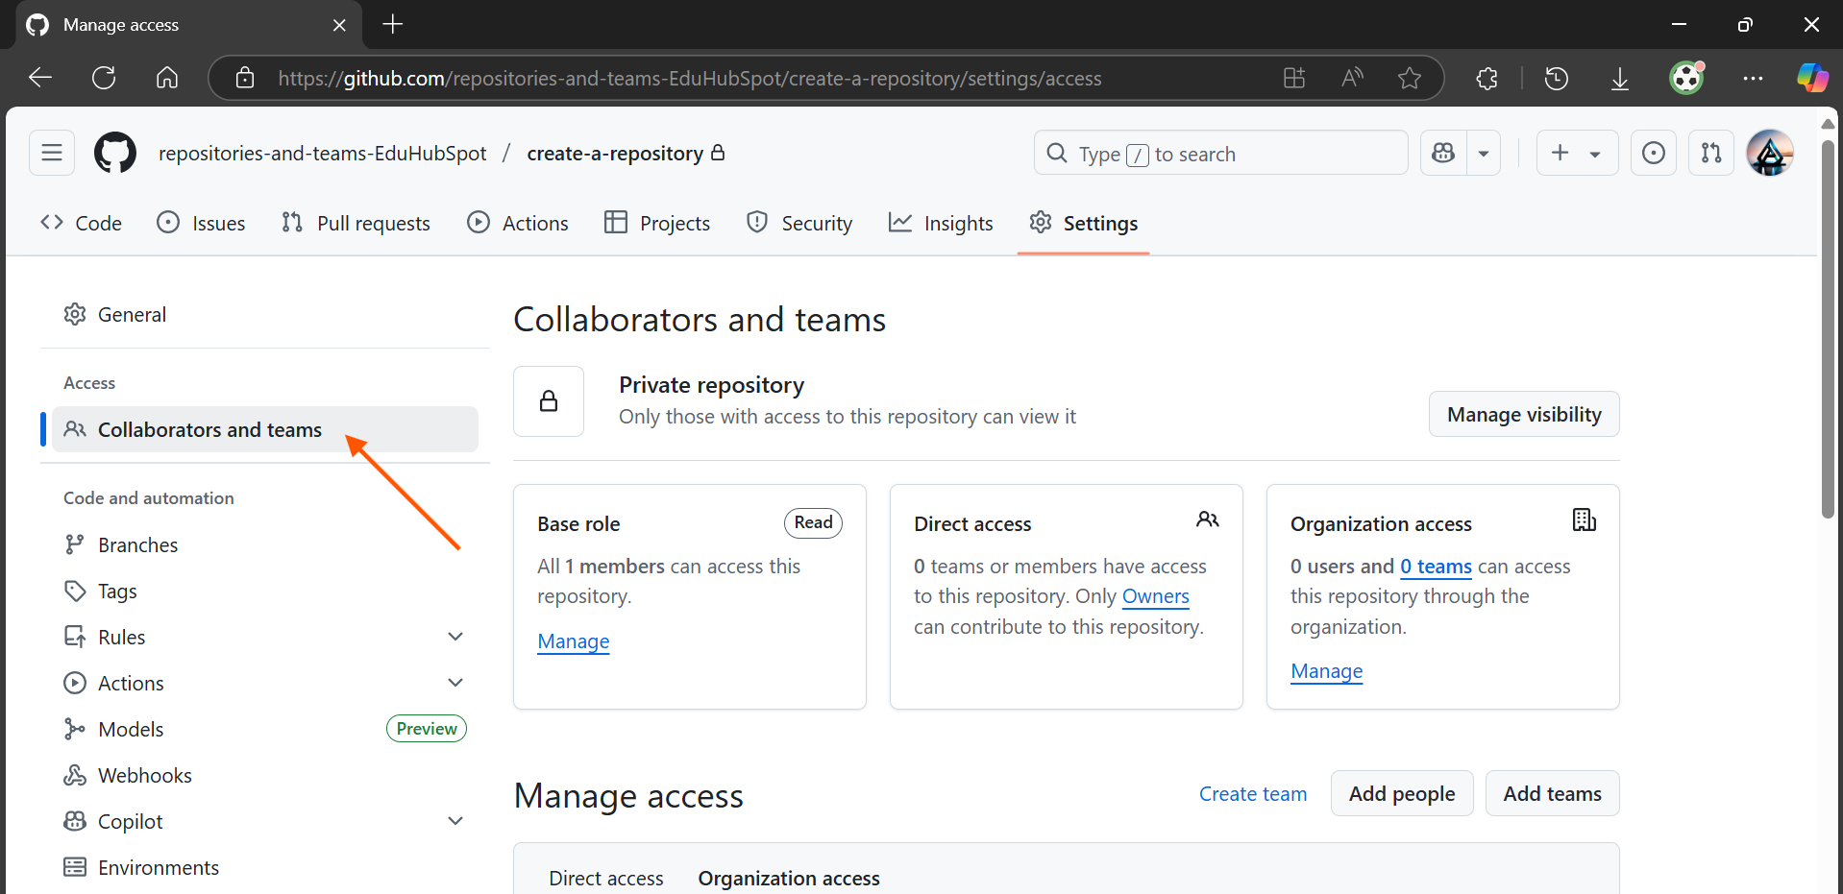

3. Add the Admins Team:

Click the Add teams button.

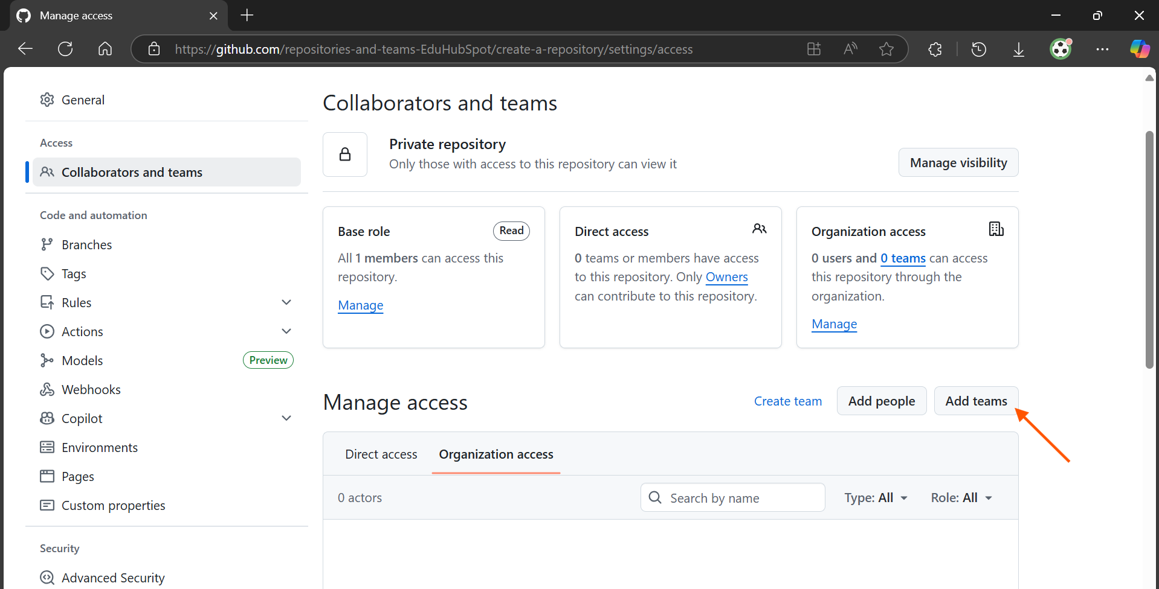

In the search box, start typing Admins and select your Admins team from the dropdown.

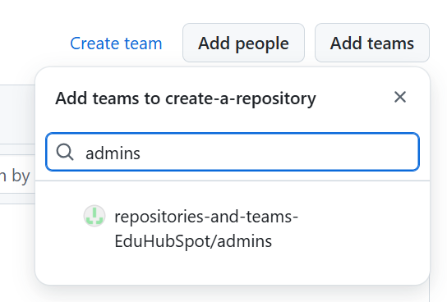

Choose a role: Select Admin.

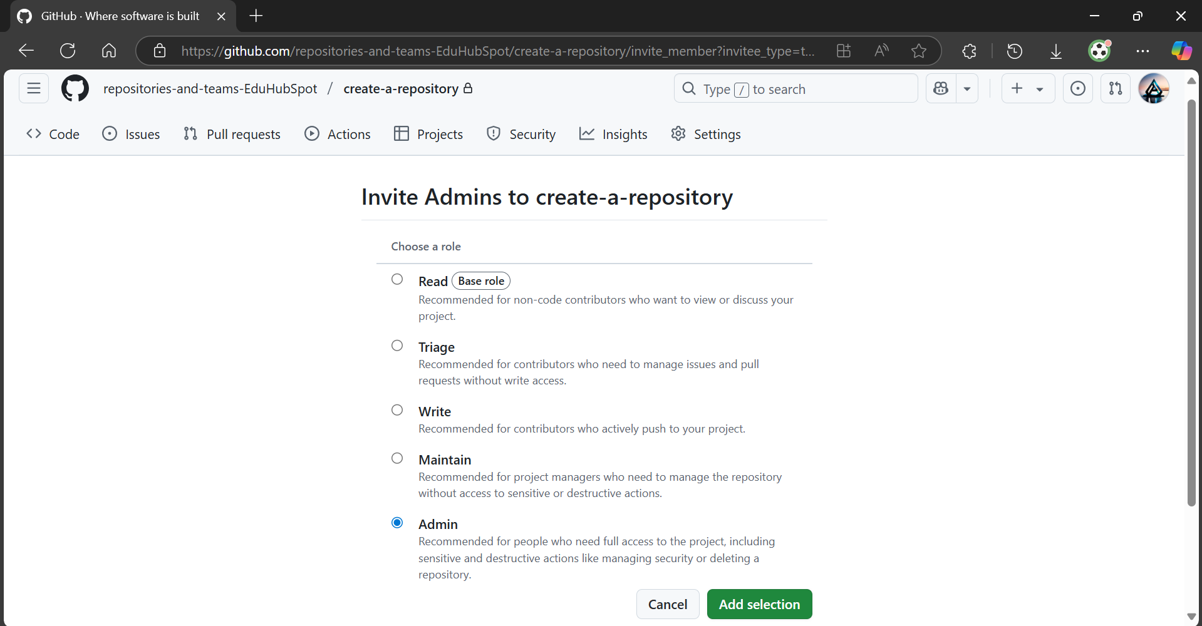

The Admin role gives full control over the repository, including managing settings, webhooks, and even deleting the repository. This is appropriate for an Admins team.

Click Add selection.

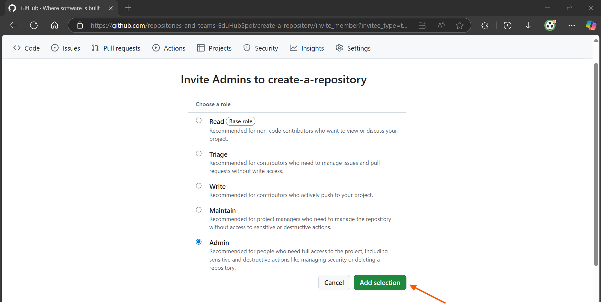

3. Add the Developers Team:

Click the Add teams button again.

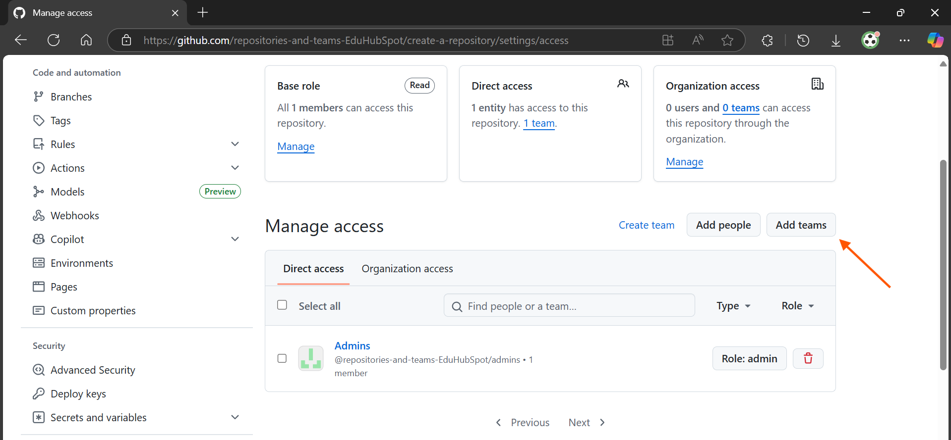

In the search box, start typing Developers and select your Developers team from the dropdown.

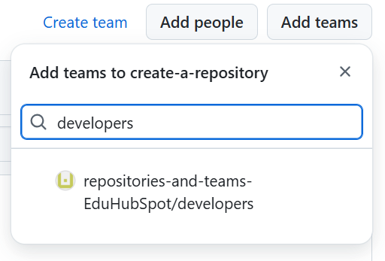

Choose a role: Select Write.

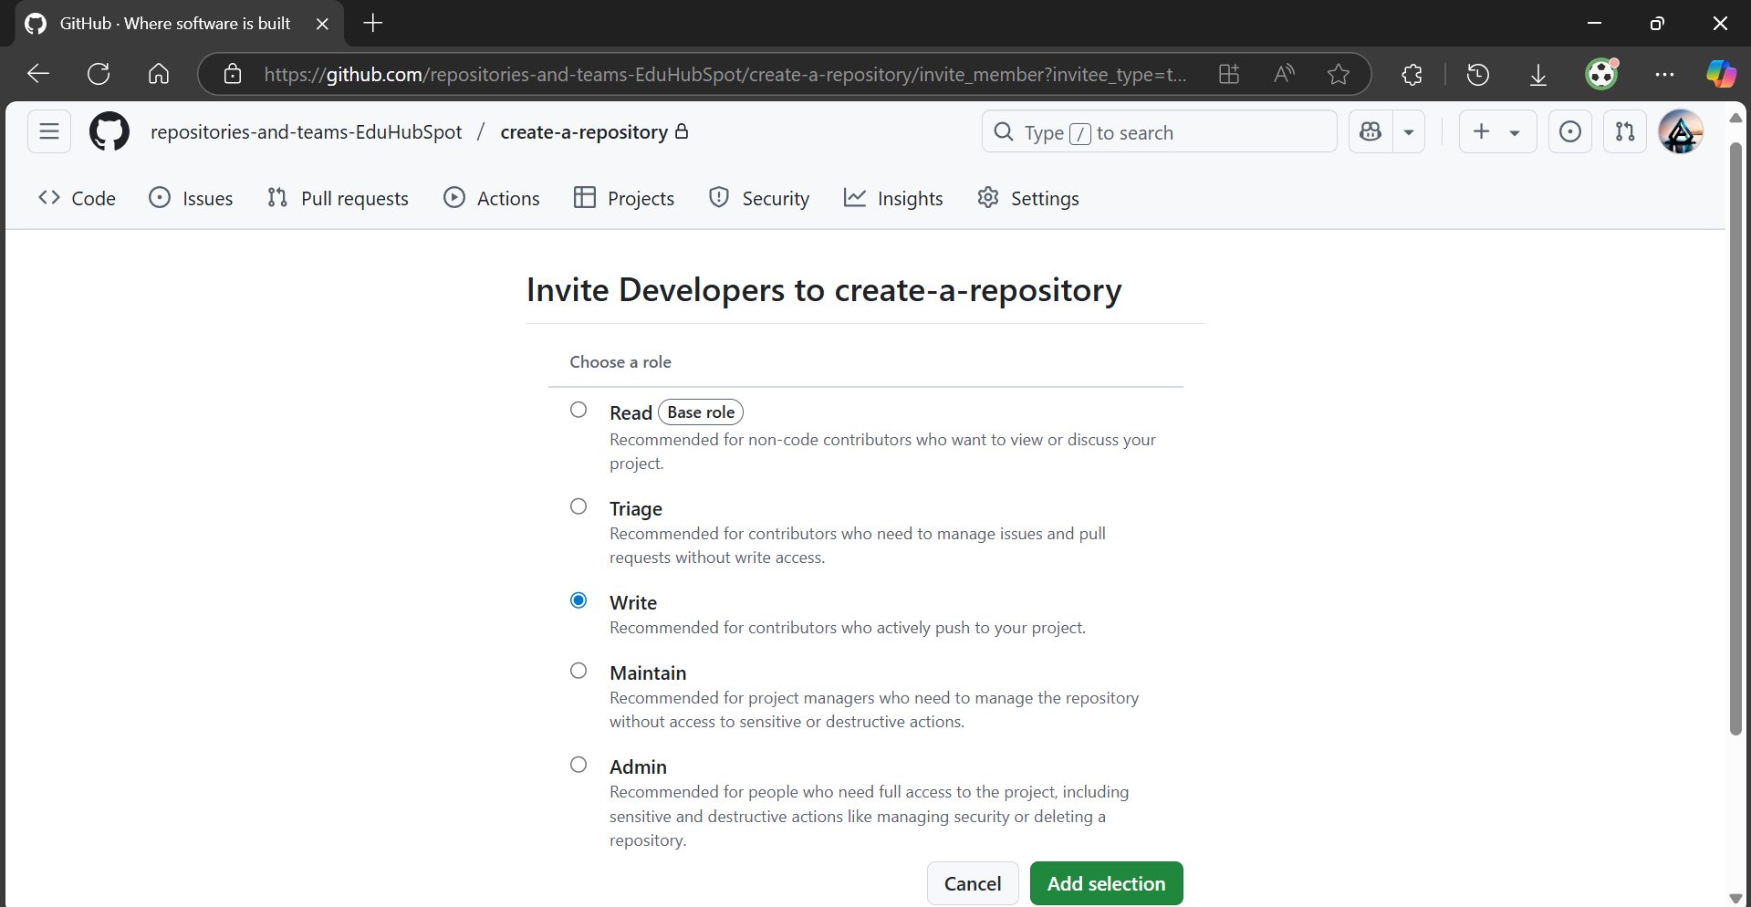

The Write role allows team members to push changes to the repository, create branches, and manage issues/pull requests. This is the standard access level for most developers contributing code.

Click Add selection.

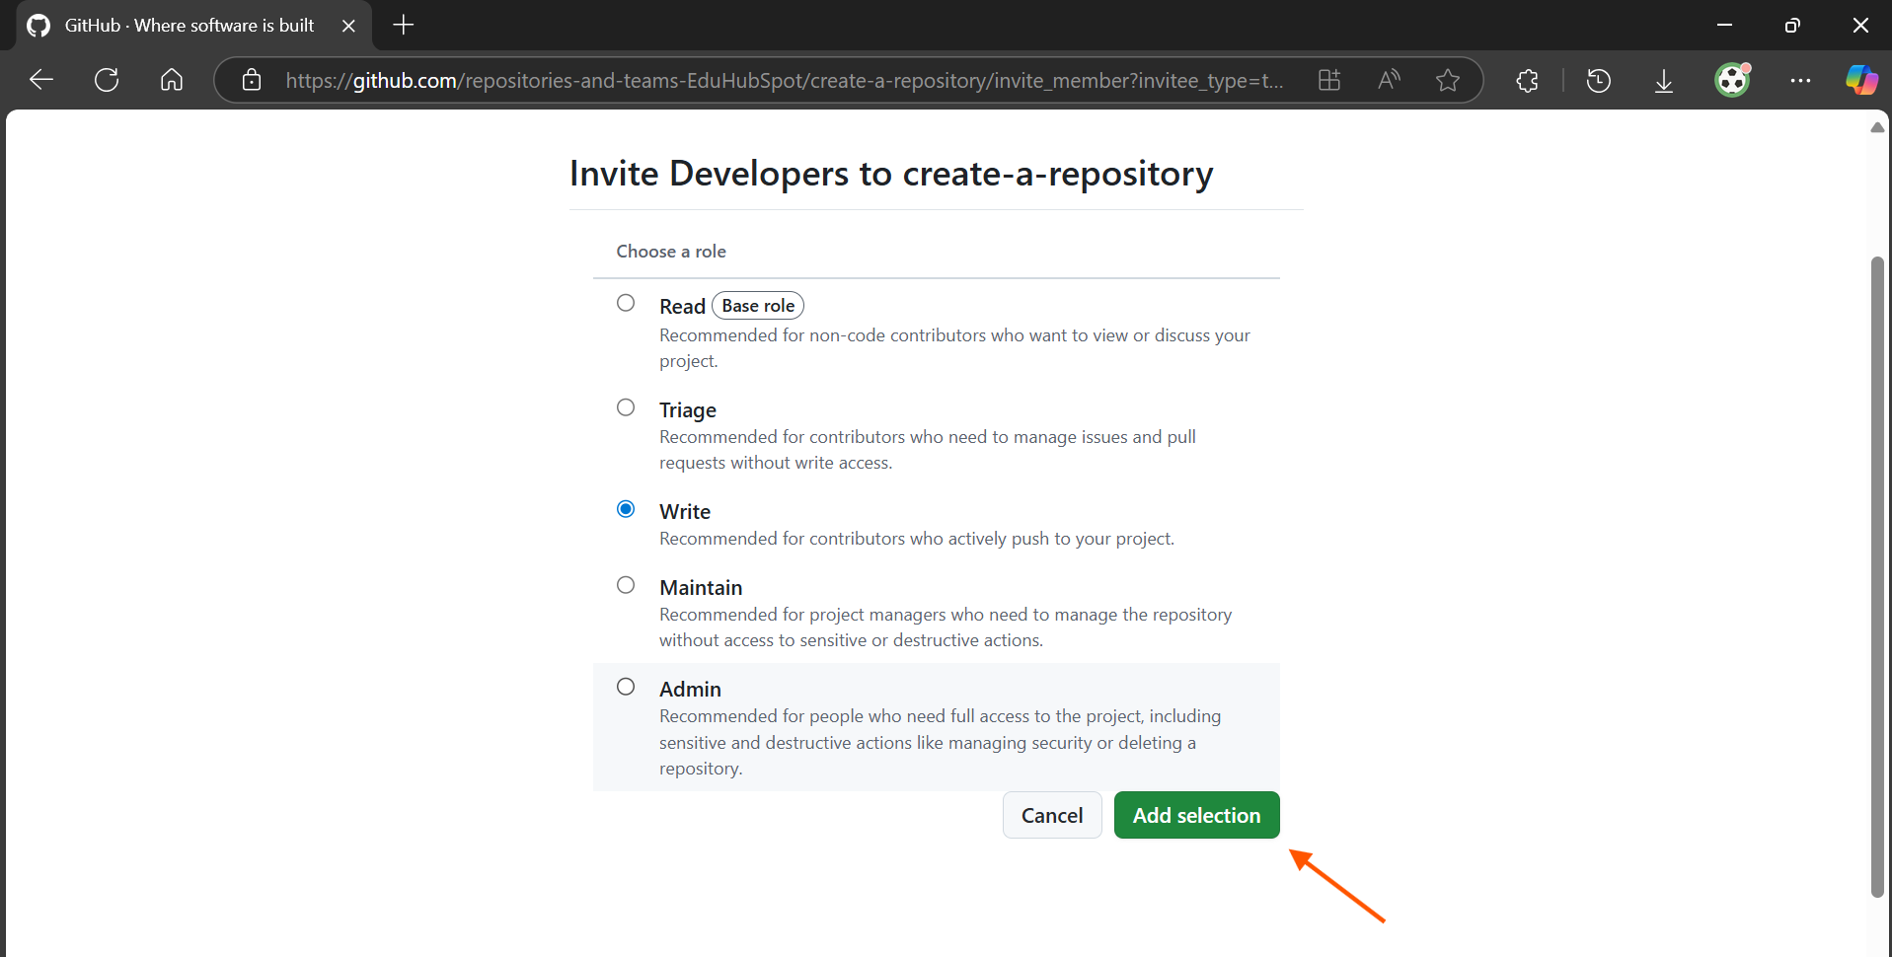

4. Verify Permissions:

You should now see both Admins and Developers teams listed under Manage access with their respective roles. This confirms that your access control is set up successfully.

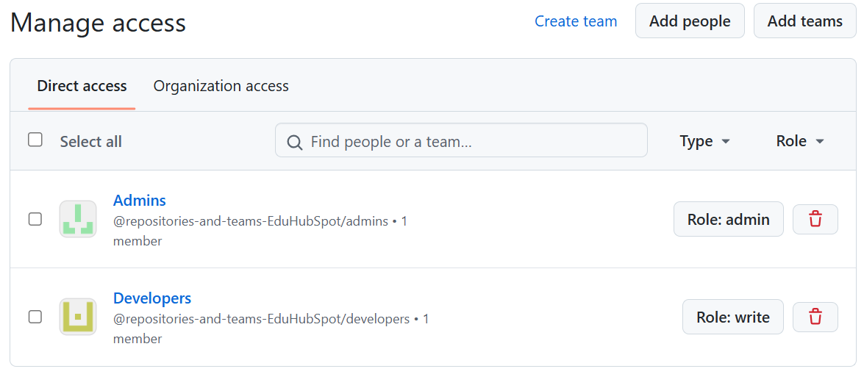

Topics Covered:

1. GitHub Organizations: Understanding their purpose and creating one.
2. GitHub Repositories: Creating a new private repository within an organization.
3. GitHub Teams: Creating and managing teams within an organization.
4. Team Membership: Adding users to teams.
5. Repository Access Control: Assigning specific permission levels to teams on repositories.

