3. Backup Automation Script
Problem Statement:
Create a backup automation script in Bash that reliably compresses and stores data from a specified source directory into a timestamped archive. The script should use configurable variables for flexibility, ensure safe creation of required directories, and organize the logic into a modular function for reusability. It must generate compressed backups using tar -czf and support unique file naming using timestamps to prevent overwrites and enable historical tracking.
Steps Involved:
- Open the Ubuntu terminal.
Press Ctrl + Alt + T to launch the Ubuntu terminal.
- Edit the existing file
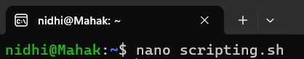
- Inside, add your backup automation script.
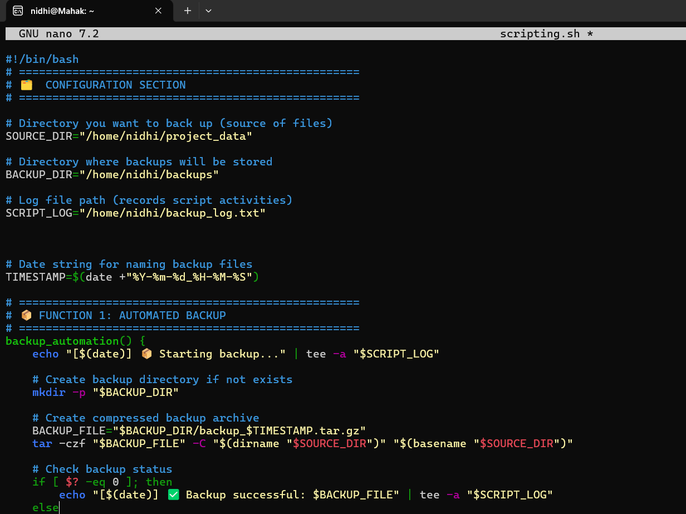

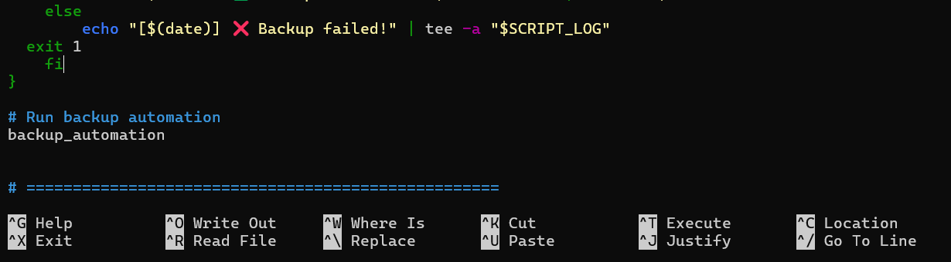
When done, save nano with CTRL + O and press ENTER, then exit with CTRL + X.
- Make the Script Executable:
- Run the Script:
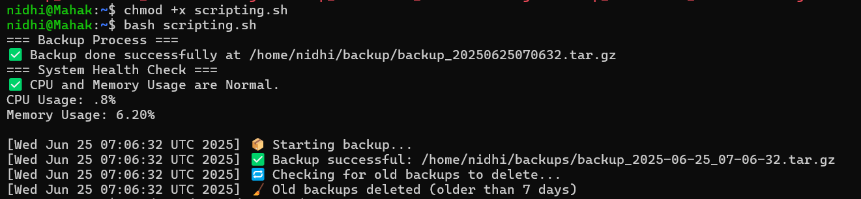
- Verify that backups are being created as expected and see their timestamps at a glance. I had run the script many times, so it is showing all the backups created.
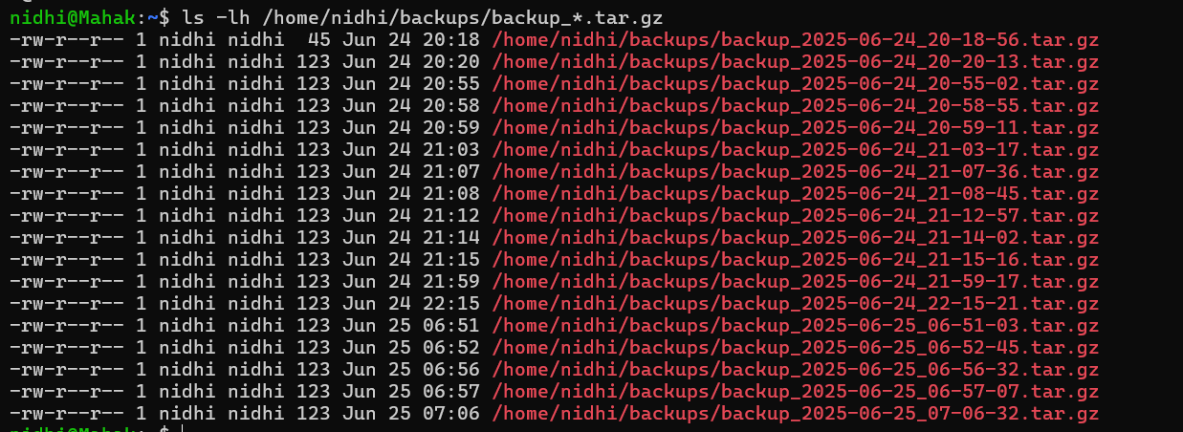

- To display the entire file at once:
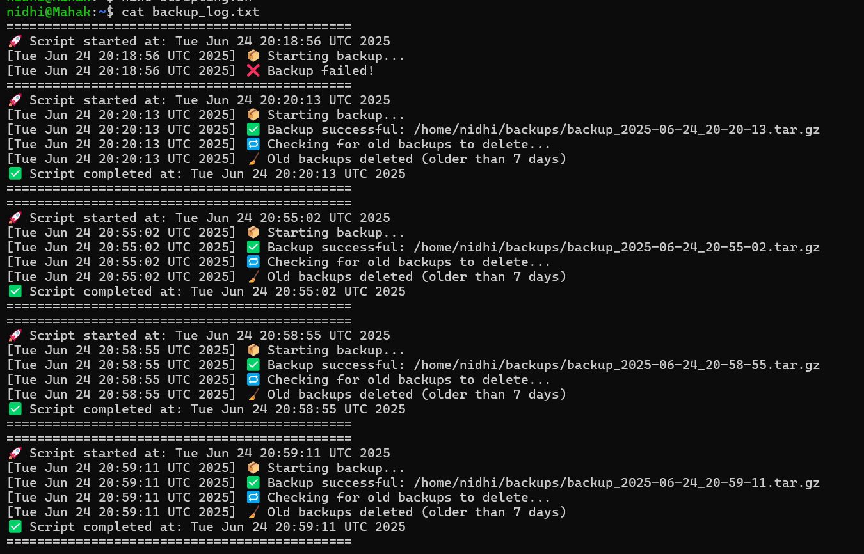


Topic covered:
- Configurable variables (SOURCE_DIR, BACKUP_DIR, SCRIPT_LOG, TIMESTAMP) for flexibility and unique file naming
- Modular function (backup_automation()) for clean structure and reusability
- Safe directory creation using mkdir -p to avoid errors
- Compressed archive generation with tar -czf using dirname/basename for accurate path handling
- Dual output logging via tee, writing to both console and log file.
- Exit-status check ($?) to detect success or failure of the backup

