Hand-on 1 Prerequisites:
Install Ubuntu for shell scripting.
Here are the steps to install Ubuntu in Windows:
- Open your terminal
- Run the command: wsl --install -d Ubuntu
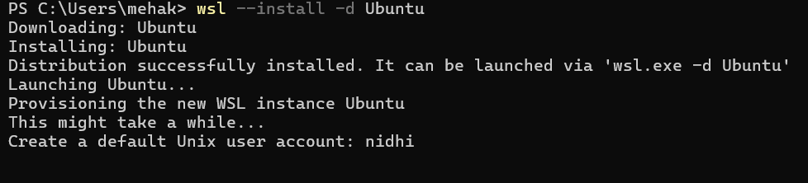
- Now, create your default user account and set up a new password.
- Ubuntu is successfully installed on your computer.
- To check if Ubuntu is working, you can write this command:
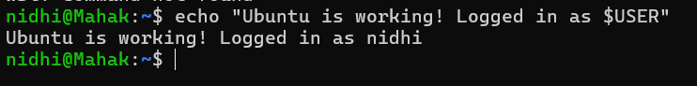
- To check the version, you can execute the command (lsb_release -a)
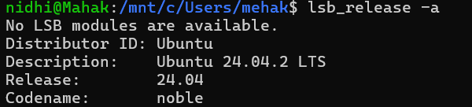

- Basic Script for Automation
Create a simple Bash automation script that gathers and displays essential system information using basic shell scripting techniques. The goal is to automate the process of retrieving data such as hostname, current date/time, uptime, memory usage, and disk space without using loops, conditionals, or advanced logic, making it ideal for beginners learning shell scripting.
Steps Involved:
- Open the Ubuntu terminal.
Press Ctrl + Alt + T to launch the Ubuntu terminal.
- Create a file named script.sh
- Write the commands inside the script.
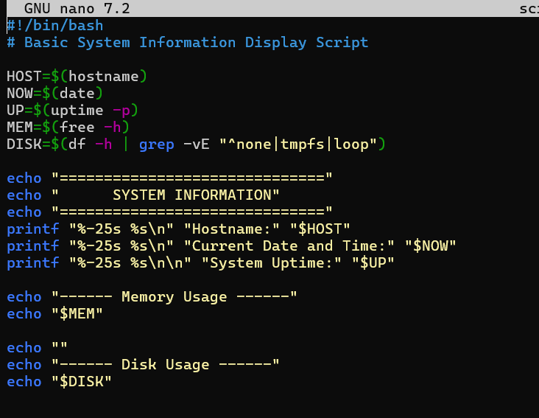
After writing the script, click CTRL + O and ENTER.
And then, to exit the script, click CTRL + X.
- To make the file script.sh executable, run this command:
- Run the script
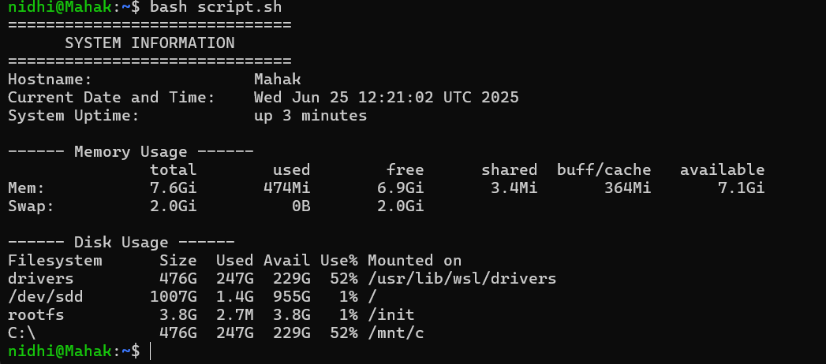
Topics covered:
- Shebang declaration (#!/bin/bash)
- Variable assignment using VAR=value
- Command substitution using $(...)
- Use of basic system commands:
  - hostname—get system hostname
  - date – get current date and time
  - uptime—check system uptime
  - free -h – view memory usage
  - df -h – check disk space usage

