5. Debugging and Optimizing the Existing Script
Problem statement:
In modern computing environments, managing system performance and ensuring data backups are vital for system reliability and disaster recovery. Manually monitoring CPU and memory usage or creating backups can be error-prone and inefficient.
This Bash script automates and optimizes the existing script for
- Real-time system health monitoring (CPU and memory)
- Scheduled directory backups with timestamped archives
- Log management and old file clean-up using log rotation
Steps Involved:
- Open the Ubuntu terminal.
Press Ctrl + Alt + T to launch the Ubuntu terminal.
- Go to the existing script (scripting.sh)
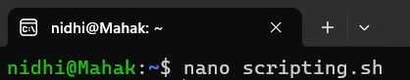
- Debug and optimize the existing script.
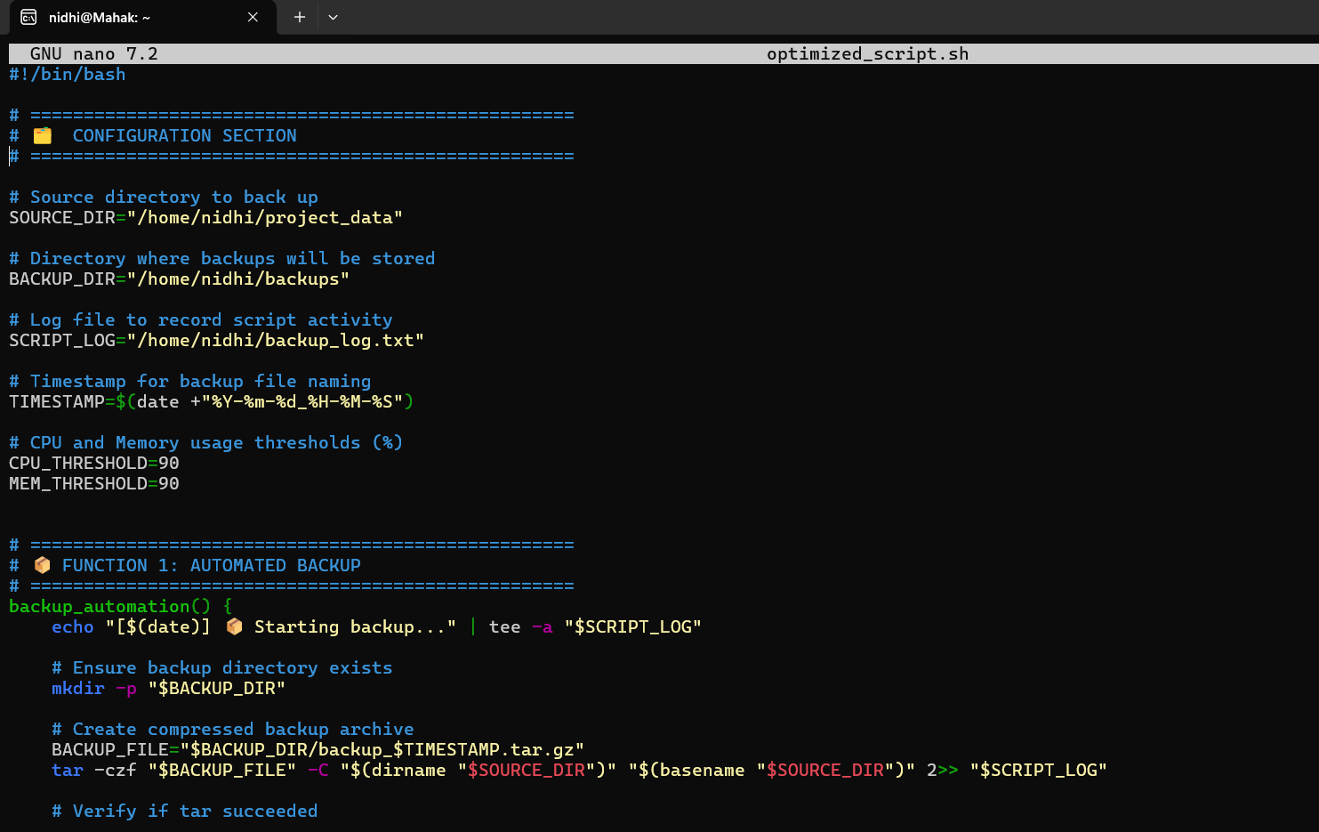
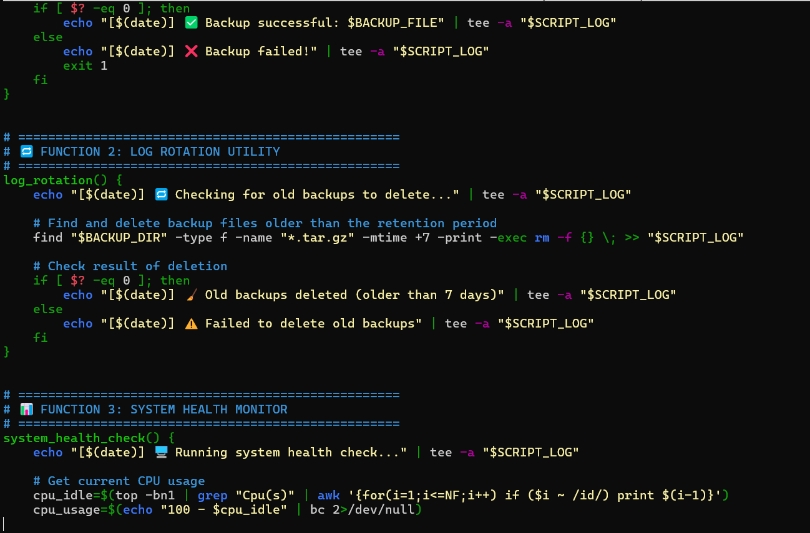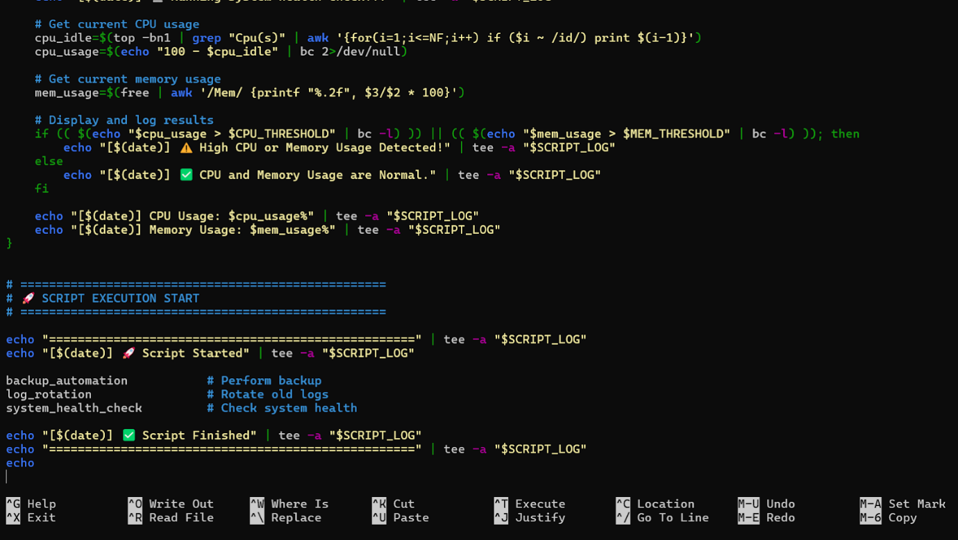
After finishing, use CTRL + O to save Nano, ENTER, and CTRL + X to exit.
- Make the Script Executable:
- Run the Script:
OUTPUT:
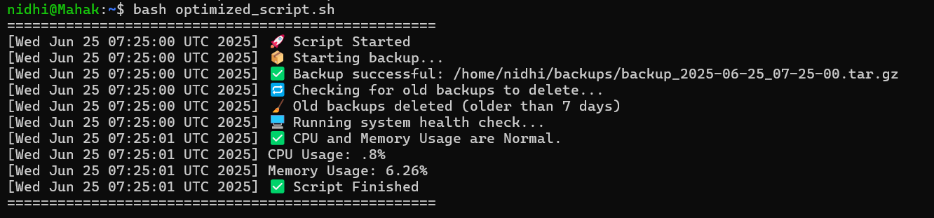
The script was debugged and optimized in the following ways:
- All logic is combined into a single, well-structured script:
- backup_automation
- log_rotation
- system_health_check
- Added a clear header and footer to separate script runs in the log file.
- Redirected errors from tar using 2>> "$SCRIPT_LOG" so that even failures are captured in the log.
- Used consistent UPPER_SNAKE_CASE for variables: $SOURCE_DIR, $SCRIPT_LOG, etc.
- Exit 1 was added as a fallback to immediately stop the script in the event of a backup failure.
- Enhanced with labeled output, thresholds, and formatted system health summary

Topic covered:
- Shell Scripting: Used variables, functions, conditionals, and formatted output with echo and printf.
- System Monitoring: Retrieved CPU and memory usage using top, free, and awk.
- Automation: Automated backup creation using tar and log rotation using find.
- Backup Management: Created timestamped .tar.gz archives and added success/failure status checks.
- Log Management: Logged all actions using tee and implemented auto-deletion of old backups with find -mtime.
- File Operations: Handled directory creation with mkdir -p, archive generation with tar, and cleanup using rm -f.
- Timestamping: Generated dynamic filenames using date +"%Y-%m-%d_%H-%M-%S" to avoid overwriting.
- Error Handling: Implemented conditional checks, exit codes, and float comparisons with bc -l to ensure reliability.
Conclusion:
The purpose of this documentation is to give readers a clear, practical grasp of the foundations of shell scripting and its real-world applications. Learners are exposed to fundamental scripting principles utilized in practical Linux environments through the development of simple scripts, a log rotation utility, a backup automation tool and a system health monitor. Debugging and optimizing an existing script also serves to reinforce recommended practices in resource management, error handling, and script architecture.
All things considered, this project functions as a thorough learning module that connects theoretical understanding with real-world application, giving students the tools they need to automate repetitive processes, improve system performance, and use shell scripting with assurance in work environments.

