2. Script for System Health Monitoring
Problem statement:
Design a system health monitoring script in Bash that checks real-time CPU and memory usage against predefined threshold limits. The script should calculate usage using standard Linux tools (top, free, awk, bc) and trigger alerts when resource usage exceeds configurable thresholds. It must implement conditional logic to compare current usage with thresholds and provide clear, formatted output to help users detect potential performance issues promptly.
Steps Involved:
- Open the Ubuntu terminal.
Press Ctrl + Alt + T to launch the Ubuntu terminal.
- Create the Script File
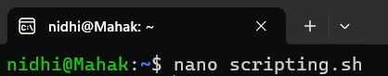
- Inside, add your script content.
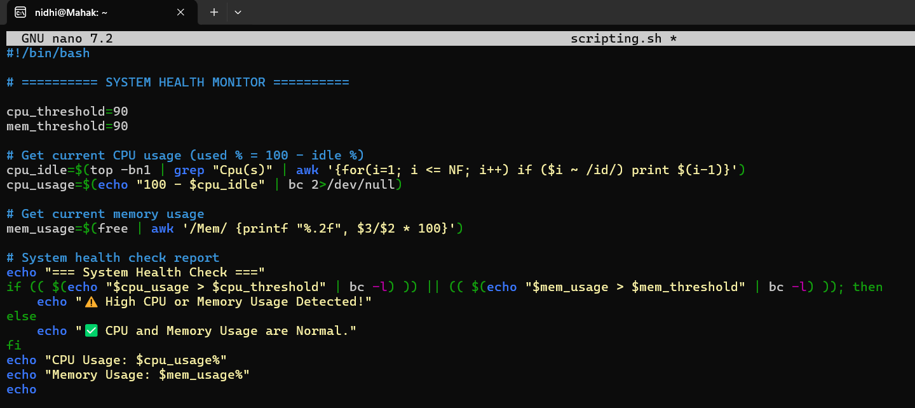
When done, save nano with CTRL + O and press ENTER, then exit with CTRL + X.
- Make the Script Executable

- Run the Script
OUTPUT
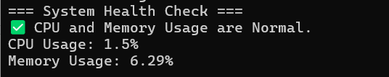
Topics covered:
- It defines threshold variables (cpu_threshold, mem_threshold) for flexible alert limits.
- It calculates CPU usage using top, grep, awk, and bc to determine active usage.
- It computes memory usage using free piped into awk, formatted to two decimal places.
- It implements threshold-based conditional logic via Bash if and bc, issuing alerts when either CPU or memory exceeds the limit.

