4. Log Rotation Utility
Problem Statement:
Develop a log rotation utility script in Bash that automatically deletes old backup or log files based on a configurable retention period. The script should use a modular function to encapsulate the clean-up logic, ensure safe deletion with proper error checking, and provide dual logging (to both the console and a log file) with timestamps to ensure transparency, traceability, and maintainability.
Steps Involved:
- Open the Ubuntu terminal.
Press Ctrl + Alt + T to launch the Ubuntu terminal.
- Edit the existing file
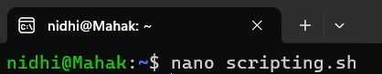
- Inside, add your script
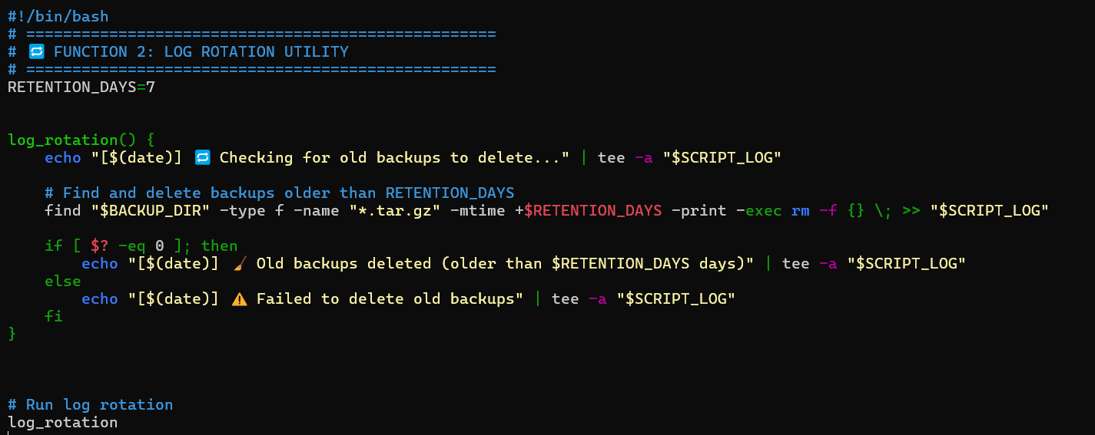
When done, save nano with CTRL + O and press ENTER then exit with CTRL + X.
- Make the Script Executable:

- Check the file present inside backups:
- Run the Script:
OUTPUT:
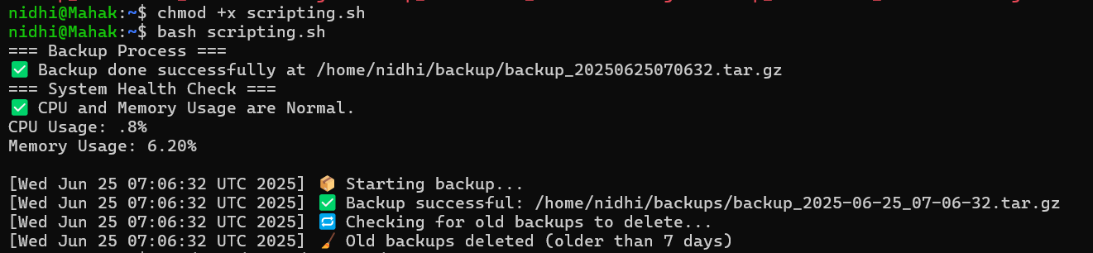
- To verify if the old backups are deleted, list the files in backups
The files that are older than 7 days are deleted.
Topics covered:
- Configurable RETENTION_DAYS=7 for how long backups/logs are kept
- In the modular log_rotation() function, cleanup logic is encapsulated.
- To find and remove old backup files that are older than the retention threshold, use find "$BACKUP_DIR" -type f -name "*.tar.gz" -mtime +$RETENTION_DAYS -exec rm -f {} \;
- Safe cleanup using an exit-status check ($?) to record a successful or unsuccessful tee
- For transparency, dual logging output (both console and log file) with timestamps

