Create Basic Infrastructure Definitions

Overview

This document guides you in creating a basic cloud infrastructure using Terraform on AWS. You will define infrastructure components like:
- VPC (Virtual Private Cloud)
- Subnet
- Security Group
- EC2 Instance
- S3 Bucket

Prerequisites
- VS Code
- Terraform
- AWS CLI
- An AWS IAM user
- You’ve already set up access keys locally

Step 1: Create Folder

- Open VS Code
- Create a folder of any name.
- Define the Infrastructure in main.tf file.

(The main.tf file is a core Terraform configuration file where you define the infrastructure resources you want to provision and manage using Terraform.)

# main.tf
provider "aws" {
region = var.region
}

# VPC
resource "aws_vpc" "main_vpc" {
cidr_block = var.vpc_cidr
tags = {
Name = var.vpc_name
}
}

# Subnet
resource "aws_subnet" "main_subnet" {
vpc_id = aws_vpc.main_vpc.id
cidr_block = var.subnet_cidr
availability_zone = var.availability_zone
tags = {
Name = var.subnet_name
}
}

# Internet Gateway
resource "aws_internet_gateway" "igw" {
vpc_id = aws_vpc.main_vpc.id
}

# Security Group
resource "aws_security_group" "web_sg" {
name = var.sg_name
description = var.sg_description
vpc_id = aws_vpc.main_vpc.id

ingress {
from_port = 22
to_port = 22
protocol = "tcp"
cidr_blocks = ["0.0.0.0/0"]
}

egress {
from_port = 0
to_port = 0
protocol = "-1"
cidr_blocks = ["0.0.0.0/0"]
}
}

# EC2 Instance
resource "aws_instance" "web" {
ami = var.ami
instance_type = var.instance_type
subnet_id = aws_subnet.main_subnet.id
vpc_security_group_ids = [aws_security_group.web_sg.id]
associate_public_ip_address = true

tags = {
Name = var.ec2_name
}
}

# S3 Bucket
resource "aws_s3_bucket" "my_bucket" {
bucket = var.bucket_name
acl = "private"

tags = {
Name = var.bucket_tag
}
}

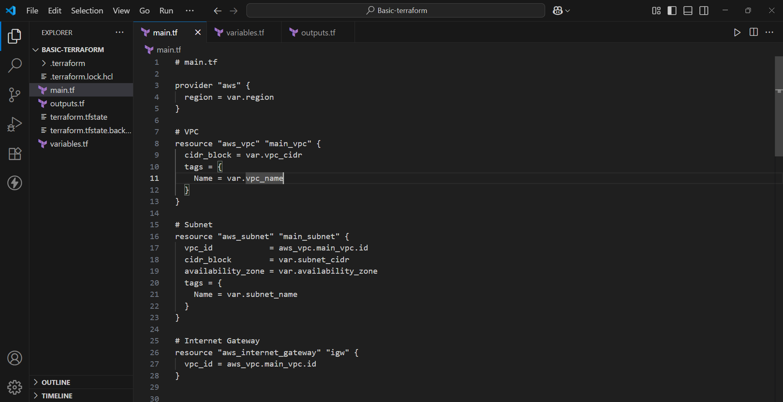

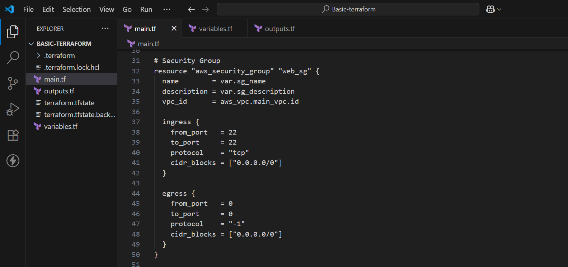

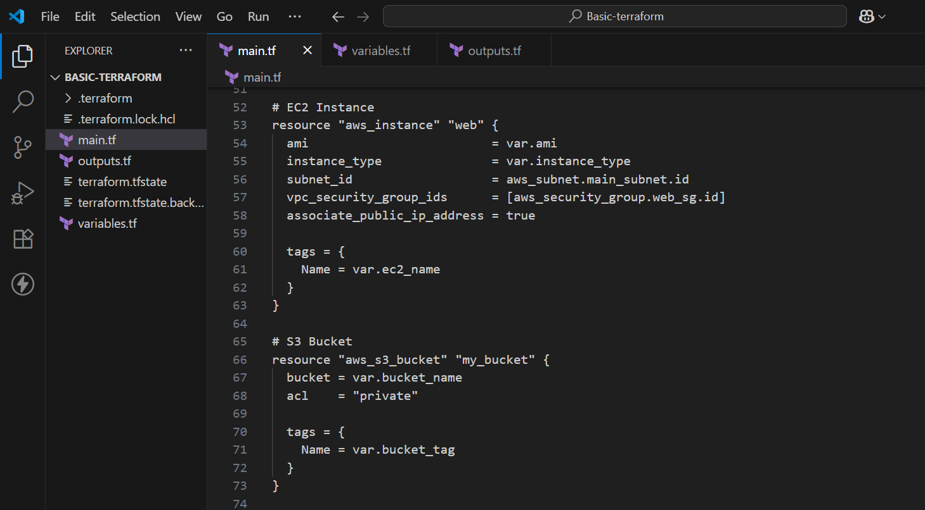

- Declare Variables
It declares variables you can use in your other .tf files (like main.tf, outputs.tf, etc.).
These variables allow you to customize values (like region, instance type, CIDR blocks) without hardcoding them directly into your code.

- Create a file named variables.tf

variable "region" {
default = "ap-south-1"
}

variable "vpc_cidr" {
default = "10.0.0.0/16"
}

variable "vpc_name" {
default = "BasicVPC"
}

variable "subnet_cidr" {
default = "10.0.1.0/24"
}

variable "availability_zone" {
default = "ap-south-1a"
}

variable "subnet_name" {
default = "BasicSubnet"
}

variable "sg_name" {
default = "allow_ssh"
}

variable "sg_description" {
default = "Allow SSH inbound traffic"
}

variable "ami" {
default = "ami-0c55b159cbfafe1f0" # Amazon Linux 2 in Mumbai
}

variable "instance_type" {
default = "t2.micro"
}

variable "ec2_name" {
default = "TerraformEC2"
}

variable "bucket_name" {
default = "eduhubspot-basic-infra-bucket-2025"
}

variable "bucket_tag" {
default = "MyBucket"
}

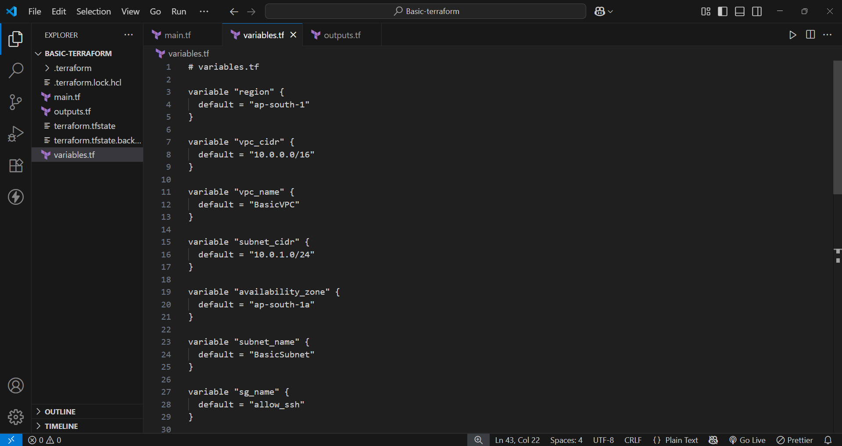

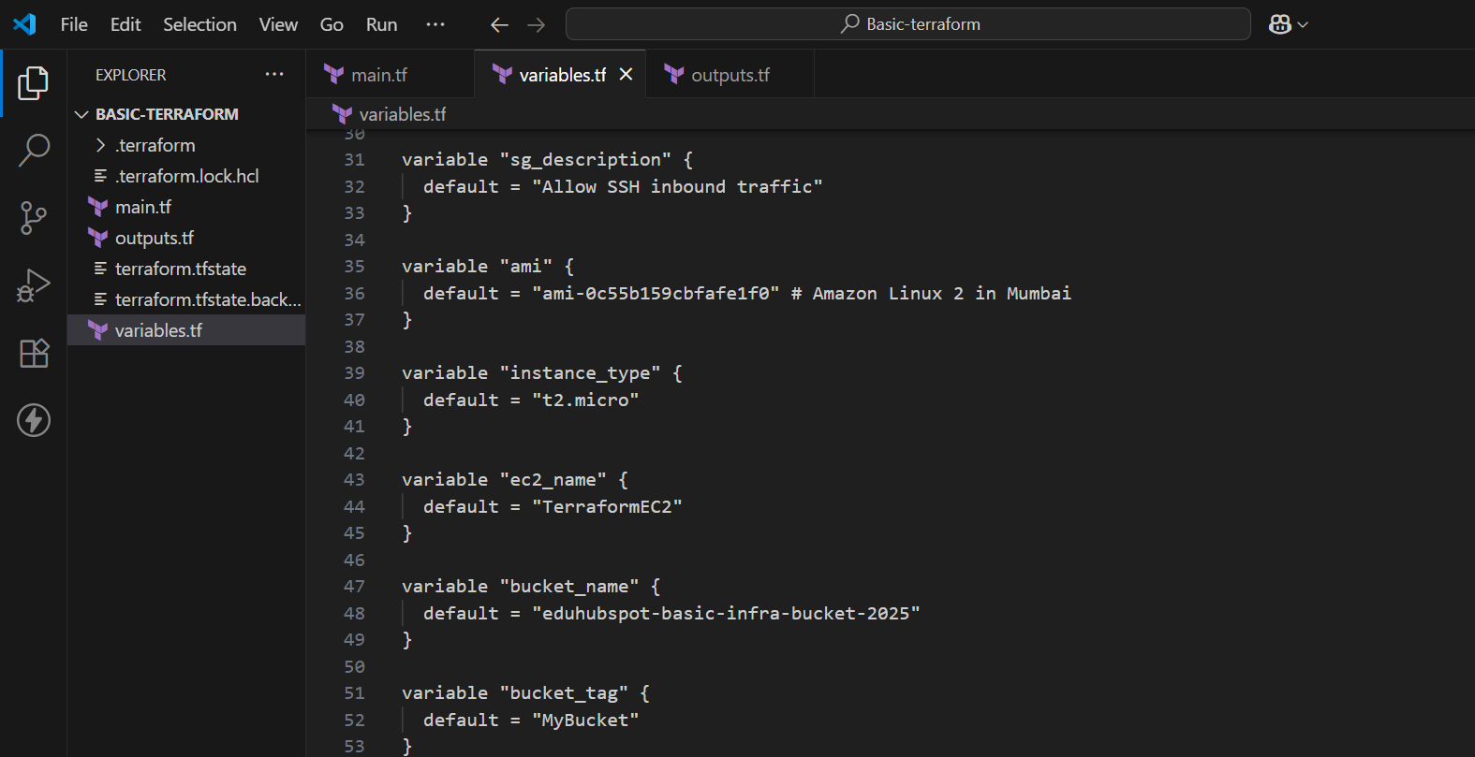

- Declare output

The outputs.tf file is used to define output values that Terraform will display after the infrastructure is applied. These outputs are helpful to:
- View key resource attributes (like public IPs, instance IDs, VPC IDs).
- Share values between modules.
- Pass values to external systems like CI/CD pipelines or other tools.

- Create a file outputs.tf

# Output the public IP of the EC2 instance

output "ec2_public_ip" {
description = "Public IP address of the EC2 instance"
value = aws_instance.web.public_ip
}

# Output the name of the S3 bucket

output "s3_bucket_name" {
description = "Name of the created S3 bucket"
value = aws_s3_bucket.my_bucket.id
}

# Output the VPC ID

output "vpc_id" {
description = "ID of the created VPC"
value = aws_vpc.main_vpc.id
}

# Output the subnet ID

output "subnet_id" {
description = "ID of the created subnet"
value = aws_subnet.main_subnet.id
}

# Output the security group ID

output "security_group_id" {
description = "ID of the security group"
value = aws_security_group.web_sg.id
}

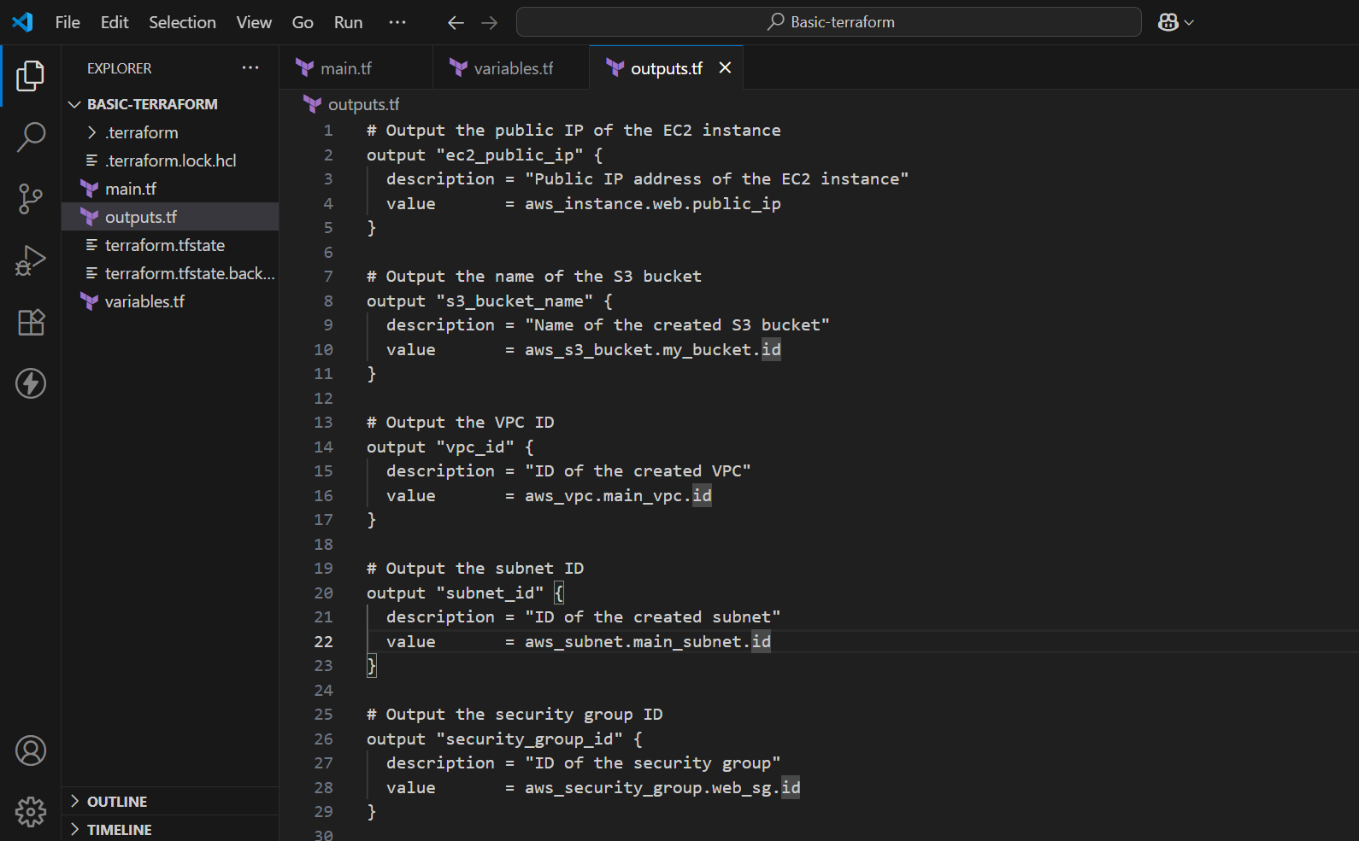

Step 2: Add permission policies in IAM user.

- Go to IAM console.
- Open https://console.aws.amazon.com/iam/

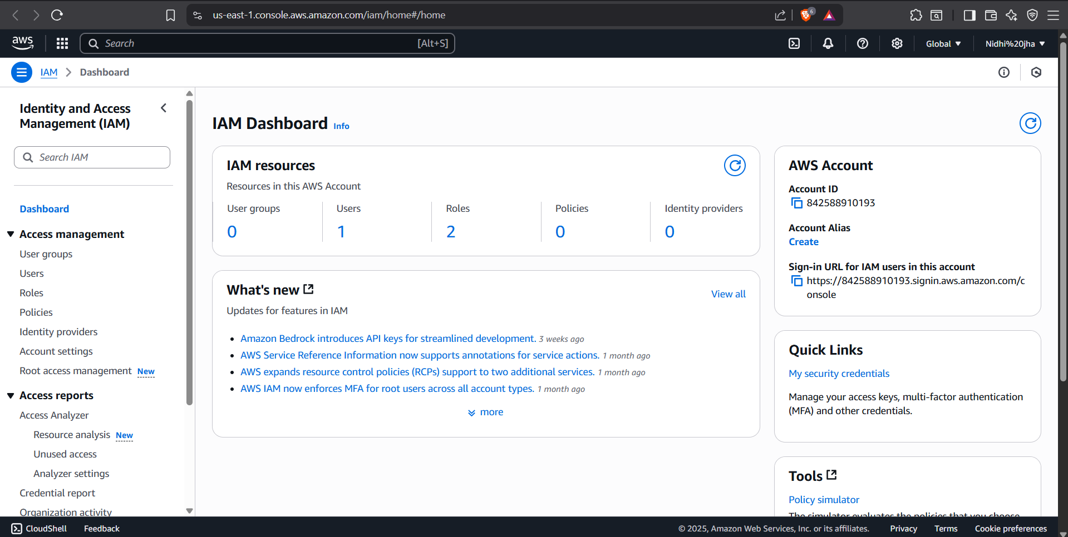

- Go to users.

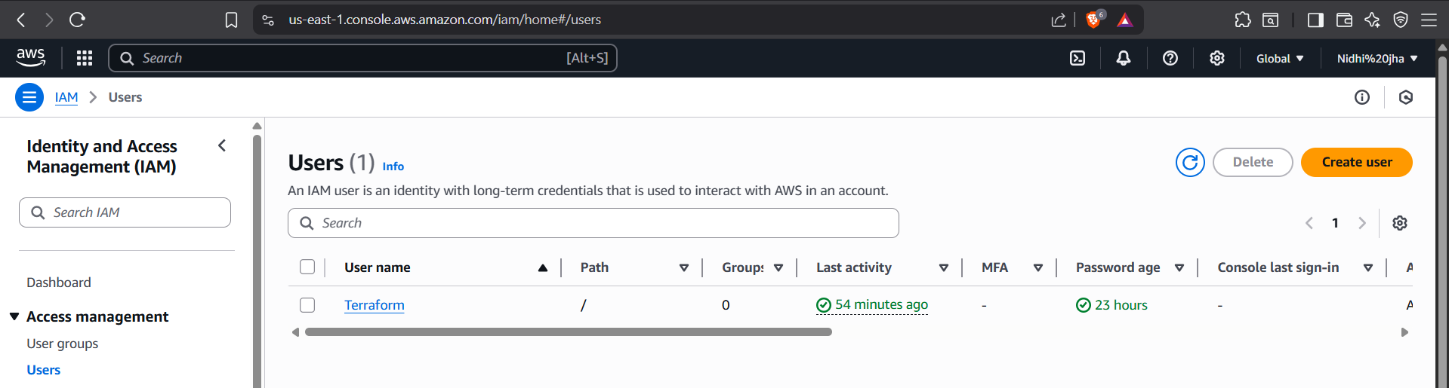

- Click on Terraform.

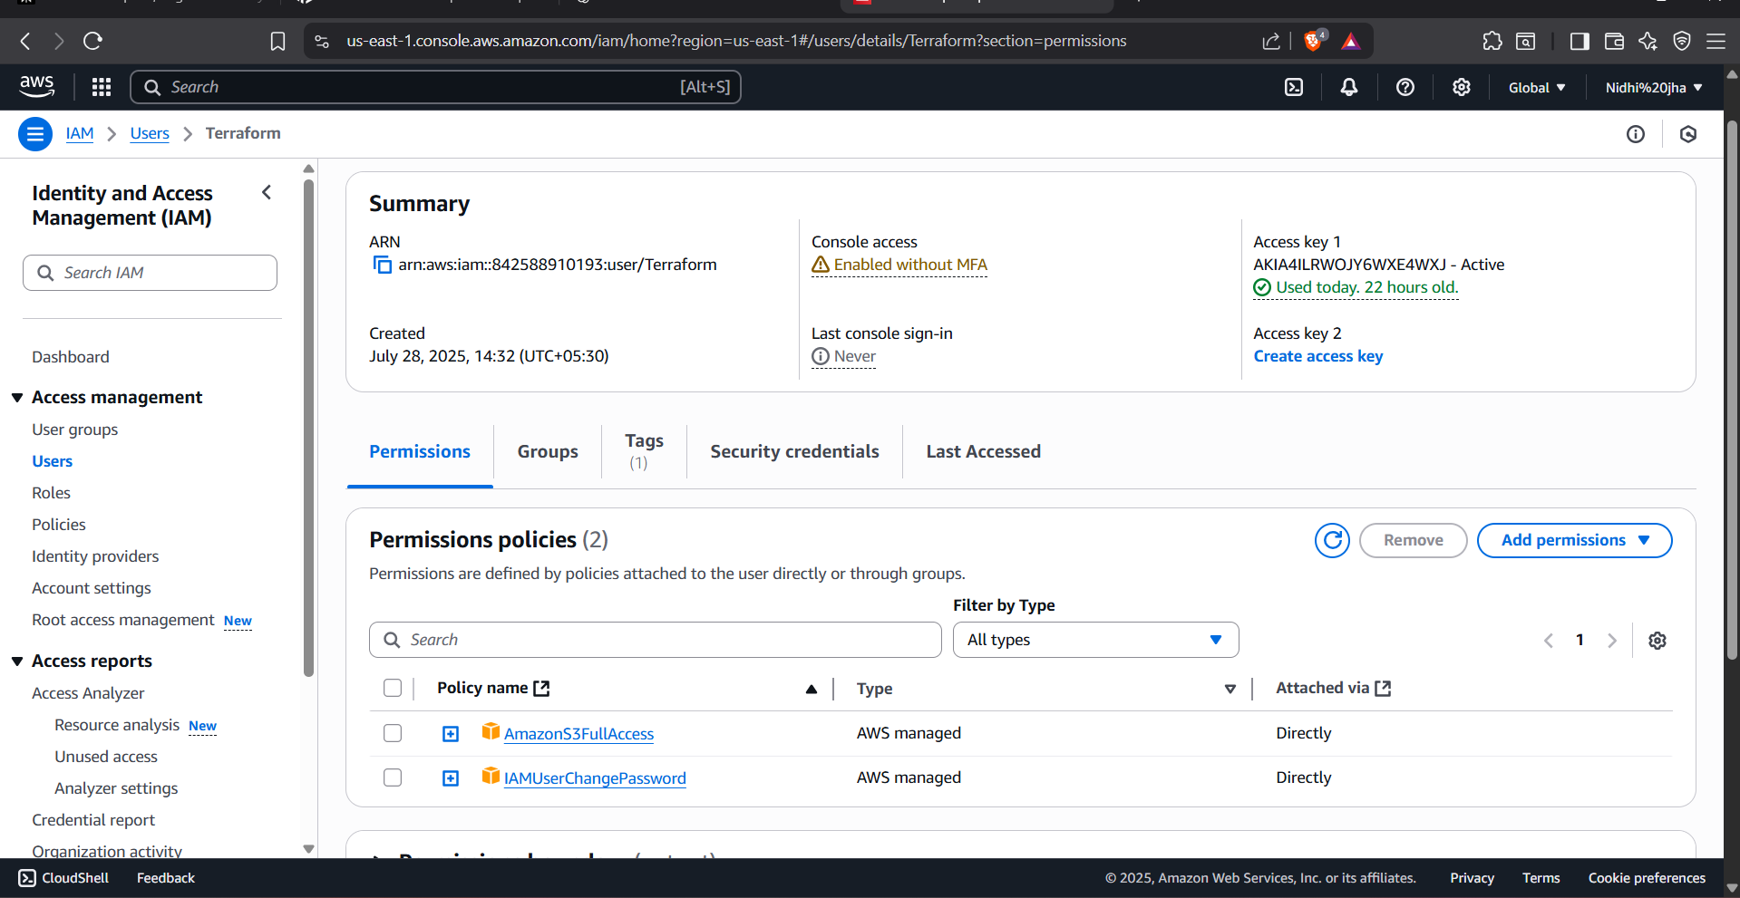

- Go to permissions policies Add permissions Add permissions.

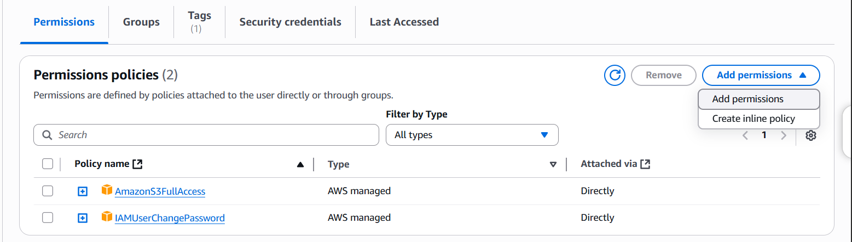

- Attach policies directly.
- In permissions policies, add AmazonEC2FullAccess.
(For S3 bucket, we already given permissions.)

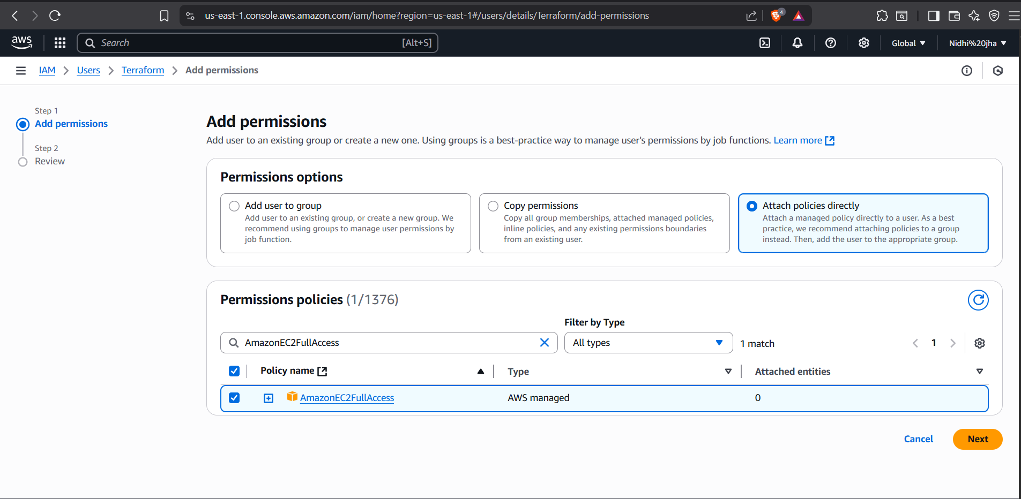

- Review the permissions and click on add permissions.

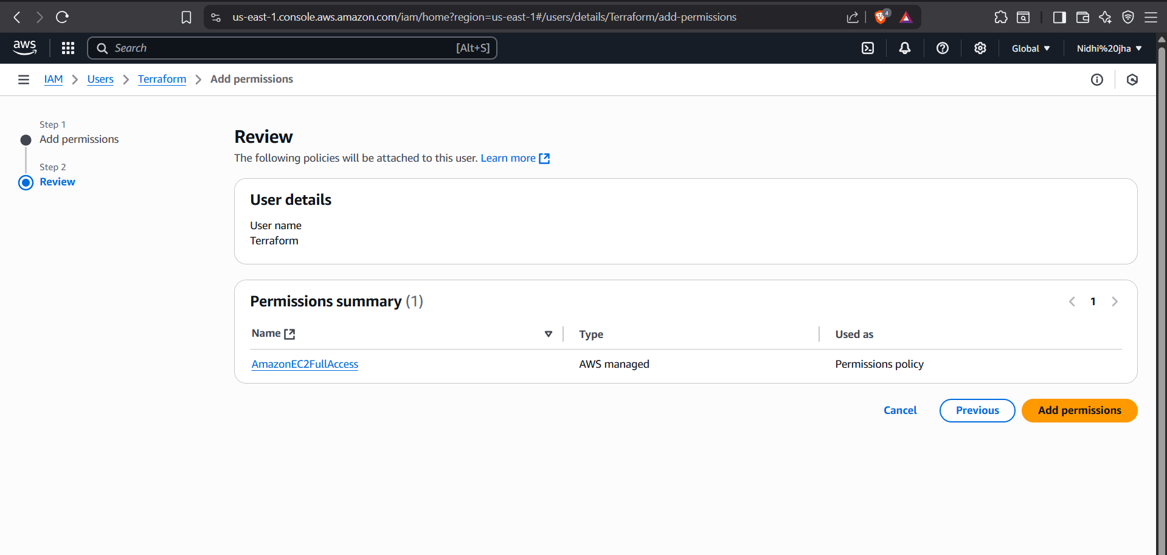

- Permissions are added successfully.

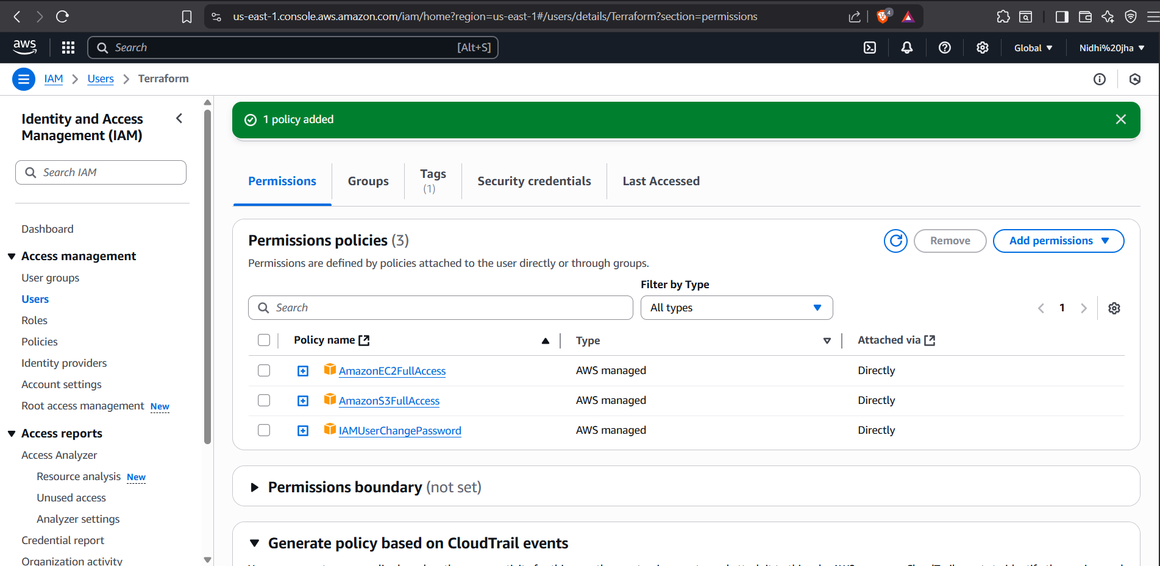

Step 3: Run Terraform Commands
- From your terminal, run:
  - terraform init

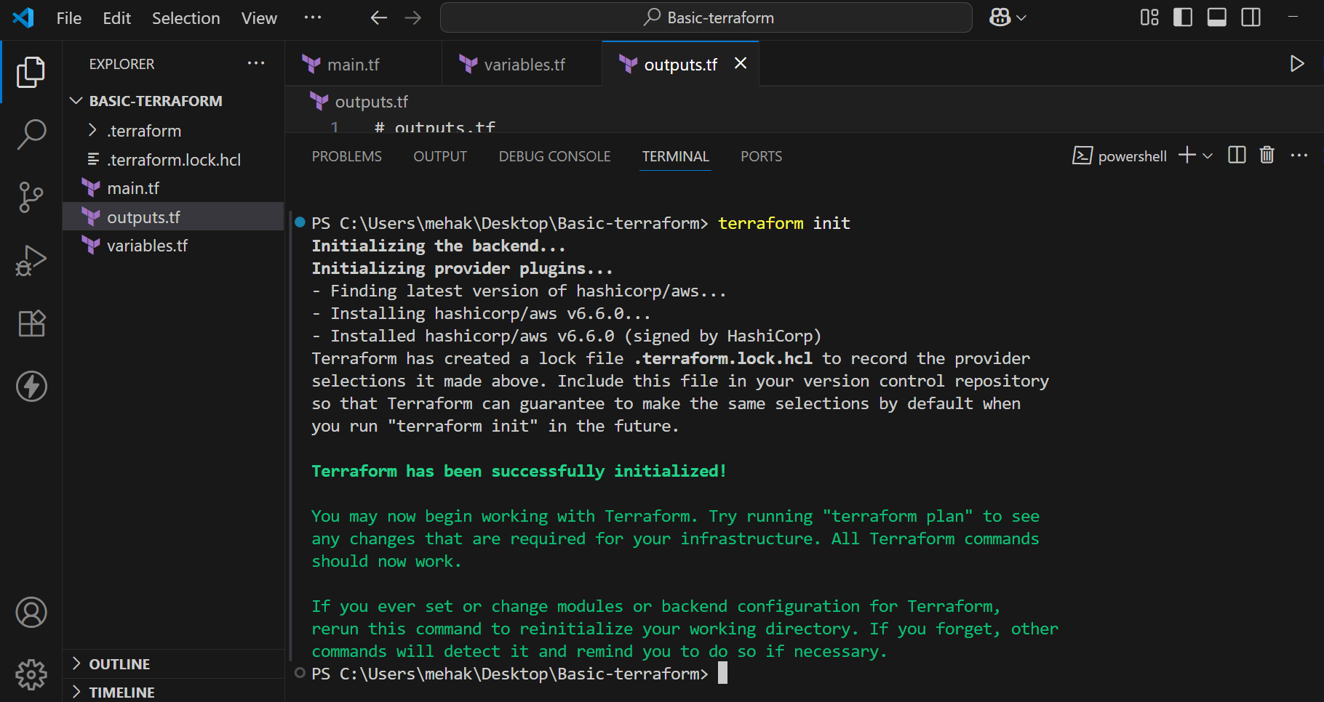

- After initializing, run the following command:
  - terraform plan

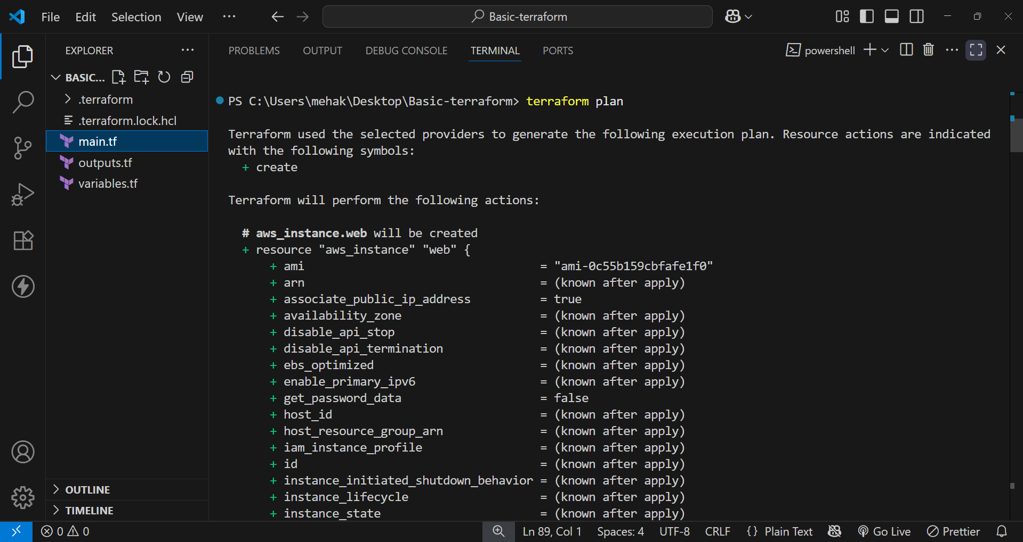

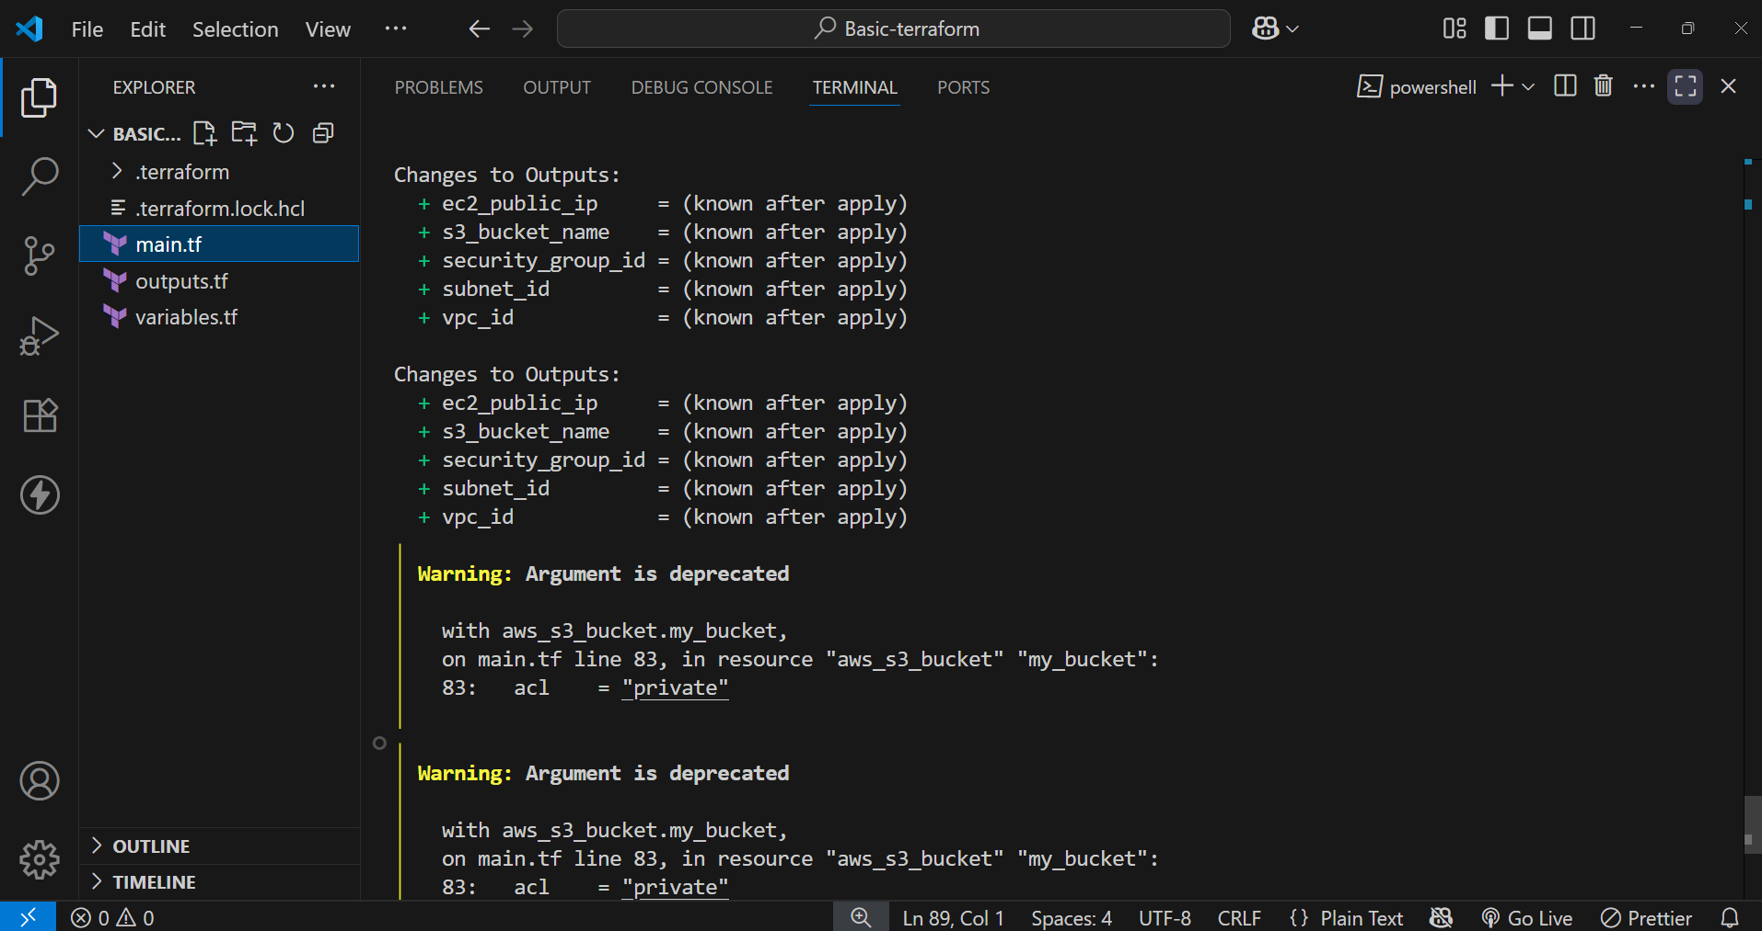

- Run the command:
  - terraform apply

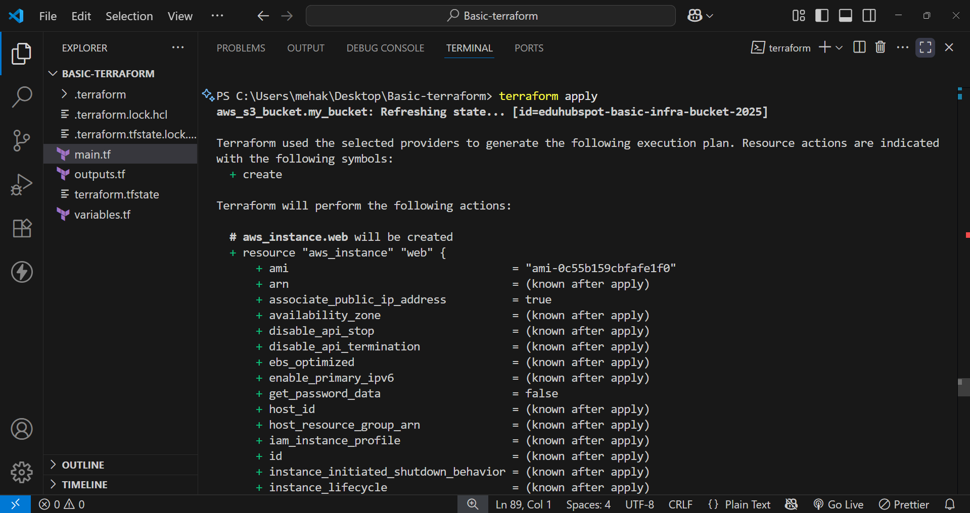

- In the Enter a value option, type “yes”

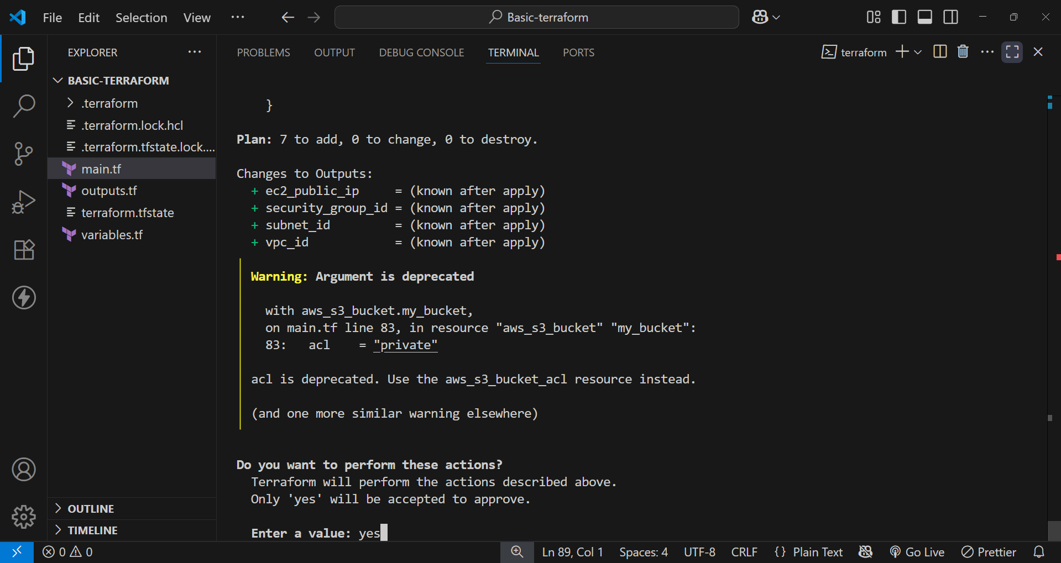

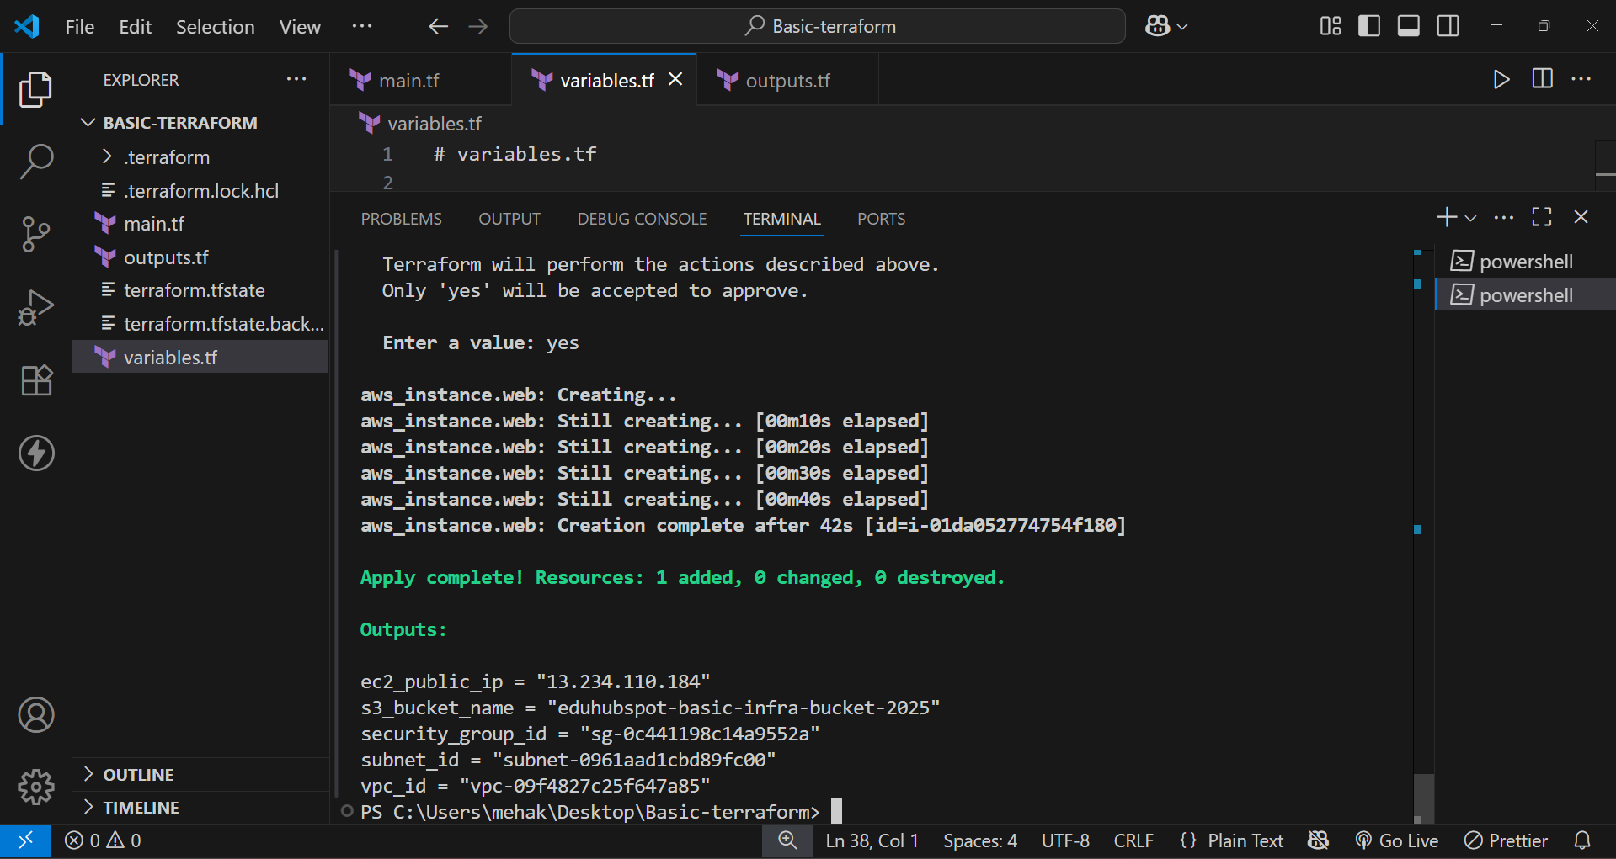

Step 4: Verification

1. VPC
- Go to: VPC Dashboard → https://console.aws.amazon.com/vpc/
- Open VPCs.

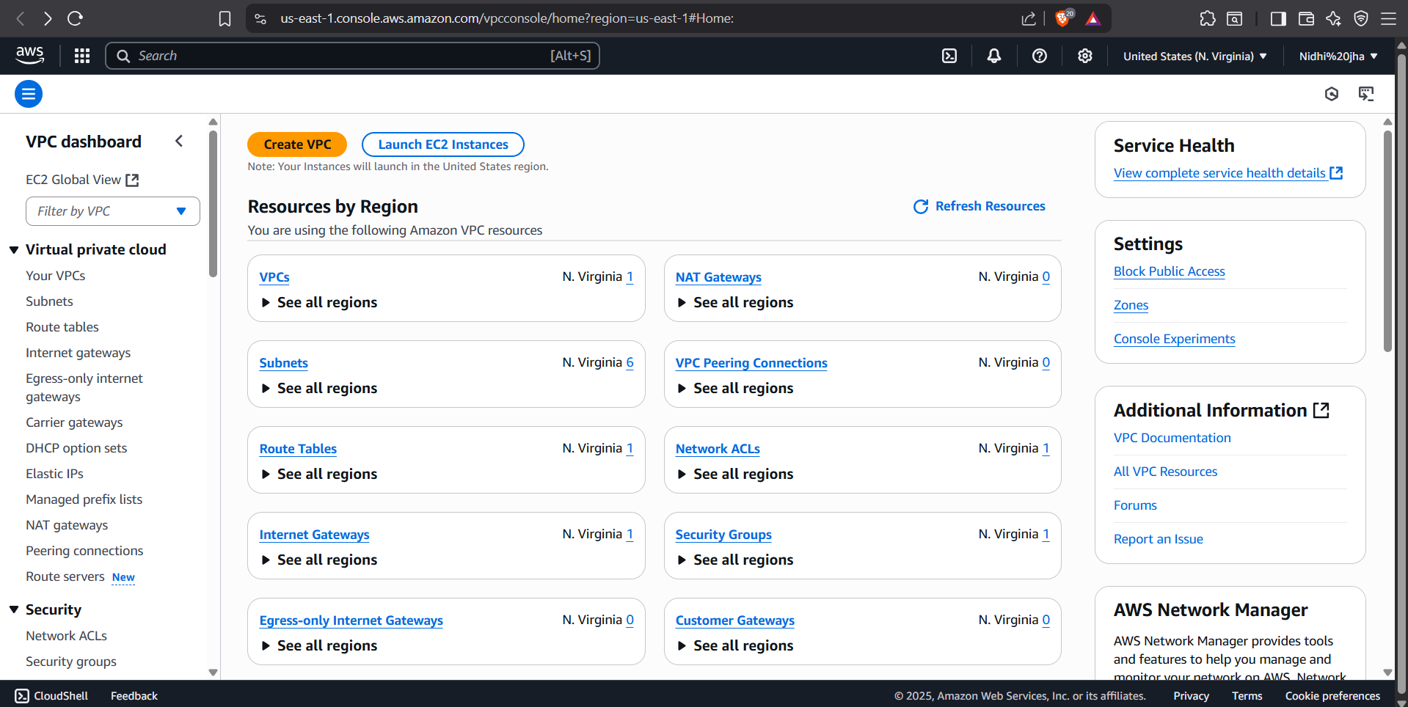

- Look for a VPC with the name tag BasicVPC (or whatever value you used in var.vpc_name)
- Check that its CIDR block is 10.0.0.0/16

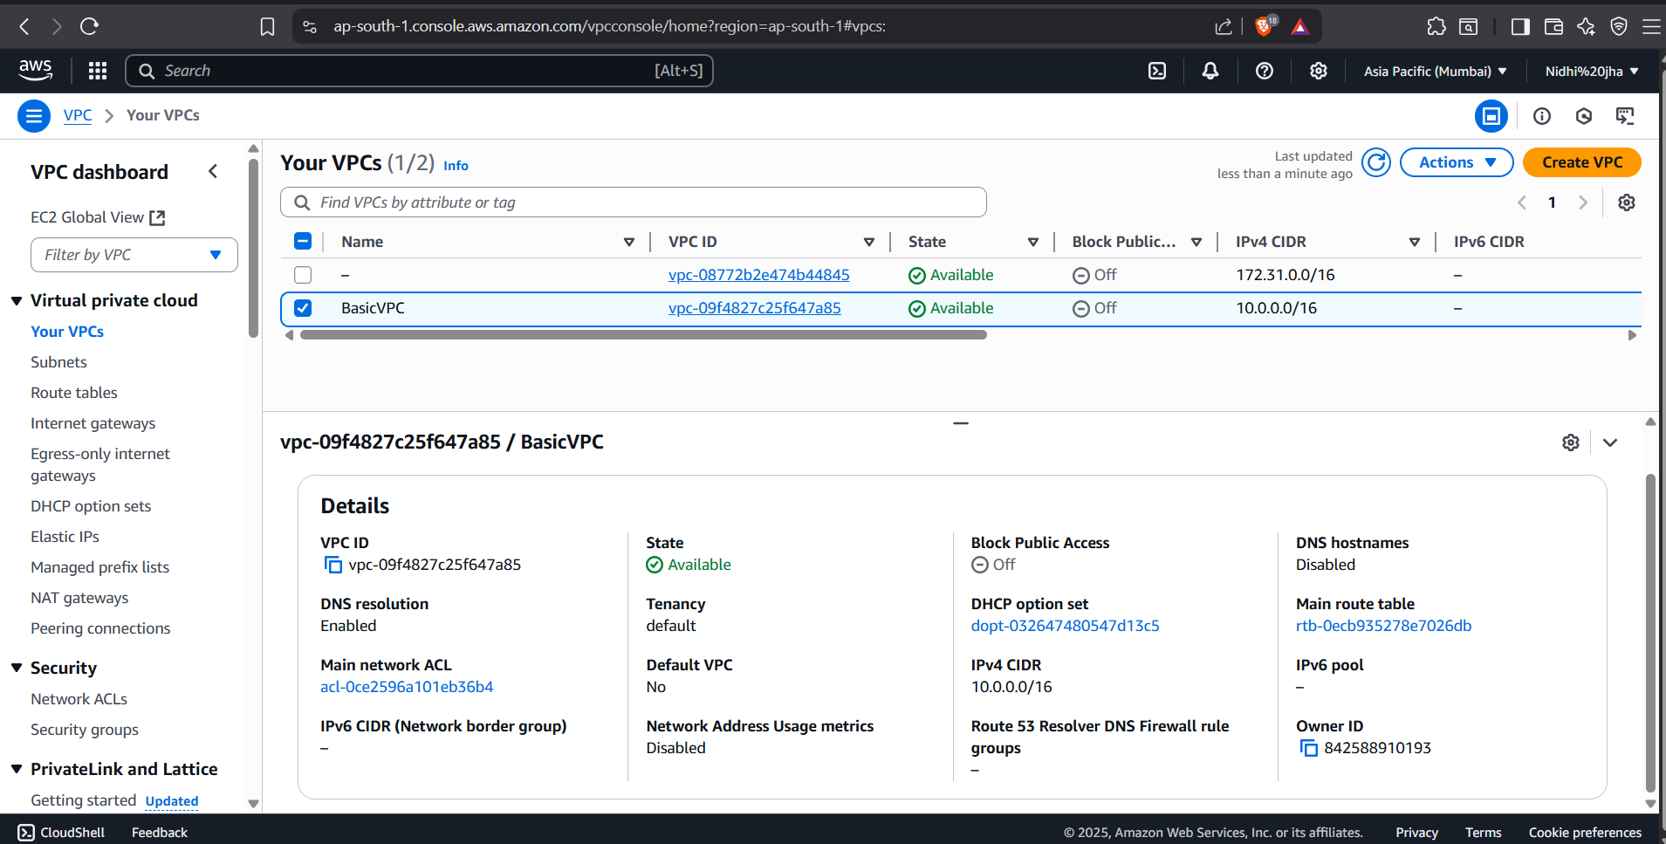

2. Subnet
VPC Dashboard → Subnets
- Confirm a subnet exists with CIDR 10.0.1.0/24
- It's linked to the VPC above
- Availability Zone should be ap-south-1a

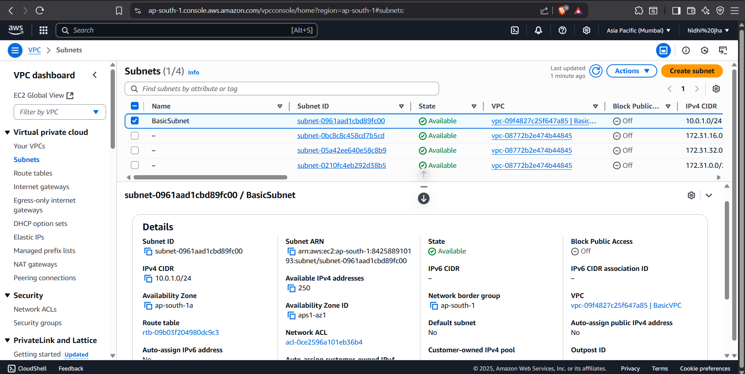

3. Internet Gateway
VPC Dashboard → Internet Gateways
- One Internet Gateway exists and is attached to your VPC

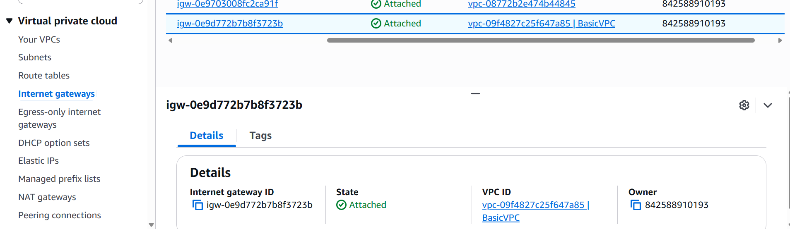

4. EC2 Instance
EC2 Dashboard → https://console.aws.amazon.com/ec2/v2/home?#Instances
- One EC2 instance is running
- Name tag = TerraformEC2

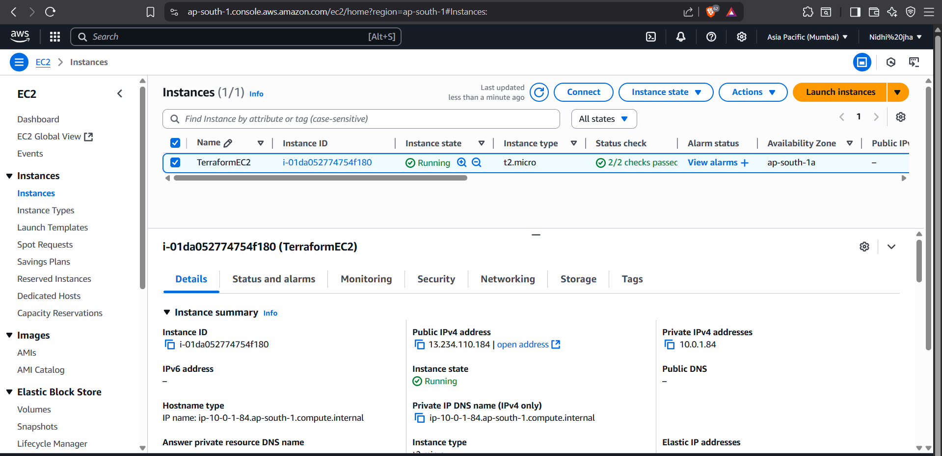

- Check instance type = t2.micro
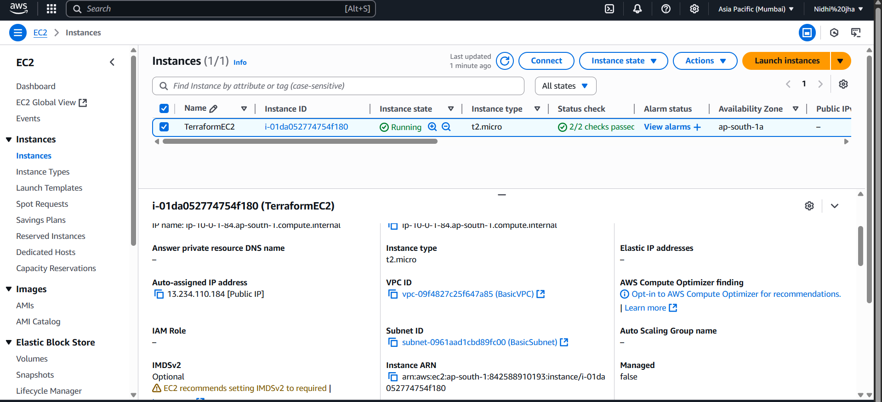

- Public IP is assigned (you can copy this to try SSH later if you have a key pair)

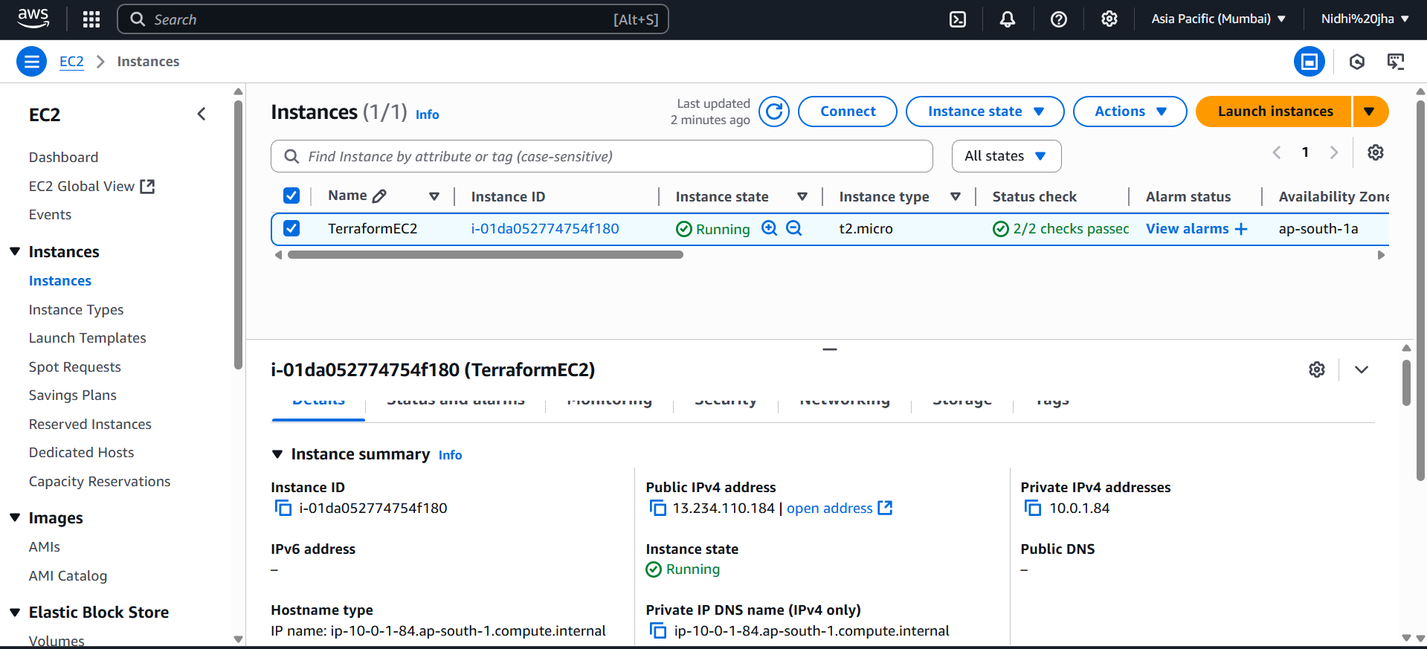

5. S3 Bucket
S3 Dashboard → https://s3.console.aws.amazon.com/s3/
- Look for your bucket: eduhubspot-basic-infra-bucket-2025 or whatever value you used

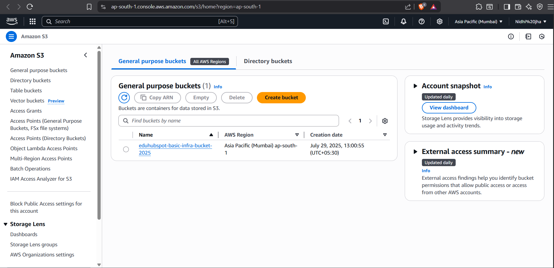

Step 5: Destroy Terraform

- In your terminal run:
  - destroy terraform

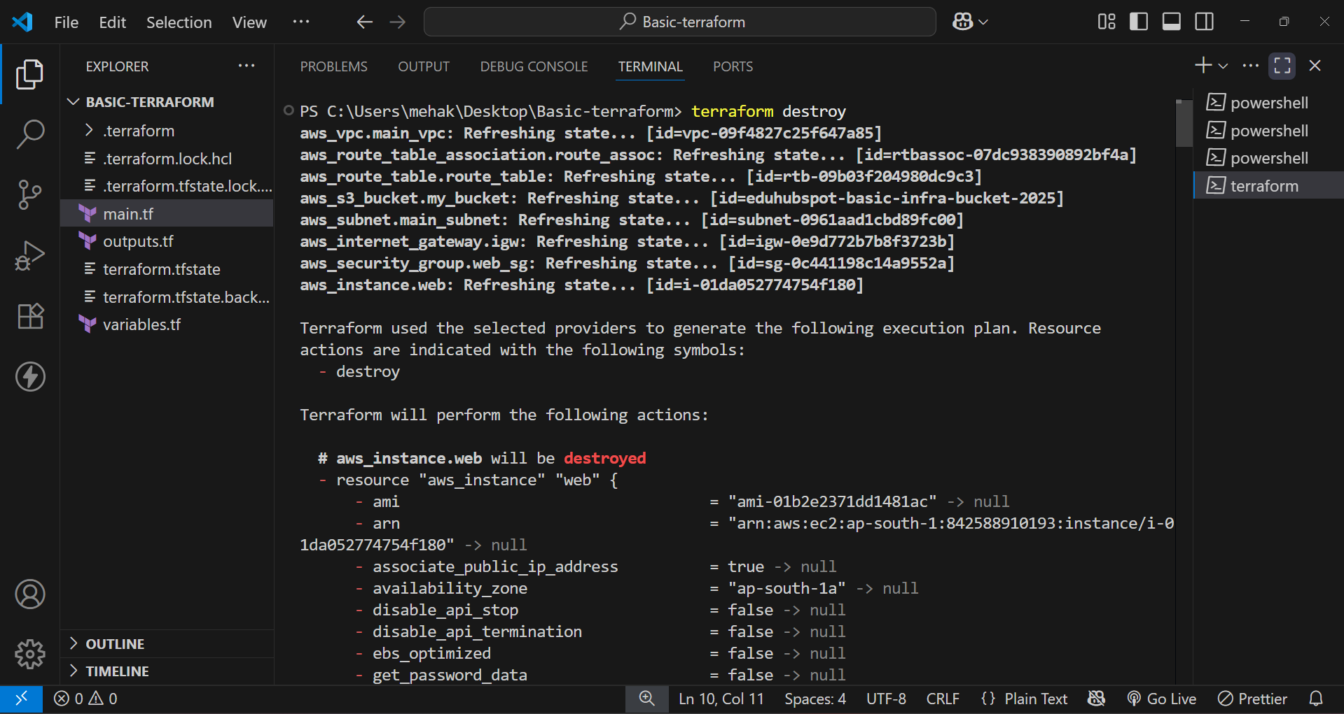

- Enter “yes”
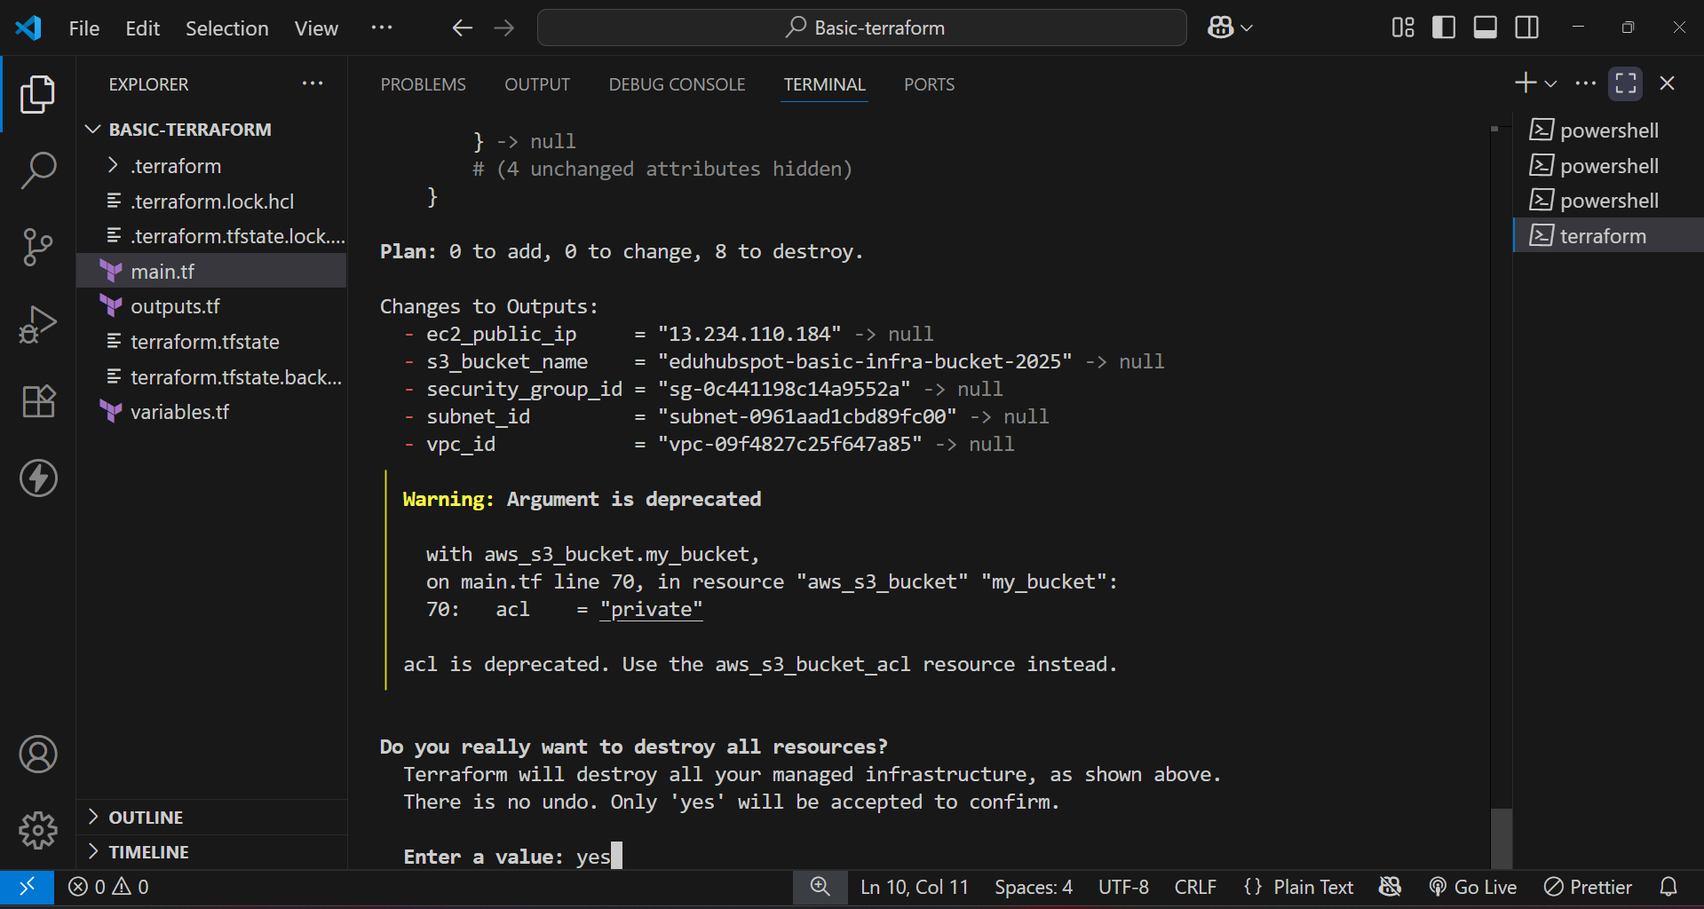

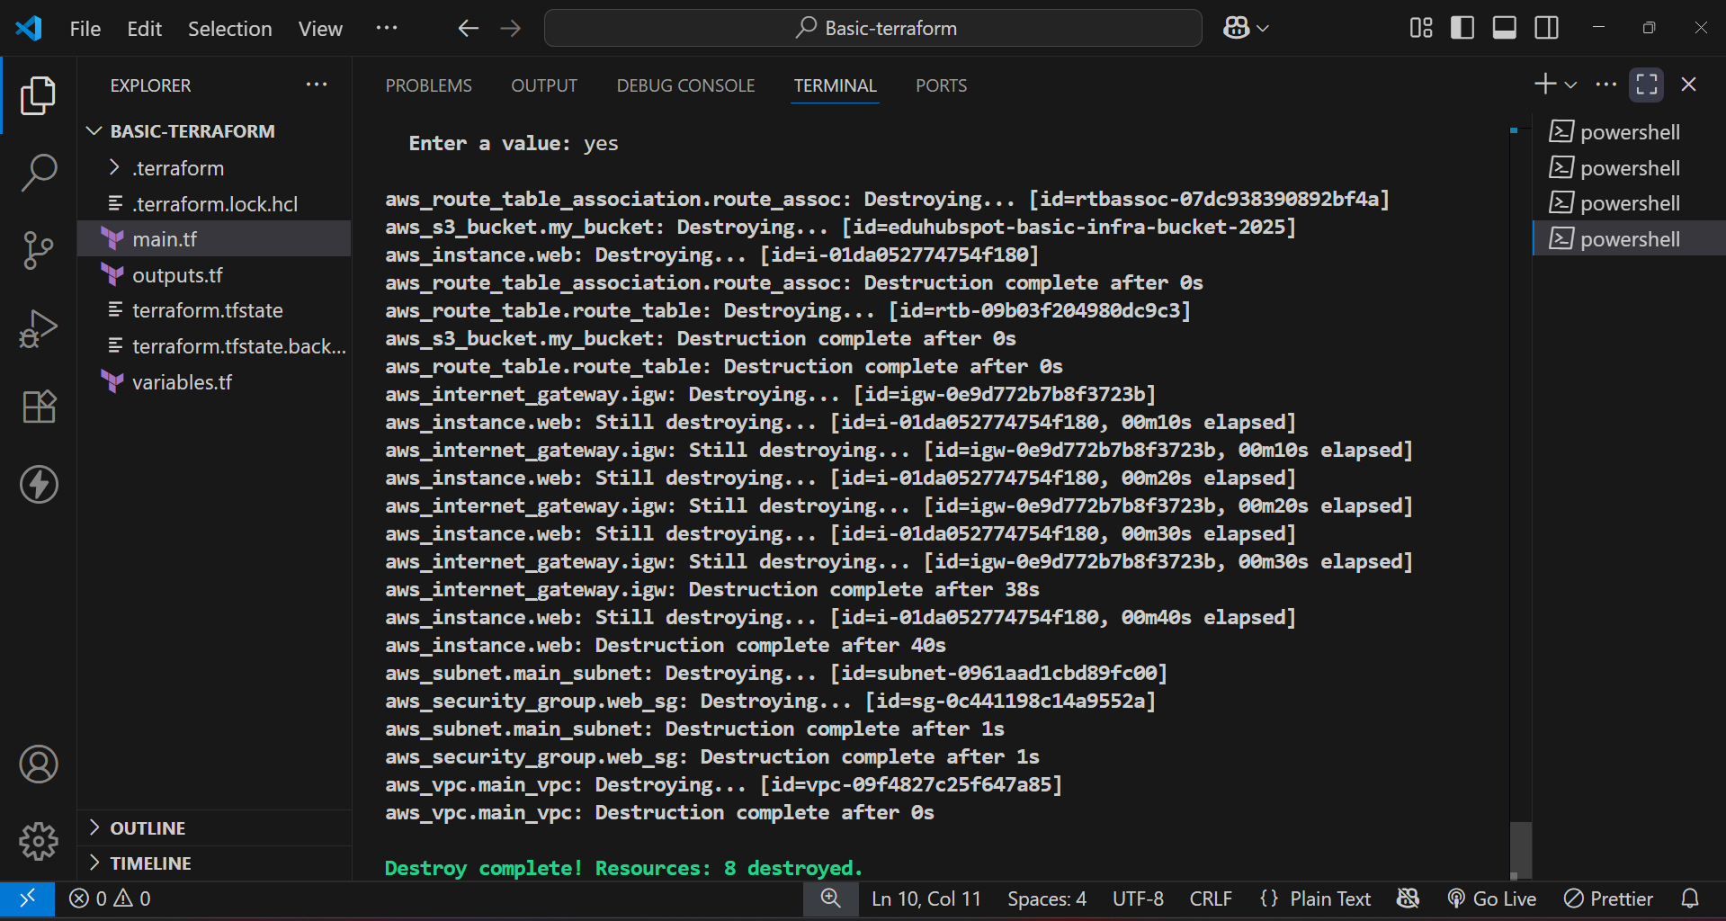

- Go to EC2 instances
- Check the instance we created is terminated successfully.

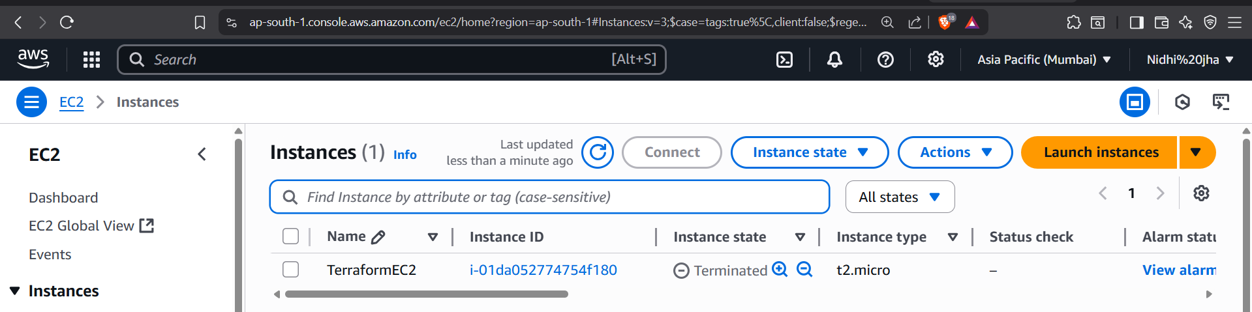

- Also check the Amazon S3 bucket (it is empty).

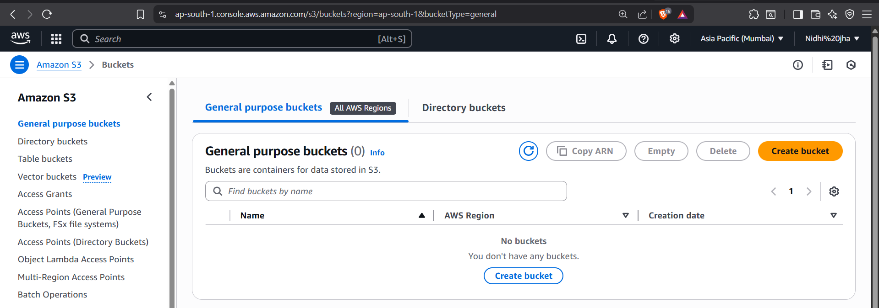

Destroy successfully.

Conclusion

In this guide, we successfully created a basic cloud infrastructure on AWS using Terraform. You defined and provisioned critical components including:

- A VPC and Subnet to structure the network
- An Internet Gateway for connectivity
- A Security Group to manage access
- An EC2 instance to deploy compute resources
- An S3 bucket for object storage

