Implement Modular Infrastructure Code

Overview

Modular infrastructure code means breaking down your Terraform code into reusable and manageable components (modules). This makes your infrastructure scalable, clean, and easier to maintain.

Instead of having all your code in a single main.tf, you create logical units like network, compute, and storage as modules, which you can reuse across projects and environments (dev, staging, prod).

Prerequisites
- VS Code
- Terraform
- AWS CLI
- IAM user

Step 1: Initialize Your Project

- Open VS Code
- Create a folder

Step 2: Create the VPC Module

- Write the code in main.tf:

resource "aws_vpc" "main" {
cidr_block = var.vpc_cidr

tags = {
Name = var.name
}
}

resource "aws_subnet" "main" {
vpc_id = aws_vpc.main.id
cidr_block = var.subnet_cidr
availability_zone = var.availability_zone
map_public_ip_on_launch = true

tags = {
Name = "${var.name}-subnet"
}
}

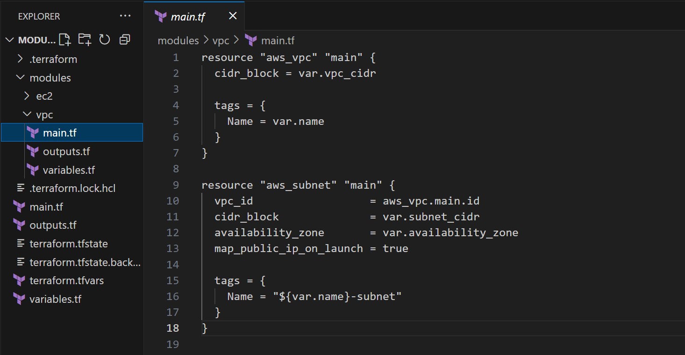

- Define variables in the file variables.tf

variable "vpc_cidr" {
type = string
description = "CIDR block for the VPC"
}

variable "subnet_cidr" {
type = string
description = "CIDR block for the Subnet"
}

variable "availability_zone" {
type = string
description = "Availability zone for the Subnet"
}

variable "name" {
type = string
description = "Name prefix for VPC and Subnet"
}

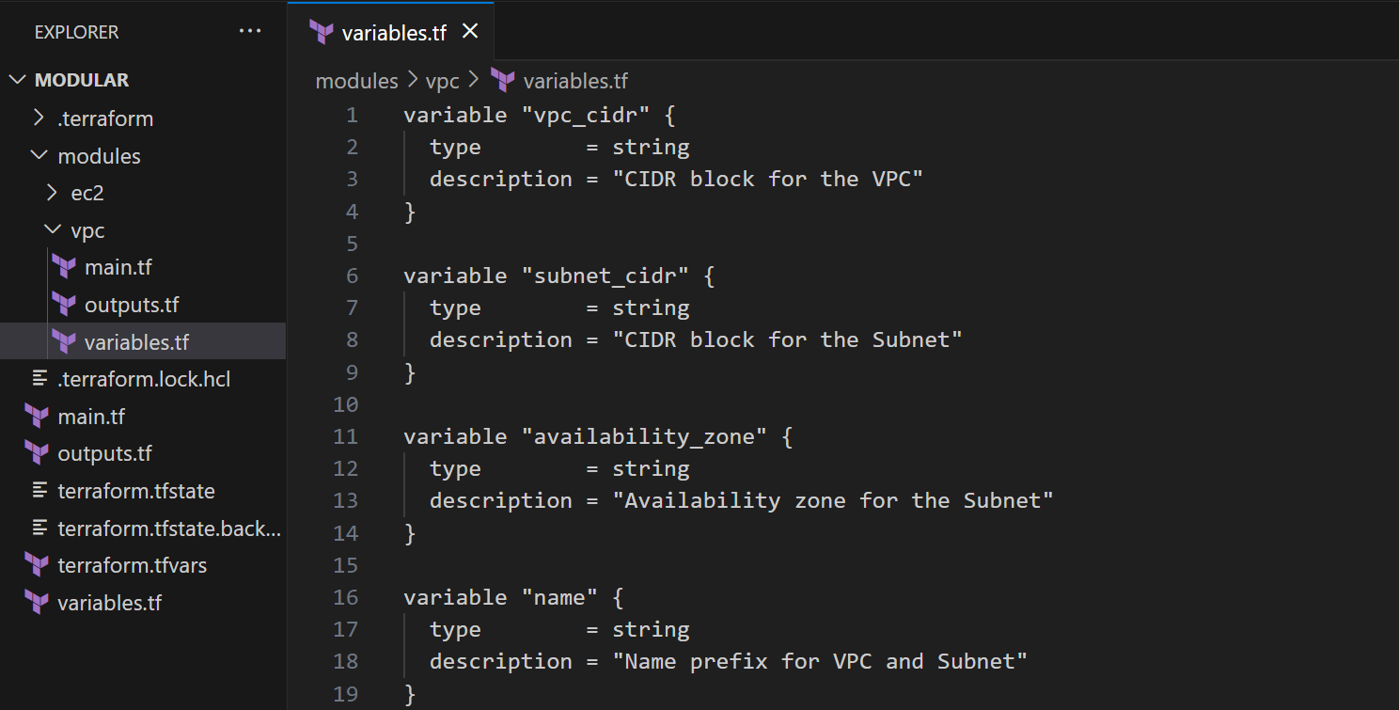

- Define output in outputs.tf

output "vpc_id" {
value = aws_vpc.main.id
}

output "subnet_id" {
value = aws_subnet.main.id
}

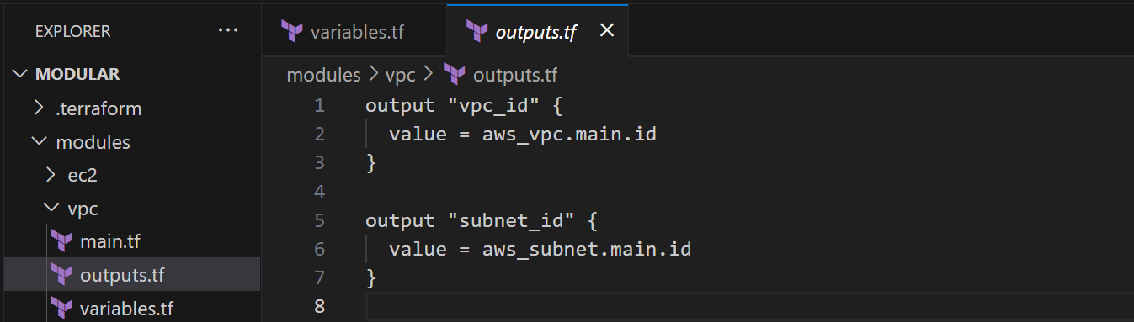

Step 3: Create the EC2 Module

- Create main.tf:
resource "aws_instance" "web" {
ami = var.ami_id
instance_type = var.instance_type
subnet_id = var.subnet_id

tags = {
Name = var.name
}
}

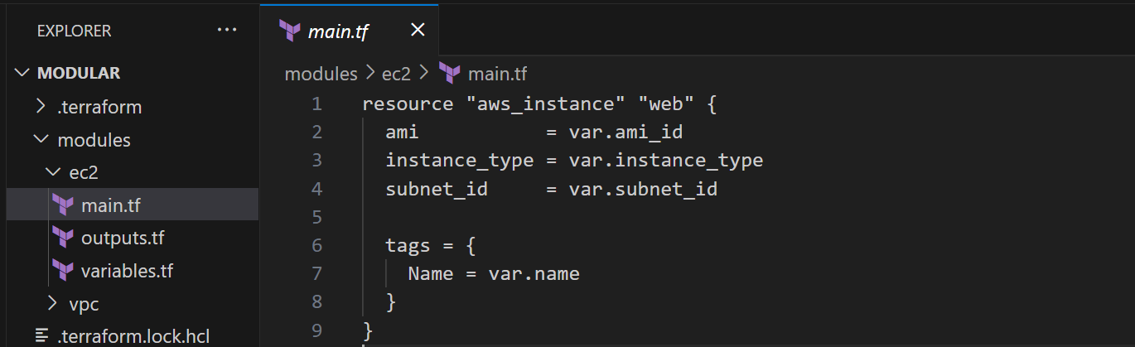

- Create variables.tf:

variable "ami_id" {
description = "AMI to use for the EC2 instance"
type = string
}

variable "instance_type" {
description = "EC2 instance type"
type = string
}

variable "subnet_id" {
description = "Subnet ID to launch instance in"
type = string
}

variable "name" {
description = "Name tag for EC2"
type = string
}

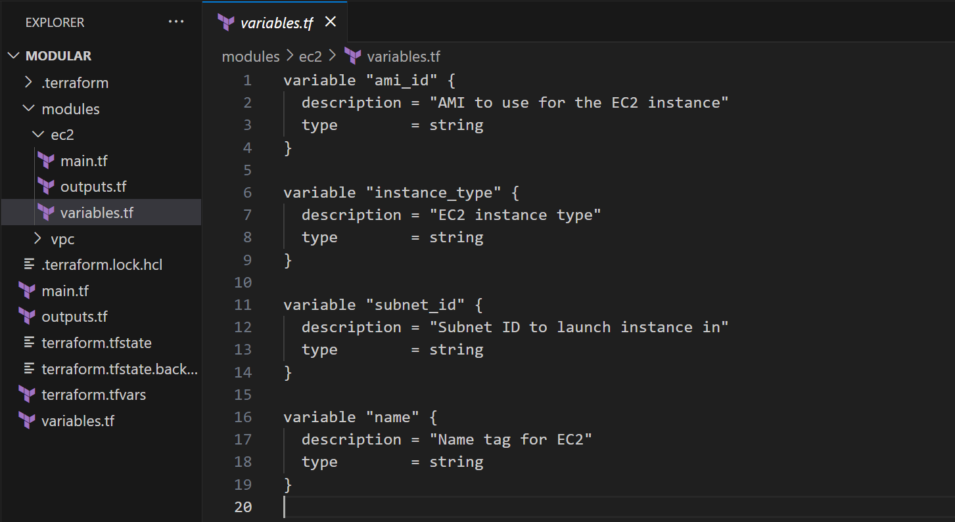

- Create outputs.tf:

output "instance_id" {
value = aws_instance.web.id
}

output "public_ip" {
value = aws_instance.web.public_ip
}

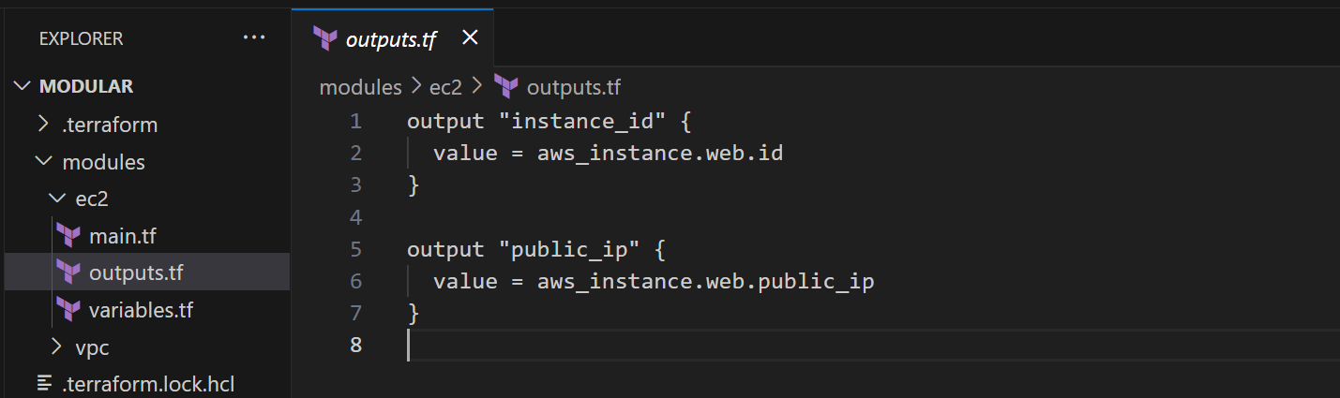

Step 4: Use Modules in Root Configuration

Now, in the root folder
- Create main.tf:
provider "aws" {
region = "ap-south-1"
}

module "vpc" {
source = "./modules/vpc"
vpc_cidr = "10.0.0.0/16"
subnet_cidr = "10.0.1.0/24"
availability_zone = "ap-south-1a"
name = "my-vpc"
}

module "ec2" {
source = "./modules/ec2"
ami_id = var.ami_id
instance_type = var.instance_type
subnet_id = module.vpc.subnet_id
name = var.ec2_name
}

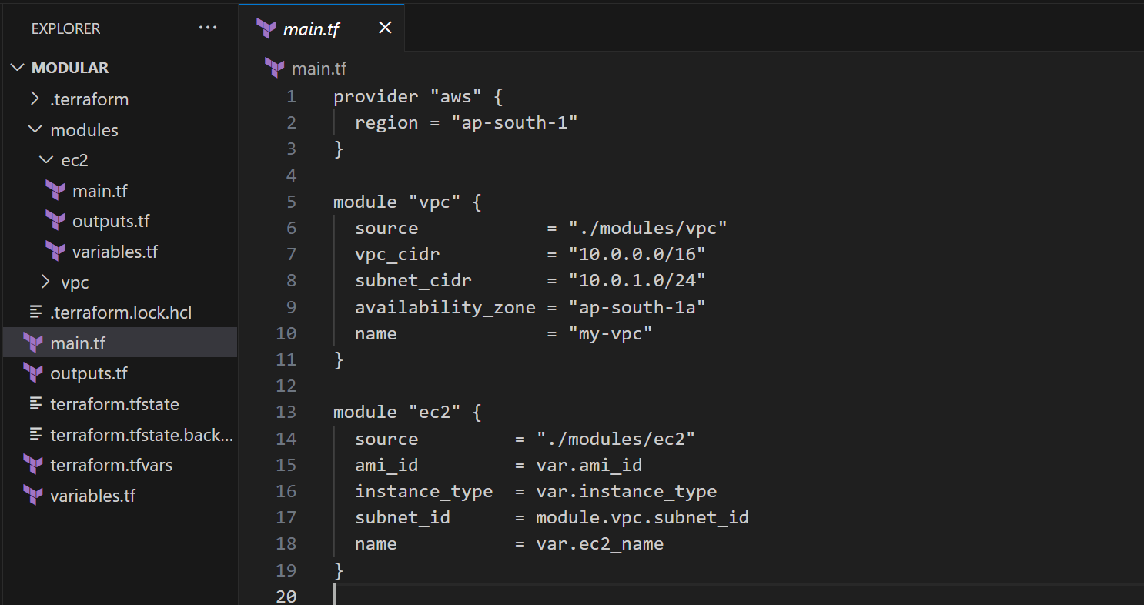
- Create variables.tf:

variable "ami_id" {
description = "AMI ID for EC2"
type = string
}

variable "instance_type" {
description = "EC2 instance type"
type = string
}

variable "ec2_name" {
description = "Name tag for EC2 instance"
type = string
}
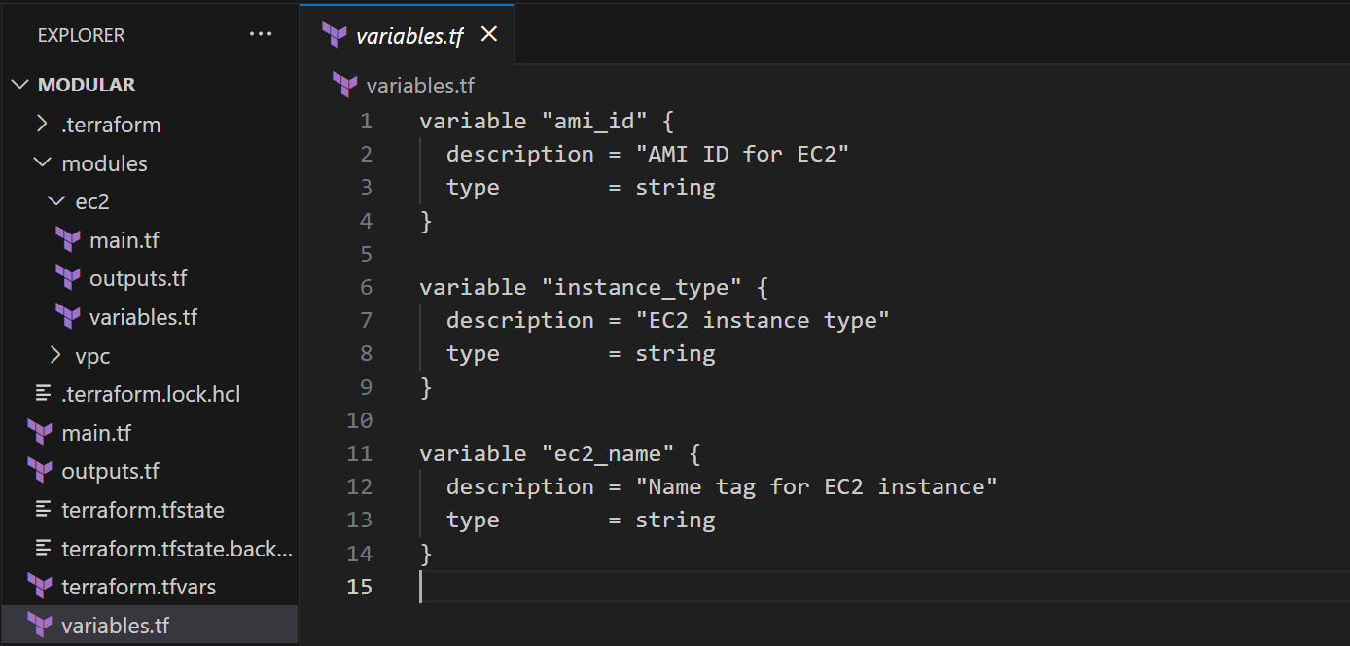

- Create terraform.tfvars:

ami_id = "ami-0223c21130e30da4c"
instance_type = "t2.micro"
ec2_name = "my-ec2-instance"

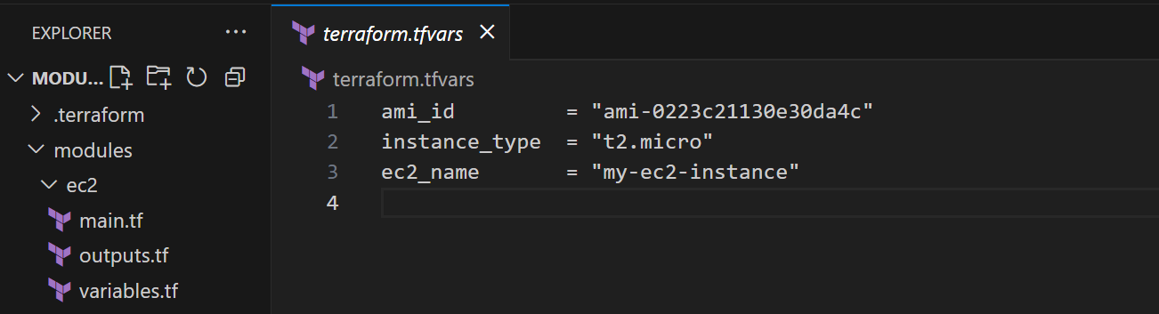

- Create outputs.tf
output "vpc_id" {
value = module.vpc.vpc_id
}

output "subnet_id" {
value = module.vpc.subnet_id
}

output "instance_id" {
value = module.ec2.instance_id
}

output "ec2_public_ip" {
value = module.ec2.public_ip
}

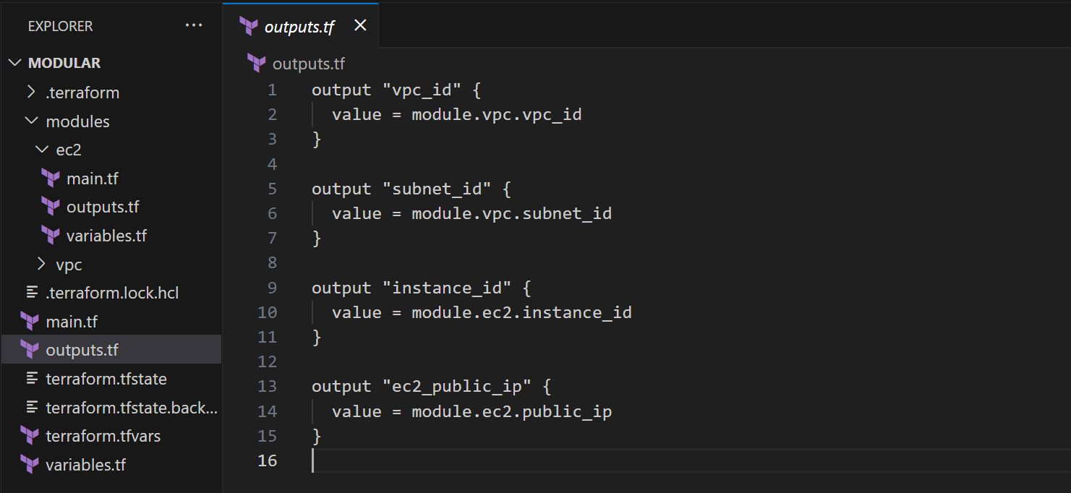

- Folder Structure

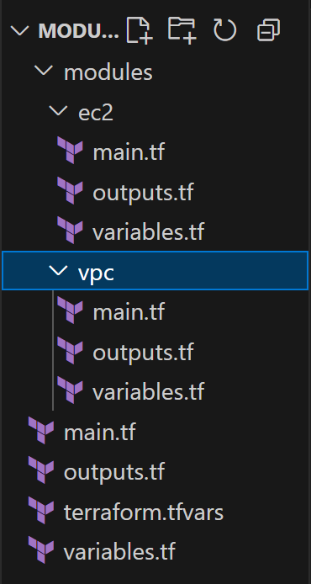

Step 5: Initialize and Apply

- Initialize in terminal using the following command:
  - terraform init
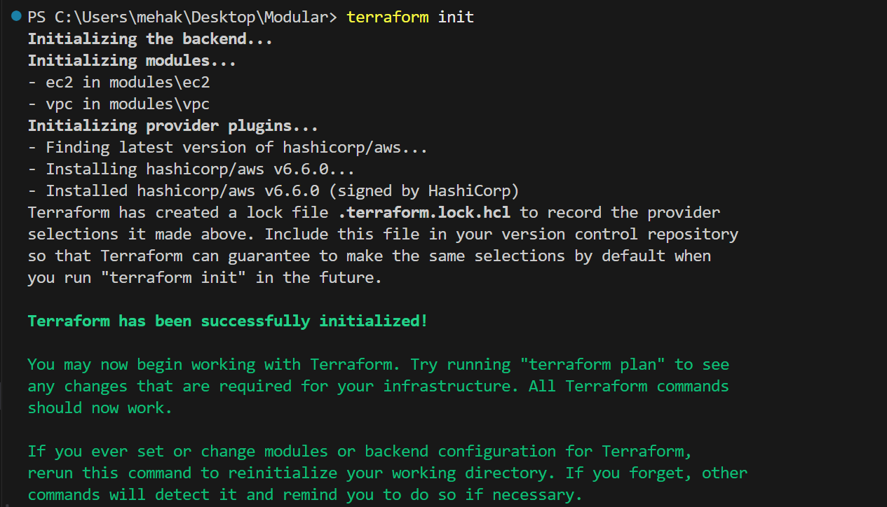

- Run the command:
  - terraform plan

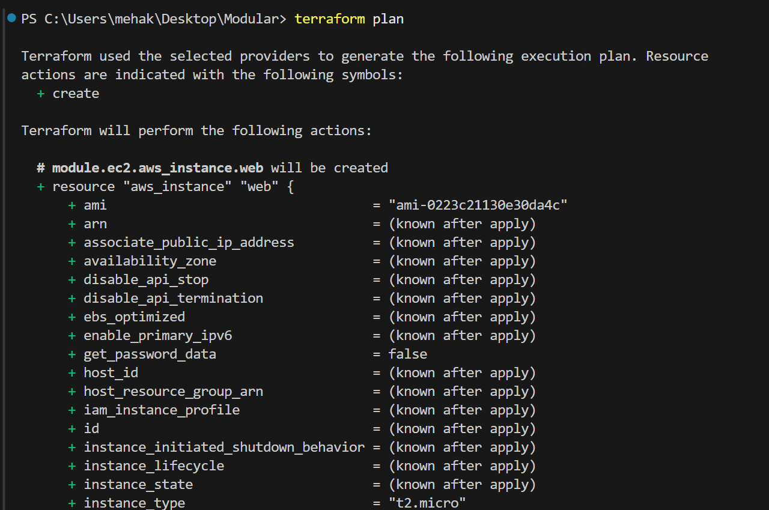

- Run the following command:
  - terraform apply

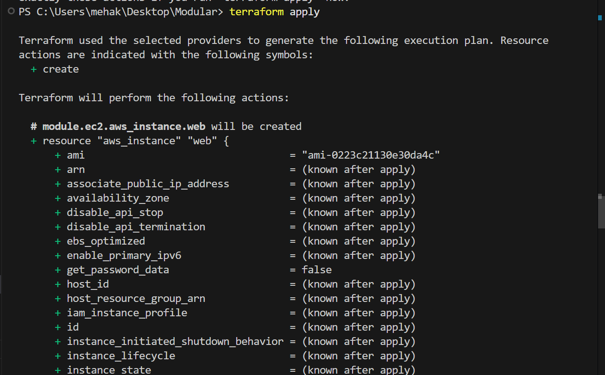

- In Enter a value, type “yes”
- You can see the output in terminal.

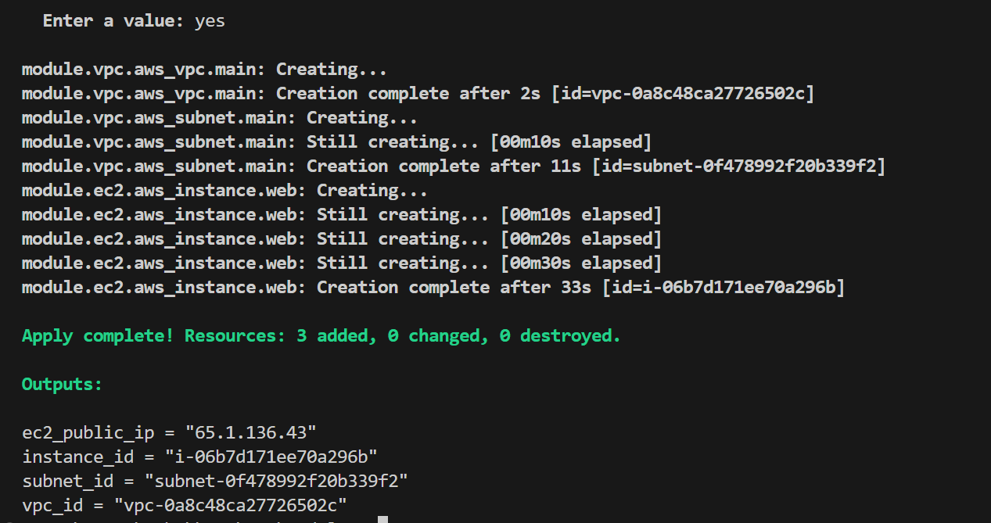

Verify in AWS

Verify the VPC
- Go to the VPC Dashboard: https://console.aws.amazon.com/vpc/
- Click on "Your VPCs" in the sidebar.
- Look for a VPC with CIDR block 10.0.0.0/16 and name tag my-vpc

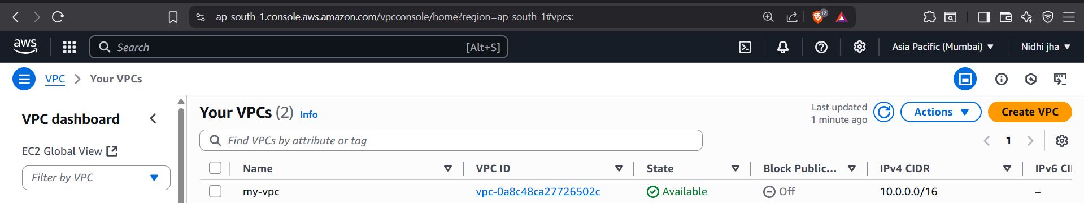

Verify the EC2 Instance
- Go to the EC2 Dashboard:https://console.aws.amazon.com/ec2/
- Click "Instances" in the sidebar.

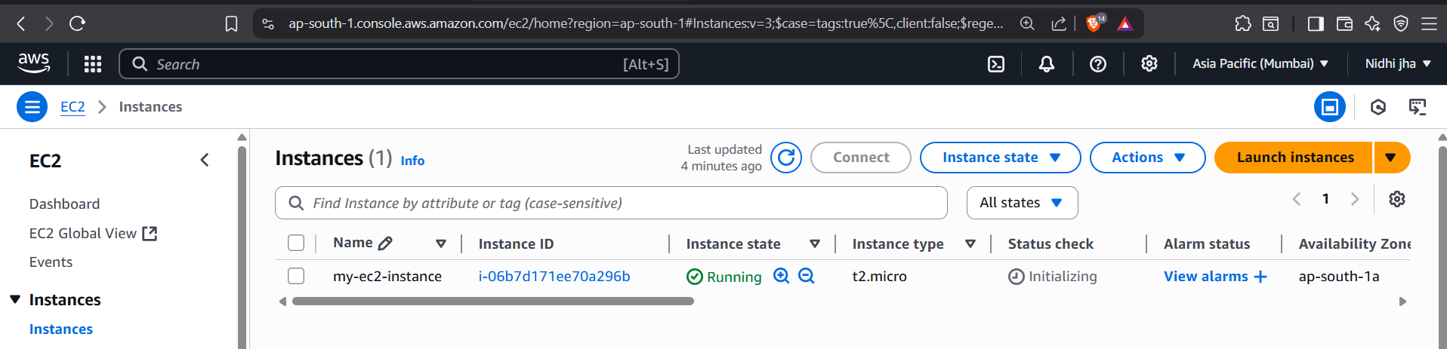

- EC2 is successfully created.

Step 6: Destroy terraform

- Run the following command:
  - terraform destroy
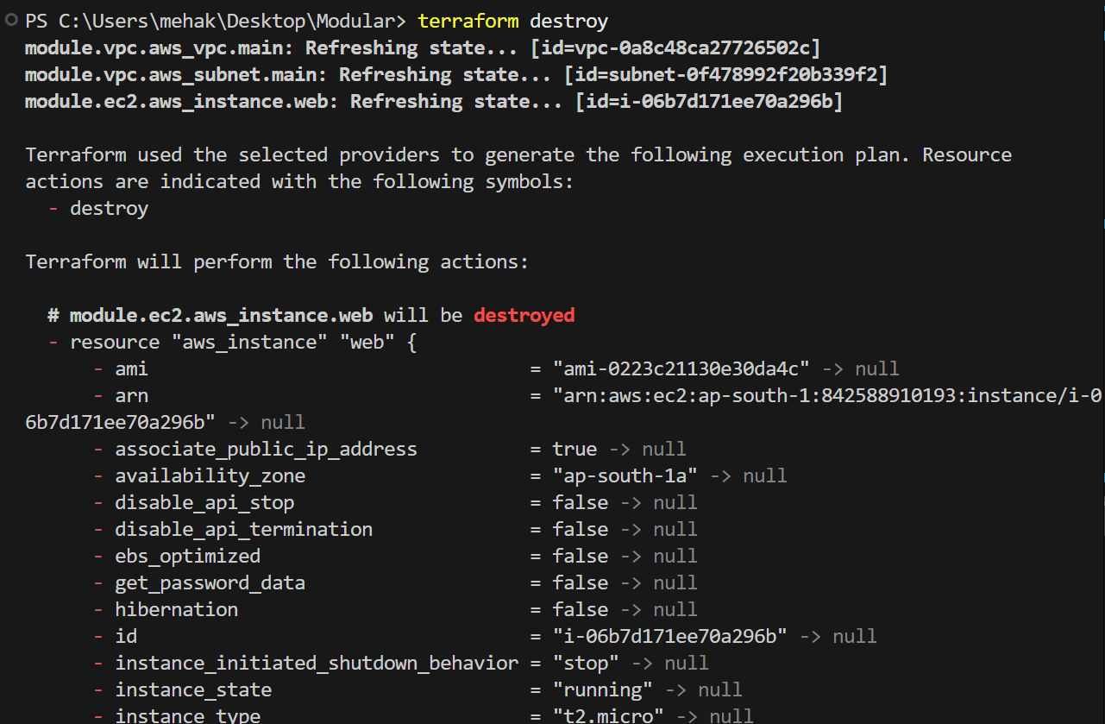

- In Enter a value, type “yes”

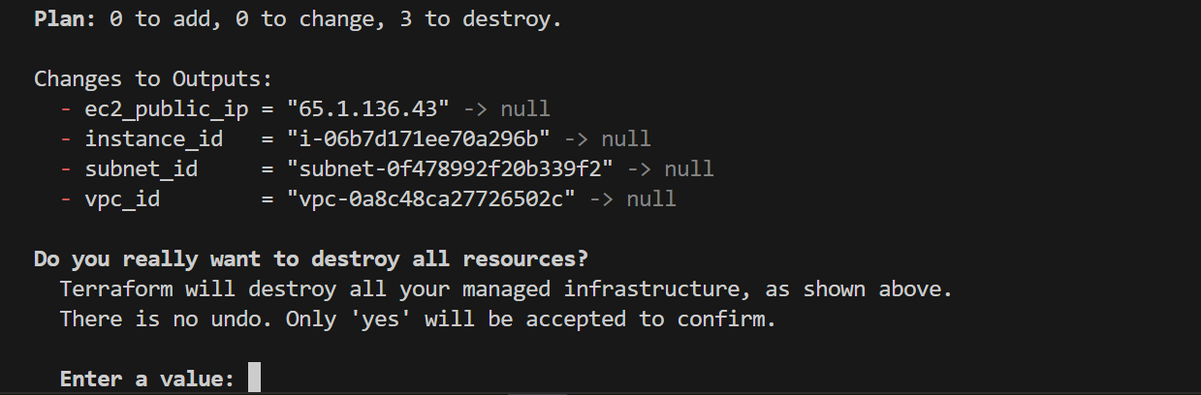

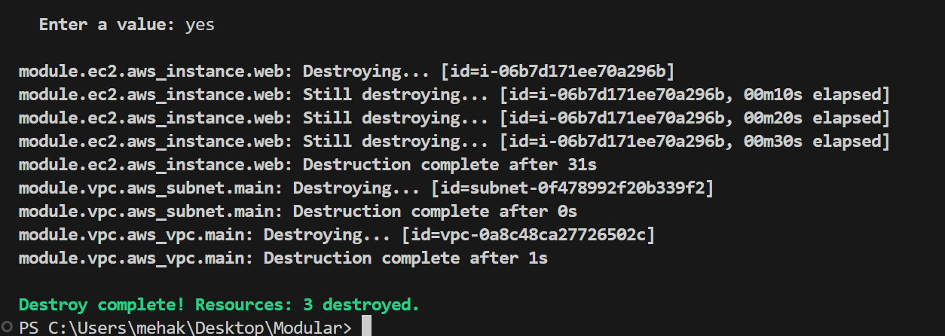

Destroyed successfully.

Conclusion

In this guide, you implemented a modular Terraform infrastructure on AWS, which promotes reusability, scalability, and clean code organization. By separating components into logical modules VPC and EC2 Instance
You:

- Created reusable infrastructure blocks that can be easily replicated across different environments (dev, staging, prod),
- Reduced complexity by isolating functionality into smaller, manageable files,
- Centralized configurations through variables and outputs for better control and flexibility,
- Enabled faster iterations and clearer team collaboration using a well-structured folder hierarchy.

