Install and Configure Terraform

Overview

Terraform is an open-source tool by HashiCorp used to define and manage cloud infrastructure using code—a practice known as Infrastructure as Code (IaC). With Terraform, you can automate the creation, modification, and destruction of resources across various cloud platforms like AWS, Azure, and Google Cloud. The document “Install and Configure Terraform” provides beginner-friendly, step-by-step instructions to help users:

- Install Terraform on Windows
- Set up your environment to run Terraform commands
- Write and initialize your first Terraform configuration
- Connect Terraform to cloud providers (like AWS)
- Plan, apply, and destroy cloud infrastructure safely

Prerequisites
- VS Code
- Basic command-line knowledge
- AWS account
- AWS CLI

Step 1: Install Terraform

- Browse to the Download Terraform page.

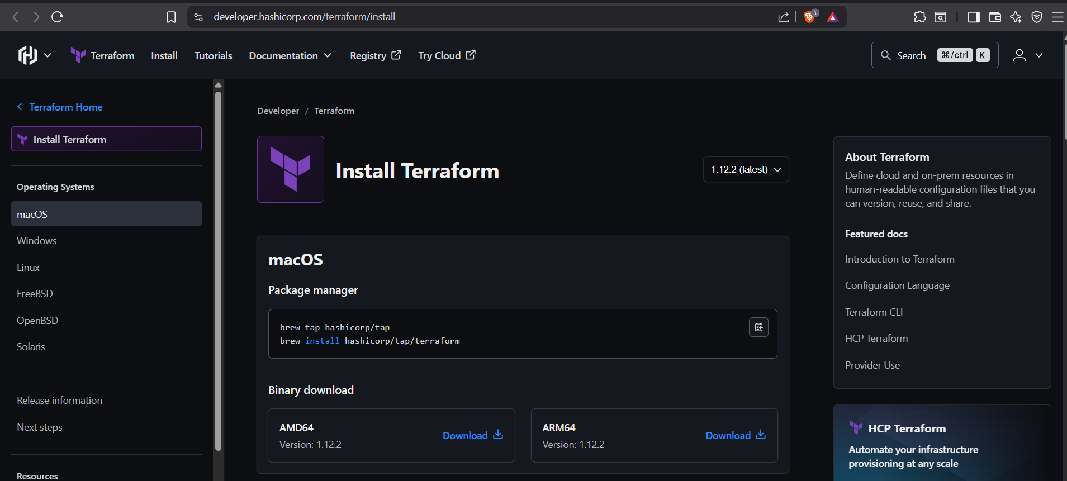

- Select the Windows tab under the Operating System heading. The latest version is preselected.

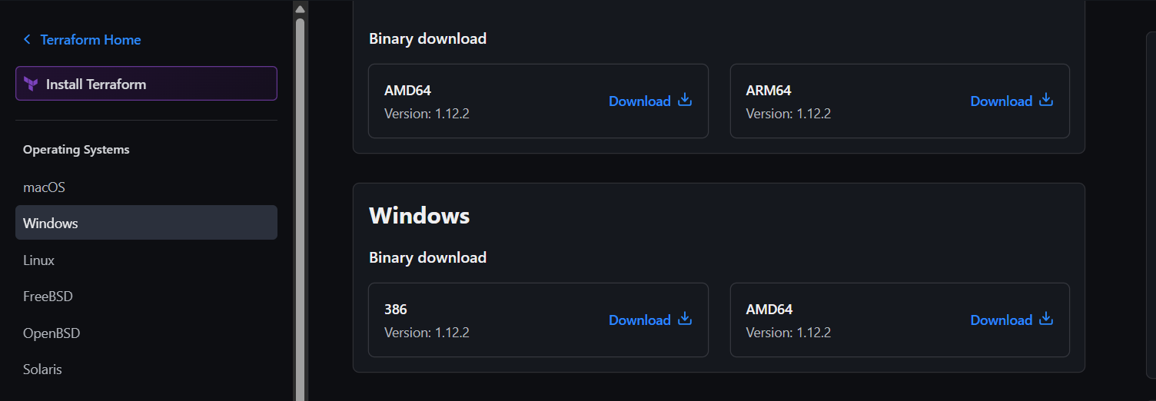

- Select 386 for 32-bit systems or AMD64 for 64-bit systems.
- We will choose 386.

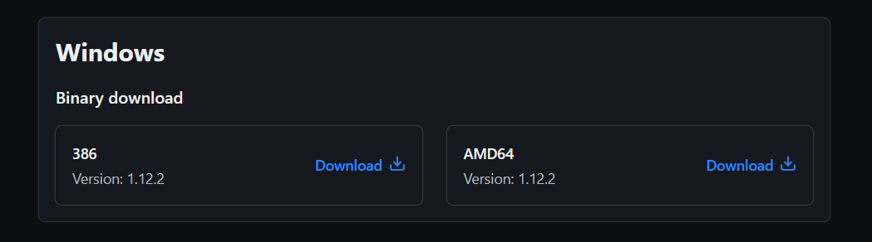

- Unzip the downloaded file.
Remember this location so you can add the path to the environment variables.

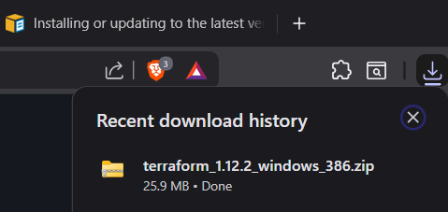

- Extract the zip folder.

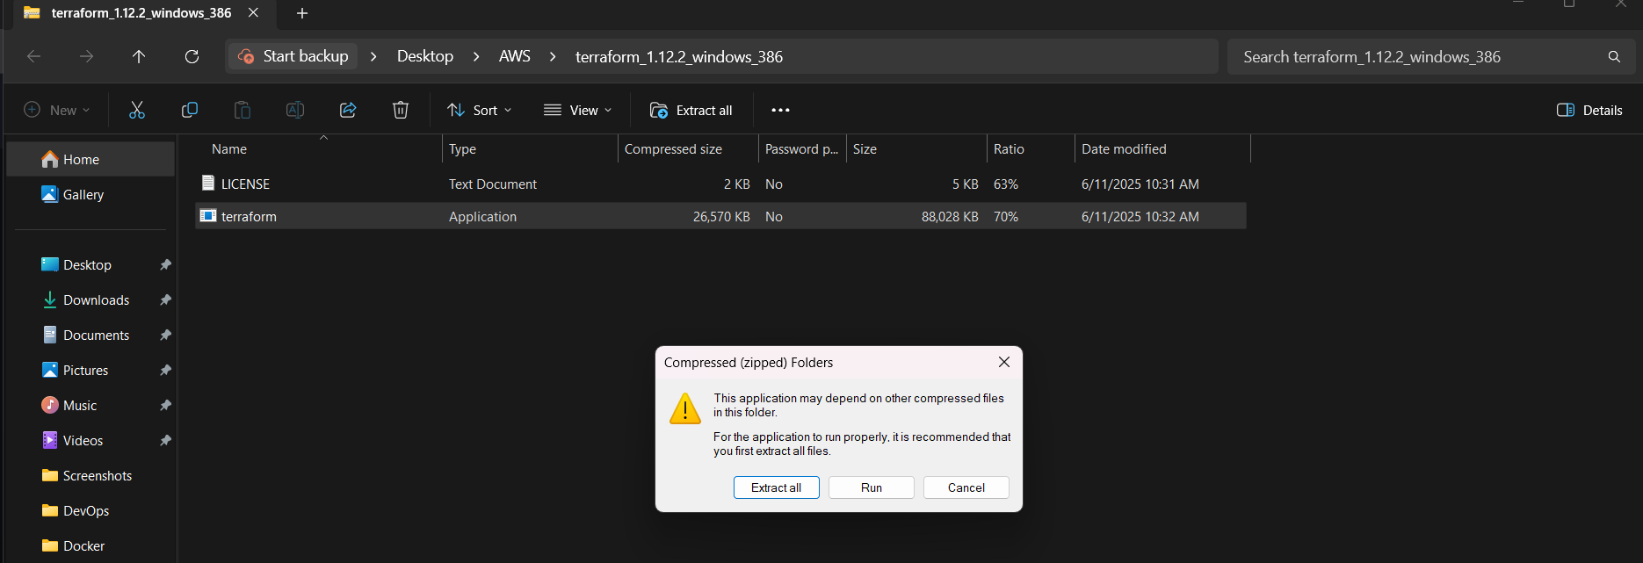
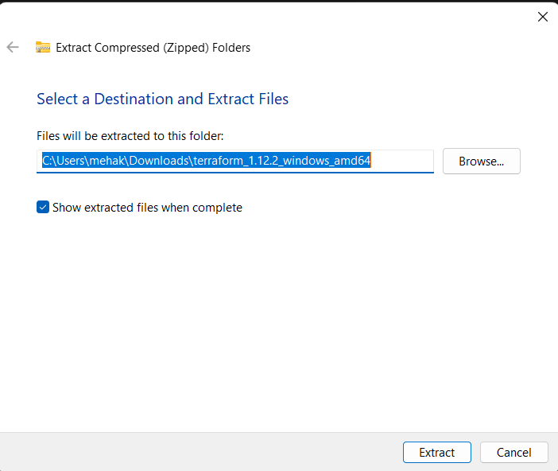

Step 2: Add Terraform Path to System Environment Variables

To add the Terraform executable to the system’s global path:
- Open the start menu, start typing environment and click Edit system environment variables.

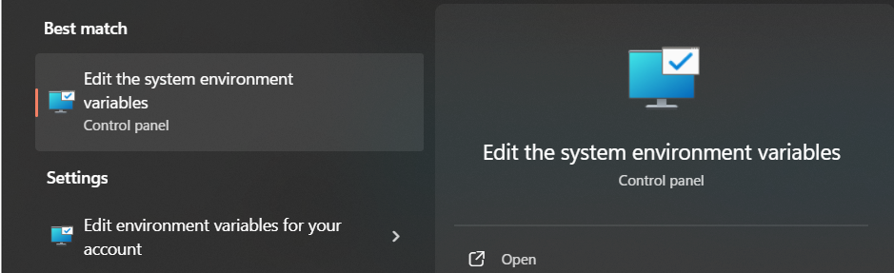

- The System Properties window opens. Click Environment Variables.

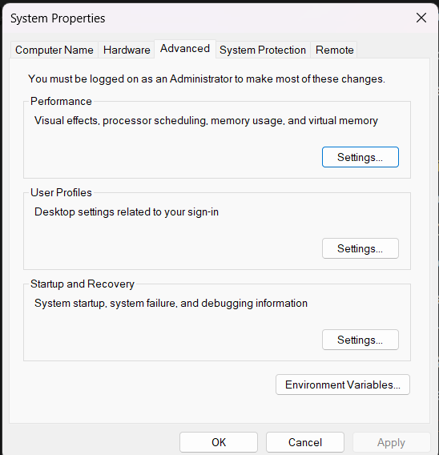

- In system variables, select path and click on edit

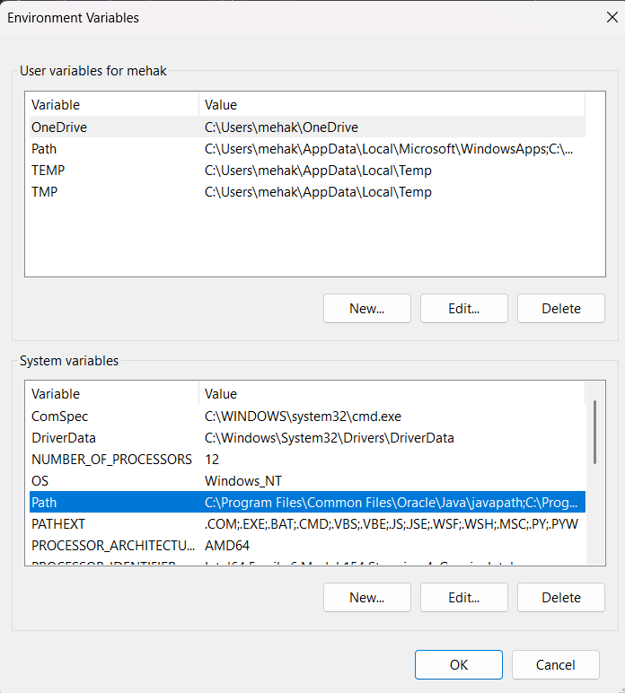

- Click on new and add the path of terraform folder you installed earlier.

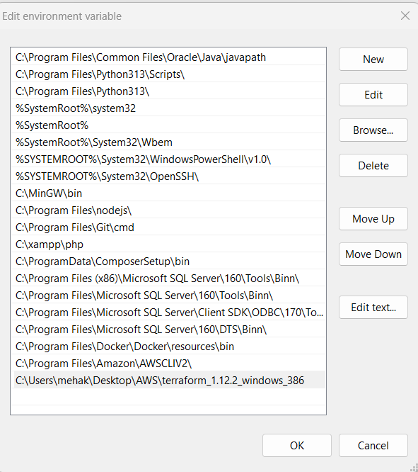

- Click Ok.

Step 3: Verify Terraform installation and configuration

      - Open a new command-prompt window.

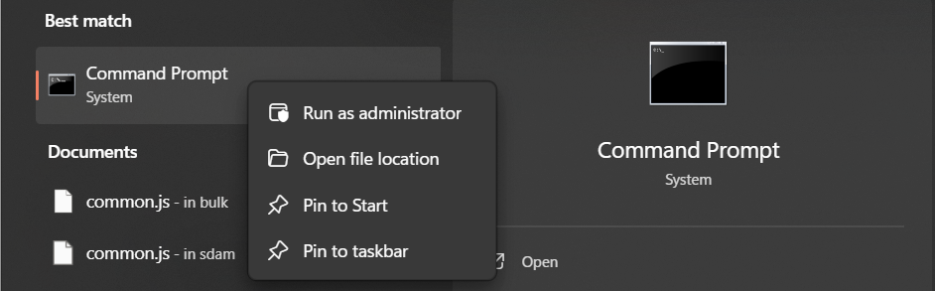

- Enter the command to check the Terraform version:
  - terraform --version

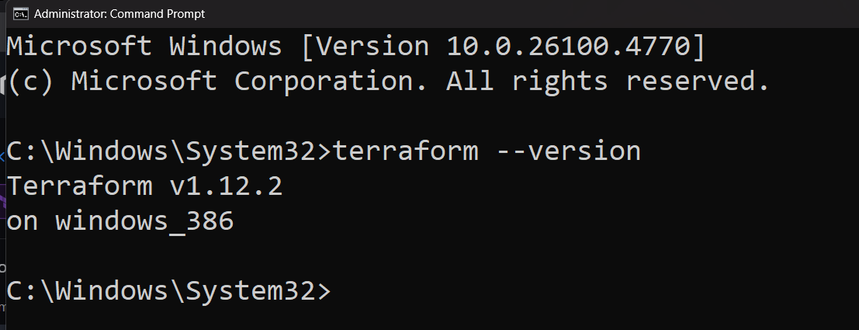

Everything is set. You can now start using Terraform.

Step 4: Set Up Your First Terraform Project

Firstly, get AWS Access Keys:

- Sign in to your AWS account.
- Visit the IAM Console.
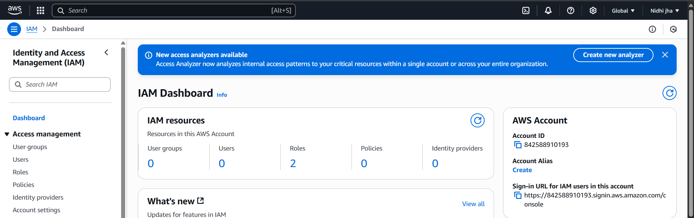

- Go to Users

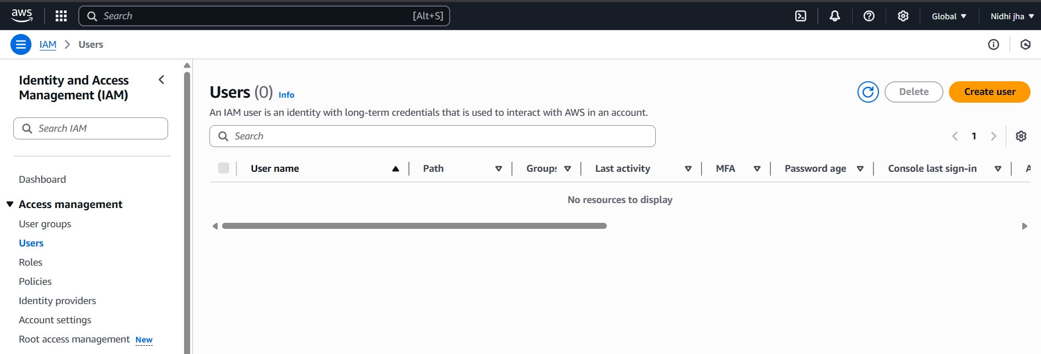

- Enter the User name and click on (Provide user access to the AWS Management Console).

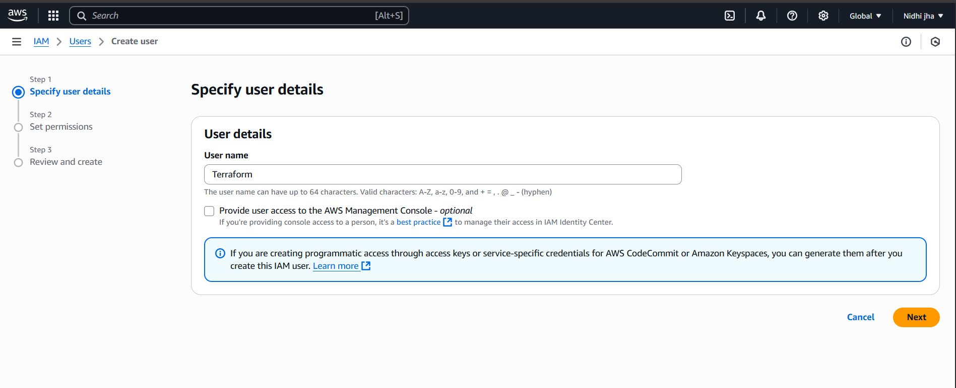

- Select I want to create an IAM user.
- You can autogenerate your password or can add your own password.

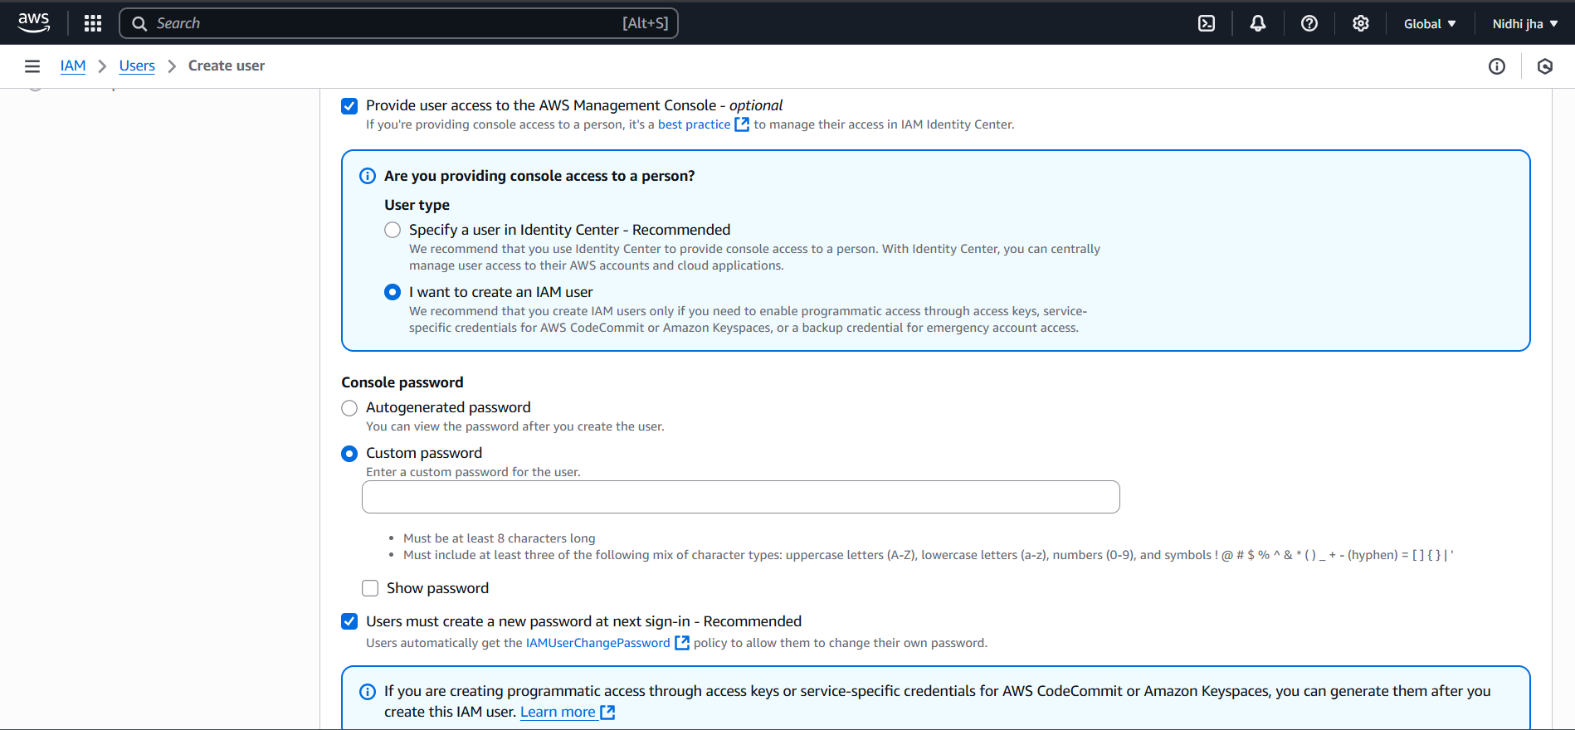

- After completing all User details, click on Next.

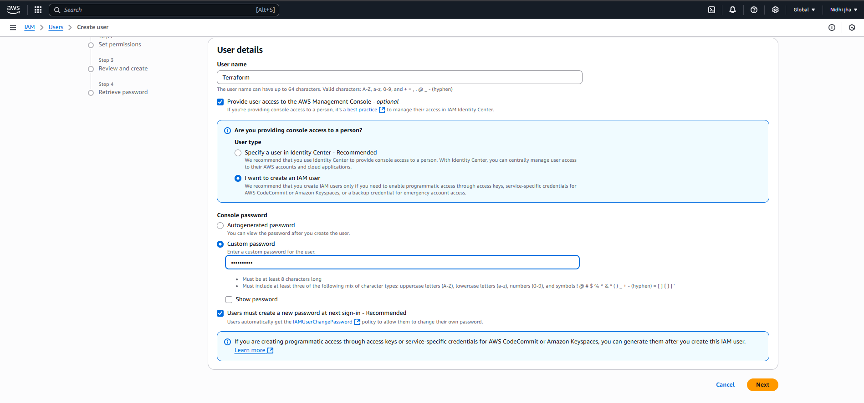

- Attach the "AmazonS3FullAccess" policy for testing.
- In permissions policies, search “AmazonS3FullAccess” and select that.
- Click on Next.
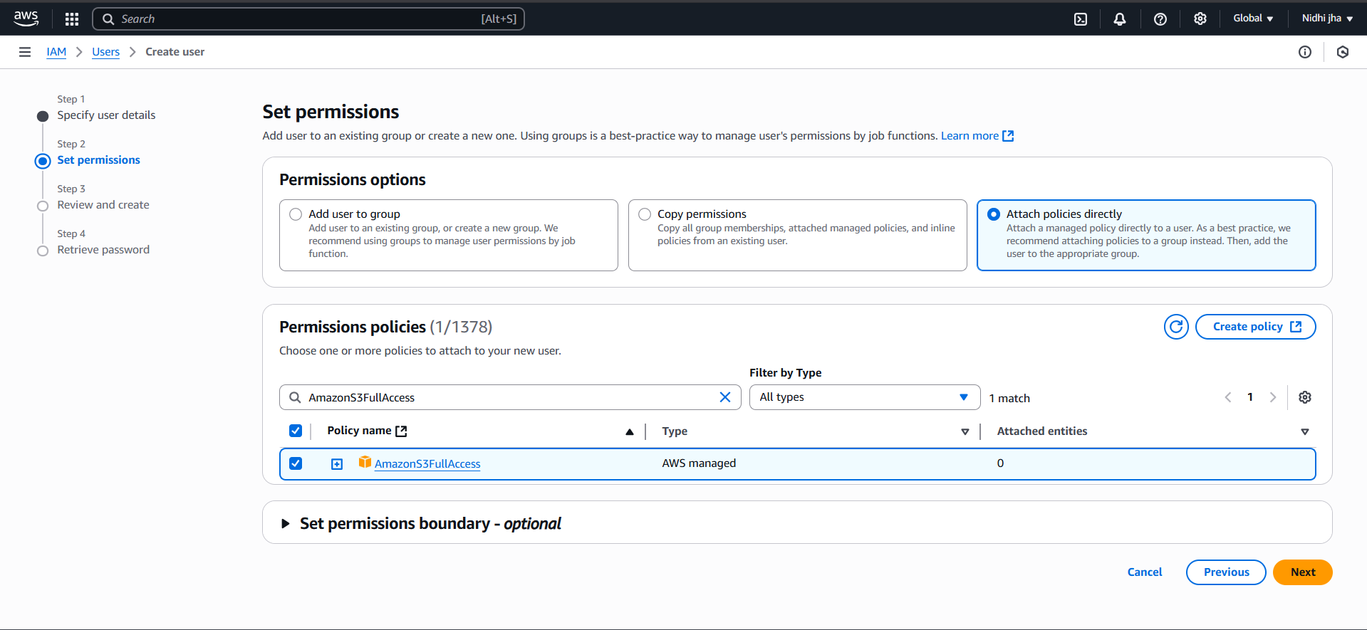

- Review all the details and click create user.

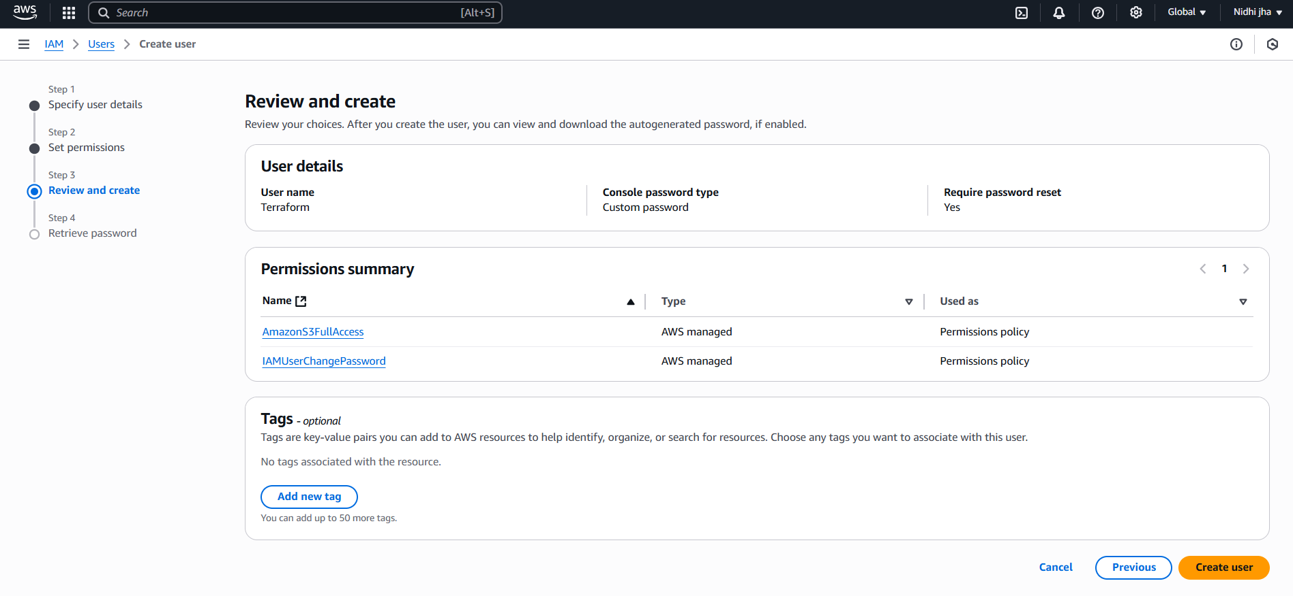

- Download your credentials
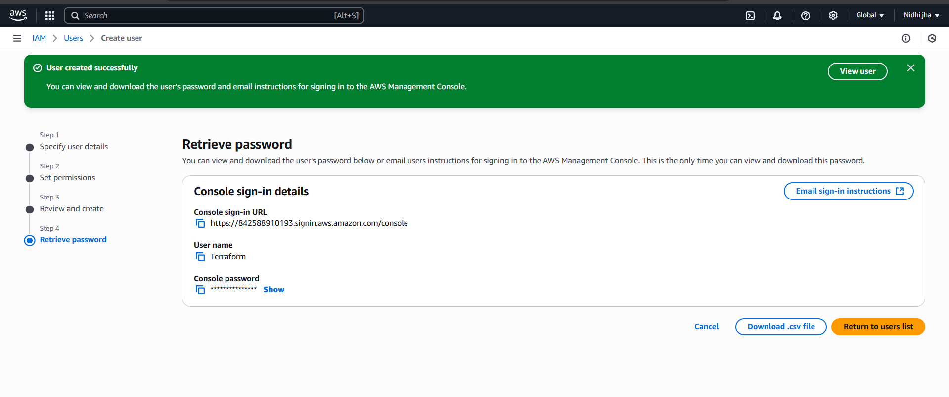

- You can see one user is created.

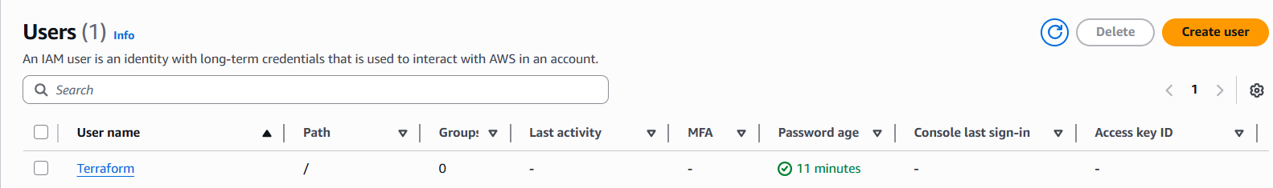

- Click on create access key.

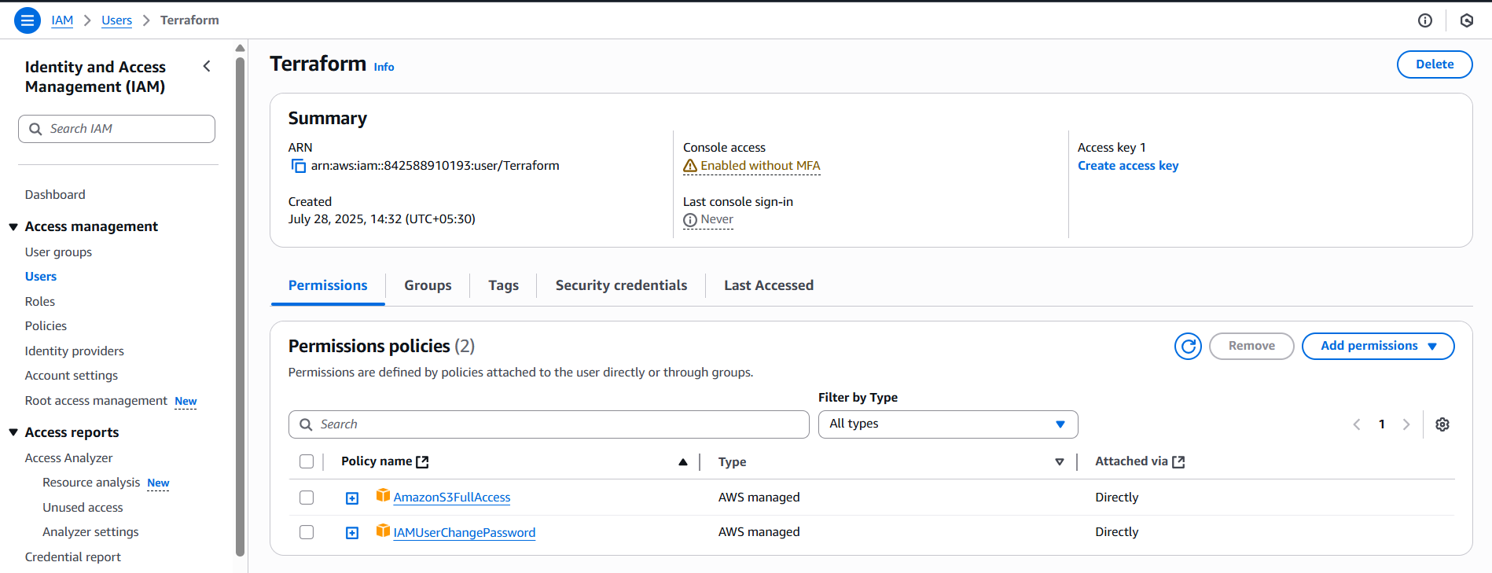

- Select the command line interface option, click Next.

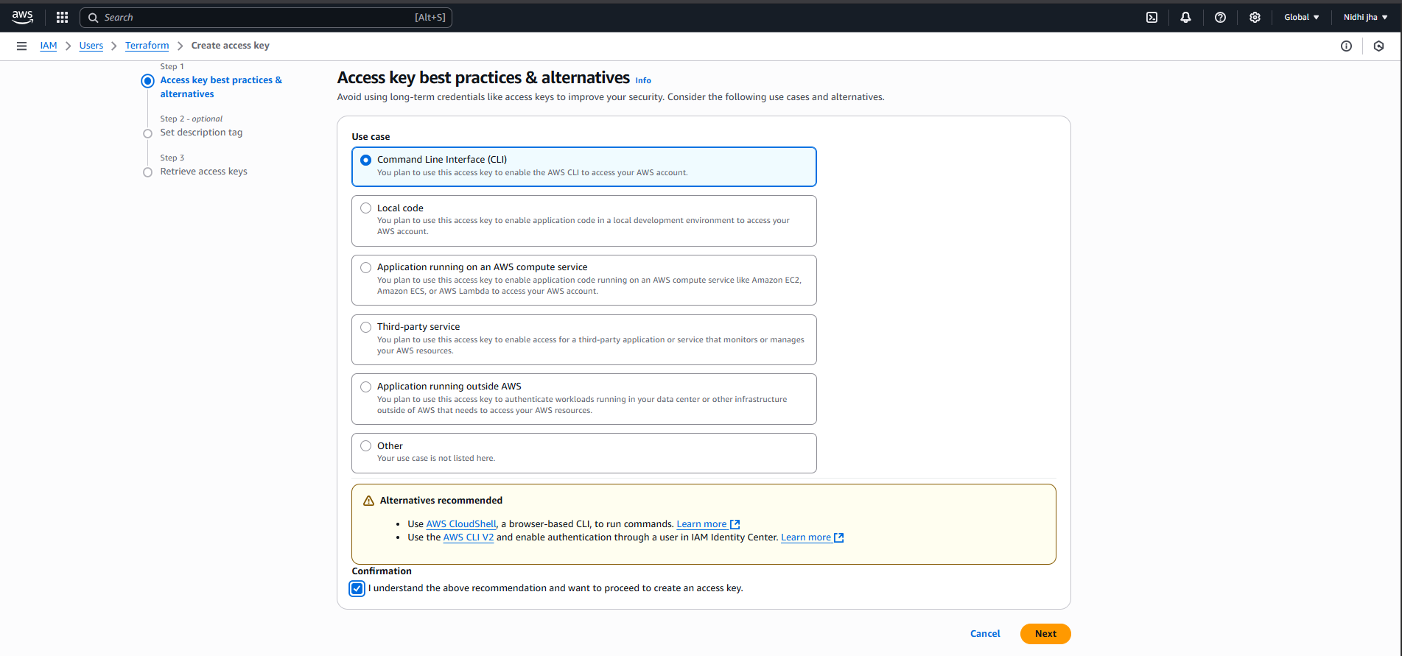

- Set description tag.
(You can also skip this part as it is optional.)

- Click Create access key.

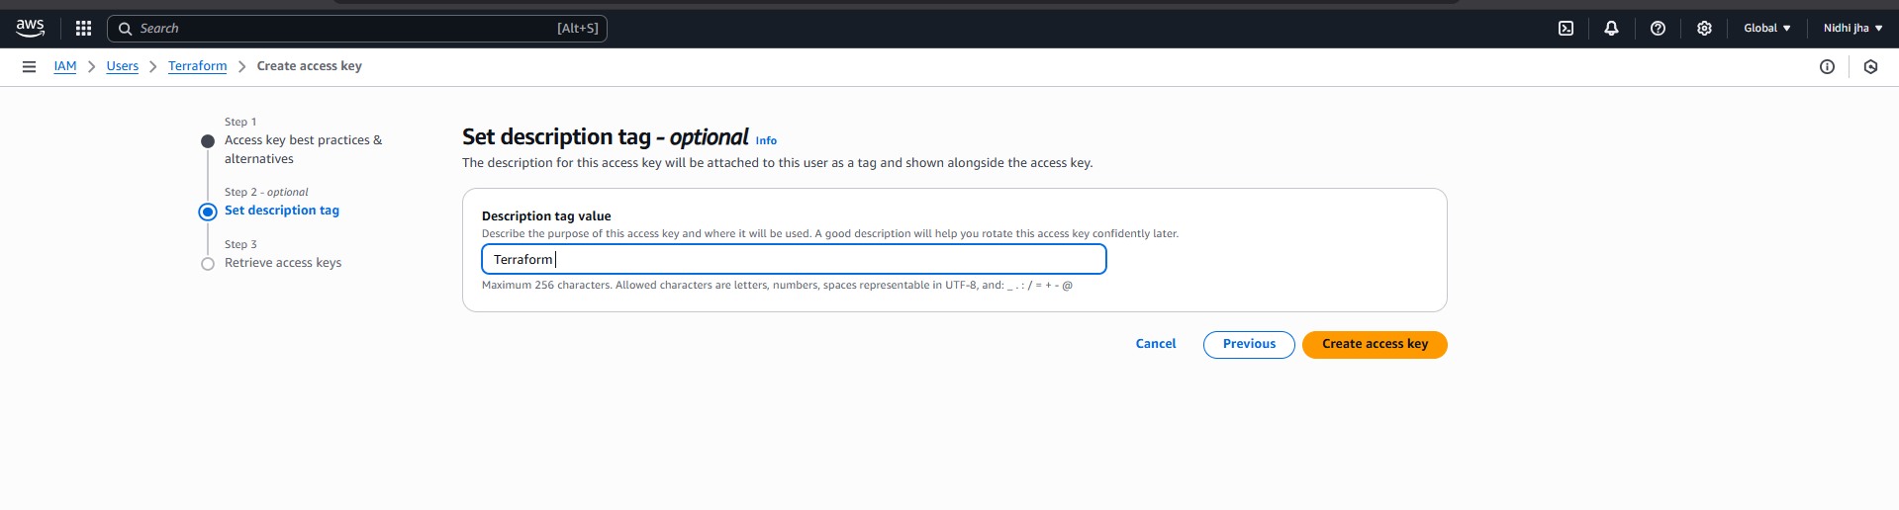

- Access key and secret access key are generated successfully.

Explanation:
Access key: This is a public identifier for your IAM user. It is used to identify the user making the API request.

Secret access key: This is a private and confidential key that works like a password.

- Download .csv file of your access keys.
(It will be used later.)

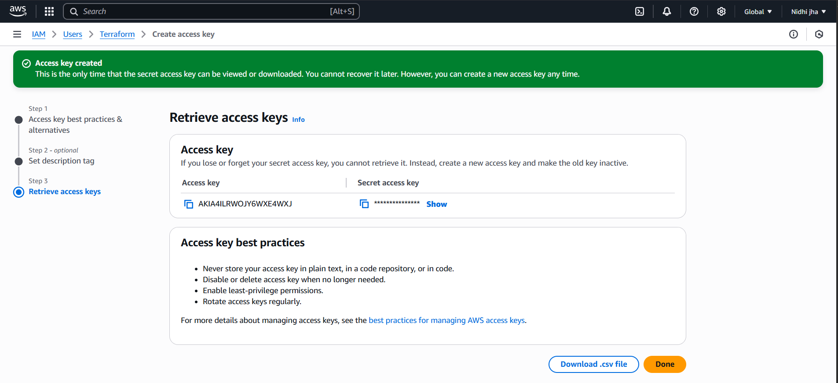

Step 5: Set Up AWS Credentials on Your Computer

- Install AWS CLI.
- Go to https://docs.aws.amazon.com/cli/latest/userguide/getting-started-install.html

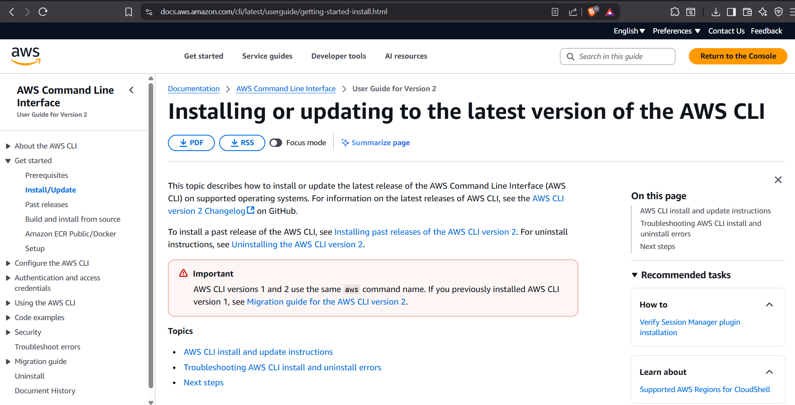
- Click on the link:
https://awscli.amazonaws.com/AWSCLIV2.msi

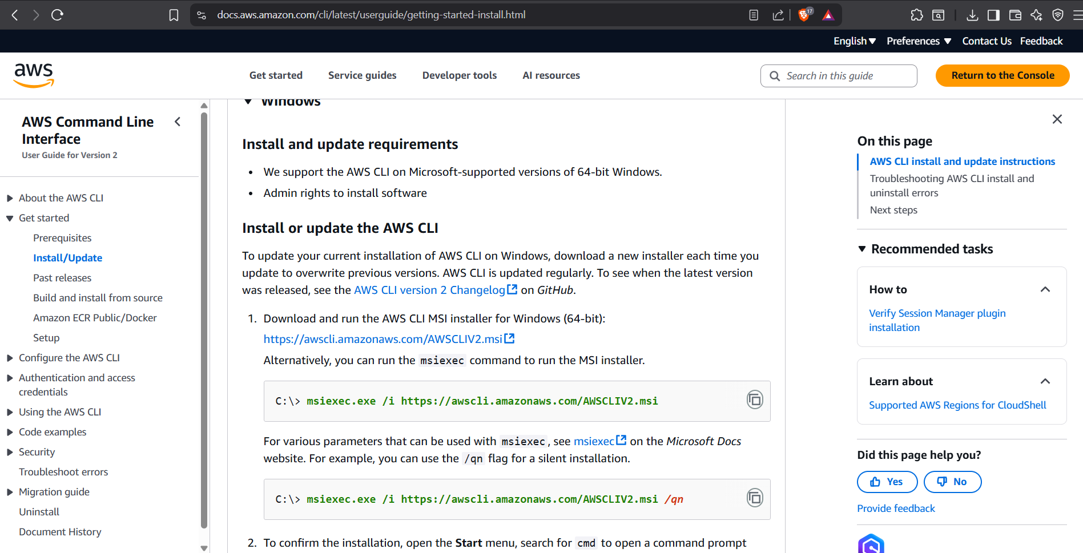

- It will start downloading.

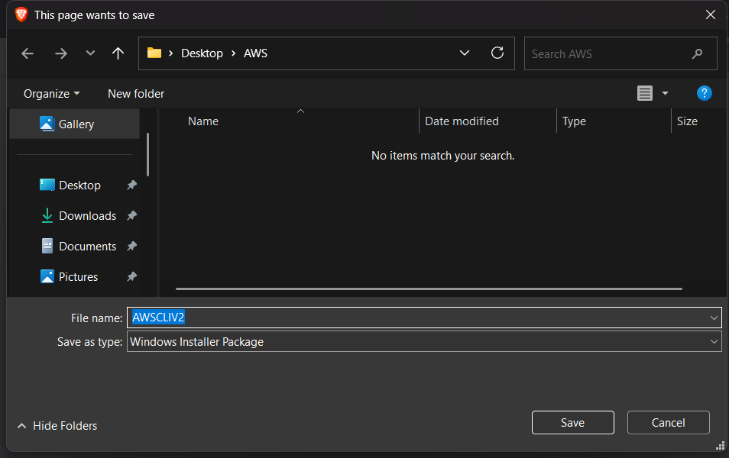

- After downloading, double click on the downloaded icon.

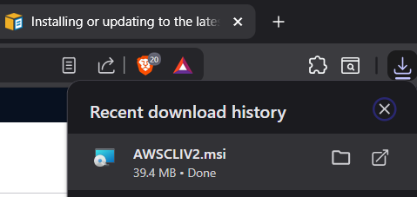

Install AWS CLI

- Click on Next.

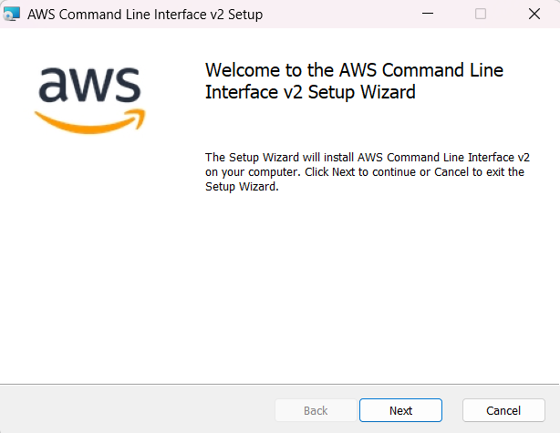
- Accept the terms and click on Next.

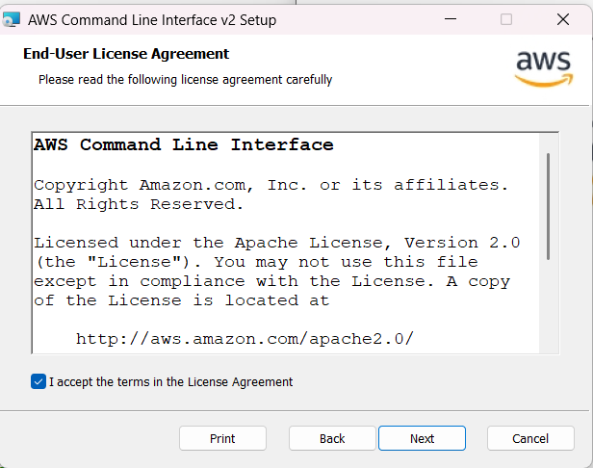

- Click on Next.

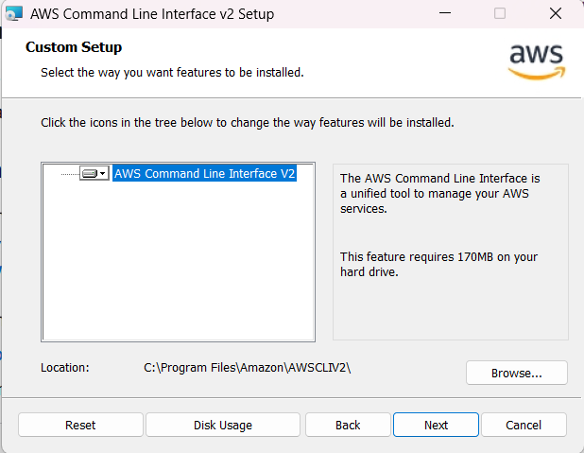

- Click on Install.

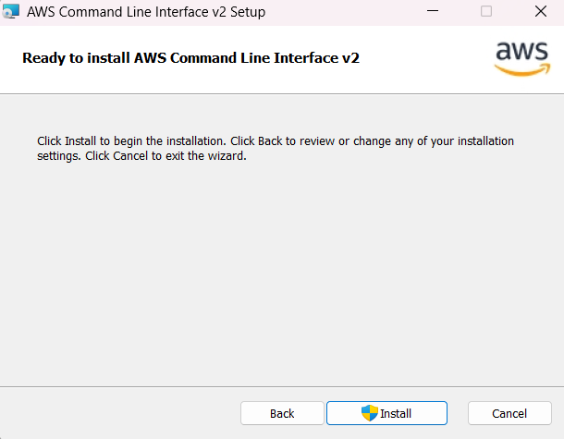

- AWS CLI is getting installed.
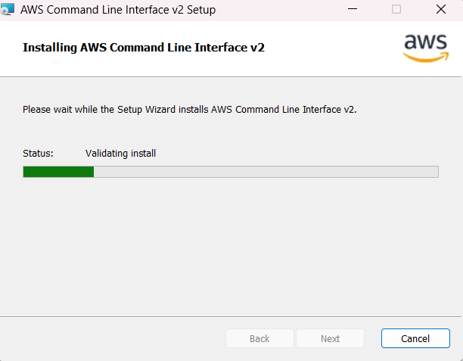
- AWS CLI is successfully installed.

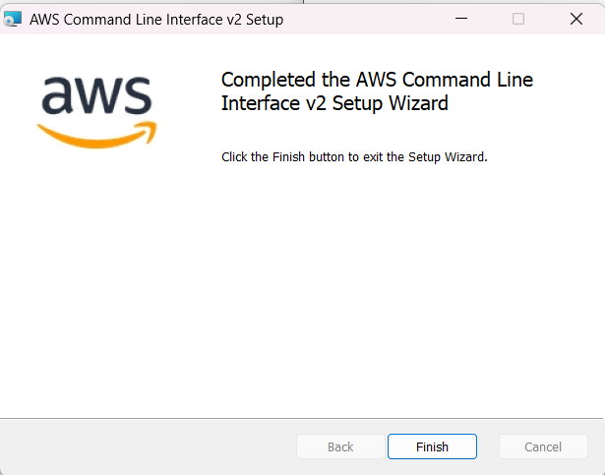

- Verify if it is successfully installed.
- Open command prompt.
- Run the command:
  - aws --version
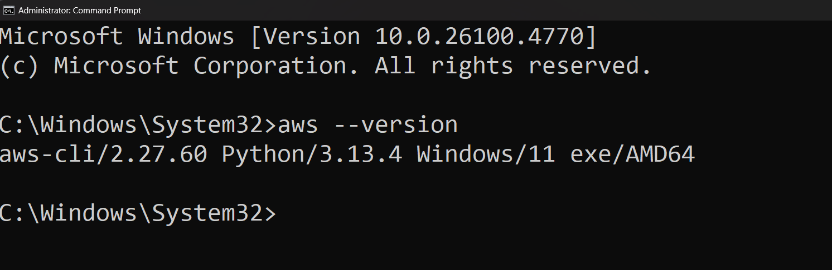

Configure AWS.
- Run the command:
  - aws configure
- Provide the AWS access key, secret access key, any default region and output format.
(Get AWS access key and secret access key from your IAM user)

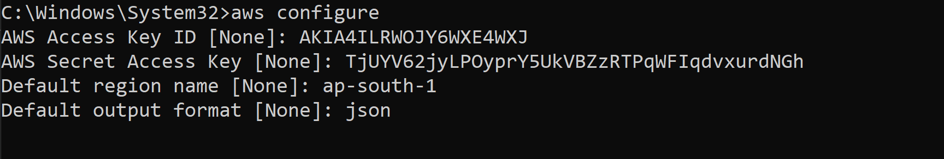
Provide all the information.

Step 6: Create a Project Folder & Main Configuration File

- Open VS code.
- Create a folder.
- Create main.tf
provider "aws" {
region = "ap-south-1"
}

resource "aws_s3_bucket" "my_bucket" {
bucket = "my-unique-bucket-name-eduhubspot"
acl = "private"
}

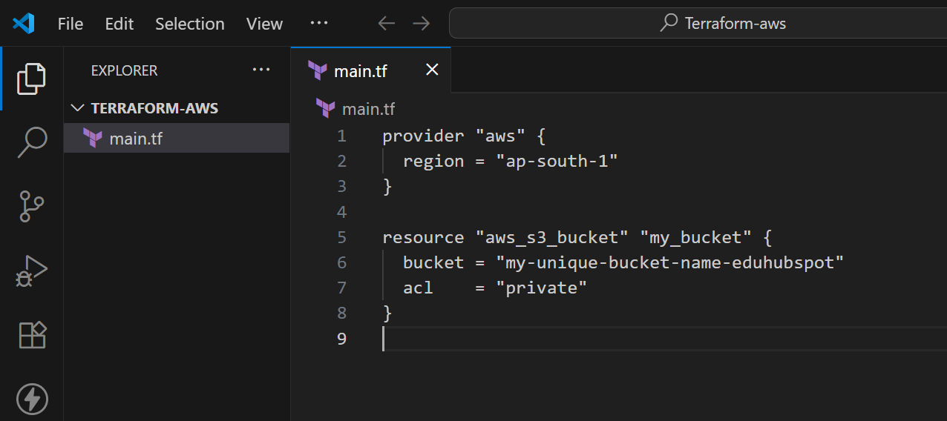
You can provide any region and bucket name.
- Open the folder in terminal.

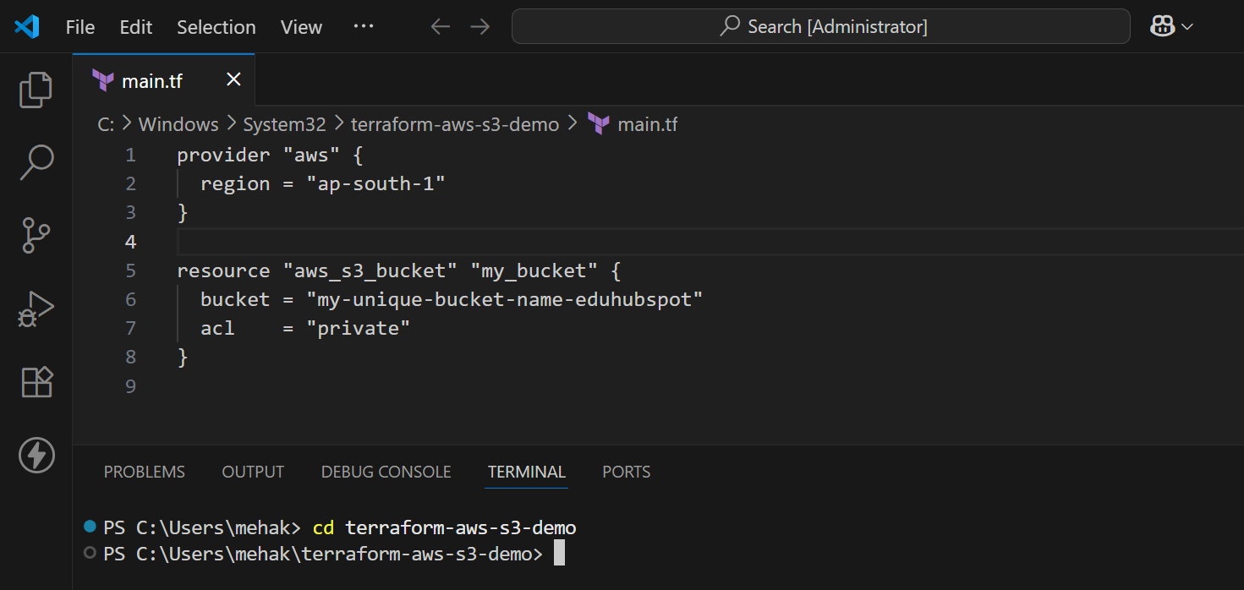

- Run the command:
  - terraform init

(The terraform init command is used to initialize a Terraform working directory. This is the first command you should run after writing your Terraform configuration files (.tf files), or cloning/downloading a Terraform project.)

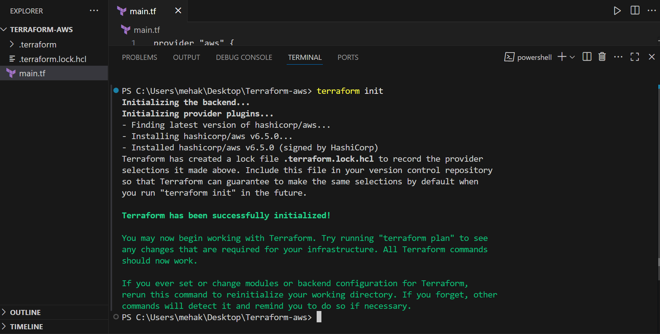

- Run the command:
  - terraform plan

(The terraform plan command is used to preview the changes that Terraform will make to your infrastructure before applying them.
It acts like a dry run, showing what will be created, updated, or destroyed - without actually making any changes.)

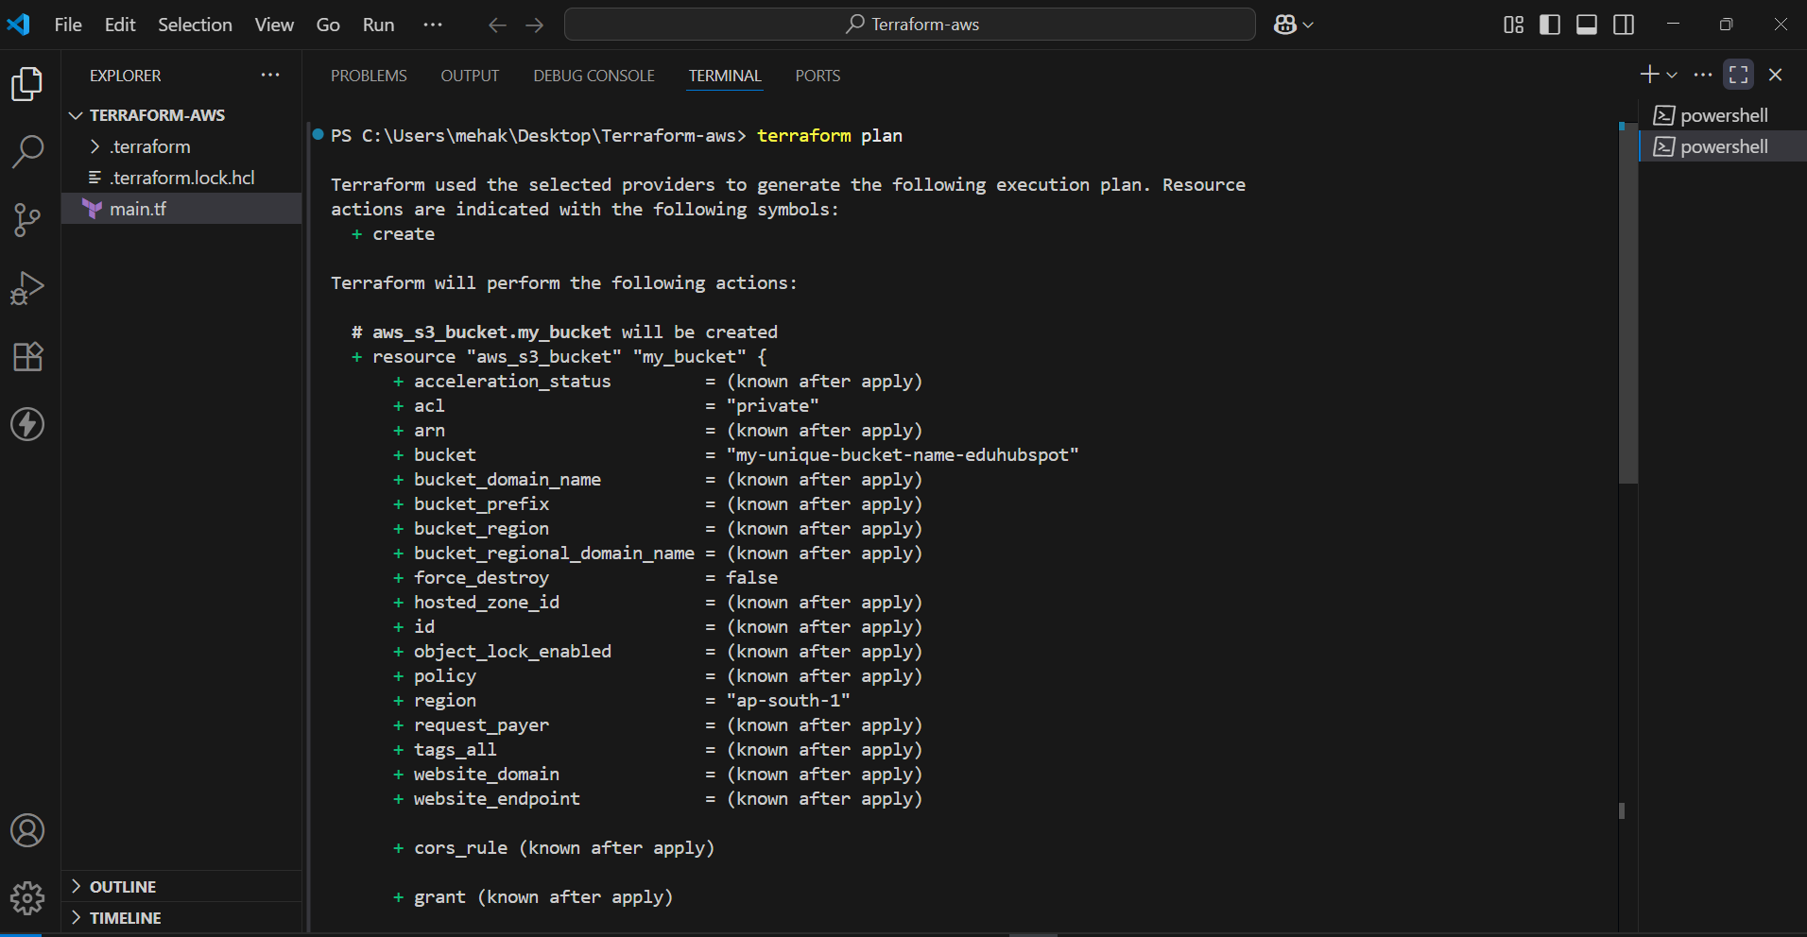

- Run the following command:
  - terraform apply

What this command does:

- Reads the configuration files (*.tf).
- Creates an execution plan showing what will change.
- Prompts for approval.
- Applies the approved plan to provision/update infrastructure.

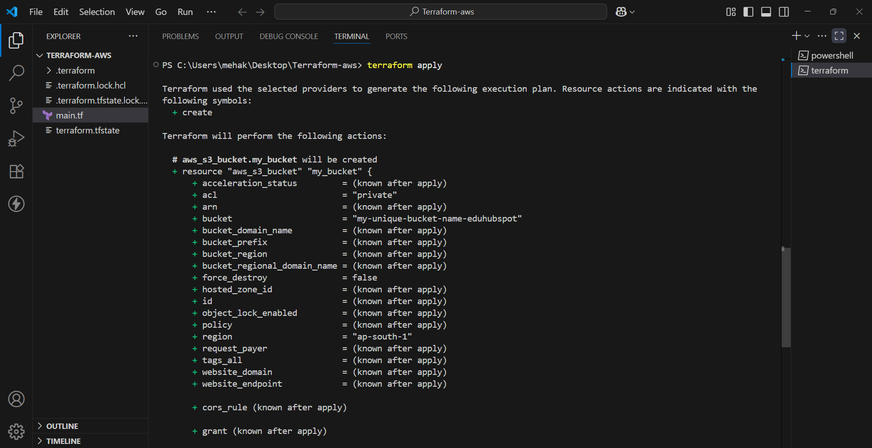

- Enter “yes”

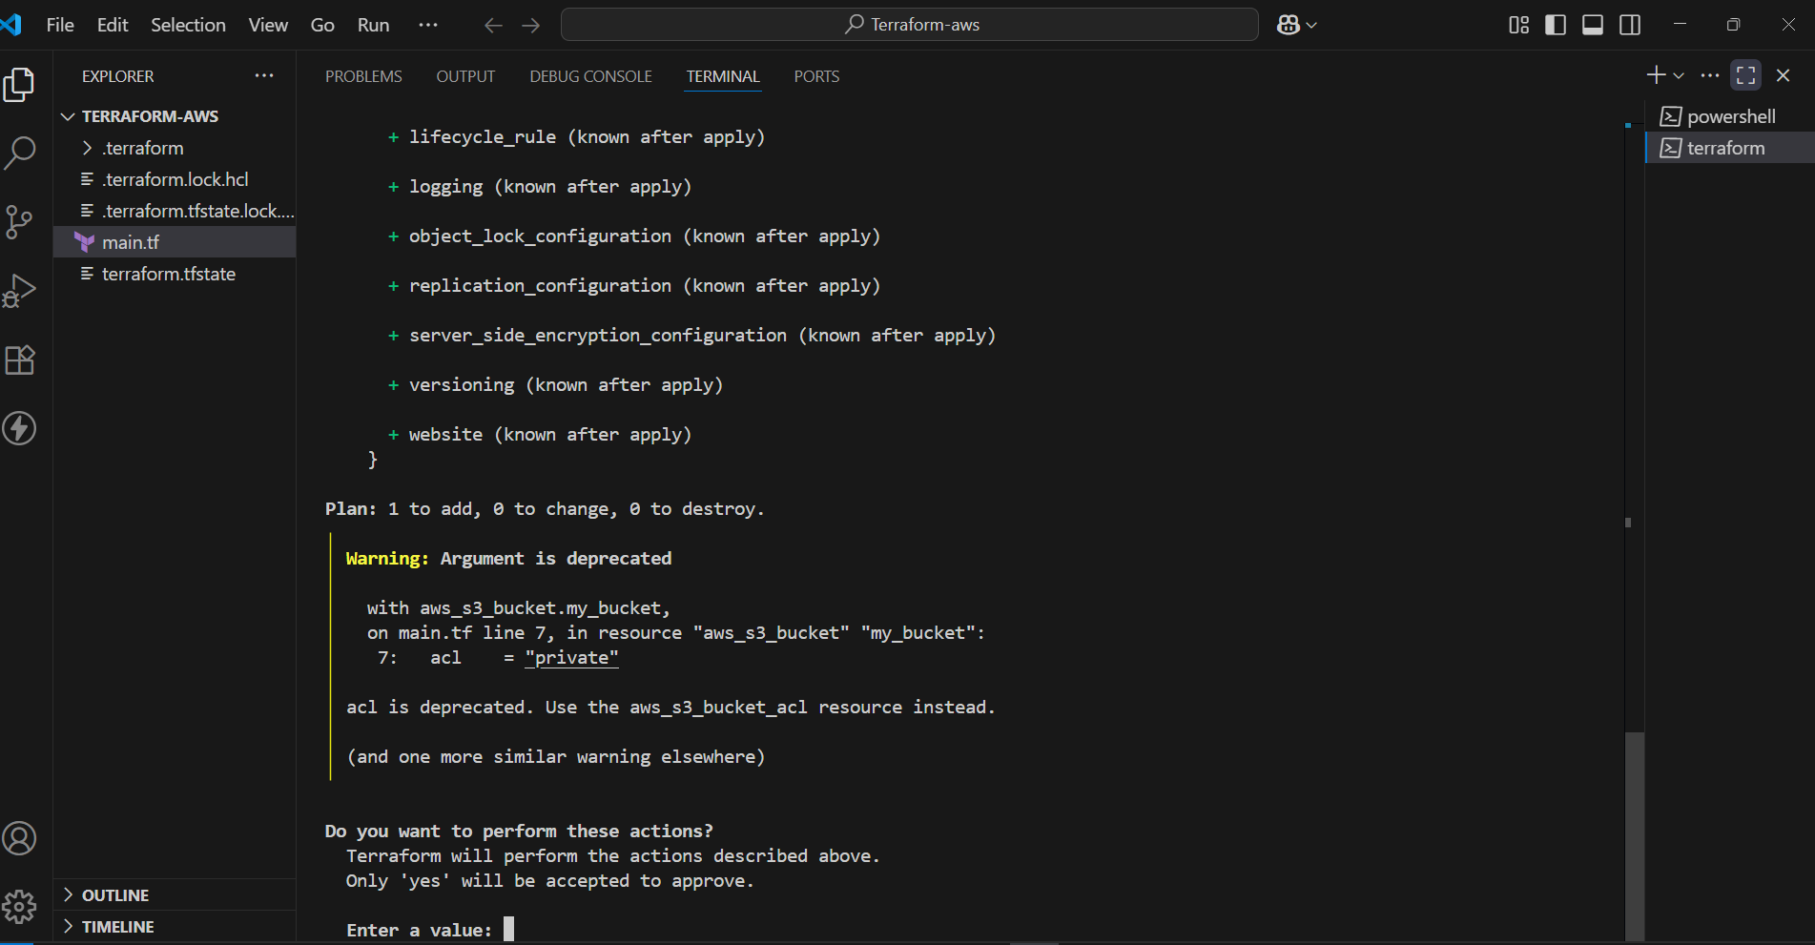

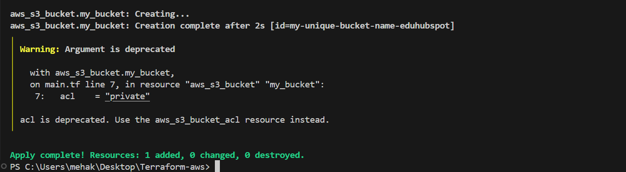

Terraform will provision your infrastructure

Verification
- Go to: https://console.aws.amazon.com/
- In the top search bar, type S3 and click on the S3 service.
- You will see a bucket is created inside S3.

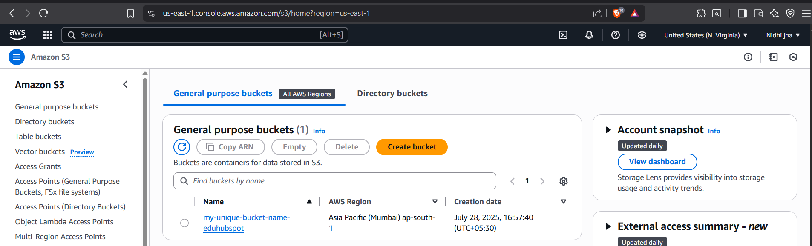

- Run the following command:
  - terraform destroy

What it does:

- Reads the Terraform state file to know what resources exist.
- Generates a plan showing which resources will be deleted.
- Asks for confirmation before proceeding.
- Sends delete requests to your cloud provider for each resource.

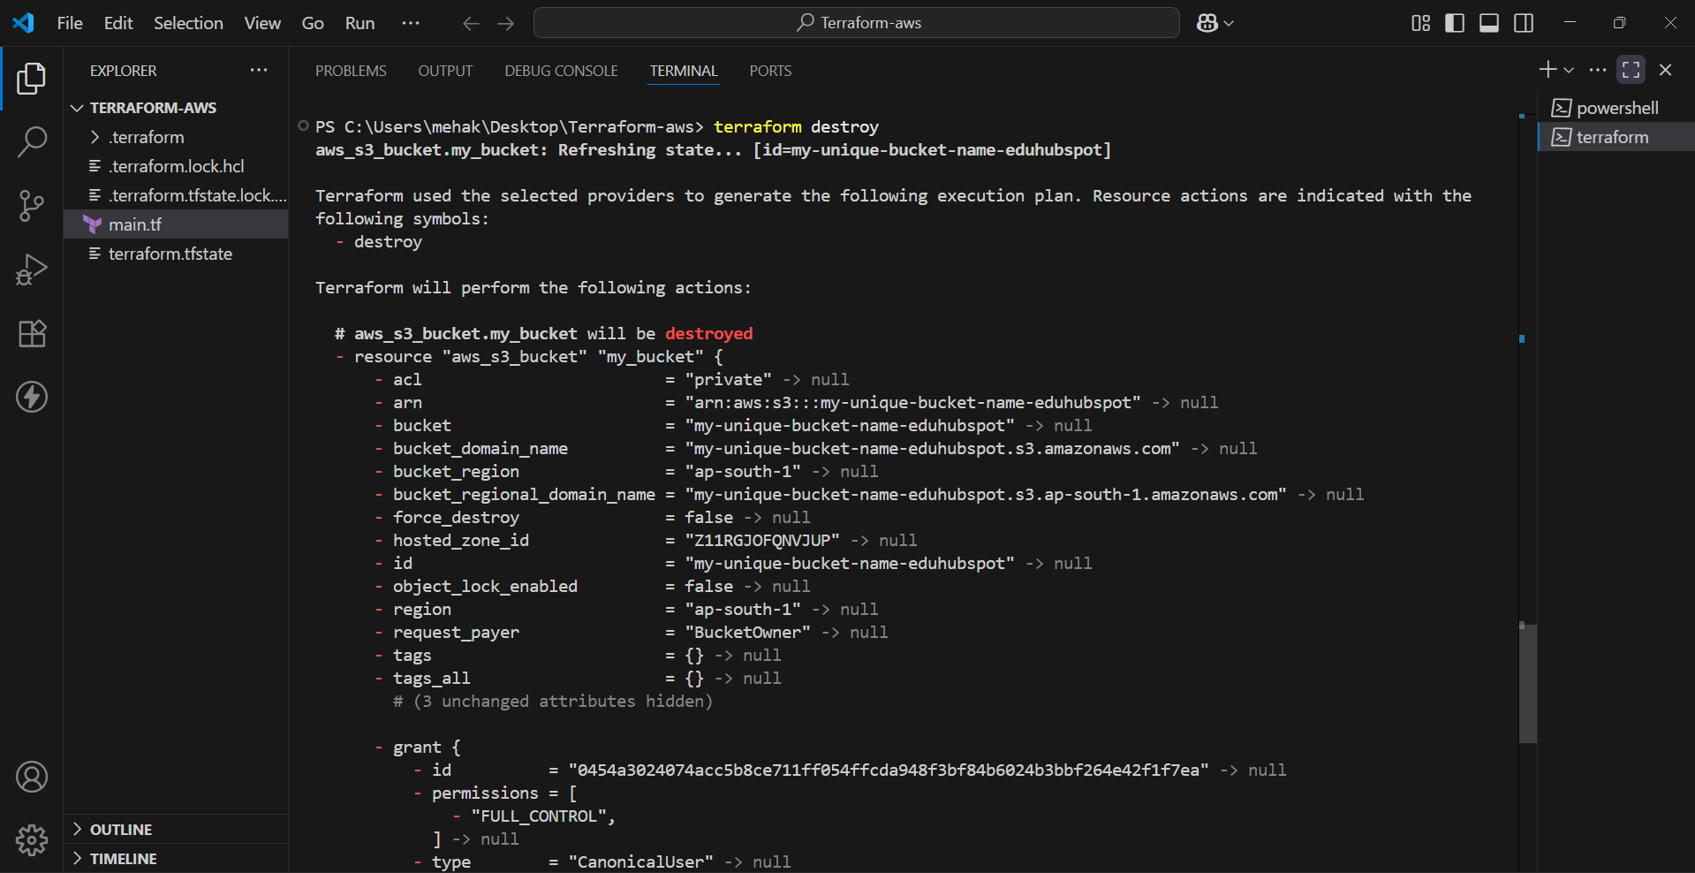

- Enter “yes”

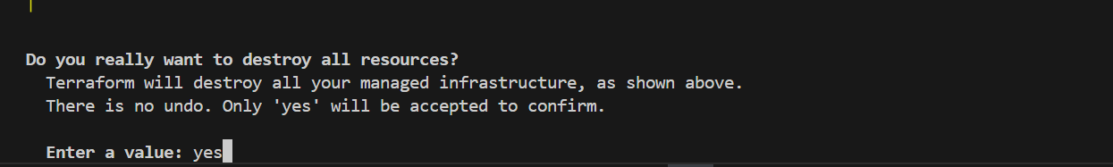

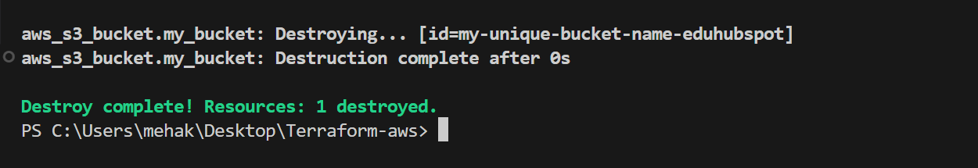

Conclusion

By following this step-by-step guide, you have successfully installed and configured Terraform on a Windows system, and deployed your first AWS resource using Infrastructure as Code (IaC). Here's what you accomplished:

- Installed Terraform and added it to your system's environment path
- Verified the installation using the command line
- Set up IAM credentials and configured the AWS CLI to securely authenticate Terraform with your AWS account
- Wrote a basic Terraform configuration to create an S3 bucket
- Initialized, planned, applied, and destroyed infrastructure using Terraform commands
- Verified the deployment directly through the AWS Management Console

