Set Up Remote State Management

Overview

Remote state management is essential in Terraform to allow teams to share state, maintain consistency, and enable advanced features such as state locking. This guide provides a professional, step-by-step walkthrough to set up remote state management using Amazon S3 as an example backend. The concepts apply to other backends as well (Azure Blob, Google Cloud Storage, etc.)

Prerequisites
- VS Code
- Terraform
- AWS access
- IAM user credentials

Step 1: Create an S3 Bucket for State Storage

Terraform by default stores its state file (terraform.tfstate) locally, which is not ideal for teams or production.
To fix this, we’ll store the state file in AWS S3, which is cloud-based, durable, and shareable.
- Go to AWS S3 Console or use CLI:
https://ap-south-1.console.aws.amazon.com/s3/get-started?region=ap-south-1
- Click “Create bucket”.
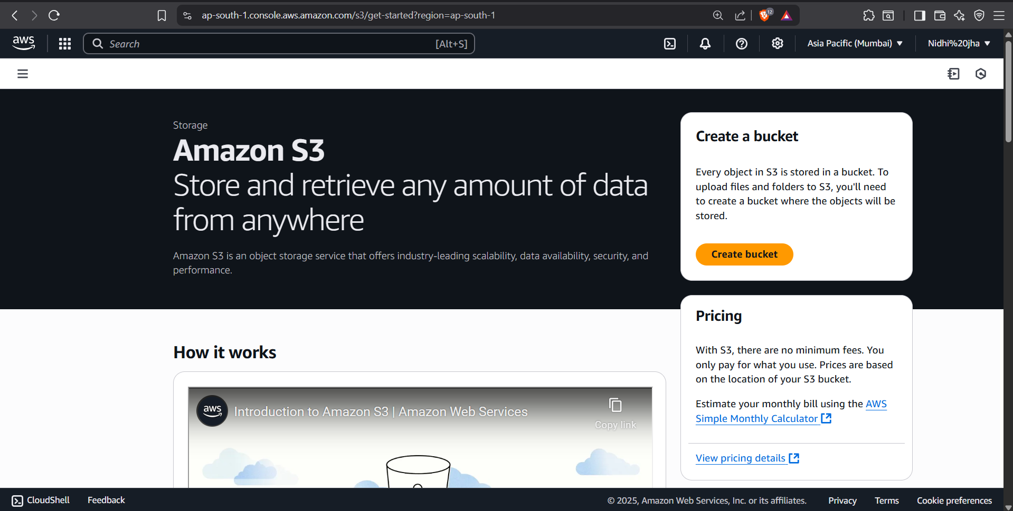

- Name your bucket (e.g., eduhubspot-terraform)

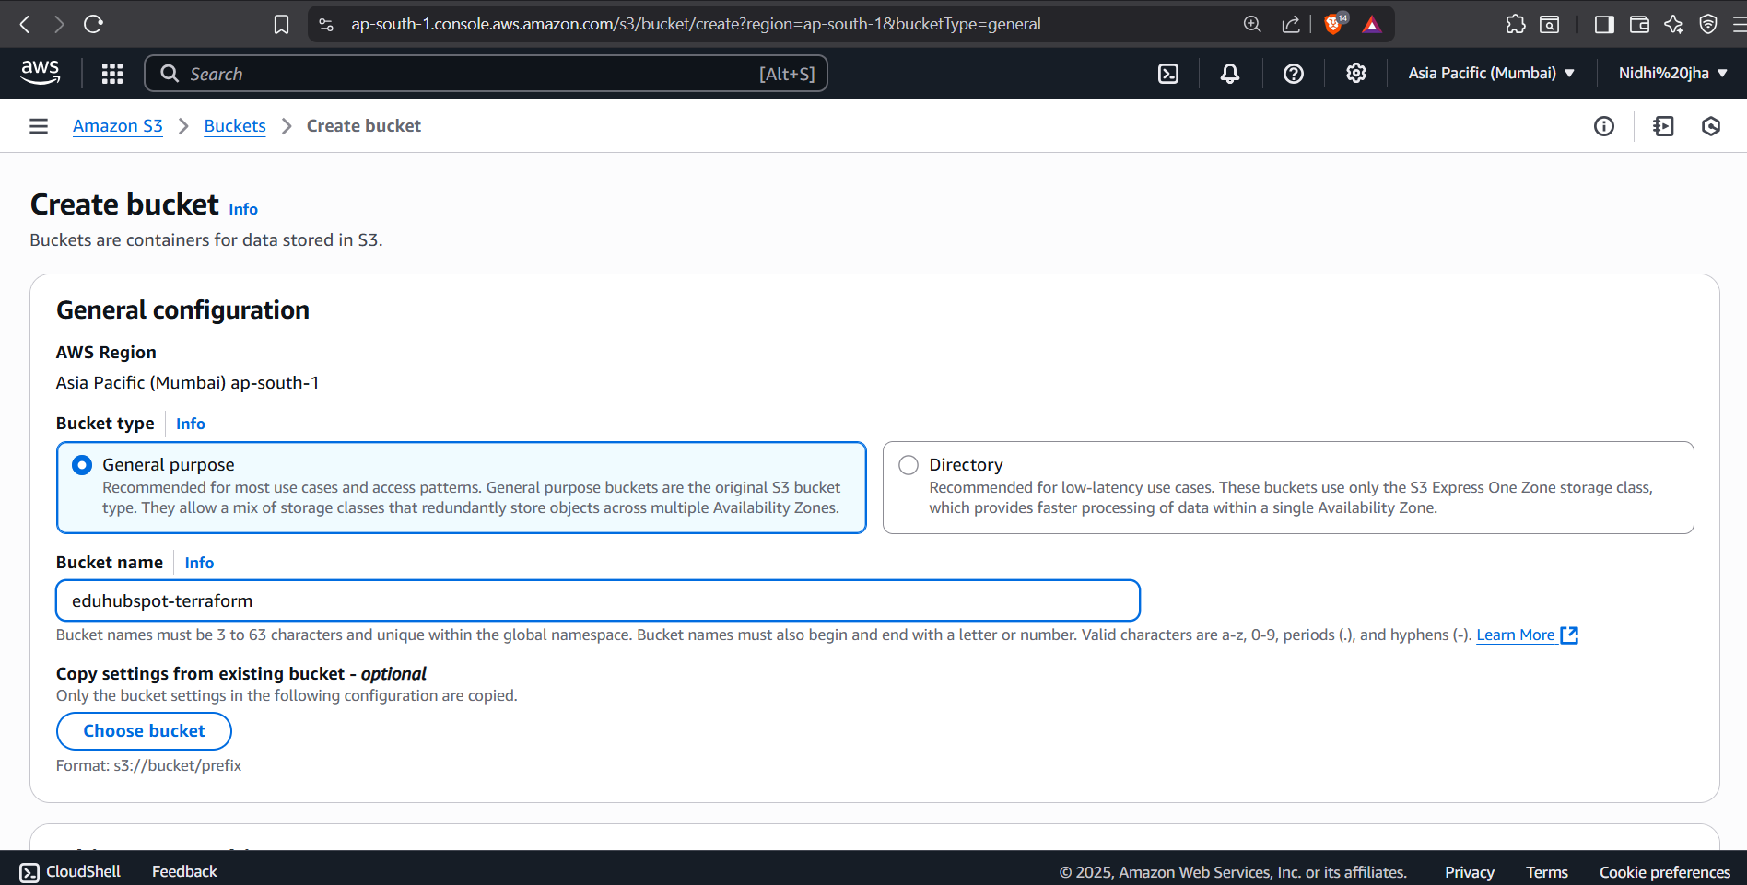

- Choose a region (e.g. Asia Pacific (Mumbai))
- Click Create Bucket

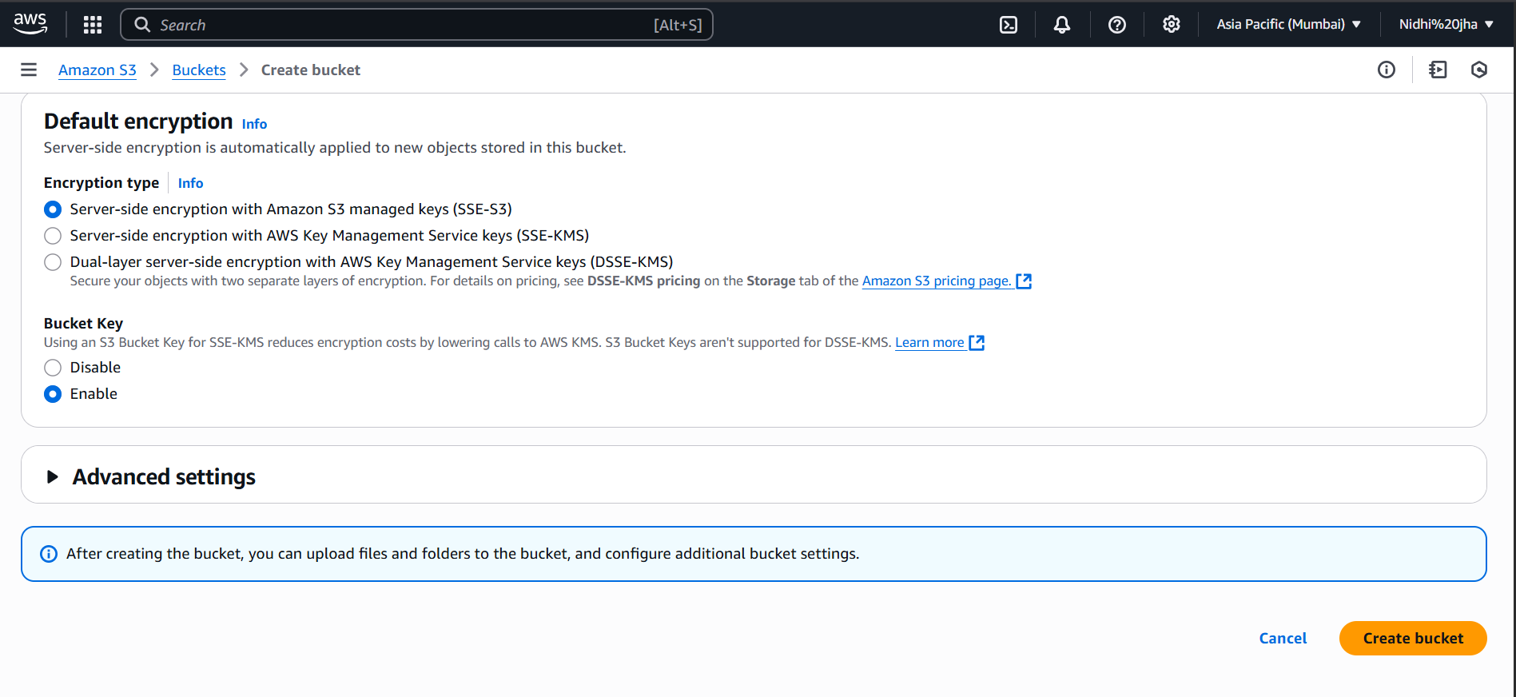

- Bucket is created successfully.

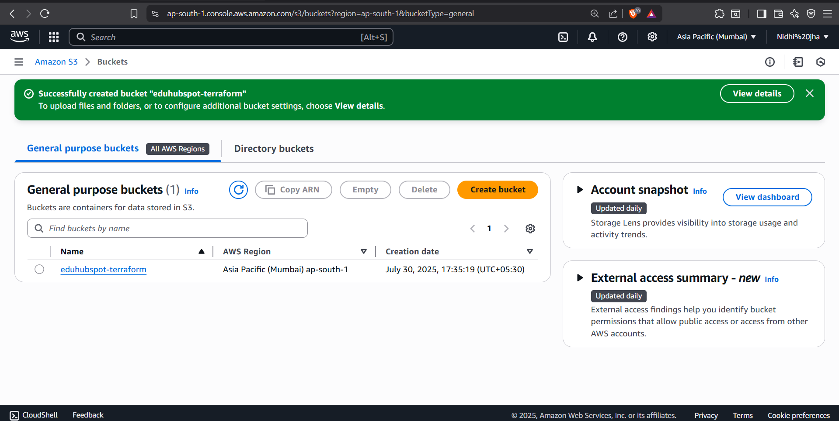

Step 2: Set Up a DynamoDB Table for State Locking

This step prevents two people from modifying the same infrastructure at the same time.
- Attach DynamoDB policy to the IAM user.
- Open: https://console.aws.amazon.com/iam/

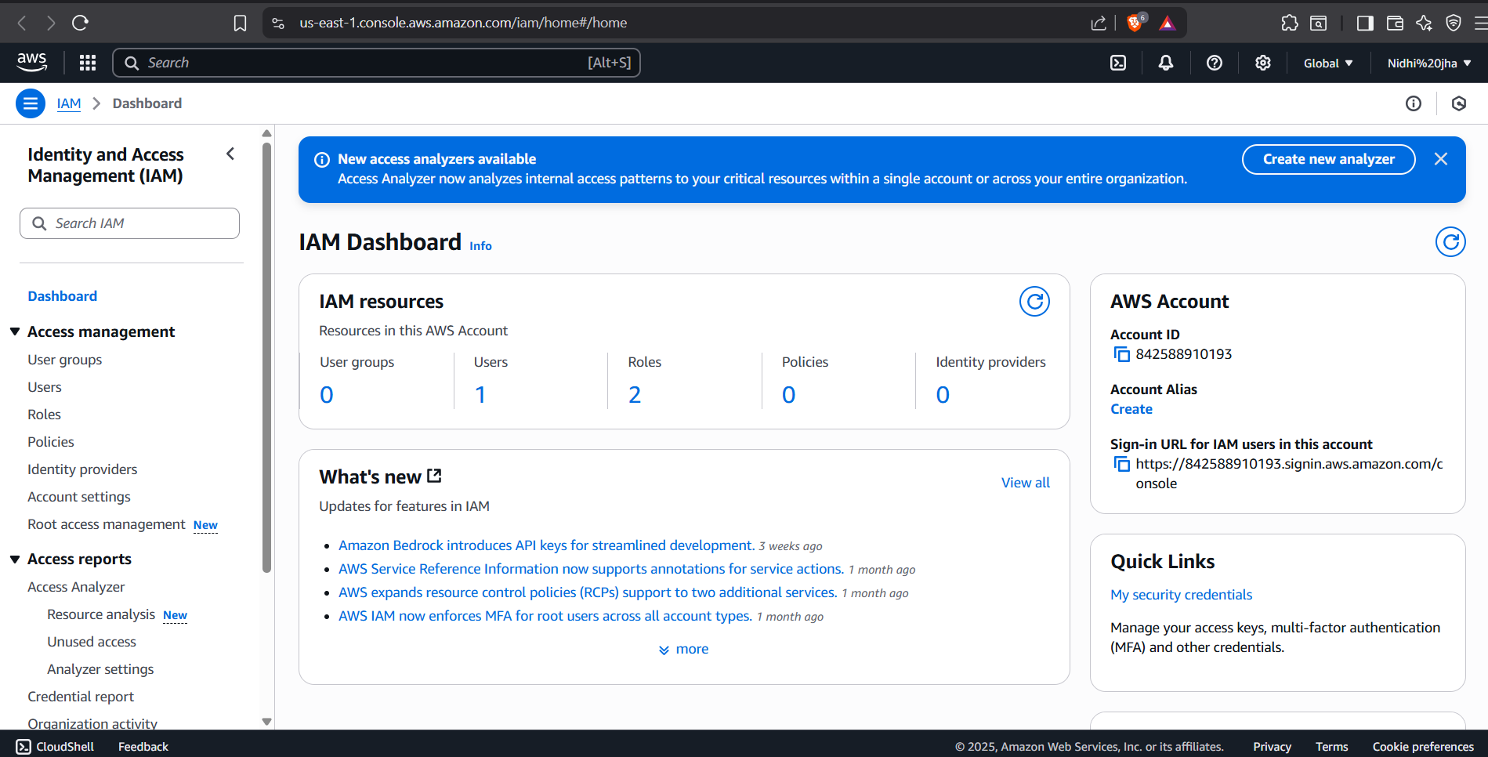

- Click Users from the sidebar.

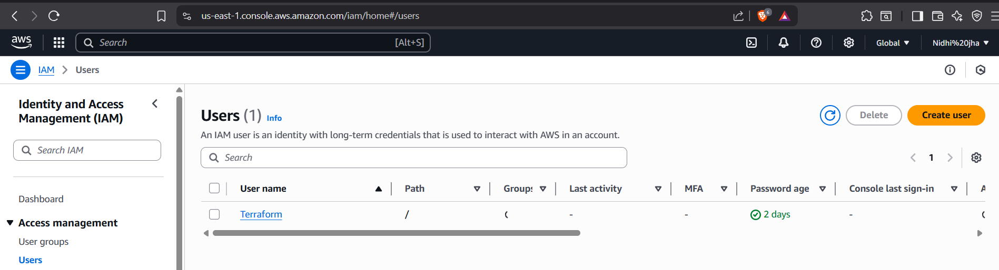

- Click the user named Terraform.
- Go to the Permissions tab.

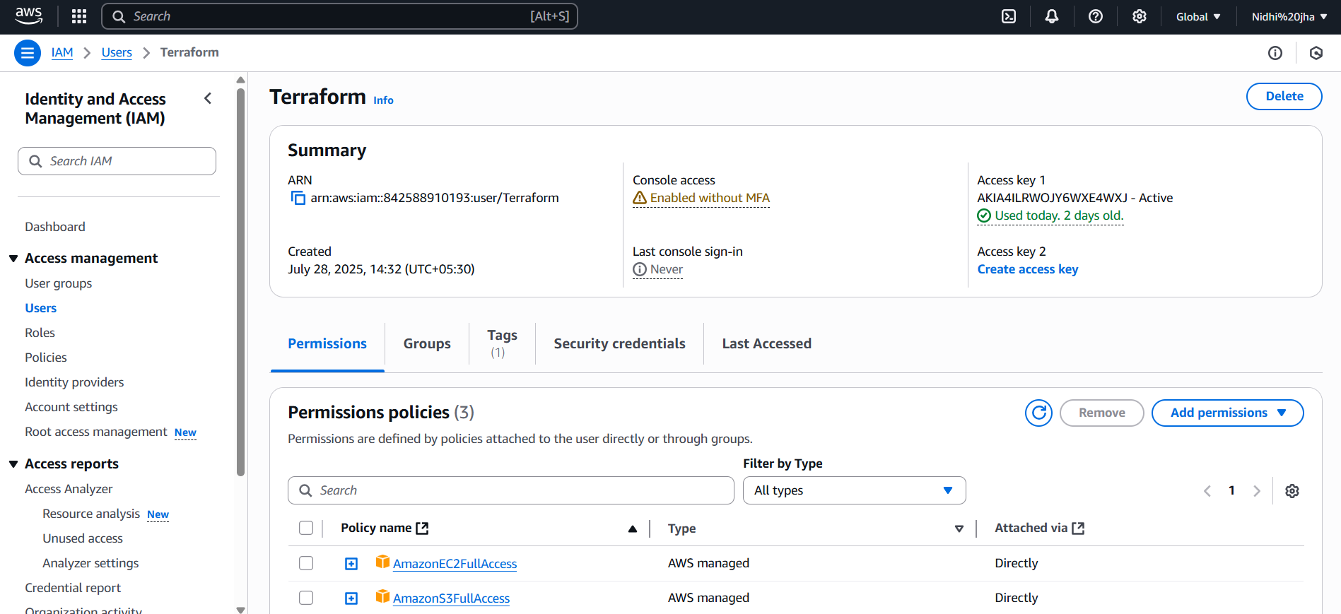

- Click Add permissions → Attach policies directly.
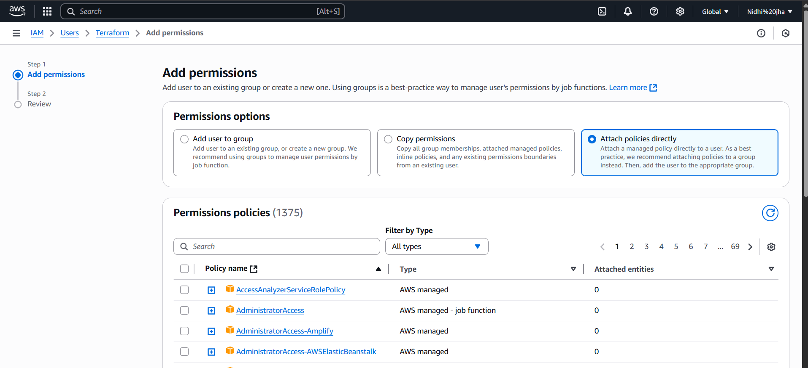

- Add DynamoDB
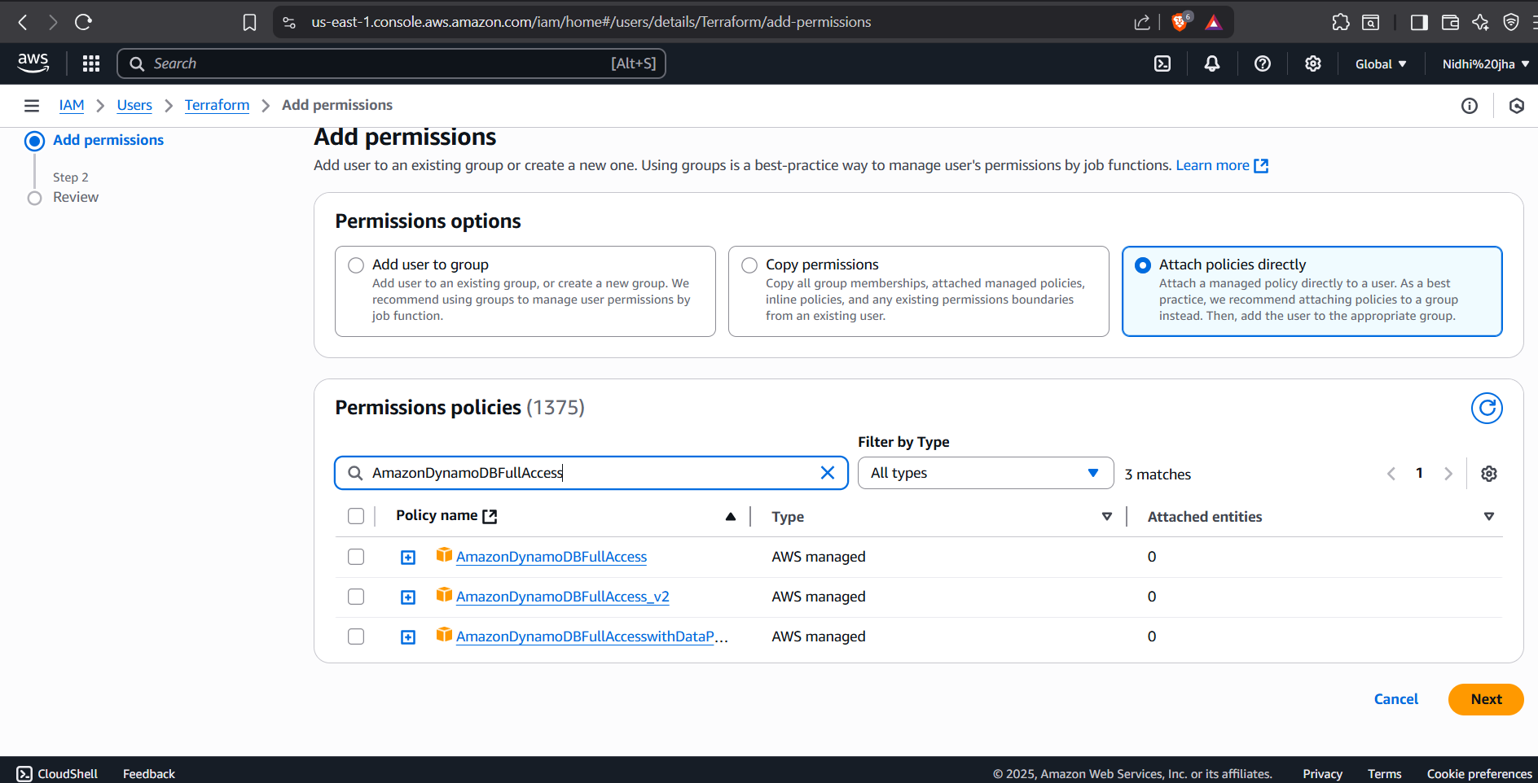

- Click Next.
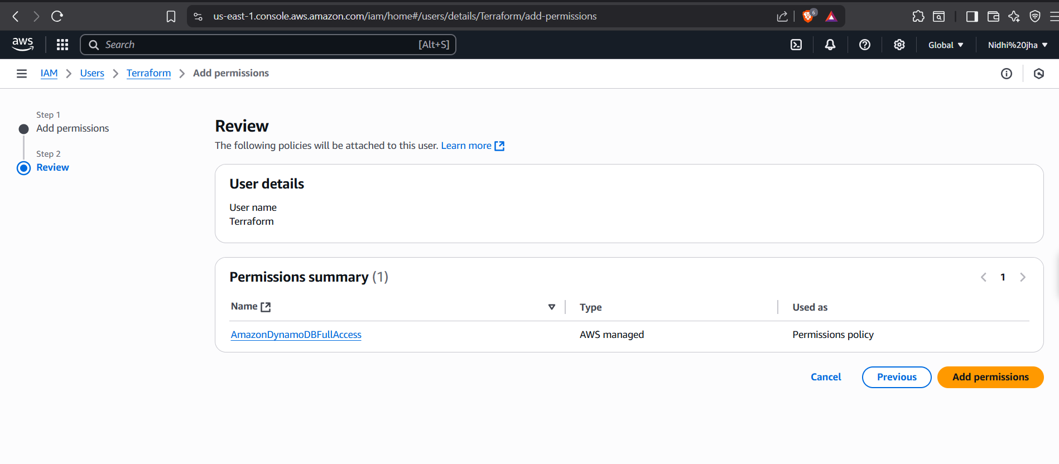

- Click add permissions.

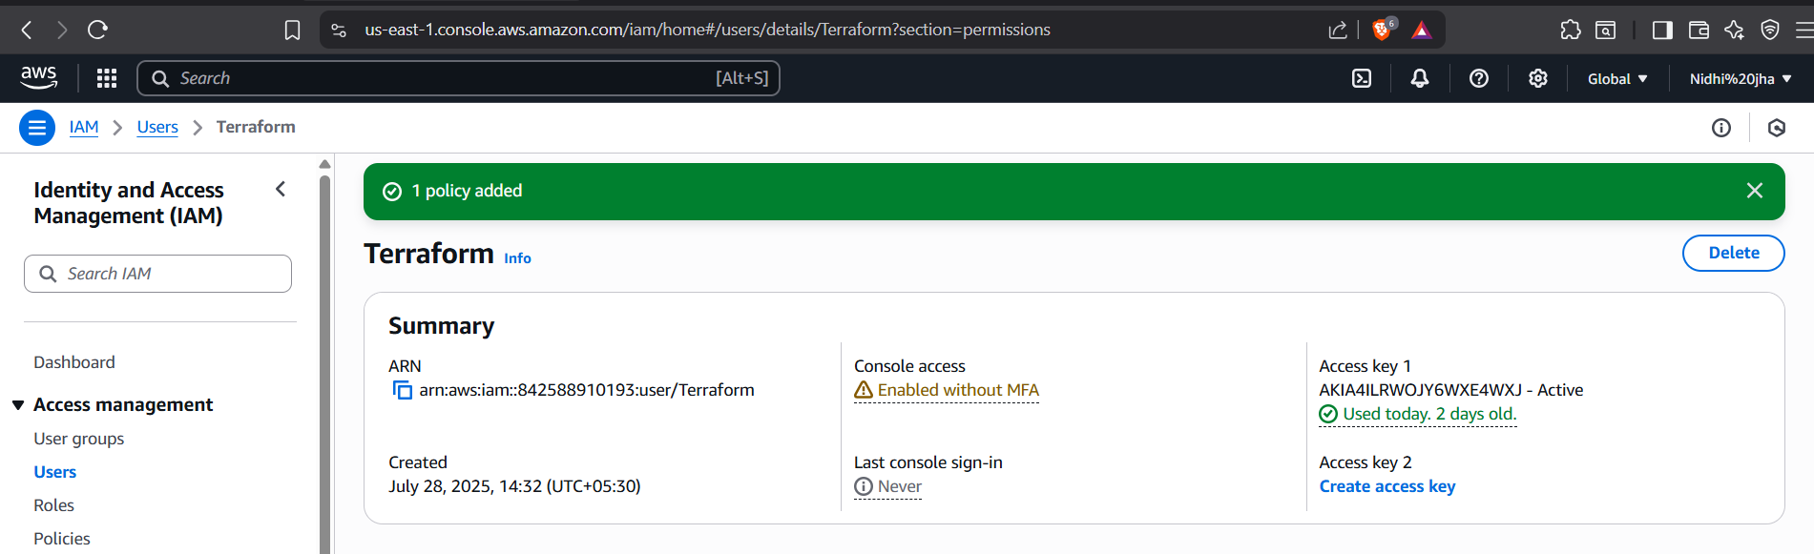

- Open Command Line

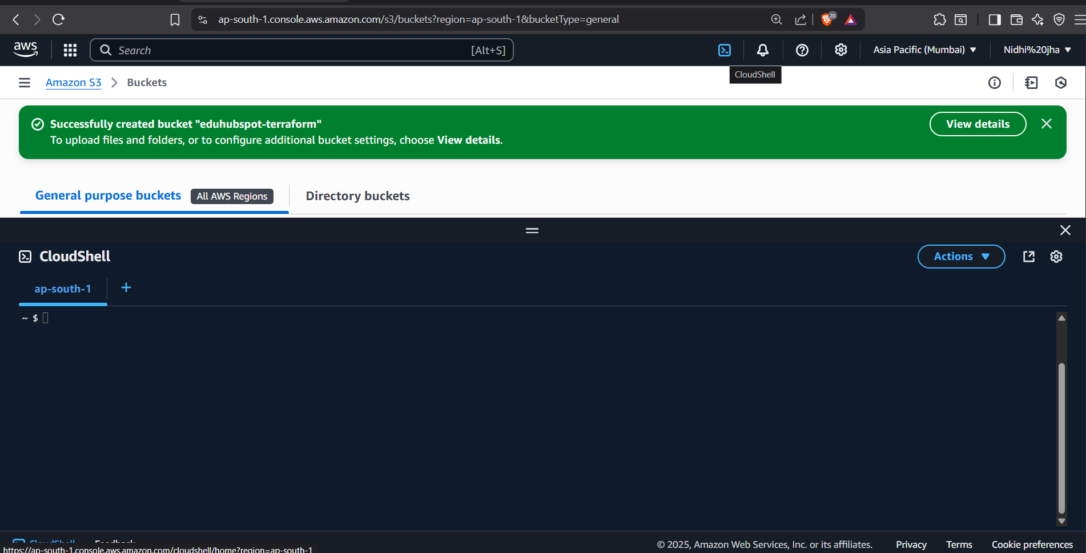

- Create the Table:

aws dynamodb create-table \
--table-name terraform-lock-table \
--attribute-definitions AttributeName=LockID,AttributeType=S \
--key-schema AttributeName=LockID,KeyType=HASH \
--provisioned-throughput ReadCapacityUnits=5,WriteCapacityUnits=5

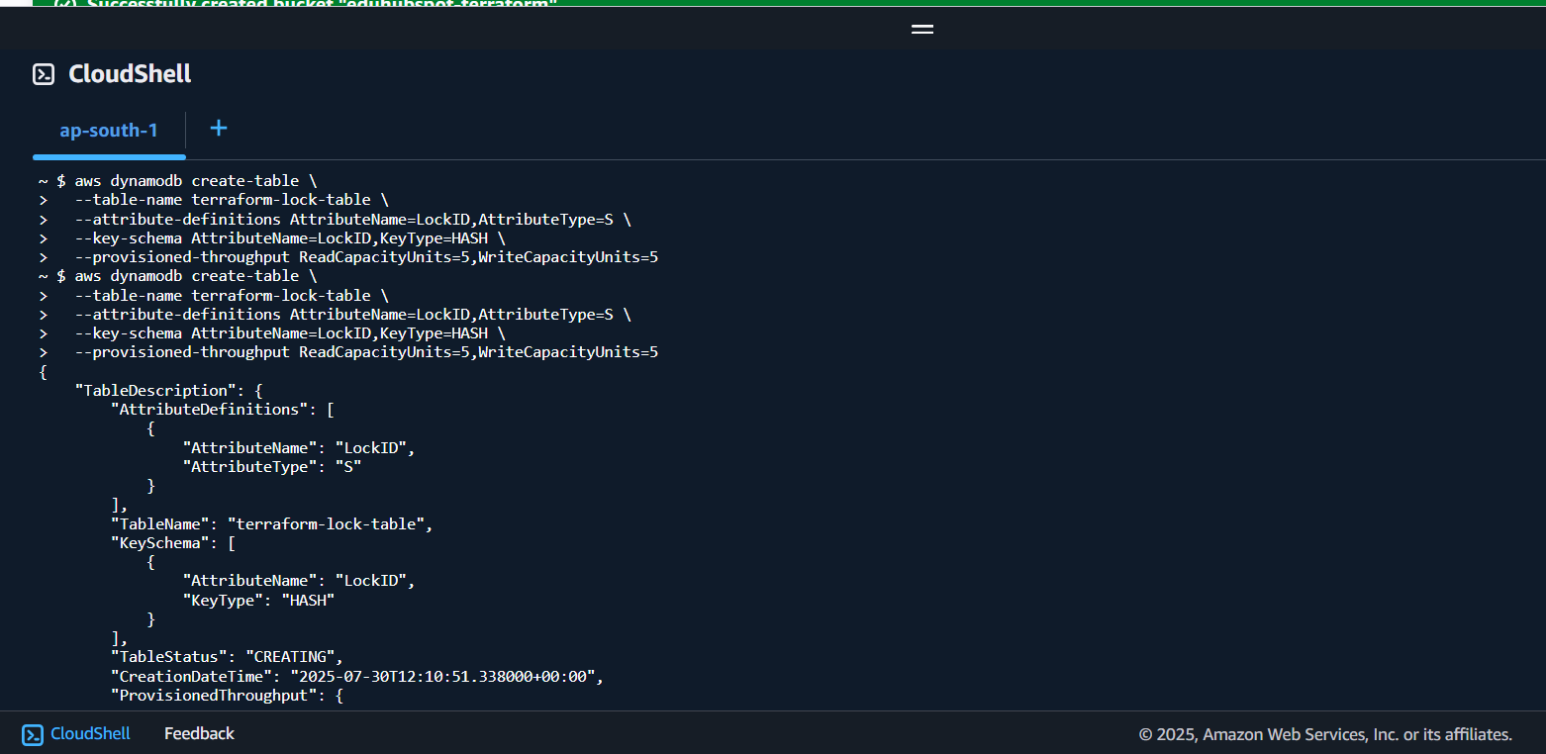

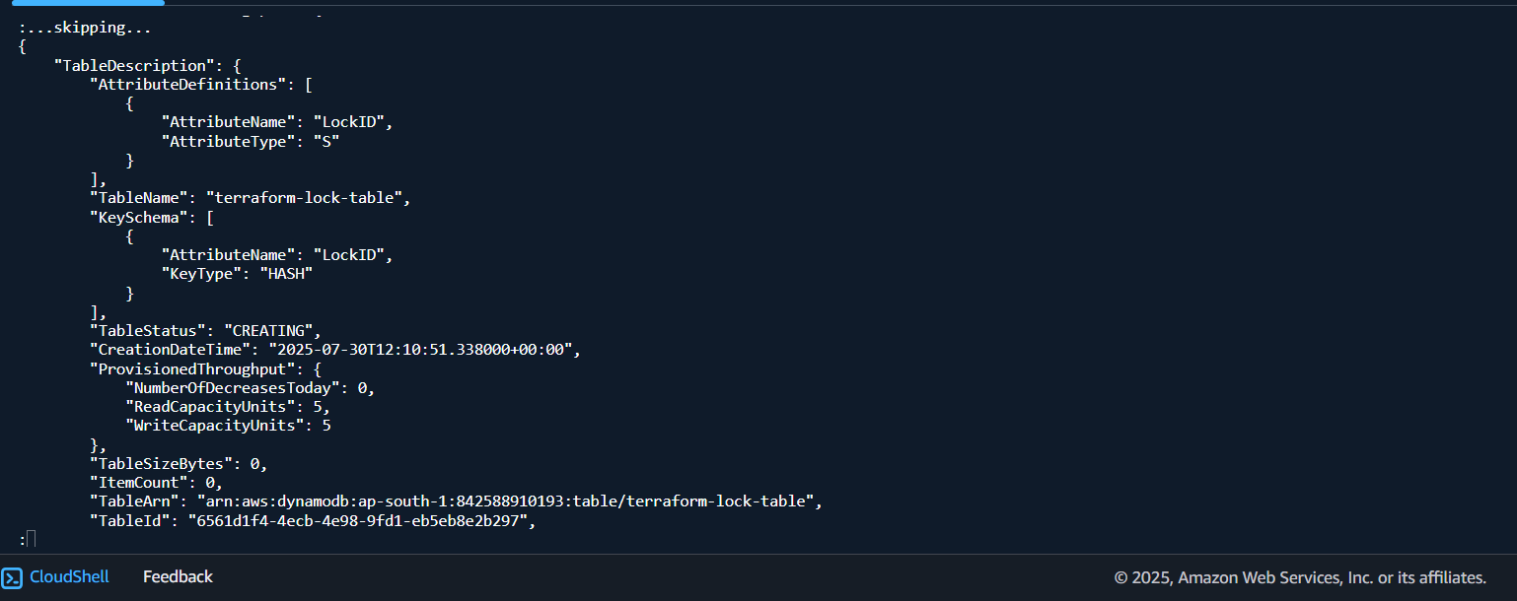

To verify

- Search DynamoDB

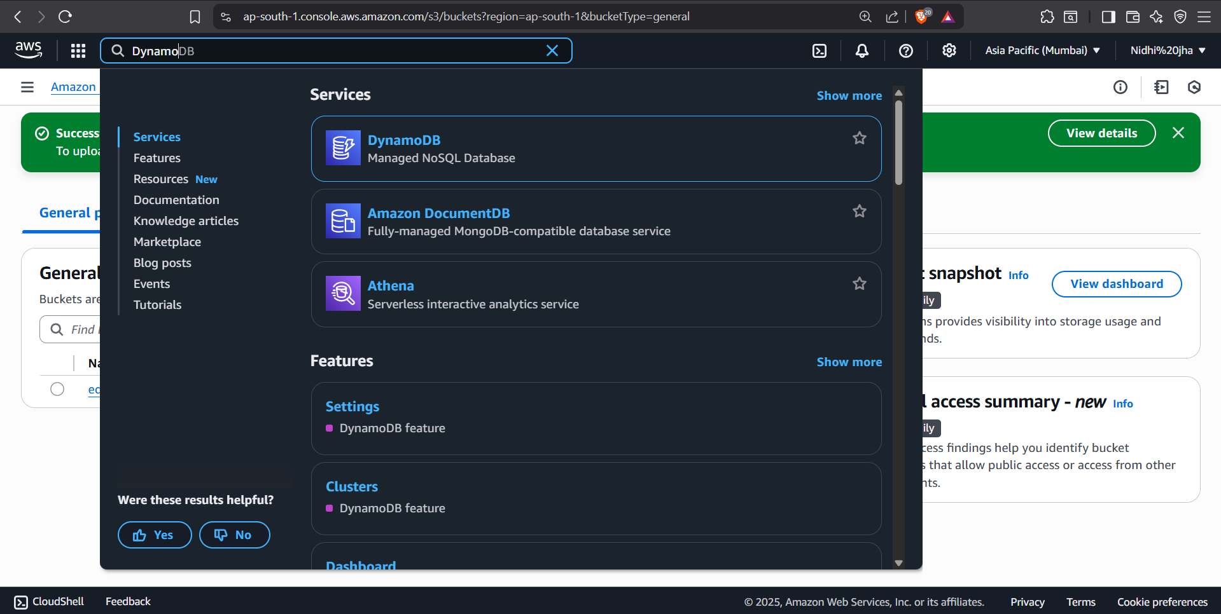

- Go to tables

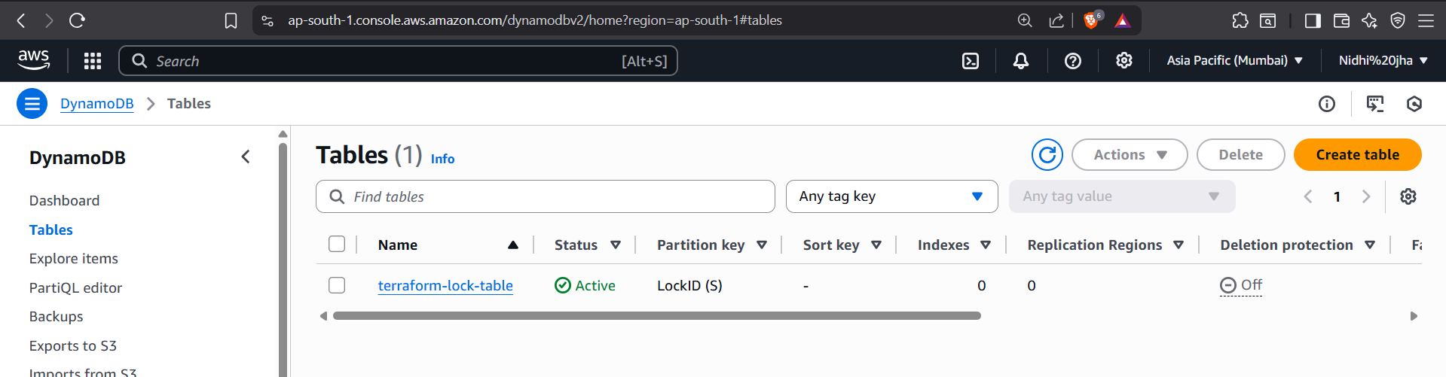

Table is created successfully.

Step 3: Configure the Backend in Your Terraform Code

Now you tell Terraform to store the state in your S3 bucket and lock it using the DynamoDB table.

- Open VS code.
- Create a project folder.
- Create the main.tf file and paste this:

terraform {
backend "s3" {
bucket = "eduhubspot-terraform" # Your bucket name
key = "global/s3/terraform.tfstate" # Path to the state file
region = "ap-south-1"
dynamodb_table = "terraform-lock-table" # Optional but recommended
encrypt = true # Encrypt the state file
}
}

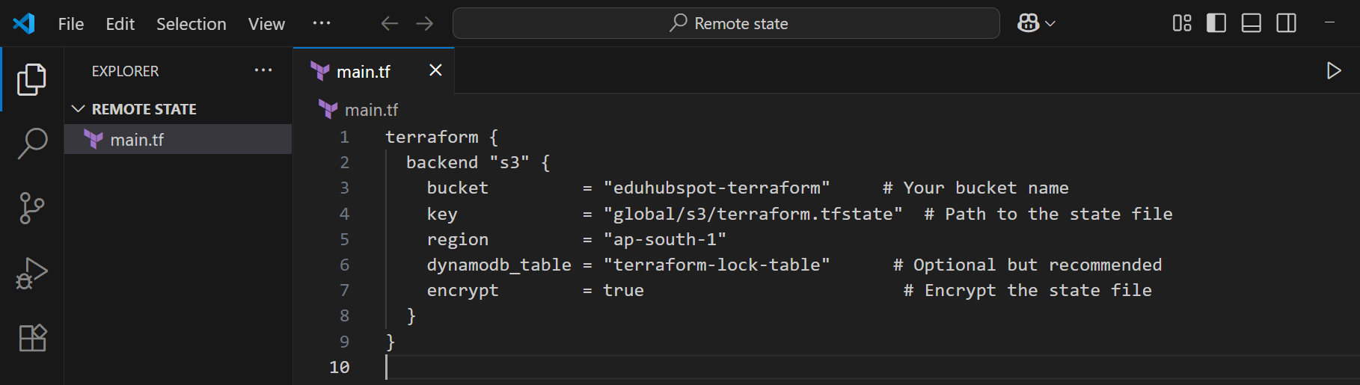

Step 4: Initialize Terraform with the Remote Backend

- This command sets up Terraform to use your S3 bucket and DynamoDB table:
  - terraform init

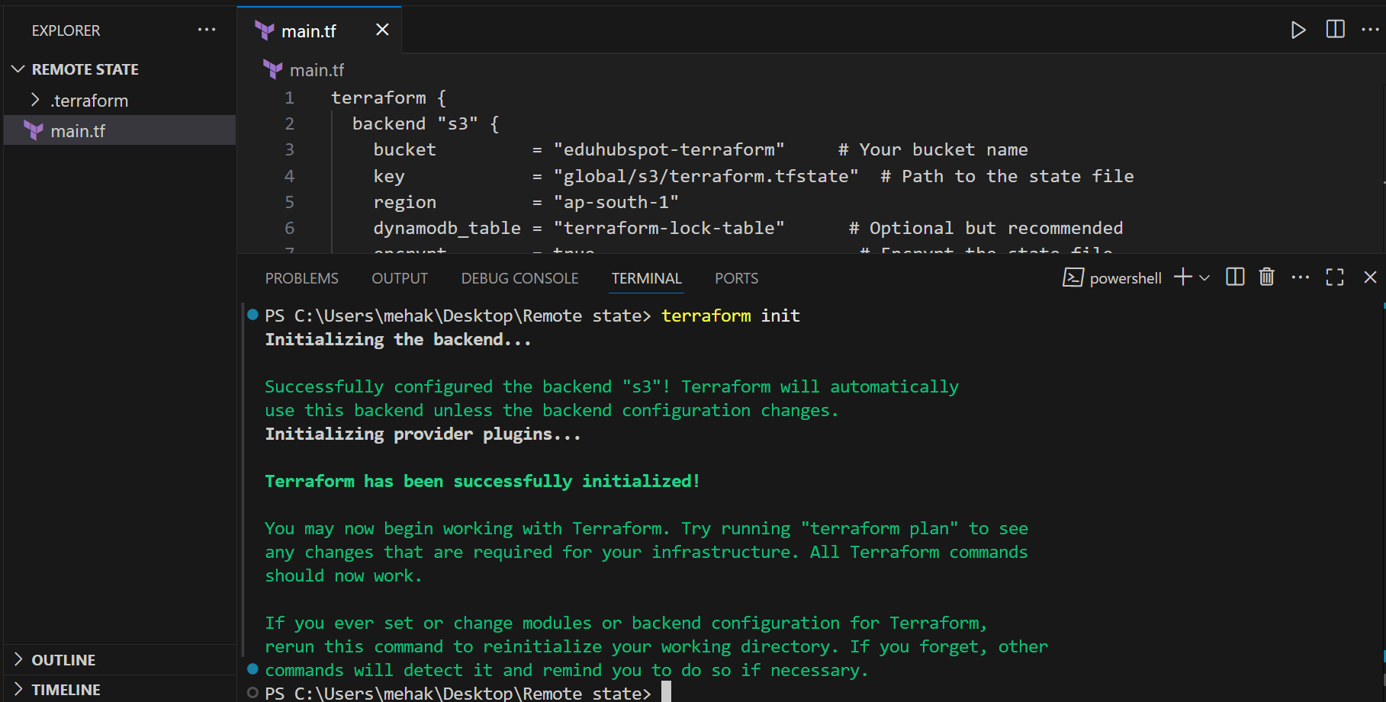

What will happen:
- Terraform checks your main.tf for the backend block.
- It connects to your S3 and DynamoDB.
- If there's already a local terraform.tfstate, it asks you if you want to migrate it to S3.
- A .terraform/ directory is created that stores metadata.

- Run the terraform command:
  - terraform plan

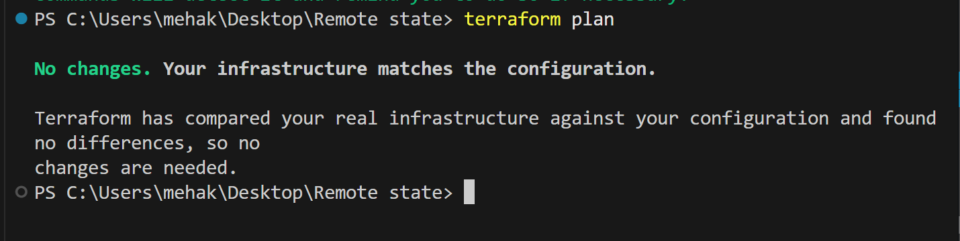

That message means everything is working perfectly.

What Just Happened:
- Terraform successfully acquired the state lock using your DynamoDB table.
- It read the state file from your S3 bucket (eduhubspot-terraform).
- It compared your actual AWS infrastructure to your Terraform configuration and found no changes.

- Run the following command:
  - terraform apply

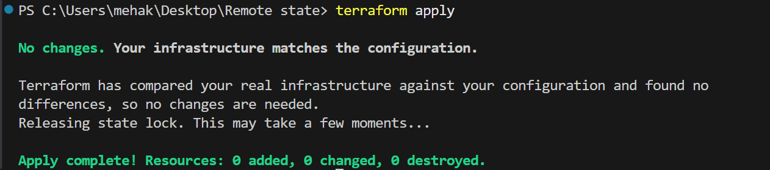

Terraform is successfully using remote state (because it’s acquiring and releasing the lock via DynamoDB).

- Check S3 bucket:

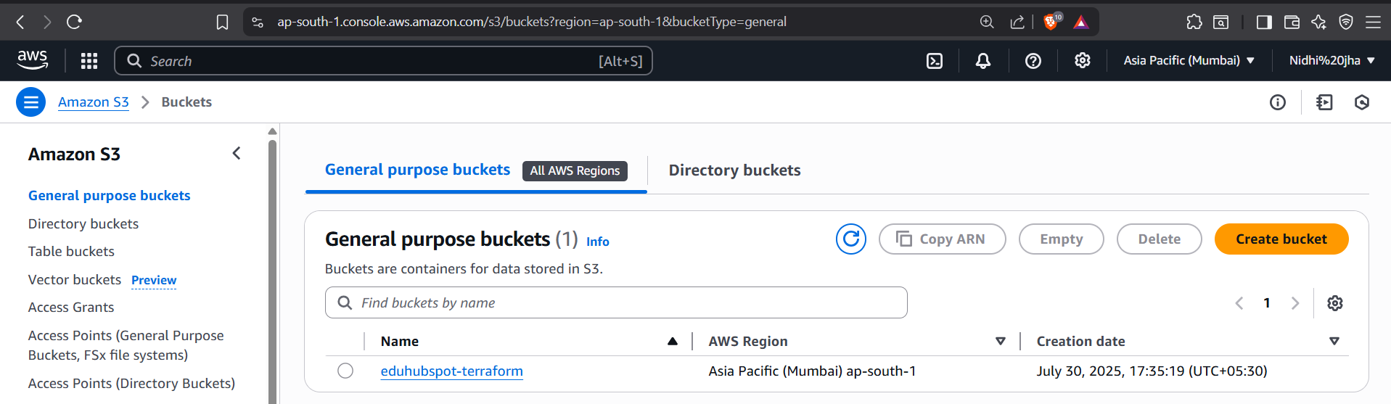

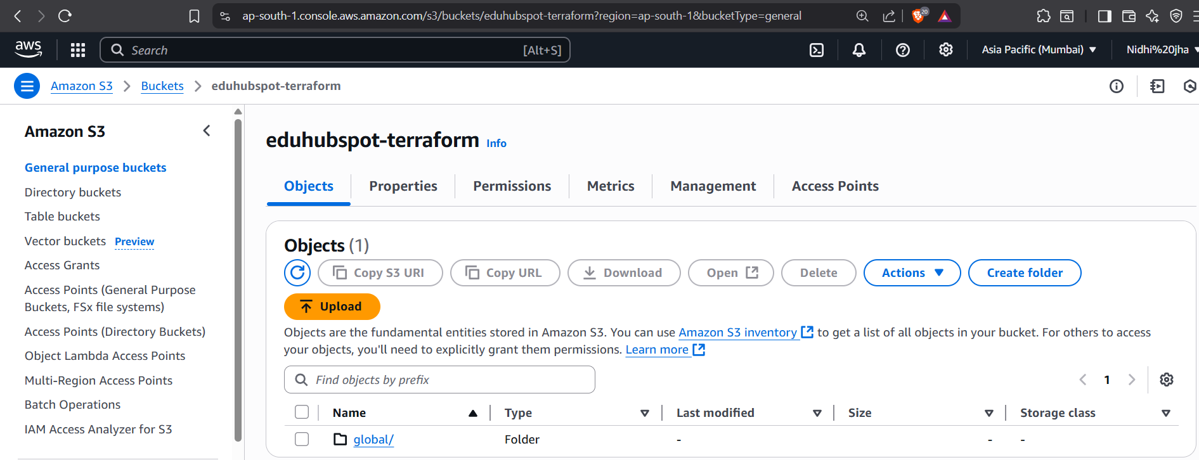

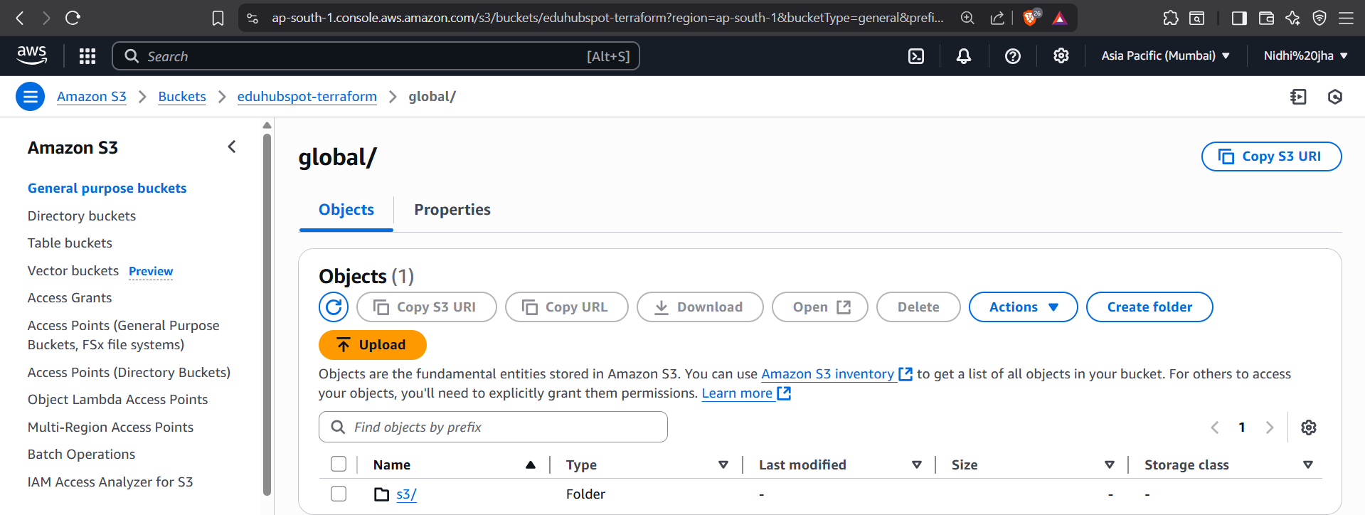

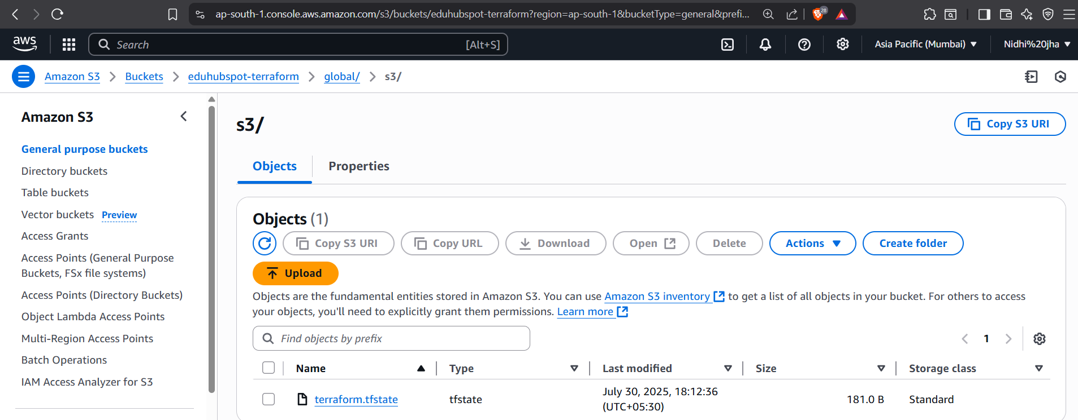

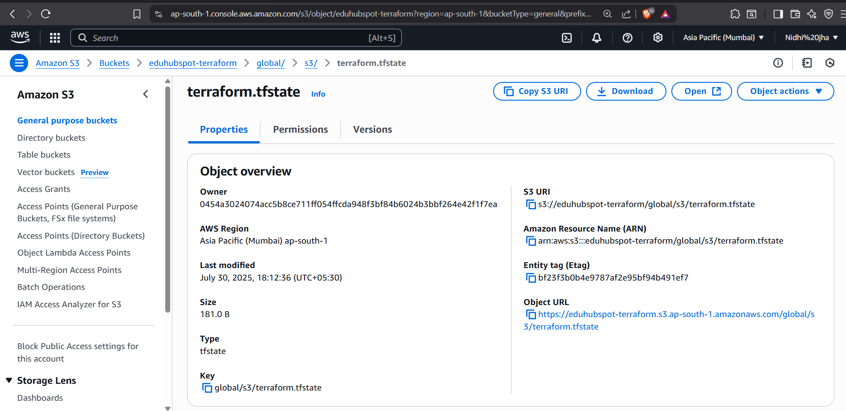

State Verification Instructions

After apply, verify state:
- In S3 bucket → navigate to global/s3/terraform.tfstate:
aws s3 ls s3://eduhubspot-terraform --recursive --region ap-south-1

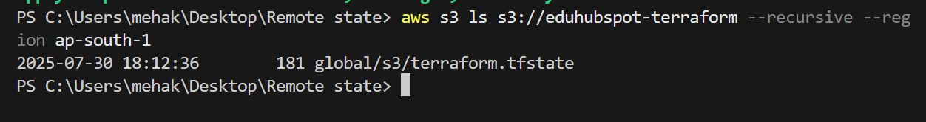

- In DynamoDB → temporary LockID appears during apply:
aws dynamodb scan --table-name terraform-lock-table --region ap-south-1

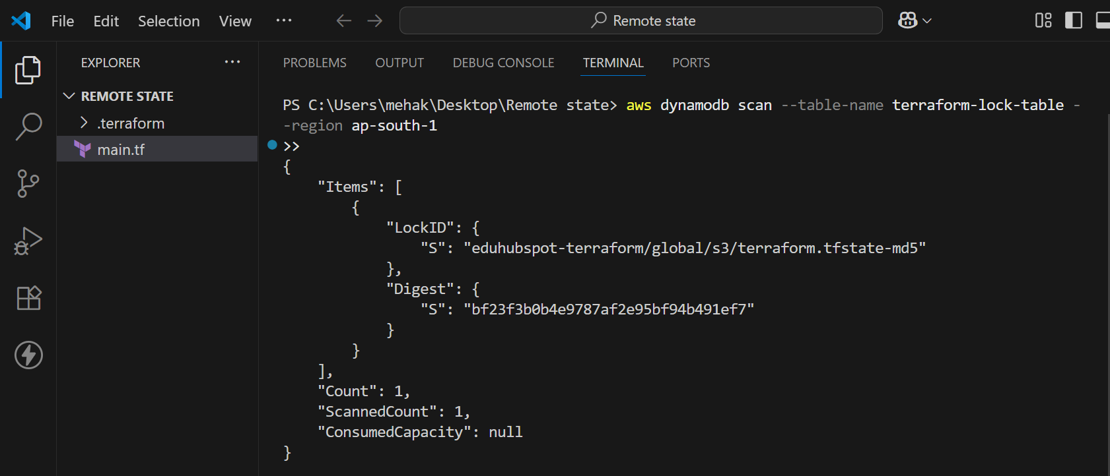

Conclusion

In this guide, you successfully set up remote state management in Terraform using Amazon S3 and DynamoDB — a critical step for maintaining consistent, collaborative, and secure infrastructure operations.

Here’s what you accomplished:
- Created an S3 bucket to store Terraform state files securely and durably.
- Provisioned a DynamoDB table to enable state locking, preventing race conditions in team environments.
- Configured the Terraform backend in your project with the proper backend "s3" block.
- Initialized Terraform to link it with your remote backend and migrate existing state.
- Verified that state locking and remote state storage were working correctly through terminal.

