Test Infrastructure Code

Overview

Testing infrastructure code refers to the process of writing, validating, planning, and applying Terraform configurations to simulate or deploy cloud resources in a controlled and predictable manner. This ensures your code performs as expected before it impacts real environments.
Terraform, an Infrastructure as Code (IaC) tool, allows you to manage cloud resources like AWS EC2 instances, S3 buckets, VPCs, and more using configuration files.

Prerequisites
- VS Code
- Terraform
- AWS CLI installed and configured
- IAM user with EC2 permissions
- Basic command-line knowledge
- AWS Access & Secret Keys

Step 1: Create Project Folder and Files

- Open VS code
- Open terminal and create a folder.
- Create the following files:
  - main.tf
  - variables.tf
  - outputs.tf
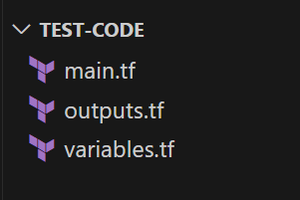

Step 2: Write Code in Terraform Files
- Write code in main.tf:
provider "aws" {
region = var.aws_region
}

resource "aws_instance" "my_ec2" {
ami = var.ami_id
instance_type = var.instance_type

tags = {
Name = "MyTestEC2"
}
}

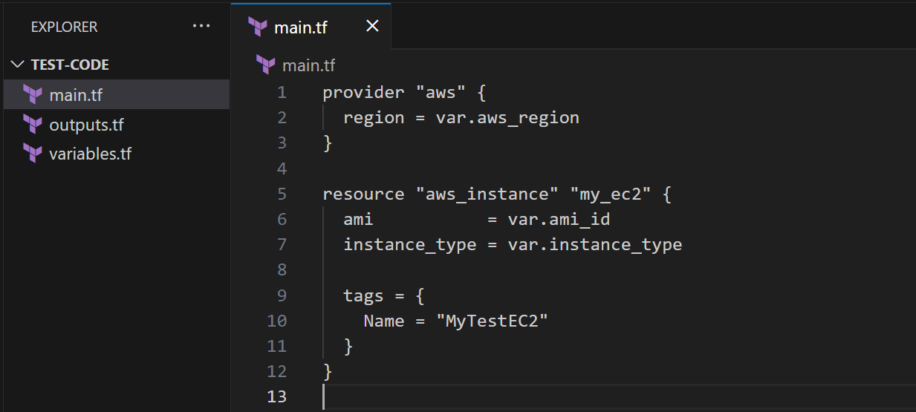
- Write code inside variables.tf:
variable "aws_region" {
description = "AWS region to deploy in"
default = "ap-south-1"
}

variable "ami_id" {
description = "AMI to use for EC2"
default = "ami-0130fdf294657c34f" # Amazon Linux 2 for ap-south-1
}

variable "instance_type" {
description = "Type of EC2 instance"
default = "t2.micro"
}
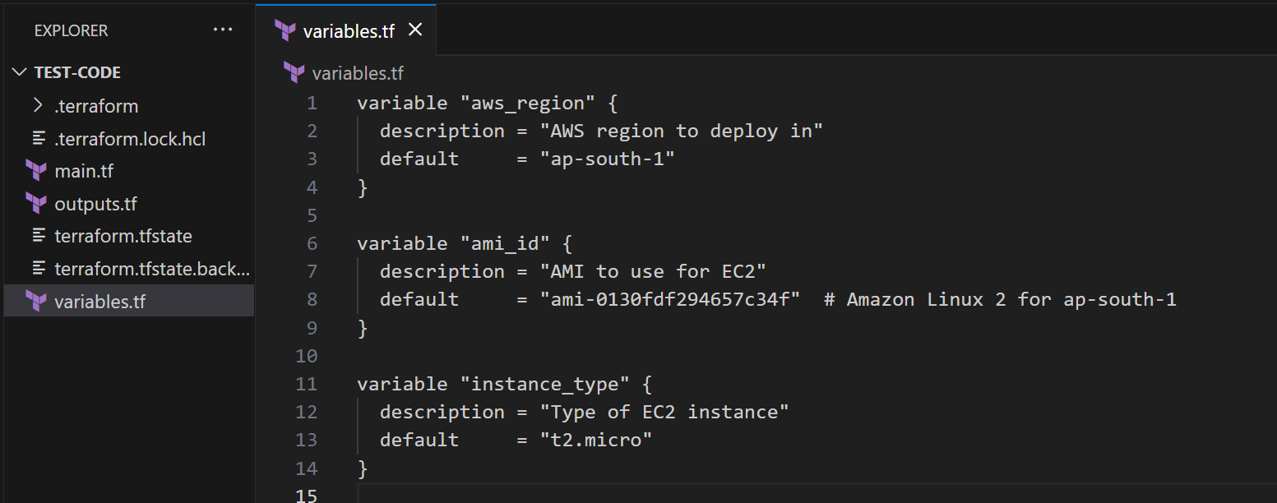
- Write code inside outputs.tf:
output "ec2_instance_id" {
description = "ID of the EC2 instance"
value = aws_instance.my_ec2.id
}
output "public_ip" {
description = "Public IP of the EC2 instance"
value = aws_instance.my_ec2.public_ip
}
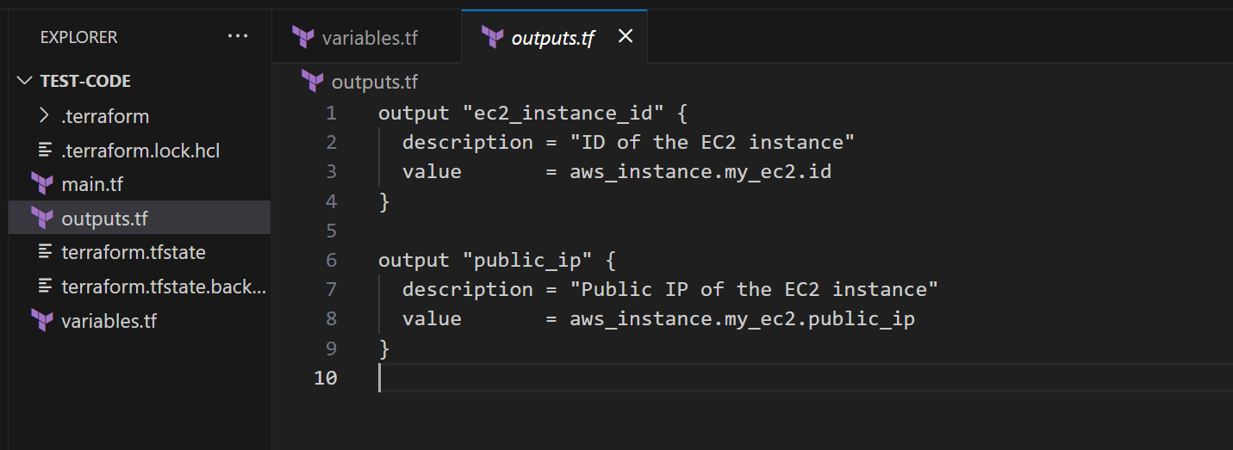
Step 3: Initialize Terraform
- Run this command:
  - terraform init
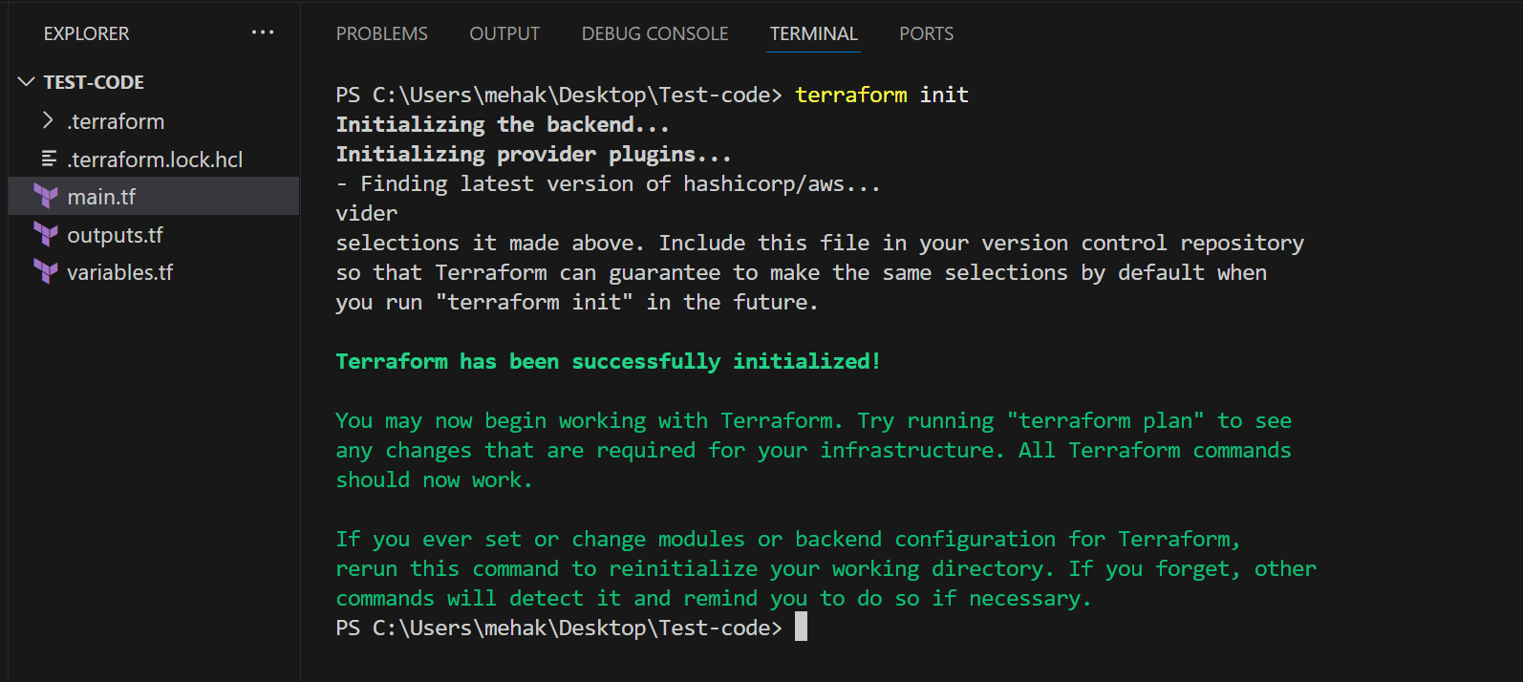

Step 4: Validate the Terraform Code
- Run the following command:
  - terraform validate
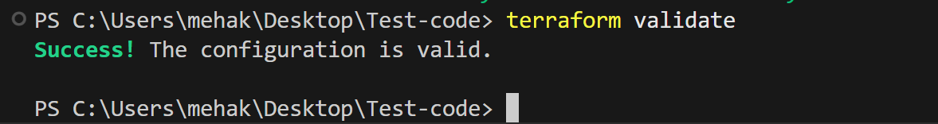

(Checks your code for syntax or logical errors.)

Step 5: Format the Code
- Run the following command:
  - terraform fmt
(The terraform fmt command is used to automatically format your Terraform configuration files (.tf and .tfvars) according to the canonical style recommended by HashiCorp.)
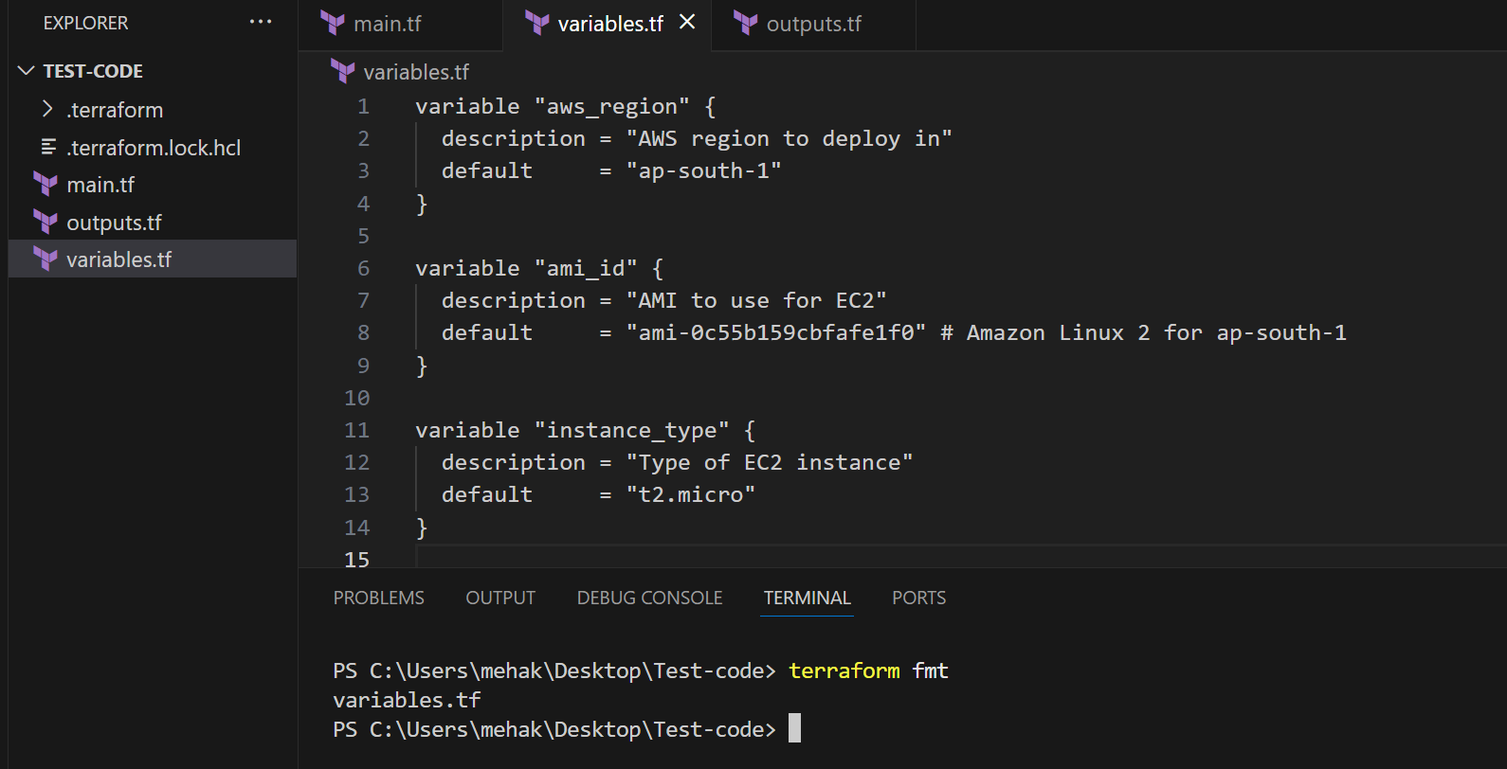

Step 6: See the Execution Plan
- Run the command:
  - terraform plan
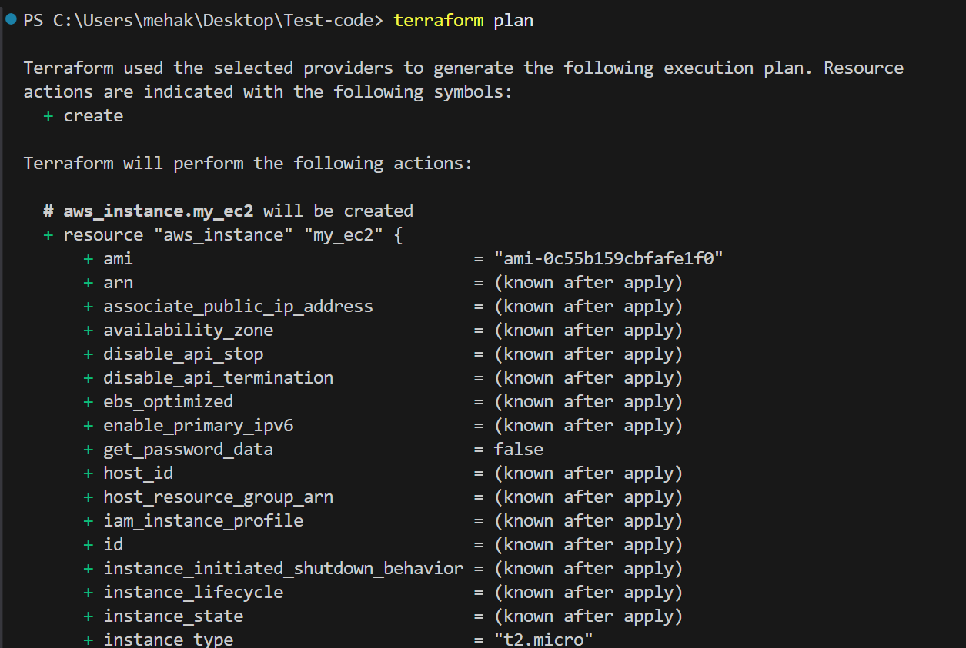

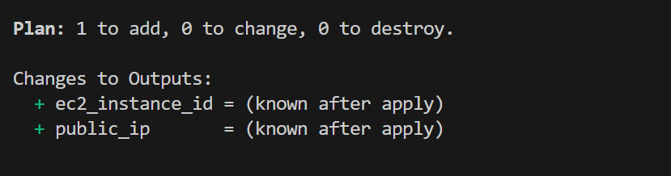

Step 7: Apply the Plan
- Run the following command:
  - terraform apply
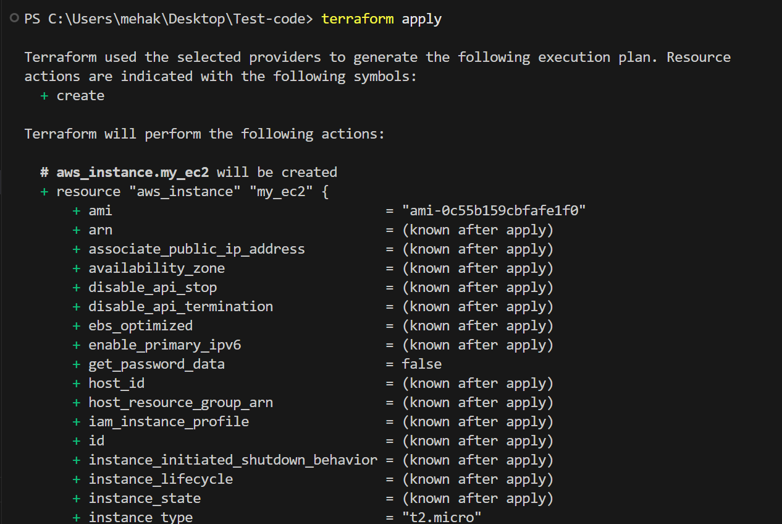

- In Enter a value, type “yes”
- Check the output

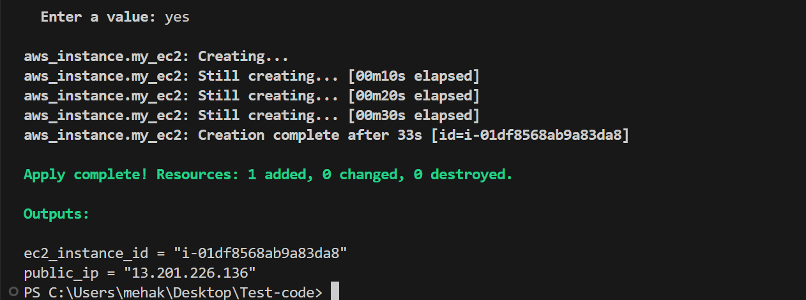

Step 8: Verify the EC2 Instance

- Go to your AWS Console → EC2 → Instances
- Check that the instance named MyTestEC2 is running.

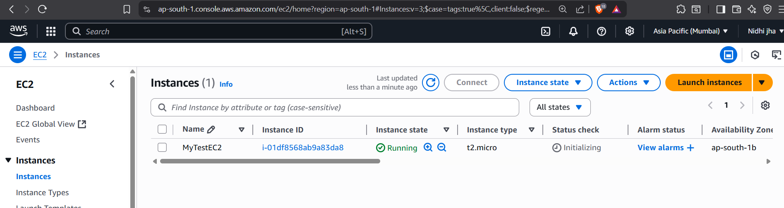

Step 9: Check Output Values

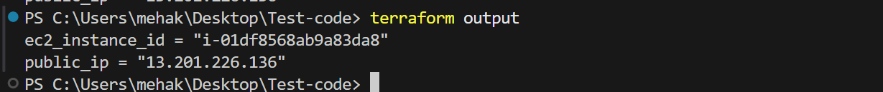

Step 10: Destroy Resources (Clean-Up)

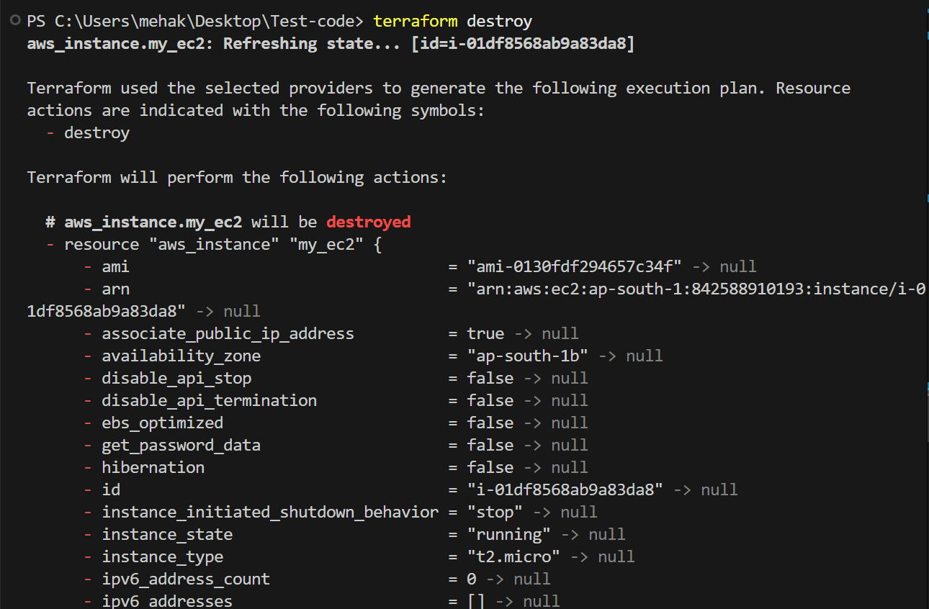

- Enter “yes”

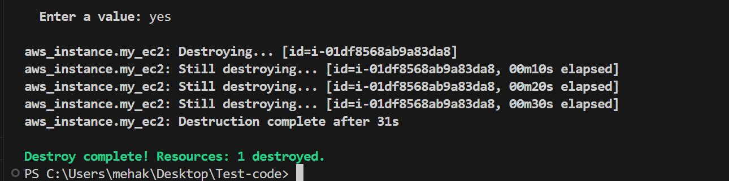

- Check EC2 instances.
- The instance is successfully terminated.

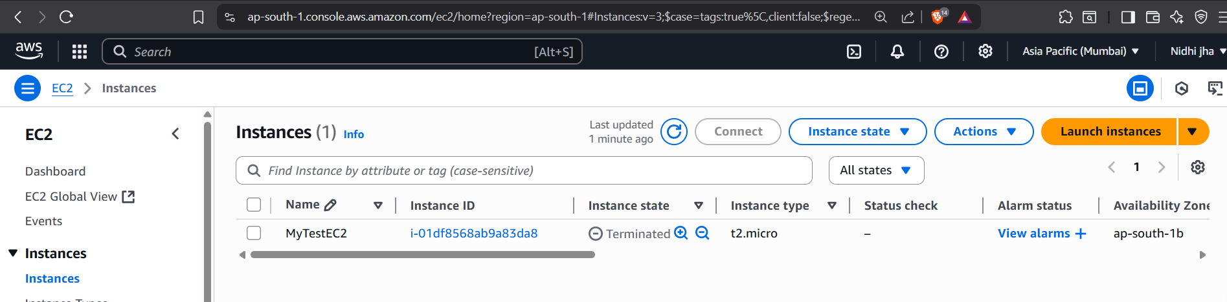

Conclusion

By following this guide, you’ve learned how to test Terraform infrastructure code end-to-end from writing configuration files to provisioning and destroying AWS resources. You also performed best practices like:

- Validating code syntax and logic
- Formatting code for readability
- Previewing changes with plan
- Managing resources using apply and destroy

