Configure Services and Ingress

Problem Statement:

Expose the deployed application to be reachable inside and outside the cluster. This lab covers creating a Kubernetes Service for internal/external access and setting up an Ingress resource to route external HTTP requests to your service.

Tools/Software Versions:

1. Running Kubernetes cluster with an app deployment (from Lab 2).

2. Minikube Ingress addon (using NGINX Ingress controller) enabled.

3. kubectl and an editor to create YAML manifests for the Ingress.

Hands-on Steps:

1. Expose the Deployment with a Service:

i) Create a Service to allow network access to the Pods.

For example, run kubectl expose deployment nginx-deploy --type=ClusterIP --port=80.

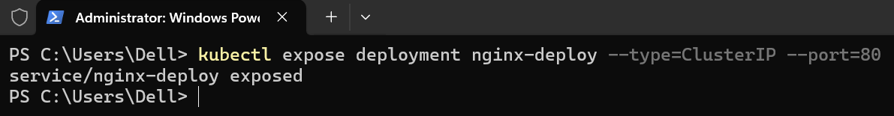

This defines a Service named nginx-deploy (same as deployment) that routes traffic on port 80 to the Pods’ container port 80.

ii) Verify the Service by running kubectl get services.

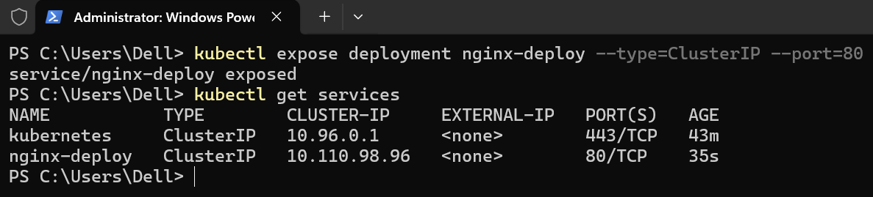

You should see nginx-deploy with a ClusterIP and port 80 listed.

Note: The ClusterIP is an internal virtual IP – reachable within the cluster.

2. Enable the Ingress Controller in Minikube:

i) Activate Minikube’s NGINX Ingress controller by running minikube addons enable ingress.

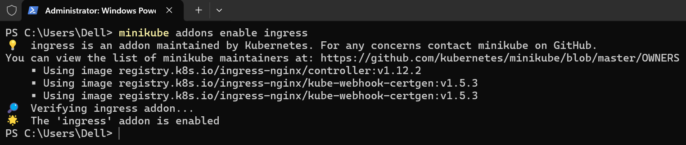

This will install an NGINX Ingress Controller Pod into your cluster (in the ingress-nginx namespace).

ii) Wait a minute and check kubectl get pods -n ingress-nginx to see that the ingress controller Pod is running.

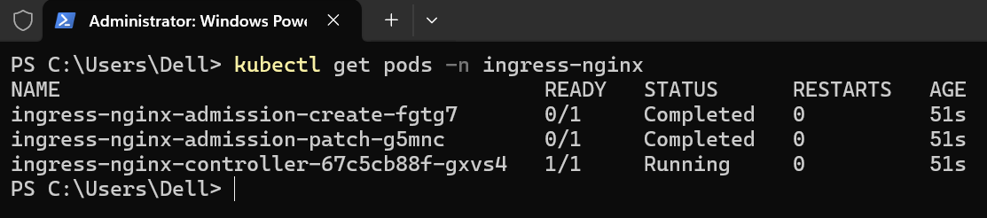

Minikube’s ingress addon will handle Ingress resources you create.

3. Create an Ingress Resource for the App:

i) Write a YAML manifest for an Ingress that routes an HTTP host to your service. For example, create a file ingress.yaml with the following content:

apiVersion: networking.k8s.io/v1
kind: Ingress
metadata:
name: example-ingress
spec:
ingressClassName: nginx
rules:
- host: demo.local
http:
paths:
- path: /
pathType: Prefix
backend:
service:
name: nginx-deploy
port:
number: 80

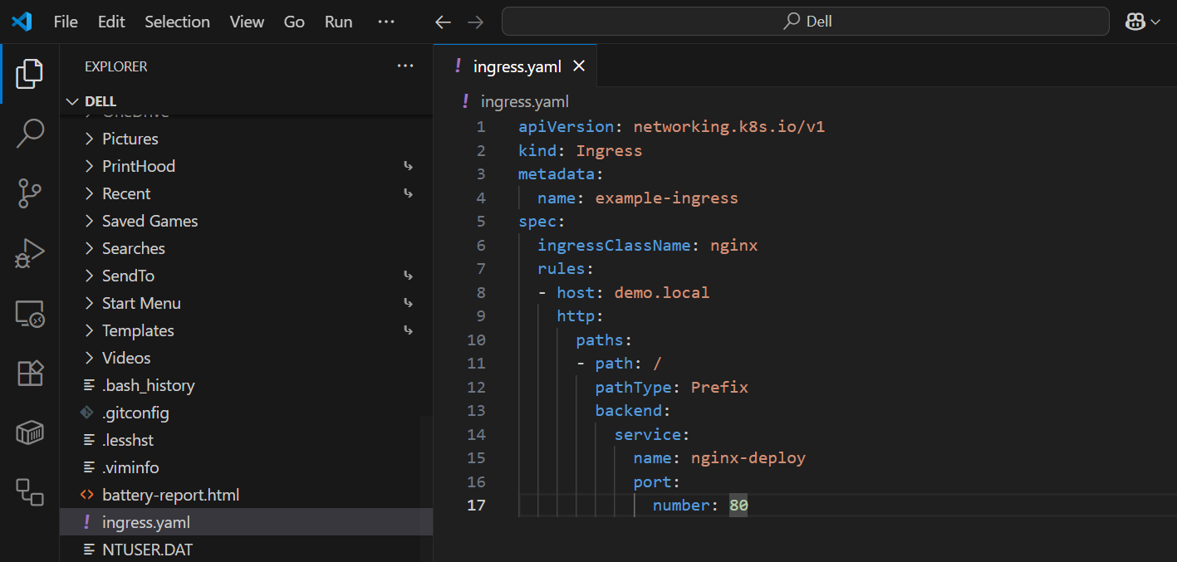

ii) Apply the ingress manifest with kubectl apply -f ingress.yaml.

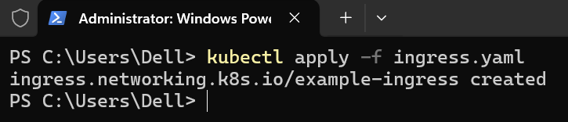

This creates an Ingress object that tells the controller to route requests for http://demo.local/ to the nginx-deploy service on port 80.

4. Test External Access via Ingress:

i) Determine Minikube’s IP by running minikube ip.

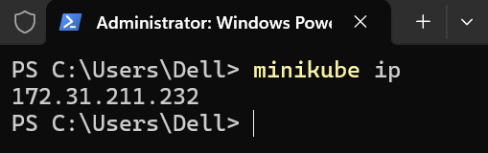

ii) Add an entry to your Windows hosts file (C:\Windows\System32\drivers\etc\hosts) mapping demo.local to that Minikube IP (172.31.211.232 demo.local).

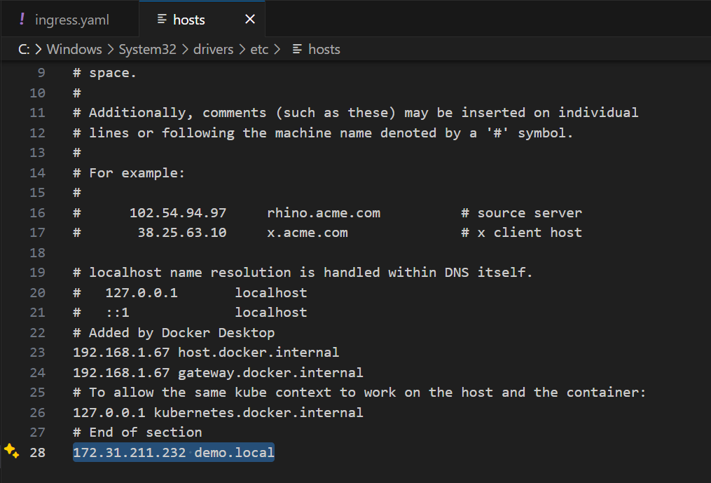

This makes your machine recognize demo.local for the Minikube cluster.

iii) Flush the DNS cache so the change takes effect immediately:

ipconfig /flushdns

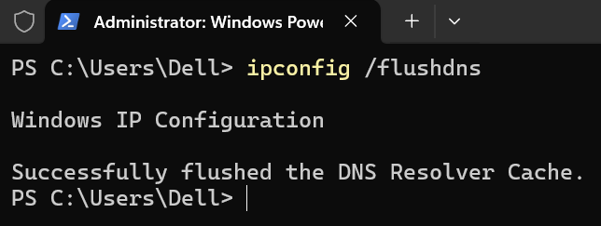

iv) Run minikube tunnel in a separate PowerShell as Administrator.

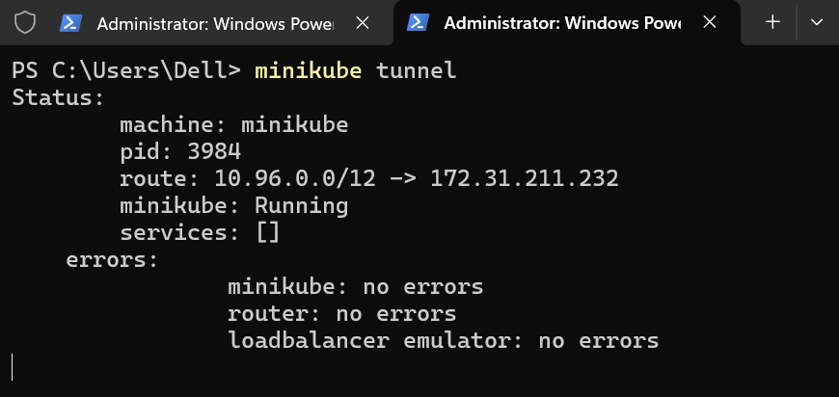

This command will route traffic from your host into the Minikube cluster for LoadBalancer/Ingress resources.

Note: You might be prompted for Windows firewall or admin access.

v) Now open a browser to http://demo.local.

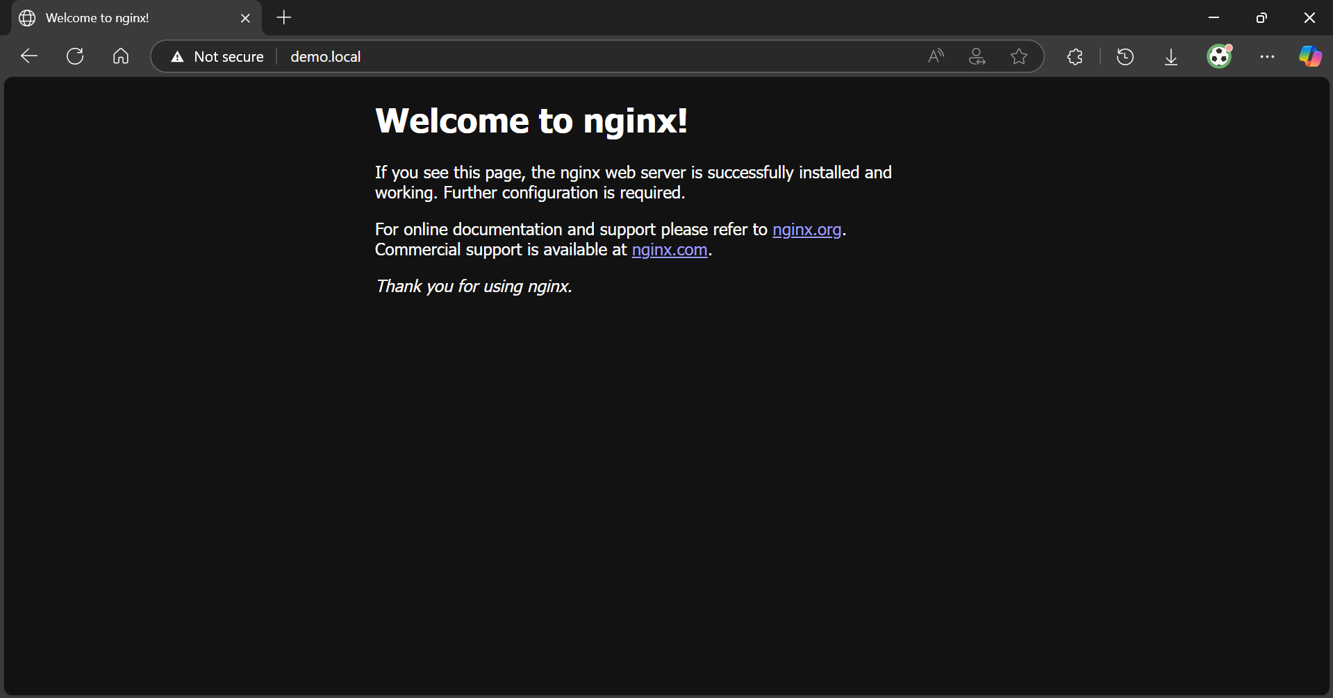

You should see the Nginx welcome page served via the Ingress!

The Ingress controller received your request and forwarded it to the service, which reached the Pod.

Topics Covered:

1. Created a Service to expose our application internally (ClusterIP) and saw how services provide stable networking for Pods.

2. Enabled an Ingress controller in Minikube and configured an Ingress resource to route external HTTP traffic to our service, using host-based routing rules.

3. Successfully accessed the Kubernetes-hosted application via a friendly URL, demonstrating how Ingress provides a single entry point to cluster services.

