Container Orchestration with Kubernetes – Prerequisites

Prepare your Windows environment with the necessary tools and configuration to run a local Kubernetes cluster for the upcoming labs. This involves installing Kubernetes tools and ensuring virtualization is enabled.

Tools/Software Versions:

1. Operating System: Windows 10/11 (64-bit) with virtualization enabled:
- Windows 10/11 Pro or Enterprise: Hyper-V
- Windows 10/11 Home: VirtualBox
2. Container Runtime: Docker Desktop (Kubernetes feature in Docker Desktop should remain disabled since Minikube will manage its own cluster).
3. Kubernetes CLI: kubectl (installed and on your PATH).
4. Kubernetes Cluster Tool: Minikube (for running a single-node cluster locally).

Installation Steps:

1. Install Docker Desktop:

Note: Docker Desktop is assumed to be installed already from previous modules, so you can skip its installation. Ensure it is running if you intend to use it as the Minikube driver, but do not enable Docker Desktop’s built-in Kubernetes (Minikube will provide its own cluster).

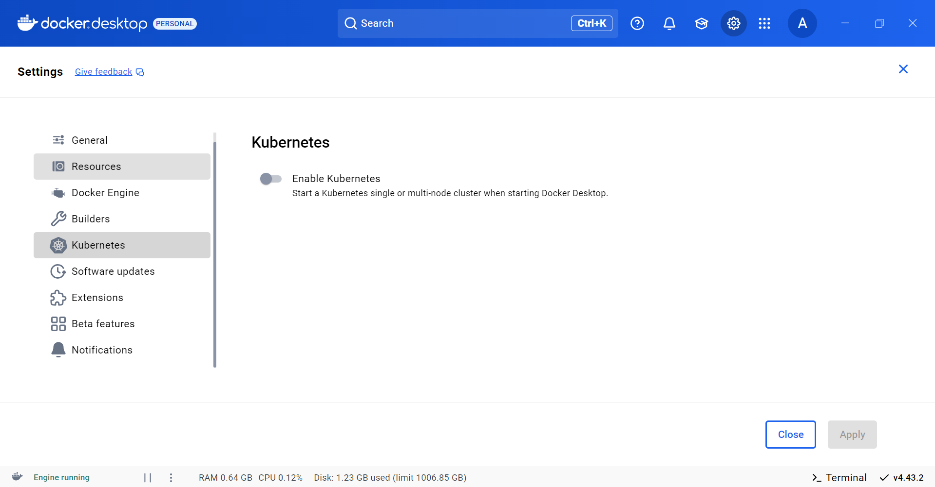

2. Enable Virtualization:

For Windows 10 Pro/Enterprise (Hyper-V):

Open Turn Windows features on or off.

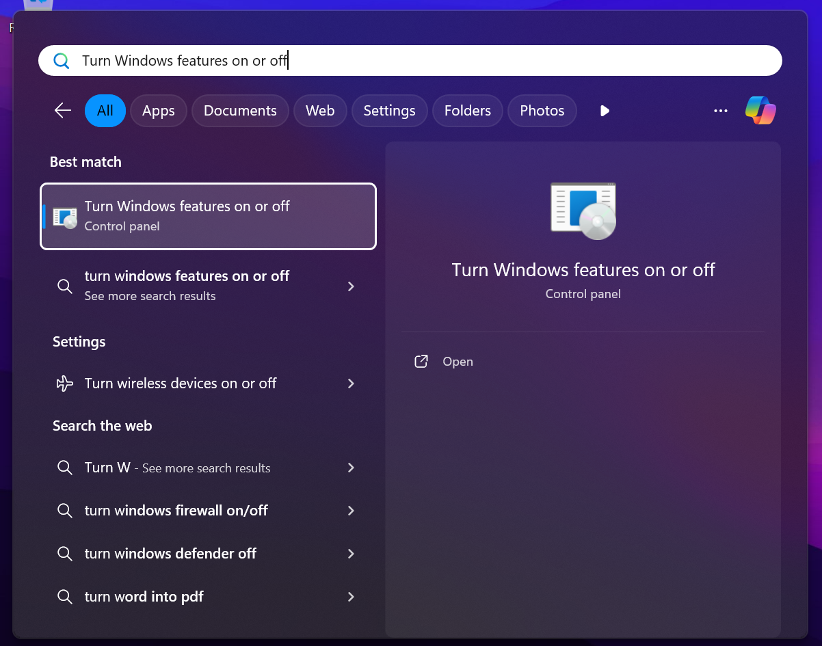

Check Hyper-V and OK.

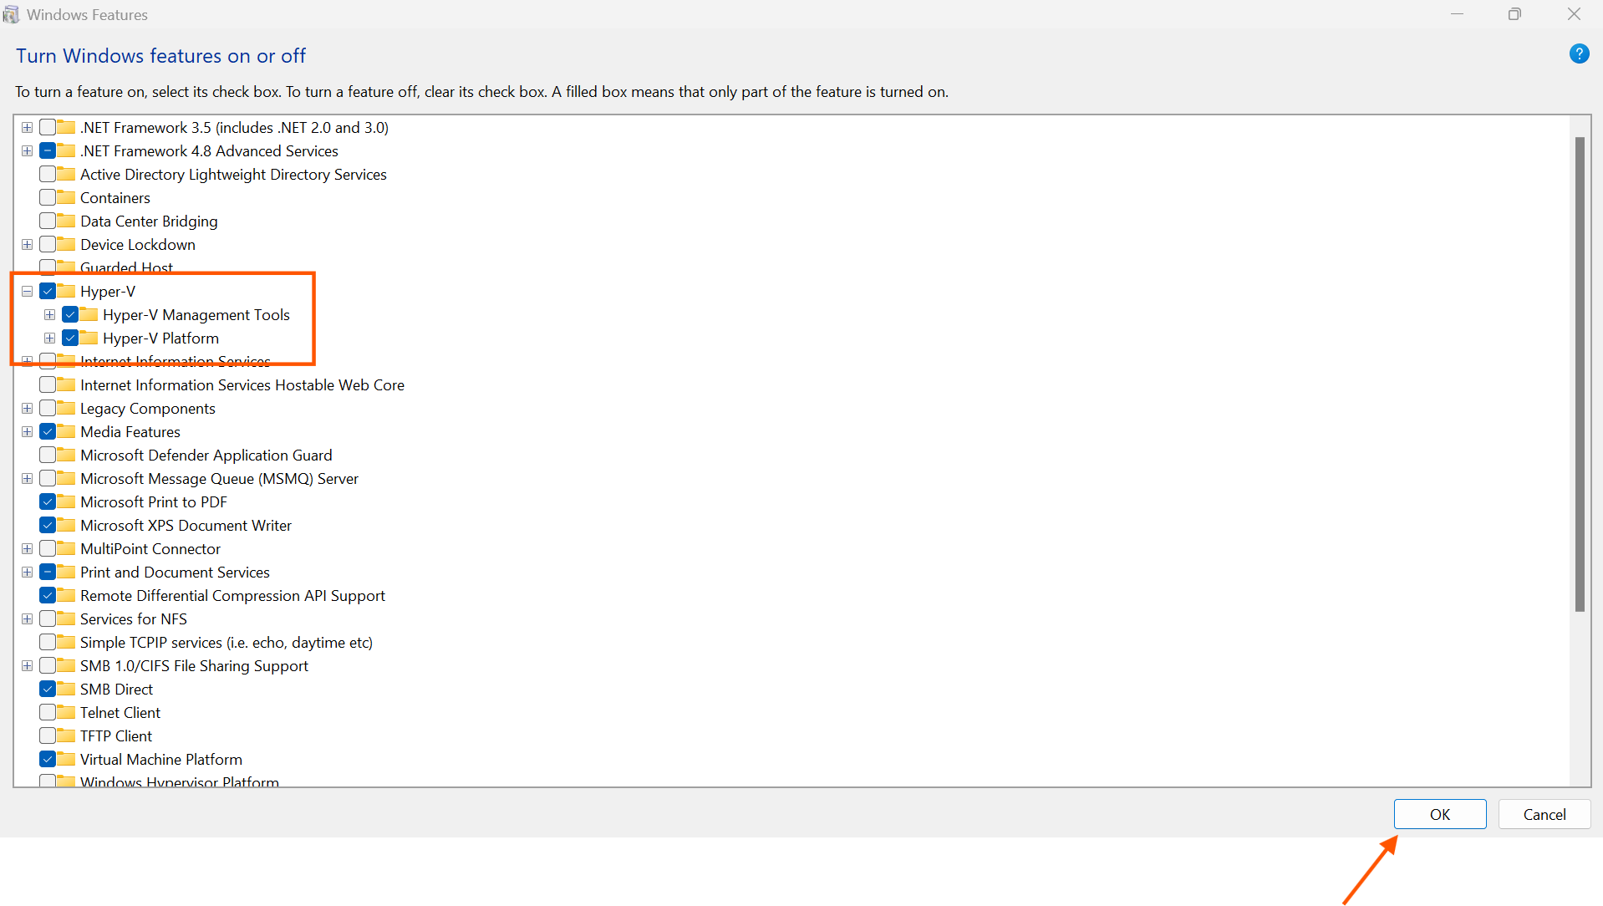

Reboot if prompted.

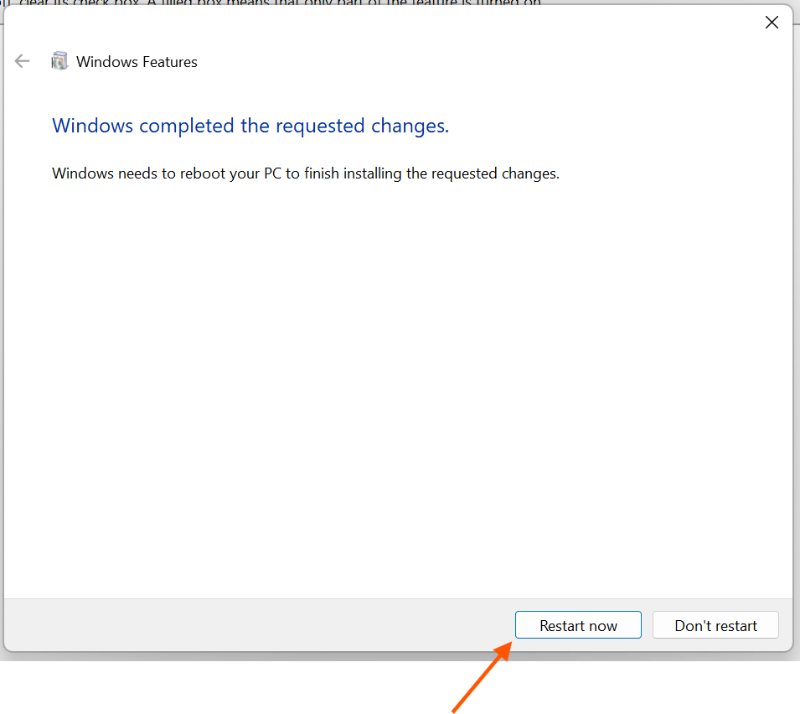

In PowerShell, verify the Hyper-V management service:

Get-Service vmms

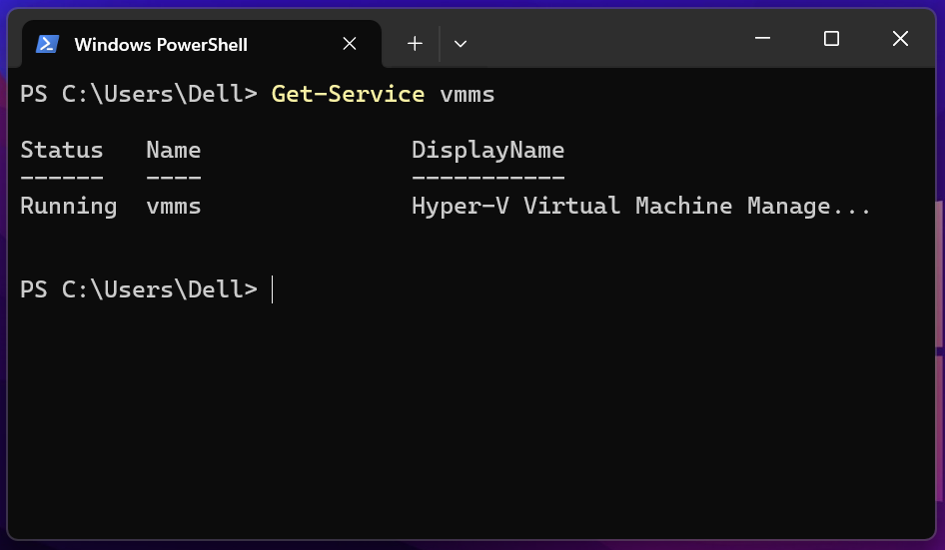

It should be running.

For Windows 10 Home:

Install VirtualBox to serve as the virtualization backend.

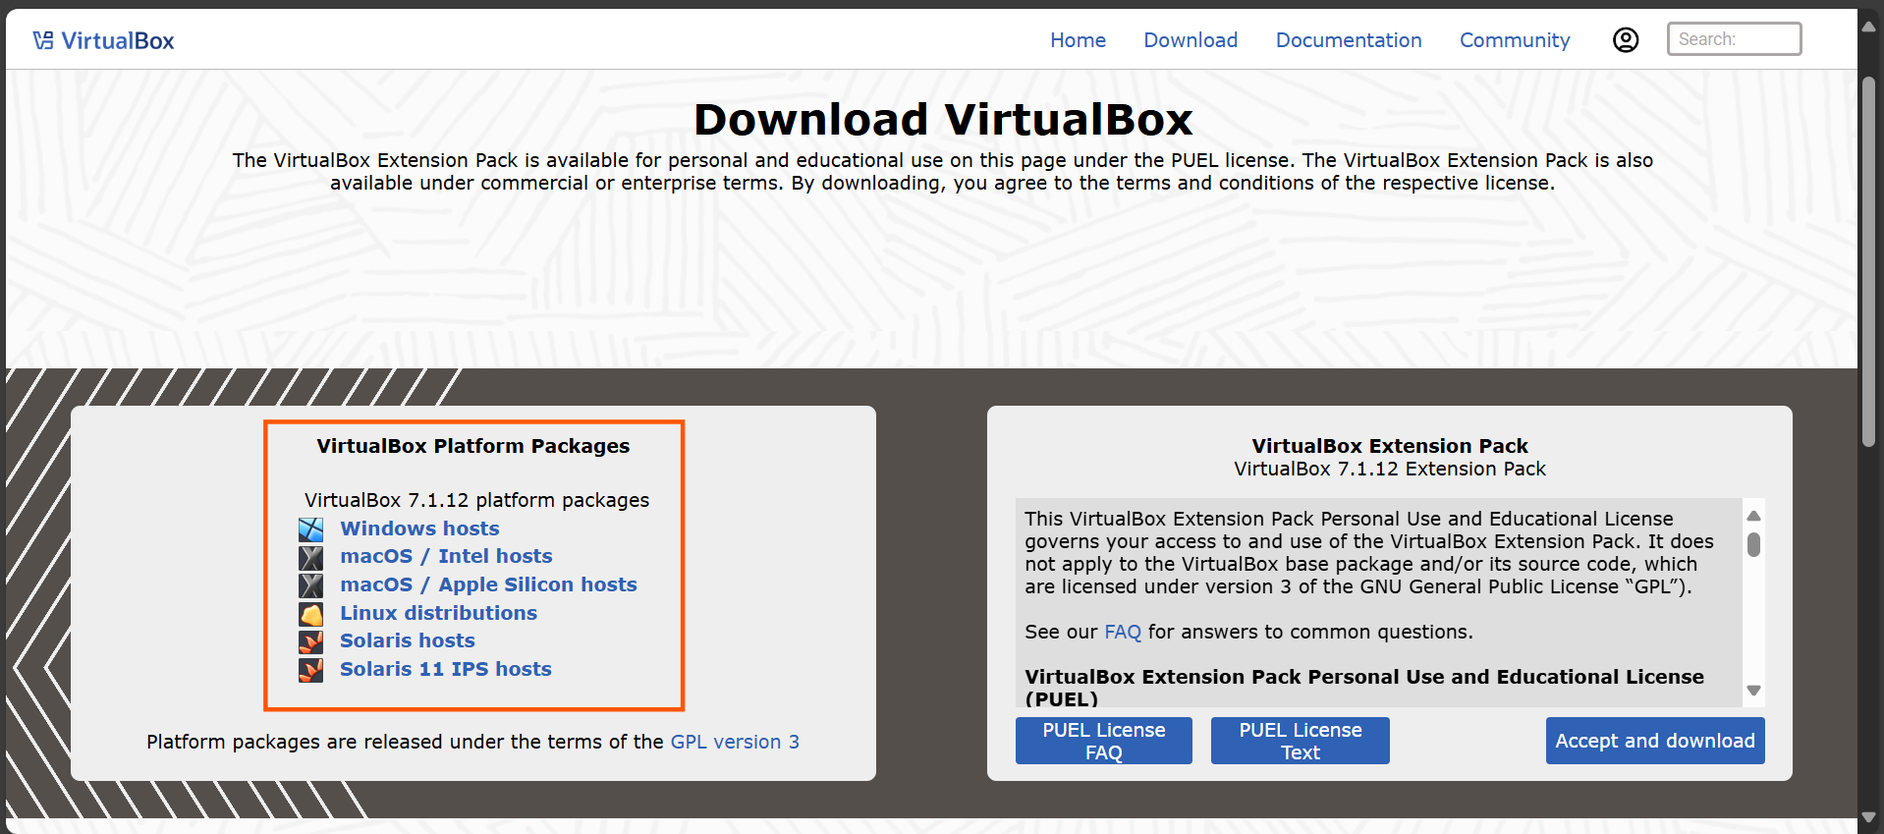

3. Install Minikube:

You can install via Chocolatey or manually:

With Chocolatey:

choco install minikube

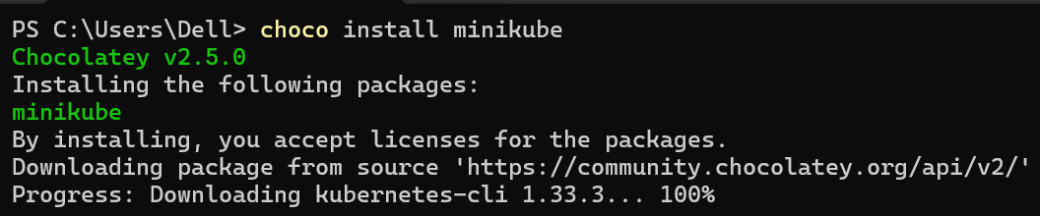

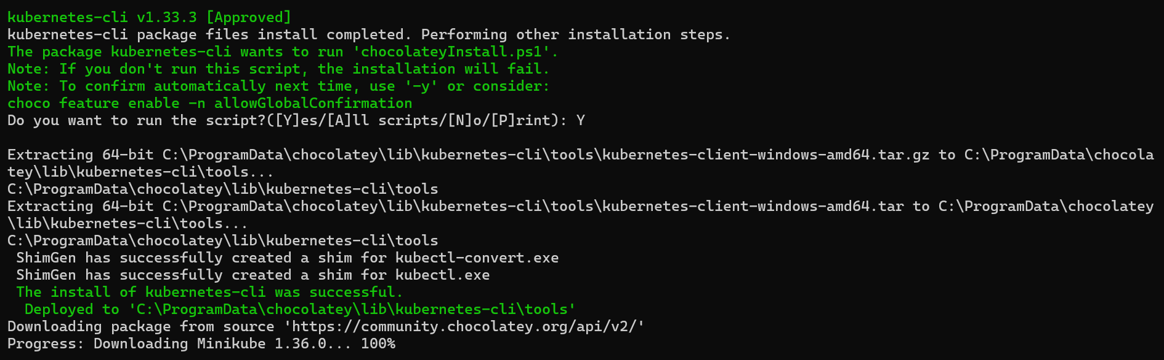

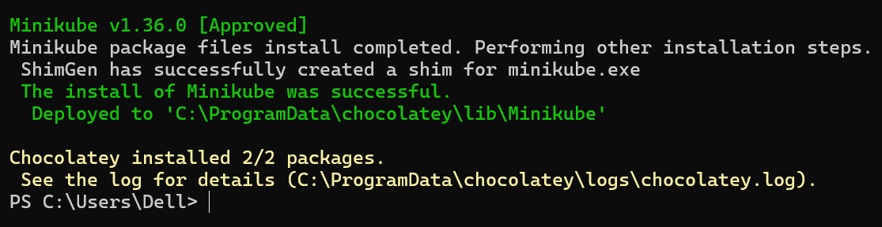

Manually:

Download the Windows installer for Minikube and follow the installer prompts.

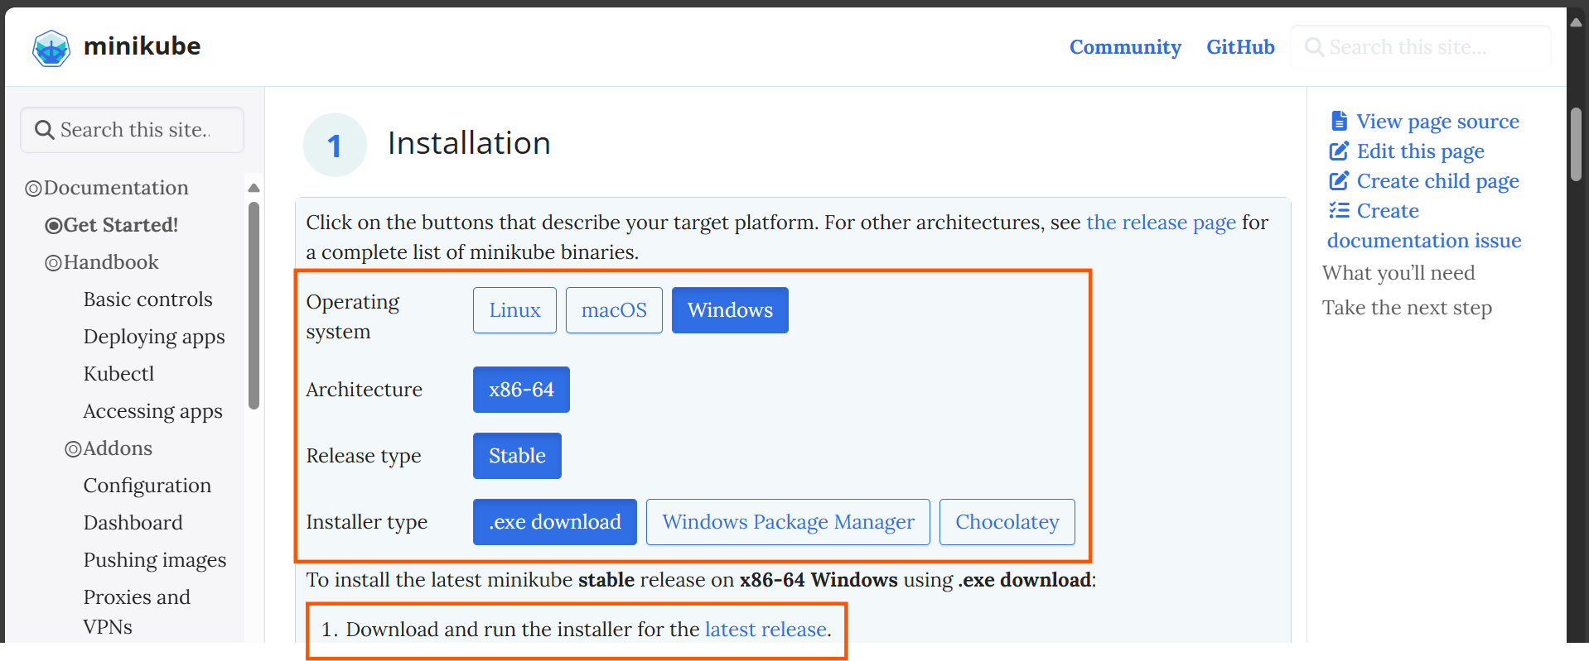

4. Install kubectl:

With Chocolatey:

i) Enter the following command on your PowerShell terminal:

choco install kubernetes-cli

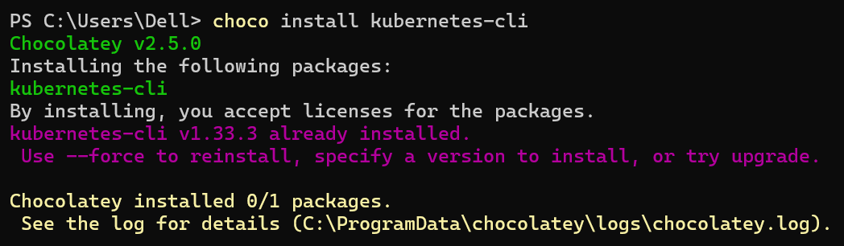

Manually:

Download the kubectl binary, place it in a directory on your PATH, and optionally rename it to kubectl.exe.

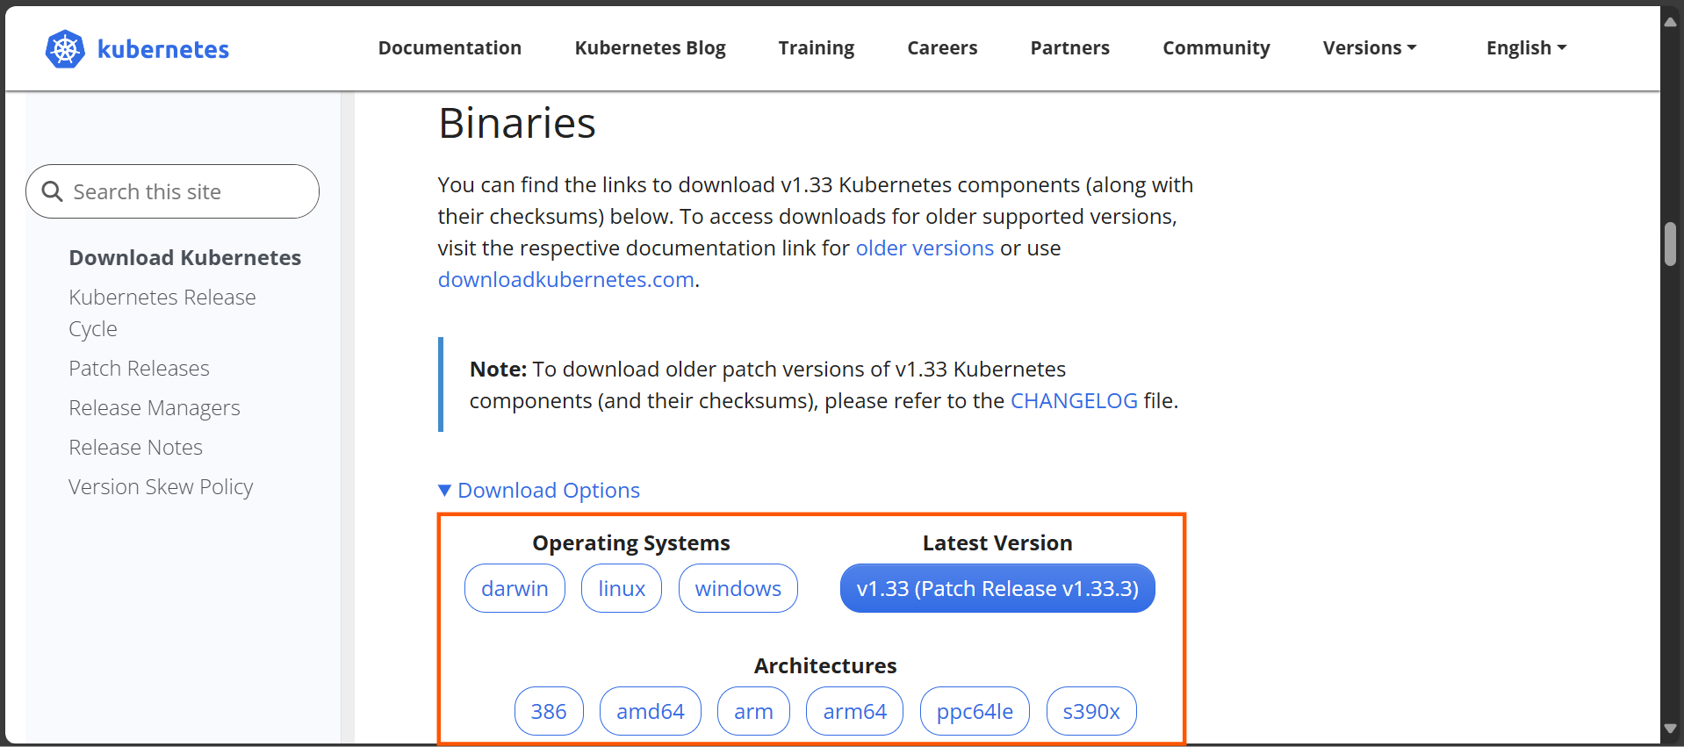

5. Verify installation:

Open PowerShell or Windows Terminal and run:

minikube version

kubectl version --client

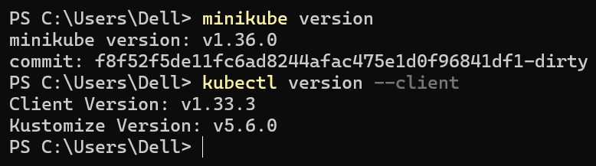

Both should report the expected versions (v1.36.0 and v1.33.3).

6. Points to Consider:

i) If you intend to use Docker as the Minikube driver, Docker Desktop must be running; Minikube will detect it, but keep Docker Desktop’s own Kubernetes disabled.

ii) If you run into driver errors, you can explicitly specify the driver when starting Minikube, like:

minikube start --driver=hyperv

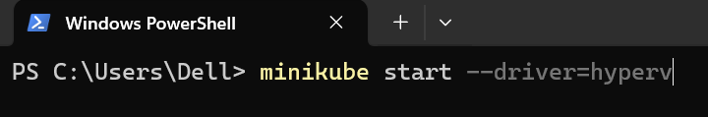

Topics Covered:

1. Prepared a Windows 10/11 environment for Kubernetes by installing Minikube (local K8s cluster tool) and kubectl (CLI).

2. Verified that virtualization (Hyper-V or an alternative) is available for Minikube to run a single-node Kubernetes cluster.

3. Ensured all tools are correctly installed and accessible, laying the groundwork for building and managing a Kubernetes cluster in subsequent labs.

