Deploy Applications to Kubernetes

Problem Statement:

Deploy a containerized application to the Kubernetes cluster. In this lab, we create a Deployment (which manages Pods) and ensure the application’s Pod is running in our Minikube cluster.

Tools/Software Versions:

1. Kubernetes cluster from Lab 1 (Minikube running, kubectl configured).
2. An example container image (e.g., nginx web server) from Docker Hub or a public registry.

Hands-on Steps:

Create a Deployment for the application:

1. Deploy an Example Application:

Use kubectl to deploy an example application. For instance, run kubectl create deployment nginx-deploy --image=nginx:latest.

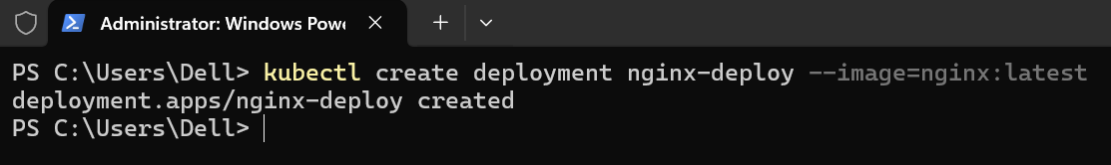

This command tells Kubernetes to create a Deployment named nginx-deploy using the Nginx container image.

2. Verify the Deployment:

You can verify the deployment by running kubectl get deployments.

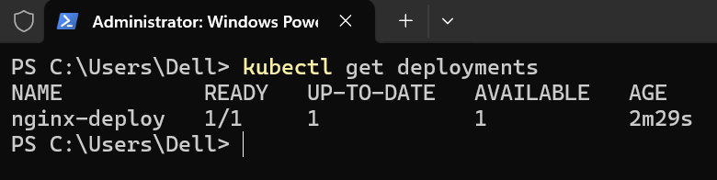

You should see nginx-deploy with 1 replica. It may take a few seconds for the container image to download and the Pod to start.

3. Check the Pod Status:

Run kubectl get pods to list Pods.

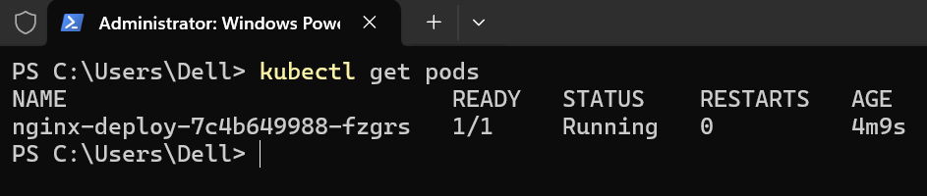

You should see a Pod named nginx-deploy-* (with a generated suffix) in Running status.

Note: If the Pod’s STATUS is not Running or maybe something like ContainerCreating, wait a moment and check again. Once it’s Running, your application is deployed inside the cluster.

4. Access the Application:

Since we haven’t exposed a service yet, you can do a quick port-forward to test the app.

Run kubectl port-forward deployment/nginx-deploy 8080:80 to forward port 8080 on your host to port 80 of the Nginx Pod.

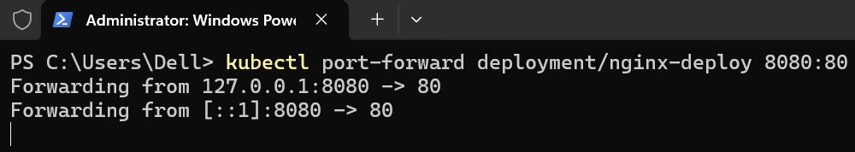

Open a browser to http://localhost:8080.

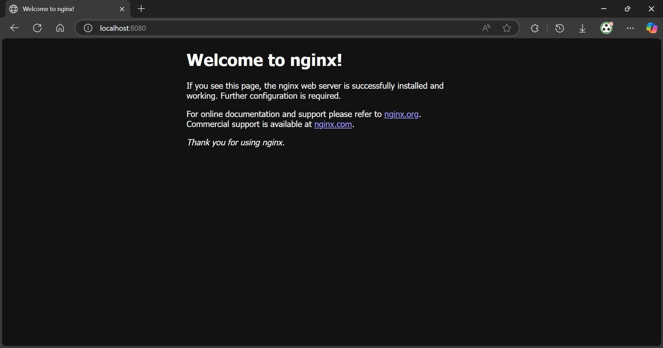

You should see the default Welcome to nginx! page, confirming the application in the Pod is serving requests.

Press Ctrl+C to stop the port-forwarding when done.

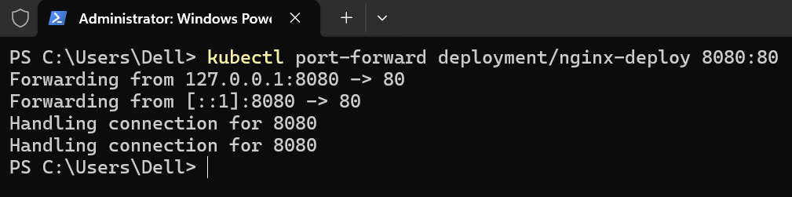

Topics Covered:

1. Deployed a containerized application to Kubernetes by creating a Deployment, which manages the lifecycle of Pods for that app.

2. Observed how to verify that the application’s Pod is running using kubectl get pods. We now have an application running within our Kubernetes cluster.

3. Learned a simple way to access a Pod’s application (using port-forward) before any Services or Ingress are configured.

