Implement Storage Solutions

Problem Statement:

Attach persistent storage to a Pod in Kubernetes. This lab demonstrates using a PersistentVolumeClaim (PVC) and mounting it into a Pod, so data can persist beyond the Pod’s lifecycle (useful for stateful applications).

Tools/Software Versions:

1. Kubernetes cluster (Minikube) with default storage class (Minikube’s hostPath provisioner).

2. kubectl and a text editor to create volume and pod manifests.

Hands-on Steps:

1. Create a PersistentVolumeClaim (PVC):

i) Define a claim for storage that the cluster can fulfill.

Define a claim for storage that the cluster can fulfill. Run:

@"
apiVersion: v1
kind: PersistentVolumeClaim
metadata:
name: demo-pvc
spec:
accessModes:
- ReadWriteOnce
resources:
requests:
storage: 100Mi
"@ | kubectl apply -f -

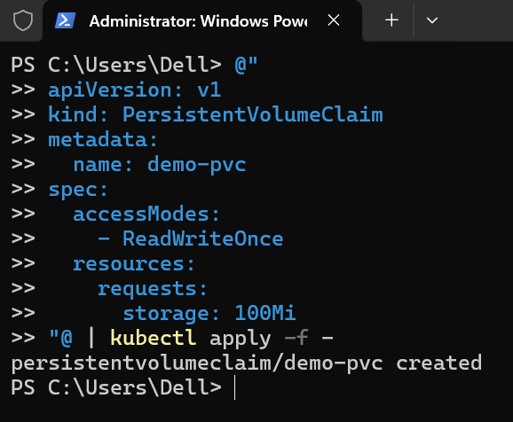

This creates a PVC named demo-pvc requesting 100Mi of storage with read-write access for one node. Kubernetes will automatically bind this claim to a hostPath PersistentVolume on the Minikube VM.

ii) Verify the PVC is bound by running kubectl get pvc.

The STATUS should show Bound, indicating the claim has been satisfied by a volume.

2. Use the PVC in a Pod:

i) Create a simple Pod that mounts this PVC as a volume. Save the following manifest as pod-pvc.yaml:

apiVersion: v1
kind: Pod
metadata:
name: pv-test-pod
spec:
volumes:
- name: data-storage
persistentVolumeClaim:
claimName: demo-pvc
containers:
- name: busybox
image: busybox
command: ["sh", "-c", "echo 'Hello from PVC' > /data/hello.txt && sleep 3600"]
volumeMounts:
- name: data-storage
mountPath: /data

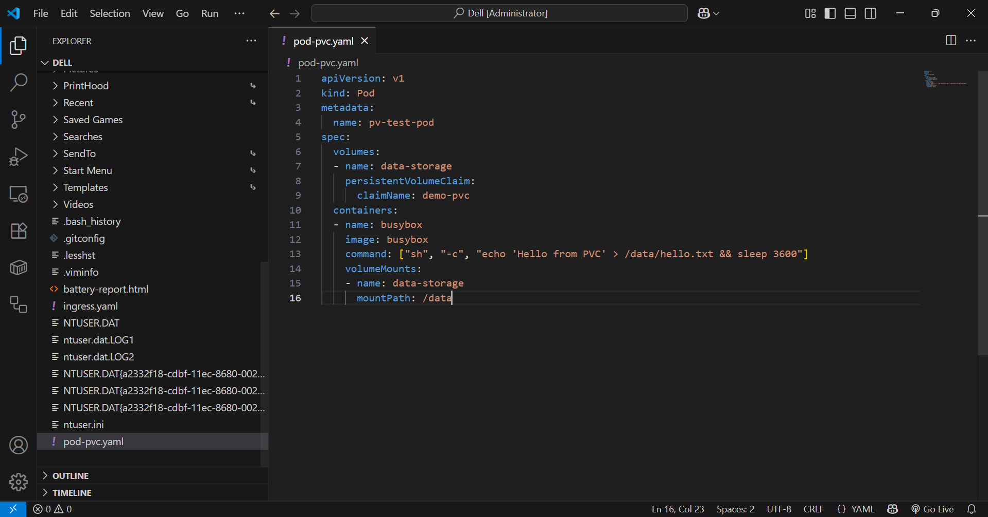

ii) Apply this pod spec with kubectl apply -f pod-pvc.yaml.

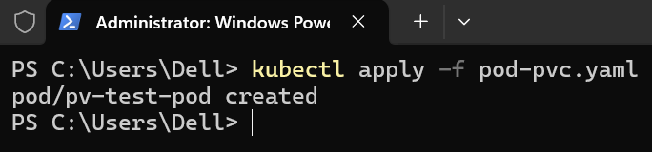

This will start a Pod that writes a file to the mounted volume and then sleeps (to keep the container running).

iii) Verify the Pod is running by running kubectl get pods pv-test-pod.

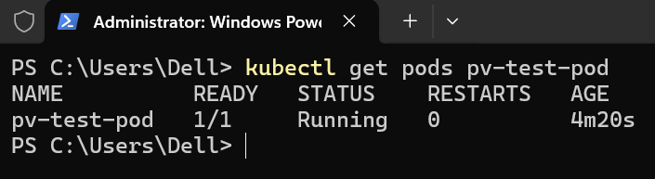

It should show STATUS Running.

iv) Now exec into the Pod to check the file by running kubectl exec pv-test-pod -- cat /data/hello.txt.

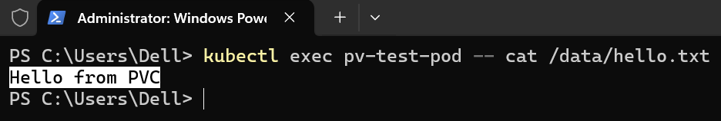

It should output Hello from PVC, confirming the file was written to the persistent volume.

3. Demonstrate Persistence:

i) Delete the Pod by running kubectl delete pod pv-test-pod.

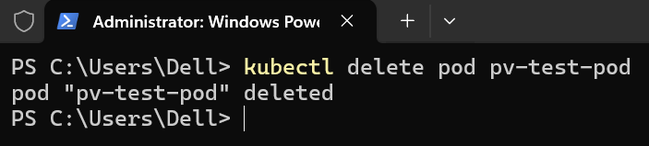

This simulates a pod failing or restarting.

ii) Re-create the pod and then exec into it by running kubectl exec pv-test-pod -- cat /data/hello.txt.

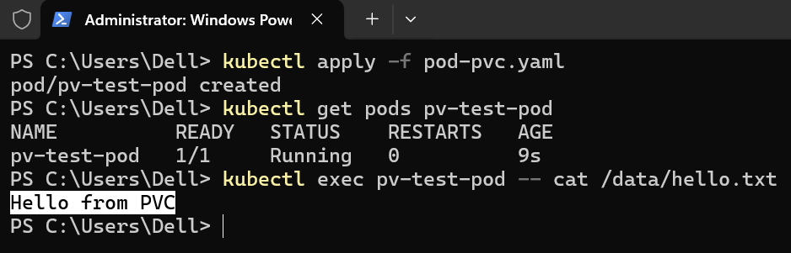

The result will say, Hello from PVC file is still present, showing that the data persisted on the volume even after the original Pod was gone. The PVC ensured the data was stored on the host and reattached to the new Pod.

Topics Covered:

1. Created a PersistentVolumeClaim to request durable storage. Minikube automatically provided a hostPath PersistentVolume for this claim.

2. Mounted the PVC into a Pod’s container, allowing the application to read/write data to a persistent location.

3. Verified that data written to the volume persists beyond the lifecycle of a single Pod – demonstrating how Kubernetes storage abstractions enable stateful workloads.

