Scale Applications Manually and Automatically

Problem Statement:

Increase and decrease the number of application instances (pods) in Kubernetes, both manually and with an autoscaler. This lab covers scaling a Deployment to handle more load and setting up a Horizontal Pod Autoscaler (HPA) to scale based on CPU usage.

Tools/Software Versions:

1. Kubernetes cluster (Minikube) with the metrics server addon enabled (for HPA).

2. An existing Deployment (e.g., nginx-deploy from Lab 2) to scale.

3. kubectl v1.33.3.

Hands-on Steps:

1. Manually scale the Deployment:

Suppose our nginx-deploy Deployment is currently running 1 replica.

i) To handle more traffic, scale it to 3 replicas by running kubectl scale deployment nginx-deploy --replicas=3.

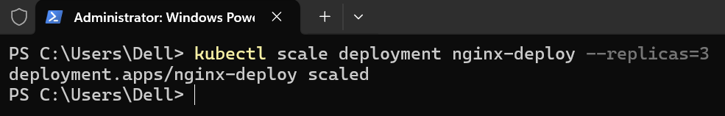

This tells Kubernetes to have 3 Pods for that deployment.

ii) Verify the change with kubectl get pods.

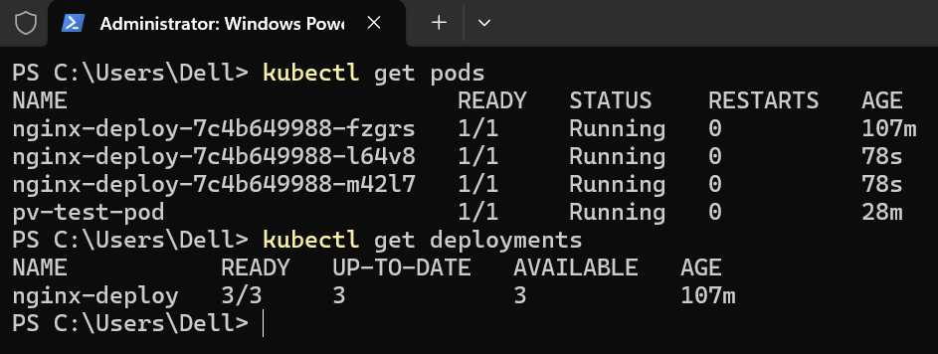

You should now see three nginx-deploy Pods. All pods will have the same template (running Nginx) and will be managed by the Deployment.

2. Enable Metrics Server for Autoscaling:

Minikube provides the Metrics Server (which HPA uses for CPU/memory metrics) as an addon.

i) Enable it by running minikube addons enable metrics-server.

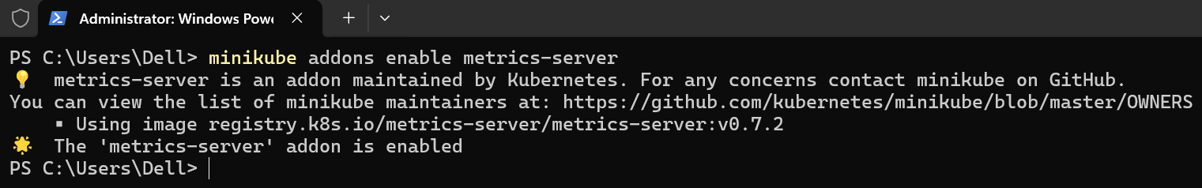

ii) Confirm it’s working by running kubectl top pods after a minute.

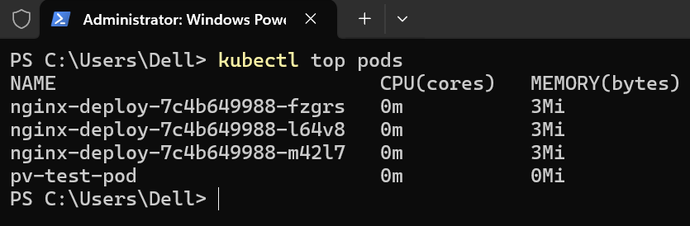

If your Pods are running, this command will display their CPU and memory usage.

3. Set up Horizontal Pod Autoscaler (HPA):

i) Create an HPA for nginx-deploy by running:

kubectl autoscale deployment nginx-deploy --min=2 --max=5 --cpu-percent=50

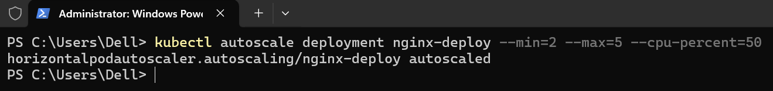

This command creates a HorizontalPodAutoscaler object that will monitor the nginx-deploy Deployment, ensuring at least 2 Pods and up to 5 Pods, aiming to keep average CPU usage at 50%.

ii) Verify the HPA is created with kubectl get hpa.

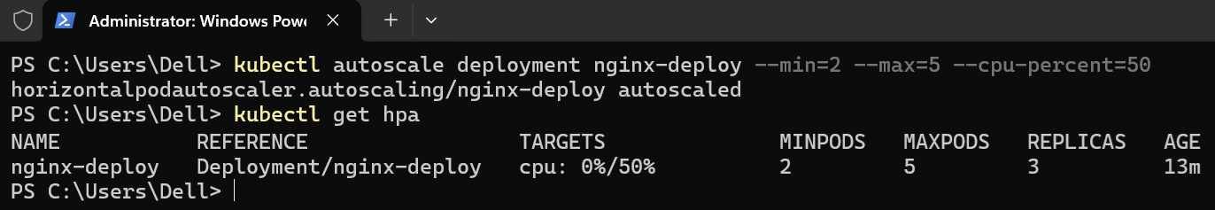

You should see an entry for nginx-deploy with CPU target 50% and current replicas.

Initially, TARGET may show 0%/50% if there’s no load (0% current CPU of 50% target), and REPLICAS will reflect the current pod count.

4. Simulate Load to Trigger Autoscaling:

To see the HPA in action, you can simulate CPU load on the Nginx pods. If CPU usage exceeds 50%, the HPA will gradually scale up the Deployment (adding pods).

For example, if you put enough load, you might observe REPLICAS increase. Use kubectl get hpa -w to watch it live.

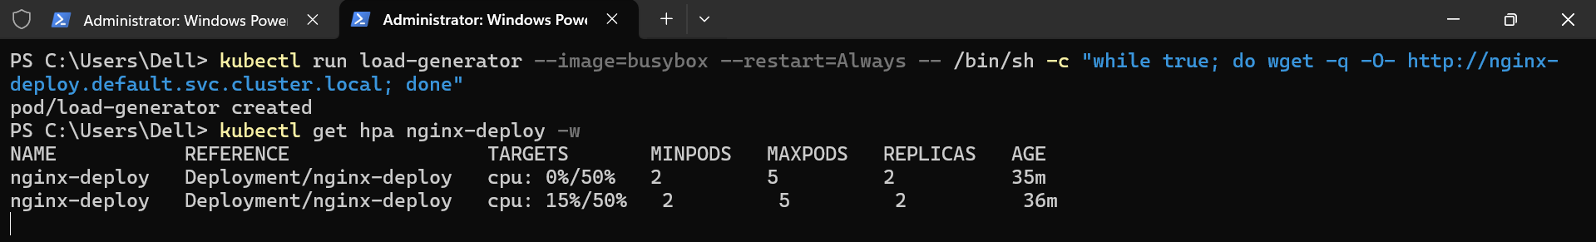

Once the load drops, after a stabilization period, HPA will scale the pods back down.

Topics Covered:

1. Manually scaled a Deployment using kubectl scale, allowing us to quickly adjust the number of pod replicas to meet demand.

2. Enabled the Metrics Server and configured a Horizontal Pod Autoscaler (HPA), which automatically monitors and adjusts pod replicas based on CPU usage thresholds.

3. Understood the difference between manual scaling and autoscaling: manual scaling is controlled by the operator, whereas HPA will dynamically scale the application up or down in response to real-time metrics, helping applications maintain performance and optimize resource usage.

