Set Up a Kubernetes Cluster

Problem Statement:

Initialize a single-node Kubernetes cluster on your local machine using Minikube. This lab will start the cluster and verify that Kubernetes is up and running on Windows 10/11.

Tools/Software Versions:

1. Windows 10/11 with Hyper-V or Docker runtime (from Prerequisites).
2. Minikube v1.36.0, kubectl v1.33.3.

Hands-on Steps:

1. Start the Minikube cluster:

i) Open PowerShell (as an Administrator) and run minikube start to launch a local Kubernetes cluster.

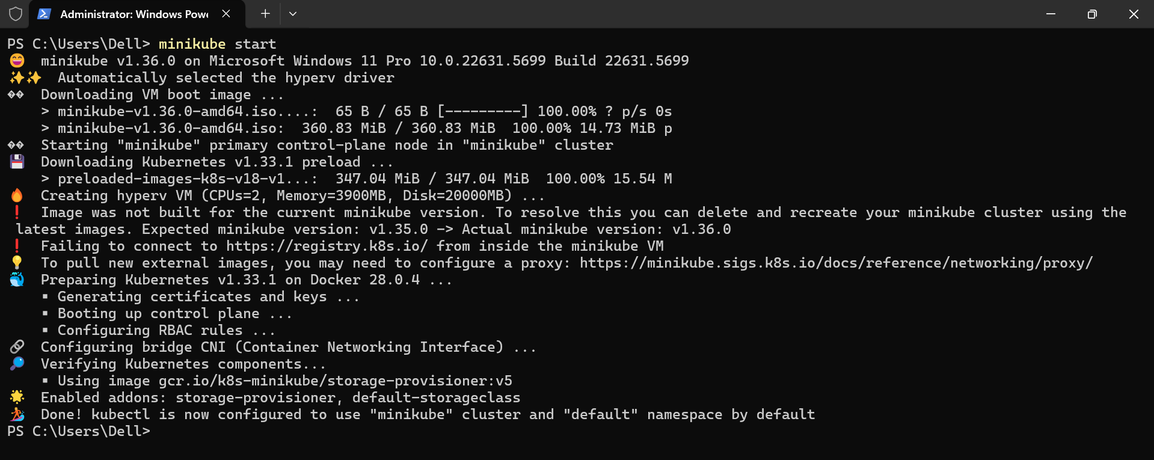

Minikube will automatically create a virtual machine or use Docker to run the Kubernetes control plane and worker node.

ii) Wait for the command to complete. You should see Minikube provisioning Kubernetes components, and a Done! kubectl is now configured to use "minikube" cluster and "default" namespace by default message upon success.

2. Verify the cluster status:

i) Run kubectl get nodes to list the nodes in the cluster.

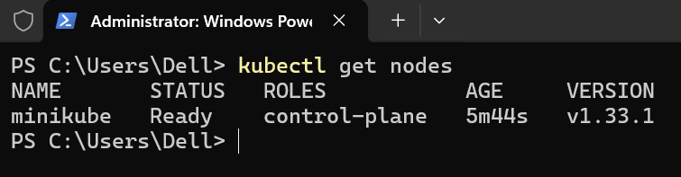

You should see a single node with the status Ready, indicating the node is up.

ii) Run kubectl cluster-info to view the cluster master and services addresses, confirming the Kubernetes API server is accessible.

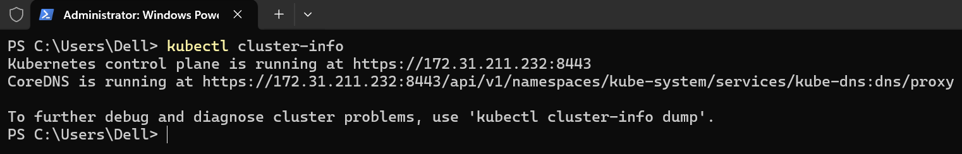

3. Launch the Kubernetes dashboard:

i) Run minikube dashboard --url.

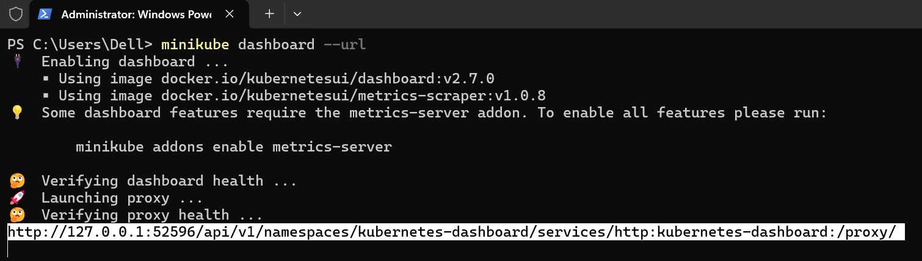

This enables the Kubernetes Dashboard UI and returns a local URL.

ii) Open the URL in your browser to see a graphical overview of the cluster.

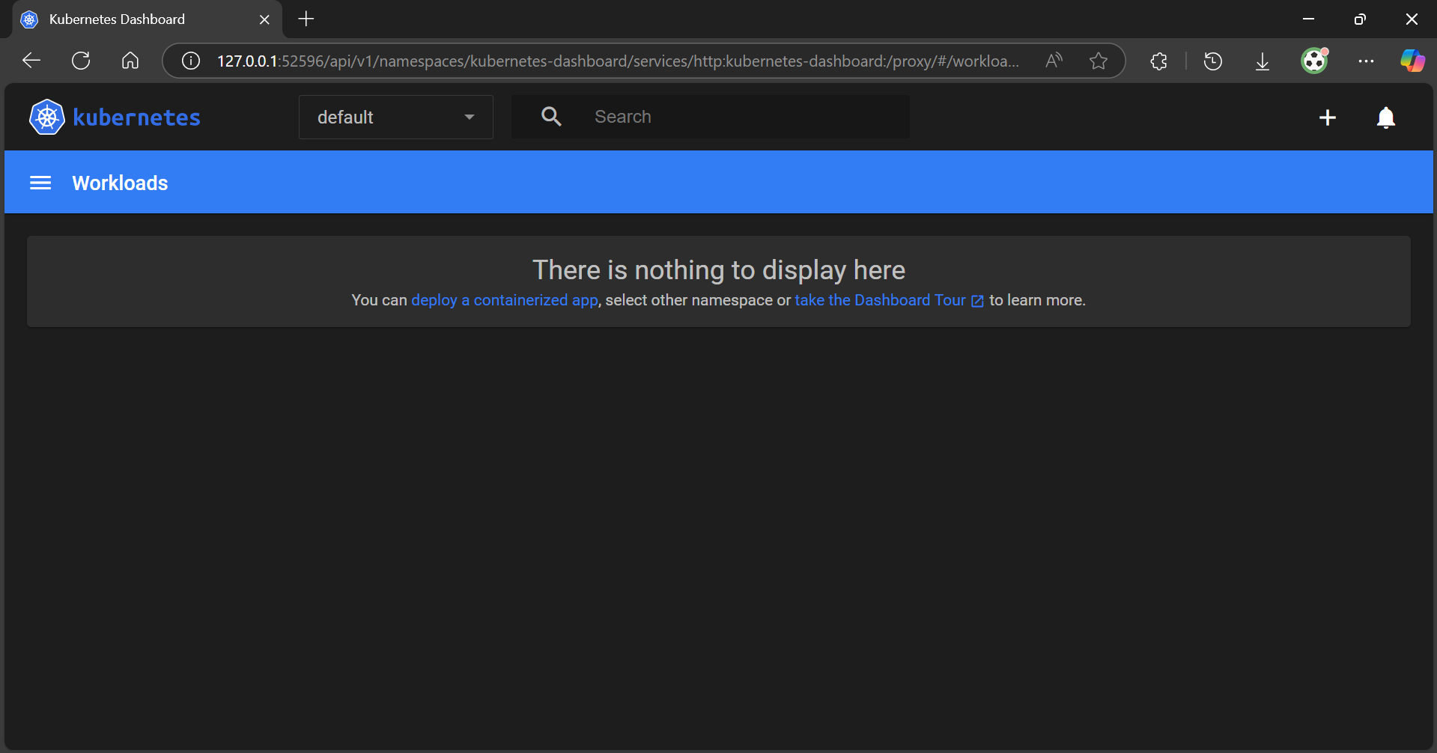

Topics Covered:

1. Used Minikube to quickly set up a single-node Kubernetes cluster locally on Windows 10/11.

2. Verified the cluster is running by checking that the Minikube node is in a Ready state and that Kubernetes commands (kubectl) can communicate with the cluster.

3. Accessed the Kubernetes Dashboard, which confirms our cluster is operational and provides a UI to view resources.

