LAB – 4

Captured accelerometer (x,y,z) values for mainly three gestures. One is right to left, left to right, top to bottom. (As these gestures are related to our project ).

So I generated three sensor.txt files.

Then I generated a combination file.

Kept all these into cloudera using winscp.

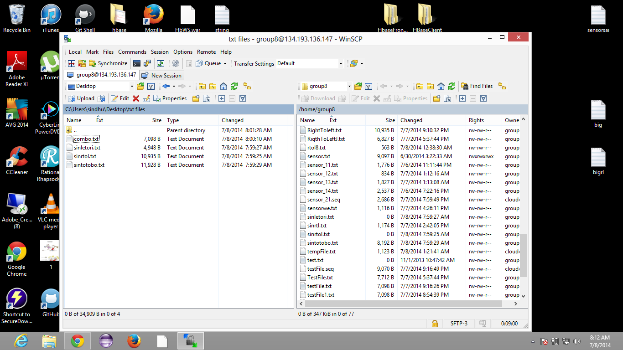

First we generate sequence file for training:

Top to down:

Input: home/group8/sintd.txt

Output: home/group8/sintd.seq

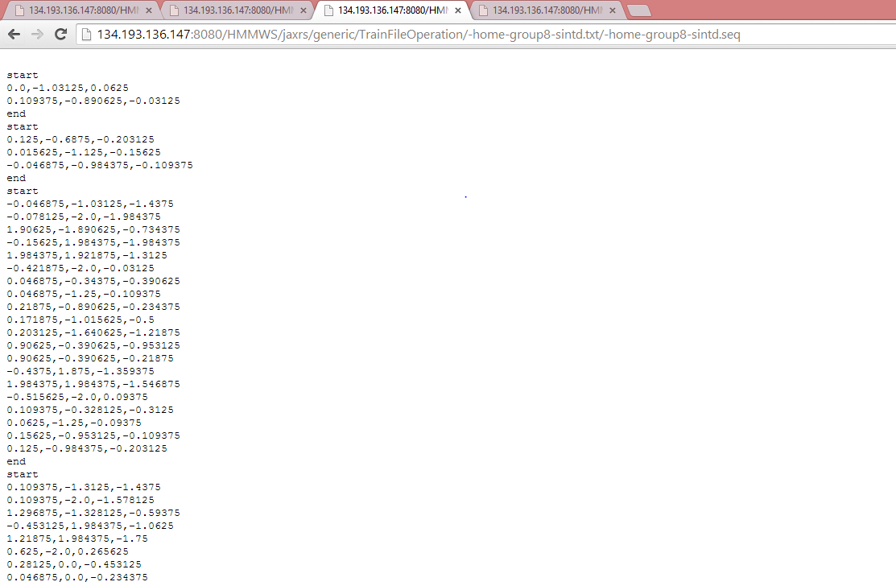

This is right to left

Input: home/group8/sinrl.txt

Output: home/group8/sinrl.seq

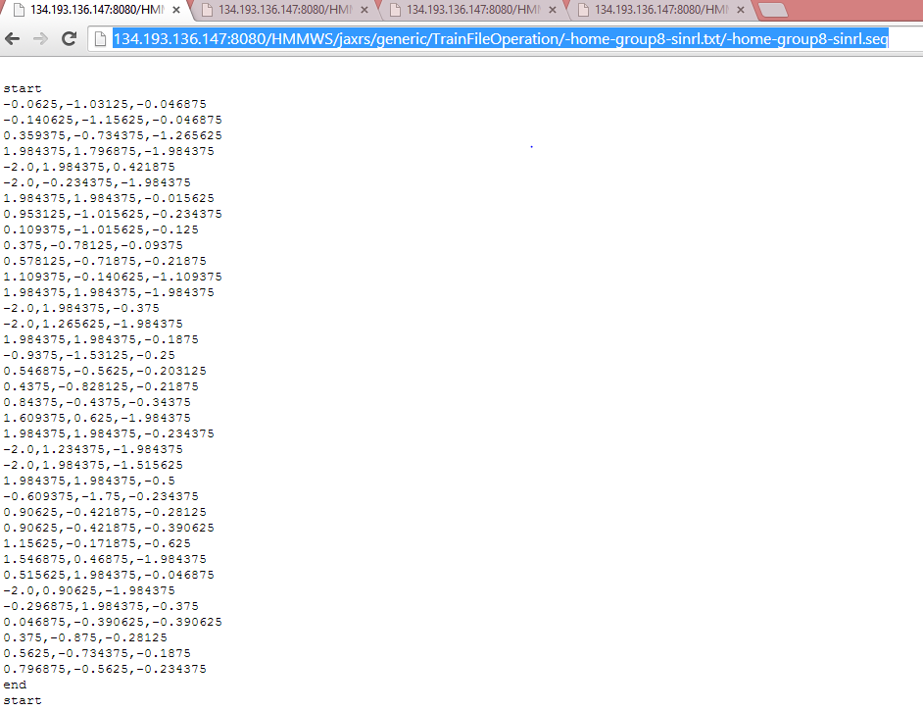

And now it is left to right

Input :home/group8/sinlr.txt

Output :home/group8/sinlr.seq

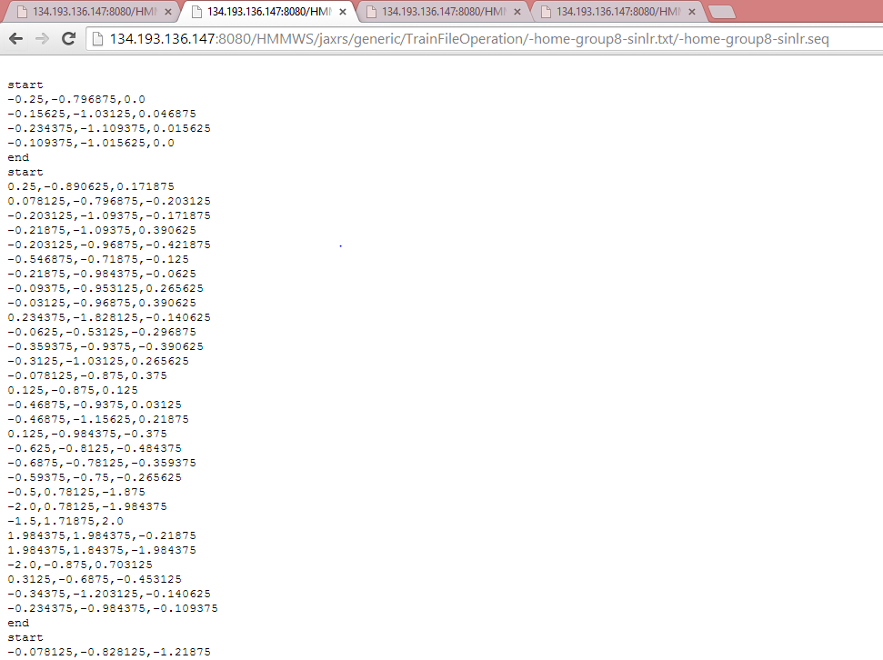

After generating the three sequence files the training and testing activity recognition is done.

Input are: home/group8/sinlr.seq, home/group8/sintd.seq, home/group8/sinrl.seq

Output is: home/group8/sintest.seq

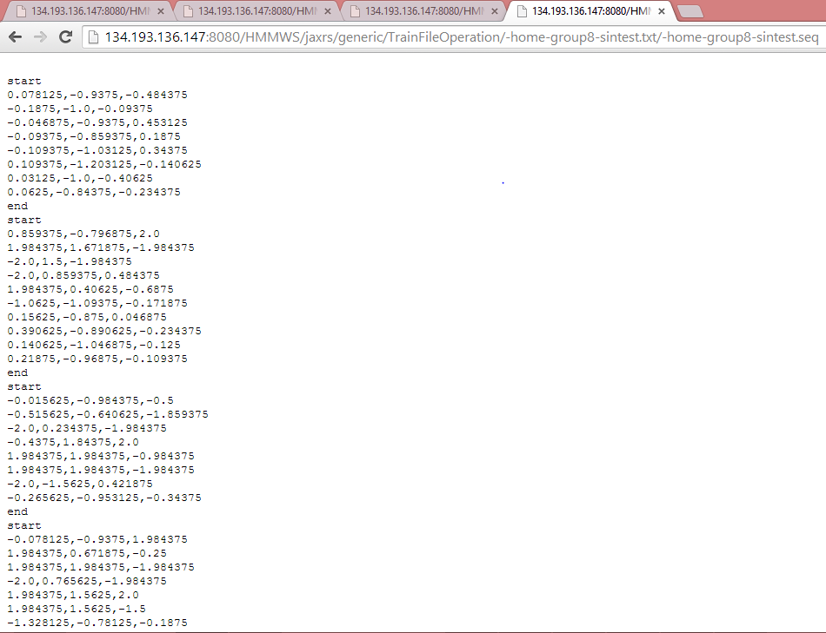

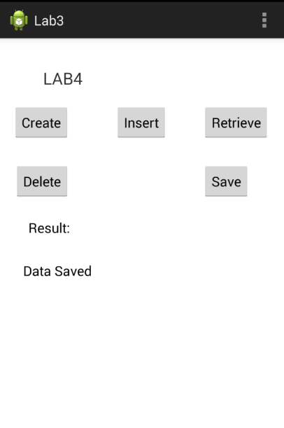

The above is the implementation of android application to insert and save data.