WEB APPLICATION PROGRAMMING / FINAL ASSESSMENT ANSWER SHEET

PantryFlow Technical Report
  - A small client-server pantry system, designed around trustworthy stock movement.
Project: PantryFlow
Module: ITS613404 / ITS64504 - Web Application Programming
Submission component: Technical report and answer sheet; official cover page is intentionally excluded
Demonstration video: [INSERT SHAREABLE VIDEO URL BEFORE SUBMISSION]
Repository: https://github.com/kong-pd/pantryflow
Report position: The report answers the assessment directly, but it also explains the engineering judgement behind the implementation. The core idea is simple: the browser may assist the user, while PHP and MySQL remain the authority for stock, identity and history.

Executive summary
PantryFlow is intentionally small. A visitor can see live food availability, request one item for a future pickup, and retain a short history during the current browser session. An authenticated pantry administrator can review requests, watch low stock, add inventory, reject requests, and archive or safely remove food records. The scope is modest, but the failure cases are real: two visitors may compete for the same units, browser validation may be bypassed, and deleting a referenced item may damage history. Those are the places where the implementation spends its complexity.
The browser renders HTML and CSS and runs JavaScript for immediate feedback. Apache executes PHP, where every important value is validated again. PDO sends prepared statements to MySQL/MariaDB. Stock reservation is completed inside a transaction with a locking read and a guarded update, so the request row and quantity change succeed together or not at all. This is the main architectural argument of the project: user experience can be optimistic, but persisted state cannot be casual.
The result covers all five application-function criteria, both database criteria, and the four documentation criteria. It also adds restrained lifecycle controls that do not distort the assignment: rejection returns reserved stock once, archive removes an item from public availability without erasing history, and permanent deletion is allowed only for archived, unreferenced records. No need to build a mini ERP just to look clever; small scope with clear invariants is the stronger answer here.

Assessment line of sight
Rubric area | What the assessor can verify | Evidence in this report
Section A / 25 | Inventory, request workflow, authentication and administrator operations run end to end. | Sections 6-8 and Figures 6-9
Section B / 5 | Two related tables, constraints, indexes, PDO, prepared statements and error handling. | Section 5 and Figure 5
Section C / 10 | Architecture, sitemap, request flow, technology justification, references, video placeholder and official rubric. | Sections 2-4, 10-13 and Appendix A

1. Problem framing and scope
A community pantry has two quite different jobs. The public experience should feel calm, private and easy: people need to know what is available and arrange a pickup without learning an inventory system. The staff experience is the opposite. It should be dense enough to review work quickly, protect client contact details, and make stock decisions without hunting through decorative cards. PantryFlow therefore uses one data model but two interaction densities.
The public flow is account-free because registration is not part of the brief and would create unnecessary personal-data handling. A request is linked to the current session only for the convenience of the My Pickups view; closing the browser removes that session cookie because its lifetime is zero. The request itself remains in MySQL, so the administrator keeps the operational record. This split gives the visitor a lightweight experience without turning browser state into the system of record.
Each request contains one food item and one quantity. That decision matches the required client_requests table exactly and avoids pretending the task is an e-commerce cart. If the scope later changed to several items per pickup, the correct response would be a request header plus request_items rows. Adding that model now would be extra surface area with no assessment benefit.
- In scope: database-backed availability, expired and low-stock states, single-item pickup requests, dual-layer validation, protected administrator access, low-stock review, add item, rejection, archive/restore and guarded deletion.
- Out of scope: public accounts, passwords in a users table, payments, email, third-party APIs, multi-item carts and framework migration.
- Quality boundary: public sessions may expire; inventory and request records must not disappear with them.

2. Client-server architecture
PantryFlow follows a conventional three-layer client-server structure. Conventional is a compliment in this case: every layer has a job that an assessor can trace from the browser to a PHP route and then to a table. The architecture does not hide core behaviour behind a framework, so the relationship between HTTP, server logic and SQL remains visible.
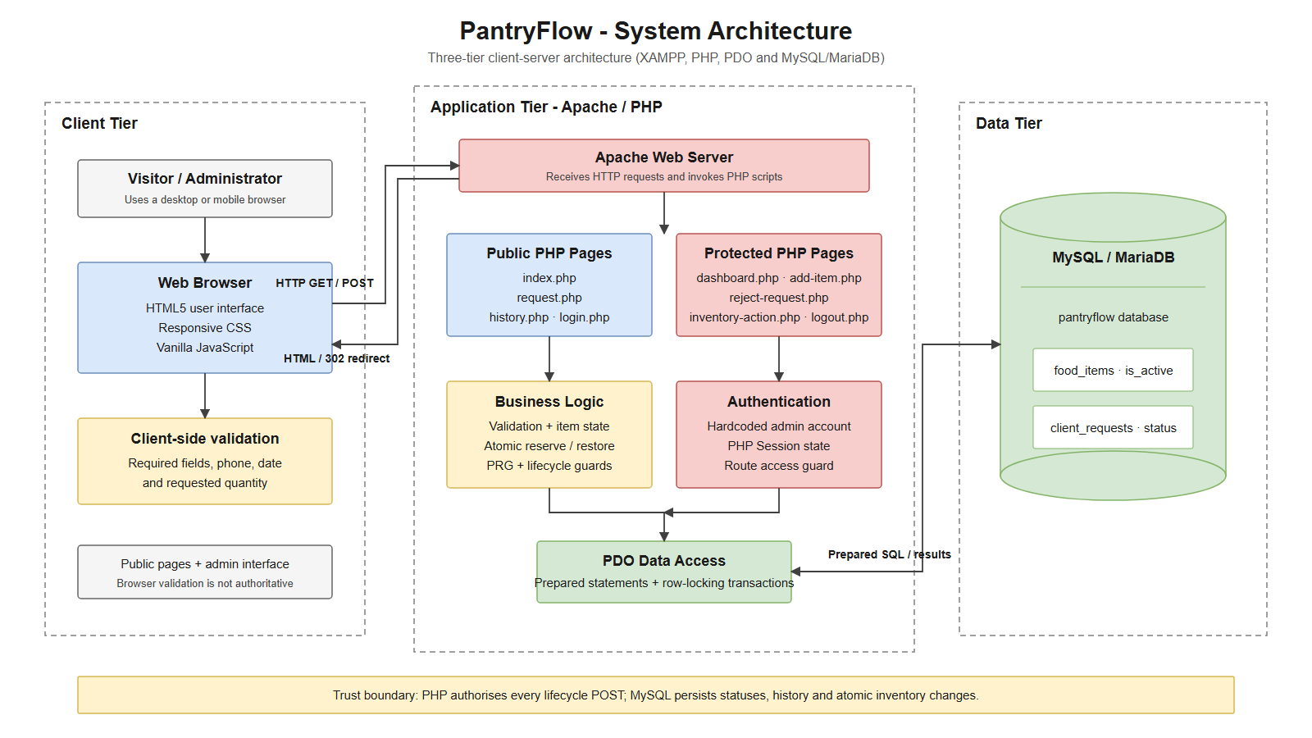
Figure 1. Client, Apache/PHP and MySQL responsibilities, including protected administrator actions.

2.1 Browser responsibilities
HTML gives the pages their semantic structure, CSS controls the responsive presentation, and vanilla JavaScript supplies immediate form feedback. JavaScript can set a quantity maximum after an item is selected, reject an obviously invalid telephone number, focus the first bad field, and announce errors through an aria-live region. It cannot approve a request or change stock. MDN makes the same security distinction: client-side validation improves the interaction but is easy to bypass, so trusted validation still belongs on the server [4]. The course form-processing material leads to the same separation [11].

2.2 Server responsibilities
Apache routes each request to PHP. GET routes read data and render complete HTML responses. POST routes validate intent, authenticate protected work, execute database changes, and redirect after success. PHP Sessions preserve the administrator login and the visitor's short request-history index across requests [1][9]. Protected scripts call a shared require_admin guard, while login regenerates the session identifier before privileged state is stored. This follows the course sequence on redirect, routing and authentication rather than inventing a second auth mechanism [10].

2.3 Database responsibilities
MySQL/MariaDB is the durable source of truth. PDO is configured for exceptions, associative fetches and native prepared statements. Foreign keys protect relationships, indexes support operational queries, and InnoDB transactions protect multi-step stock changes. The server can listen on port 8080 on the development laptop and port 80 in the assessor's XAMPP without a PHP change; the application uses relative routes under /pantryflow instead of hardcoding the local port.

3. Technology choices

3.1 HTML and CSS
Semantic HTML is sufficient for this information architecture: headings, navigation, tables, labels, inputs, buttons and status regions all have native meanings. CSS handles layout and states without a component framework. The final interface uses a restrained hospitality-inspired visual language, but the important HCI work is structural: visible focus, readable contrast, text labels in addition to colour, compact administrator tables, and layouts that collapse without hiding actions. These choices were checked against Vercel's framework-independent interface guidance [7].

3.2 JavaScript
Vanilla JavaScript is used only where the browser can add useful immediacy. The request form reads data attributes already rendered by PHP, updates the selection summary, applies field-level messages, and prevents an accidental second click while submission is in progress. The administrator action script asks for confirmation before rejection, archive and permanent deletion. If JavaScript is disabled, the forms still submit and PHP still validates them; progressive enhancement is a better fit than making the workflow depend on a client bundle.

3.3 PHP, PDO and Sessions
PHP matches the teaching stack and keeps request processing explicit. PDO prepared statements separate parameter data from SQL syntax; both the PHP manual and OWASP recommend this as the primary defence against SQL injection [2][5]. Session cookies are HttpOnly, SameSite=Lax and session-only. The hardcoded pantry_admin / help2026 credential is retained because the rubric requires it, but it is isolated as configuration rather than scattered across pages. In a real deployment, that credential would become a password hash behind an administrator account or identity provider.

3.4 MySQL/MariaDB and XAMPP
The data is relational and small, so MySQL is the obvious rather than fashionable answer. The course database and PDO slides already cover the same browser-server-database path used here [8][12]. InnoDB provides the two features that matter most: referential integrity and transactions. XAMPP makes the result reproducible for marking because Apache, PHP and MariaDB can be started locally and the schema can be imported through phpMyAdmin or the MySQL client.

4. Site structure and interaction flow
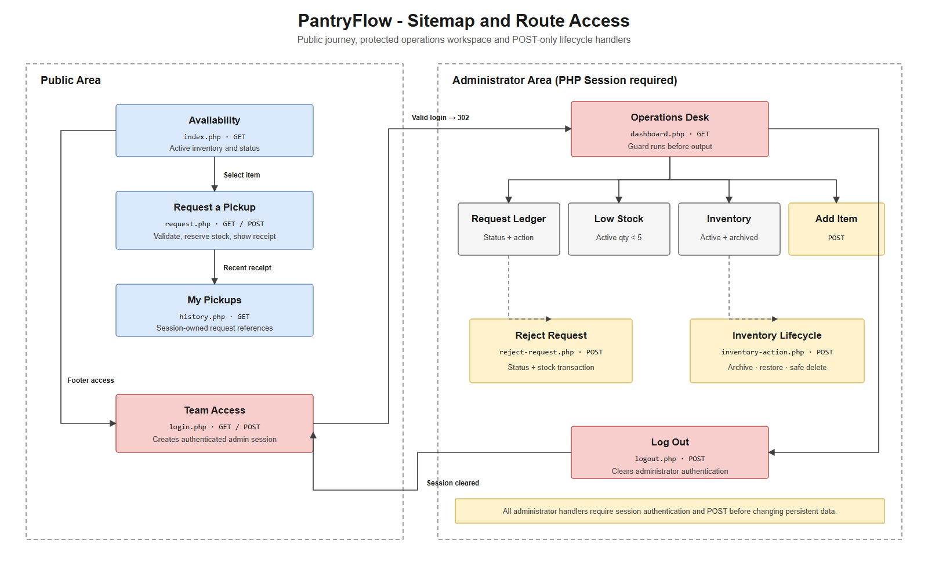
Figure 2. Public pages, protected administrator workspace and POST action routes.
The public header contains only Availability and Request a Pickup. My Pickups appears only when the current session has recent request IDs. Team access was moved to the footer because it is not a normal visitor task; showing a privileged entrance as a primary call to action was technically harmless but conceptually noisy. After login, Operations becomes the staff workspace and Log out appears as a POST form.
Action scripts are deliberately not navigation destinations. add-item.php, reject-request.php, inventory-action.php and logout.php accept POST only, require the administrator session where appropriate, perform one bounded operation, then redirect. This keeps refresh behaviour predictable and stops destructive actions from being represented as ordinary links.

4.1 Request and response flow
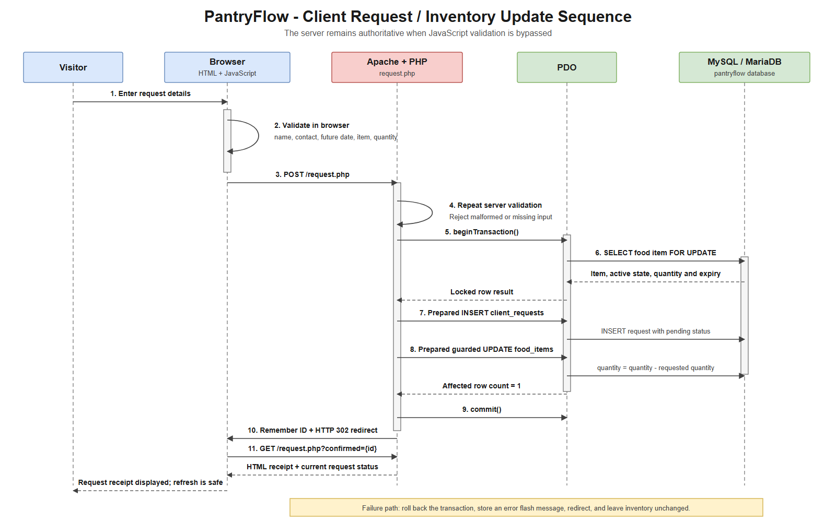
Figure 3. The public reservation path from database-backed form to confirmation receipt.
- A GET request reads active, unexpired items with quantity above zero and renders the dropdown plus current limits.
- JavaScript checks required fields, contact format, future pickup date and quantity for fast feedback.
- PHP receives the POST and repeats all trusted validation using parsed integers and strict date handling.
- A database transaction starts; SELECT ... FOR UPDATE locks the selected food row and reads its latest state.
- PHP rejects archived, expired or insufficient stock before inserting a pending client request.
- A guarded UPDATE decrements stock only when enough units still exist. The request insert and stock change then commit together.
- PHP stores only the new request ID in the session, redirects to GET, and renders a confirmation receipt. A failure rolls back and returns an actionable message.
The locking read is not academic decoration. Without it, two visitors could both read the same quantity and both believe the stock is available. MySQL documents FOR UPDATE for exactly this check-then-update pattern [3]. Post/Redirect/Get also matters: a refresh after success retrieves the receipt instead of resubmitting the POST.

4.2 Administrator lifecycle
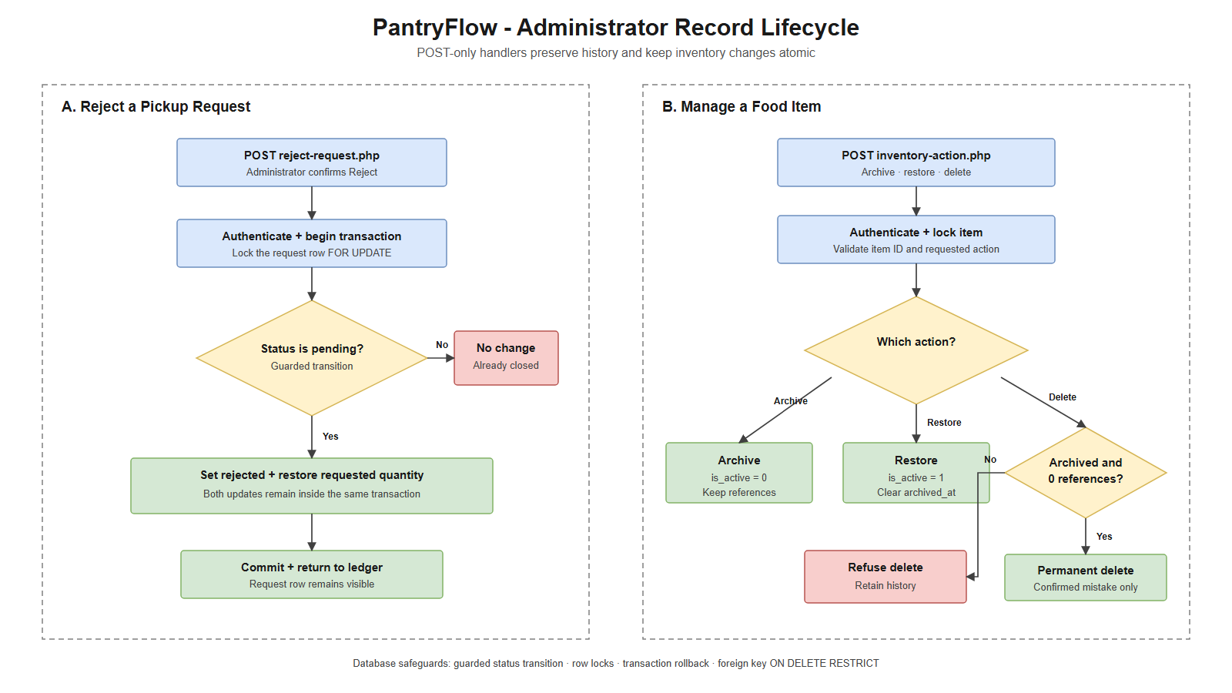
Figure 4. Request rejection and food-item lifecycle controls with data-integrity guards.
A pending request may be rejected once. The request row is locked, its status becomes rejected, and the reserved units are returned inside the same transaction. Repeating the action does not add stock again. A food item may be archived to remove it from public availability while retaining request history. Permanent deletion is a narrower operation: the row must already be archived and have zero request references. The database foreign key remains the final guard even if application logic is bypassed.

5. Database design
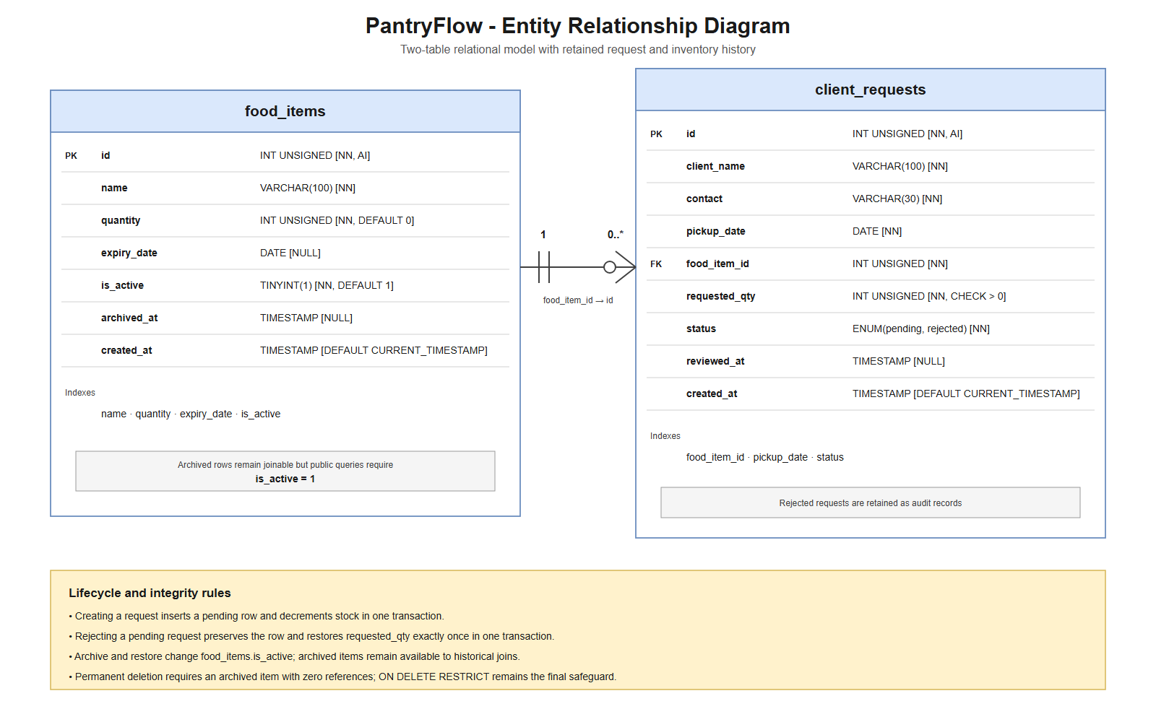
Figure 5. Implemented two-table schema, cardinality and lifecycle fields.
The ERD has one genuine relationship: one food item may appear in zero or many client requests, while each request refers to exactly one food item. The simplicity is intentional. An administrators table would contradict the hardcoded-login requirement, and a request_items table would imply a multi-item order that the interface does not support.
Table | Purpose and key fields | Integrity decisions
food_items | id, name, quantity, expiry_date, is_active, archived_at, created_at | Primary key; indexed name, quantity, expiry and active state; quantity cannot be negative.
client_requests | id, client_name, contact, pickup_date, food_item_id, requested_qty, status, reviewed_at, created_at | Primary key; foreign key to food_items; positive requested quantity; indexed item, pickup and status.
ON DELETE RESTRICT makes historical damage difficult. The application normally avoids reaching that constraint by exposing Delete only for an archived item with no references. Lifecycle columns are preferable to adding artificial tables: they preserve operational meaning while keeping the rubric's required schema recognisable. The versioned migration adds these columns to an existing installation without resetting rows, while schema.sql remains the clean installer with six sample food items.
Data ownership: Closing a visitor's browser clears the session cookie and therefore the My Pickups convenience list. It does not delete client_requests or undo stock movement. Persistent operational truth belongs to MySQL, not to the cookie.

6. Functional implementation against Section A

6.1 A1 - Food items listing
index.php reads food items from MySQL and presents name, remaining quantity and expiry date. Expired stock receives a red visual treatment and an explicit Expired label; zero stock is unavailable; quantity below five is Low stock; active requestable stock is Available. Text carries the state so colour is not the only cue. Archived items are excluded from the public query but remain visible to staff in the complete inventory table.
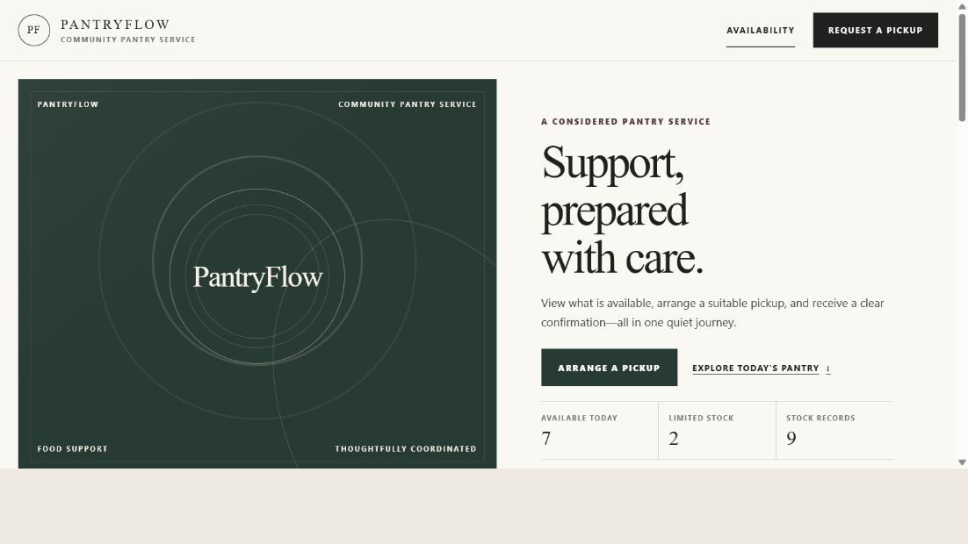
Figure 6. Final public landing experience with live availability summary and one clear primary action.

6.2 A2 - Client request form
The item control is populated from active, unexpired database rows with stock above zero. The form contains the rubric fields plus requested quantity. JavaScript supplies inline errors, date minimums, quantity limits and a live pickup summary. PHP retains safe old input after an error, so a failed submission does not punish the user with a blank form.
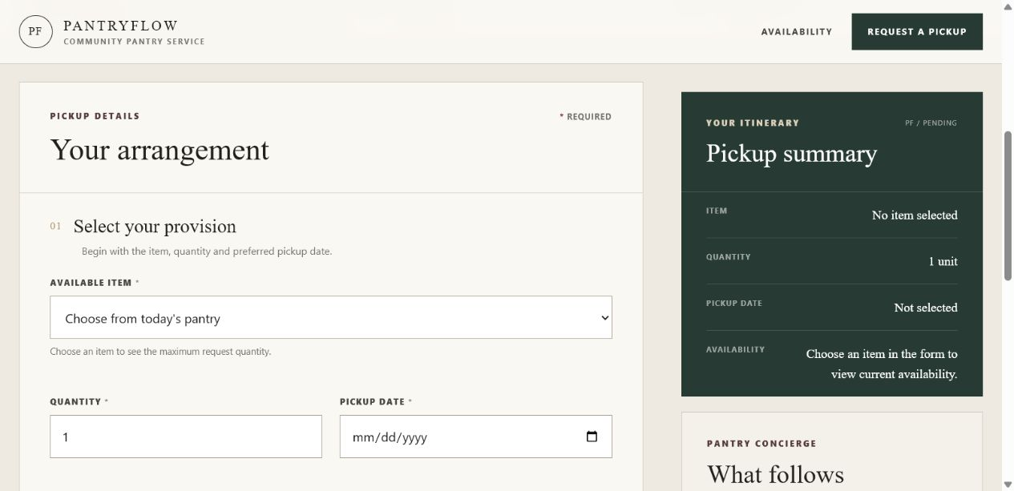
Figure 7. Database-backed item selection, requested quantity, future date and live itinerary summary.

6.3 A3 - Server-side request processing
The server checks name length, contact format, parsed item ID, positive integer quantity and a strictly future date. It then re-reads the item under lock and checks active state, expiry and current quantity. PDO prepared statements carry all visitor values. Dynamic output is escaped through a shared htmlspecialchars helper using UTF-8, ENT_QUOTES and ENT_SUBSTITUTE, which follows OWASP's output-encoding principle for XSS prevention [6]. A successful transaction creates the request, decrements stock, redirects and returns a clear receipt.

6.4 A4 - Administrator authentication
login.php compares the required hardcoded values with hash_equals and regenerates the session ID on success. The require_admin guard runs before protected pages or actions. Logout accepts POST only, removes privileged session state and regenerates the identifier. The session cookie is HttpOnly, SameSite=Lax and non-persistent. Direct navigation to dashboard.php without the session returns the visitor to login with a short explanation.

6.5 A5 - Administrator dashboard
The final Operations desk favours density over spectacle. Four summary figures show pending requests, requested units, low-stock items and total inventory. The left work column contains the pickup queue and complete inventory ledger; the right column keeps low-stock warnings visible. Add item is a bounded task, while Reject, Archive, Restore and Delete appear beside the records they affect. Confirmation is used for consequential actions, and success notices are consumed instead of hanging permanently at the top.
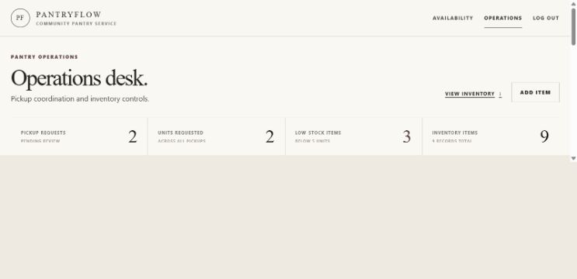
Figure 8. Final administrator operations summary with direct inventory controls and work metrics.

7. Validation, security and data integrity
Security is treated as a sequence of boundaries rather than one magic feature. Browser checks reduce avoidable mistakes. PHP rejects untrusted values. Prepared statements protect SQL structure. Output encoding protects the HTML context. Session guards protect staff work. Database constraints, locks and transactions protect persisted state. Each layer assumes the layer before it can be bypassed.
Risk | Implemented control | Why it matters
SQL injection | Native PDO prepares; bound parameters; exception handling | Visitor values never become SQL syntax.
Stored/reflected XSS | Central e() output encoding; no raw printing of form/database text | Markup characters render as text instead of executable HTML.
Unauthorised admin access | PHP Session, hash_equals, ID regeneration, require_admin on pages and actions | Knowing a protected URL is not enough to run it.
Overselling stock | FOR UPDATE, latest-state checks, guarded decrement and transaction | Concurrent requests cannot rely on the same stale quantity.
Double stock return | Pending-to-rejected transition is locked and idempotent | Refreshing or repeating Reject cannot restore units twice.
Historical deletion | Archive first; zero-reference check; foreign-key RESTRICT | Operational history remains trustworthy.
The honest limitation is CSRF protection. POST-only routes and SameSite=Lax reduce accidental cross-site navigation, but a production administrator workflow should also carry unpredictable CSRF tokens. Production deployment would additionally require HTTPS, a database-backed hashed credential, audit identity, secret management outside source code, rate limiting and a formal retention policy for contact details. Naming these gaps is not a weakness in the report; it shows where an assessment prototype stops and an operational service begins.

8. HCI and responsive design
The interface went through several reductions. Early versions displayed too many status legends, technical footer labels and oversized hero sections. The final public experience keeps one dominant action, shortens the vertical journey, moves administrator access out of the primary navigation, and uses language that sounds like a service rather than a software demo. The request page groups selection, timing and contact details around one live summary. After confirmation, it presents a receipt and next actions instead of dropping the visitor back into an empty form.
The administrator side deliberately uses a different rhythm. Staff do not need a marketing hero every time they check a queue. Metrics, requests, low-stock items and inventory sit close enough to support scanning, while actions remain visually quiet until needed. This is less is more in the practical sense: fewer competing blocks, but more useful information per screen.
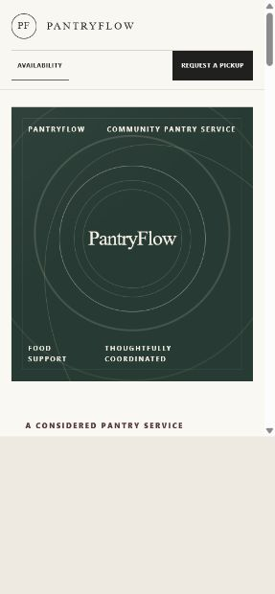
Figure 9. Narrow public layout preserving brand, navigation and primary action without horizontal page overflow.
- Native controls remain keyboard-operable and retain visible focus treatment.
- Field errors are linked with aria-describedby; live regions announce validation and submission state.
- Status always includes text, so meaning does not depend on colour alone.
- Mobile tables retain internal horizontal scrolling while the page itself stays within the viewport.
- The public footer contains service navigation, not implementation-stack or assessment wording.

9. Testing and verification
Testing focused on state transitions rather than only whether a page opened. Syntax checks were followed by HTTP and database checks, then desktop and mobile visual review. Temporary test records were removed by exact ID, and the working database returned to its pre-test user-owned state rather than being reset behind the user's back.

Check | Expected result | Result
PHP lint | Every PHP file parses cleanly | PASS - 16 files
JavaScript syntax | Request and admin scripts parse | PASS
Valid request | Insert pending request and decrement exact quantity | PASS
Excess quantity / invalid date | No insert and no stock movement | PASS
Unauthorised dashboard | Redirect to login | PASS
Reject request | Status rejected and stock restored exactly once | PASS
Archive / restore / delete | Public filtering works; referenced delete blocked | PASS
Responsive operations | One-column layout, internal table scroll, no console errors | PASS
Data preservation | Remove test rows and retain existing local records | PASS
The clean installation path remains database/schema.sql, which creates the rubric-required tables and six sample items. The additive migration database/migrations/20260726_admin_lifecycle.sql is for an existing PantryFlow database that must preserve rows while gaining lifecycle fields. This distinction matters during marking: schema.sql is the reproducible start; the migration is evidence that later functionality was added without destructive re-imports.

10. Deployment and submission readiness
The project runs from XAMPP htdocs/pantryflow. On this laptop Apache listens on 8080, so the development URL is http://localhost:8080/pantryflow/. A standard XAMPP installation on port 80 uses http://localhost/pantryflow/ with no source change. Database settings have sensible localhost defaults and optional PANTRYFLOW_DB_* environment overrides.
The repository is published at https://github.com/kong-pd/pantryflow. The submitted source archive should be generated from the committed tree so it contains PHP, CSS, JavaScript, SQL, README and docs but not .git or local test files. The final PDF assembly still needs the official TU cover page before this answer sheet, the shareable video URL in the highlighted field, and the marking rubric retained at the end.
Required student replacement: Insert the final video URL in the first-page Demonstration video field and again in the submission PDF if the lecturer expects a clickable standalone line. Test the link in a private browser window before uploading.

11. Conclusion
PantryFlow meets the requested inventory, pickup and administrator workflows with a transparent client-server design. Its strongest part is not the visual theme; it is the consistency of authority. JavaScript helps, PHP decides, and MySQL records. Stock movement is transactional, privileged actions are guarded, output is encoded, and history survives a visitor session.
The project also stays honest about scale. One item per request, two tables and one hardcoded administrator are correct for this brief. Where the workflow needed more care, the additions are operational rather than decorative: rejection is idempotent, archive is reversible, and deletion respects references. This is the correct kind of boring - no framework drama and no fake enterprise modules, just a system the assessor can run, trace and explain.

12. References
Authoritative documentation and the module's own teaching materials were used together. Online sources were accessed on 26 July 2026.
[1] PHP Documentation. Sessions https://www.php.net/manual/en/book.session.php
[2] PHP Documentation. PDO::prepare https://www.php.net/manual/en/pdo.prepare.php
[3] Oracle, MySQL 8.4 Reference Manual. InnoDB Locking Reads https://dev.mysql.com/doc/refman/8.4/en/innodb-locking-reads.html
[4] MDN Web Docs. Client-side form validation https://developer.mozilla.org/en-US/docs/Learn_web_development/Extensions/Forms/Form_validation
[5] OWASP Foundation. SQL Injection Prevention Cheat Sheet https://cheatsheetseries.owasp.org/cheatsheets/SQL_Injection_Prevention_Cheat_Sheet.html
[6] OWASP Foundation. Cross Site Scripting Prevention Cheat Sheet https://cheatsheetseries.owasp.org/cheatsheets/Cross_Site_Scripting_Prevention_Cheat_Sheet.html
[7] Vercel. Web Interface Guidelines https://vercel.com/design/guidelines
[8] Marjani, Mohsen. Web Application Programming lecture slides. Accessing MySQL Using PDO, Version 1.01
[9] Marjani, Mohsen. Web Application Programming lecture slides. Cookies and Sessions, Version 1.01
[10] Marjani, Mohsen. Web Application Programming lecture slides. Redirect, Routing, and Authentication
[11] Marjani, Mohsen. Web Application Programming lecture slides. Form Processing in PHP, Version 1.02
[12] Marjani, Mohsen. Web Application Programming lecture slides. Relational Databases and MySQL, Version 1.01

Appendix A - Official marking rubric
The rubric is reproduced from the assessment brief so the answer sheet can be combined with the official cover page as one submission document. The Marks column is intentionally left blank for the assessor.
Criteria | Excellent (5) | Good (4) | Satisfactory (3) | Fair (2) | Poor (1-0) | Marks
A1: Food Items Listing Page  Display available items from DB with name, quantity, expiry date. Expired items highlighted. | Perfect display, expiry highlighted red, responsive design, clean CSS. | Display works, minor CSS or responsiveness issues. | Shows items but expiry not highlighted or formatting poor. | Items load but layout is broken. | No listing page or DB fetch fails. | /5
A2: Client Request Form (Front-End)  HTML form with JS validation and DB-populated dropdown. | All JS validations work perfectly, user-friendly error messages, dynamic dropdown from DB. | Most validations work, minor JS bugs. | Form exists but missing some validation. | Validation weak or dropdown not dynamic. | No form or no JS validation. | /5
A3: Client Request Processing (Back-End)  Server validation, stock decrement, SQLi/XSS prevention and notification. | All server validations work, quantity updates correctly, PDO prepared statements, clear success/error messages. | Mostly works, minor bug in quantity update or message. | Submission works but missing quantity check OR security incomplete. | DB update unreliable or no proper validation. | Form submission fails or no DB update. | /5
A4: Admin Authentication  Hardcoded login, session management and logout. | Perfect session auth, protected pages, logout works, no unauthorized access. | Works but minor session issues. | Login works but logout or protection missing. | Auth exists but easily bypassed. | No authentication or broken. | /5
A5: Admin Dashboard Features  View requests, low-stock items and add food items. | All 3 features work perfectly with clean UI. | All features work with minor UI issues. | 2 of 3 features work. | 1 feature works. | None work. | /5
Subtotal Section A |  |  |  |  |  | /25

Section B - Database Development
Criteria | Excellent (5) | Good (4) | Satisfactory (3) | Fair (2) | Poor (1-0) | Marks
B1: Database Design  Required tables, PK/FK and sample items. | Perfect schema, proper data types, foreign key, indexes, at least 5 sample items. | Good schema, minor issue such as missing FK or insufficient sample data. | Basic tables, missing constraints or no sample data. | Tables exist but flawed, wrong data types or no PK. | No schema or non-functional. | /3
B2: PHP-DB Connection  PDO, prepared statements and error handling. | PDO with exception handling, all queries use prepared statements, clean error handling. | PDO used, mostly prepared statements, minor issues. | Basic connection, but not fully secure. | Connection works but queries vulnerable. | No connection or broken. | /2
Subtotal Section B |  |  |  |  |  | /5

Section C - Documentation
Criteria | Excellent (5) | Good (4) | Satisfactory (3) | Fair (2) | Poor (1-0) | Marks
C1: Client-Server Architecture Explanation  Logic location, communication and technology justification. | Clear, detailed explanation with strong justification and deep understanding of separation. | Good explanation, minor gaps in justification. | Basic explanation present but lacks depth or justification is weak. | Vague or incomplete explanation. | Missing or completely wrong. | /3
C2: Site Map & Request/Response Flow Diagram | Both diagrams present, clear, accurate and professionally drawn. | Both present but minor errors or unclear. | Only one diagram present OR both are incomplete. | Diagrams present but incorrect. | No diagrams. | /3
C3: References & Video Demo  Minimum 5 references and a maximum 5-minute working demo. | At least 5 quality references and video clearly demonstrates all functions. | At least 5 references but low quality OR video missing minor features. | 3-4 references OR video incomplete. | 1-2 references OR video poor quality. | No references OR no video. | /2
C4: Report Professionalism & Submission Completeness | All files submitted correctly, well-organized and professionally formatted. | Minor issues such as missing cover page or messy ZIP. | Multiple formatting issues or missing file. | Poor organization, hard to assess. | Incomplete submission. | /2
Subtotal Section C |  |  |  |  |  | /10

