SIMATS ENGINEERING
CSA6303- Threat Intelligence and Network Security
A1-Threat Intelligence Report
Assessment Questions
Subject | Threat Intelligence | Total Marks | 50
Questions | 10 (all compulsory) | Marks per Question | 5
REg.No | 192365025 | Name | KONGARA SAI
Faculty | Dr.V.Parthipan | Slot | A
Instructions: Answer all questions. Each question carries 5 marks. Support answers with examples and diagrams where appropriate.
Code of Conduct:

I kongara sai/192365025 certify that this submission is my original work and that I have adhered to the guidelines specified for this assessment. I understand that any violation of academic integrity rules will result in disciplinary action.

Signature of Student

k.sai

Questions
Q1. Malware [5 Marks]
Define malware and explain any four types of malware (virus, worm, trojan, ransomware, spyware). For each type, state how it spreads and one impact on the victim.
Q2. Phishing [5 Marks]
Describe how a phishing attack is carried out. Differentiate between spear phishing, whaling and vishing, and list three measures an organisation can adopt to reduce phishing risk.
Q3. DoS and DDoS [5 Marks]
Distinguish between a Denial of Service (DoS) attack and a Distributed Denial of Service (DDoS) attack. Explain the working of a SYN flood and outline two mitigation techniques.
Q4. Man-in-the-Middle Attacks [5 Marks]
What is a Man-in-the-Middle (MITM) attack? Explain two techniques used to carry it out (for example ARP poisoning, rogue Wi-Fi access point, SSL stripping) and state how encryption helps defend against it.
Q5. Spoofing and Sniffing [5 Marks]
Compare spoofing and sniffing. Explain IP spoofing and ARP spoofing with an example each, and describe how packet sniffers such as Wireshark can be used both maliciously and legitimately.
Q6. Vulnerability Assessment [5 Marks]
Explain the vulnerability assessment process. Describe its main phases, and differentiate between vulnerability assessment and penetration testing. Name two commonly used scanning tools.
Q7. Vulnerability Scoring [5 Marks]
What are CVE and CVSS? Explain how CVSS scores help in prioritising vulnerabilities and why a high CVSS score alone may not decide the order of patching.
Q8. Threat Data Sources and OSINT [5 Marks]
Discuss the main sources of threat data (internal, external, open-source and commercial). Define Open-Source Intelligence (OSINT) and describe three OSINT sources or tools used in threat intelligence gathering.
Q9. Indicators of Compromise (IoCs) [5 Marks]
What are Indicators of Compromise (IoCs)? Classify them into network-based, host-based and file-based indicators with two examples of each, and explain how a security team uses IoCs during incident response.
Q10. Threat Feeds [5 Marks]
Explain what a threat intelligence feed is. Describe the common feed formats and sharing standards (STIX/TAXII), list two advantages and two limitations of using threat feeds, and name two example feeds.

Marking Scheme (for evaluator)
Q.No | Expected points and mark distribution (total 5)
1 | Definition (1); four types with spread method and impact (4 x 1 = 4).
2 | Attack flow (1.5); three variants differentiated (1.5); three countermeasures (2).
3 | DoS vs DDoS (1.5); SYN flood working (1.5); two mitigations such as rate limiting, SYN cookies, CDN/scrubbing, blackhole routing (2).
4 | Definition and interception concept (1); two techniques (2); defences such as TLS, HSTS, certificate validation, VPN (2).
5 | Comparison (1); IP and ARP spoofing with examples (2); sniffer dual use (1.5); one countermeasure (0.5).
6 | Phases: asset discovery, scanning, analysis and prioritisation, reporting, remediation (2); VA vs pen test (2); two tools such as Nessus, OpenVAS, Qualys (1).
7 | CVE meaning (1); CVSS meaning and severity ratings (1.5); role in prioritisation (1.5); context factors such as exploitability and asset criticality (1).
8 | Threat data source categories (2); OSINT definition (1); three OSINT sources or tools such as Shodan, VirusTotal, WHOIS, social media, dark web monitoring (2).
9 | Definition (1); classification with examples (3); use in detection and response (1).
10 | Definition (1); STIX/TAXII or similar formats (1.5); two advantages and two limitations (2); two example feeds such as AlienVault OTX, MISP, abuse.ch (0.5).

1. Explain malware and its major types.
Introduction and definition
Malware, short for malicious software, is any program, script, or file intentionally created to harm a computer, steal information, disrupt services, spy on users, or provide unauthorized access to a system. Malware may reach a device through email attachments, unsafe downloads, infected websites, removable drives, pirated software, or exploitation of unpatched vulnerabilities. Once installed, it may operate openly or remain hidden for a long period.
Major types of malware
1. Virus: attaches itself to a legitimate file or program and spreads when the infected host is executed. It may corrupt files or modify system behaviour.
2. Worm: independently replicates and spreads between computers or networks, often by exploiting security weaknesses. It can spread rapidly without the user opening an infected file.
3. Trojan horse: pretends to be a useful or genuine application but performs hidden harmful actions, such as stealing information or installing a backdoor.
4. Ransomware: locks a system or encrypts files and demands payment for restoration. Some operators also steal data and threaten to publish it.
5. Spyware: secretly monitors a user or device and collects information such as browsing activity, personal details, or credentials.
6. Adware: displays unwanted advertisements and may track browsing behaviour. Some adware is bundled with suspicious applications.
7. Rootkit: hides malicious activity and may help an attacker maintain privileged access to a compromised system.
8. Keylogger: records keyboard input and may capture passwords, messages, or financial information.
How malware infects systems
Common infection methods include phishing emails, malicious links, fake software updates, untrusted applications, infected USB drives, macro-enabled documents, drive-by downloads, and exploitation of outdated software. Attackers may use more than one method in a single campaign. For example, a phishing email may deliver a document that downloads a second malicious program.
Effects and example
Malware can cause data loss, identity theft, financial damage, unauthorized surveillance, system slowdown, service outages, and reputational harm. For example, ransomware in a college or hospital could make important records unavailable and interrupt normal operations. A worm can consume network resources while spreading from one vulnerable computer to another.
Prevention and conclusion
Users should install updates promptly, use reputable endpoint protection, enable a firewall, download software only from trusted sources, avoid suspicious attachments, use MFA, and follow least-privilege principles. Important files should be backed up regularly, with at least one backup protected from ordinary network access. Organizations should train staff, monitor unusual behaviour, and maintain an incident-response plan. In conclusion, understanding malware types helps users recognize threats and choose appropriate controls.

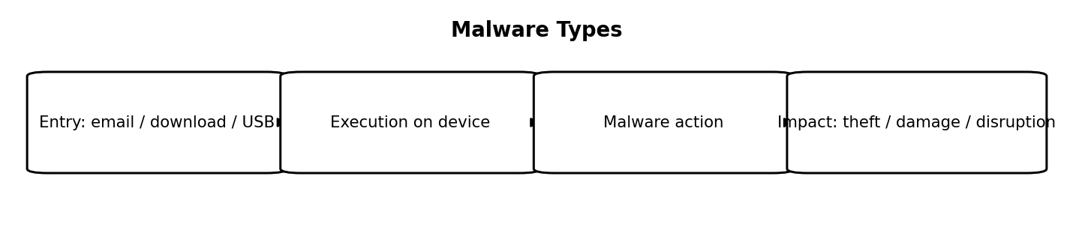
Figure 1: Malware Types
2. What is phishing? Explain its types and prevention.
Definition
Phishing is a social-engineering attack in which a criminal pretends to be a trusted person, company, bank, university, or service to trick a victim into revealing sensitive information, transferring money, opening a malicious attachment, or visiting a fraudulent website. Instead of directly breaking technical security, phishing often manipulates human trust, fear, curiosity, or urgency.
Types of phishing
1. Email phishing: mass emails imitate familiar organizations and request that users click a link or open an attachment.
2. Spear phishing: a customized message targets a particular individual or organization using details relevant to that target.
3. Whaling: a targeted form of phishing aimed at senior executives or other high-value individuals.
4. Smishing: phishing delivered through SMS or messaging applications.
5. Vishing: voice calls in which an attacker impersonates a bank employee, support agent, or official.
6. Clone phishing: a genuine message is copied and altered so that a link or attachment is replaced with a malicious one.
7. Business email compromise: an attacker impersonates or compromises a business account to request payments or sensitive documents.
How a phishing attack works
First, the attacker prepares a believable message. The message may claim that an account will be suspended, a parcel is delayed, a payment must be confirmed, or an urgent document is attached. The victim follows the link or opens the file. A fake page may collect login credentials, while a malicious attachment may install malware. The attacker then uses the stolen information for account takeover, fraud, or further attacks.
Warning signs and example
Warning signs include an unfamiliar sender address, a slightly misspelled domain, unexpected attachments, urgent threats, unusual payment requests, generic greetings, and links that do not match the displayed organization. For example, a fake bank SMS may direct a user to a look-alike website and ask for a username, password, and one-time code. A real organization should not be trusted solely because its logo or display name looks genuine.
Prevention and conclusion
Users should inspect sender addresses and link destinations, avoid opening unexpected attachments, and verify unusual requests through a separate trusted channel. MFA can reduce the impact of stolen passwords, especially when phishing-resistant methods are used. Organizations should use email authentication and filtering, provide security-awareness training, enable reporting mechanisms, and respond quickly to reported messages. If credentials are entered on a suspicious site, the user should contact the legitimate service, change the password from a trusted device, revoke active sessions where possible, and report the incident. Phishing prevention requires both technical controls and careful user behaviour.

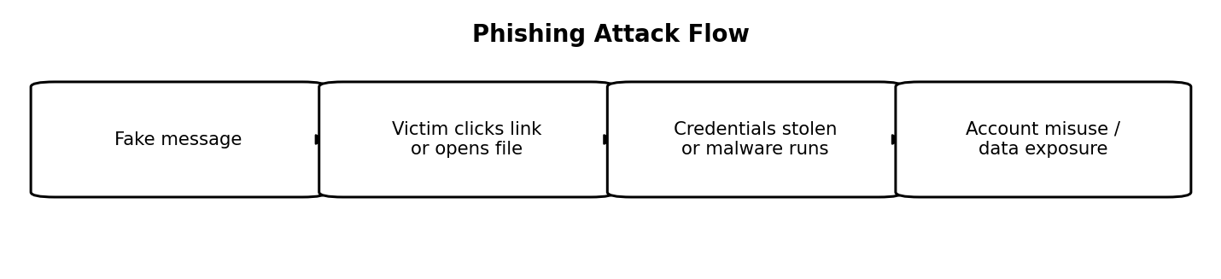
Figure 2: Phishing Attack Flow

3. Explain DoS and DDoS attacks.
Definition
A Denial-of-Service (DoS) attack attempts to make a computer, website, application, or network unavailable to legitimate users. It does so by exhausting resources or overwhelming a service with requests. A Distributed Denial-of-Service (DDoS) attack has the same broad goal but uses many systems, often compromised devices controlled as a botnet, to generate traffic from multiple sources.
DoS versus DDoS
A traditional DoS attack may originate from one main source, making its traffic comparatively easier to identify and block. A DDoS attack is distributed across many devices and networks, so blocking a single source is usually insufficient. DDoS traffic can include legitimate-looking requests, making it difficult to separate malicious activity from genuine demand.
Common attack categories
1. Volumetric attacks attempt to consume available bandwidth with large amounts of traffic.
2. Protocol attacks exploit weaknesses or state limits in network protocols and devices, exhausting connection tables or processing capacity.
3. Application-layer attacks send repeated requests to resource-intensive services, such as search pages or login endpoints, to overload the application.
4. Reflection or amplification attacks abuse third-party servers to send a much larger volume of traffic toward a victim than the attacker directly sends.
How an attack affects an organization
A successful attack can cause slow response times, failed transactions, website outages, lost revenue, missed deadlines, reduced customer confidence, and operational disruption. Critical services may become inaccessible even if attackers never gain access to confidential data. DDoS attacks can also be used as a distraction while criminals attempt another intrusion.
Example and prevention
For example, an online store may receive an unusually large number of requests and become unavailable during a major sale. Defenses include traffic monitoring, rate limiting, web application firewalls, content delivery networks, load balancing, resilient architecture, upstream filtering, and specialist DDoS mitigation services. Organizations should prepare response procedures and coordinate with their hosting provider or internet service provider. No single control prevents every DDoS attack; layered defenses and a tested response plan are important.
Conclusion
DoS and DDoS attacks primarily threaten service availability. The distributed nature of DDoS makes detection and mitigation more challenging. Early monitoring, capacity planning, filtering, and professional mitigation support help reduce their impact.

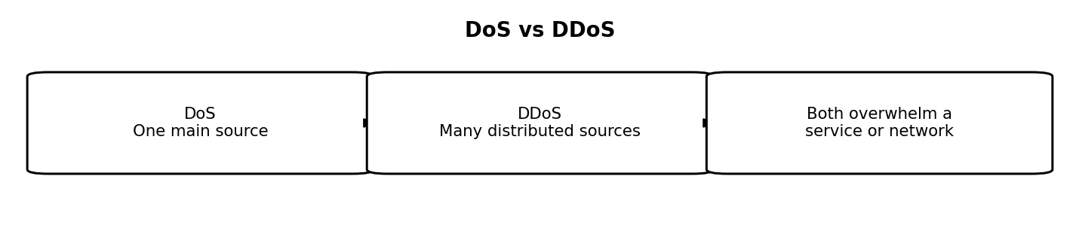
Figure 3: DoS vs DDoS

4. What is a Man-in-the-Middle (MITM) attack?
Definition
A Man-in-the-Middle (MITM) attack occurs when an attacker secretly places themselves between two parties that are communicating. The attacker may observe, relay, or alter messages while each party believes that communication is occurring directly with the other. The attack targets the confidentiality and integrity of communication and may also lead to unauthorized access.
Stages of a MITM attack
1. Positioning: the attacker gains a position on the communication path, perhaps through a rogue Wi-Fi hotspot, compromised router, or network manipulation.
2. Interception: traffic between the victim and the intended service is captured or relayed.
3. Inspection or modification: the attacker attempts to read data, steal session tokens, or change a message.
4. Relay: the attacker forwards traffic so that the connection may appear normal to the users.
5. Exploitation: stolen credentials or altered instructions may be used for account access or fraud.
Common methods
MITM attacks may involve rogue wireless access points, ARP spoofing on a local network, DNS manipulation, session hijacking, or attempts to downgrade secure connections. A fake Wi-Fi hotspot may imitate a public network name and persuade users to connect. If an application transmits information without suitable encryption, an attacker who can observe the traffic may read it.
Impacts and example
Possible consequences include stolen passwords, exposed private messages, account takeover, financial fraud, and modified transactions. For example, an attacker might alter payment details displayed during an insecure communication session. Modern HTTPS/TLS substantially reduces interception risk when certificates are correctly validated; an attacker should not be able to silently impersonate a properly authenticated website.
Prevention and conclusion
Users should use HTTPS websites, avoid bypassing browser certificate warnings, keep devices updated, and be cautious with unknown Wi-Fi networks. A trusted VPN can help protect traffic on untrusted networks, although it does not make every activity safe. Organizations should configure TLS correctly, use secure session cookies, apply MFA, secure network equipment, and monitor unusual network behaviour. In conclusion, MITM attacks exploit weaknesses in communication paths, so encryption, authentication, and careful network practices are essential.

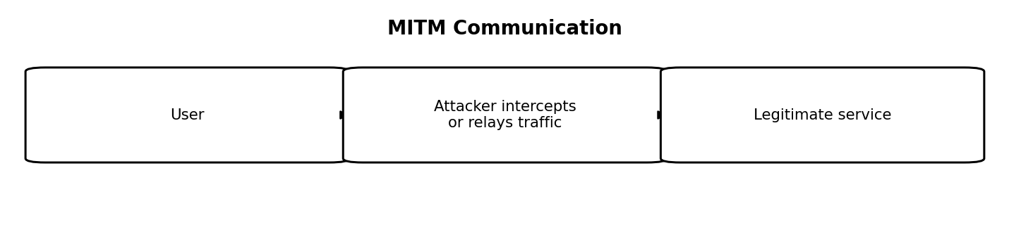
Figure 4: MITM Communication
5. Differentiate spoofing and sniffing.
Definition of spoofing
Spoofing is the act of falsifying an identity, address, or data field so that a message or connection appears to come from a different or trusted source. Attackers use spoofing to gain trust, mislead users, evade basic filtering, or redirect traffic. Common forms include IP spoofing, email spoofing, DNS spoofing, and caller-ID spoofing.
Definition of sniffing
Sniffing is the capture and examination of network traffic. Administrators use packet analyzers to troubleshoot performance, investigate faults, and understand network communication. Unauthorized sniffing can be used to collect unencrypted credentials, messages, or metadata. Sniffing may be passive, where traffic is observed, or associated with active techniques that manipulate a network to expose traffic.
Key differences
Spoofing forges or impersonates; sniffing observes or captures. Spoofing focuses on making data or identity appear different from reality, while sniffing focuses on inspecting traffic in transit. Spoofing may be used to make malicious traffic look trusted. Sniffing may expose sensitive information if the traffic is not encrypted. The two techniques can be combined, but they are not interchangeable.
Examples and security impact
An attacker may send an email that appears to come from a manager and request a payment; this is email spoofing. On an insecure network, a packet-capture tool may reveal data transmitted in clear text; this is sniffing. These activities can lead to phishing, privacy violations, credential theft, redirection, and unauthorized access.
Prevention
Encryption protocols such as HTTPS/TLS protect the contents of communications from simple observation. Secure Wi-Fi, network segmentation, switch security controls, monitoring, and strong authentication also help. Email systems should implement SPF, DKIM, and DMARC to make domain spoofing harder. DNS security measures and certificate validation reduce certain impersonation risks. Packet capture should be performed only with proper authorization.
Conclusion
Spoofing and sniffing are different techniques with different goals, but both can be involved in network attacks. Understanding the distinction helps security teams select appropriate controls and investigate suspicious activity accurately.

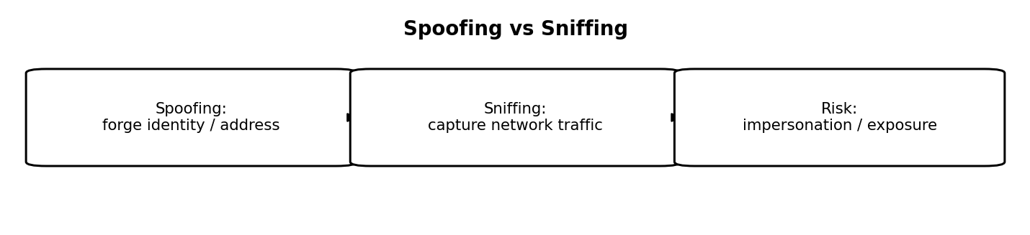
Figure 5: Spoofing vs Sniffing

6. Define vulnerability assessment and describe its stages.
Definition and purpose
A vulnerability assessment is a structured process used to identify, validate, evaluate, and prioritize security weaknesses in computer systems, applications, networks, cloud environments, and configurations. Its purpose is to help an organization understand where it may be exposed to attack and what should be fixed first. It is generally broader and more systematic than checking one individual vulnerability.
Stages of a vulnerability assessment
1. Scope and planning: obtain authorization, identify objectives, define systems and testing boundaries, and choose suitable testing times.
2. Asset discovery: identify hosts, applications, operating systems, open services, software versions, and important data stores.
3. Vulnerability identification: use approved scanning tools, configuration reviews, patch checks, and manual inspection to identify possible weaknesses.
4. Validation: confirm findings where safe, investigate evidence, and remove false positives. Testing should avoid unnecessary disruption.
5. Risk analysis and prioritization: consider technical severity, exploitability, internet exposure, asset importance, data sensitivity, and potential business impact.
6. Reporting: document the finding, affected assets, evidence, severity, impact, and recommended remediation.
7. Remediation: patch software, change configurations, remove unnecessary services, or apply compensating controls.
8. Reassessment: test again to confirm the weakness has been fixed and check for remaining exposure.
Tools and outputs
Depending on scope, an assessment may use network scanners, web application testing tools, cloud security posture tools, configuration checklists, and asset inventories. The output is usually a report or prioritized remediation list rather than a simple list of scanner alerts. Findings should include enough evidence for the system owner to understand and resolve the issue.
Example
Suppose an authorized scan identifies an outdated web server with a known vulnerability. The security team verifies the version, determines whether the server is exposed to the internet, checks whether a relevant exploit is known, and evaluates the importance of the data it handles. The team then prioritizes patching or temporarily restricting access, and retests after the change.
Benefits and conclusion
Vulnerability assessment reduces avoidable risk, supports compliance, improves visibility, and helps teams use limited remediation time effectively. It must be authorized and repeated regularly, especially after major system changes. The most valuable assessment is one that leads to verified fixes, not merely a long list of findings.

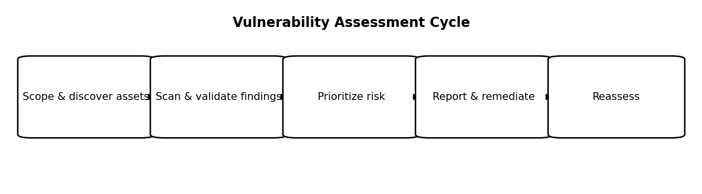
Figure 6: Vulnerability Assessment Cycle
7. Explain CVE and CVSS.
CVE: Common Vulnerabilities and Exposures
CVE is a public catalogue and naming system for disclosed cybersecurity vulnerabilities. A CVE identifier gives a particular vulnerability a consistent reference, commonly written as CVE-year-number, for example CVE-2024-XXXX as a format illustration. Security advisories, vulnerability databases, scanners, and patch notes use CVE identifiers so different teams can discuss the same issue without confusion. A CVE identifier identifies a vulnerability; it does not by itself describe every environment in which the issue is dangerous.
CVSS: Common Vulnerability Scoring System
CVSS is a framework for describing the technical severity of a vulnerability using a numerical score and supporting metrics. The metrics can consider attack vector, attack complexity, privileges required, user interaction, and the impact on confidentiality, integrity, and availability. CVSS v3.x base scores range from 0.0 to 10.0 and are commonly grouped into None, Low, Medium, High, and Critical severity categories. Organizations should identify which CVSS version and score they are using.
Difference between CVE and CVSS
CVE answers, 'Which publicly identified vulnerability are we discussing?' CVSS answers, 'How severe is this vulnerability according to the scoring framework?' A CVE identifier is a label, whereas CVSS is a severity assessment. Not every CVE has a complete score available immediately, and the same vulnerability may create different levels of practical risk in different environments.
Why severity alone is not enough
A security team should also consider whether the affected system is exposed to the internet, whether working exploits are available, whether the asset is business-critical, what data it holds, and whether active attacks are being reported. A medium-scored issue on a highly exposed critical system may deserve quick attention, while a high-scored issue on an isolated, unused system may have a different priority.
Example and conclusion
If a vulnerability database lists a software flaw under a CVE identifier and assigns it a high CVSS score, an organization can use the identifier to find patches and advisories, then use the score as one input to remediation planning. CVE supports consistent identification; CVSS supports severity comparison. Together with asset context and threat intelligence, they help teams make better patching decisions.

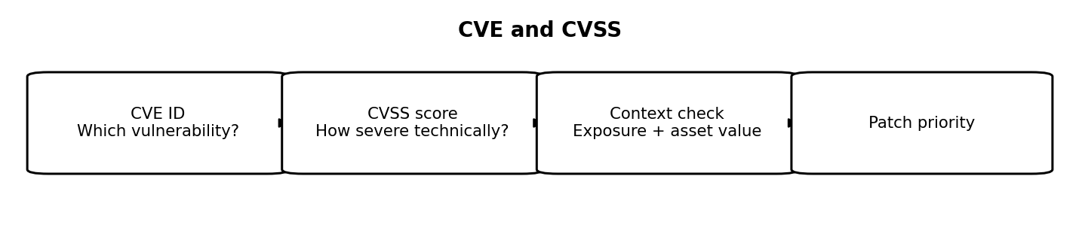
Figure 7: CVE and CVSS
8. What is threat data and OSINT?
Threat data
Threat data is information that describes possible, suspected, or active cybersecurity threats. It may include malicious IP addresses, domains, URLs, file hashes, phishing indicators, malware behaviour, vulnerability information, attacker tactics, techniques, procedures, and details about known campaigns. When analyzed and enriched, raw threat data can become useful threat intelligence that supports practical security decisions.
OSINT definition
OSINT stands for Open-Source Intelligence. It is the process of collecting and analyzing information from publicly accessible sources. Cybersecurity analysts may use public security advisories, company websites, domain registration records, public code repositories, certificate transparency records, public reports, and other lawful sources. OSINT does not automatically mean that every source is accurate or that every use of public information is appropriate.

OSINT collection and analysis process
1. Define the question: decide what needs to be learned, such as whether a domain is associated with a campaign.
2. Collect: gather relevant information from suitable public sources.
3. Verify: check source reliability, dates, context, and corroborating evidence.
4. Correlate: connect related domains, IP addresses, hashes, infrastructure, and reports.
5. Analyze: decide what the evidence suggests and what remains uncertain.
6. Report: communicate findings, confidence, limitations, and recommended actions.
7. Review: update conclusions as new evidence appears.
Uses and limitations
Threat data and OSINT can help organizations discover exposed services, identify phishing infrastructure, investigate suspicious domains, track vulnerabilities, and understand attacker behaviour. However, data may be outdated, incomplete, misleading, or deliberately planted. Shared hosting and cloud services can also cause legitimate systems to appear alongside malicious indicators. Analysts should avoid treating a single unverified clue as proof.
Example and conclusion
An analyst investigating a suspicious email may examine the sending domain, related public security reports, domain history, and reported malicious URLs. The analyst then compares those details with internal email and network logs before deciding on a response. Collection should follow applicable law, privacy obligations, and source terms. In conclusion, threat data provides raw observations, while OSINT provides a method for collecting and analyzing public information to produce defensible security findings.

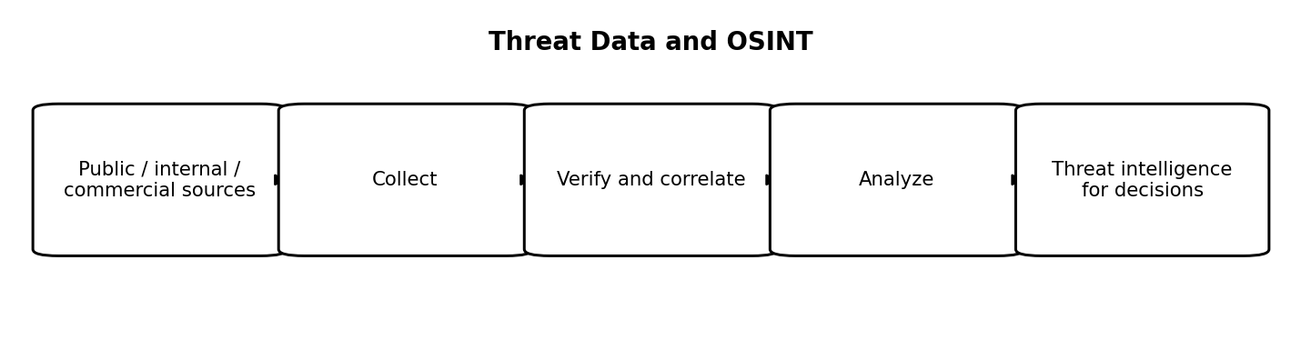
Figure 8: Threat Data and OSINT

9. What are Indicators of Compromise (IoCs)? Give examples.
Definition
Indicators of Compromise (IoCs) are observable clues that suggest a computer, account, or network may have been compromised. Security teams use IoCs to search logs, detect suspicious activity, investigate incidents, and help determine whether known malicious activity has reached their environment. IoCs are evidence to investigate, not always definitive proof on their own.
Common examples
1. File hashes: a cryptographic hash associated with a known malicious file.
2. IP addresses: addresses reported as command-and-control servers or other malicious infrastructure.
3. Domains and URLs: sites used to deliver malware, host phishing pages, or communicate with compromised systems.
4. File and process indicators: unexpected executables, suspicious process names, unusual file locations, or unauthorized persistence mechanisms.
5. Registry or configuration changes: unexpected changes that may help malware run after reboot.
6. Authentication indicators: unusual login locations, repeated failures, unexpected privilege changes, or suspicious account activity.
7. Network behaviour: unusual outbound connections, unexpected data transfers, or communication with known malicious infrastructure.
How IoCs are used
A security team may compare IoCs with endpoint logs, DNS queries, firewall records, email gateways, cloud logs, and security monitoring systems. A match creates an alert for investigation. Analysts should consider when the indicator was observed, which asset generated it, whether the source is reliable, and whether the activity is consistent with normal business operations. Multiple independent indicators can strengthen a conclusion.
Benefits and limitations
IoCs can accelerate detection and help teams share information about incidents. However, attackers frequently change domains, IP addresses, files, and tools. Some indicators can also be shared by legitimate users, such as cloud-hosted infrastructure. A hash may detect one known file but miss a modified version. For this reason, IoCs should be combined with behaviour-based detection, context, and current threat intelligence.
Example and response
If an endpoint connects to a domain associated with malware, the security team should not rely only on the domain match. It should inspect DNS and network logs, examine the endpoint, check for suspicious processes, and determine whether data or credentials were affected. If compromise is confirmed, the team may isolate the device, preserve evidence, remove the threat, reset affected credentials, and monitor for recurrence.
Conclusion
IoCs are useful signals for threat detection and incident response. Their value depends on freshness, confidence, context, and proper investigation.

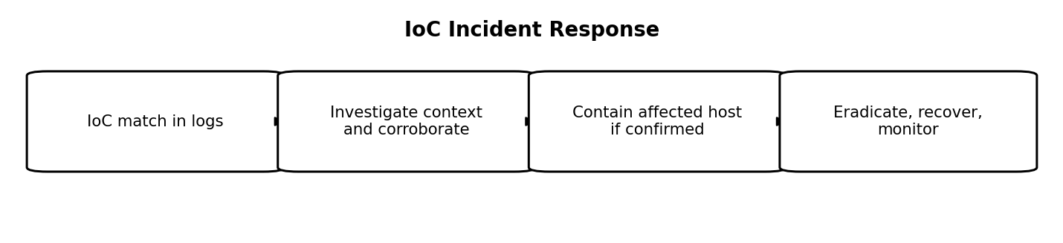
Figure 9: IoC Incident Response
10. What are threat feeds and how are they used?
Definition
A threat intelligence feed is a stream of updated information about known or suspected cybersecurity threats. A feed may contain malicious IP addresses, domains, URLs, file hashes, vulnerability notices, malware indicators, attacker tactics, or details about campaigns. Feeds may be public, commercial, community-based, or produced internally by an organization's own security team.
How threat feeds are used
1. Ingestion: collect data from selected feeds into security systems such as a SIEM, firewall, endpoint detection platform, email gateway, or threat-intelligence platform.
2. Normalization: convert different formats into consistent fields and remove duplicate records.
3. Validation: evaluate source reliability, confidence, freshness, and relevance to the organization.
4. Enrichment: add context such as first-seen time, threat type, related campaign, and source notes.
5. Matching and detection: compare feed indicators with logs, files, DNS activity, web requests, and network connections.
6. Investigation: examine alerts and gather additional evidence before concluding that an incident has occurred.
7. Response: block or isolate activity when confidence and policy justify it.
8. Maintenance: expire stale indicators, monitor feed quality, and review whether the feed is producing useful detections.
Benefits
Threat feeds can help security teams learn about new malicious infrastructure, enrich alerts, identify known indicators, and respond more quickly to recurring threats. Integration with monitoring tools can reduce manual searching and make information available across the security team. Feeds are especially useful when combined with local observations and a clear response process.
Risks and limitations
Not every feed is accurate or timely. Low-quality data may produce false positives, waste analyst time, or cause legitimate services to be blocked. Indicators can become stale when attackers abandon infrastructure, and an indicator that is malicious in one context may be shared with legitimate services in another. Automatically blocking every indicator without validation can therefore disrupt business operations.
Example
A company receives a feed update containing a domain associated with credential theft. Its email gateway checks incoming messages for links to that domain and flags matching emails. An analyst reviews the message, verifies the source and context, checks whether users clicked the link, and follows the incident-response process. The company can then remove the message and protect affected accounts if necessary.
Conclusion
Threat feeds help transform external and internal threat information into practical detections. They work best when the organization checks quality, adds context, updates indicators regularly, and uses automation carefully.
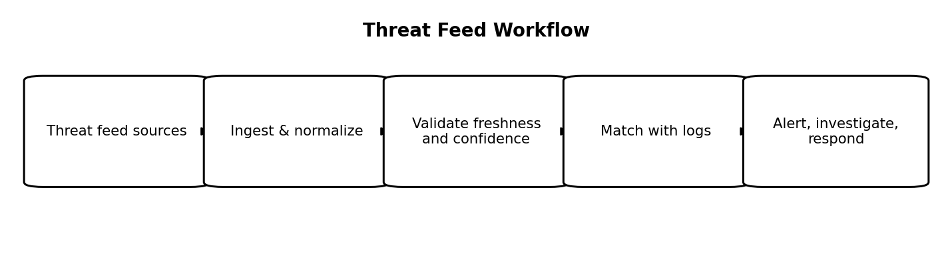
Figure 10: Threat Feed Workflow

