SIMATS ENGINEERING
CSA6303- Threat Intelligence and Network Security
A2-Vulnerability Assessment Report
Assessment Questions
Subject | Threat Intelligence | Total Marks | 50
Questions | 10 (all compulsory) | Marks per Question | 5
REg.No | 192365025 | Name | KONGARA SAI
Faculty | Dr.V.Parthipan | Slot | A
Instructions: Answer all questions. Each question carries 5 marks. Support answers with examples and diagrams where appropriate.
Code of Conduct:

I kongara sai/192365025 certify that this submission is my original work and that I have adhered to the guidelines specified for this assessment. I understand that any violation of academic integrity rules will result in disciplinary action.

Signature of Student

k.sai

A2 – VULNERABILITY ASSESSMENT REPORT

Q1. Explain the common types of network attacks: malware, phishing, DoS and DDoS. Give one example and one preventive measure for each. (10 marks)
Network attacks are attempts to compromise the confidentiality, integrity or availability of computer systems and data. Four common types are malware, phishing, Denial of Service (DoS) and Distributed Denial of Service (DDoS).
1. Malware: Malware is malicious software designed to damage a system, disrupt operations or steal information. Common types include viruses, worms, Trojans, ransomware and spyware. Example: ransomware encrypts an organization’s files and demands payment. Prevention: keep reputable anti-malware software enabled, patch operating systems and applications, and avoid running untrusted attachments or downloads.
2. Phishing: Phishing uses deceptive emails, messages, links or websites to trick people into revealing passwords, banking details or other sensitive information. Example: an email impersonating a bank directs a user to a fake sign-in page. Prevention: provide user-awareness training, verify the sender and website address, use multi-factor authentication (MFA), and deploy email filtering.
3. Denial of Service (DoS): A DoS attack floods a service or network from a single main source, or otherwise exhausts its resources, making it unavailable to legitimate users. Example: one compromised computer sends repeated requests to a website until it becomes unresponsive. Prevention: use firewalls, rate limiting, traffic monitoring and filtering.
4. Distributed Denial of Service (DDoS): A DDoS attack uses many distributed devices, often a botnet, to overwhelm a target with traffic. Example: compromised Internet-connected devices flood an online store during a sale. Prevention: use a content delivery network (CDN), DDoS protection or traffic-scrubbing service, rate limiting and an incident-response plan.
In summary, malware targets systems or data, phishing targets users, and DoS/DDoS attacks primarily target service availability. Layered technical controls and user awareness reduce risk.
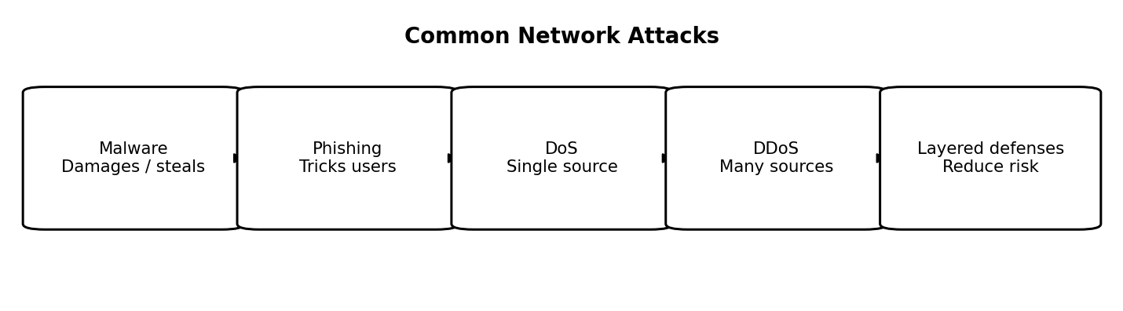
Figure 1: Common Network Attacks

Q2. What is a Man-in-the-Middle (MitM) attack? Describe how it works and the techniques used to carry it out, and list the countermeasures. (8 marks)
A Man-in-the-Middle (MitM) attack occurs when an attacker positions themselves between two communicating parties and secretly intercepts, relays or alters their communication. The users may believe they are communicating directly with the legitimate service.
How it works:
1. The attacker gains a position on the communication path, for example on an insecure public Wi-Fi network.
2. The victim sends traffic intended for a legitimate service.
3. The attacker intercepts or relays the traffic. If the connection is not adequately protected, information may be read or modified.
4. The attacker may capture credentials, session information or sensitive messages, or change the content before forwarding it.
Common techniques include:
• ARP poisoning: sending forged Address Resolution Protocol messages on a local network to redirect traffic.
• Rogue Wi-Fi access points: setting up a deceptive wireless hotspot that users join.
• DNS spoofing: manipulating name-resolution responses so a user is directed to an unintended address.
• Session hijacking: stealing or reusing a valid session token to act as an authenticated user.
Countermeasures:
• Use HTTPS with modern TLS and never ignore certificate warnings.
• Validate certificates and ensure applications reject invalid certificates.
• Use a trusted VPN on untrusted networks where appropriate.
• Enable HTTP Strict Transport Security (HSTS) on websites.
• Secure Wi-Fi with strong encryption and avoid unknown hotspots.
• Use dynamic ARP inspection and other network access controls on managed switches.
• Protect session cookies with Secure, HttpOnly and appropriate SameSite attributes, and use MFA.
MitM risk is reduced when both endpoints authenticate each other and communication is encrypted end-to-end.
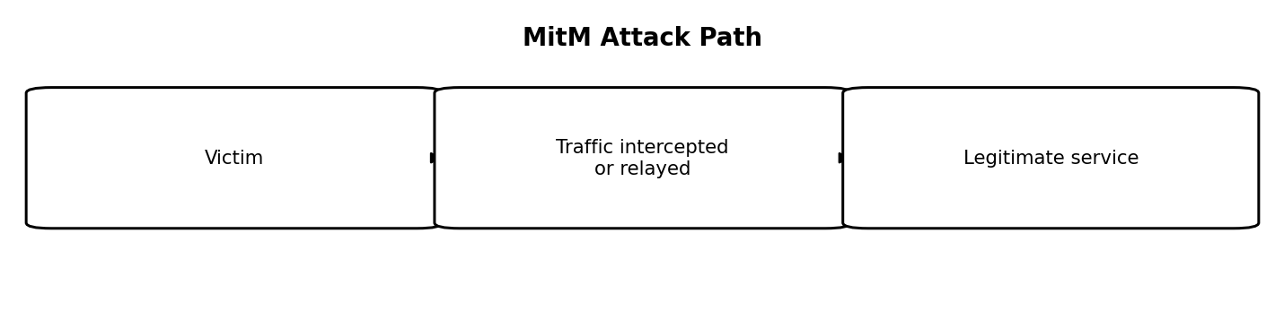
Figure 2: MitM Attack Path

Q3. Differentiate between spoofing and sniffing. Describe the types of spoofing and explain how sniffing can be detected or prevented. (8 marks)
Spoofing and sniffing are different network-related activities. Spoofing means falsifying an identity or source information to make traffic appear to come from a trusted source. Sniffing means capturing and inspecting network packets. Sniffing can be used for legitimate troubleshooting, but unauthorized sniffing may expose sensitive information.
Differences:
• Purpose: spoofing impersonates a device, user or service; sniffing observes network traffic.
• Method: spoofing forges information such as an address or sender identity; sniffing captures packets travelling across a network.
• Main risk: spoofing can support impersonation, redirection or access-control bypass; sniffing can expose credentials and data when traffic is unencrypted.
• Tools/examples: packet analyzers such as Wireshark and tcpdump are used for authorized packet capture and troubleshooting; spoofing may involve forged IP, MAC, email or DNS information.
Types of spoofing:
1. IP spoofing: forging the source IP address in packets.
2. MAC spoofing: changing a device’s presented MAC address.
3. Email spoofing: forging the sender field to make a message appear to come from another person or organization.
4. DNS spoofing: providing false DNS information to redirect a user to an unintended destination.
Detecting or preventing sniffing:
• Encrypt traffic using HTTPS/TLS, SSH and secure VPN connections so captured packets reveal less useful content.
• Use switched networks and properly configured wireless encryption to limit unnecessary exposure of traffic.
• Apply switch port security and restrict physical access to network equipment.
• Monitor network devices for unexpected interfaces, unauthorized packet-capture software, unusual promiscuous-mode activity where detectable, and suspicious traffic patterns.
• Use network access control and regularly review device inventories and logs.
• Never transmit passwords or sensitive information through unencrypted protocols.
Anti-spoofing filters, ingress/egress filtering, secure DNS practices and email authentication such as SPF, DKIM and DMARC help reduce spoofing. These controls address different risks and should be used together.
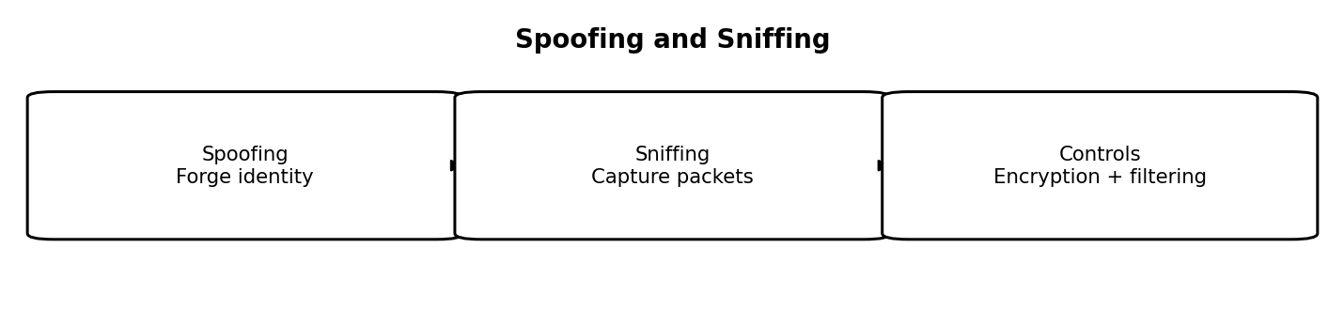
Figure 3: Spoofing and Sniffing

Q4. Define vulnerability assessment. Explain its steps and describe the contents of a good vulnerability assessment report. (8 marks)
A vulnerability assessment is a systematic process for identifying, evaluating and prioritizing security weaknesses in systems, networks, applications or configurations. Its purpose is to help an organization understand exposure and decide which weaknesses should be fixed first.
Steps in a vulnerability assessment:
1. Define scope and authorization: identify the systems, IP ranges, applications and testing limits; obtain permission before scanning.
2. Identify assets: create an inventory of hosts, operating systems, applications and network services.
3. Scan for vulnerabilities: use approved tools such as Nessus or OpenVAS to identify known weaknesses and misconfigurations.
4. Validate and analyze findings: remove duplicates, verify likely false positives and gather evidence without causing unnecessary disruption.
5. Rate risk: consider severity (for example, CVSS), exploitability, exposure, business importance and potential impact.
6. Report and prioritize: document findings, evidence and practical remediation steps.
7. Remediate and reassess: apply patches or configuration changes, then rescan to verify the fixes.
Contents of a good report:
• Executive summary: overall security posture and the most important risks.
• Scope and methodology: assets tested, dates, tools, assumptions and limitations.
• Findings: title, affected asset, description, evidence and relevant CVE identifier where available.
• Severity and impact: CVSS score where applicable, likely consequences and business risk.
• Remediation: specific, prioritized recommendations and suggested owners or timelines.
• Limitations and appendices: excluded assets, false-positive notes and supporting technical details.
Vulnerability assessment versus penetration testing: a vulnerability assessment primarily identifies and prioritizes weaknesses across a defined scope. A penetration test goes further by attempting controlled exploitation to demonstrate whether selected weaknesses can be chained or used to compromise systems. Both require authorization and can complement one another.
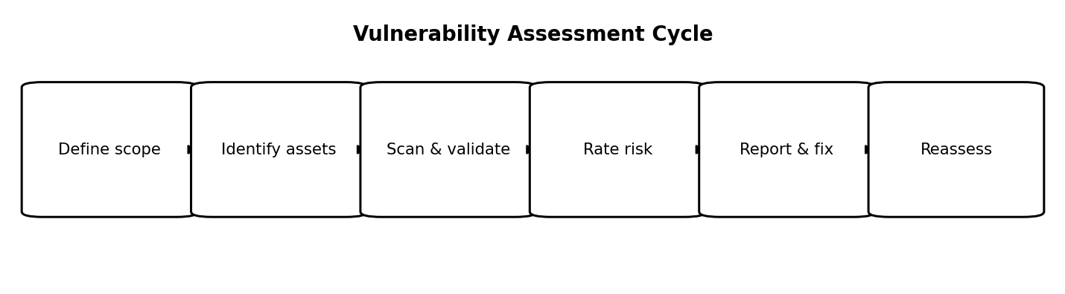
Figure 4: Vulnerability Assessment Cycle

Q5. What is Open-Source Intelligence (OSINT)? Discuss the common threat data sources and the techniques used to collect threat data. (8 marks)
Open-Source Intelligence (OSINT) is the process of collecting and analyzing information from publicly available sources to produce useful intelligence. In cybersecurity, OSINT helps defenders understand exposed assets, emerging threats, attacker infrastructure and possible risks. Public availability does not automatically mean that every use of data is lawful or ethical.
Common threat data sources:
1. WHOIS and domain-registration records: provide registration and domain-related information where available.
2. Shodan and other Internet-exposure search services: help identify publicly reachable devices and services.
3. Social media, news sites and public forums: may reveal threat reports, impersonation attempts, leaked information or emerging campaigns.
4. Code repositories: can expose accidentally committed secrets, vulnerable code or malicious packages.
5. CVE and National Vulnerability Database (NVD): provide vulnerability identifiers and technical details, including severity information where available.
6. DNS and certificate information: can help relate domains, subdomains and certificates.
7. Internal sources: system logs, firewall records, endpoint alerts and honeypots provide organization-specific evidence.
8. Commercial threat feeds: supply curated indicators, reports and contextual intelligence under a service agreement.
Collection techniques:
• Passive collection: review publicly available information without directly probing the target’s systems.
• Web searches and monitoring: use targeted searches and monitor trusted public advisories.
• Web scraping or APIs: collect permitted information from websites or services while respecting terms, access controls and rate limits.
• DNS and domain lookups: examine records and relationships between domains and IP addresses.
• Log and honeypot analysis: study observed events and suspicious interactions in systems controlled by the organization.
• Correlation and validation: compare multiple sources, record timestamps and confidence, and distinguish confirmed facts from unverified claims.
Legal and ethical considerations include obtaining authorization for active testing, respecting privacy and data-protection laws, following website terms and access restrictions, minimizing collected personal data, and securely storing any sensitive findings. OSINT is most useful when information is verified, relevant and placed in context.
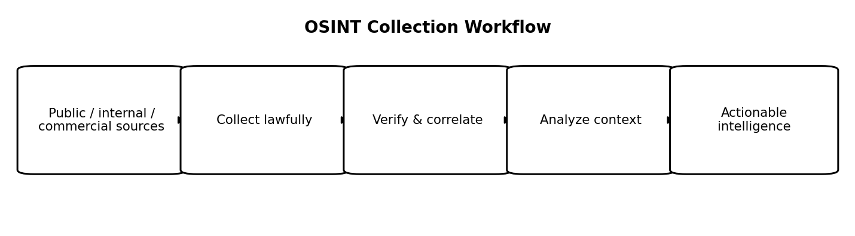
Figure 5: OSINT Collection Workflow

Q6. What are Indicators of Compromise (IoCs)? Explain the types of IoCs and describe how threat feeds help organizations improve their defense. (8 marks)
Indicators of Compromise (IoCs) are observable artifacts or signals that may indicate a system or network has been compromised or is associated with malicious activity. An IoC is evidence to investigate, not automatic proof of an attack; context and validation are important.
Types of IoCs:
1. File hashes: cryptographic hashes, such as SHA-256, that identify a known suspicious or malicious file.
2. IP addresses: network addresses associated with command-and-control servers, malicious infrastructure or suspicious activity.
3. Domains and URLs: domains or web addresses used for phishing, malware delivery or command-and-control.
4. File paths and names: locations or names associated with known malicious files, although these can be changed by attackers.
5. Registry keys and system artifacts: unexpected persistence-related entries or configuration changes on endpoints.
6. Email indicators: suspicious sender infrastructure, message patterns or attachment characteristics.
7. Network behavior: unusual outbound connections, repeated beaconing, unexpected protocols or abnormal traffic patterns.
How threat feeds help:
• They distribute IoCs and contextual threat information from open-source, government, community or commercial providers.
• Security teams can ingest suitable indicators into security information and event management (SIEM) platforms, endpoint tools, intrusion detection systems and firewalls.
• Matching observed logs or endpoint events against indicators can help prioritize alerts, identify affected assets and accelerate investigation.
• Validated indicators may support blocking or containment rules, subject to organizational policy and risk review.
• Common exchange standards include STIX for representing threat information and TAXII for exchanging it.
Limitations and good practice:
• False positives can occur when indicators are shared, reassigned or misclassified.
• Stale indicators may no longer be relevant, while attackers can quickly change domains, IP addresses and file hashes.
• Feeds vary in quality, coverage, timeliness and confidence.
• Organizations should record source, timestamp, confidence and expiry; correlate indicators with local evidence; and avoid automatic blocking when the potential business impact is high.
Threat feeds improve visibility and response speed when their indicators are timely, trustworthy and used with contextual analysis.
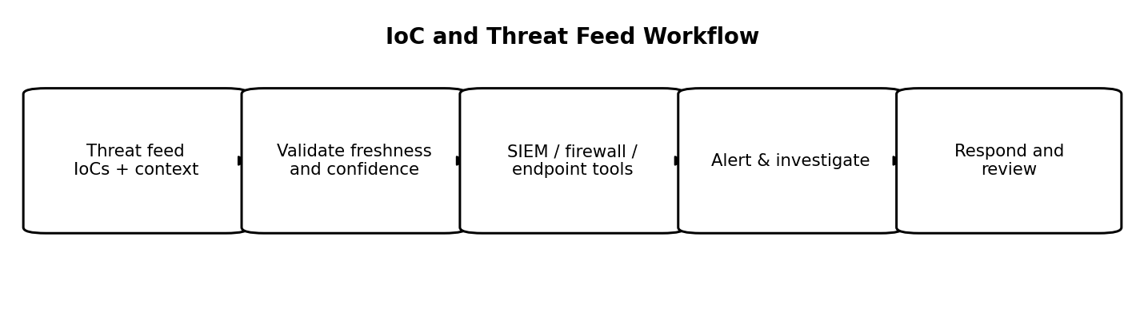
Figure 6: IoC and Threat Feed Workflow

