52.05-13-53.57
- 联网失败，不休眠
- 晚上连不上网。
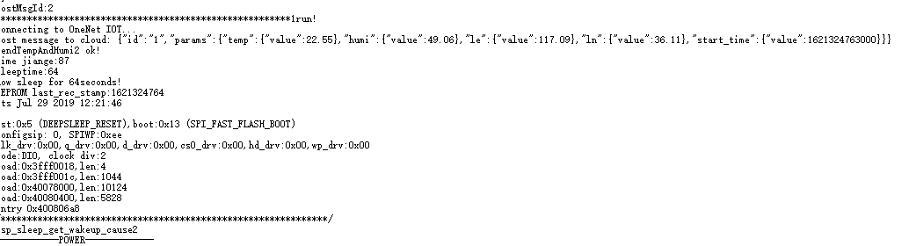
- 下载完后 lose 和LIST frist flag 不是第一次
- 停止记录后，不穿漏发。
- 发送格式错误
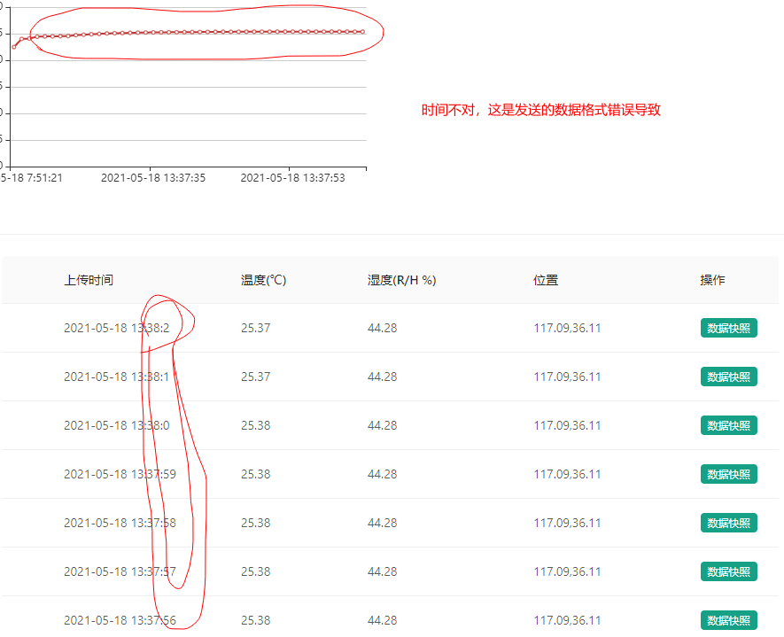

联onenet失败
ets Jul 29 2019 12:21:46
/**************************************************************/
esp_sleep_get_wakeup_cause2 //使用RTC\u IO的外部信号引起的唤醒

------------POWER-------------
IP5306 setPowerBoostKeepOn: OK
Battery from ADC: 4.23V
------------POWER-------------
IP5306 Battery level:154%
Battery from ADC: 4.23V
------------POWER-------------
workingState:0 // NOTWORKING
oledState:0 //关OLED
EEPROM 1: 1 //
FFS size:1378241,used:0 //文件系统大小
this is not the first load //不是第一次加载
sleeptime:64 //睡眠时间
tempUpperLimit:50.00 //温度上限
tempLowerLimit:-40.00 //温度下限
//几个时间
last_rec_stamp:1621326267 //
screen_On_last_span:1621326267
screen_Off_to_sleep_span:1621326267
time now: 21-5-18 9:20:10
sleep count: 3343 ,end_time:1621329610,last_rec_stamp:1621326267

displayOn
longPressStart
duringLongPress:1010
longPressStop
workingState = WORKING;

.//采集时间到
zhengchang mode time Ok!
Initializing modem...
Waiting for network... OK
Connecting to APN: CMNET OK
signalQuality:
13
getting LBS...
zhengchang mode wangluo OK!//连接网络成功

start save list ... //记忆到LIST
list not the first rec! 这里不对要解决这个问题
file size:89
,{"tm":"20210518 09:20:33","tmsp":1621329633,"tp":23.50,"h":48.02,"E":117.09,"N":36.11}
]}
postMsgId:1
1*******************************************************1run!
connecting to OneNet IOT... //连接ONENET
onenet_connect fial! //连接ONENET失败，下面要显示漏发状态。
start save lose ...
lose_count:1
Reading file: lose.hex
lose size:8
945181719616313546
/*****************************READ LOES END***********************************/

漏传文件数目不对
ets Jul 29 2019 12:21:46

/**************************************************************/
esp_sleep_get_wakeup_cause4//计时器引起的唤醒

------------POWER-------------
IP5306 setPowerBoostKeepOn: OK
Battery from ADC: 4.23V
------------POWER-------------
IP5306 Battery level:51%
Battery from ADC: 4.23V
------------POWER-------------
workingState:1
oledState:0
EEPROM 1: 1
FFS size:1378241,used:1004
this is not the first load
sleeptime:64
tempUpperLimit:50.00
tempLowerLimit:-40.00
last_rec_stamp:1621329710
screen_On_last_span:1621329710
screen_Off_to_sleep_span:1621329710
time now: 21-5-18 9:22:55
sleep count: 65 ,end_time:1621329775,last_rec_stamp:1621329710

zhengchang mode time Ok!
Initializing modem...
Waiting for network... OK
Connecting to APN: CMNET OK
signalQuality:
15
getting LBS...
zhengchang mode wangluo OK!
start save list ...
list not the first rec!
file size:178
//先解决SM的问题：
,{"tm":"20210518 09:20:33","tmsp":1621329633,"tp":23.50,"h":48.02,"E":117.09,"N":36.11}
,{"tm":"20210518 09:23:13","tmsp":1621329793,"tp":23.53,"h":47.59,"E":117.09,"N":36.11}
]}
postMsgId:2
1*******************************************************1run!
//没有检测漏发标志
connecting to OneNet IOT...
Post message to cloud:
{"id":"1","params":{"temp":{"value":23.53},"humi":{"value":47.59},"le":{"value":117.09},"ln":{"value":36.11},"start_time":{"value":1621329793000}}}
sendTempAndHumi2 ok!
time jiange:84
sleeptime:64
now sleep for 64seconds!
EEPROM last_rec_stamp:1621329794

有一次发送

ets Jul 29 2019 12:21:46

/**************************************************************/
esp_sleep_get_wakeup_cause4计时器引起的唤醒
------------POWER-------------
IP5306 setPowerBoostKeepOn: OK
Battery from ADC: 4.23V
------------POWER-------------
IP5306 Battery level:51%
Battery from ADC: 4.23V
------------POWER-------------
workingState:1
oledState:0
EEPROM 1: 1
FFS size:1378241,used:1004
this is not the first load
sleeptime:64
tempUpperLimit:50.00
tempLowerLimit:-40.00
last_rec_stamp:1621329710
screen_On_last_span:1621329710
screen_Off_to_sleep_span:1621329710
time now: 21-5-18 9:22:55
sleep count: 65 ,end_time:1621329775,last_rec_stamp:1621329710

zhengchang mode time Ok!
Initializing modem...
Waiting for network... OK
Connecting to APN: CMNET OK
signalQuality:
15
getting LBS...
zhengchang mode wangluo OK!

//这里显示温湿度坐标参数
start save list ...
list not the first rec!
file size:178
,{"tm":"20210518 09:20:33","tmsp":1621329633,"tp":23.50,"h":48.02,"E":117.09,"N":36.11}
,{"tm":"20210518 09:23:13","tmsp":1621329793,"tp":23.53,"h":47.59,"E":117.09,"N":36.11}
]}
postMsgId:2
1*******************************************************1run!
connecting to OneNet IOT...
Post message to cloud:
{"id":"1","params":{"temp":{"value":23.53},"humi":{"value":47.59},"le":{"value":117.09},"ln":{"value":36.11},"start_time":{"value":1621329793000}}}
sendTempAndHumi2 ok!
time jiange:84
sleeptime:64
now sleep for 64seconds!
EEPROM last_rec_stamp:1621329794

OK
Connecting to APN: CMNET OK
signalQuality:
15
getting LBS...
zhengchang mode wangluo OK!
start save list ...
list not the first rec!
file size:267
,{"tm":"20210518 09:20:33","tmsp":1621329633,"tp":23.50,"h":48.02,"E":117.09,"N":36.11}
,{"tm":"20210518 09:23:13","tmsp":1621329793,"tp":23.53,"h":47.59,"E":117.09,"N":36.11}
,{"tm":"20210518 09:24:38","tmsp":1621329878,"tp":23.53,"h":47.72,"E":117.09,"N":36.11}
]}
postMsgId:3
1*******************************************************1run!
connecting to OneNet IOT...
Post message to cloud: {"id":"1","params":{"temp":{"value":23.53},"humi":{"value":47.72},"le":{"value":117.09},"ln":{"value":36.11},"last_time":{"value":1621329878000}}}
sendTempAndHumi2 ok!
time jiange:85
sleeptime:64
now sleep for 64seconds!
EEPROM last_rec_stamp:1621329879

再一次

ets Jul 29 2019 12:21:46

rst:0x5 (DEEPSLEEP_RESET),boot:0x13 (SPI_FAST_FLASH_BOOT)
configsip: 0, SPIWP:0xee
clk_drv:0x00,q_drv:0x00,d_drv:0x00,cs0_drv:0x00,hd_drv:0x00,wp_drv:0x00
mode:DIO, clock div:2
load:0x3fff0018,len:4
load:0x3fff001c,len:1044
load:0x40078000,len:10124
load:0x40080400,len:5828
entry 0x400806a8
/**************************************************************/
esp_sleep_get_wakeup_cause4
------------POWER-------------
IP5306 setPowerBoostKeepOn: OK
Battery from ADC: 4.23V
------------POWER-------------
IP5306 Battery level:154%
Battery from ADC: 4.23V
------------POWER-------------
workingState:1
oledState:0
EEPROM 1: 1
FFS size:1378241,used:1255
this is not the first load
sleeptime:64
tempUpperLimit:50.00
tempLowerLimit:-40.00
last_rec_stamp:1621329879
screen_On_last_span:1621329879
screen_Off_to_sleep_span:1621329879
time now: 21-5-18 9:25:44
sleep count: 65 ,end_time:1621329944,last_rec_stamp:1621329879
zhengchang mode time Ok!
Initializing modem...
Waiting for network... OK
Connecting to APN: CMNET OK
signalQuality:
15
getting LBS...
zhengchang mode wangluo OK!
start save list ...
list not the first rec!
file size:356
,{"tm":"20210518 09:20:33","tmsp":1621329633,"tp":23.50,"h":48.02,"E":117.09,"N":36.11}
,{"tm":"20210518 09:23:13","tmsp":1621329793,"tp":23.53,"h":47.59,"E":117.09,"N":36.11}
,{"tm":"20210518 09:24:38","tmsp":1621329878,"tp":23.53,"h":47.72,"E":117.09,"N":36.11}
,{"tm":"20210518 09:26:04","tmsp":1621329964,"tp":23.54,"h":47.59,"E":117.09,"N":36.11}
]}
postMsgId:4
1*******************************************************1run!
connecting to OneNet IOT...
Post message to cloud: {"id":"1","params":{"temp":{"value":23.54},"humi":{"value":47.59},"le":{"value":117.09},"ln":{"value":36.11},"last_time":{"value":1621329964000}}}
sendTempAndHumi2 ok!
time jiange:87
sleeptime:64
now sleep for 64seconds!
EEPROM last_rec_stamp:1621329966

/*****************************READ LOES END***********************************/
start save list ... list_first_flag=0
list not the first rec!
file size:292
{"st":"20210518 10:35:01","data": [{"tm":"20210518 10:35:01","tmsp":1621334101,"tp":24.25,"h":46.17,"E":0.00,"N":0.00}
,{"tm":"20210518 10:35:34","tmsp":1621334134,"tp":24.28,"h":46.01,"E":0.00,"N":0.00}
,{"tm":"20210518 10:36:06","tmsp":1621334166,"tp":24.29,"h":45.90,"E":0.00,"N":0.00}
]}
postMsgId:3
*************************3******************************
//这里显示漏发标志
start save lose ...lose_first_flag = 0
lose_count:3
Reading file: lose.hex
lose size:24
912018896163152859123172489616315211891241723796163152150
/*****************************READ LOES END***********************************/

