Introduction

Nowadays, almost all the well-known film platforms on the market are comprehensive including all types of movies, which successfully meets the basic needs of most people but accordingly less convenient for people specifically interested in one filed. As a fiction movie lover, I want to develop a website for people like me, providing them an easy access to the latest news of the industry on different platforms.

**Interview questions**

1.你大概多久会看一次电影？在这之中科幻片的占比有多高？

How often do you go to the movies? What percentage of these are science fiction films?

2. 你一般从哪些渠道获得科幻电影资讯？

Where do you usually get the information of fiction movies from?

3. 你会特别关注某一类或者是某个导演/作者的科幻电影吗？

Do you pay special attention to a certain type or a certain director/author's science fiction films?

4.你觉得从这些渠道获得的信息靠谱吗？如果不靠谱你觉得有哪些可以改进的地方？

Do you think the information from these platforms is reliable? If not, what should be added to help them improve?

5. 请根据你的个人经验，列出至少三个有参考性的电影评分平台

Please list down at least three informative movie rating platforms based on your own experience.

6. 如果有一个专注于科幻电影的资讯集合平台，你会感兴趣吗？

Would you be interested if there was a collection of information platforms focused on science fiction films?

7. 请描述一下你看电影的流程。

Please describe your process of watching a film.

8. 你平常会经常在家看科幻片吗？如果是的话你一般从哪里得到片源？

Do you often watch fiction movies at home? If yes, where will you get the film source?

9. 你对专业影评人的意见怎么看？你会在多大程度上收到这些评论的影响？

Are you interested in the opinions of professional film critics? To what extent do they influence your decisions?

10. 你是否乐忠于分享你对一部科幻电影的看法？如果是请问你一般会分享到哪个平台？

Are you happy to share your thoughts on a science fiction film? If so, which platform do you usually share it on?

Persona types

After the interview, I have summarized three main types of users of this site, they are:

1. Science Fiction Lovers: People obsessed with science fiction and accordingly have a strong interest in science fiction films.
2. General Science Fiction Fans：People interested in fiction movies with less experience and consider more about the entertaining rather than the professional part of a film.
3. Beginners interested in science fiction films: Freshman in the field, looking for a platform to start.
4. Movie Bloggers: People who do the film commentary or recommendations on public media. They may not only focus on science fiction films, but need a convenient platform to collect information.

Journey Map

According to the result of previous interview, I choose the General Science Fiction Fans to do the journey map. Since they take the highest percentage of all interviewees and have very clear requirements for the platform I want to develop, I think they would be the perfect subjects for research.

Here is the journey map and story map of a general science fiction fan, Ivan.

<https://jamboard.google.com/d/1EzuU4Zb3N-_Uuo-pqHZFQJrpwzyKqs3Ci9Q4rQpomrk/edit?usp=sharing>

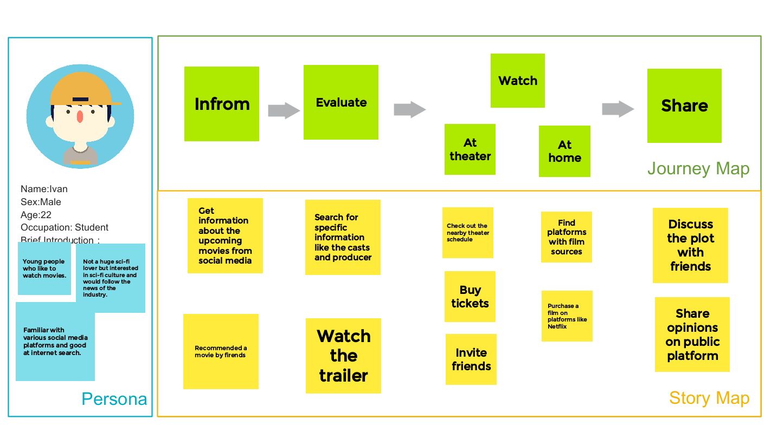

Problem Statement

The corresponding problem statement of the journey map above is: How might we help a general science fiction fan to integrate the information and resources of science fiction film so that their movie experience can be improved with convenience.?

**Open Card Sort**

Participant No. 1

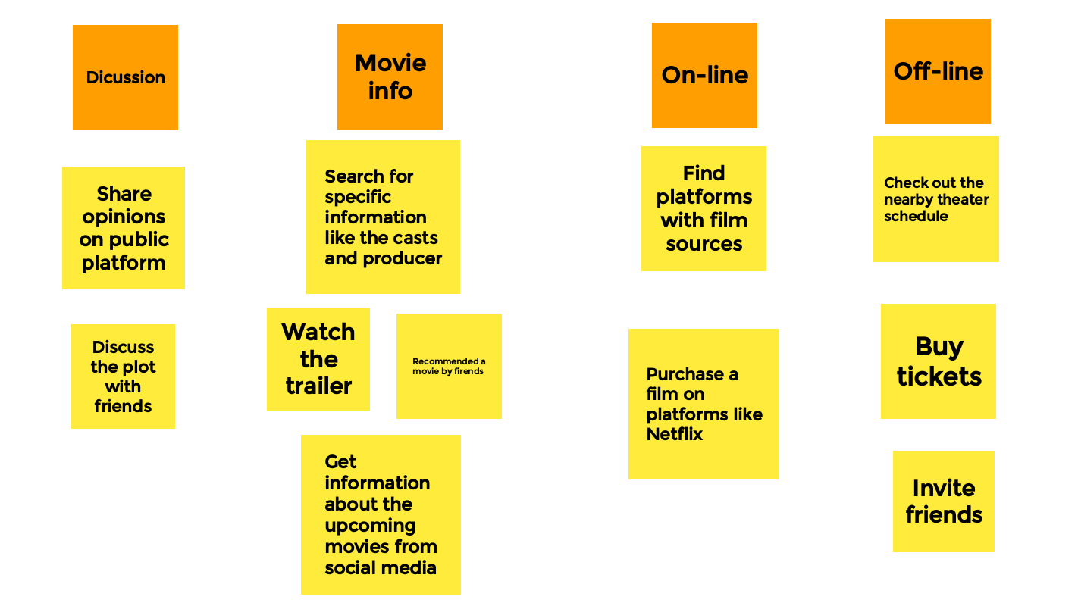

Participant No. 2

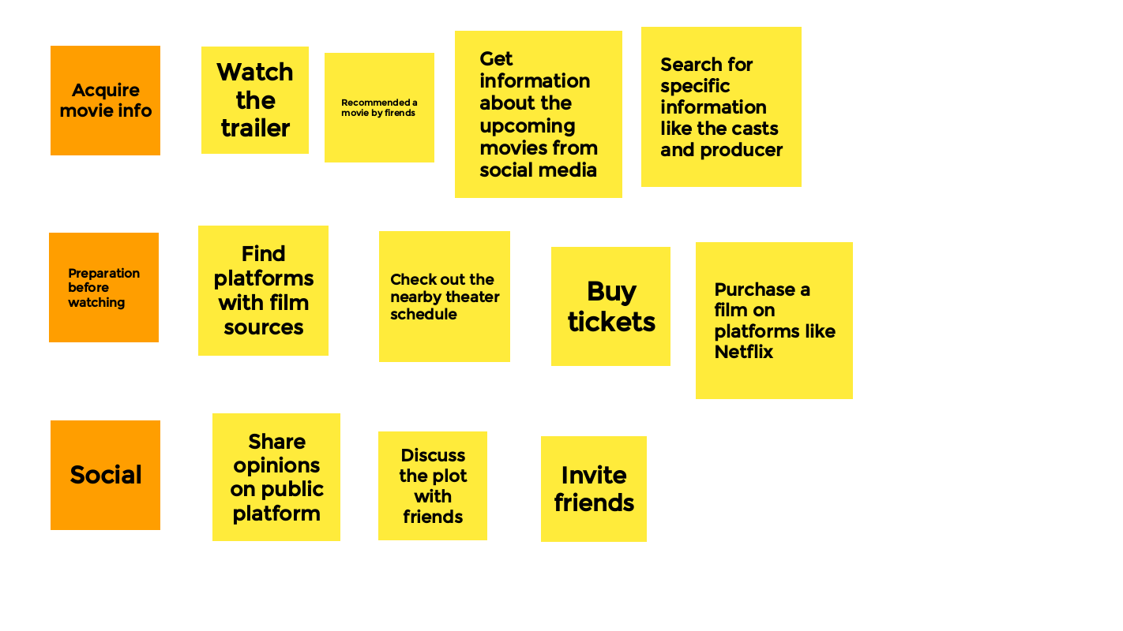

**Positioning Map**

Based on my personal definition and findings from interviews, the two main functions of the platform should be information integration specifically on sci-fi film and providing links to online resources. So here is the positioning map of this web.

