Usability Test Plan

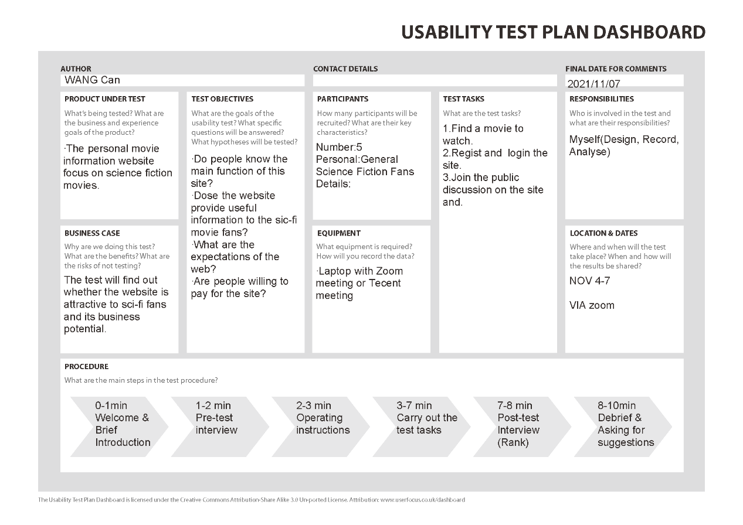

Test Result Analysis

After having the usability test with 5 general science fiction movie fans, I have got some useful information and suggestions from the test participants. In general, all the participants can understand the type of the website the first they saw the web and the main function (providing information specifically related to science fiction films) after finishing the test tasks and a brief free exploration. Besides that, here are the other advantages about this web according to most participants:

1. Concise design style, simple palpability visual effect. Many movie information platforms such as Douban have inserted too much elements including irrelative ads in the pages, it is good to only display the necessary features.
2. The desktop and mobile version share similar layouts in every pages and follow a consistent operation logic, which save the time of re-familiar when the version changes.
3. Focused features are highlighted with accent color, so when the participants were asked to perform a test task related to a key function, they can basically find the entry directly.

AS most of the good points raised by the participants focused on the overall design of the site, it proves that I am on the right track with the development and overall framework. However, there are also many disadvantages need to be improved. The following list the problems in terms of the frequency of which they were mentioned during the test tasks and importance in the view of the test participants.

1. Lack of the search bar. In the first test “Find a movie to watch”, although the button at the homepage and the prime navigation bar provide a very straightforward way to the movie list page (Actually the first reaction of almost all participants after hearing the task description was to click the buttons), they all express strong demand to the search bar as it is more convenient and more in line with their usual usage logic.
2. The homepage is a little bit monotonous. As mentioned before, the concise layout and limited elements are desirable, but the present homepage seems to be not rich enough. Some participants suggest to refine the recommendation module by defining a specific theme and increase the number of movies.
3. The segmentation of movies can be more diverse. There are only one kind of segmentation based on the genre right now. Adding more segmentation by different ways such as districts, release years or themes can satisfy more needs and let the site seems more professional. Base on this, one participant has even though of upgrading the current pure type system to a more flexible tagging system.
4. Need information detail page for each movie. At first, I though it is unnecessary to build separated detail pages, as the cards are already capable of carrying enough information. But in the first test , many participants would like to click the card and looking forward to see more details like the abstracts of the movie to make a better decision.
5. The discussion board is unfocused. Referring to some of the mainstream forum sites shown by participants, I find out that I may need to optimize the discussion board to have a better organization of the user generated contents and provide a reliable communication platform to the sci-fi fans.

As for the monetization problem, I do have asked them if I put a link to charge for the membership, whether they are really willing to click or do the further payment. Although some people said a simple link will not affect his/her basic impression to the site, there are also a couple of them said it will seem to be too urgent at the initial stage. I should consider delaying the time to charge for the membership since the primary task is to build an adequate platform. Not to mention I just use the prototype to do the test and what they can experience are actually pretty limited and it is hard to convince them to pay for a series wireframes.

Main improvements

According to above summary and analysis, I identify three main improvements need to be achieve.

1. **The search function.** The reason I didn`t provide the search function at first is that I think it will task a lot of time to achieve and the navigation is quite enough. However as it seems that most of the users are search-oriented, it is so necessary that I have to think about a possible solution. Although I can use the regular expression to convert the input to a legal DQL and search in database, the biggest challenge is the limited number of existing data. What if the movie they want is not in the database? At the moment I can only think of whether asking the user to manually supplement the missing movie they want to search or just record the input and flash a message saying ”We have receive your problem we will upload the movie later, thank you for your patient”.

**Modification example:**





1. **The detail page of movies.** Technically it is not hard, what I should do is collecting more data. But to be honest, it will cost lots of time on cleaning or translating the information I get.

**Modification example**

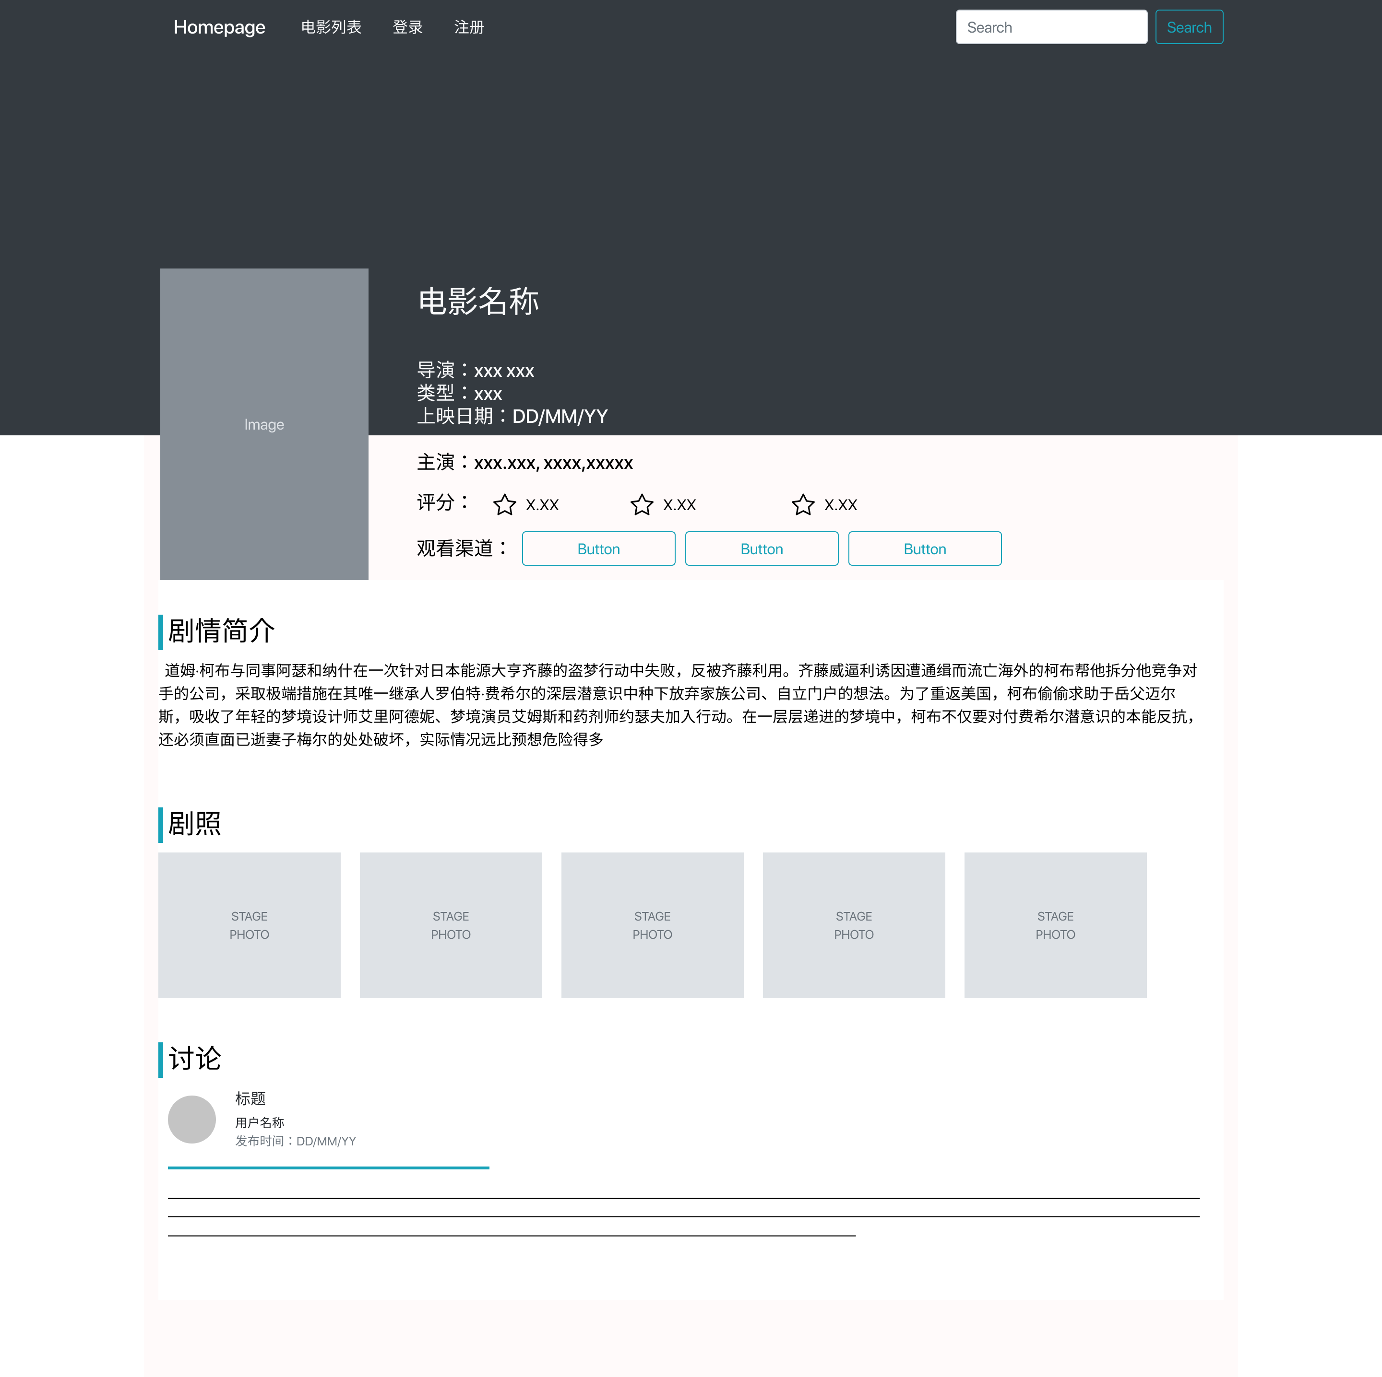

1. **Segment the movie list and discussion board.** These two tasks are similar since I may have to add more tag the movies and comments so that I can divide then to different subtypes. Basically, the segments of the movie list are quite clear and I decide to divide the discussion board into three sub-sections-mutual area, chatting room and opinion sharing zoom and separately add the discussion focusing on a specific movie to the corresponding detail page. But the management logic. Is still a big question.

**Modification example**

