
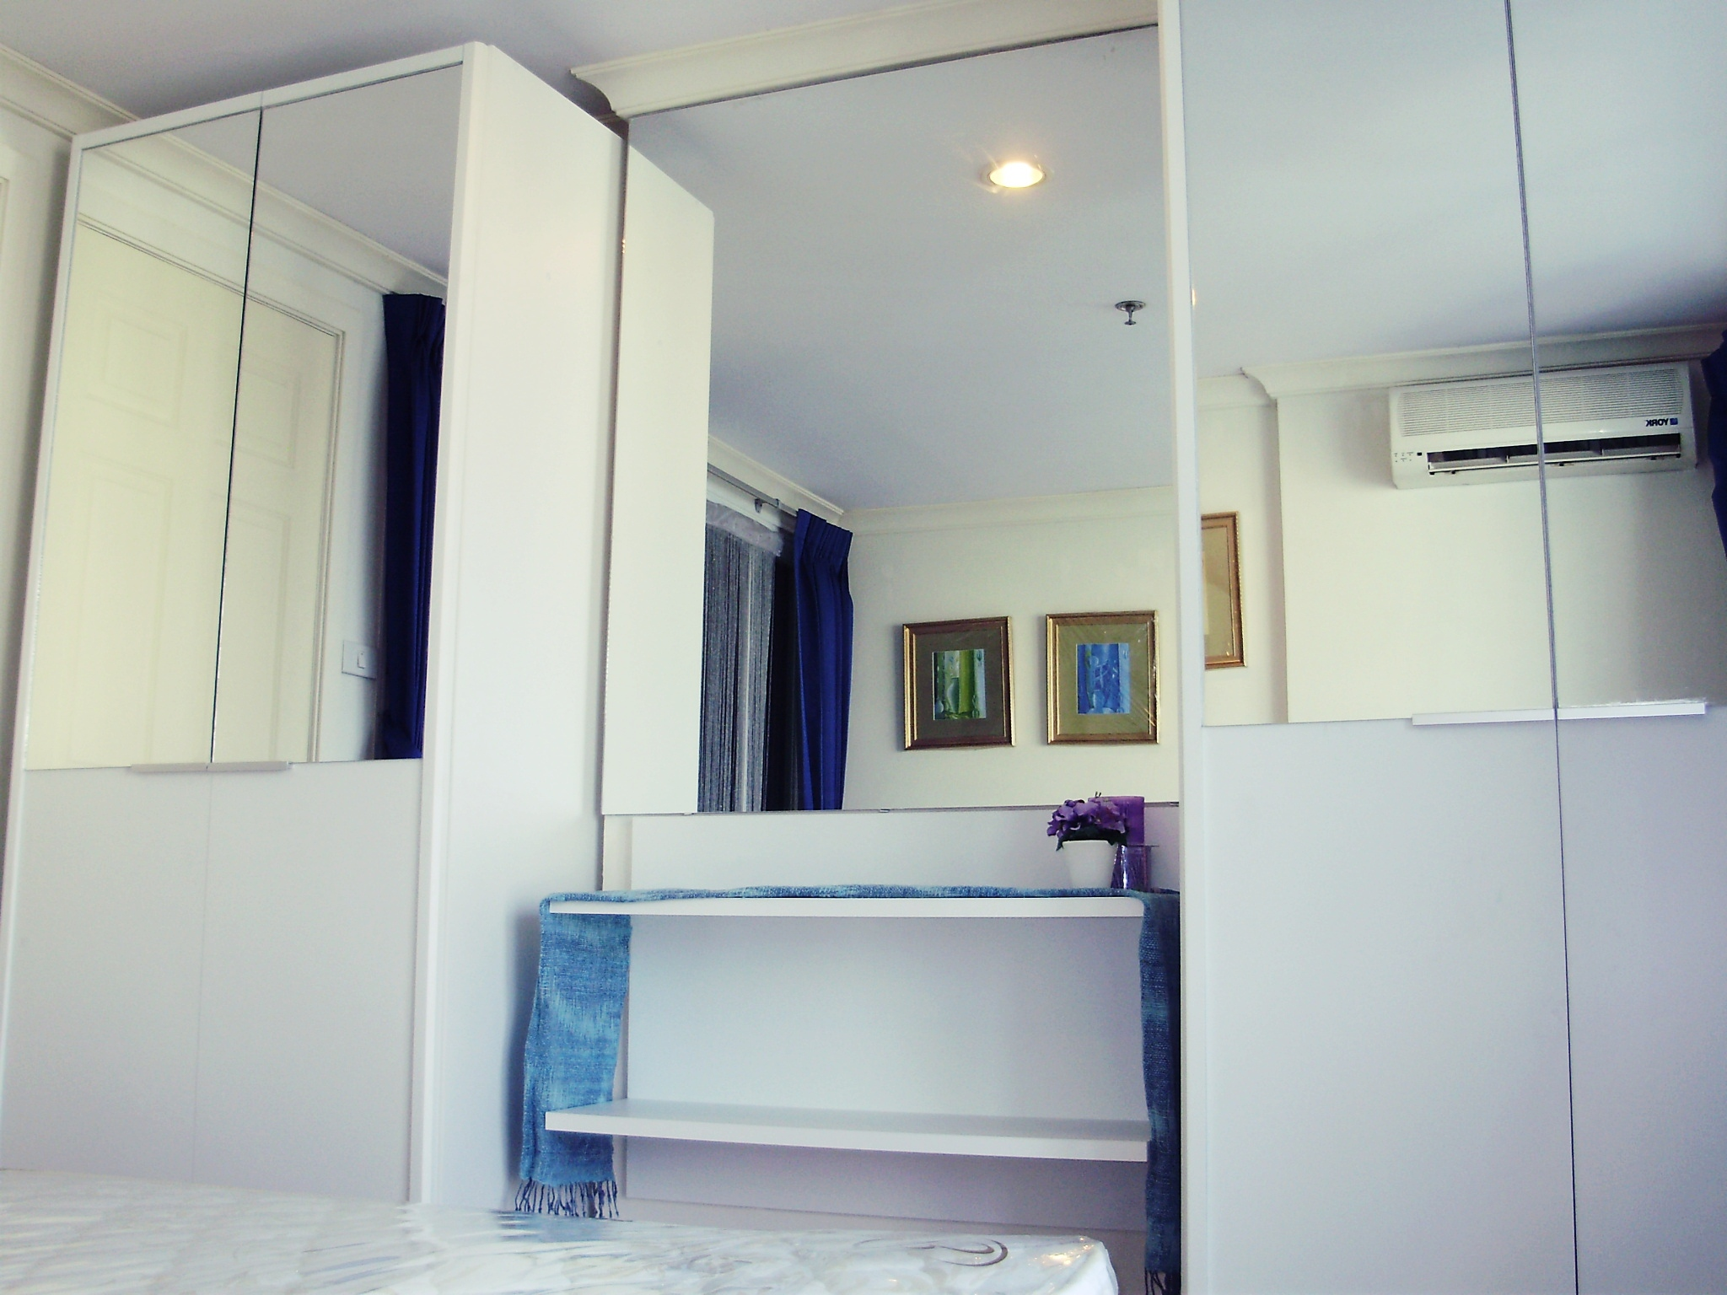
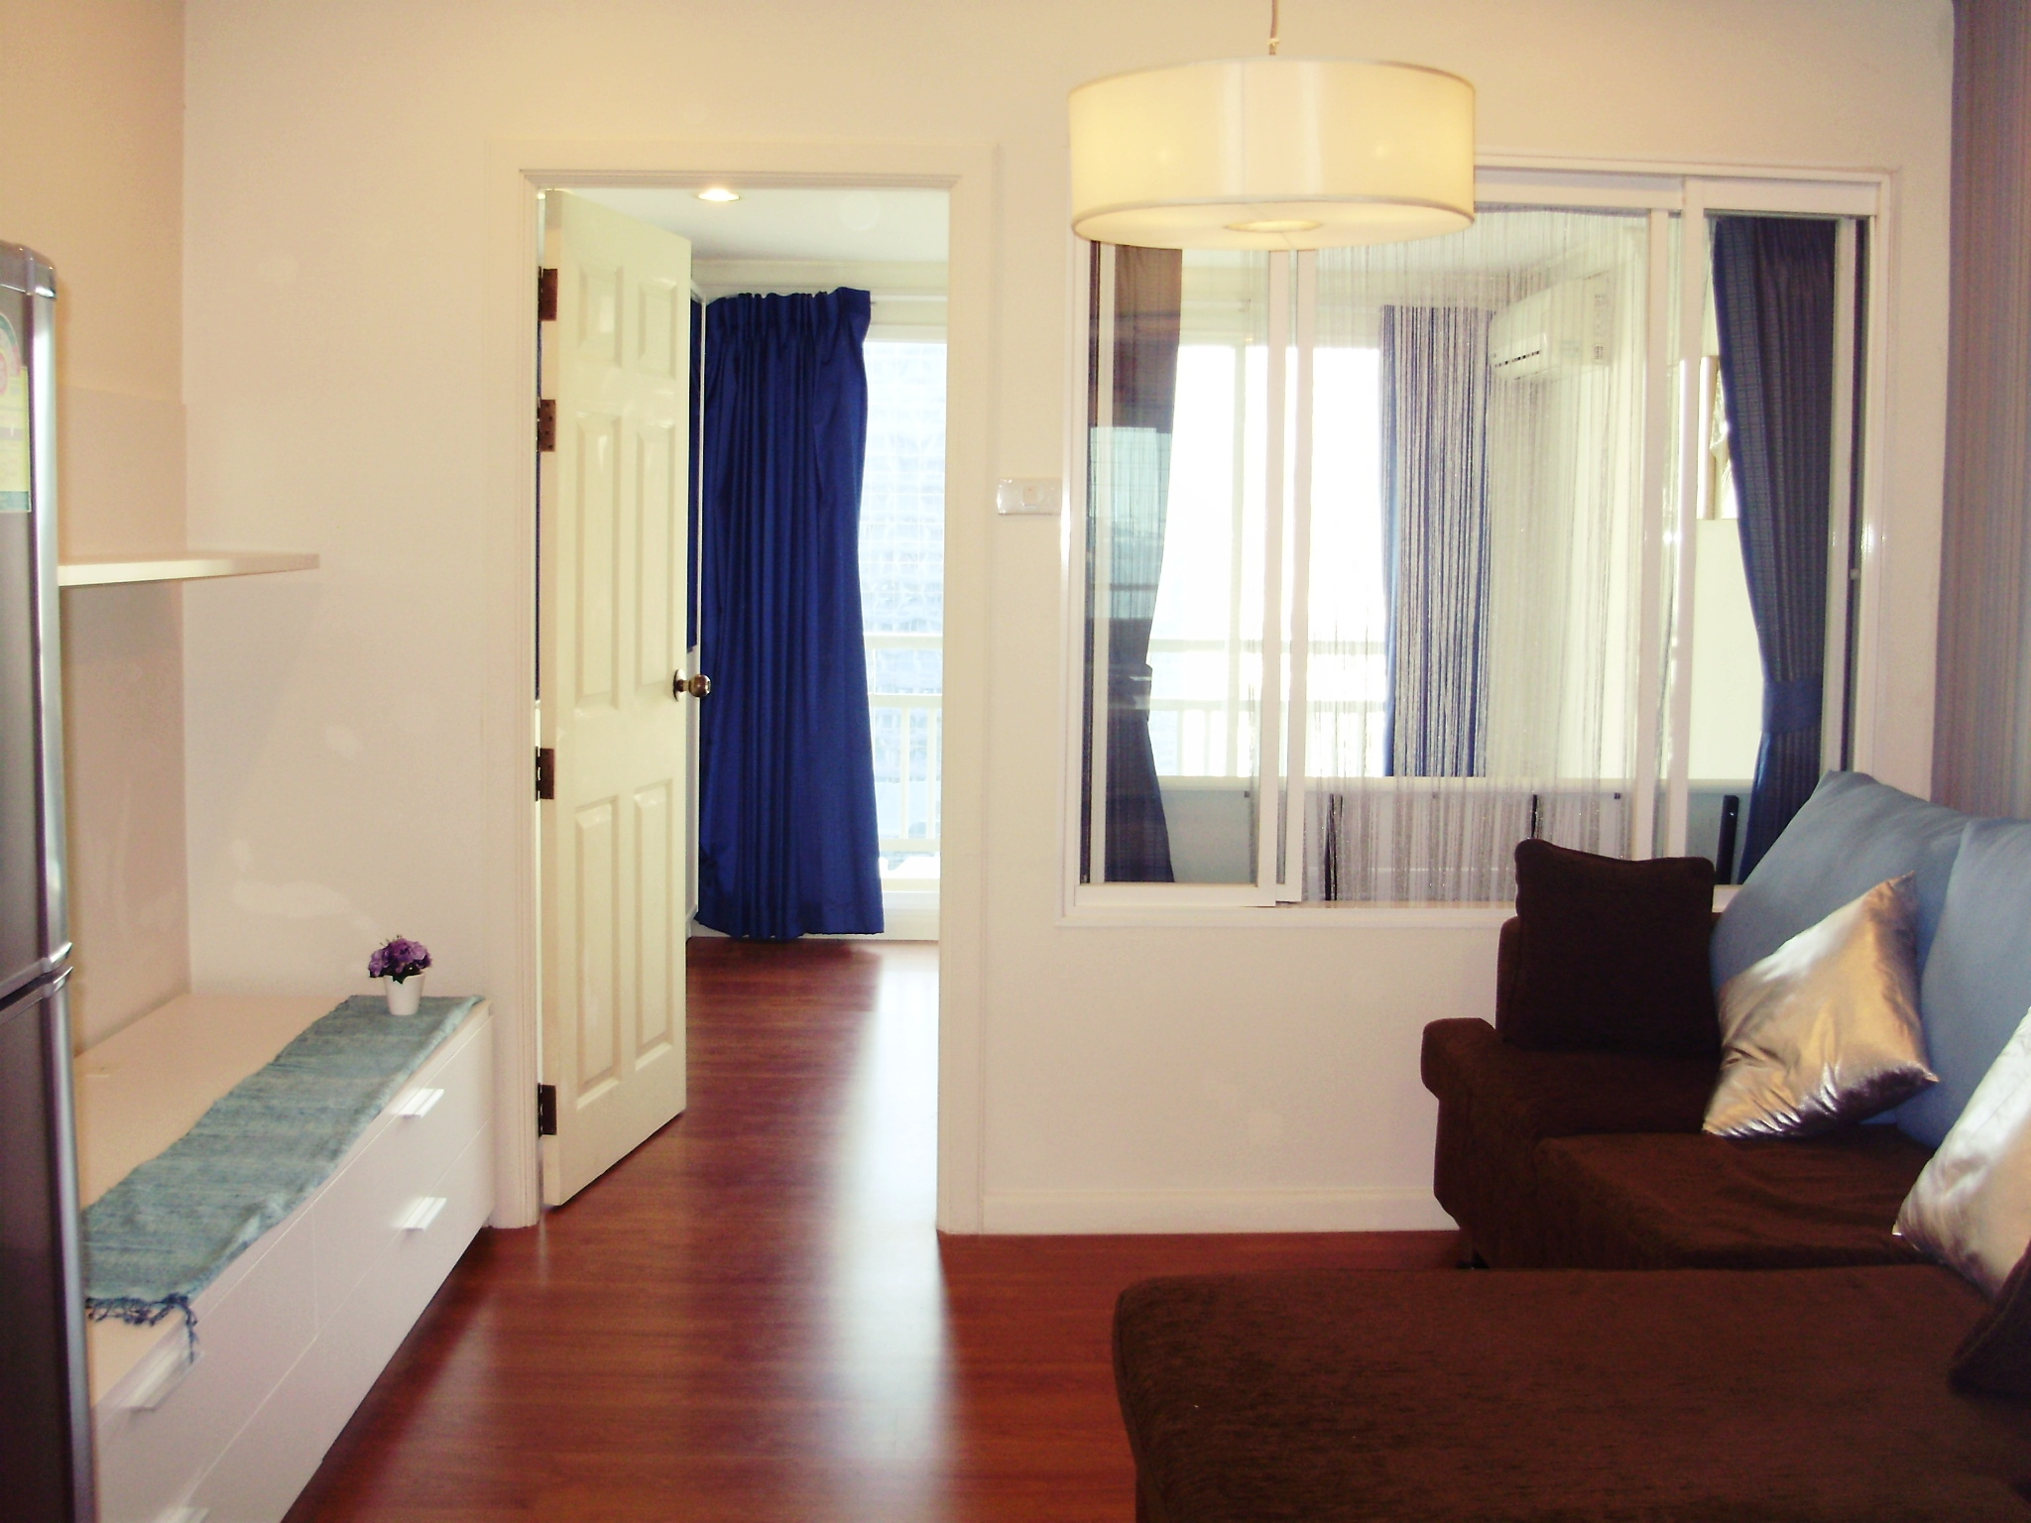
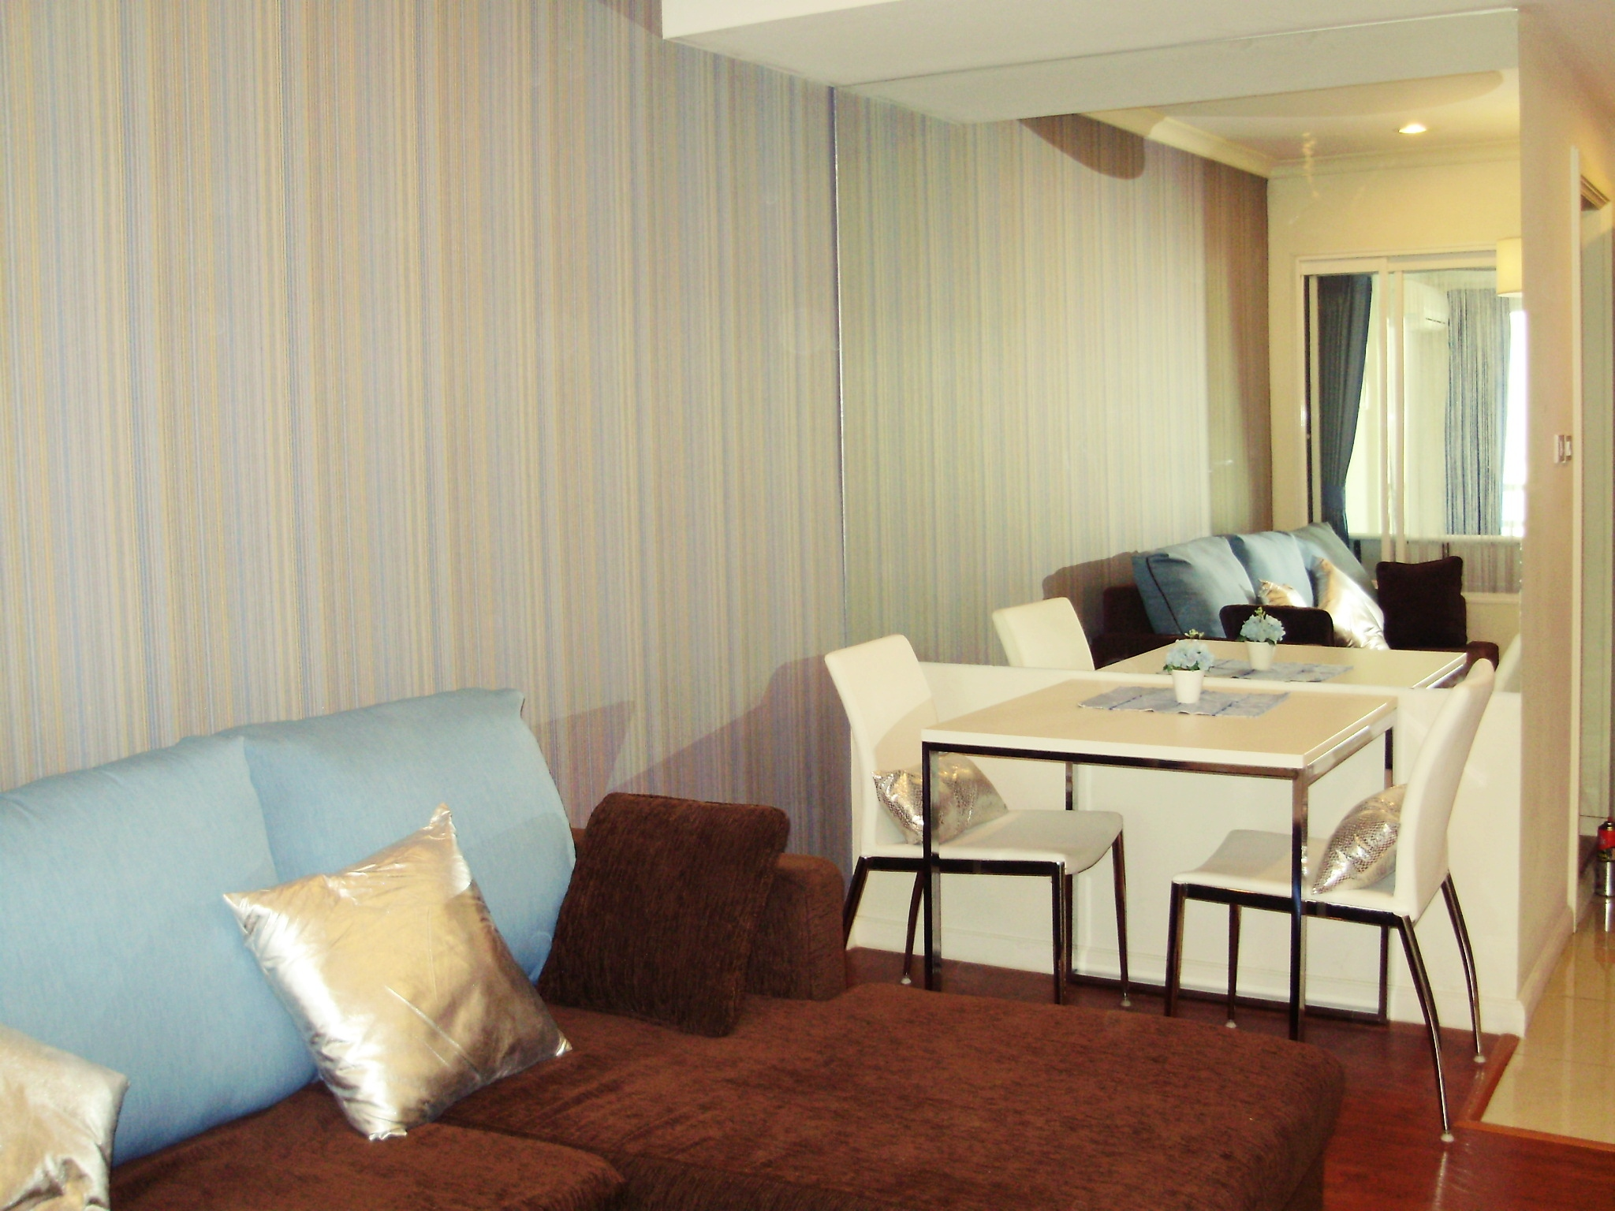
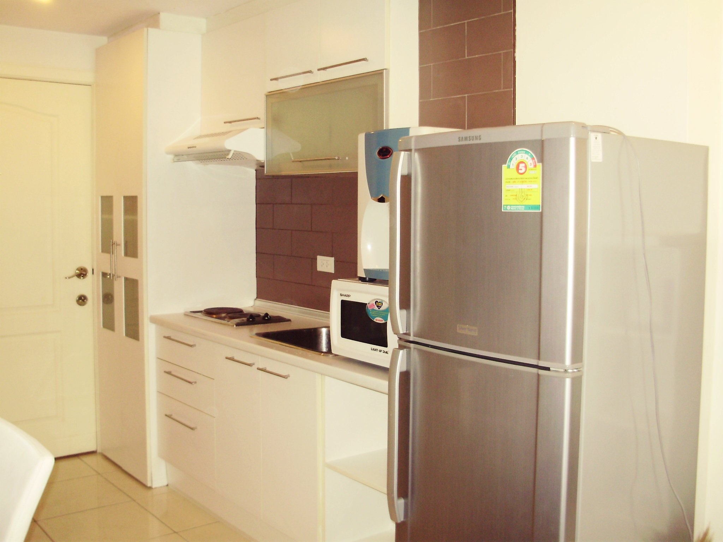
Condominium 35 sqm. Level 27
One bed room with balcony and swimming pool.
Sukhumvit soi 21. BTS & MRT Asoke Station.
Include : Furniture,
Air-condition, TV, Refrigerator.
22,000 baht/month
.

081-657-7659

Grand Park View

Sukhumvit Soi 21
BTS – MRT Asoke

