
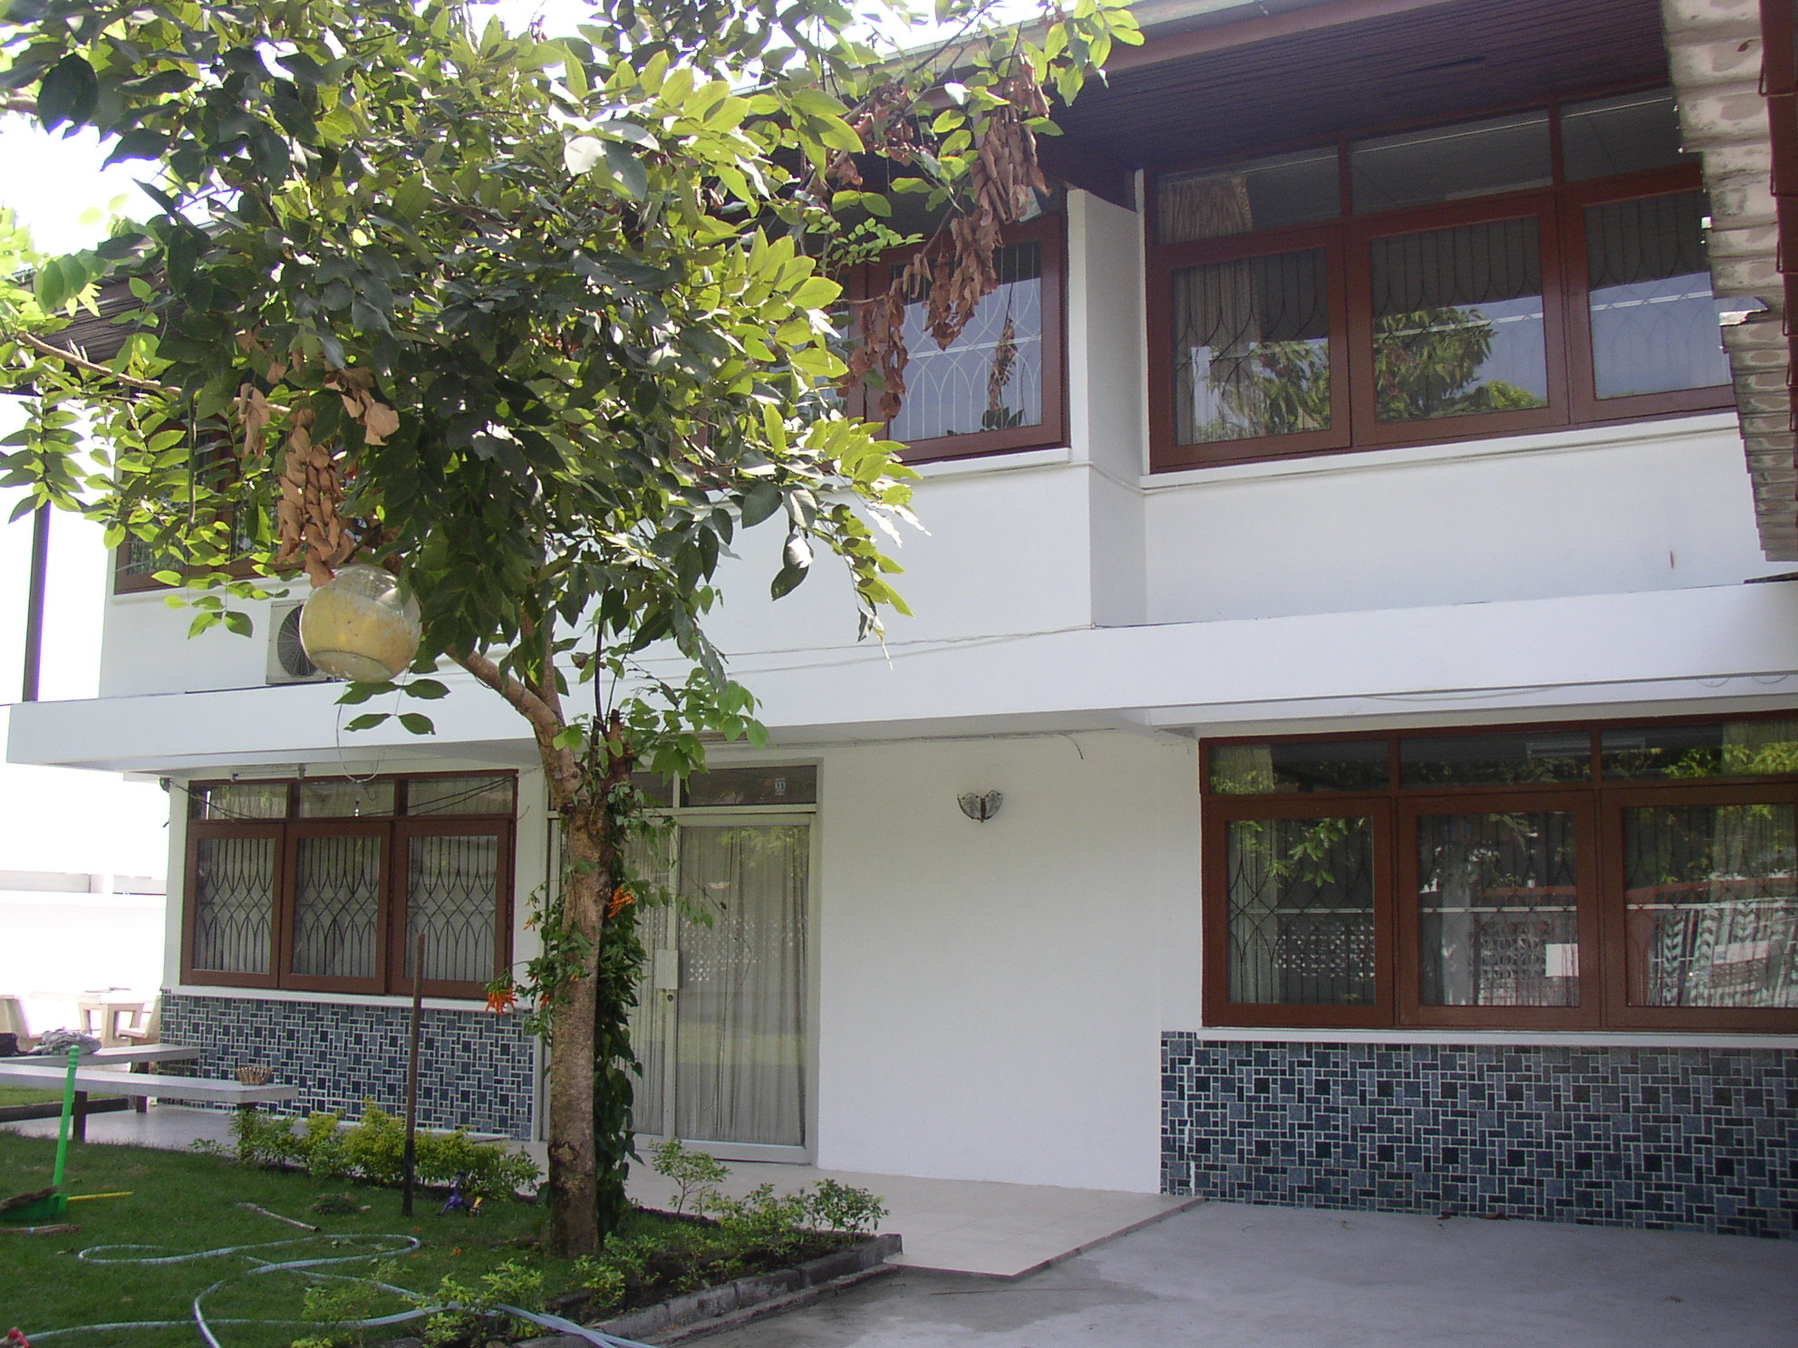
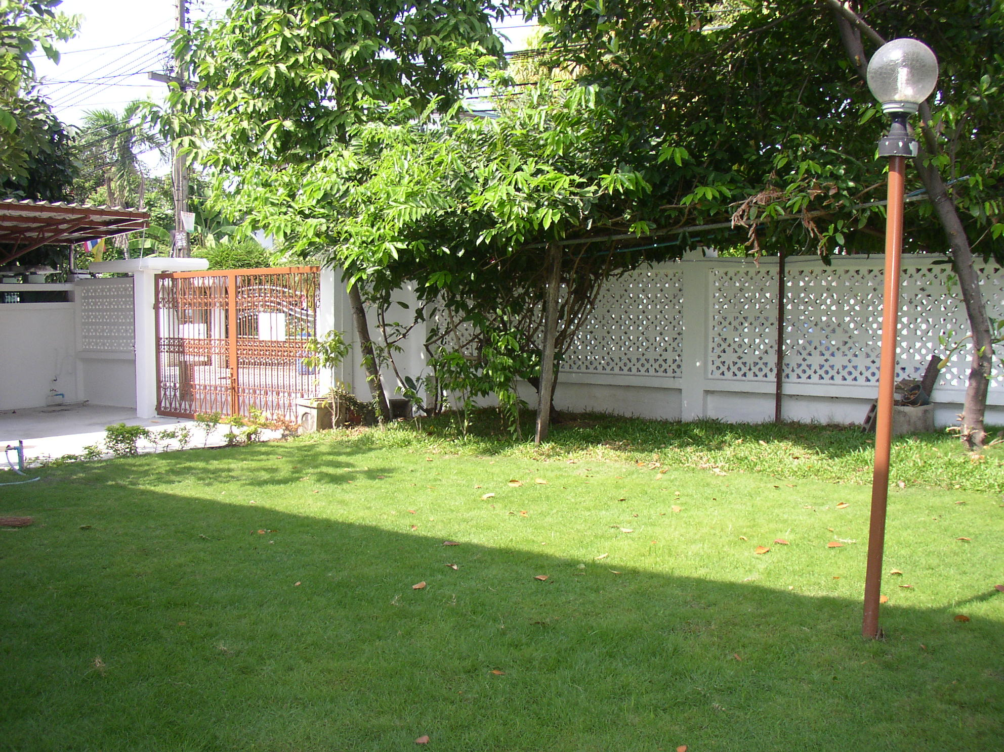
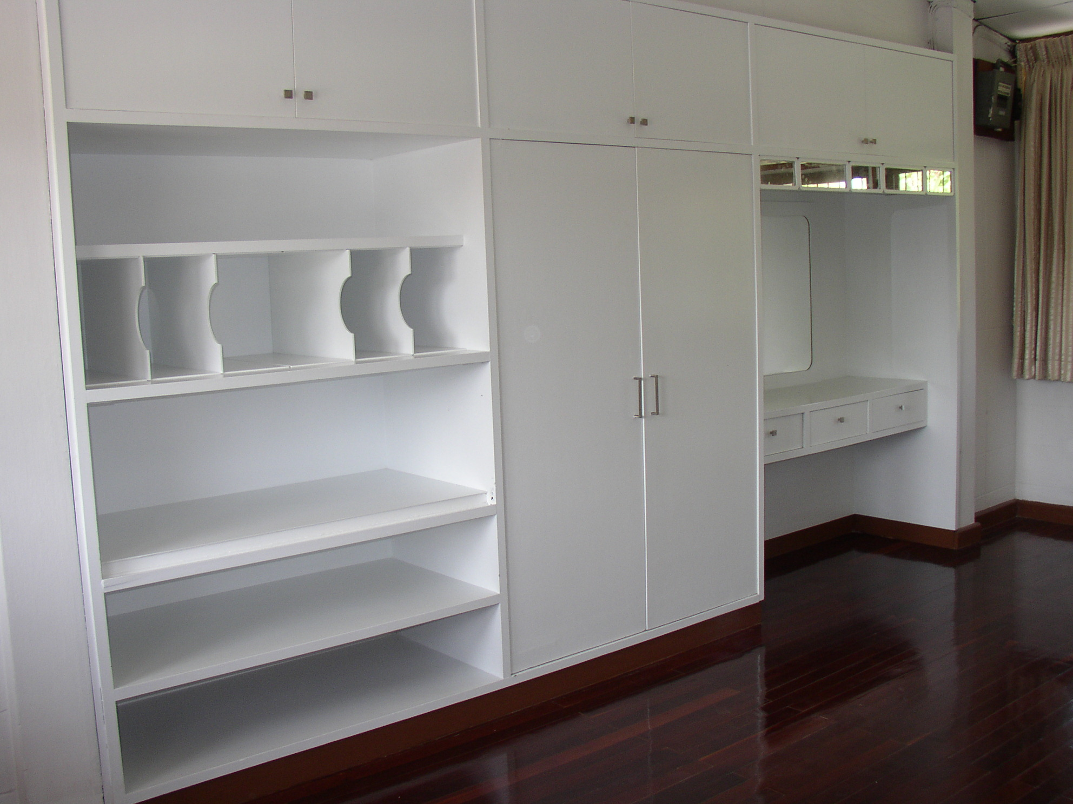
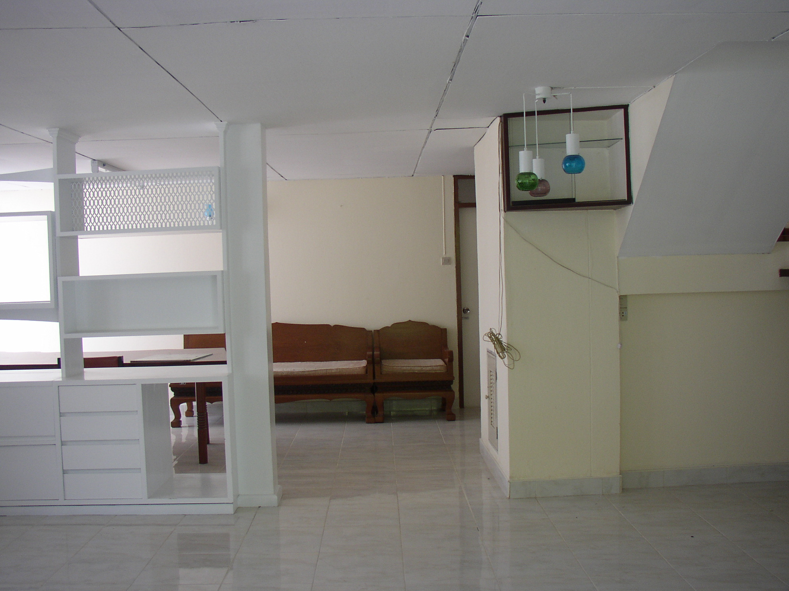
House for Rent 500 SqM. New Decor.
With Yard. 4 BR. 3 BT. and Maid RM
Praram 9 Soi 41. 15 Min Suvarnabhumi Airport. Near ABAC and Ramkhamhaeng U.
35,000 B/M
Inc:Furniture,Air-condition, Refrigerator. Any.
Rent 22,000 Baht/a Month

089-815-0223

Home Office
With Garden
Praram 9 Rd.

