2021 MCM

2021 MCM

Problem A: Fungi

问题一:真菌

The carbon cycle describes the process of the exchange of carbon throughout the geochemical cycle of the Earth, and is a vital component for life on the planet.Part of the carbon cycle includes the decomposition of compounds, allowing carbon to be renewed and used in other forms.One key component of this part of the process is the decomposition of plant material and woody fibers.

碳循环描述了地球化学循环中的碳交换过程，是对地球生命而言的是一个重要的组成部分。碳循环一部分包括化合物的分解，允许碳以其他形式被更新和使用。这一过程的一个关键组成部分是植物材料和木质纤维的分解。

Some of the key agents in decomposing woody fibers are fungi. The authors of a recent research article on wood decomposition by fungi identified fungi traits that determine decomposition rates and also noted links between certain traits[1].In particular, the slow growing strains of fungi tend to be better able to survive and grow in the presence of environmental changes with respect to moisture and temperature, while the faster growing strains tend to be less robust to the same changes. A synopsis of this article can be found below on page 3.

分解木质纤维的一些关键因素是真菌。最近一篇关于真菌分解木材的研究文章的作者确定了决定分解速度的真菌特征，并指出某些特征之间的联系[1]。特别是，生长缓慢的真菌菌株往往能够更好地在湿度和温度的环境变化中存活和生长，而生长较快的菌株往往对相同的变化不太鲁棒。这篇文章的概要可以在下面的第3页找到。

These researchers examined a large number of traits associated with different fungi and their role in the decomposition of ground litter (dead plant material) and woody fibers. For this MCM Problem you should focus on just two traits of a fungus: the growth rate of the fungus and the fungus' tolerance to moisture. Your primary goal is to model the decomposition of woody fibers in a given patch of land, and do so in the presence of multiple types of fungi breaking down woody fibers in the same area.

这些研究人员检查了与不同真菌相关的大量特征，以及它们在枯枝落叶层(死亡植物材料)和木质纤维分解中的作用。对于这个MCM问题，你应该只关注真菌的两个特征:真菌的生长率和真菌对水分的耐受性。

**你的首要目标是在给定的一块小块土地上模拟木质纤维的分解，并在同一地区有多种真菌分解木质纤维的情况下进行。**

As you explore the relationship of the two traits of interest, growth rate and moisture tolerance, with the rate of decomposition, several questions may arise to include: Using these two traits, how do the different fungi interact and decompose ground litter in a fixed patch of land in different environments? Within these different environments, how will the decomposition be impacted over time as conditions vary? How do environmental changes and the variation in environmental change impact the longterm dynamics with respect to decomposition, as well as competition between fungi in a given environment? The estimation for the decomposition rates, given the growth rate, is shown in Figure 1.The estimation of the decomposition rates, given the relative moisture tolerance, is shown in Figure 2.

当你探索生长速度和对水分的耐受性这两个有趣的特征与分解速度之间的关系时，可能会出现几个问题:

**利用这两个特征，在一块固定的小块土地上，不同的真菌如何在不同的环境中相互作用并分解枯枝落叶层？**

**在这些不同的环境中，随着时间的推移，随着条件的变化，分解会受到怎样的影响？**

**环境变化（复数）和环境变化（单数）的变异如何影响分解的长期动态，以及给定环境中真菌之间的竞争？**

给定增长率，分解率的估计如图1所示。给定相对湿度容限，分解速率的估计如图2所示。

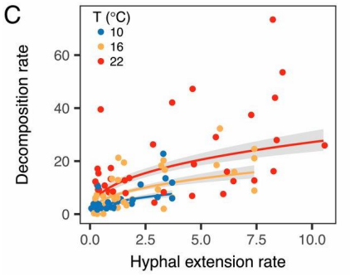

Figure 1: The relationship between the hyphal extension rate (mm/day) of various fungi and the resulting wood decomposition rate (% mass loss over 122 days) at various temperatures.(Figure 1C in [1]).

图1:不同温度下各种真菌的菌丝延伸速率(毫米/天)与最终木材分解速率(超过122天的质量损失)（%）之间的关系。

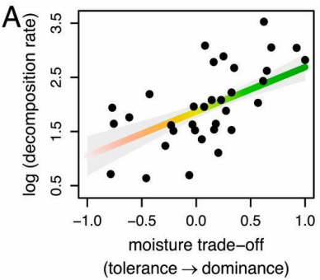

Figure 2: The relationship between the moisture tolerance (difference of each isolate's competitive ranking and their moisture niche width, both scaled to [0,1]) of various fungi and the resulting wood decomposition rate (% mass loss over 122 days, log transformed).(Figure 4A in [1]).

图2:各种真菌的耐湿性(每个孤立点的竞争等级与其水分生态位宽度的差异，均按[0，1]的比例)与最终木材分解率(超过122天的质量损失，对数转换)之间的关系。(图4A在[1])。

Requirement: Your paper should explore and address the following aspects.

要求:你的论文应该探讨和解决以下几个方面。

• Build a mathematical model that describes the breakdown of ground litter and woody fibers through fungal activity in the presence of multiple species of fungi.• In your model, incorporate the interactions between different species of fungi, which have different growth rates and different moisture tolerances as shown in Figures 1 and 2.• Provide an analysis of the model and describe the interactions between the different types of

建立一个数学模型，描述在多种真菌存在的情况下，通过真菌活动分解地面垃圾和木质纤维的情况。在您的模型中，加入不同种类真菌之间的相互作用，它们具有不同的生长率和不同的耐湿性，如图1和2所示。提供模型分析，并描述不同类型之间的相互作用

fungi.The dynamics of the interactions should be characterized and described including both shortand longterm trends.Your analysis should examine the sensitivity to rapid fluctuations in the environment, and you should determine the overall impact of changing atmospheric trends to assess the impact of variation of local weather patterns.

真菌。应该对相互作用的动态进行描述，包括短期和长期趋势。您的分析应该检查对环境快速波动的敏感性，您应该确定不断变化的大气趋势的总体影响，以评估当地天气模式变化的影响。

• Include predictions about the relative advantages and disadvantages for each species and combinations of species likely to persist, and do so for different environments including arid, semiarid, temperate, arboreal, and tropical rain forests.

**包括对每个物种和可能持续存在的物种组合的相对优势和劣势的预测，并针对不同环境进行预测，包括干旱、半干旱、温带、树栖和热带雨林。**

• Describe how the diversity of fungal communities of a system impacts the overall efficiency of a system with respect to the breakdown of ground litter. Predict the importance and role of biodiversity in the presence of different degrees of variability in the local environment.

**描述系统中真菌群落的多样性如何影响系统分解枯枝落叶层的整体效率。在当地环境存在不同程度的可变性的情况下，预测生物多样性的重要性和所扮演的角色。**

Include a two-page article of your results. Your article should be appropriate for inclusion in an introductory college level biology textbook to discuss recent developments in our understanding of the roles fungi play in ecological systems.

包括一篇两页的结果文章。你的文章应该适合放在**大学水平的生物学入门教材**中，讨论我们对真菌在生态系统中所起作用的理解的最新进展。

Your PDF solution of no more than 25 total pages should include: • One-page Summary Sheet.• Table of Contents.

您的总页数不超过25页的PDF解决方案应包括:

• One-page Summary Sheet.  
• Table of Contents.  
• Your complete solution.  
• Two-page Article.  
• References list.

一页摘要表。

目录。

您的完整解决方案。

两页的文章。

参考列表。

Note: The MCM Contest now has a 25 page limit.All aspects of your submission count toward the 25 page limit (Summary Sheet, Table of Contents, Reference List and any Appendices).

注意:MCM竞赛现在有25页的限制。您提交的所有内容均计入25页的限制(汇总表、目录、参考列表和任何附录)。

Reference:

参考:

[1] Nicky Lustenhouwer, Daniel S. Maynard, Mark A. Bradford, Daniel L. Lindner, Brad Oberle, Amy E. Zanne, and Thomas W. Crowther, "A traitbased understanding of wood decomposition by fungi," Proceedings of the National Academy of Sciences of the United States, May 13, 2020.https://www.pnas.org/content/pnas/117/21/11551.full.pdf

[1] Nicky Lustenhouwer，Daniel S. Maynard，Mark A. Bradford，Daniel L .林德纳，Brad Oberle，Amy E. Zanne和Thomas W .克罗泽，“基于真菌对木材分解的理解”，美国国家科学院学报，2020年5月13日。https://www.pnas.org/content/pnas/117/21/11551.full.pdf

Research Article Synopsis

研究文章简介

We provide a brief synopsis below of the research article by Lustenhouwer, et al [1] .The original full article is available at https://www.pnas.org/content/pnas/117/21/11551.full.pdf. Note that you do not need to read the original article to complete this MCM Problem.

我们在下面提供了Lustenhouwer等人[1]的研究文章的简要概述。完整的原始文章可以在https://www.pnas.org/content/pnas/117/21/11551.full.pdf.找到。请注意，您不需要阅读原始文章来完成这个MCM问题。

The decomposition of organic material is a critical component of the carbon cycle.Large scale modeling of the carbon cycle as well as global climate models are becoming more refined and are incorporating more small scale details.One important detail is the rate associated with the decay of organic material by microbial and fungal communities.The focus of the paper is the different decay rates associated with different types of fungi.

有机物质的分解是碳循环的重要组成部分。碳循环的大规模模型以及全球气候模型正变得越来越精细，并包含了更多小规模的细节。一个重要的细节是微生物和真菌群落对有机物质的腐蚀速率。论文的重点是不同类型真菌的不同腐烂率。

The authors of the paper explored several different traits of fungi to determine the effects of the decomposition of wood.They did so by measuring how much mass was lost in wood blocks after introducing different types of fungi into the blocks.The researchers examined a large number of different traits associated with each fungus and attempted to determine the role these traits play in the decomposition of the wood blocks.

该论文的作者探索了真菌的几种不同特性，以确定木材分解的效果。他们通过测量在木块中引入不同类型的真菌后，木块中损失了多少质量来做到这一点。研究人员检查了与每种真菌相关的大量不同特征，并试图确定这些特征在木块分解中的作用。

For example, one important trait is the hyphal extension rate.The hyphae are the cells that branch out and form the filaments and structure of a fungus, and the different kind of hyphae play different roles in the life cycle of a fungus.The hyphal extension rate is essentially the growth rate of a fungus.Another trait examined was the density of the hyphae in a given volume.

例如，一个重要的性状是菌丝延伸率。菌丝是分枝出来的细胞，形成真菌的细丝和结构，不同种类的菌丝在真菌的生命周期中起着不同的作用。菌丝延伸速度本质上是真菌的生长速度。另一个被检测的特征是给定体积内菌丝的密度。

These two traits are associated with a number of properties of a fungus.For example, it was found that if the hyphal extension rate was larger (faster growth), the fungus was more likely to decompose wood faster.Likewise, if the filaments were denser it was more likely that the decomposition of wood was slower.Additionally, these two traits are also associated with how a fungus reacts to different environmental conditions.

这两个特征与真菌的许多特性有关。比如发现菌丝延伸速度越大(生长越快)，真菌分解木材的速度越快。同样，如果细丝密度更大，木材的分解就更慢。此外，这两个特征也与真菌对不同环境条件的反应有关。

In particular the researchers found that fungi that were better able to adapt to a more varied range of moisture conditions tended to also decompose wood slower.Fungi that grew faster and out-competed other fungi tended to decompose wood faster.Figures 1 and 2 in the MCM Problem A statement show these relationships.

特别是，研究人员发现，能够更好地适应更多样的湿度条件的真菌往往也会更慢地分解木材。生长更快并且比其他真菌更具竞争力的真菌往往会更快地分解木材。多芯片组件问题中的图1和图2陈述了这些关系。

Woody materials break down through multiple stages, and the fungi that were examined in the research article are most relevant with respect to the decay of woody materials in the middle of their decay cycle.The results may differ for other stages of decay.For the purpose of this modeling exercise, you can focus on the results for the middle stage and assume it is consistent for other stages of decomposition.Another consideration is that local environmental conditions can vary greatly over an area and impact the overall dynamics as well.

木质材料经过多个阶段分解，在研究文章中检查的真菌与木质材料在其腐烂周期中间的腐烂最为相关。其他衰变阶段的结果可能不同。出于建模练习的目的，您可以关注中间阶段的结果，并假设它与分解的其他阶段一致。另一个考虑因素是，一个地区的局部环境条件可能会有很大差异，也会影响整体动态。

Glossary:

词汇表:

Biodiversity: Broadly, the variety of life in the world.On a smaller scale, the variety of life in a particular habitat or ecosystem.

生物多样性:广义而言，世界上生命的多样性。在较小的范围内，特定栖息地或生态系统中生命的多样性。

Carbon Cycle: The continuous process (or series of processes) by which carbon is exchanged between organisms and the environment, and then reused throughout the planet.

碳循环:生物体和环境之间交换碳，然后在整个地球上重复使用的连续过程(或一系列过程)。

Competitive Ranking: A measure of the ability for a fungus to outcompete other fungi in a series of pair wise tests in similar conditions.

竞争性排名:一种衡量真菌在相似条件下的一系列成对测试中战胜其他真菌的能力的估计。

Earth's Biosphere: The lithosphere (crust and upper mantle of the earth), the hydrosphere (all of the water on the earth's surface), and the atmosphere (the envelope of gases surrounding the earth) of the earth.

地球生物圈:地球的岩石圈(地壳和上地幔)、水圈(地球表面所有的水)和大气层(地球周围的气体封套)。

Fungus (plural: fungi): Any member of the group of eukaryotic (cells that have a nucleus enclosed within a nuclear envelope) organisms.Examples are yeasts, molds, and mushrooms.

真菌:真核生物(细胞核被包裹在核膜内的细胞)中的任何一员。例如酵母、霉菌和蘑菇。

Geochemical Cycle: The various pathways and steps by which elements are exchanged through and between the Earth's biosphere.

地球化学循环:地球生物圈中元素交换的各种途径和步骤。

Hyphae: The cells that form the filaments within a fungal community.

菌丝:在真菌群落中形成细丝的细胞。

Hyphal Extension Rate: The rate of growth of a fungus.

菌丝延伸率:真菌的生长速度。

Moisture Niche Width: The difference between the maximum and minimum moisture levels in which half of a fungal community can maintain its fastest growth rate.

水分生态位宽度:半个真菌群落能够保持最快生长速度的最大和最小水分水平之间的差异。

Moisture Tolerance: The difference between a fungus' competitive ranking and its moisture niche width.

耐湿性:真菌的竞争等级与其水分生态位宽度之间的差异。

2021 MCM

2021 MCM

Problem B: Fighting Wildfires

问题二:扑灭野火

Background

背景

The 20192020 fire season in Australia saw devastating wildfires in every state, with the worst impact in New South Wales and eastern Victoria. The wildfires occurred during a severe drought and persistent heat wave exacerbated by climate change. Figure 1 shows the wildfire hot spots in this area from October 1, 2019 to January 7, 2020, with yellow showing fires from October 1st to January 6th , and red showing active fires on January 7, 2020.Firefighters have used drones for surveillance and situational awareness (SSA) for several years; SSA drones carry high definition & thermal imaging cameras and telemetry sensors that monitor and report data from wearable devices on frontline personnel. Wearable devices can be used as Personal Locator Beacons or more complex environmental monitors. SSA drones help monitor the evolving situation, letting the Emergency Operations Center (EOC) best direct active crews for optimal effect and maximal safety.

澳大利亚2019-2020年的火灾季节，每个州都发生了毁灭性的野火，其中影响最严重的是新南威尔士和维多利亚东部。野火发生在严重干旱和持续热浪期间，气候变化加剧了热浪。图1显示了该地区2019年10月1日至2020年1月7日的野火热点，黄色表示10月1日至1月6日的火灾，红色表示2020年1月7日的活跃火灾。消防员使用无人机进行监视和态势感知(SSA)已经有好几年了；SSA无人机携带高清热成像摄像机和遥测传感器，用于监控和报告前线人员可穿戴设备传输的数据。可穿戴设备可以用作个人定位信标或更复杂的环境监控器。SSA无人机有助于监控不断变化的情况，让紧急行动中心(EOC)最好地指导现役人员，以获得最佳的效果和最大程度上的安全。

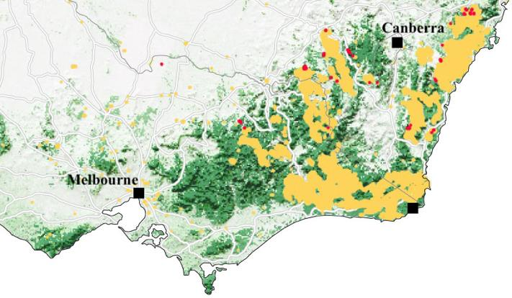

Figure 1.Wildfire Hot Spots in Southeast Australia, Oct 1, 2019 to Jan 7, 2020.Source: Australian Government Bureau of Meteorology, NASA Fire Information for Resource Management System.

图1。澳大利亚东南部的野火热点，2019年10月1日至2020年1月7日。资料来源:澳大利亚政府气象局，美国宇航局资源管理系统火灾信息。

Two-way radio communication allows "bootsontheground" forward teams to give status reports to the EOC and allows the EOC to give orders directly to forward teams. Deployed personnel carry handheld two-way radios operating in the VHF/UHF bands. The range of handheld radios is limited by their low transmitting power, typically a maximum of 5 watts, and is determined mainly by distance and physical topography in rural areas or "building topography" in urban areas; weather has little effect on VHF/UHF signals. A 5watt radio has a nominal range of 5 km over flat, unobstructed ground, but drops to 2 km in an urban area. Repeaters, transceivers that automatically rebroadcast signals at higher powers, can extend radio range. A repeater located between the front lines and the EOC can relay radio signals both from the front lines to the EOC and from the EOC to the front lines. The range of a repeater is also determined by distance and topography, but is significantly greater than lower power handheld radios.

双向无线电通信允许“bootsontheground”前方小组向紧急行动中心(EOC)提交状态报告，并允许紧急行动中心(EOC)直接向前方小组下达命令。部署人员携带在甚高频/超高频波段工作的手持双向无线电。手持无线电的范围受到发射功率低的限制，通常最大功率为5瓦，范围主要由农村地区的距离和物理地形或城市地区的“建筑地形”决定；天气对甚高频/超高频信号影响不大。一台5瓦特的收音机在平坦、无障碍的地面上标称范围为5公里，但在城市地区下降到2公里。中继器是自动以更高功率重播信号的收发器，可以扩大无线电范围。位于前线和紧急行动中心(EOC)之间的中继器可以将无线电信号从前线中继到紧急行动中心(EOC)以及从紧急行动中心(EOC)中继到前线。中继器的范围也由距离和地形决定，但比低功率手持无线电大得多。

Recently, hovering drones carrying repeaters have been used to dramatically extend the range of low power radios on the front lines. A 10watt repeater, weighing 1.3 kg carried by a drone hovering well above ground level, can achieve a range of 20 km. Akme Corporation's prototype WileE15.2X hybrid drone is projected to cost approximately $10,000 (AUD) when equipped with either a radio repeater or video & telemetry capability.Tests have shown this drone has the capabilities listed in Table 1.

最近，携带中继器的悬停无人机被用来大幅扩大前线低功率无线电的范围。一个10瓦的中继器，重1.3公斤，由悬停在地面以上的无人机携带，可以达到**20公里的通信范围**。当配备无线电中继器或视频和遥测功能时，Akme公司的原型WileE15.2X混合动力无人机预计成本约为10，000 (澳元)。测试表明，这种无人机具有表1所列的能力。

Table 1.WileE15.2X Hybrid Drone Capabilities

表1 .WileE15.2X倍混合动力无人机

Flight range: 30 km Maximum speed: 20 m/s Maximum flight time: 2.50 hr

飞行距离:30公里；最大速度:20米/秒；最大飞行时间:2.50小时

1.75 hour recharge time for the builtin battery.

内置电池的充电时间为1.75小时。

Note: Auxiliary batteries for radios or video/telemetry can be swapped while the builtin battery recharges.

注意:内置电池充电时，收音机或视频/遥测辅助电池可以互换。

Requirements: Your team of consultants has been retained to:

要求:您的顾问团队已被保留，以便:

1.Create a model to determine the optimal numbers and mix of SSA drones and Radio Repeater drones to purchase for a proposed new division, "Rapid Bushfire Response", of Victoria's Country Fire Authority (CFA). Your model should balance capability and safety with economics, as well as consider observational and communications mission needs and topography. Your model should also incorporate fire event size and frequency as parameters.

**1.建立一个模型来确定SSA无人机和无线电中继器无人机的最佳数量和组合，以便为维多利亚国家消防局(CFA)提议的新部门“快速丛林火灾响应”购买。你的模型应该在能力和安全性与经济性之间取得平衡，同时考虑观测和通信任务需求以及地形。您的模型还应该包含火灾事件大小和频率作为参数。**

2.Illustrate how your model adapts to the changing likelihood of extreme fire events over the next decade.Project what equipment cost increases will occur assuming the cost of drone systems stays constant.

**2.说明您的模型如何适应未来十年极端火灾事件可能性的变化。假设无人机系统的成本保持不变，预测设备成本会增加多少。**

3.Determine a model for optimizing the locations of hovering VHF/UHF radio repeater drones for fires of different sizes on different terrains such as those shown in Figure 2: Topographical Map of Eastern Victoria. Note that elevations range from sea level at the coast to 1,986 meters at Mt. Bogong, Victoria.

**3.确定一个模型，用于优化悬停甚高频/超高频无线电中继器无人机的位置，以应对不同地形上不同大小的火灾，如图2:维多利亚东部地形图所示。请注意，海拔范围从海岸的海平面到维多利亚的博贡山的1986米。**

4.Prepare a oneto twopage annotated Budget Request supported by your models for CFA to submit to the Victoria State Government.

**4.准备一份一到两页的附加注释的预算请求，由您的模型支持，提交给维多利亚州政府。**

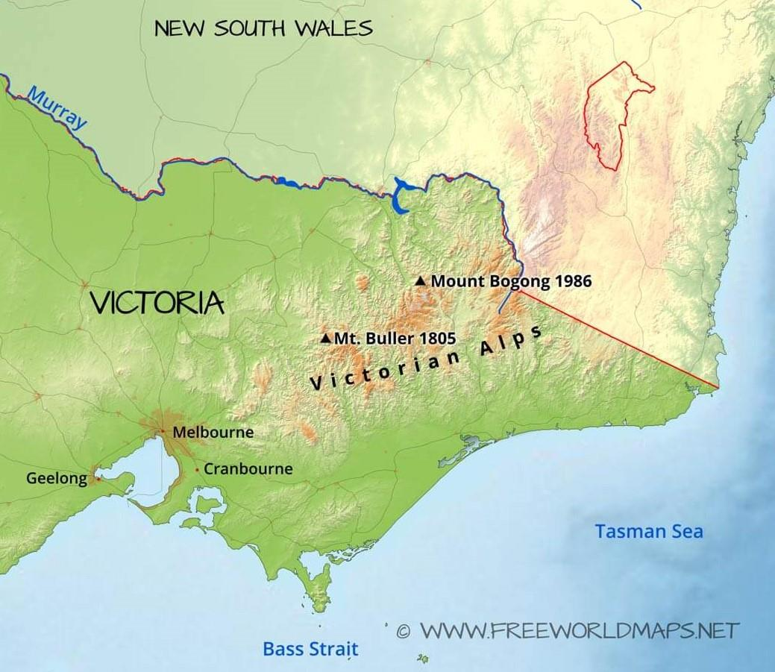

图2： 东维多利亚地形图  
WWW.FREEWORLDMAPS.NET

Your PDF solution of no more than 25 total pages should include: Onepage Summary Sheet. Table of Contents.

您的总页数不超过25页的PDF解决方案应包括:

一页摘要表。

目录。

Your complete solution.

您的完整解决方案。

Oneto twopage annotated Budget Request.References list.

一到两页带注释的预算请求。参考列表。

Note: The MCM Contest now has a 25 page limit.All aspects of your submission count toward the 25 page limit (Summary Sheet, Table of Contents, Reference List and any Appendices).

注意:MCM竞赛现在有25页的限制。您提交的所有内容均计入25页的限制(汇总表、目录、参考列表和任何附录)。

Glossary

词表

"Bootsontheground" Forward Teams: The idiom "Boots on the ground" indicates personnel that are physically at the location of action.In firefighting, these are teams that are at the front lines of the efforts to control a fire event;they have immediate, critical knowledge of the rapidly changing situation.

“靴子在地上”前锋队:成语“靴子在地上”指的是在行动地点的人员。在消防工作中，这些团队处于控制火灾事件的第一线；他们对迅速变化的形势有直接的、批判性的了解。

Budget Request: A budget request is a business letter seeking funds for costs, expenses, and/or operating overhead for a project or department within an organization.An annotated budget request provides a justification or rationale for each requested item.

预算请求:预算请求是一封商业信函，为组织内的项目或部门寻求成本、费用和/或运营间接费用的资金。附加注释的预算请求为每个请求的项目提供理由或理由。

Country Fire Authority (CFA): A volunteer fire service responsible for fire suppression, rescues, and response to other accidents and hazards across most of the state Victoria, Australia

国家消防局:一个志愿消防服务机构，负责澳大利亚维多利亚州大部分地区的灭火、救援和应对其他事故和危险

Emergency Operations Center (EOC): The central command and control point for emergency related operations and activities, and for requests for activation and deployment of resources (personnel or equipment).A mobile EOC can be deployed near the site of an emergency.

紧急操作中心(EOC):紧急相关操作和活动以及资源(人员或设备)激活和部署请求的中央指挥和控制点。可以在紧急情况现场附近部署一个移动紧急事件中心。

Repeater: An unattended radio transceiver that automatically rebroadcasts a received signal at high power on a nearby frequency ( 600kHz (0.6 MHz) for VHF & 5MHz for UHF) or on an adjacent channel.

中继器:一种无人值守的无线电收发器，可以在附近的频率(对于甚高频为600千赫(0.6兆赫)，对于超高频为5兆赫)或相邻的频道上以高功率自动重播接收的信号。

Situational Awareness: The perception of the current elements of an event, understanding their significance, and extrapolating their status to the near future;In other words, the knowledge and understanding what is going on around you.

情境意识:对事件当前要素的感知，理解其意义，并推断其在不久的将来的状态；换句话说，了解和理解你周围发生的事情。

Surveillance: The systematic collection and analysis of data, and the sharing of those data to others who can act upon that information.

监视:系统地收集和分析数据，并将这些数据分享给其他能够根据这些信息采取行动的人。

Transceiver: A radio that can both transmit and receive.

收发器:既能发射又能接收的无线电设备。

UHF: Ultra High Frequency, radio frequencies from 300 megahertz to 3,000 megahertz.

超高频:超高频，无线电频率从300兆赫到3000兆赫。

VHF: Very High Frequency, radio frequencies from 30 megahertz to 300 megahertz.

甚高频:甚高频，无线电频率从30兆赫到300兆赫。