Makeswift Setup for the GES Home Page Template
This document describes how the GES Home Page template is registered with Makeswift in the bc-catalyst repo, how the page route composes the template with BigCommerce data, and how registered components are aligned inside the template's editable Slots.

1. High-level architecture diagram
The diagram below shows the two flows that make the template work: the registration flow (left) that mounts every Makeswift component on the shared runtime, and the request/rendering flow (middle -> right) that pulls the Makeswift snapshot and hydrates the template with BC product data.
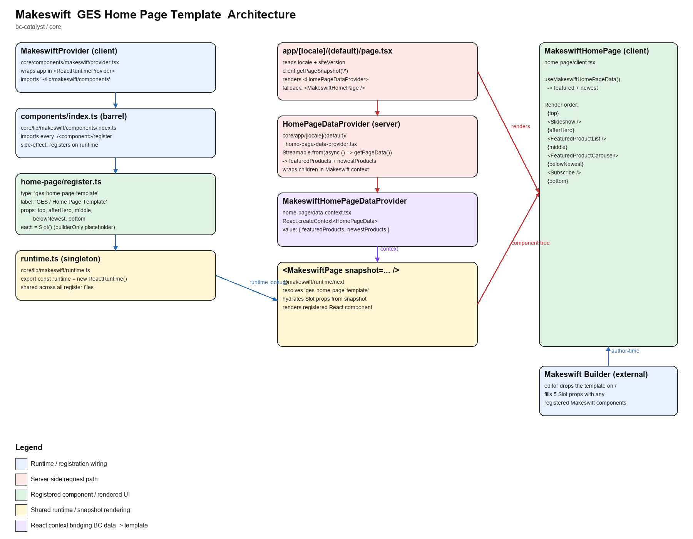

2. The shared runtime
Every Makeswift component registers itself on a single ReactRuntime instance. Because it is a module-level export, all register.ts files operate on the same object.
// core/lib/makeswift/runtime.ts
import { ReactRuntime } from '@makeswift/runtime/next';
export const runtime = new ReactRuntime();

3. Client provider that boots the registry
MakeswiftProvider is mounted high in the client tree. Importing '~/lib/makeswift/components' pulls the barrel file, which in turn imports every register.ts (side-effect imports). By the time the provider renders, every component type is known to the runtime.
// core/components/makeswift/provider.tsx
'use client';
import { ReactRuntimeProvider, type SiteVersion } from '@makeswift/runtime/next';
import '~/lib/makeswift/components';
import { runtime } from '~/lib/makeswift/runtime';
export function MakeswiftProvider({ children, siteVersion }: ...) {
return (
<ReactRuntimeProvider runtime={runtime} siteVersion={siteVersion}>
{children}
</ReactRuntimeProvider>
);
}

4. Component barrel (registration order)
core/lib/makeswift/components/index.ts is the single import list. Adding a new component means writing its register.ts and adding one line here. The home-page template is registered in the 'GES components' block.
// core/lib/makeswift/components/index.ts (excerpt)
// Layout components
import './section/register';
import './sticky-sidebar/register';
// Basic UI components
import './accordion/register';
import './card/register';
import './carousel/register';
// ...
// GES components
import './faq/register';
import './find-show/register';
import './home-page/register'; // <-- GES Home Page Template
import './mega-banner/register';
// ...

5. Registering the GES Home Page Template
The template exposes five editable Slots that a Makeswift editor can drop other registered components into. The type id 'ges-home-page-template' is what Makeswift uses to look up the React component when it renders the snapshot.
// core/lib/makeswift/components/home-page/register.ts
import { Slot } from '@makeswift/runtime/controls';
import { runtime } from '~/lib/makeswift/runtime';
import { MakeswiftHomePage } from './client';
const optionalSlot = () =>
Slot({ unstable_placeholder: { builderOnly: true } });
runtime.registerComponent(MakeswiftHomePage, {
type: 'ges-home-page-template',
label: 'GES / Home Page Template',
props: {
top: optionalSlot(),
afterHero: optionalSlot(),
middle: optionalSlot(),
belowNewest: optionalSlot(),
bottom: optionalSlot(),
},
});

6. The template's rendering component
MakeswiftHomePage receives the five Slot ReactNodes as props. It interleaves them with fixed Catalyst sections (Slideshow, FeaturedProductList, FeaturedProductCarousel, Subscribe). Products come from React context, not Makeswift, so the template stays a client component while BC data is fetched on the server.
// core/lib/makeswift/components/home-page/client.tsx
'use client';
export function MakeswiftHomePage({
top, afterHero, middle, belowNewest, bottom,
}: Props) {
const t = useTranslations('Home');
const { featuredProducts, newestProducts } = useMakeswiftHomePageData();
return (
<div style={{ /* full-bleed */ }}>
{top}
<Slideshow />
{afterHero}
<FeaturedProductList products={featuredProducts} .../>
{middle}
<FeaturedProductCarousel products={newestProducts} .../>
{belowNewest}
<Subscribe />
{bottom}
</div>
);
}

7. React context that bridges BC data into the template
Slots inside the template are just ReactNodes, but the fixed sections need product data. That data flows through a context created next to the template so any client descendant can read it.
// core/lib/makeswift/components/home-page/data-context.tsx
'use client';
interface HomePageData {
featuredProducts: Streamable<Product[]>;
newestProducts: Streamable<CarouselProduct[]>;
}
const HomePageDataContext = createContext<HomePageData | null>(null);
const fallbackHomePageData: HomePageData = {
featuredProducts: [], newestProducts: [],
};
export function MakeswiftHomePageDataProvider({ children, value }) {
return (
<HomePageDataContext.Provider value={value}>
{children}
</HomePageDataContext.Provider>
);
}
export function useMakeswiftHomePageData() {
return useContext(HomePageDataContext) ?? fallbackHomePageData;
}

8. Server-side data provider
The server component builds streamable BC queries and hands them to the client context. Streamable lets the shell render immediately while the product lists finish loading.
// core/app/[locale]/(default)/home-page-data-provider.tsx
export async function HomePageDataProvider({ children }) {
const format = await getFormatter();
const streamablePageData = Streamable.from(async () => {
const customerAccessToken = await getSessionCustomerAccessToken();
const currencyCode = await getPreferredCurrencyCode();
return getPageData(currencyCode, customerAccessToken);
});
const streamableFeaturedProducts = Streamable.from(async () => {
const data = await streamablePageData;
return productCardTransformer(
removeEdgesAndNodes(data.site.featuredProducts), format);
});
const streamableNewestProducts = Streamable.from(async () => {
const data = await streamablePageData;
return productCardTransformer(
removeEdgesAndNodes(data.site.newestProducts), format);
});
return (
<MakeswiftHomePageDataProvider
value={{
featuredProducts: streamableFeaturedProducts,
newestProducts: streamableNewestProducts,
}}
>
{children}
</MakeswiftHomePageDataProvider>
);
}

9. The page route (composition point)
The home route requests the '/' snapshot from Makeswift and renders it inside the data provider. If no snapshot exists yet (fresh env, editor hasn't published), the template renders directly so the site still works.
// core/app/[locale]/(default)/page.tsx
export default async function Home({ params }: Props) {
const { locale } = await params;
setRequestLocale(locale);
const siteVersion = await getSiteVersion();
const makeswiftSnapshot = await client.getPageSnapshot('/', {
siteVersion,
locale,
allowLocaleFallback: true,
});
return (
<HomePageDataProvider>
{makeswiftSnapshot
? <MakeswiftPage snapshot={makeswiftSnapshot} />
: <MakeswiftHomePage />}
</HomePageDataProvider>
);
}

10. All Makeswift components registered in the repo
The following components are registered on the same runtime and are available to editors when filling the five Slots in the GES Home Page Template. Grouped by the label prefix used in the Makeswift Builder sidebar.

Layouts
type id | Builder label | register file (under core/lib/makeswift/components/)
layouts-section | Layouts / Section | section/register.ts
layouts-sticky-sidebar | Layouts / Sticky Sidebar | sticky-sidebar/register.ts

Basic
type id | Builder label | register file (under core/lib/makeswift/components/)
primitive-accordions | Basic / Accordion | accordion/register.ts
primitive-card | Basic / Card | card/register.ts
primitive-carousel | Basic / Carousel | carousel/register.ts
primitive-card-carousel | Basic / Card Carousel | card-carousel/register.ts
bullet-points | Basic / Bullet Points | bullet-points/register.ts
belami-custom-text | Basic / Custom Text | custom-text/register.ts
custom-tooltip | Basic / Tooltip | tooltip/register.ts

Catalog
type id | Builder label | register file (under core/lib/makeswift/components/)
arizon-category-list | Catalog / Category List | category-list/register.ts
catalog-product-card | Catalog / Product Card | product-card/register.ts
primitive-products-list | Catalog / Products List | products-list/register.ts
primitive-products-carousel | Catalog / Products Carousel | products-carousel/register.ts
catalyst-product-grid | Catalyst / Product Grid | product-grid.tsx
Catalog / Product Detail | Catalog / Product Detail | product-detail/register.ts

Sections
type id | Builder label | register file (under core/lib/makeswift/components/)
section-slideshow | Sections / Slideshow | slideshow/register.ts
section-subscribe | Sections / Subscribe | subscribe/register.ts

Catalyst
type id | Builder label | register file (under core/lib/makeswift/components/)
catalyst-button-link | Button | button-link/register.ts
catalyst-hero-banner | Catalyst / Hero Banner | hero-banner.tsx
catalyst-promo-banner | Catalyst / Promo Banner | promo-banner.tsx
catalyst-customer-group-slot | Catalyst / Customer Group Slot | customer-group-slot/register.ts

GES
type id | Builder label | register file (under core/lib/makeswift/components/)
ges-home-page-template | GES / Home Page Template | home-page/register.ts
ges-breadcrumbs | GES / Breadcrumbs | breadcrumbs/register.ts
ges-accordions | GES / Accordions | ges-accordion/register.ts
primitive-accordions-page | GES / Accordions Page | ges-accordion-page/register.ts
faq-component | GES / FAQ's | faq/register.ts
find-show | GES / Find Show | find-show/register.ts
mega-banner | GES / Mega Banner | mega-banner/register.ts
wizard-product-page | GES / Wizard Product Page | wizard/register.ts
custom-btn | GES / Custom Button | custom-btn/register.ts
print-button | GES / Print Button | print-button/register.ts
contact-us-page | GES / Contact Us Page | contact-us/register.ts
date-schedule-page | GES / Date Schedule Page | date-schedule/register.ts
move-in-page | GES / Move In Page | move-in/register.ts
move-out-page | GES / Move Out Page | move-out/register.ts
quick-facts-page | GES / Quick Facts Page | quick-facts/register.ts
show-microsite-page | GES / Show Microsite Page | show-microsite/register.ts

Site chrome (hidden)
type id | Builder label | register file (under core/lib/makeswift/components/)
site-header | Site Header | site-header/register.ts
site-footer | Site Footer | site-footer/register.ts

11. Request lifecycle summary
1. Browser mounts MakeswiftProvider -> imports components/index.ts -> each register.ts calls runtime.registerComponent(...) on the shared ReactRuntime.
2. In Makeswift Builder, an editor drops 'GES / Home Page Template' on '/' and drags any registered component into the five Slot props.
3. On request, page.tsx fetches the snapshot, wraps everything in HomePageDataProvider (which streams BC products into a React context), and hands the snapshot to <MakeswiftPage />.
4. Makeswift resolves 'ges-home-page-template' on the runtime and renders MakeswiftHomePage, hydrating the five Slot props with the editor's content.
5. MakeswiftHomePage reads featuredProducts / newestProducts from context and interleaves the editor slots with the fixed Catalyst sections.

