Makeswift-Driven Catalyst PDP Template
This document describes the design that lets editors control the Product Detail Page layout in Makeswift while every product URL still renders the full Catalyst <ProductDetail /> component (images, variants, prices, add-to-cart, accordions, wishlist). One Makeswift snapshot at /pdp-template is published, and the same snapshot is hydrated with the current product's data on every live PDP and inside the Makeswift editor.

1. High-level approach
The design has three moving parts:
- 1. A Makeswift template page at /pdp-template that editors compose freely. It contains one draggable block, 'Catalog / Product Detail (Catalyst)', plus any surrounding Makeswift components (sections, cards, text, banners) placed above, below, left, or right of it.
- 2. A React context, CatalystProductContext, whose value carries the current product's entityId AND a fully assembled <ProductDetail /> JSX element built server-side by buildCatalystProductContextValue().
- 3. Two server routes that build the context: the real PDP route (app/[locale]/(default)/product/[slug]/page.tsx) for live traffic, and the catch-all (app/[locale]/(default)/[...rest]/page.tsx) which handles /pdp-template?previewProduct=<id> for editor preview.
Because the Catalyst <ProductDetail /> tree is prebuilt on the server and passed through context as a ReactNode, the Makeswift client component does not need to re-implement translations, streamables, server actions, or wishlist wiring. It just renders whatever ReactNode the server put in the context.

2. Architecture diagram
The diagram shows the three flows sharing one runtime: registration (left), live PDP render (middle), and Makeswift editor preview (right). Both request paths converge on the same buildCatalystProductContextValue() helper, then wrap the snapshot with CatalystProductProvider so the rendered Makeswift block can pick the ReactNode out of context.
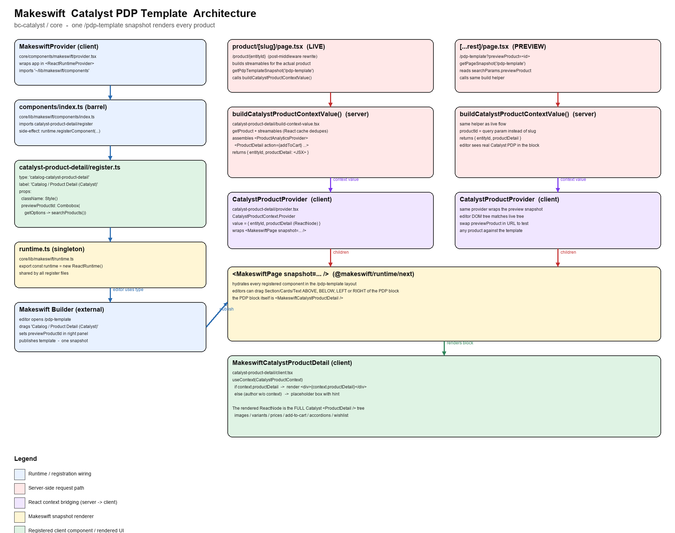

3. Component interaction and flow

3.1 Registration flow (browser boot)
MakeswiftProvider imports the components barrel as a side effect. The barrel imports catalyst-product-detail/register, which mutates the module-level runtime singleton. By the time the provider mounts, the runtime knows about the type 'catalog-catalyst-product-detail'.
// core/lib/makeswift/components/index.ts (excerpt)
import './product-detail/register';
import './self-hydrating-product-detail/register';
import './catalyst-product-detail/register'; // <-- this design
// core/lib/makeswift/components/catalyst-product-detail/register.ts
runtime.registerComponent(MakeswiftCatalystProductDetail, {
type: 'catalog-catalyst-product-detail',
label: 'Catalog / Product Detail (Catalyst)',
props: {
className: Style(),
previewProductId: Combobox({
label: 'Preview product (editor only)',
getOptions: (query) => searchProducts(query).then(...),
}),
},
});

3.2 Live PDP render flow
A visitor hits an SEO URL like /products/g123-...-.html. Middleware rewrites it internally to /product/{entityId}. The PDP page:
a. Loads baseProduct (React-cached).
b. Fetches the /pdp-template snapshot via Makeswift SDK.
c. Calls buildCatalystProductContextValue() to assemble the full <ProductAnalyticsProvider><ProductDetail ... /></ProductAnalyticsProvider> tree with all streamables and the addToCart server action.
d. Wraps <MakeswiftPage snapshot=... /> in CatalystProductProvider.
e. Also keeps its own streamables for the non-Makeswift blocks below (related products, reviews, product schema, product-viewed, wishlist form).
// app/[locale]/(default)/product/[slug]/page.tsx (excerpt)
const [pdpTemplateSnapshot, catalystProductContextValue] = await Promise.all([
getPdpTemplateSnapshot(),
buildCatalystProductContextValue({
productId, customerAccessToken, searchParams, detachedWishlistFormId,
}),
]);
return (
<>
{pdpTemplateSnapshot && catalystProductContextValue ? (
<CatalystProductProvider value={catalystProductContextValue}>
<MakeswiftPage snapshot={pdpTemplateSnapshot} />
</CatalystProductProvider>
) : (
catalystProductContextValue?.productDetail
)}
{/* related products, reviews, schema, etc. below */}
</>
);

3.3 Editor preview flow
The Makeswift editor loads the template at /pdp-template. To see a real Catalyst PDP inside the block, the editor URL becomes /pdp-template?previewProduct=<entityId>. The catch-all route inspects the path and query, and if it matches, builds the SAME context value as the live route before rendering the snapshot.
// app/[locale]/(default)/[...rest]/page.tsx (excerpt)
if (pathname === '/pdp-template' && !Number.isNaN(previewProductNumber)) {
const customerAccessToken = await getSessionCustomerAccessToken();
const contextValue = await buildCatalystProductContextValue({
productId: previewProductNumber, customerAccessToken, searchParams,
});
if (contextValue) {
return (
<HomePageDataProvider>
<CatalystProductProvider value={contextValue}>
<MakeswiftPage snapshot={snapshot} />
</CatalystProductProvider>
</HomePageDataProvider>
);
}
}

3.4 The Makeswift block
The registered client component is tiny. It only reads the context and renders the ReactNode. When no context is present (a page that is not /pdp-template with a preview product), it falls back to a placeholder so the block is still visible in the editor.
// core/lib/makeswift/components/catalyst-product-detail/client.tsx
'use client';
import { useContext } from 'react';
import { CatalystProductContext } from './context';
export function MakeswiftCatalystProductDetail({ className, previewProductId }) {
const context = useContext(CatalystProductContext);
if (context?.productDetail) {
return <div className={className}>{context.productDetail}</div>;
}
return <div className={className}>{/* placeholder */}</div>;
}

3.5 Context shape
// core/lib/makeswift/components/catalyst-product-detail/context.ts
'use client';
import { createContext, type ReactNode } from 'react';
export interface CatalystProductContextValue {
entityId: string;
productDetail: ReactNode; // pre-built <ProductDetail /> tree
}
export const CatalystProductContext =
createContext<CatalystProductContextValue | null>(null);

4. Why pass a ReactNode instead of raw data
The alternative was to put every scalar (product name, images, prices, translations, form action) into the context and rebuild <ProductDetail /> inside the Makeswift client component. That would have forced us to re-implement Catalyst's PDP wiring inside the Makeswift block.
By moving the entire tree assembly to a server helper and shipping the result as a ReactNode, the client component stays trivial and the block always renders exactly what /product/{id} rendered before this design.

5. Key files
- core/lib/makeswift/components/catalyst-product-detail/context.ts
- core/lib/makeswift/components/catalyst-product-detail/provider.tsx
- core/lib/makeswift/components/catalyst-product-detail/client.tsx
- core/lib/makeswift/components/catalyst-product-detail/register.ts
- core/lib/makeswift/components/catalyst-product-detail/build-context-value.tsx
- core/lib/makeswift/components/index.ts (registers new component)
- core/app/[locale]/(default)/product/[slug]/page.tsx (live PDP)
- core/app/[locale]/(default)/[...rest]/page.tsx (editor preview)
- core/lib/makeswift/utils/search-products.ts (Combobox getOptions source)

6. Editor workflow
1. In Makeswift, open the /pdp-template page. If it does not exist, create it and use Edit URL to set the path to /pdp-template.
2. Drag 'Catalog / Product Detail (Catalyst)' onto the canvas. Compose sections/cards/text/banners around it as desired.
3. In the right panel of that block, set 'Preview product' to a real product (Combobox searches BigCommerce).
4. Change the page URL in the URL field to /pdp-template?previewProduct=<entityId> to see that product hydrate the block in the editor. Swap the query param to test other products.
5. Click Publish. Every /product/{id} and SEO URL will now render with the template layout.

