# Sharding-jdbc-datasource

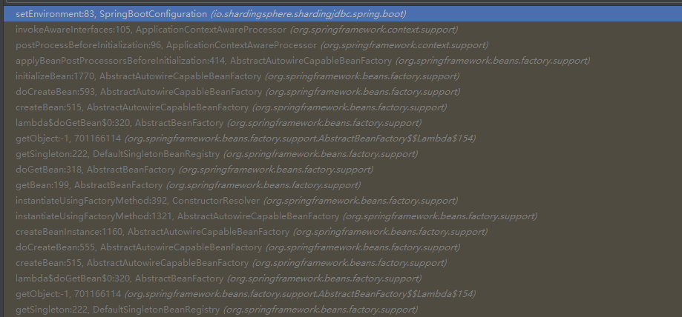

## Role-config

YamlShardingRuleConfiguration

ShardingDataSource

ShardingConnection

ShardingPreparedStatement

BatchPreparedStatementExecutor

SQLExecuteTemplate

算法:

RoundRobinMasterSlaveLoadBalanceAlgorithm

Sql路由：

PreparedStatementRoutingEngine

## ShardingMasterSlaveRouter

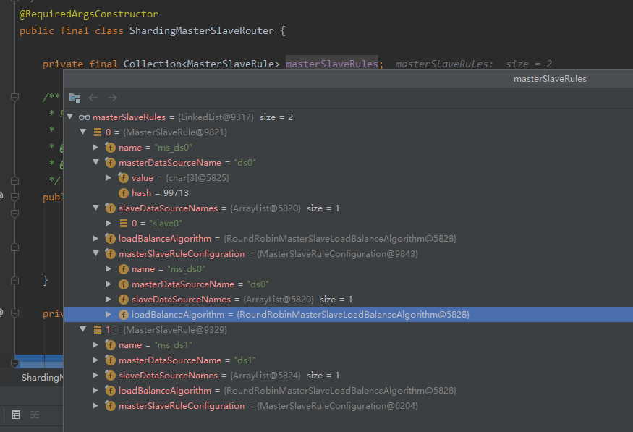

## actualDataNodes

actual-data-nodes: ms_ds$->{0..1}.account_$->{0..1}

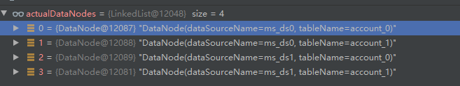

## TableUnit

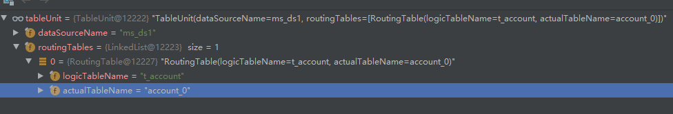

## SQLRewriteEngine

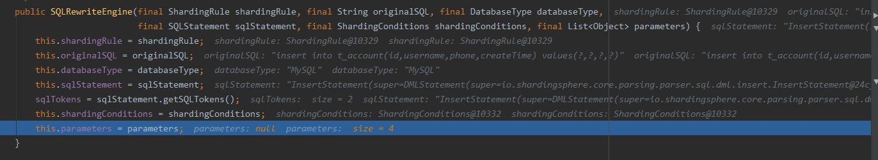

## SQLLogger

## RouteUnit

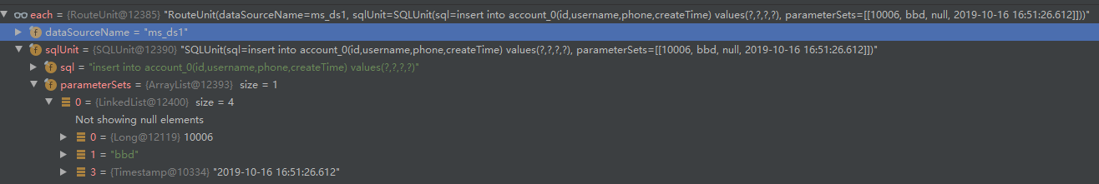

## PreparedStatementExecutor

### Execute

## SQLType

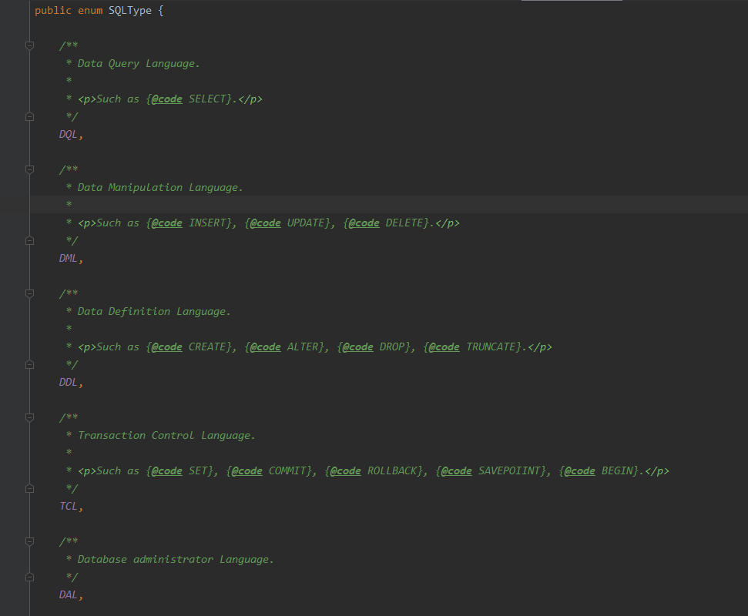

## SQLUnit

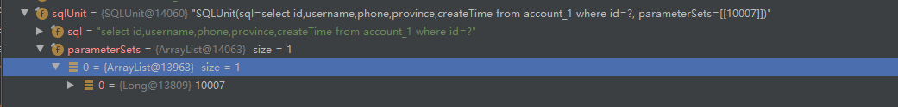

## SQLExecuteTemplate

## ShardingExecuteGroup

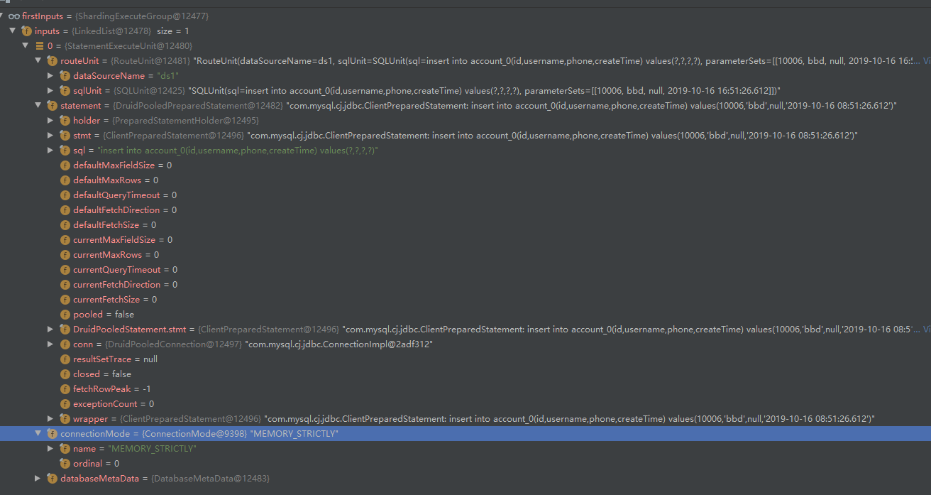

## MasterSlaveRule

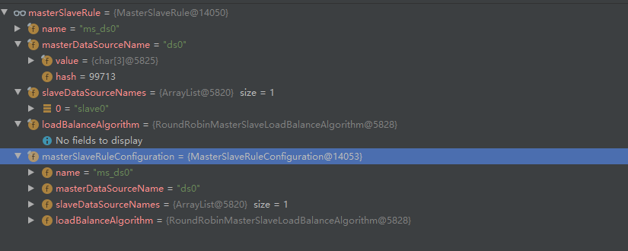

## 主键规则

V3默认是雪花算法，可以自己制定生成主键规则

### KeyGenerator

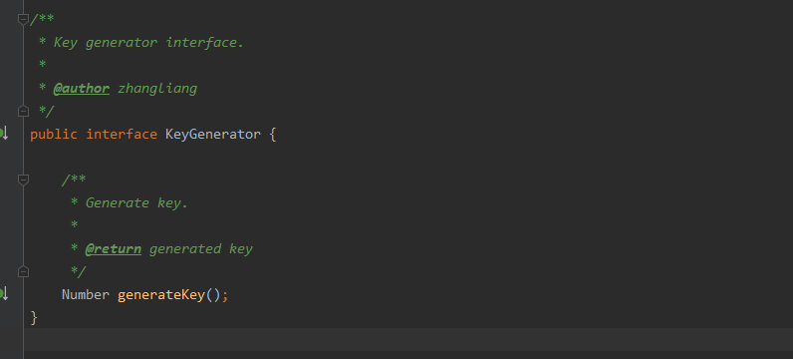

### KeyGeneratorFactory

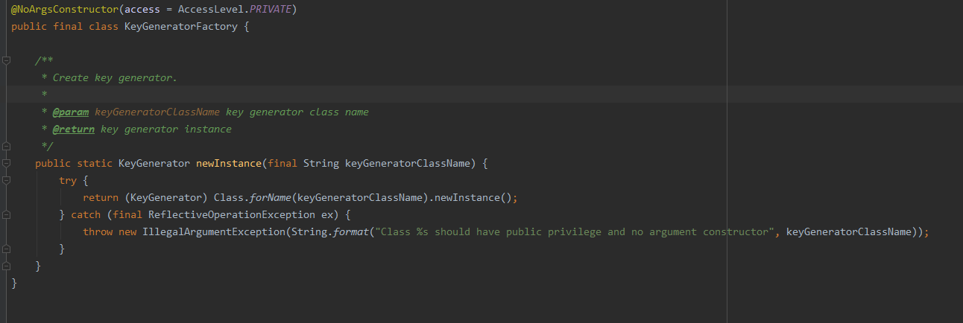

### DefaultKeyGenerator

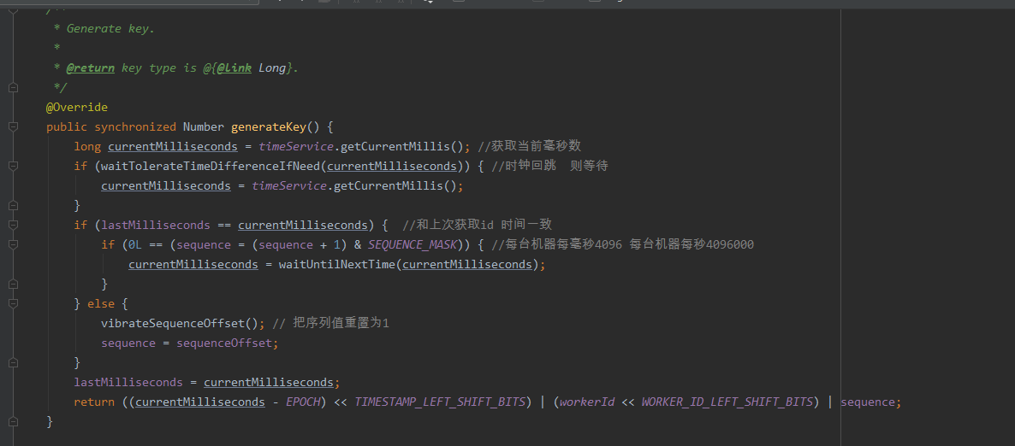

# Mybatis

SqlSessionTemplate

## SimpleExecutor

### doQuery

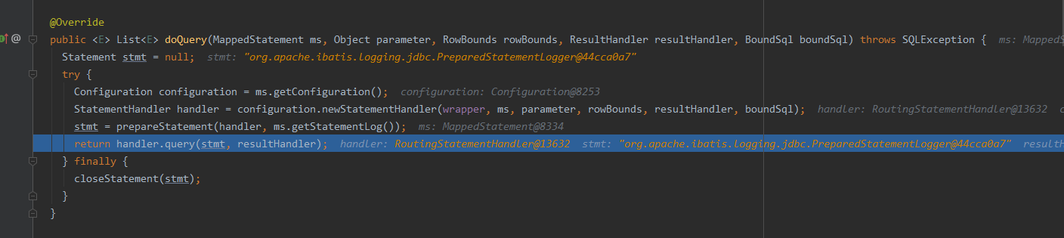

## ConnectionLogger

### Invoke

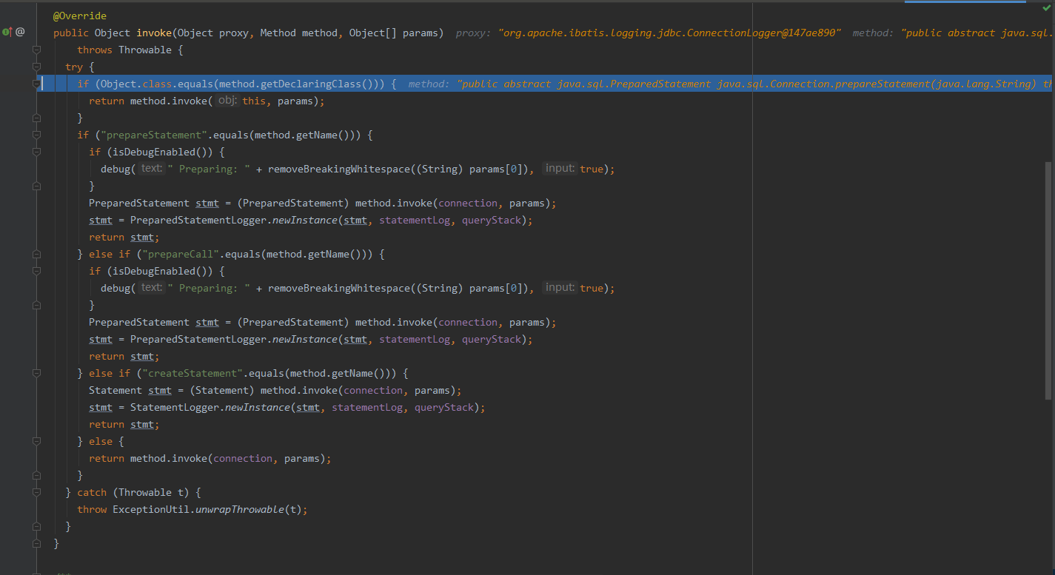

MappedStatement

## BaseStatementHandler

### Prepare

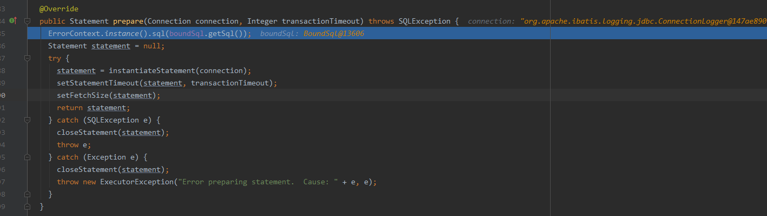

## PreparedStatementHandler

### update

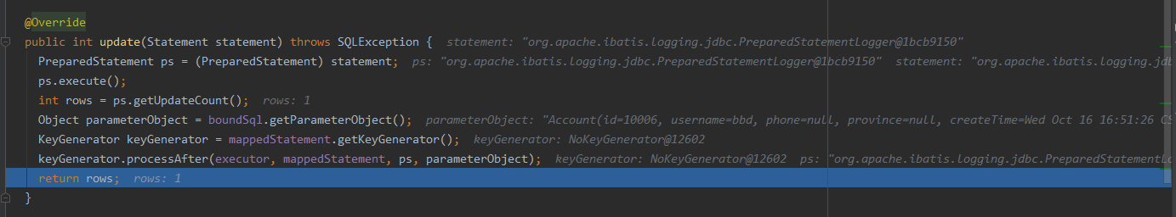

### newInstance

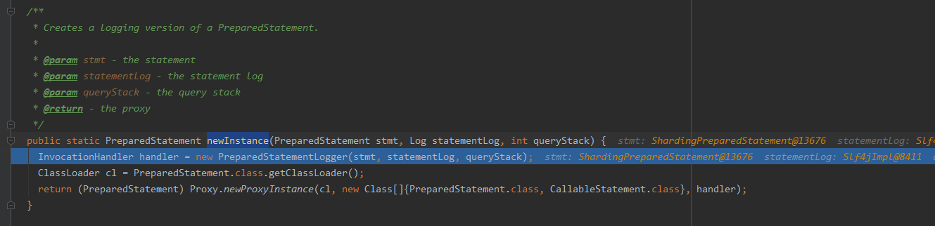

## RoutingStatementHandler

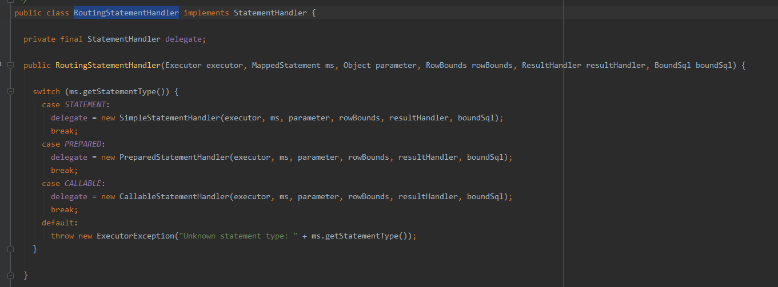

## Configuration

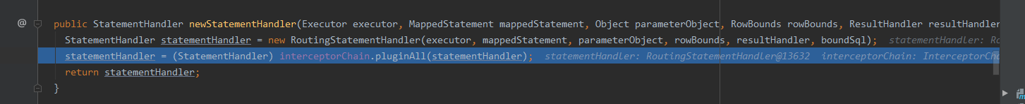

## InterceptorChain

