1. What is Nuclear Engineering？

Nuclear engineering is an endeavor that makes use of radiation and radioactive material for the benefit of mankind.

1. What is Nuclear Reactor?

A nuclear reactor is an engineering device, in which nuclear fuel and structural materials are arranged such that a self-sustained fission chain reaction can occur in a controlled manner.

1. Results of reactor analysis.
2. Power distributions
3. effective multiplication factors
4. What is the multiplication factor?

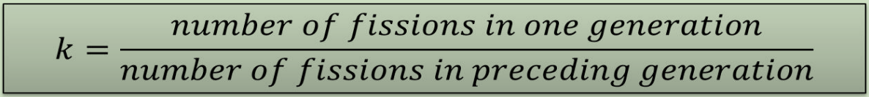

1. What is the relationship between a nuclear reactor and the multiplication factor k?

Nuclear reactor is a device that designed to let the chain reaction to proceed in a controlled manner by varying the value of k.

1. To design a convertor or a breeder, what is the demand for $η$ (Reproduction Factor)?

$η$ must be greater than 1 for conversion, while it must be substantially greater than 2 for breeding due to the words in red previously. This is because one fission neutron must eventually be absorbed in fuel just to keep the reactor critical and maintain the chain reaction. If the reactor is to breed, more than one(at least another one) neutron must be absorbed in fertile material to produce the new fissile isotope.

In any reactor, some neutrons are inevitably absorbed by nonfuel atoms or lost by leakage.

1. Main differences between PWRs and BWRs
2. Steam generators in separate heat transfer loops are required for a PWR, while they are in the same loops for a BWR
3. Control rods are always placed at the bottom of the reactor in a BWR
4. Less water must be pumped through a BWR per unit time than through a PWR for the same power output.
5. The pressure in a BWR is approximately 7 MPa—about one-half the pressure in a PWR
6. Futures of CANDU

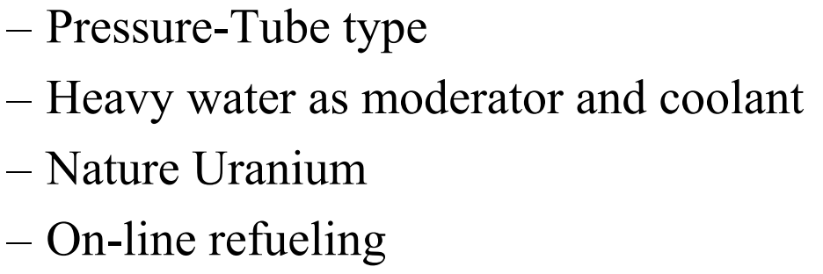

1. What is a thermal reactor?

A nuclear reactor with a large fission rate by thermal neutrons

1. How many thermal reactors?

Currently about 450 nuclear power stations are in operation worldwide.

The majority is of the light-water type with a lead for the PWR.

1. Conversion Ratio

The average number of fissile atoms produced in a reactor per fissile fuel atom consumed.

1. The Linear Doubling Time

The hypothetical time interval during which the amount of fissile material in a reactor doubles,

1. Specific Burnup

The fission energy released per unit mass of the fuel

1. The neutron cycle in a thermal reactor

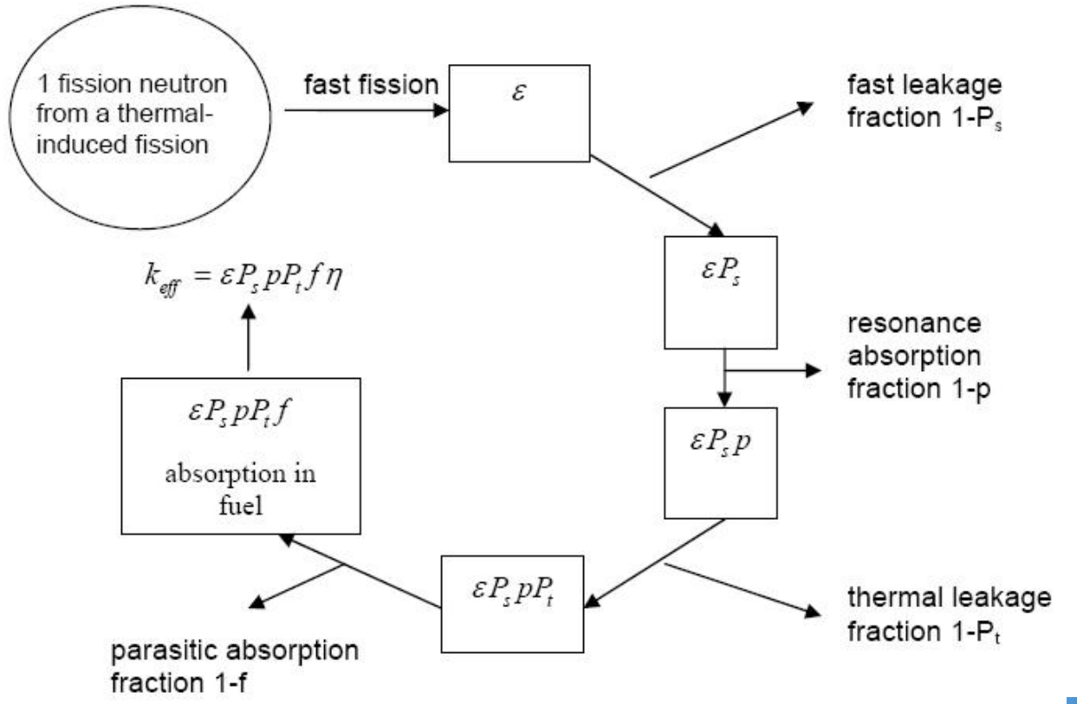

1. Why control rods are always placed at the bottom of the reactor in a BWR?

The coolant at the bottom of core has low steam content, high reactivity and high power density, and the control rods insert from the bottom of core can make the axial power distribution even.

1. What is the function of reflector?

• Flatten the radial neutrons flux density distribution

• Improve core edge fuel efficiency

• Reduce neutrons leakage and critical core radius

• Usually use the same material as the moderator

1. Why we need the multigroup model?

Neutrons have a wide energy spectrum, ranging from a fraction of an eV to a few MeV. The cross sections vary over decades in this range so we can hardly expect the one group approximation to be very accurate.

1. Closed fuel cycle

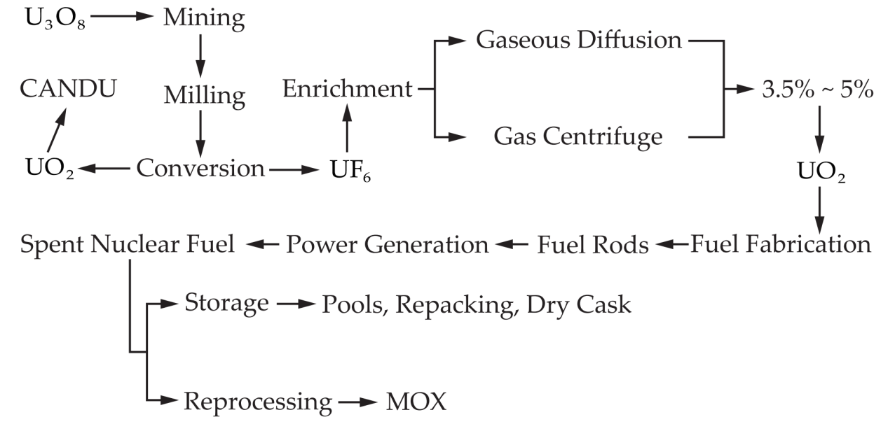

1. Numerical Computational Methods for Neutron Transport Theory under Complex Environments

l Angular discretization

l Spatial discretization

l Energy discretization

l Time discretization

facing challenges:

Ø Complex Geometry

Ø Large computational burden

Ø High accuracy requirements

1. The step of Pin-by-Pin

Ø Lattice cell calculation

Ø Whole-core calculation

Ø Pin Power reconstruction

1. Isotope separation method

• Gas diffusion

• Gas centrifuge

• Aerodynamic processes

• Laser techniques

• Chemical methods

• Plasma separation process

• Thermal diffusion method

1. Fuel Reprocessing & Radioactive Waste Disposal

• good：Recover fissile material for energy extraction

• bad： Economic disadvantage and political risks

1. Thermal Design of a Reactor

1) Determine the thermal paramenters

2) Fuel rod paramenters

3) compute Δp, MDNBR, t and so on

4) Technical and economic evaluation

5) Thermal and hydraulic experiment