|  |  |  |
| --- | --- | --- |
|  | | |
|  | | |
|  | | |
|  | | 上海海勃膜结构股份有限公司  Shanghai HIGHBIRD Fabric structures Co., Ltd. |
|  | | |
|  | | |
|  | | |
|  | 测试报告  双轴拉伸测试和弹性模量测定  根据MSAJ/M-02-1995 Testing Method for Elastic Constants of Membrane Materials | |
|  | Report on  Biaxial Tensile Test and evaluation of Young’s modulus  According to MSAJ/M-02-1995 Testing Method for Elastic Constants of Membrane Materials | |
|  |  | |

|  |  |
| --- | --- |
| 项目名称  Project Name | 测试项目 |
| 建设单位  Client | 天地皇家建设工程部门 |
| 测试编号  Test No. | No.122321312131 |

|  |  |
| --- | --- |
| **测试**  **Examined by** | 张攀  Pan Zhang |
| **审核**  **Reviewed by** | 张攀  Pan Zhang |
| **批准**  **Approved by** | 鲁全峰  Quanfeng Lu |
|  |  |
| 日期  Date | 2021/03/03 |

目录 Contents

1. 基本信息Task information 1

2. 测试方法 Introduction 1

3. 测试结果 Test results 1

4. 模量测定 Calculation of modulus 1

附件 Attachment 1

# 基本信息Task information

按MSAJ/M-02 TESTING METHOD FOR ELASTIC CONSTANTS OF MEMBRANE MATERIALS [1] 进行双轴测试并确定弹性常数。

Biaxial test and determination of elastic constants according to MSAJ/M-02 TESTING METHOD FOR ELASTIC CONSTANTS OF MEMBRANE MATERIALS [1].

|  |  |
| --- | --- |
| 材料供应商  Material Producer | Verseidag Indutex Gmbh |
| 材料种类  Kind of Material | PTFE Coated glass fiber fabric |
| 材料型号  Type of Material | B18089 |
| 取样日期  Sample receipt date |  |
| 卷/批号  Batch/Roll number |  |
| 试样编号  Sample number |  |
| 测试标准  Test standard | MSAJ/M-02-1995 |
| 测试温度  Test temperature | 50℃ |
| 测试日期  Test date |  |
| 加载组合  Load combination | Warp to fill tensions 1:1, 2:1, 1:2, 1:0, 0:1 |
| 预应力  Pre-stress | 2.0 kN/m |
| 试样数量  Number of samples | 3 |
| 试样尺寸 Size of sample | |
|  | |

# 测试方法 Test Procedure

如下图figure 2.1所示为用来确定膜材弹性常数的加载时程图谱，按照MSAJ中提供的测试程序，每种载荷比循环加载三个周期。

In the following figure 2.1 time history of the load scheme is shown be used for determine the elastic constant. According to the test procedure shown in the MSAJ procedure three cycles for each load ratio have been used.

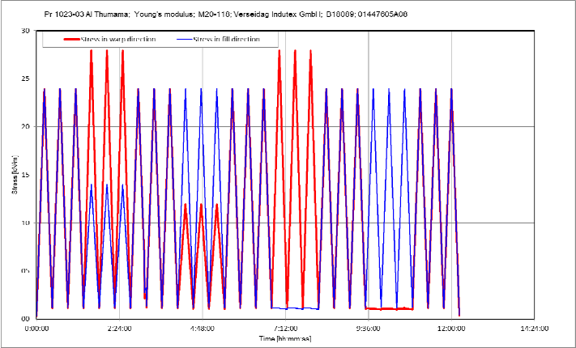

figure 2.1 Stress diagram

如图figure 2.2所示为相应的应力-应变关系曲线图。

In the following figure 2.2 the corresponding stress-strain-relation diagram is shown.

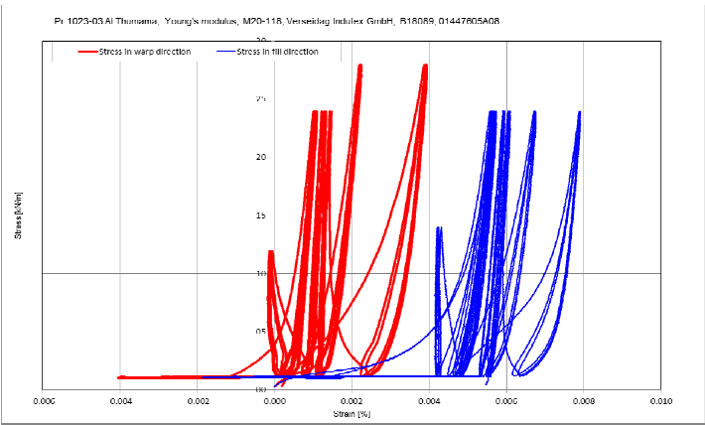

figure 2.2 Stress to strain diagram

如图figure 2.3所示为相应的应变时程图谱。

In the following figure 2.3 the corresponding time history of strain diagram is shown.

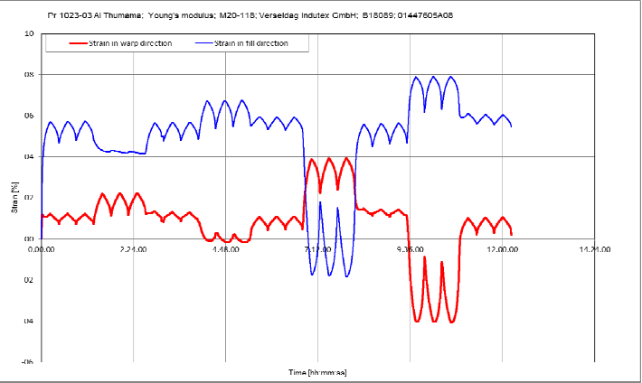

figure 2.3 Strain diagram

如图figure 2.4所示为上述应力和应变的叠加时程图谱。

In the following figure 2.4 the time history of stress and strain is shown.

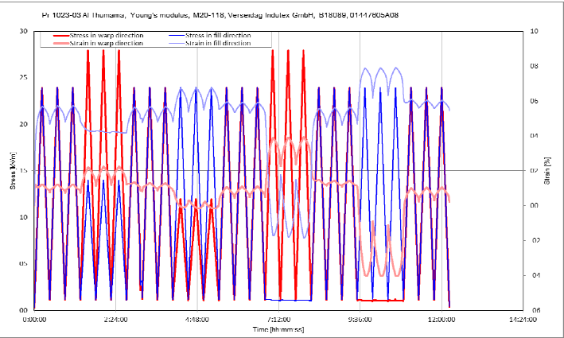

figure 2.4 Stress and strain diagram

# 测试结果 Test results

按图figure 2.1中所示的机制进行加载，在不同载荷比下的应力应变关系的结果如图figure 3‑1~3-5所示。

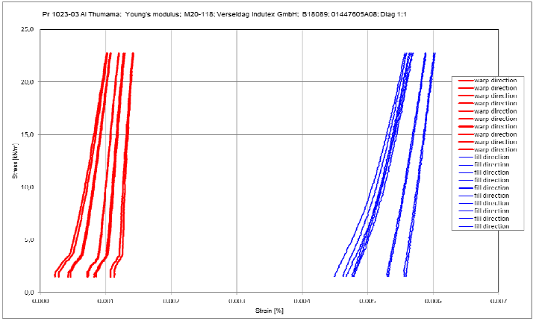

The load regime shown above in figure 2.1 has been applied. The resulting stress strain relations for the different load ratios are shown in the following figures 3.1 ~ 3.5.

figure 3‑1 Stress and strain diagram for load ratio 1:1

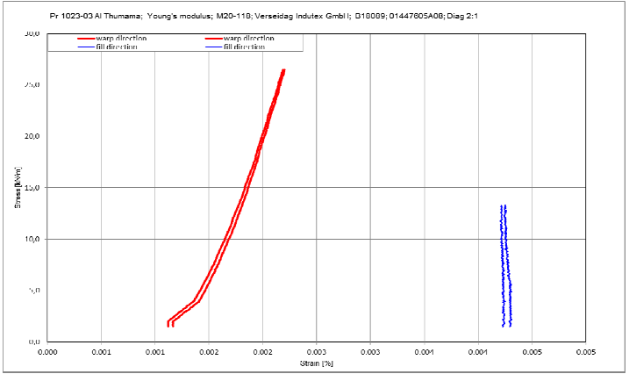

figure 3‑2 Stress and strain diagram for load ratio 2:1

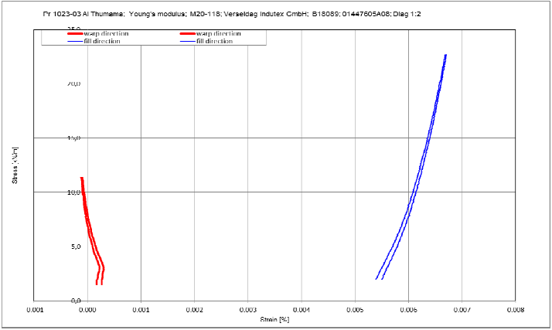

figure 3‑3 Stress and strain diagram for load ratio 1:2

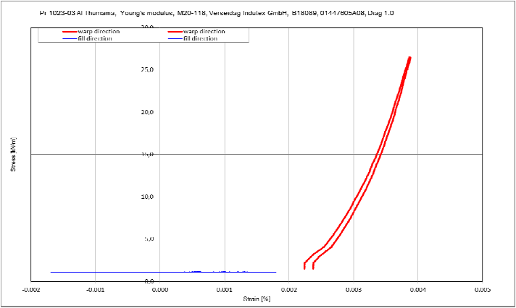

figure 3‑4 Stress and strain diagram for load ratio 1:0

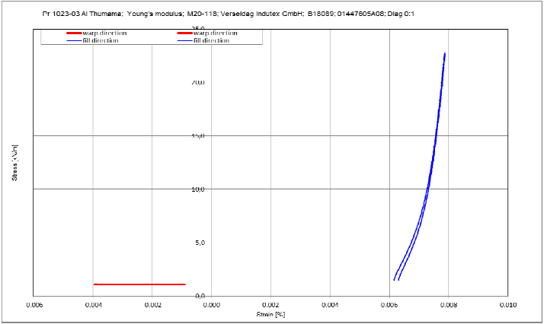

figure 3‑5 Stress and strain diagram for load ratio 0:1

# 模量测定 Evaluation of modulus

膜材的弹性模量根据MSAJ中的方法a) 使用最小二乘法，采用应变误差最小化的方法进行测算。

The elastic modulus of membrane material is evaluated in a method of minimize the strain terms according to MSAJ method a) Using the least square method.

应变和应力的关系采用下式表示：

The relationship between strain and stress is expressed as follows.

各应力应变关系的梯度值如表table 4.1所示。按应力组合计算得到的结果包括弹性模量及泊松比，如表table 4.2所示。

Gradient ratio of stress and strain values were taken for each relationship(Δn11, Δε11, Δn22, Δε22….) as shown in table 4.1. Then calculation was done according to stress combinations as shown in table 4.2 including Elastic modulus and Poisson’s ratio.

**table 4.1: Gradient values**

|  |  |  |  |  |  |  |  |  |
| --- | --- | --- | --- | --- | --- | --- | --- | --- |
| 经纬向应力比  Stress ratio warp to fill(weft) | 最后2个循环  Last 2 cycles | | | | 最后2个循环平均值  Average values last 2 cycles | | | |
| Δn11 | Δn22 | Δε11 | Δε22 | Δn11 | Δn22 | Δε11 | Δε22 |
| [kN/m] | [kN/m] | [%] | [%] | [kN/m] | [kN/m] | [%] | [%] |
| 1:1 |  |  |  |  |  |  |  |  |
|  |  |  |  |  |  |  |  |  |
| 2:1 |  |  |  |  |  |  |  |  |
|  |  |  |  |  |  |  |  |  |
| 1:1 |  |  |  |  |  |  |  |  |
|  |  |  |  |  |  |  |  |  |
| 1:2 |  |  |  |  |  |  |  |  |
|  |  |  |  |  |  |  |  |  |
| 1:1 |  |  |  |  |  |  |  |  |
|  |  |  |  |  |  |  |  |  |
| 1:0 |  |  |  |  |  |  |  |  |
|  |  |  |  |  |  |  |  |  |
| 1:1 |  |  |  |  |  |  |  |  |
|  |  |  |  |  |  |  |  |  |
| 0:1 |  |  |  |  |  |  |  |  |
|  |  |  |  |  |  |  |  |  |
| 1:1 |  |  |  |  |  |  |  |  |
|  |  |  |  |  |  |  |  |  |

**table 4.2: 各应力比作用下最后2两个加载循环周期的弹性模量平均值  
 Elastic moduli mean value of last 2 load cycles in dependency of stress ratio**

|  |  |  |  |  |  |
| --- | --- | --- | --- | --- | --- |
| 经纬向应力比  Stress ratio warp to fill(weft) | 弹性模量平均值  Elastic Moduli mean value | | | 泊松比平均值  Poisson’s Ratio mean value | |
| EW | EF | EWF=EFW | VWF | VFW |
| [kN/m] | [kN/m] | [%] |  |  |
| 1:1 |  |  |  |  |  |
| 2:1 |  |  |  |  |  |
| 1:1 |  |  |  |  |  |
| 1:2 |  |  |  |  |  |
| 1:1 |  |  |  |  |  |
| 1:0 |  |  |  |  |  |
| 1:1 |  |  |  |  |  |
| 0:1 |  |  |  |  |  |

Jiang Su, China <报告日期>

|  |  |  |  |
| --- | --- | --- | --- |
|  |  |  |  |
| <联系人签名处> |  |  |  |
|  |  |  |  |
| <联系人姓名> |  |  |  |
| 实验技术主任 **Technical laboraty** manager |  |  |  |

**注：**

测试结果仅适用于上述试样

**Remark:**

All test results are only referring to the above-mentioned samples.

上海海勃膜结构股份有限公司 Shanghai HIGHBIRD Fabric structures Co., Ltd.

地址 Addr.: 上海市闵行区申南路515号2幢9层

9/F, 2. Etage, No. 515 Shennan Road, Shanghai, China

电话 Tel.: +86 (21) 64688000

传真 Fax.: +86 (21) 64289680

附件 Attachment

测试数据记录 Record of test values

| 时间  Time | 经向应力  Stress in warp | 纬向应力  Stress in weft | 经向应变  Strain in warp | 纬向应变  Strain in weft |
| --- | --- | --- | --- | --- |
| [s] | [kN/m] | [kN/m] | [%] | [%] |
| 0:00:00 | 0.000 | 0.000 | 0.000 | 0.000 |
|  |  |  |  |  |
|  |  |  |  |  |
|  |  |  |  |  |
|  |  |  |  |  |
|  |  |  |  |  |
|  |  |  |  |  |
|  |  |  |  |  |
|  |  |  |  |  |
|  |  |  |  |  |
|  |  |  |  |  |
|  |  |  |  |  |
|  |  |  |  |  |
|  |  |  |  |  |
|  |  |  |  |  |
|  |  |  |  |  |
|  |  |  |  |  |
|  |  |  |  |  |
|  |  |  |  |  |
|  |  |  |  |  |
|  |  |  |  |  |
|  |  |  |  |  |
|  |  |  |  |  |
|  |  |  |  |  |
|  |  |  |  |  |
|  |  |  |  |  |
|  |  |  |  |  |
|  |  |  |  |  |
|  |  |  |  |  |
|  |  |  |  |  |
|  |  |  |  |  |
|  |  |  |  |  |
|  |  |  |  |  |
|  |  |  |  |  |
|  |  |  |  |  |
|  |  |  |  |  |
|  |  |  |  |  |
|  |  |  |  |  |
|  |  |  |  |  |
|  |  |  |  |  |
|  |  |  |  |  |
|  |  |  |  |  |
|  |  |  |  |  |
|  |  |  |  |  |
|  |  |  |  |  |
|  |  |  |  |  |
|  |  |  |  |  |
|  |  |  |  |  |
|  |  |  |  |  |
|  |  |  |  |  |
|  |  |  |  |  |
|  |  |  |  |  |
|  |  |  |  |  |
|  |  |  |  |  |
|  |  |  |  |  |
|  |  |  |  |  |
|  |  |  |  |  |
|  |  |  |  |  |
|  |  |  |  |  |
|  |  |  |  |  |
|  |  |  |  |  |
|  |  |  |  |  |