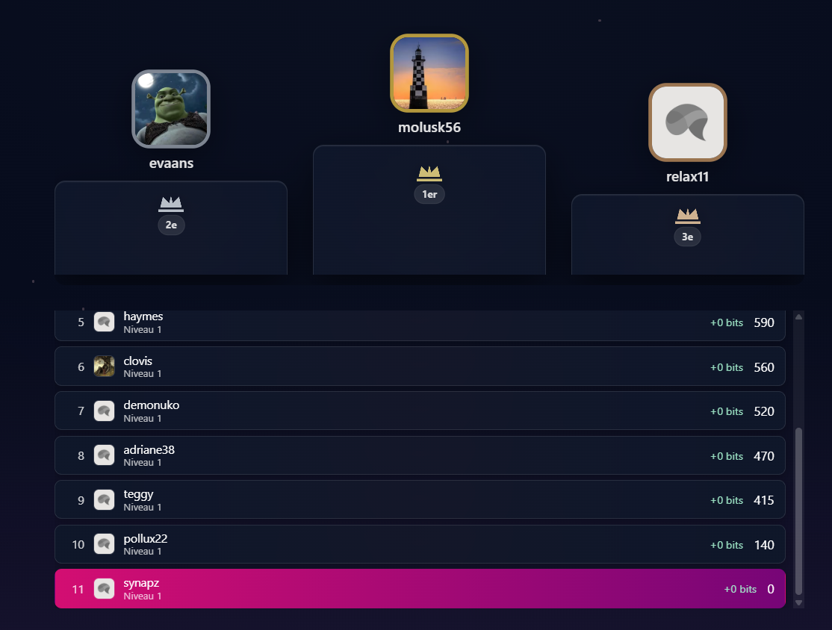

{/* couronne + rang */}
<div className="absolute left-1/2 -translate-x-1/2 pointer-events-none" style={{ top: "14%" }}>
<div className="flex flex-col items-center gap-1" aria-hidden="true">
<svg
width="34"
height="20"
viewBox="0 0 34 20"
className={[
"opacity-80",
t.rank === 1 ? "fill-amber-200" : t.rank === 2 ? "fill-slate-200" : "fill-orange-200",
"drop-shadow-[0_6px_10px_rgba(0,0,0,.45)]",
].join(" ")}
>
<path d="M3 17h28v3H3v-3Zm2-2 3-12 7 7 2-8 2 8 7-7 3 12H5Z" />
</svg>

<span
className={[
"px-2 py-0.5 rounded-full",
"text-[11px] font-bold tabular-nums",
"bg-white/10 text-white/85 ring-1 ring-white/15",
].join(" ")}
>
{t.rank === 1 ? "1er" : t.rank === 2 ? "2e" : "3e"}
</span>
</div>
</div>

