**Midterm Report – Pokémon Battler**

**Design**:

This application builds upon the Pokémon game built in class. When the application is started the user will be prompted to select between two types of Pokémon (water or fire). After the user has selected their Pokémon type, they are then prompted to enter a name for it. Once that has been completed the battle starts. There are two labels, one to display the player’s Pokémon’s life points and another for the computer’s life points. There are also two buttons, one for normal attack, the other for special attack. The user is prompted to select one of the attacks. The special attack changes based on which type of Pokémon was chosen. The computer’s type will always be the opposite of the player’s choice. The player is prompted to select one of the attacks and once they have done that the top label is updated to say what kind of attack was made and how much damage was done. The computer’s life points are then updated and printed on the label. After a couple of seconds, the user will see the label says it’s the computer’s turn. After a couple more seconds the computer attacks the player with one of the two attacks based on a random number. Again, the top label is updated to say what attack was done by the computer and the player’s life points are updated. Then it’s the player’s turn to go again. The game continues until one of the Pokémon’s has reached zero life points. At which point the top label is updated to say who won, then after a few seconds the application closes itself.

I wanted to make this GUI because I was inspired by the original in class application and wanted to make a GUI version of it where the user can interact with it.

**UML**:

Game Operator

player

cpu

selection

set_selection_water()

set_selection_fire()

set_up_game()

terminate()

check_win_condition()

tksleep()

norm_attk()

spec_attk()

cpu_attk()

WaterType

waterjet()

FireType

fireball()

Pokémon

name

hitPower

lifePoints

life_points_remaining()

attack()

**Executable Files Screenshot:**

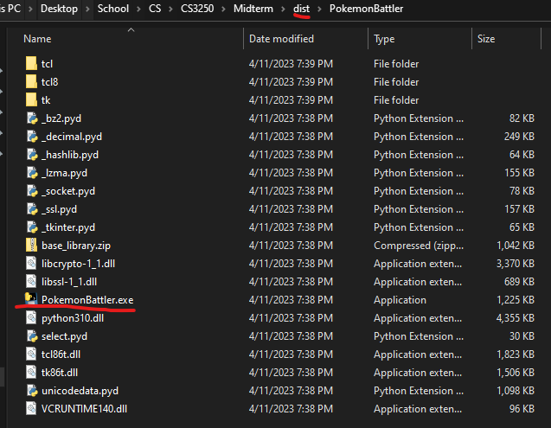

**Application In Use Screenshots:**

1. Application Startup (User prompted to select type):

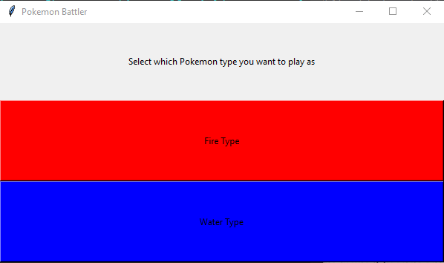

1. User prompted to enter a name for their Pokémon:

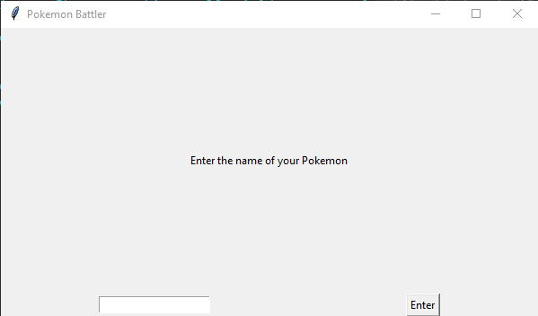

1. User prompted to select an attack:

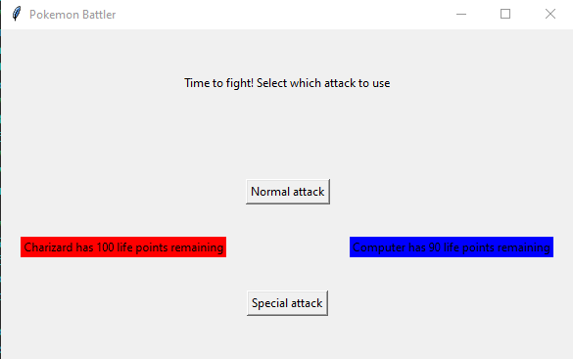

1. Player’s attack is outputted to user then the computer makes it’s turn. Life points for each are updated:

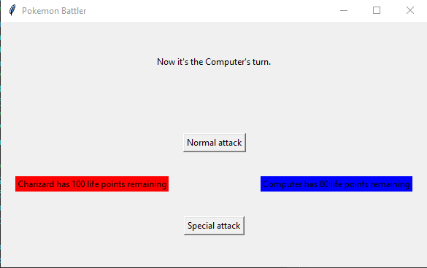

1. This loop continues until a Pokémon reaches zero health. The user sees a message saying they either won or lost. Then the program says thanks for playing and gives a countdown from 5 before terminating:

